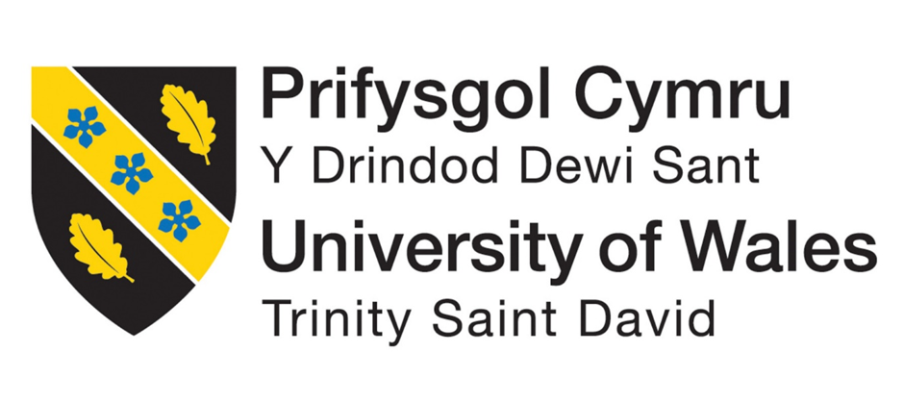

Synthesise a Solution to a Potential Real-Life Scenario Steel Form Manufacturing Ltd (SFM)

Module Name: Networks and Cyber Security Essentials

Module Code: ACCA4024

Student Name: Akaur Rahman

Student Number: 2505136

Lecturer Name: Muhammad Azeem Abbas

Abstract

This report kind of examines cyber security risks for Steel Form Manufacturing Ltd (SFM), a manufacturing company that has brought in Internet of Things (IoT) devices, automated machinery and cloud-based production systems. As SFM gets more reliant on digital technology, it also starts to look more exposed to cyber security threats in general. The report goes on to name the main internal issues like human error, weak passwords, and insider misuse, plus outside dangers such as malware, phishing ransomware and industrial espionage.

The report suggests a range of security policies, plus some technical steps to help lower these risks. It mentions access control, password management, data protection, firewalls, antivirus software, plus network segmentation. There is also Multi-Factor Authentication (MFA) and routine software updates, which should be kept on track.

The report also explains why network monitoring matters, alongside incident response procedures and employee cyber security awareness training. These suggestions are meant to help SFM strengthen its overall cyber security, while still guarding its systems business information and production processes. An organisation can’t completely block cyber-attacks, but using these practical measures can reduce security risks, and in turn help the company keep running its day-to-day operations more safely.

1. Introduction

Cyber security is getting more important, simply because lots of organisations now rely on computers, networks and the internet for their everyday tasks. In manufacturing too, companies are leaning more and more on technology to refine the way they make goods. That can mean using automated machines, cloud-based systems, and Internet of Things (IoT) devices to speed up production and make it more efficient. Yet, even if these tools bring real advantages, they can also raise the odds of cyber-attacks because many more systems get linked together [1].

Steel Form Manufacturing Ltd (SFM) is, a medium size manufacturing firm that makes custom engineered components for automotive AND aerospace clients. Lately the company has started putting in place IoT sensors, more automated machinery, and a cloud-based production management system, so the whole process is faster, and the team can keep a closer eye on daily activities. In practice these tools help employees run production more efficiently, and they also make day to day coordination between departments a bit smoother, with better information flow.

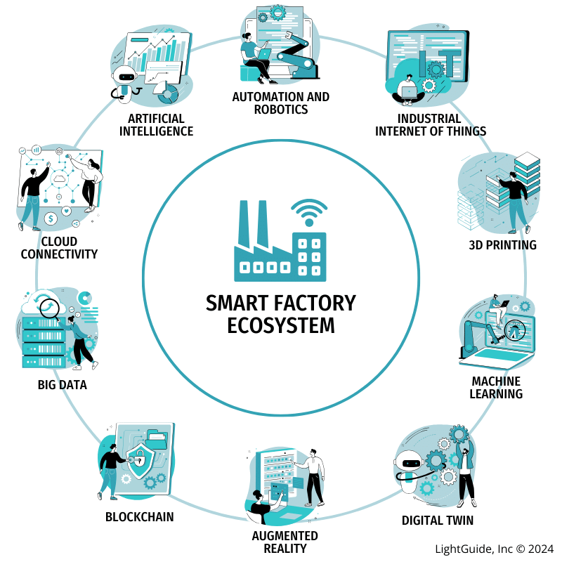
Figure 1. Smart manufacturing environment showing how IoT devices, automated machinery and cloud systems connect within an Industry 4.0 production network.
In this scenario it looks like SFM has already had a few cyber security problems, like malware infections, phishing emails, and tries to get into its production network without permission. These events suggest the company should make cyber security better to lower the chance of more attacks later on. And if these threats work, they might halt production completely, harm important company information, and reduce customer trust.

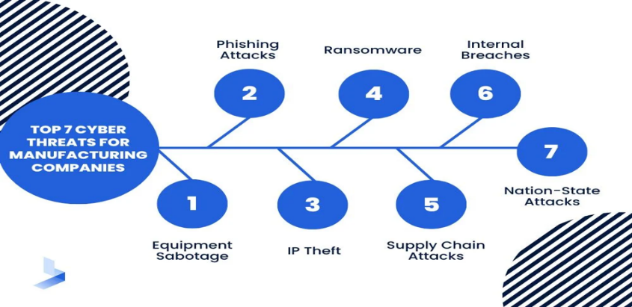
Figure 2. Main cyber security threats affecting manufacturing organisations, including malware, phishing, ransomware and unauthorised access.

As the IT Security Manager, my job is basically to come up with ways that SFM can make its cyber security better, like, not only in one place but, across the whole company. That means I help by putting security policies in place, suggesting technical controls that really fit the environment, and making sure employees understand how to act in a safer manner day to day. When cyber security improves, it also helps guard the company’s production systems, the engineering data, and customer information, from both in-house risks and outside threats.

This report will identify the main cyber security threats that could affect SFM and recommend practical ways to reduce these risks. It will discuss security policies, technical measures, network monitoring, incident response and staff training. The aim is to help SFM improve its cyber security and protect its systems, employees and important business information while allowing the company to continue its manufacturing operations safely.

2. Identification of Internal Threats

Internal threats in cyber security are basically risks that show up from inside an organisation. They tend to be linked to people who already have access to the company’s systems, like employees, contractors, or other associated users. A lot of the time these threats are not meant on purpose. They can appear because someone slips up, forgets to stick to company procedures, or they simply do not see the cyber security risks clearly. For SFM, internal threats are important because many employees use computers, cloud systems and automated production equipment every day [2].

A common internal risk comes from plain human error. Like, an employee can accidentally open a dangerous email attachment, click on a spoofed website or even pass company information to the wrong person. Those little slips, kind of mundane at first, can still let malware slide into the company network, or cause confidential data to be exposed.

Another threat is the use of weak passwords. If employees choose simple passwords or reuse the same password for different accounts, attackers may be able to guess them and gain unauthorised access to company systems. This could allow someone to view or change important production or customer information.

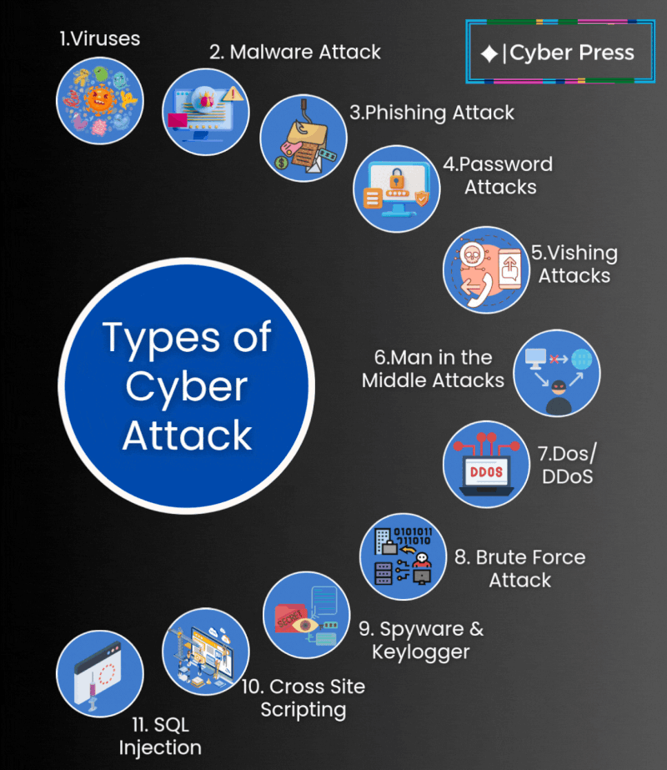
Figure 3. Internal cyber security risks caused by employee actions, such as weak passwords, phishing mistakes and unsafe system use.

An insider threat can also occur when an employee deliberately misuses their access to steal information or damage company systems. Although this is less common, it can have a serious effect on the business. At SFM, engineering drawings, customer details and production information are valuable, so access to this data should be controlled.

Another risk is the use of unauthorised USB devices or personal equipment. If an employee connects an infected USB drive or an unapproved device to the company network, malware could spread to other computers and production systems.
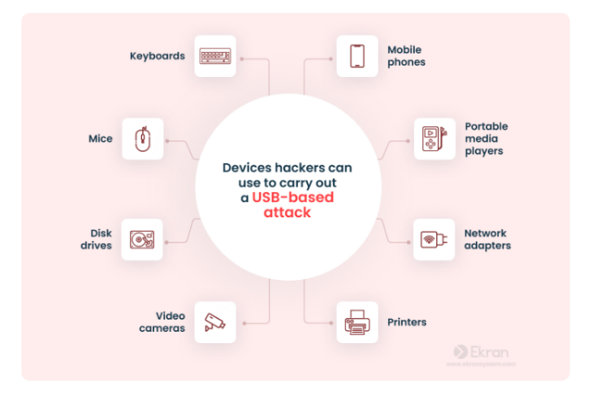
Figure 4. Example of how unauthorised USB devices can introduce malware and compromise a company network.

To reduce these risks, SFM should provide regular cyber security training, encourage employees to report suspicious activity, use strong password rules and limit access to important systems. These simple measures can help reduce mistakes and improve the company's overall cyber security.

Internal Threats at SFM

Internal Threat | Possible Impact on SFM
Human error | Malware infection or accidental data loss
Weak passwords | Unauthorised access to company systems
Insider threat | Theft or misuse of company information
Unauthorised USB devices | Malware spreading across the network
Lack of cyber security awareness | Increased chance of successful cyber attacks

3. Identification of External Threats

External threats are cyber security risks that come from outside an organisation. These threats are usually carried out by cyber criminals who want to steal information, damage systems or make money. Manufacturing companies such as SFM can be attractive targets because they store valuable customer information, engineering designs and production data. If an attack is successful, it could disrupt production and cause financial loss [3].

One of the biggest external threats is malware. Malware is harmful software that can infect computers and networks. It may slow down systems, steal information or damage important files. Malware often spreads through email attachments, infected websites or unsafe downloads. SFM has already experienced malware infections, it is important that the company improves its protection against this type of attack.

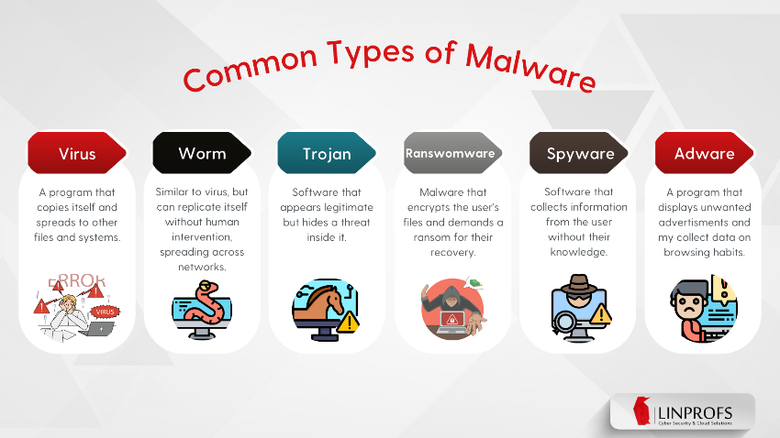
Figure 5. Common external cyber threats, including malware attacks and phishing attempts targeting business systems.
Another common threat is phishing. Phishing emails are designed to trick employees into clicking fake links or providing personal information such as usernames and passwords. The scenario states that procurement staff have already received phishing emails, showing that attackers are targeting employees to gain access to company systems.

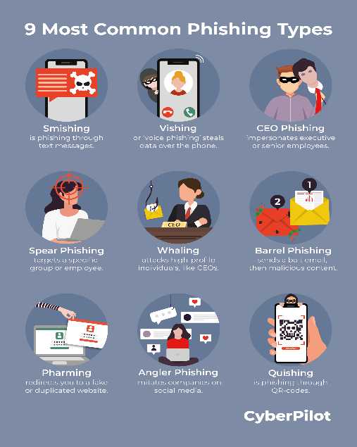
Figure 6. Different types of phishing attacks that may be used to trick employees into sharing sensitive information.

Ransomware is another serious threat. This type of malware locks or encrypts files so they cannot be accessed until a payment is made. If ransomware affected SFM, production could stop and important business information might become unavailable. This could result in delays, financial loss and damage to the company's reputation.

Manufacturing companies may also face industrial espionage, where attackers try to steal confidential information such as product designs, manufacturing methods or customer details. Competitors or organised cyber criminals may attempt to gain this information through cyber-attacks.

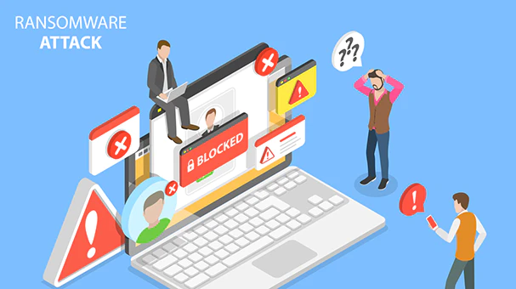
Figure 7. Cyber threats such as ransomware and industrial espionage that can disrupt manufacturing operations and expose confidential data.
A potential risk involves a Distributed Denial of Service (DDoS) attack. Such an incident occurs when malicious actors flood a company’s network or website with excessive traffic, resulting in slowed performance or complete service outages. Even though SFM primarily concentrates on manufacturing operations, a DDoS attack could still disrupt online services, hinder communication with clients, or impede access to cloud-based platforms.

To mitigate these risks, SFM ought to implement antivirus programs, email filtering, firewalls, routine software updates, and employee training. Such security protocols can lower the likelihood of successful cyber-attacks and safeguard the organisation's systems and data.

External Threats at SFM

External Threat | Possible Impact on SFM
Malware | Damage to systems and loss of data
Phishing | Stolen usernames, passwords or company information
Ransomware | Production disruption and financial loss
Industrial espionage | Theft of engineering designs and confidential data
DDoS attack | Network disruption and loss of access to online services

4. Security Policies

Security policies are important because they explain how employees should use company systems safely and responsibly. They help reduce cyber security risks by giving staff clear rules to follow. At SFM, security policies are especially important because employees use computers, cloud systems and automated production equipment every day. Having clear policies can help protect company information, reduce human error and improve the overall security of the business [4].

One important policy is an Access Control Policy. Employees should only be given access to the systems and information they need to do their job. For example, production staff should only be able to access production systems, while finance staff should only have access to financial records. Limiting access reduces the chance of important information being viewed or changed by the wrong person.

Another important policy is a Password Policy. Employees should create strong passwords that include a mixture of letters, numbers and special characters. Passwords should not be shared with other employees and should be changed regularly. Where possible, SFM should also use Multi-Factor Authentication (MFA) to make user accounts more secure.

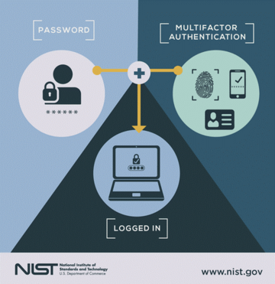
Figure 8. Access control and multi-factor authentication as security measures for protecting company user accounts.

A Data Protection Policy should explain how company and customer information is collected, stored and shared. Employees should only access information needed for their work and should keep sensitive data secure. This policy also helps SFM meet its legal responsibilities under the Data Protection Act 2018 [5].

SFM should also have an Acceptable Use Policy. This explains how employees should use company computers, email and the internet. Staff should avoid downloading unknown software, opening suspicious email attachments or using company devices for unsafe activities that could increase cyber security risks.

Another useful policy is a Backup and Recovery Policy. Important files and production data should be backed up regularly so they can be restored if they are lost because of hardware failure, accidental deletion or a cyber-attack such as ransomware.

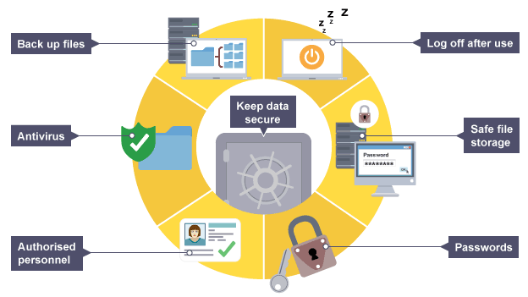
Figure 9. Backup and recovery processes that help organisations restore important data after system failure or cyber-attack.

SFM should have an Incident Reporting Policy. Employees should know how to report suspicious emails, unusual computer activity or possible cyber-attacks as soon as they are noticed. Reporting incidents quickly allows the IT team to investigate problems before they become more serious.

Recommended Security Policies for SFM

Security Policy | Purpose
Access Control Policy | Limits access to authorised employees only
Password Policy | Encourages strong passwords and secure accounts
Data Protection Policy | Protects company and customer information
Acceptable Use Policy | Explains the safe use of company devices and systems
Backup and Recovery Policy | Allows important data to be restored after an incident
Incident Reporting Policy | Helps employees report cyber security issues quickly

5. Technical Mitigation Measures

Technical security measures are tools and technologies used to protect computer systems, networks and information from cyber-attacks. They work alongside security policies to reduce the chance of malware, unauthorised access and data loss. Since SFM uses cloud systems, IoT devices and automated machinery, it is important that the company has suitable technical controls to protect its production network and business information [6].

One of the most important security measures is a firewall. A firewall monitors network traffic and helps block unauthorised users from accessing the company's systems. It acts as a barrier between SFM's internal network and the internet, helping to reduce the risk of cyber-attacks.

Another useful measure is network segmentation. This means dividing the company network into smaller sections instead of having one large network. For example, production machines, office computers and guest Wi-Fi can all be kept on separate networks. If one part of the network becomes infected, it is less likely that the attack will spread to the whole company.

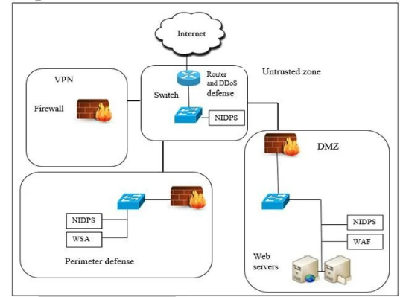

Figure 10. Firewall and network segmentation controls used to separate systems and reduce the spread of cyber-attacks.
SFM should also install antivirus and endpoint protection software on all company computers. These programs help detect and remove malware before it can damage systems or steal information. Keeping this software updated is important because new cyber threats appear regularly.

Another useful security measure is Multi-Factor Authentication (MFA). MFA asks users to provide a second form of verification, such as a code sent to a mobile phone, before they can log in. This makes it harder for attackers to access accounts, even if they know a user's password.

SFM should also make sure that all software and operating systems are updated regularly. Installing security updates helps fix known weaknesses that attackers may try to exploit. Regular updates are one of the simplest ways to improve cyber security.

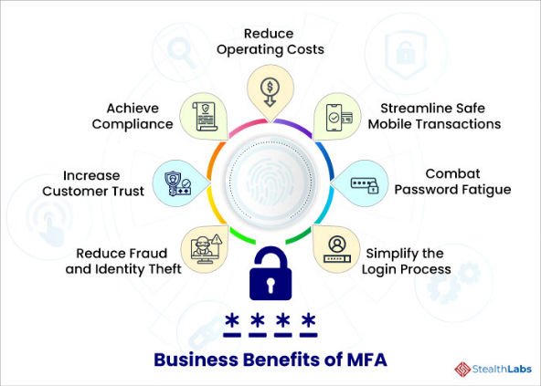
Figure 11. Multi-factor authentication and software updates as technical controls for improving system and account security.

Using these technical measures together will give SFM better protection against common cyber threats. Although no security system can stop every attack, these controls can reduce the risk of successful cyber-attacks and help keep the company's production systems running safely.

Recommended Technical Security Measures
Technical Measure | Benefit to SFM
Firewall | Blocks unauthorised network access
Network Segmentation | Prevents attacks from spreading across the network
Antivirus Software | Detects and removes malware
Endpoint Protection | Protects company computers and devices
Multi-Factor Authentication (MFA) | Makes user accounts more secure
Regular Software Updates | Fixes known security weaknesses

6. Network Monitoring and Incident Response

Even with good security policies and technical controls, cyber-attacks can still happen. For this reason, SFM should regularly monitor its network so that unusual activity can be detected as early as possible. Finding problems quickly can reduce damage, protect important information and help keep production running. Monitoring should include checking company computers, servers and network devices for anything that looks unusual [7].

One approach involves utilising security logs. Computers, servers, and network devices typically document data concerning user logins, file access, and various other actions. The IT department can examine these records to identify failed login attempts, anomalous network traffic, or other indicators suggesting a potential cyber-attack.

A Security Information and Event Management (SIEM) system serves as another valuable resource. By aggregating security logs from various devices into a centralised location, a SIEM simplifies the identification of suspicious behaviour for the IT department. Consequently, this capability enables personnel to react more rapidly in the event of a cyber-attack.
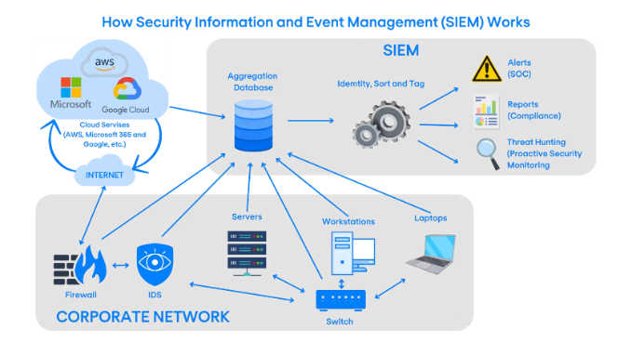
Figure 12. Network monitoring and SIEM systems used to detect suspicious activity across company networks.

SFM should also have an Incident Response Plan. This is a simple plan that explains what employees and the IT team should do if a cyber security incident happens. Having a clear process helps reduce confusion and allows the company to recover more quickly.

For example, if an employee receives a phishing email, they should avoid clicking any links or opening attachments. The email should be reported to the IT department immediately. The IT team can then investigate the email, remove it from other inboxes if necessary, and check whether any accounts have been affected.

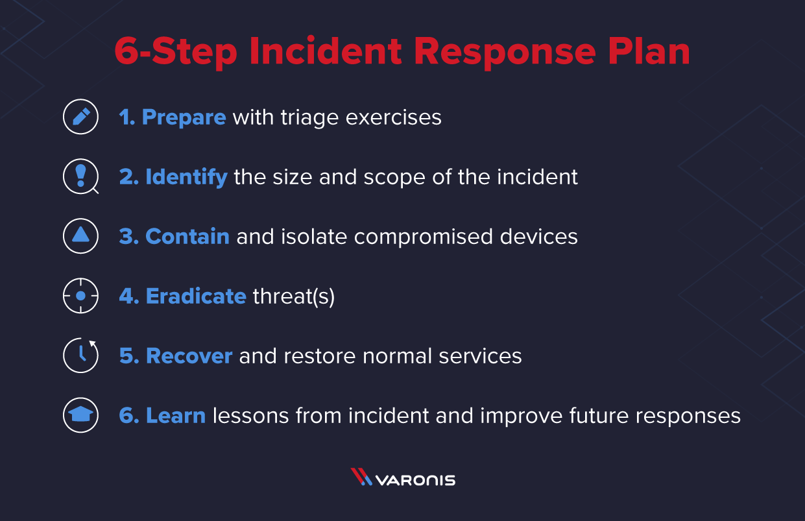
Figure 13. Basic incident response process for identifying, containing and recovering from cyber security incidents.

After every incident, SFM should review what happened and identify ways to improve its security. For example, if an attack was successful because an employee clicked a phishing email, the company could provide extra staff training or improve its email filtering. Learning from incidents will help SFM reduce the risk of similar attacks in the future.

7. Training and Awareness

Technology alone cannot protect a company from cyber-attacks. Employees also need to understand how to work safely and recognise common cyber security risks. Many cyber-attacks happen because someone accidentally clicks a harmful link, opens an unsafe email attachment or shares information with the wrong person. Regular training can help reduce these mistakes and improve SFM's overall security [8].

Onboarding is the first line of defence. SFM new hires must grasp the basics immediately. Strong passwords. Phishing detection. Information protection. Reporting anomalies. Instilling these habits at the start builds a culture of caution rather than reaction.

SFM should also provide regular refresher training for existing employees. Cyber threats continue to change, so staff should be reminded about good cyber security practices throughout the year. Short training sessions every few months can help employees remember the importance of following company security policies.

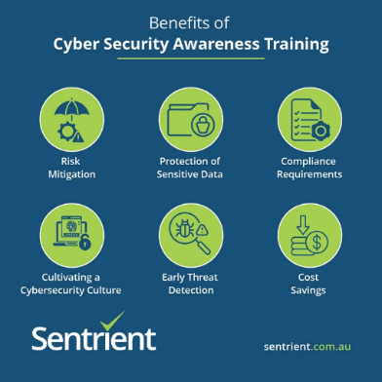
Figure 14. Cyber security awareness training helping employees recognise threats and follow safe working practices.

Various departments may require distinct training approaches. For instance, because the scenario indicates they have already been targeted, procurement personnel need to learn how to detect phishing emails. Production workers should be educated on the safe operation of automated machinery and the prohibition of connecting unauthorised hardware, such as personal USB drives. Meanwhile, IT employees should undergo supplementary instruction regarding system monitoring, the implementation of software patches, and the handling of cyber security breaches.

Conducting phishing simulations is another beneficial practice. In these exercises, the IT department distributes practice phishing emails to assess whether staff members can identify suspicious communications. If an individual falls for the fake message, they can be provided with additional guidance and training, ensuring no damage is done to the organisation.

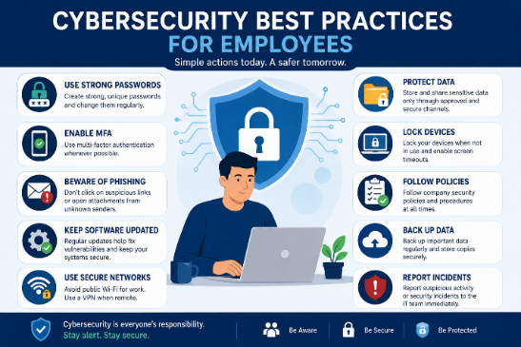
Figure 15. Employee reporting process for suspicious emails and cyber security incidents to support faster response.

Employees should also be encouraged to report security problems immediately. If someone notices unusual computer behaviour, receives a suspicious email or believes they have made a mistake, they should inform the IT department as soon as possible. Reporting problems quickly allows the company to respond before the situation becomes more serious.

Providing regular training and encouraging employees to follow company security policies will help SFM reduce human error, improve cyber security awareness and lower the risk of successful cyber-attacks.

Suggested Cyber Security Training for SFM

Employee Group | Training Required
New employees | Basic cyber security awareness and company policies
All employees | Regular refresher training throughout the year
Procurement staff | Recognising phishing emails and online scams
Production staff | Safe use of production systems and USB devices
IT staff | Network monitoring, software updates and incident response

8. Conclusion

For Steel Form Manufacturing Ltd, cyber security isn't just a checklist—it’s survival. The company relies on IoT devices, automated machinery, and cloud systems to keep production moving, but those same technologies open doors to new risks. The evidence is already there: malware infections, phishing emails, and unauthorised access attempts have struck. The warning signs are clear. Stronger protection is no longer optional.

This report mapped out the threats facing SFM, both inside and out. Internally, the dangers are often human error, weak passwords, or insider misuse. Externally, the landscape is far more hostile, featuring malware, phishing, ransomware, and industrial espionage. Identifying these specific vectors is the only way to pinpoint where security gaps exist.

The solution involves a mix of policy and technical controls. SFM needs strict access controls, robust password policies, and comprehensive data protection. Firewalls and antivirus software are baseline requirements, but network segmentation and Multi-Factor Authentication (MFA) add critical layers of defence. Regular software updates keep these defence’s current. Together, they significantly lower the odds of a successful attack.

But technology alone isn't enough. Network monitoring and a clear incident response plan allow SFM to detect and manage breaches before they spiral. Equally important is regular cyber security training. Since many incidents start with human error, staff awareness must be an ongoing commitment, not a one-time event.

SFM can harden its position by combining clear policies, technical controls, continuous monitoring, and employee training. No organisation is immune to cyber-attacks. These practical measures won't prevent every attempt, but they will protect SFM’s systems, business information, and daily manufacturing operations, while minimising the impact of future incidents [9].

References

[1] W. Stallings and M. M. Manna, Data and Computer Communications, 10th ed. Harlow, England: Pearson Education, 2014.

[2] Cisco Networking Academy, Cybersecurity Essentials, Cisco Press, 2024.

[3] W. Stallings, Network Security Essentials: Applications and Standards, 7th ed. Harlow, England: Pearson, 2023.

[4] ISO/IEC 27001:2022, Information Security, Cybersecurity and Privacy Protection — Information Security Management Systems — Requirements. Geneva: International Organization for Standardization, 2022.

[5] UK Government, Data Protection Act 2018. London: The Stationery Office, 2018.

[6] National Institute of Standards and Technology (NIST), Cybersecurity Framework (CSF) 2.0, Gaithersburg, MD: NIST, 2024.

[7] M. M. Masdari and M. Jalali, "A Survey and Taxonomy of SIEM Systems," Journal of Network and Computer Applications, vol. 171, 2021.

[8] M. A. Alhawamdeh, A. Alkhateeb and A. Almaghayreh, "Cyber Security Awareness and Incident Response Planning: Improving Organisational Resilience," International Journal of Information Security, 2022.

[9] M. Herbane, "Rethinking Organizational Resilience and Strategic Renewal in SMEs," Entrepreneurship & Regional Development, vol. 31, no. 5–6, pp. 476–495, 2019.

Figure Sources
Figure 1: https://www.lightguidesys.com/wp-content/uploads/2024/02/Smart-Factory-Ecosystem-Diagram.png

Figure 2: https://www.bitlyft.com/hs-fs/hubfs/Top%207%20Cyber%20Threats%20for%20Manufacturing%20Companies.jpg?width=1000&height=700&name=Top%207%20Cyber%20Threats%20for%20Manufacturing%20Companies.jpg

Figure 3: https://media.licdn.com/dms/image/v2/D5622AQFW9J9CzcCmWw/feedshare-shrink_800/B56ZidVOcBG0Ag-/0/1754986270041?e=2147483647&v=beta&t=Pt4mOhyeegEd_bYf9jbjZ-2qM_A-5I0n-yW5kO7cq6Y

Figure 4: https://www.syteca.com/wp-content/uploads/2023/05/figure-2-How-Can-Ekran-System-Protect-You-against-Infected-USB-Devices.png

Figure 5: https://linprofs.com/wp-content/uploads/2024/10/Common-Types-of-Malware.-Article-1.png

Figure 6: https://www.cyberpilot.io/hs-fs/hubfs/9%20Common%20Phishing%20Types.png?width=2480&height=3508&name=9%20Common%20Phishing%20Types.png

Figure 7: https://www.rubrik.com/content/dam/rubrik/company/ransomware-stock-image-340.png

Figure 8: https://www.infosec.ox.ac.uk/sites/default/files/styles/mt_image_medium/public/infosec/images/media/nist_mfa.png?itok=yuICBbwC

Figure 9: https://bam.files.bbci.co.uk/bam/live/content/z2bk2hv/large

Figure 10: https://www.researchgate.net/profile/Salima-Benqdara/publication/340665336/figure/fig1/AS:880880184737794@1587029610943/Proposed-perimeter-network-segmentation-7-EXPERMENTAL-SETUP-71-Framework.jpg

Figure 11: https://www.stealthlabs.com/wp-content/uploads/2021/04/business-benefits-of-mfa.jpg

Figure 12: https://img.nomios.com/images/Brand-content/Illustrations/SIEM-explained.png?auto=compress%2Cformat&fit=max&fm=jpg&q=70&w=1600&s=3c15c343e592f9c73dfa35bc4118157b

Figure 13: https://www.varonis.com/hs-fs/hubfs/Imported_Blog_Media/6-step-incident-response-plan.png?width=1241&height=803&name=6-step-incident-response-plan.png

Figure 14: https://www.sentrient.com.au/wp-content/uploads/2023/11/Benefits-of-Cyber-Security-Awareness-Training.webp

Figure 15: https://wallstreetcover.com/wp-content/uploads/2026/06/new-image-1.png

PRESENTATATION SCREENSHOTS



