REPORT FOR SWANSEA COUNCIL: SITING AN AMMUNITION DEPOT ON THE SA1 WATERFRONT
OME SAFETY MANAGEMENT AND LEGISLATION, ACDA 6022
Luke Malcolm (2030773)
2025
Contents
Summary 3
1. Aim 4
2. Background 4
2.1 Assumptions 4
3. Quantity Distances 5
3.1 Key Distances 5
3.2 Issues with Quantity Distance 6
3.2.1 Public Traffic Route Distance 6
3.2.2 Inhabited Building Distance 7
3.2.3 Vulnerable Building Distance 8
3.3 Explosion Consequence Analysis 8
4. Compatibility Groups 9
5. Additional Safety, Storage, Transportation, and Other Issues 11
5.1 Site Access 11
5.1.1 Access via Road 11
5.1.2 Access via Sea 11
5.1.3 Access via Rail 12
5.2 Site Plan 12
5.3 Security 12
5.4 Environment 12
5.5 Marina and Port Usage 13
6. Conclusion 13
6.1 Quantity Distance and Explosion Consequence Analysis 13
6.2 ESH Planning & Compatibility Groups 13
6.3 Additional Issues 13
7. Recommendation 14
References 15
Annexe 1: Risk Reduction Questions 16
Annexe 2: Example Port Tenant Safety Notice 21
Annexe 3: QD Definitions 22
Annexe 4: Compatibility Group Mixing Rules 23
Annexe 5: Aggregation Rules 24
Annexe 6: Port Plan 25
Annexe 7: Flood Risk Map 26

Figure 1 - Proposed Site Location 4
Figure 2 - North side of QD Map 7
Figure 3 - Overall QD Map 8

Table 1 - 7-Bar ECM Quantity Distances 5
Table 2 - 3-Bar ECM Quantity Distances 5
Table 3 - Minimum "No Break" Range for Windows 8
Table 4 - Ground Shock 8
Table 5 - Injury Ranges 9
Table 6 - Damage Ranges 9
Table 7 - ESH Numbers and Holdings (kg) 10

Summary
From the information presented by BigBang, the proposed site is not a suitable location for an ammunition depot, even if the “best case scenario” is considered from a licencing standpoint. The quantity distances alone do not permit the construction of a depot on the planned site (both from a perspective of risk to the public and risk to administration workers in the depot), and no attention appears to have been paid to the feasibility of building anything other than the magazines themselves. Transport links and routes are unsuitable and expose the public to an unacceptable degree of risk. The proposal for the depot itself and the five ESHs is poorly-thought out; in reality at least seven ESHs would be required along with at least one process building.
There are also deeper concerns about BigBang as a corporate entity, this proposal indicates significant knowledge gaps in seemingly every key area. Given this, bigger concerns should be raised about their ability to safely deliver and manage a depot anywhere in the country, let alone on the SA1 waterfront.

1. Aim
This report aims to examine the feasibility of the proposed site detailed in Section 2. Background.
The International Ammunition Technical Guidelines (“IATG”) [1] will be the primary tool used throughout to provide this feasibility assessment.

2. Background
A planning application has been made to Swansea Council from BigBang Storage Solutions Ltd (“BigBang”) for an explosive facility to be erected on the SA1 waterfront at the following location:
Latitude: 51.61868
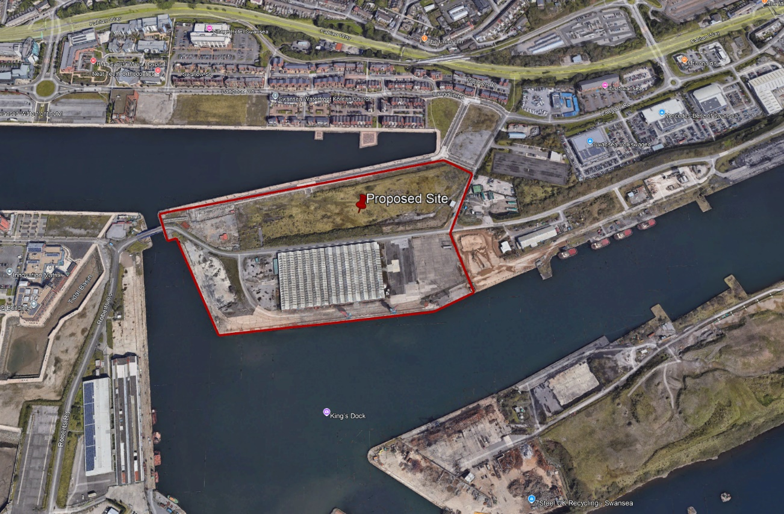
Longitude: -3.91886
Figure 1 - Proposed Site Location
The site will consist of five Explosives Storehouses (ESH), built east to west, along this land. Each ESH is required to store up to 1000kg of each hazard division. The ESHs will be earth covered, with directional effects for blast as described in IATG table C.1 “Side of magazine perpendicular to the direction of the ES” (Exposed Site) The ES can be a building, feature (e.g. overhead power line), or route (e.g. public footpath or road). This means that the side of the magazine is perpendicular to a site which is exposed to the hazards of a fire or explosion at the Potential Explosion Site (PES) under consideration.

2.1 Assumptions
BigBang’s intent regarding storage is not clear from their wording – it could be that they expect to licence each building to simply hold 1000kg of each hazard type at any one time (i.e. the building being licenced for 1000kg of HD1.1, 1000kg HD1.2, 1000kg HD1.3, and 1000kg HD1.4, or they could attempt to licence each building “for 1000kg of each hazard type” – there being four (principal) hazard types, and considering aggregation rules, would result in each building being licenced for 3000kg of HD1.1 and 1000kg of HD1.4.
The assumption will be made that the former applies (each ESH being licenced for 1000kg of HD1.1…etc), as it is “best case” licencing scenario for BigBang yet still remains unsuitable for reasons given subsequently.
Given that a detailed site plan has not been provided, and due to site issues (with respect to suitability) identified in subsequent sections of this report, the assessment has been completed as a “bounding case” for a single ESH, in the geographical centre of the site, holding only 1000kg of HD1.1; if the site is not suitable for a single ESH holding 1000kg of 1.1 then it certainly is not suitable for five or seven.

3. Quantity Distances

3.1 Key Distances
BigBang has stated to the council that:
- The Vulnerable building distance is no more than 300 m for each ESH
- The Inhabited building distance is no more than 125 m for each ESH
- The Public traffic route distance is 270 m for each ESH
These statements are grossly incorrect. A single ESH of this type (standard ECM, perpendicular effects for blast), holding 1000kg of HD1.1, has the following quantity distances:
Table 1 - 7-Bar ECM Quantity Distances
Standard 7 Bar ECM
Exposed Site |  | Distance (m) | IATG Table Reference
Vulnerable Building Distance |  | 450 | 2 x D12
Inhabited Building Distance |  | 400 | D13 (≥400m)
Public Traffic Route Distance | Low Density | 113 | 0.5 x D12
Public Traffic Route Distance | Medium Density | 270 | D11 (≥270m)
Public Traffic Route Distance | High Density | 400 | D13 (≥400m)
Office | <20 Support staff | 270 | D11 (≥270m)
Office | >20 Support staff | 400 | D13 (≥400m)
Overhead Power | Minor Network | 80 | D10
Petrol, Oils, Lubricant Facility | Unprotected, Above Ground, Minor | 270 | D13

It should be noted that the IBD and PTRD in the above table are subject to fixed minimum distances to give protection against fragmentation and debris.
Table 2 - 3-Bar ECM Quantity Distances
Non-Standard or 3 Bar ECM
Exposed Site |  | Distance (m) | IATG Table Reference
Vulnerable Building Distance |  | 800 | 2 x D15
Inhabited Building Distance |  | 400 | D15
Public Traffic Route Distance | Low Density | 200 | 0.5 x D15
Public Traffic Route Distance | Medium Density | 270 | D17
Public Traffic Route Distance | High Density | 400 | D15
Office | <20 Support staff | 270 | D17
Office | >20 Support staff | 400 | D15
Overhead Power | Minor Network | 80 | D10
Petrol, Oils, Lubricant Facility | Unprotected, Above Ground, Minor | 270 | D13

3.2 Issues with Quantity Distance
PTRD, IBD, and VBD are defined in Annexe 3: QD Definitions. A port plan is provided in Annexe 6: Port Plan.
On the maps shown in the subsequent section, the colour key is given below:
PTRD (Low and Medium Density): Green line(s), low density is the inner line
PTRD (High Density): Yellow Line
IBD: Yellow line
VBD: Purple line

3.2.1 Public Traffic Route Distance
Fabian Way is the principal route in and out of Swansea, linking the city to the M4 – it is a “high density usage” route, and consequently 100% of the IBD applies as the PTRD for this route. Approximately 220m of the westbound carriageway and 150m of the eastbound carriageway is covered by the IBD. There is also a cable-stayed bridge over Fabian Way for pedestrians, cyclists, and buses which may be affected in the event of an incident. It should be noted that the bridge is unlikely to collapse (the IBD being as high as it is, is a result of fragment minimums and not blast itself); nonetheless if the bridge were to collapse, this would significantly hinder emergency services response.
It is not stated if any traffic studies have been carried out along Langdon Road (the main road through the housing development). There is also a public footpath around the basin, but again no studies have been conducted as to usage (it is within the medium PTRD, but outside of the low PTRD with only a small adjustment to a fence required). The smaller residential roads branching off Langdon Road are likely to be low density, and they are outside of the low density PTRD – but the principal issue of Fabian Way remains the biggest problem from a PTRD standpoint.
A Part of the Prince of Wales Dock is also covered by the PTRD (in any density). While navigational access to this dock has not been practiced for a number of years, and control of the dock has been handed over from ABP to the Welsh Government [2], local watersports activities still take place there - and as such, this must also be considered.

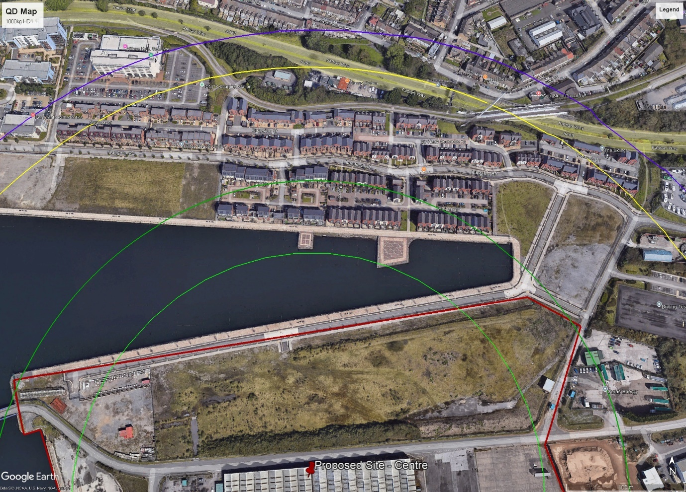
Figure 2 - North side of QD Map

3.2.2 Inhabited Building Distance
There should be no buildings within which the public or those not involved in explosive operations live, work, or congregate, within the north side of the IBD. There is virtually an entire section of a housing development within this IBD, along with four small businesses (car wash, car rental lot, mechanic, permanent food stand, a driving test centre and a church. Even if the single 1000kg ESH was moved onto the south most edge of the quay (which is not practical), some houses would still remain within the IBD.
To the east, the IBD covers some tug facilities and the aggregate terminal, and to the the south side of the IBD, there is a scrap metal merchant on Georgia wharf partly inside the line. The top edge of the Phoenix wharf (agribulk terminal) is also affected. To the west, the IBD covers most of the A&B shed wharf and also impinges on the edge of a university building.
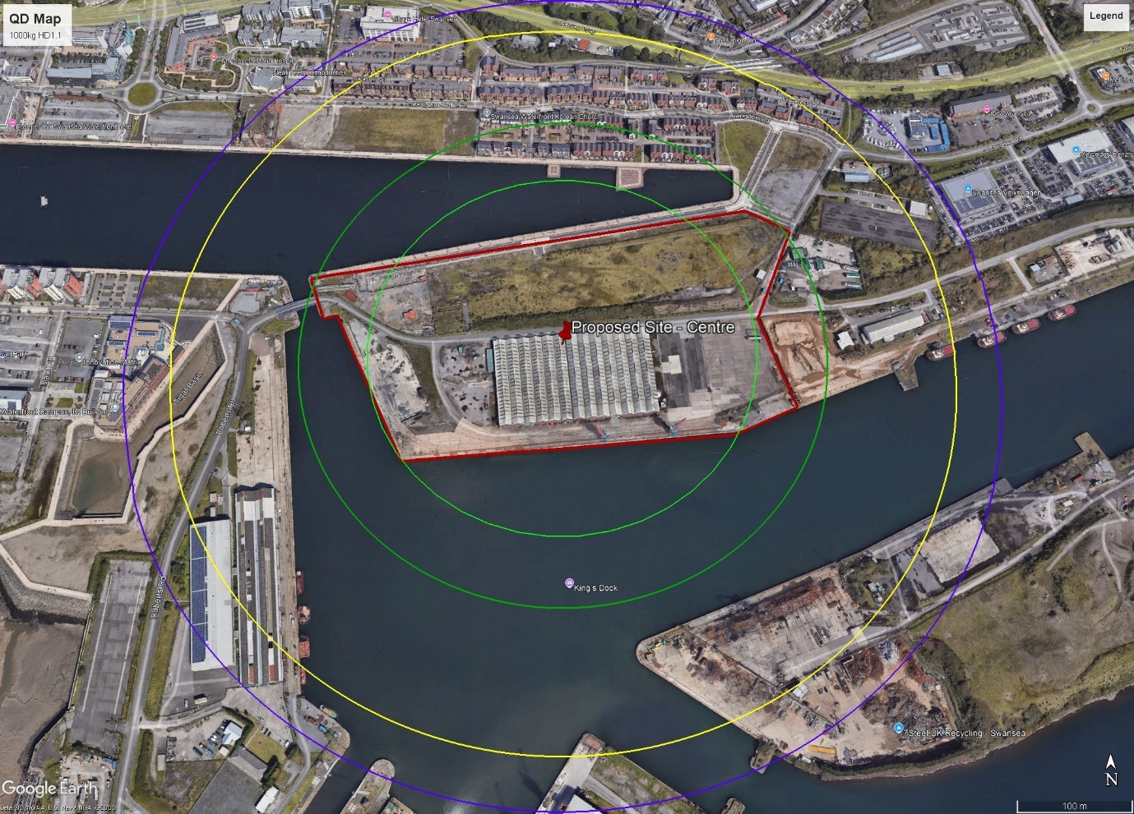
Figure 3 - Overall QD Map

3.2.3 Vulnerable Building Distance
There are numerous vulnerable structures within the VBD. The east half of a university building (which is open to students 24/7) is covered, along with most of the front of a large 5-storey hotel and the west wall of a glass-fronted car dealership, and one large ship-to-shore crane.

3.3 Explosion Consequence Analysis
A basic Explosion Consequence Analysis (ECA) assessment was conducted using the IATG “Blast Damage Estimation” tool for 1000kg of TNT - the result of which is given in the following tables:
Table 3 - Minimum "No Break" Range for Windows
Minimum Range to “No Break”
Window Type | Range (m)
Small Window (0.55m x 0.55m) | 260
Medium Window (1.25m x 0.55m) | 420
Large Window (1.25m x 1.25m) | 940

Table 4 - Ground Shock
Ground Shock
Maximum Affected Range (m) | 1012

Table 5 - Injury Ranges
Injury/Fatality to Personnel
Injury | Range (m)
Fatality | 23
Lung Damage | 37
Eardrum Rupture | 94

Table 6 - Damage Ranges
Damage to Brick Structures
Damage | Range (m)
Houses completely demolished | 32
Houses damaged beyond repair | 48
Houses uninhabitable, serious repair req’d. | 83
Houses uninhabitable, reasonably fast repair | 143
House required repairs, but remains habitable | 285

It must be noted that the above ECA only considers damage from blast alone. Fragmentation is often the dominating effect, as fragments carry lethal energy significantly beyond the range at which blast would guarantee death. Consequently, the principal interests from this ECA lie in the ground shock and the window break range. There are three large glass-fronted car dealerships (approximately 450m, 590m and 670m away) within this minimum no-break range, along with the UWTSD IQ building approximately 400m away. There are many other residential buildings and commercial buildings (some of which are high-rise, meaning the blast would impinge on them directly rather being somewhat sheltered by other buildings) that incorporate medium and large windows within this no-break range.
Ground shock is difficult to directly examine, as it depends somewhat on the type of ground underpinning the area. There are structures which are not designed to resist sudden shock loading within this ground shock range, notably lock gates in the dry dock and large ship-to-shore cranes – if the lock gates are breached, this may have lethal consequences for dry dock workers, and any crane collapse would almost certainly be lethal to the operator.
Another effect that is difficult to quantify would be any tidal wave effect produced by the ground shock being transmitted into the water by the completely vertical quay wall. Given the nature of the area as a man-made port with a depth of approximately 10m (i.e. a pit with vertical walls rather than a gradual increase in depth) [3], the quay wall could produce a “pistoning effect”, resulting in a wave that could cause significant damage to the port and marina, with potentially lethal effects in the dry dock.
Both ground shock and any wave effects would require advanced modelling to examine properly, but given the location, this should be conducted.

4. Compatibility Groups
BigBang has stated that they plan to build five ESHs across the parcel of ground on the proposed site. They have stated the following OME will be stored:
- HD 1.1 (divided as follows):
  - HD 1.1B – 50 kg
  - HD 1.1D – 3200 kg
  - HD 1.1E – 1250 kg
  - HD 1.1F – 500 kg
- HD 1.2 (divided as follows):
  - HD 1.2C – 350 kg
  - HD 1.2D – 100 kg
  - HD 1.2F – 50 kg
- HD 1.3C – 1000 kg
- HD 1.4S – 1000 kg
Following a review of the aggregation rules and compatibility group mixing rules (following the IATG tables 3 and 6, given in Annexe 4: Compatibility Group Mixing Rules and
Annexe 5: Aggregation Rules), it has been determined that five ESHs is not sufficient – the minimum requirement is seven ESHs.
B is only allowed to be mixed with S, so one complete ESH would be hold 50kg of 1.1B and 1000kg of 1.4S.
D, E, and F can be mixed so long as F is segregated (and the assumption this is possible has been made), but the total NEQ of the 1.1D/E/F is 4950kg and consequently five additional ESHs are required - as each ESH is licenced for 1000kg of each hazard type.
C, D, and F can be mixed so long as F is segregated. The NEQ for the 1.2 is 500kg, and the NEQ of the 1.3 is 1000kg – but the NEQs do not need to be aggregated, only the largest NEQ is used to determine QD. As such, a seventh ESH would be required to store the 1.2 and 1.3.
A basic plan of the ESH versus the hazard type is given in Table 7 - ESH Numbers and Holdings (kg).
Table 7 - ESH Numbers and Holdings (kg)
ESH Number --> |  | 1 | 2 | 3 | 4 | 5 | 6 | 7
Hazard Type | Compatibility Group
1.1 | B | 50
1.1 | D |  | 1000 | 1000 | 1000 |  | 200
1.1 | E |  |  |  |  | 1000 | 250
1.1 | F |  |  |  |  |  | 500
1.2 | C |  |  |  |  |  |  | 350
1.2 | D |  |  |  |  |  |  | 100
1.2 | F |  |  |  |  |  |  | 50
1.3 | C |  |  |  |  |  |  | 1000
1.4 | S | 1000

It should be noted that the combined holding is “only” 7500kg, which does not meet the 10,000kg threshold for a lower-tier COMAH site under the Control of Major Accident Hazards Regulations 2015.

5. Additional Safety, Storage, Transportation, and Other Issues

5.1 Site Access

5.1.1 Access via Road
There are three routes to the proposed site via road:
1. Access via Fabian Way and Baldwin Crescent
2. Access via Fabian Way and Langdon Road
3. Access via Fabian Way and King’s Road
Any access whatsoever via Fabian Way poses considerable issues. From the East, the entire Swansea University campus must be driven past – which is a series of large buildings, each of which contains many windows and all of which are very close to the road. From the West, the much of Swansea must be driven through, including passing by busy areas such as Wind Street.
At the junction between Fabian Way and Baldwin Crescent, there is a hazardous chemical plant (which is a lower tier COMAH site [4]) only 230m away. Any incidents here could be catastrophic.
Continuing down the port road (starting from Baldwin Crescent), the driver will pass a large fertilizer bagging and distribution plant. This plant contains a 5700m² warehouse and 8500m² of storage, along with a 100 tonne per hour bagging capacity [5]. The Beirut port explosion occurred with 2,750 tonnes of ammonium nitrate fertilizer [6], so it is important for this particular risk to be understood and characterised. After this, a port storage facility is passed, along with a cement facility. The road then runs parallel to a large industrial estate, including three glass-walled car dealerships (each only ~60m away from the road), a driving test centre, and a port aggregate terminal before arriving at the planned site.
Access via Langdon road still requires the driver to continue on Fabian Way, still very close (less than 100m) past the fertilizer plant and only 230m from the lower-tier COMAH chemical site. It then requires the driver to pass the three car dealerships, a hotel, and a small number of houses before reaching the site.
Access via King’s Road requires the driver to drive in very close proximity to many glass-fronted office buildings, two hotels, many residential buildings, a hospital, and a church. The road is also reasonably narrow and access is primarily through a heavily congested junction. Any emergency response in this area would be extremely difficult and any incident would be severe.

5.1.2 Access via Sea
Site access via sea requires a different set of regulations to be followed and there is no indication that BigBang has considered these regulations. IATG Annexe P must also be followed for quantity distances when sailing into the port, this may have a significant effect on port activity or severely limit what can be brought in at any one time.

5.1.3 Access via Rail
Access via rail has not been considered (despite there being rail links to the port), but given past security incidents this is unlikely to be allowed by BigBang’s MOD customer [7].

5.2 Site Plan
Given that no site plan has been provided, no assessment has been conducted on other buildings required to run an ammunition depot properly. A planning application should have included these buildings – at a bare minimum, from an energetics standpoint, an Ammunition Process Building (APB) should have been planned for. This is a licenced facility (consequently, it would contribute to the QD map) which allows for the handling, inspection, and processing of explosives. Without this facility, BigBang would have no ability to conduct surveillance on any of its holdings to ensure continued safety – which is completely unacceptable. Other items missing from the plan include a basic road schematic (the driver should be able to drive in and out without reversing), any office/admin buildings (which would be required for the running of the facility), and no reception or guardroom.
It should be noted that the QD for an office containing less than 20 support staff (which would also include a guardroom) is 270m. This cannot be fit anywhere on the proposed site and is yet another reason it is unsuitable to use this parcel of land.

5.3 Security
A brief reconnaissance visit to the main port entrance was conducted. The port itself is access controlled, with the main gate being accessed from Baldwins Crescent. There is a guardroom manned by contract security staff, and the fences around the port appear of good quality in the places observed by the writer. Photography is not permitted on the site, and basic PPE (such as a high-visibility jacket and safety footwear) is required to enter. This is positive for an OME facility - even though the facility would still require its own layer of security and access control (which has not been addressed by BigBang), the additional layer of security provided by the port is positive.

5.4 Environment
The proposed site is on the coast, with a marine atmosphere. The marine environment is not kind to explosives, high humidity has a marked negative effect on virtually all energetic substances, and higher levels of salt contribute to corrosion on metal cases, etc. This all reinforces the need for the unplanned process building to adequately survey the stock.
Certain parts on the north section of the proposed land have a small flood risk – a flood risk map is shown in Annexe 7: Flood Risk Map [8], but this appears to be caused by some low spots on the land, which should be fairly straightforward to remedy with some landscaping.
Earthquake risk is minimal, one M4.3 earthquake was recorded in 2018 but this should not be significant enough to damage buildings, and the only other previous notable earthquake occurred in 1906. While the area around the lower Swansea valley has been reasonably geologically active (by UK standards) [9] the levels are orders of magnitude below what would be considered concerning and as such this is not a credible concern.
There are also no landslide risks.

5.5 Marina and Port Usage
Swansea handles approximately £140M of trade per year [3], and brings important jobs to the local economy. BigBang would be required to work incredibly closely with the port authority, given that many activities of the port and of the depot are likely to impinge on eachother to some degree. A permanent liaison officer on each end is recommended, as a single responsible point of contact between both entities. The considerable (and unavoidable) paperwork and bureaucracy involved would almost certainly affect the port’s trade, as they may no longer be able to conduct what is currently a quick and routine task, under the depot’s safeguarding rules. Consequently, some negative socioeconomic impacts are possible. BigBang does not appear to have considered or consulted on this impact.
Formal advice to port users is given in Annexe 2: Example Port Tenant Safety Notice.

6. Conclusion

6.1 Quantity Distance and Explosion Consequence Analysis
As stated in section 3.2 Issues with Quantity Distance, virtually every QD (except the low-density PTRD) is violated in some way, exposing the public to unacceptable risk.
There are further additional QD problems within the facility itself – no administration buildings (which are necessary) have been planned, yet it is impossible to fit these buildings onto the parcel of land without violating the QD requirement – exposing the support staff to unnecessary risk.
ECA showed there to be considerable risks regarding window breakage and the vulnerable glass-fronted buildings nearby. Additional modelling should be conducted to understand both the fragmentation hazard, and the risk from any wave effects due to ground shock and “pistoning” of the quay wall.

6.2 ESH Planning & Compatibility Groups
The plan for five ESHs is flawed, analysis of the aggregation rules and compatibility group mixing rules shows that the minimum permissible number of ESHs to store the required NEQs and CGs to be seven. A process building is also required for adequate surveillance, otherwise the depot is at risk of unknowingly storing unsafe items as there would be no way to check the condition of any of its holdings.

6.3 Additional Issues
Site access is difficult, and virtually every way into the site involves hazardous materials being transported in close proximity to houses, vulnerable buildings, and buildings themselves housing hazardous materials.
The site plan is not adequate and does not allow for a full assessment to be made as to the rest of BigBang’s plan.
Port security is adequate as a first layer, but BigBang would need to organise their own additional security for the depot.
The proposed environment is not strictly ideal, but in practice, many depots are located close to the sea and provided the buildings are adequately controlled and temperature/humidity logs examined, with a proper stockpile management system in place, this is not a huge problem in practice.

7. Recommendation
It is not believed the proposed location on the SA1 waterfront is a suitable location for the explosives facility in question, the risk to the public and to facility workers is unacceptable. Alternative land allowing considerably more separation should be sought, in a different environment, with better transport links. Any further application made by BigBang should be subject to increased scrutiny given the questionable judgement they appear to have shown in this application.

References

[1] | United Nations Office for Disarmament Affairs, “International Ammunition Technical Guidelines 01.10,” UNODA, New York, 2021.
[2] | R. Youle, “Historic Swansea dock to be taken over by Welsh Government,” 06 2022. [Online]. Available: https://www.business-live.co.uk/commercial-property/historic-swansea-dock-taken-over-24196283. [Accessed 11 2025].
[3] | Associated British Ports, “Swansea,” [Online]. Available: https://www.abports.co.uk/locations/swansea/. [Accessed 11 2025].
[4] | Health and Safety Executive, “COMAH 2015 Public Information Record for Swansea,” [Online]. Available: https://notifications.hse.gov.uk/COMAH2015/PublicInformation.aspx?piid=3855. [Accessed 11 2025].
[5] | Yara UK, “Where we operate in the UK,” [Online]. Available: https://www.yara.co.uk/about-yara/about-yara-uk/where-yara-operate-in-the-uk/. [Accessed 11 2025].
[6] | Z. Tariq, “Loss Prevention Bulletin - Port of Beirut — lessons from the ammonium nitrate explosion that devastated the peninsula,” Institute of Chemical Engineers, 2022.
[7] | BBC, “Five jailed over theft of 40 anti-tank mines in Warrington,” 16 9 2013. [Online]. Available: https://www.bbc.co.uk/news/uk-england-merseyside-24108657. [Accessed 11 2025].
[8] | Natural Resources Wales, “Flood and Coastal Erosion Risk Maps,” [Online]. Available: https://naturalresources.wales/flooding/check-your-flood-risk-on-a-map-flood-risk-assessment-wales-map/?lang=en. [Accessed 11 2025].
[9] | Adventure Britain, “Earthquake Hits South Wales,” 19 02 2018. [Online]. Available: https://www.adventurebritain.com/earthquake-hits-south-wales/. [Accessed 11 2025].

Annexe 1: Risk Reduction Questions
These are questions which require a response before the depot can be approved or built. Responses should be examined by a SME. Given that no plan has been provided for the depot itself, these questions allow for a “ground up” approach.
Governance and Risk Reduction Process Level (RRPL)
1. Will the initial RRPL target be set, and will there be a properly resourced roadmap to RRPL 2/3?
2. Will a national authority be identified and engaged to approve siting, licencing and continued oversight?
3. Will there be a formal safety management system and documented risk management process (e.g. probability and consequence analysis) that will be used to formally govern siting decisions?
4. Will the stockpile level be justified using Daily Ammunition Expenditure Rates (DAER) or similar commercial scenarios (e.g. business plans)?
Site Suitability
5. Will the proposed site and planned stockpile allow adequate quantity distances to be met, both inside (IQD) and outside (OQD) of the site itself?
a. Will traffic surveys be conducted to understand traffic density?
6. Will the site be screened for susceptibility to “environmental events” such as flooding, landslides, seismic activity, high winds, and any temperature or humidity extremes?
a. If the answer is “yes”, will the impact to the ammunition be considered?
7. Will the load-bearing capacity of the ground be considered, along with the slope and drainage conditions, so that water will not be permitted to pool near a Potential Explosion Site (PES)?
8. Will any land be reserved so that operations can be scaled up if required, while retaining adequate QDs?
9. Will utilities be provided for the site (power, water, communication) in a way that will avoid introducing unnecessary hazards?
Safeguarding & Control
10. Will the VBD, IBD, and PTRD be calculated and plotted on an explosives safeguarding map?
11. Will a formal consultation begin with local planning authorities to ensure no new developments or routes will be permitted within the relevant safeguarding zones?
12. Will quarterly safeguarding map reviews and physical inspections be scheduled to detect any new encroachment?
Licencing & Safety Cases
13. Will Explosive Limit Licences (ELLs) be proposed for each PES, showing the authorised HD, NEQ, CG, and any special conditions?
14. If any QDs are tight, will an Explosion Consequence Analysis (ECA) be completed? Will an explosive safety case be produced following this ECA?
a. Will risk decisions be documented and communicated to the relevant stakeholders? This may include members of the public.
15. Will the appropriate handover and takeover procedure be defined, such that no OME will be received before licence approval and final sign-off?
a. Will any appropriate pre-conditions be documented?
Plan and Layout
16. Will the proposed layout of the depot follow a sensible “systems approach” (with appropriate segregation for receipt and issue areas, processing buildings, quarantine areas, etc.), with logical traffic flow and fire breaks?
17. Will IQD/OQD tables be produced for all PES and Exposed Site (ES) pairs, including any port transit areas?
18. Will any planned barricades be suitably positioned and sized to reduce fragmentation risk, without becoming a hazard themselves?
19. Will any overflight restrictions be set and agreed with the relevant national authority?
Building Design and Materials
20. Will magazines and process buildings be non-combustible, and will they be designed with adequate blast/fragmentation mitigation?
a. Will any ECMs be designed to the 7 bar NATO standard or another standard, and will the appropriate QD be applied in the event of a non-standard or 3 bar ECM being used?
21. Will dedicated facilities be planned for any ammunition subject to additional controls?
Electrical, Lightning, Static, and RF Controls
22. Will appropriate electrical categories (A/B/C/D) be applied, and will only compliant equipment be planned for installation?
23. Will a Lightning Protection System (LPS) be specified, and will thunderstorm procedures be planned?
24. Will the process buildings be designed with the appropriate antistatic and conductive regimes in mind?
a. Will there be any specific considerations for any of the individual pieces of OME being stored?
25. Will an RF survey be conducted, and will safe separation distances be applied?
a. Will there be any activities planned that may involve removing shielding, etc., from any piece of electrically initiated OME such that its safe power threshold will be considerably lower—and if so, will the survey be conducted with this in mind?
b. Will the port authority be involved in this RF assessment, as ships are often fitted with powerful emitters such as radars and long-range radio communication equipment?
26. How often will LPSs, conductive floors, and hazardous area personnel test meters be checked and inspected?
Security Architecture
27. Will the class of security fence (1/2/3/4), lighting, and intruder detection system be commensurate with risk?
28. Will entry points be adequately controlled, with proper keyholder procedures in place?
a. Will locks compliant with EN12320:2001 be intended for use?
29. Will staff be adequately vetted?
30. Will administration areas be adequately separated by both QD and procedural controls, such that the risk of exposure of ammunition diversion will be minimised?
Operations Planning and PES Estate Management
31. Will contraband rules be defined, and how will they be enforced?
32. How will vegetation and vermin be adequately managed?
33. Will a permit-to-work (PTW) system be planned for contractors undertaking estate works? How will this be managed?
Ammunition Accounting and Storage
34. Will the depot adequately account for its holdings using lot/batch codes, ADAC codes, condition codes, and will regular stock checks be undertaken?
a. How will any unsafe lots be segregated?
b. What actions will be taken in the event of missing stocks?
35. Will Unit of Space (UOS) calculations be completed, to ensure aisle, gangway, and racking clearances can be met while the maximum holding is being stored?
36. Will security seals be controlled from receipt to issue?
37. Will appropriate APBs be planned, to allow for the inspection of damaged packing/items, and for handling loose and unpackaged items safely?
Compatibility Groups, Special Conditions, and Stock Quarantine
38. Will CG mixing rules be applied?
a. How will any within-building compartmentalization be implemented?
39. Will any particularly hazardous items be stored (e.g. items containing white/red phosphorus, metal powders, radioactive materials, or other dangerous chemicals)?
a. If so, what dedicated controls will be in place for their storage and processing?
40. Will any captured munitions or experimental explosives be stored?
a. If so, what special rules and quarantine will be applied to their storage and processing?
Vehicles, Manual Handling Equipment (MHE), and RF Emitting Equipment
41. Will vehicles and MHE be zoned for PES/Non-PES areas, with appropriate restrictions on fuel types and controls on refuelling and battery charging?
a. Will fire extinguishers be sited appropriately around the facility or be required to be kept within vehicles used in the PES, for the express purpose of dealing with vehicle fires?
42. Will any asset tracking tools, vehicle key fobs, and radios be assessed for RF impact and managed per category rules?
Fire and Emergency Response
43. Will the depot have a fire safety plan that will be integrated with local response units?
a. Will appropriate evacuation routes be designed into the depot from the beginning?
44. Will major fire strategies and immediate actions be rehearsed, with pre-prepared briefings ready for use when briefing senior response officers if required?
45. Will accident/incident procedures be defined, along with technical investigation procedures?
Surveillance, Proof, and Condition Classification
46. Will a surveillance and proof plan be defined for the depot’s holdings?
a. Will the surveillance plan be individual to each type of munition stored?
b. Will this include trend analysis?
47. Will unsafe and life expired lots be rapidly identified, coded, safely segregated, and scheduled for disposal?
Internal Works and Permitting
48. Will PTW processes be defined for contractor activity within the PES, including safety briefing and equipment controls?
a. Will contractors be monitored throughout the course of their works to ensure processes are being followed and only compliant equipment is used?
49. Will ELL impact checks be carried out for required work, and will appropriate temporary restrictions be imposed?
Demil and Disposal Readiness
50. Will there be a properly resourced plan for demil/destruction of surplus or unsafe stock?
a. How will this be managed within the proposed site, with respect to items that are unsafe to move on the road?
b. Will personnel carrying out demil activity be SQEP?
Improvement and Assurance
51. Will there be a scheduled inspection regime, both internal and external?
52. Will data-driven performance reviews be planned, to feed updates to policies and procedures?
53. Will specific RPRL audits be planned?
Staff, Training, and Competence
54. Will competence requirements for all site roles be defined, and will they be backed by suitable training?
55. Will competency requirements be adequately mapped to the requirements of running the depot?
56. Will any special conditions of employment be managed to ensure that staff will not be unduly discriminated against, whilst ensuring everyone’s safety?

Annexe 2: Example Port Tenant Safety Notice
Purpose
To keep all port users safe and compliant when operating near (but not within or connected to) the BigBang SA1 Depot.
Permitted Locations:
- Consult the Explosives Safeguarding Map (ESM) before entering the port or starting work. Observe the:
  - Yellow line – Inhabited Building Distance (IBD)
  - Purple line – Vulnerable Building Distance (VBD)
  - Green line – Public Traffic Route Distance (PTRD)
- Follow all temporary cordons and signage issued for specific movements or operations.
- Consult with port authority before entering port area while carrying any hazardous cargo or other dangerous goods
Daily Requirements:
- Routes: Use only designated access routes. Do not park, queue, idle, or berth inside safeguarding lines.
- Briefing: Supervisors must brief teams on cordons, routes, weather, and emergency actions.
- Contraband: Follow all contraband rules in posted areas.
- RF discipline: Keep handheld radios and other transmitters on lowest practical power near the boundary. Shut off radars as soon as you enter port.
Works, Maintenance and Changes:
- Permit-to-Work (PTW): Required for any hot work, piling/excavation, electrical tasks, new or moved plant, and any new structures in or near safeguarded zones.
- Notify the Harbour/Port Authority in advance of tenancy layout changes to confirm they do not create a new Exposed Site (ES) or reduce required separation distances.
Thunderstorms:
- Be prepared to stop activities in posted areas if thunderstorm risk is medium or higher.
- Supervisors: brief crews on specific thunderstorm requirements
In the Event of Alarm Sounding:
- Stop work immediately.
- Secure plant (make operation safe, isolate ignition sources).
- Evacuate along posted routes to muster points outside the IBD (yellow line), or shelter-in-place if instructed.
- Supervisors: account for personnel and await instructions.

Annexe 3: QD Definitions
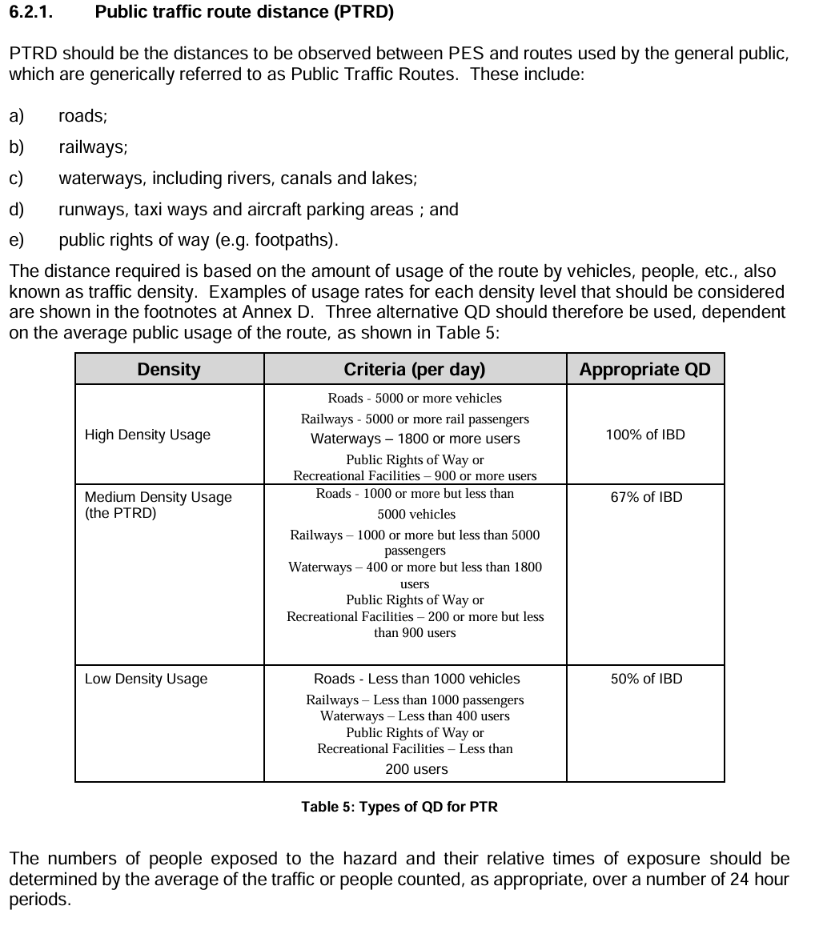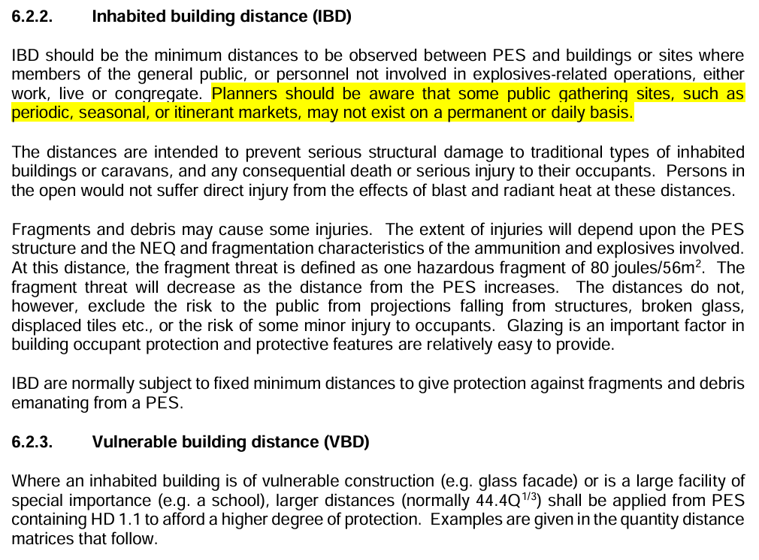

Annexe 4: Compatibility Group Mixing Rules
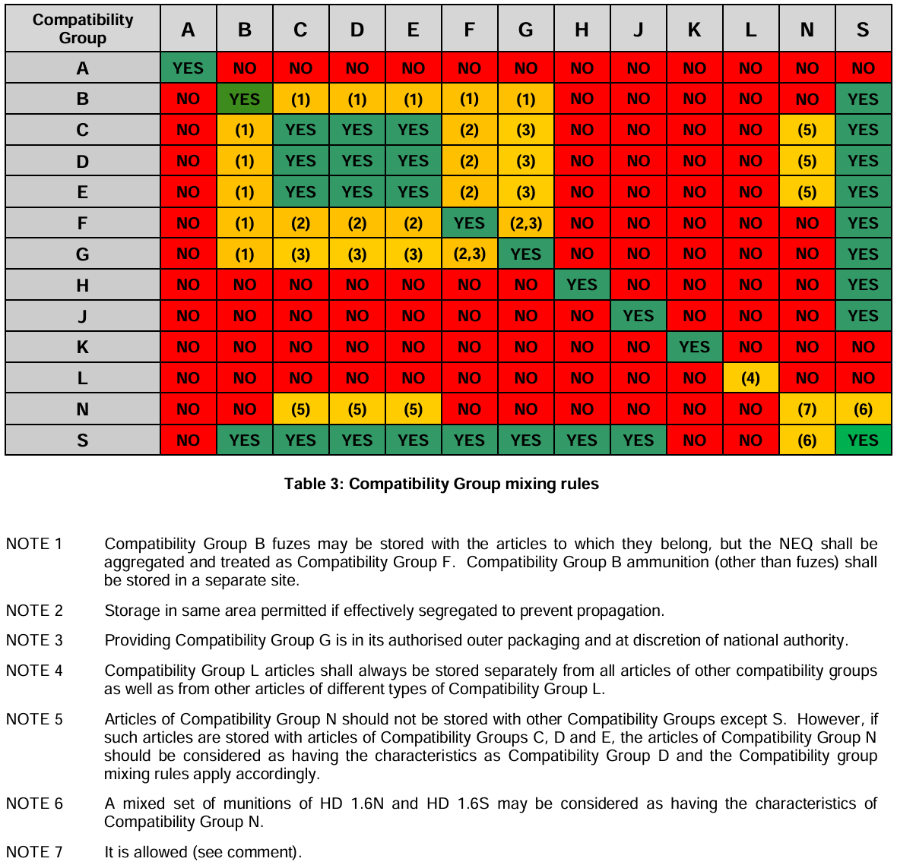

Annexe 5: Aggregation Rules
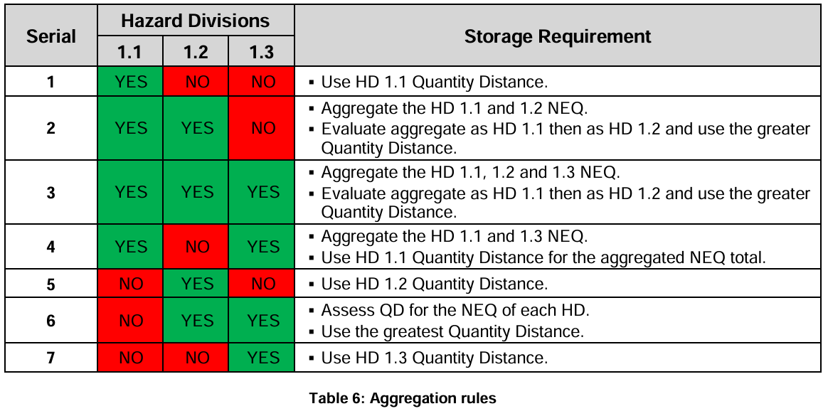

Annexe 6: Port Plan
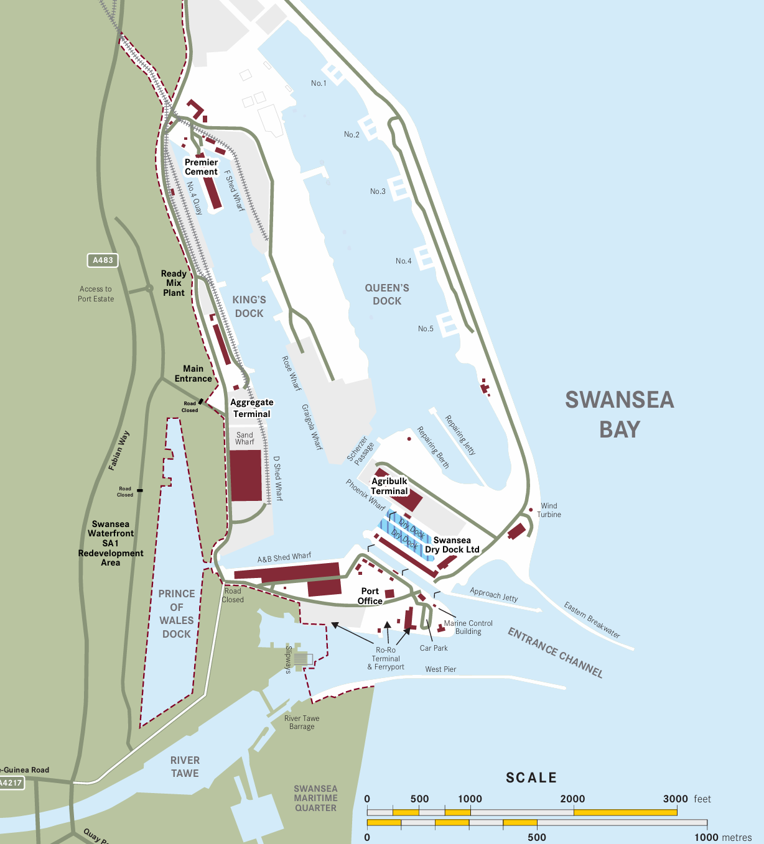

Annexe 7: Flood Risk Map


