Problem Solving and Decision making
BMSW4004_Group 1

Lecturer: RITA UKACHI-LOIS
Student: Violeta Cicu - 2109660

Table of Contents
Introduction 3
Impact of the complex problems in the workplace 3
There are different types of issues regarding the poor management of the organization. This is leading to disruptions in the functions of the management. 3
Solutions to the problem 4
Analysis of the Fishbone Diagram 5
Reference List 9

Introduction
The purpose of the study is to demonstrate problem solving as well as the making of the decision against the problems. It has been seen that there is a major problem regarding the management and the employees are dissatisfied with it. The employees are also unhappy with their unsupported boss. The Assess is going to evaluate the effect of the problem on the organizational workplace. In this sense, this study has the aim to develop the solutions to the problem. The report is going to include the proper frameworks regarding the solutions of the problems. Through the report alternative solutions are also developed that can improve the effectiveness. Through the implementation of the plan management of the stakeholders is important that will also be included through the assessment.

Impact of the complex problems in the workplace

There are different types of issues regarding the poor management of the organization. This is leading to disruptions in the functions of the management.
Employees dissatisfaction/absenteeism - This is the major issue of the workplace that is leading to the poor performance of the organization. It can be said that the poor management of the organization is included with the minimum numbers of the motivation and the lack of motivation is leading to the dissatisfaction of the employees. In this sense, the unsupportive boss makes the leadership issues through the organizations. So, the work performance in the organization is down. It has been seen that the boss is not behaving properly with the employees and that causes them dissatisfaction and the employees do not like the atmosphere of the organization. So, the employees don’t come to the workplace. So, this issue in the organization is leading to the loss of productivity in the organization (Akhmad et al., 2018). In this context, the productivity of the employees is also reduced from the organization.
Through the analysis of the issue, it can be said that the poor management is the huge problem and this can reduce the growth of the organization. In this sense, the employees can also resign from the job and that creates different areas of issues for the organization. Bad management is also leading to the less interaction with the employees that makes the issues in reaching the goal of the organization. So, the problems have to be minimized in getting the proper outcomes of the organization.

Solutions to the problem
The solutions to this problem can be included with the different numbers of the steps. First step is included with the identification of the proper problems of the employees with the organization as well as it is important to identify the expectations of the employees to the organization. After that the authority means the boss of the organization needs to focus on the proper leadership style. In this sense, the boss can make a transferable relationship with the employees that can create the proper satisfaction among the employees. Next step can be included with the arrangements of the meeting that is important for the discussion regarding the different areas of the organization with the employees (Chinyamurindi and Tsvangirai, 2019). This can create the proper satisfaction among the employees and the employees can feel that they are getting the proper value within the workplace. In this context, a feedback session for the employees can be beneficial. Through this the organizational management can play a supportive approach and the employees can express their needs. Through this the management can make satisfaction among the employees. Through this it can be said that the organizational management has to maintain a cooperative relationship with the employees that is important for the development of satisfaction among the employees. This can reduce the absenteeism of the employees from the workplace. In this sense, the employees can be praised for their better effort in the organization. In this sense, employee recognition is important. The management can provide the facility of getting the reward for the employees that can make satisfaction among the employees (Chinyamurindi and Tsvangirai, 2019).
SWOT
Strength -The solution process through the organization makes the employee satisfied. This motivates the employees.
Weakness - Through the development of the solution solution process, there is also the possibility of reduction of the employee performance because a high percentage of the flexibility to the employees is providing the different ways to escape from the work.
Opportunity - Development of the solution is providing the major opportunity to develop the growth of the organization. This makes the development of the brand reputation and the employees can get the better knowledge.
Threats - This situation can make a huge threat for the employees. Lack of motivation to employees is leading to the resignation to the job that makes the loss of the organization. In this sense, a new solution process can also be included with more investment.
PESTLE
Political - UK is one of the powerful countries all over the world and this affects the solution process from the management (BBC, 2020)
Economical - The value of the wages is increased and the labor cost also increases, which can be impactful for the management of the employees in the workplace.
Social - UK is included with the big consumer markets. So, the employees should be motivated to satisfy the consumers (David, 2022).
Technological - As the UK is promoting advanced technology, the organization should provide the proper training to the employees regarding technology.
Legal - The organization has to follow the Employment Act 1966 and the Equality Act 2010 that protects the people in the workplace (David, 2022).
Environmental - Changing climate is making the issues for managing the employees in the proper places (David, 2022).

Analysis of the Fishbone Diagram
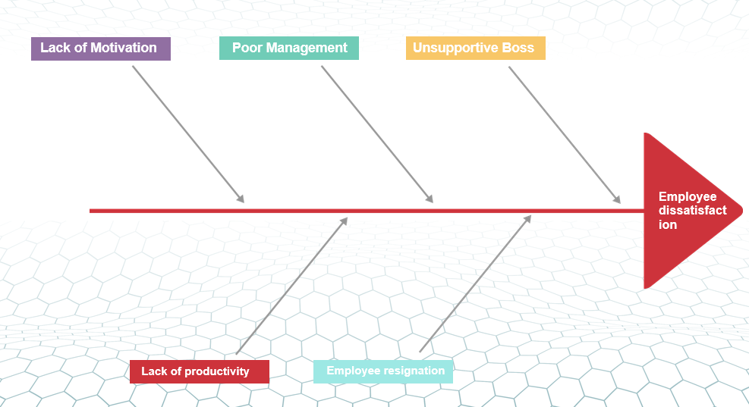
Image 1: Fishbone diagram
Source: Self developed
Cause - The organization is facing the issues of absenteeism and this is the major problem for the organization. This means the employees are dissatisfied with the organization. The employees are not recognized properly and they are demotivated within the workplace. In this sense, there is no flexibility of the work that causes a huge dissatisfaction among the employees. The people in the workplace are pressurized within the workplace and they are not getting any types of reward for their hard work. There is also the communication issue with the boss of the organization.
Effect - The organization can face difficulties in the growth of productivity and this will lead to absence of employees in the workplace. The productivity of the employees will also be reduced. So, the organization can lose their proper position from the marketplace. However, this can create issues for the workplace and this can create a situation that is impossible for working.
So, my organization has to follow the proper strategies for the development of the workplace structure and the solution process will be helpful for the development of the growth of the organization.
Proposing alternative solution
Reduction of the problems that are associated with the bad management and unsupportive boss, the management team of organizations in the UK should adopt developed strategies within their organizational structure to reduce those issues efficiently. Alternative solutions to those issues are presented below:
Identification of motivation for employees
The leaders within different organizations of the UK must focus on the identification as well as engagement of motivational factors within organization operation. It helps in the management of developed workforces among employees and also resulted in the removal of bad management systems from the company (Hbs, 2022).
Include developed leadership
Engagement of the developed leadership style of the leaders is identified as the alternative solutions to the bad management system. Based on the presence of effective styles among leaders, they can easily make successful decisions for managing the entire operation of the company towards the achievement of desired goals. Therefore, the availability of strong leadership style of the leaders also helps to serve encouragement to the employees within the organizational structure and that can help to reduce dissatisfaction from the minds of the employees about the unsupportive boss (Hbr, 2022).
Offer instant feedback to employees
The management team of different organizations in the UK must focus on the delivery of instant feedback to the employees in the organization considering their workforces within organizational activities. Delivery of feedback to the employees can serve solutions to the organization in the UK to reduce the issue related to unsupportive bosses. On the other hand, it can be mentioned that the delivery of feedback to the employees according to their works in the organization also offers solutions to the company for removing the issue of bad management. The process can offer support to the management team of the company to manage performances of all the employees in the company to ensure achievement of desired goals (Leadershipreview, 2022).
Using decision-making techniques to identify the most appropriate solutions
Consequence style decision making
Consequence style decision making is identified as one of the most effective decision-making techniques as it focuses on the maintenance of high stake of all the members within the decision-making activities. In that case, it is noticed that at the time of using this technique the leaders of the organizations are focusing on the adoption of full support of all the members within organizational decisions (Wang et al., 2019).
Through the usage of consequence style decision-making, it is analysed that the identification and delivery of motivational factors to the employees are effective enough to reduce issues associated with bad management and unsupportive bosses as it helps to reduce agitation from the minds of the employees regarding their higher authority (Sourcesofinsight, 2022).
On the other hand, the implementation of the consequence based decision-making technique evaluated that the introduction of the developed leadership styles of the leaders are effective enough to remove the challenges related to bad management. It helps in the maintenance of organisational works in a developed format.
Moreover, consequence-based decision-making also stated that the delivery of instant feedback to the employees can help to reduce the issue of unsupportive bosses from the organisation. It helps in the reduction of dissatisfaction from employees about the ineffectiveness of leadership operations of leaders or bosses.
All the alternative solutions based on the implementation of consequence based decision-making technique it is realized that the engagement of developing leadership style of the leaders within organisation activities is significant enough to reduce the issues associated with bad management and unsupportive boss from organisational structure. Within this regard, it can be mentioned that the implementation of this solution within organisational structure can help the organizations of the UK to encourage all the employees to show their best efforts in the business by taking support from the leaders (Raza and Sikandar, 2018).
Communicate the plan to stakeholder
At the time of communicating the plan of Introducing developed leadership style of the leaders within the organizational structure of the organizations in the UK clear information of the plan is presented in front of all the members of the company. It helps in the adoption of concern of all the members as well as stakeholders of the organization to ensure the successful implementation of that plan within business to reduce issues that are linked with bad management and unsupportive bosses. Therefore, the overall plan is also discussed with the higher authority of the company to take suggestions from them for the application of that plan in the decision-making activities of the company in the UK. Moreover, shareholders of the organisations are also informed about this plan or solution to take active support from them within the decision-making operations to resolve issues from the organizational structure (Nirn, 2022).
Assess monitoring and review techniques to ensure successful implementation of the solution
Monitoring staff turnover
The monitoring process of employee turnover within the organizational structure of the company in the UK will be performed by taking the total number of separations and dividing all the number of employees in a specific time (Lever, 2022). It helps in the analysis of the reduced dissatisfaction level of employees about bad management and unsupportive bosses.
Track progress of organizational projects
The progress level of workforces of all the employees of in organizational projects can help to track the progress level of the company within its existing business market (Endvawnow, 2022). Through this process the leaders of the company in the UK can easily measure the success of the decision that will be made to reduce issues connected with bad management and unsupportive bosses.
Application of review and monetary techniques within decision making activities of the company in the UK analysed that usage of develop leadership style is successful enough to remove the issues that are interlink with a supportive boss and bad management system. Through the availability of leadership efficiency among leaders the employees within the company can get potential support from their supervisors to lead their assigned jobs towards the achievement of success.
Conclusion
In that context, it can be concluded that the management team of different organisations in the UK should forecast on the maintenance of developed management as well as leadership activities for presenting a healthy working environment to all the employees. It helps in the maintenance of developed work forces in all the employees and that resulted in the adoption of desired goals of the company.

Reference List
Akhmad, B.A., Suryadi, B. and Rajiani, I., 2020. Communicating the dissatisfaction in workplace among public sector employees: loyalty and neglect as an alternative model of responses. Polish Journal of Management Studies, 21.
BBC News. 2020. United Kingdom country profile. [online] Available at: <https://www.bbc.co.uk/news/world-europe-18023389> [Accessed 9 May 2022].
Chinyamurindi, W.T. and Tsvangirai, F.P., 2019. The moderating effect of employee motivation on workplace surveillance and employee engagement amongst employees at the Zimbabwe Revenue Authority. SA Journal of Human Resource Management, 17(1), pp.1-8.
David, J., 2022. PESTEL analysis of the UK (Country Profile). [online] howandwhat. Available at: <https://howandwhat.net/pestel-analysis-uk/> [Accessed 9 May 2022].
Endvawnow.org, 2022. What is monitoring and evaluation?. [online] Endvawnow.org. Available at: <https://www.endvawnow.org/en/articles/330-what-is-monitoring-and-evaluation-.html> [Accessed 5 May 2022].
Hbr.org, 2022. What to Do When You Have a Bad Boss. [online] Harvard Business Review. Available at: <https://hbr.org/2018/09/what-to-do-when-you-have-a-bad-boss> [Accessed 7 May 2022].
Hbs.edu, 2022. 7 Strategies for Improving Your Management Skills | HBS Online. [online] Business Insights Blog. Available at: <https://online.hbs.edu/blog/post/how-to-improve-management-skills> [Accessed 5 May 2022].
Leadershipreview.net, 2022. How to deal with an unsupportive boss - Leadership Review. [online] Leadership Review. Available at: <https://www.leadershipreview.net/how-to-deal-with-an-unsupportive-boss/> [Accessed 9 May 2022].
Lever.co, 2022. How to Track Your Employee Turnover Rate (Annual and Monthly). [online] Lever. Available at: <https://www.lever.co/blog/how-to-track-your-employee-turnover-rate-and-when-to-take-action/> [Accessed 2 May 2022].
Nirn.fpg.unc.edu, 2022. [online] Nirn.fpg.unc.edu. Available at: <https://nirn.fpg.unc.edu/sites/nirn.fpg.unc.edu/files/resources/Stakeholder%20Engagement%20Process%20Handout.pdf> [Accessed 3 May 2022].
Raza, S.A. and Sikandar, A., 2018. Impact of leadership style of teacher on the performance of students: An application of Hersey and Blanchard situational model. Bulletin of Education and Research, 40(3), pp.73-94.
References
Sourcesofinsight.com, 2022. 4 Decision Making Methods. [online] Sourcesofinsight.com. Available at: <https://sourcesofinsight.com/4-decision-making-methods/> [Accessed 6 May 2022].
Wang, Z., McNally, R. and Lenihan, H., 2019. The role of social capital and culture on social decision-making constraints: A multilevel investigation. European Management Journal, 37(2), pp.222-232.

