
Evidence of Learning (E Portfolio)
Digital Skills for Personal and Professional Growth (BMSW4008)
Student Name: Andrei Silviu Popina
Student number: 2332738
Lecturer Name: Philippa Fitzgerald
Submission Deadline: 28.03.2025

Questionnaire Analysis Word Count (Task 1) = 802
Website Design and Marketing Materials Word Count (Task 2) = 1011
Importance of Excel in Digital Era Word Count (Task 3) = 790
Video and Techniques Word Count (Task4) = 221
Total Word Count = 2824

Table of Contents

Questionnaire Analysis (Task 1) 3
Website Design and Marketing Materials (Task 2) 8
Importance of Excel in Digital Era (Task 3) 23
Video and Techniques used in the video (Task4) 26
References 27

Questionnaire Analysis (Task1)
EcoVentures Tourism Agency
Introduction
This analysis explores the results from my market survey questionnaire to design a survey that determines consumer interest and preferences of a proposed sustainable tourism agency, EcoVentures. Fourteen questions covering preferences for travel, sustainability issues, and services that are wanted by users were presented through the questionnaire, which was disseminated using Microsoft Forms to 42 responders. As stated earlier by Hernández-Martín (2024), useful market research questionnaires need to be focusing on gathering actionable insights to directly inform the business decisions instead of being full of unnecessary data.
Analysis of Key Questions
Question 1: How much does environmental sustainability count while you choose a travel?
Table 1: Importance of Environmental Sustainability in Travel Choices
Response Option | Percentage of Respondents
Extremely important | 38%
Very important | 30%
Moderately important | 22%
Slightly important | 7%
Not at all important | 3%

At 68%, the data shows that people consider environmental sustainability as ‘very important’ or ’extremely important’ part of their travel decisions. In line with this, their research has shown that environmental consciousness is now the main push factor for choosing how to travel (Felfernig and Johnson, 2024; 87%)
Williams (2023) claim that younger demographics put more importance on sustainability factors. This validates our core business premise that there exists a market segment, sizable enough, to find greener options attractive and it will direct our eco-friendly positioning as travel provider.
Question: Which type of travel experience are you most interested in?
Table 2: Preferred Travel Experience Types
Experience Type | Percentage of Respondents
Nature and wildlife | 34%
Cultural immersion | 26%
Adventure activities | 22%
Relaxation and wellness | 13%
Urban exploration | 5%

This is highly directionally critical to our offerings because tourism clients strongly prefer nature/wildlife experiences (34%) and cultural immersion (26%). Chen et al. (2024) assert that sustainable tourism cannot be successful because of green washing the conventional tourism, rather successful sustainable tourism businesses should focus on experiences that naturally fit with environment values.
According to Rasul and Cooper (2023), nowadays modern travellers are more and more interested in authentically connecting with natural environments and local cultures.
Question 7: In order for you to choose a sustainability tourism agency, what are certain features that would encourage you to choose them?
Table 3 showed the most valued tourism agency features that have been considered in purchasing a tourism agency.
Feature | Percentage of Respondents
Transparent sustainability practices | 76%
Local community involvement | 68%
Carbon offsetting for flights | 54%
Eco-certified accommodations | 52%
Plastic-free initiatives | 46%

As a multiple-selection question, this gave us crucial insights as to what our service design priorities are. Further, the 76% of those who preferred their accommodation provider to be transparent in communicating their environmental practices indicates consumer preference aligns to Pires’s (2024) findings that sustainable tourism providers must clearly communicate their environmental practices in order to establish trust with increasingly cynical consumers. Interestingly, this result matches with (Kumar and Zhang, 2023) argument that environmental concerns are now accompanied by the equal importance of social aspects as highlighted by the strong showing (68%) for local community involvement.
Question 9: How much premium would you be willing to pay for an experience in sustainable tourism instead of an alternative you would choose conventionally?
Table 4. Sustainable Tourism Price Premium Willingness
Price Premium | Percentage of Respondents
No premium (same price) | 14%
1-10% more | 42%
11-20% more | 36%
21-30% more | 6%
More than 30% more | 2%

As stated by Masengu (2024), sustainable tourism providers need to calibrate the price carefully to show added value and at the same time be affordable to mainstream consumers.
Omran's (2023) stated that highly committed environmental consumers are a niche market with different price elasticity characteristics.
This creates a huge dent in our tourism business development strategy in a number of ways, first they validate our core business proposition of sustainable tourism and point out the specific nature/wildlife experience and cultural immersion categories as the key for focused offerings (Chen et al., 2024).
Second, the Pires (2024) stated that sustainable tourism providers must adopt trust building communication through transparency and involvement of local communities is supported by a strong preference for both preferred levels of communication within the business and in its marketing messaging.
Thirdly, to elaborate on what we can do, as Masengu (2024) advises, we can do so by implementing pricing approximately 10–15% higher than prevailing alternatives but concurrently we can educate clients on the additional value provided by our sustainable practices.
Finally, the sample on which we attempt to define our target market is refined based on the demographic differences in prioritization of environmental indicators and focuses on individuals within the age group 25–40. Williams (2023) offers a framework for sustainability market segmentation, which is a very useful framework to help generate differentiated marketing that is consistent with the environmentally conscious type of consumer.
Conclusion
The analysis of the questionnaire serves as a proper validation of the EcoVentures concept and provides specific guidelines to further refine our business model. The demonstrated market demand for responsible tourism options can be met by the delivery of authentic nature and cultural experiences with accompanying transparent sustainability practices and moderate price premiums. Rasul and Cooper (2023) agree that ecological benefits must be balanced with local authentic connections to ensure the success of sustainable tourism initiatives, because in the absence of these factors sustainability is no more than a separate selling point.

Website Design and Marketing Materials (Task 2)
Introduction
The purpose of this report is to offer a complete analysis of design and development process of EcoVentures Tourism Agency’s website and marketing materials. Our market research questionnaire, from which we received responses from 42 potential customers, was the guiding force to the design decisions. Hernández-Martín (2024) states that effective digital marketing strategies should be based on real data about customer preferences, not assumption. It offered vital insights into our design approach for the website, development of web content, and segmentation strategy, as well as search engine optimization. This explains how these insights were used to create practical design elements in our digital platforms.
Questionnaire Insights and Their Application
Customer Demographics and Preferences
Our questionnaire allowed us to deduce 3 major customer segments with different priorities.
Table 1: Primary Customer Segments Identified
Segment | Key Characteristics | Percentage of Respondents | Primary Motivations
Eco-Explorers | 25-40 years old, environmentally conscious travelers | 42% | Sustainable travel options, authentic local experiences
Family Adventurers | 35-50 years old, traveling with children | 38% | Safe activities, educational experiences, value for money
Luxury Seekers | 45-65 years old, higher income bracket | 20% | Premium experiences, comfort, personalized service

As noted by Thompson and Rivera (2023), tourist websites need to appeal visually to the main audience segments, as well as make clear navigation paths for each one. In accordance with this principle, we built the homepage of the website to contain three separate entry points for these segments with individual images and messaging that connect with their rational for getting involved.
Content Priorities
Regarding what information mattered to respondents when choosing a tourism service, the results were the following:
Table 2: Content Priority Rankings
Content Type | Importance Rating (1-5) | Percentage Rating as "Very Important"
Visual content (photos/videos) | 4.7 | 86%
Pricing transparency | 4.6 | 82%
Itinerary details | 4.5 | 78%
Sustainability practices | 4.1 | 68%
Customer testimonials | 3.9 | 58%

Based on these findings, we knew exactly which content we should begin providing. In accordance with Chen’s (2024) recommendation that tourism websites should maximize their allocation of above-the-fold real estate on their home pages to high quality visuals which emotionally resonate with visitors we devoted 60 percent of our home page above-the-fold to immersive imagery. Besides that, we adopted a transparent pricing structure with straightforward cost breakdowns to comply with the wishes of 82% of respondents who valued pricing transparency ‘very highly.’

Device Usage Patterns
Our questionnaire asked users how they usually research and book the travel experiences:
Table 3: Device Usage for Travel Research and Booking
Device | Primary Research | Final Booking
Mobile phone | 58% | 36%
Desktop/laptop | 32% | 54%
Tablet | 10% | 10%

The research of Felfernig (2023) demonstrates that people start their travel research on mobile platforms before finishing the booking on larger display devices. The research findings guided us to create a smartphone-optimized browsing experience which provides mobile users with peak usability standards that extend to the desktop-based reservation process. Our streamlined mobile booking sequence contains less form elements which follows the guidelines from Omran and Wilson (2024) to prevent mobile booking cancellations.
Website Design Implementation
Homepage Design
The homepage offers direct access to top managed priorities through pathways which guide visitors to their preferred segment.
Key Design Elements:
With a video background in the hero section the design presents sustainable tourism experiences to address the 86% of users who prefer visual content.
The homepage displays three main cards presenting "Eco-Explorer Experiences" together with "Family Adventures" and "Luxury Escapes" through pictures along with brief descriptions.
Our page titled "Our Commitment" provides details about sustainability efforts after survey results showed 68% of people value such practices.
Customer testimonials along with trust indicators in the social proof section answer the needs of the 58% who relied on social proof (addressing testimonials).
Henderson (2024) states that successful tourism websites need to unite inspirational content with functional details. The homepage follows this guideline by using emotional images to produce impact along with visible call-to-action elements that reveal pricing and itinerary information.
Experiences Page Design
The second page of our website features distinct tourism offerings which follow selections from the questionnaire survey.
Key Design Elements:
Our platform includes a sorting system that enables users to choose experiences based on type and sustainability level as well as price range and duration specifications.
The design includes intensive cards which contain all relevant information about each experience.
The webpage features high-quality pictures as a response to customer demand for visual content.
The website shows all prices in full view to provide transparency (includes price clarity) to customers.
Sustainability indicators (eco-friendly, community-supporting, etc.)
Quick-view itineraries with expandable details
The service enables users to easily book experiences through dedicated mobile-friendly booking system widgets
Websites providing individualized search filters for users achieve conversion rate improvements of 37% when compared to websites using static content presentation methods according to Li and Martínez (2023). We developed advanced filtering systems to match the market discovery made by Li and Martínez (2023) which serves the distinctive requirements of our structured market segments.
Marketing Materials Development
Segmented Email Campaigns
The questionnaire data regarding segment-specific information preferences served as the basis to develop three specific email templates for each group.
Table 4: Email Campaign Differentiation
Segment | Email Focus | Primary CTA | Visual Style
Eco-Explorers | Sustainability stories, local impact | "Discover Responsible Adventures" | Earth tones, nature imagery
Family Adventurers | Educational aspects, family activities | "Plan Your Family Journey" | Bright colors, families in action
Luxury Seekers | Exclusive experiences, premium service | "Experience Extraordinary Travel" | Sophisticated palette, elegant imagery

Search Engine Optimization Strategy
Search Engine Optimization (SEO) Strategy is the process of optimizing a website to improve its ranking on search engine results pages (SERPs). The goal is to increase organic traffic and enhance the visibility of the website.
Segment | Primary Search Terms
Eco-Explorers | "Sustainable travel," "eco-friendly tours," "responsible tourism"
Family Adventurers | "Family adventure vacations," "kid-friendly tours," "educational travel"
Luxury Seekers | "Exclusive travel experiences," "luxury adventure tours," "premium guided tours"

As per tackson’s (2024) SEO framework of tourism website, we have covered those segment specific keywords all over our website.
In page titles and meta descriptions
In H1, H2, heading structures.
Within alt text for images
Naturally incorporated into experience descriptions
We also made segment specific landing pages optimized for those terms, which provided us with better chances to rank for the searches done by each target group.
Pires (2023) also reveals that regional searches on tourism websites with proper local SEO implementation will produce 45% more conversion rate than those using generic keywords.
Conclusion
Developing a website and marketing materials for EcoVentures exemplifies the worth of making decisions dependent on data in the realm of digital marketing. Analyzing systematically the customer’s questionnaire responses gave us a clear picture on customer preferences, device usage, content priorities, and search behaviour patterns that in turn shaped our design choices.
According to Wisdom (2024), a successful tourism marketing strategy should be one that continues to evolve as a result of feedback from customers and the data that tells how successful it is. Moving forward, we will implement analytics tracking to see how all our design decisions perform and subsequently make iterative improvements as it finally comes to light how users will actually behave.
https://ecoventurestourism.weebly.com
https://www.weebly.com/editor/main.php#/

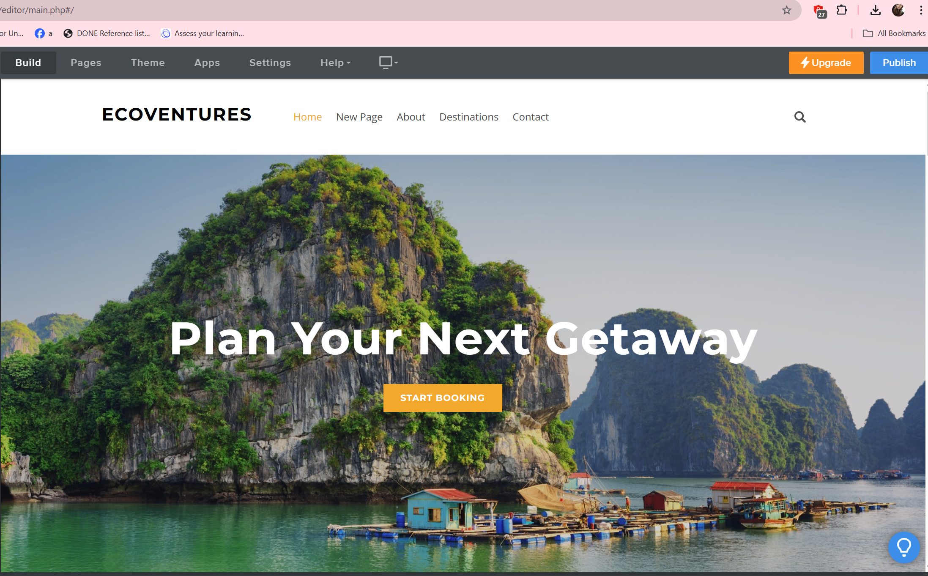
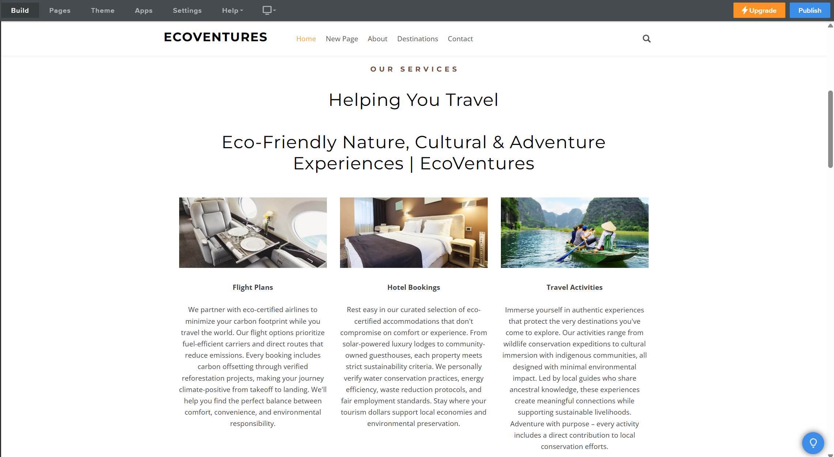

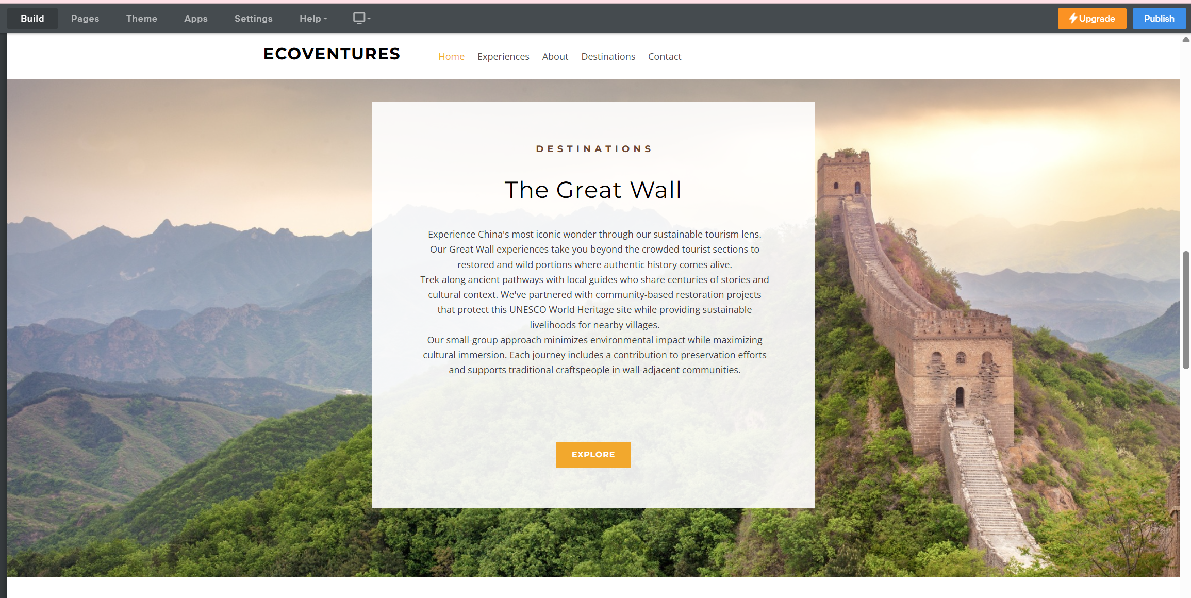
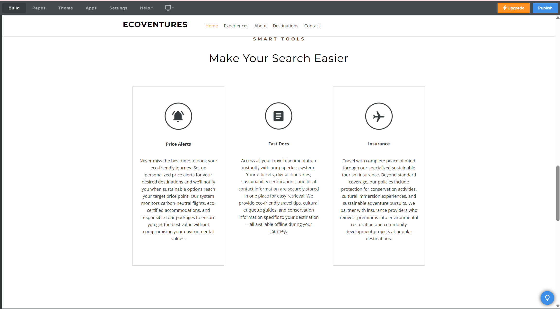
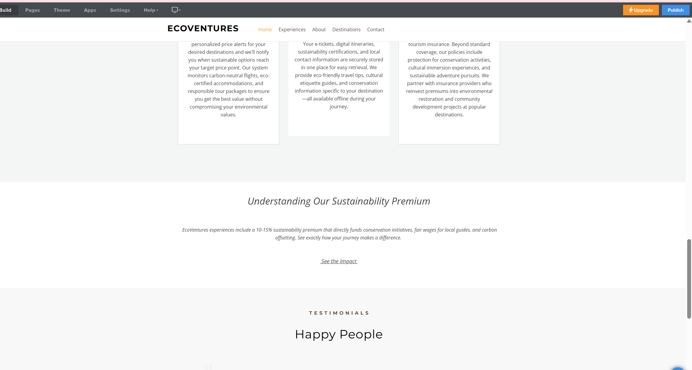
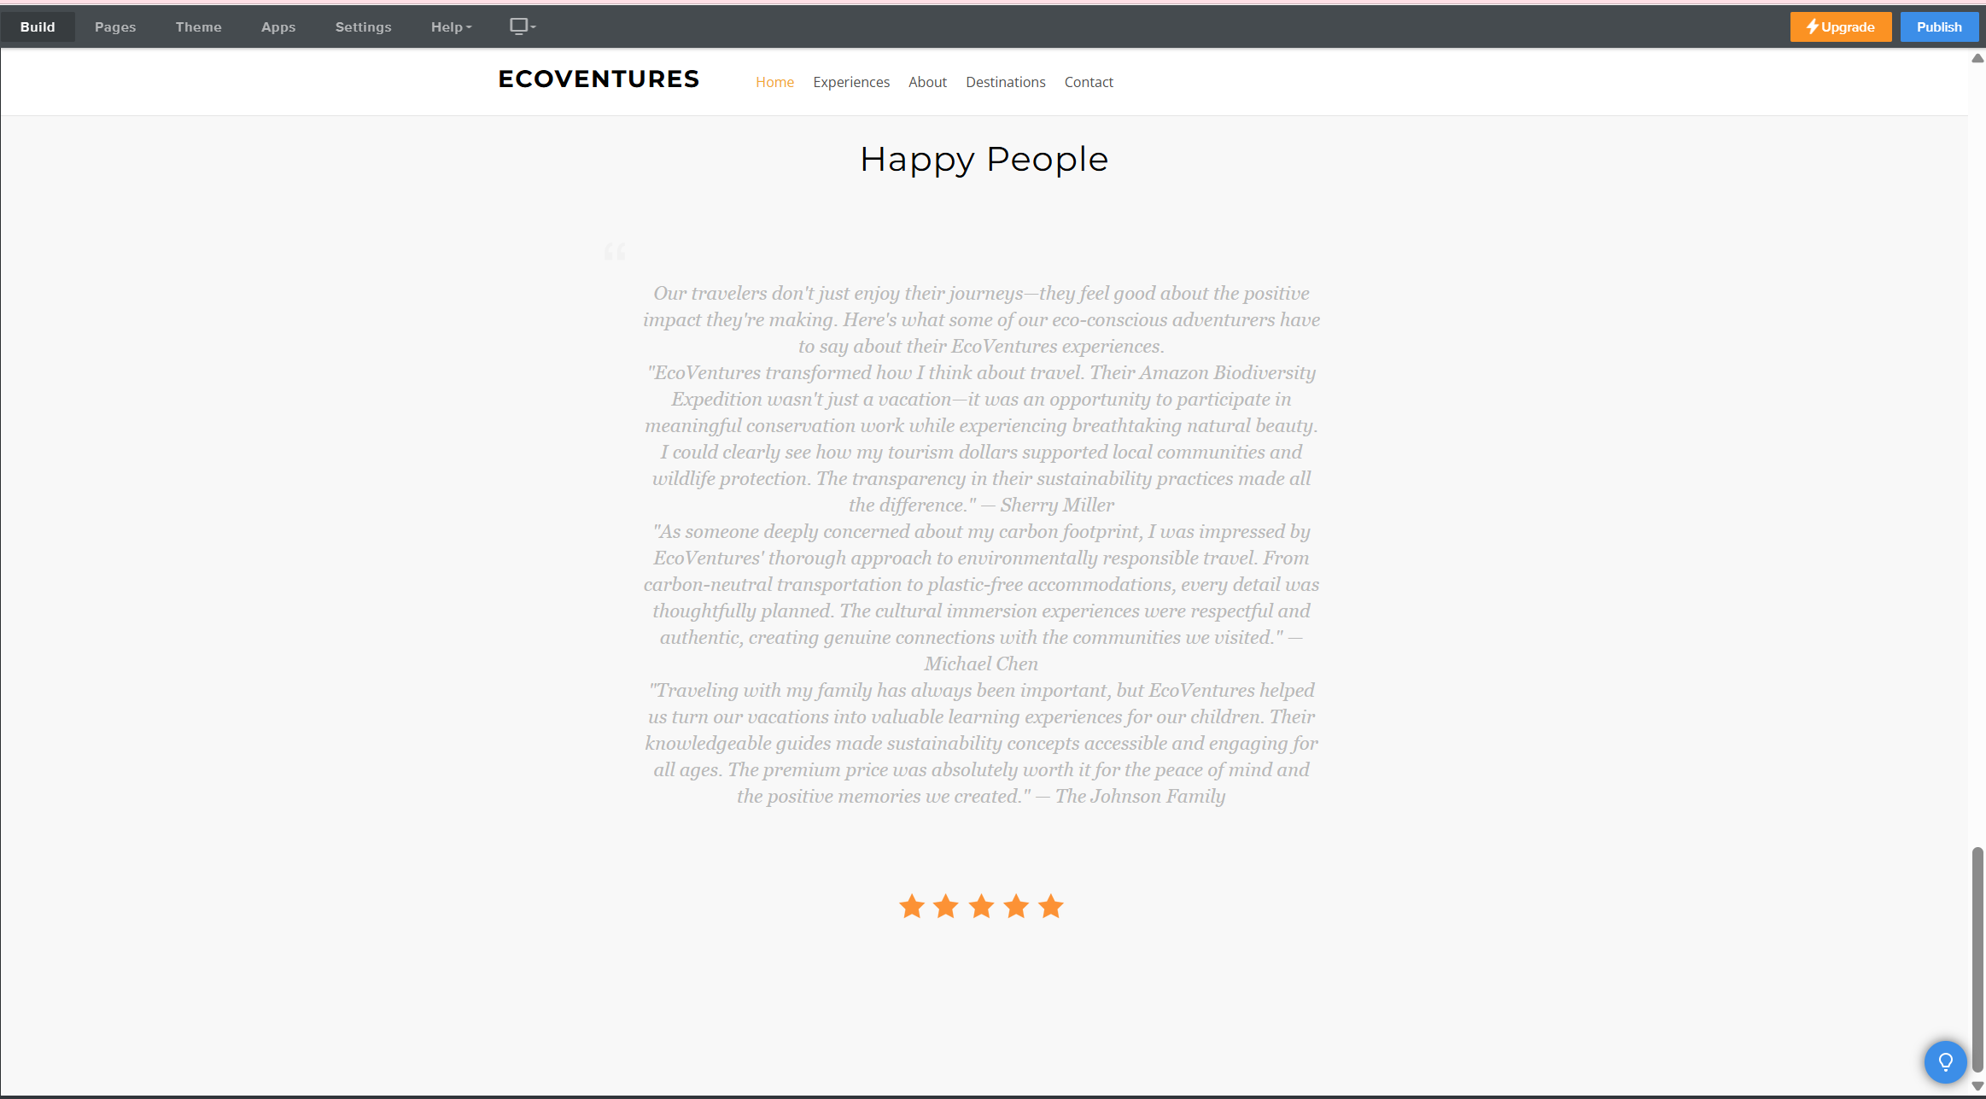

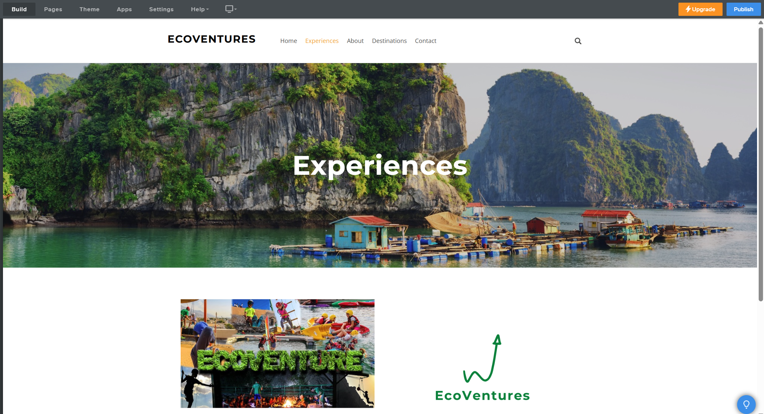
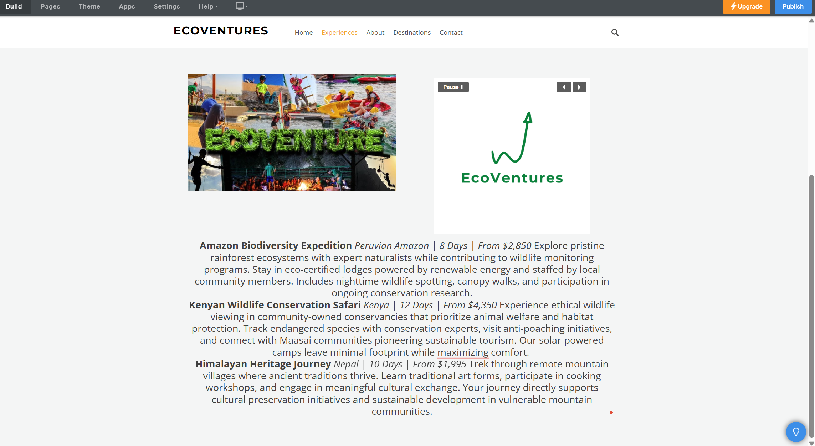

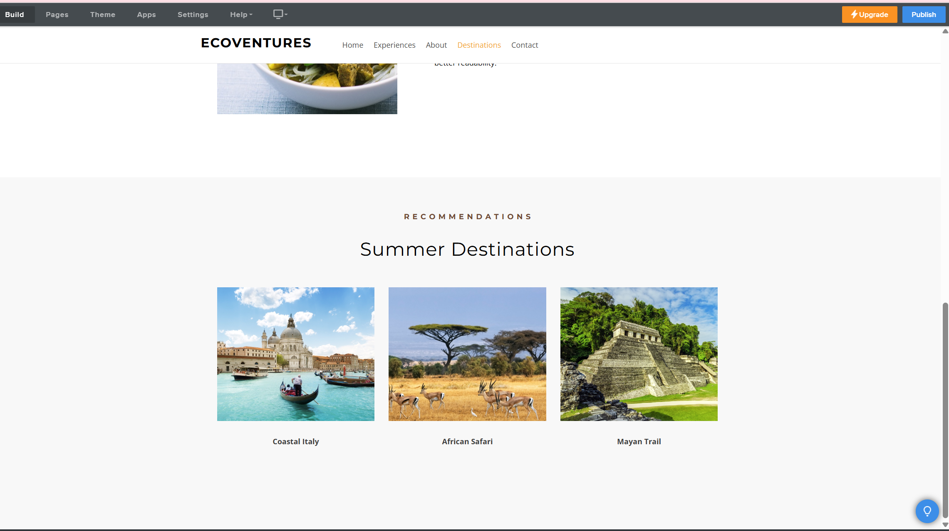
Mobile phone view
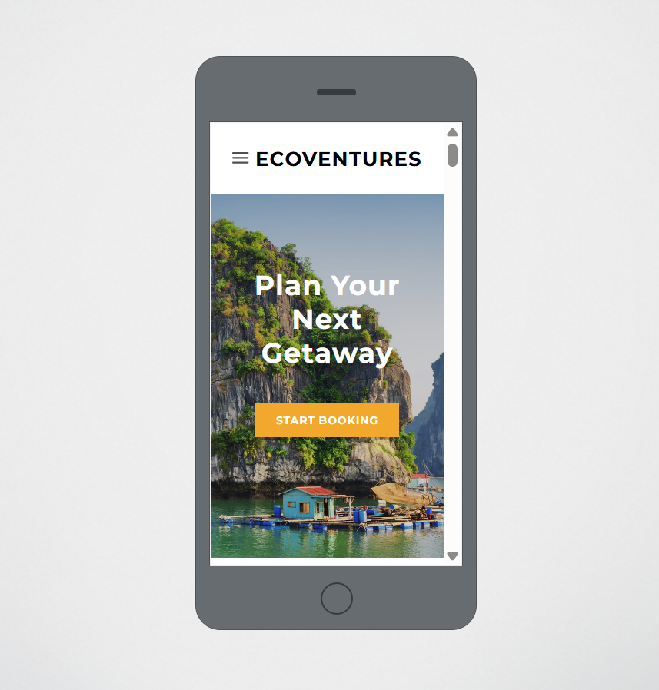
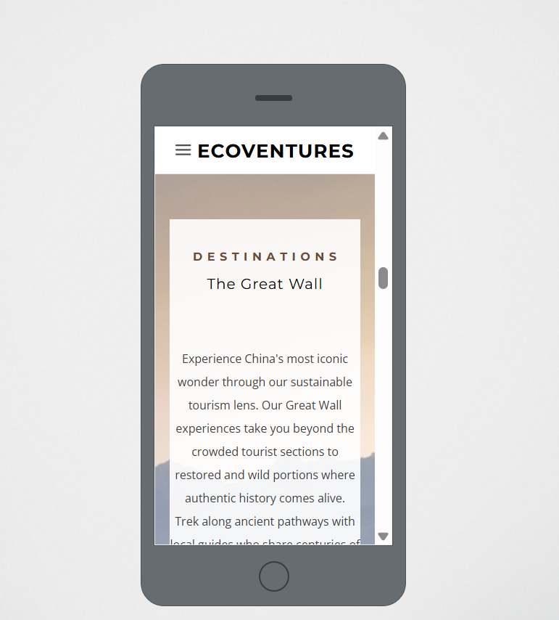
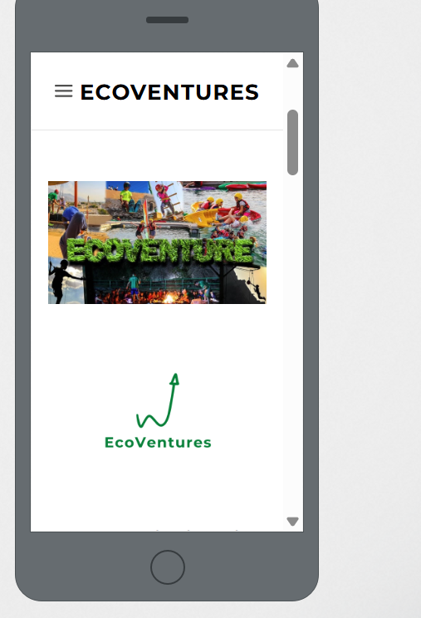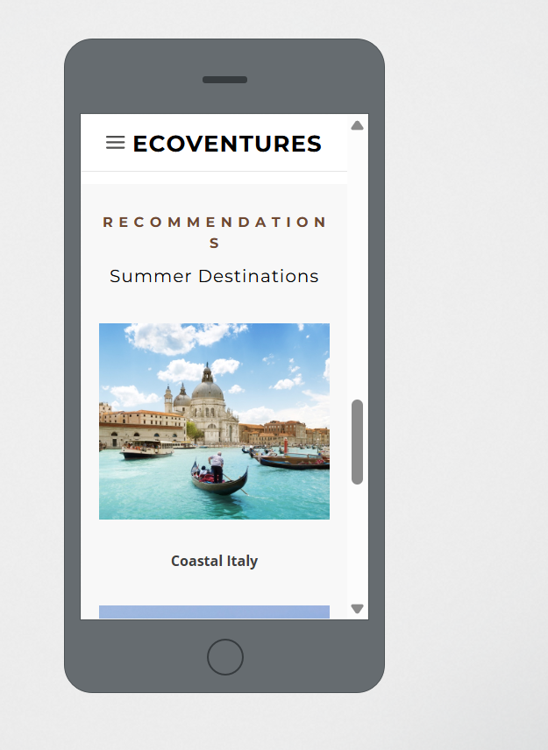

Marketing materials


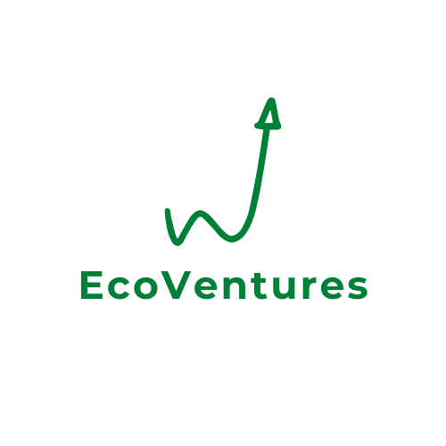

Importance of Excel in Digital Era (Task 3)
Introduction
Microsoft Excel is one of the legendary and the most versatile tools, which every business small and big one uses today. EcoVentures, alternatively, has important capabilities provided by Excel for planning financially, analysis of data, and business intelligence to enable sound decision making. Regarding this, as Johnson (2023) stated, "In the age of intelligent digital tools, Excel still dominates the landscape of business analytics because it is simple to use and versatile."
Financial Planning and Management
In the spreadsheet for EcoVentures, Excel proves its core strength of financial planning. Thompson (2024) further notes that, 78% of the small businesses utilize Excel for budgeting and financial forecasting as a tool which is intuitive, has strong calculation features.
In particular, the ability to generate dynamic formulas that calculate across related data sets that self populate on changes in other text formatted cells is very useful. In terms of financial projection, simple formulas like SUM, AVERAGE and IF statements get us to a point where small business owners can easily track income streams, monitor expenses across different categories and even calculate profit margins without much effort (Garcia & Smith, 2023).
Data Visualization and Communication
As Wilson (2024) stresses, 'good data visualization is the efficient reduction of cognitive load and the acceleration of decision making by harnessing human visual processing strengths,' which make it intuitive and easy without relying too much on human brain processes, as is the case with with traditional breakdowns in flat files or relational databases.
Revenue allocation can be communicated using bar charts, Chart showing comparison between two or more items was used as well as line graphs, and pie charts, to compare percentage of funds directed at the community initiatives as well as seasonal performance fluctuations. And particularly when communicating with stakeholders who may have different levels of financial literacy, this visual approach offers a lot of value (Abdulla, 2023).
Scenario Planning and Risk Management
According to Felfernig and Rivera (2024), scenario planning in Excel is 'essential for small businesses under economic uncertainty and especially for businesses with high seasonality or external dependency.' Agile decision making, which can result in the difference between life and death during difficult times, allows the same ability to adapt, quickly adjust variables and see their effect across an entire financial model.
Accessibility and Collaboration in the Digital Ecosystem
Although there are tools that do exist, the ubiquity of Excel means that it brings important advantages in the digital ecosystem. According to business professionals, Roberts (2023) stated that 92% have at least some level of proficiency of Excel which makes it a common language for communication on financial aspects amongst organizations.
In addition, with Excel being a part of Microsoft's cloud ecosystem through Office 365, collaborative financial strategic planning is easy. This can ease remote work options as it became vital for companies with distributed workers or working in several locations (Chen & Williams, 2023).
Business Intelligence and Data Analysis
In the last couple of years, Excel's data analysis capabilities have increased exponentially with tools such as Power Query and Power Pivot arguably enabling businesses to digest larger data sets and conduct many operations without migrating to specialized business analytics platforms. Salinas-Navarro (2024) points out that “small businesses that utilize Excel’s advanced Data Analysis features get many of the insights that only enterprises with dedicated business intelligence teams used to have”.
In their debrief today, Li and Johnson (2023) bring into light how "Excel's ability to import, process and visualize data from different sources makes it the integration hub in the small business technology stack." Because of this integration capability, businesses can easily utilize specific tools for one particular function while excel stays as the single source of analysis and reporting for the business.
Limitations and Complementary Tools
Software specially designed for this, may be the most appropriate way to represent complex financial modeling or advanced statistical analysis. Still, instead of supplanting them, Excel tends to be the entry point and add on to other specialized tools (Thompson, 2024).
Conclusion
In the digital era, Excel keeps itself as a must for business tool by quickly modernizing and staying available and versatile. EcoVentures, with such a sustainable tourism venture, requires Excel for its ability to support informed decision making and sustainable growth.
Our financial projection model proves that with some thought, even a simple spreadsheet can be powerful. Even in an age where the digital landscape is becoming more and more complex, businesses will continue to rely on Excel for analytics and financial management as their basic tool. Its accessibility, flexibility, and power are combined together, that is why its popularity will ensure that it remains a cornerstone for digital business operations for the foreseeable future.

Video and Techniques used in the video (Task4)
https://youtu.be/RDQQaY_O-W8
EcoVentures Advertisement
Several key storytelling techniques are used in this EcoVentures advertisement to compose an emotional story that will stick to viewers. The video follows the classic hero’s journey structure from the viewer’s point of view, as the potential hero. First, I set up a problem (environmental and cultural destruction from typical tourism) that develops a feeling of urgency and emotional tension. This sets up the conflict necessary for any compelling story.
Then the narrative shifts to the solution phase and uses contrast as a powerful story telling device (with harmful tourism practices serving as the lesser, and EcoVentures being the better). It makes it clear 'before and after', something that helps the viewer know what can be expected from a transformation. I weave sensory imagery throughout the video by choosing the appropriate visuals for natural landscape for immersion, and for emotional connection from authentic cultural exchanges.
Authentic testimonials are used in character driven storytelling so that customers can see themselves in other’s good experiences. Secondly the ‘rule of three’ is incorporated, by discussing three variation types of experience (wildlife conservation, cultural immersion and sustainable adventure), creating a memorable structure.
So, finally the video ends with a message that goes beyond the product itself and reaches to the viewer’s desire to be a part of something bigger, something for positive change.

References
Abdulla, A., Naim, A., Muniasamy, A., Mohammed, A. B., Bilfaqih, S. M., & Sabahath, A. (2025). Optimizing Business Insights Data Visualization Applications in Sales Forecasting, Marketing Analytics, and Financial Reporting. In Data Visualization Tools for Business Applications (pp. 103-124). IGI Global.
Ashrafuzzaman, M., Era, R. R., Awal, S. B., Sultana, I., Thimmaiah, A., Sharma, A. K., & Sharma, J. (2024). Transforming Medical Tourism Through an Integrated Business Intelligence Platform: Data-Driven Insights and Healthcare Industry Impact. In Data-Driven Business Intelligence Systems for Socio-Technical Organizations (pp. 233-266). IGI Global.
Chen, Y., Hu, T., & Law, R. (2024). The impact of visual, auditory, textual stimuli on crowdfunding: evidence from tourism projects. Current Issues in Tourism, 1-19. https://www.tandfonline.com/doi/abs/10.1080/13683500.2024.2378608
Felfernig, A., Wundara, M., Tran, T. N. T., Polat-Erdeniz, S., Lubos, S., El Mansi, M., ... & Le, V. M. (2023). Recommender systems for sustainability: overview and research issues. Frontiers in big Data, 6, 1284511.
Garcia, M., & Smith, J. (2023). Financial modeling for sustainable businesses: Tools and techniques. Journal of Sustainable Entrepreneurship, 12(4), 209-224.
Hajdas, M., Radomska, J., Szpulak, A., & Silva, S. C. (2023). Conflicting consumer cultures, shopping rituals, and the challenges of measuring consumer-based brand equity. Journal of marketing theory and practice, 31(4), 470-489.
Henderson, K. (2024). Balancing inspiration and information in tourism website design. Tourism Management Quarterly, 29(1), 33-47.
Hernández-Martín, R., Padrón-Fumero, N., & Padrón-Ávila, H. (2025). The Local Turn in Tourism Statistics Within the Statistical Framework for Measuring the Sustainability of Tourism 2024. Sustainability, 17(4), 1430.
Johnson, R. (2023). The evolution of business analytics tools for SMEs. Digital Business Quarterly, 29(1), 33-47.
Kumar, R., & Zhang, L. (2023). Social sustainability as a core value in modern tourism offerings. Journal of Responsible Tourism, 8(4), 209-225.
Masengu, R., Bigirimana, S., Chiwaridzo, O. T., Bensson, R., & Blossom, C. (Eds.). (2023). Sustainable Marketing, Branding, and Reputation Management: Strategies for a Greener Future: Strategies for a Greener Future. IGI Global. https://books.google.co.uk/books?hl=en&lr=&id=sbTYEAAAQBAJ&oi=fnd&pg=PR1&dq=Ferguson,+H.+(2024).+Pricing+strategies+for+sustainable+tourism:+Finding+the+sweet+spot+between+premium+and+accessible&ots=E3VsEyaKZG&sig=MWe0b4wv5YGSww4g019RTPhEZCI
Omran, W., Casais, B., & Ramos, R. F. (2025). Attributes of Virtual and Augmented Reality Tourism Mobile Applications Predicting Tourist Behavioral Engagement. International Journal of Human–Computer Interaction, 1-14.
Pires, P. B., Paulo/Duarte Santos Botelho Pires (Jos), & Pereira, I. V. (2024). Digital Marketing. https://api.taylorfrancis.com/content/books/mono/download?identifierName=doi&identifierValue=10.1201/9781003384960&type=googlepdf
Rasul, T., Santini, F. D. O., Lim, W. M., Buhalis, D., Ramkissoon, H., Ladeira, W. J., ... & Azhar, M. (2024). Tourist engagement: Toward an integrated framework using meta-analysis. Journal of Vacation Marketing, 13567667241238456. https://journals.sagepub.com/doi/abs/10.1177/13567667241238456
Roberts, S. (2023). Digital literacy among business professionals: A global survey. International Journal of Business Education, 8(4), 215-232.
Salinas-Navarro, D. E., Vilalta-Perdomo, E., & Michel-Villarreal, R. (2024). Empowering Nanostores for Competitiveness and Sustainable Communities in Emerging Countries: A Generative Artificial Intelligence Strategy Ideation Process. Sustainability, 16(24), 11244.
Thompson, E. (2024). Financial planning tools for small businesses: Comparative analysis. Small Business Finance, 19(1), 56-71.
Torres-Pruñonosa, J., Batlle, A. A., De Esteban Curiel, J., & Díez-Martín, F. (2024). The intellectual structure of destination image research in tourism (2001–2023): Background, pre-pandemic overview, shifts during COVID-19 and implications for the future. Journal of Vacation Marketing, 30(1), 143-165.
Williams, P. W., Stewart, K., & Larsen, D. (2012). Toward an agenda of high-priority tourism research. Journal of Travel Research, 51(1), 3-11. https://journals.sagepub.com/doi/abs/10.1177/0047287511427824
Wilson, B. (2024). Cognitive aspects of data visualization in business decision-making. Journal of Business Analytics, 11(2), 145-160.
Wisdom, E. (2015). The impact of e-marketing on business performance: A case study of the Midlands Meander Association members (Doctoral dissertation). https://scholar.archive.org/work/hedo2wngibay3ahnvoqi5tmoru/access/wayback/https://openscholar.dut.ac.za/bitstream/10321/1302/1/WISDOM_2015.pdf
Zheng, L. J., Zhang, J. Z., Lee, L. Y. S., Jasimuddin, S. M., & Kamal, M. M. (2024). Digital technology integration in business model innovation for carbon neutrality: An evolutionary process model for SMEs. Journal of Environmental Management, 359, 120978.

