Student number: 2212595
Word count: 3055

Supporting Young children through TRANSITIONS


(Source: dreamstime.com, 2000)

  - A HANDBOOK FOR PRACTITONERS

CONTENTS

Introduction Page 3
The needs of the child Page 4-7

Environment Page 8-9

The role of the adult Page 10
Partnerships Page 11

Interventions Page 12
Proposed outcomes Page 13

Reference list Page 14-18

Introduction

The purpose of this handbook is to aid and support early years practitioners who are working with young children in childcare settings. Children face multiple transitional phases throughout their lives which could result in a detrimental effect on their development if not managed effectively. Therefore, it is the duty of the practitioner to make those transitions as smooth as possible. In this handbook there are a range of key themes, interventions and examples of work by theorists for practitioners to implement into practice for children to experience a successful transition. The selected age group this handbook caters to is children that are first entering school at foundation phase (Age 3-5) Nursery and reception. The focus throughout is to enable both the child and the practitioner opportunities to gain experience, enhance knowledge and develop skills when guiding children through transitions.
What is a transition?
A transition is “the process or a period of changing from one state or condition to another.” (Oxford University Press, 2022) Transitions are forever evolving throughout a child’s life and can range from elements such as reaching milestones, starting a new school or welcoming a new family member. The focal point of this handbook is to understand how a child adjusts and how to accommodate their needs whilst they transition.
(Rhondda Cynon Taf County Borough Council) explain the following transitions:
Vertical transitions are transitions which constitute a major change to a child’s everyday routine, for example, starting school for the first time. However, horizontal transitional changes, also shape children’s experience of vertical transitions and may affect their well-being.
The brain of the infant develops through experiences. Ultimately practitioners are preparing children during their most influential stage for school life and so implementing structure and applying early interventions are vitally important in order to take care of children and families and to prevent issues. It is also important to create a safe environment for children to flourish whilst they adapt to change as it will inevitably contribute to their own personal success throughout their lives.

The needs of the child

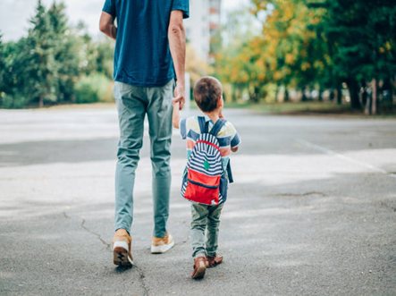
Whilst many children will find transitioning difficult it is important to note that not every child is the same. A lot of children excel in social environments such as school which is why it is important to recognise and cater to each child’s individual needs. Lindon (2012) notes that frameworks across the UK may have variable outcomes regarding areas of improvement. However, each framework shares the same purpose of making every child feel valued. Lindon (2012) also emphasises the importance of understanding children’s physical, emotional, mental and intellectual well-being through holistic development.
What is the meaning of holistic?
The definition of holistic is “dealing with or treating the whole of something or someone and not just a part.” (Cambridge University Press, 2022)
Children do not develop or learn in a set way. The developed curriculum in Wales now implements there are no longer phases or stages of learning, instead there are four purposes with the
(Source: Word 2022)
aim to create students that are:
- Ambitious, capable learners, ready to learn throughout their lives
- Enterprising, creative contributors, ready to play a full part in life and work
- Ethical, informed citizens of Wales and the world
- Healthy, confident individuals, ready to lead fulfilling lives as valued members of society
(National Day Nurseries Association, 2021)
UNICEF’s article 29 (Goals of education) from the un convention on the rights of a child states that education must encourage children to enhance their abilities to reach their full potential, whilst showing respect to others and the environment.

The types of attachment
The types of attachment include:
- Secure attachment
- Ambivalent attachment
- Avoidant attachment
- Disorganised attachment
Secure attachment
(Source: https://www.healthychildren.org/English/ages-stages/toddler/Pages/Soothing-Your-Childs-Separation-Anxiety.aspx, 2022)
A secure attachment is formed when children’s needs are consistently met through sensitive and catered responses. A child will feel confident that their caregiver can be relied on.
John Bowlby’s Attachment Theory
Bowlby’s attachment theory (1969) primarily focusses on the formation and the development of the relationship between the caregiver and the child. Flaherty and Sadler (2010) Explain how Bowlby suggests secure attachments between a mother and child are displayed depending on how promptly signals from a child are responded and tended to.
Ambivalent attachment
An ambivalent attachment pattern will show when a child doesn’t feel comfortable leaving their parent or main caregiver to be left with a practitioner. If left, the child will become distressed, overwhelmed and difficult to comfort. Children with an ambivalent attachment style are less likely to be independent through a lack of confidence. Children with an ambivalent quality will find it harder to focus on tasks and activities due to being separated from their main caregiver resulting in them constantly feeling anxious.
Avoidant attachment
Avoidant attachment is when a parent or main caregiver detaches themselves from the relationship with the child due to being emotionally unavailable. This results with the child feeling like their sole purpose is to make their caregiver happy, whilst having a complete disregard for their own needs. Frost et al (2013) explain how children with an avoidant attachment style might find it difficult to approach practitioners when needing help and so will eventually learn to become self-reliant.
Disorganised attachment
Disorganised attachment suggests an environment doesn’t feel secure for a child to feel safe. The child may care for the relationship; however, they may still feel anxious and fearful around the caregiver. Disorganised attachments can cause distress and confusion to a child due to the lack of stability in the relationship.
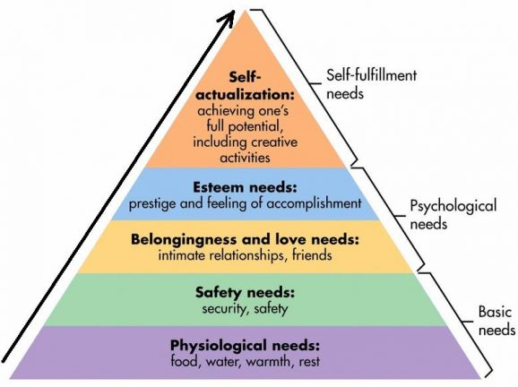
Abraham Maslow’s Hierarchy of Needs
Maslow’s Hierarchy of Needs (1943) is presented through a diagram to symbolise Maslow’s model of the five sets of needs that he believed all individuals initially progress from. For children to transition successfully it is important for their basic needs to be met before they can develop any further.
(Source: simplypsychology.org/maslow, 2022)
An article by the BBC (2013) states how Maslow explained that the order of needs for some people may structure differently to others or might even be completely absent altogether. Stoyanov (2017) states how Maslow claimed individuals are programmed to fulfil even the most basic of needs in order to function through life.
Pedagogy
“Early years pedagogy is aligned with child-rearing practices that are believed, by well-meaning adults who claim to know what constitutes valued knowledge, to promote desirable outcomes for all.” (Farquhar and White, 2013) Pedagogy is based around the delivery of material by teachers and practitioners to enhance skills on relevant topics through meaningful interaction to form an understanding.
Schema
A schema focuses on the repetition in behaviours and actions to enhance a child’s brain development. The Scottish Government (2022) explain how engagement in repetitive behaviours such as the up and down motion can contribute to the development of children’s abilities further on in life when learning new skills such as the ability to write.
The importance of play
“In order to be educative, the child must have a sense of the purpose, meaning and joy of activities – and that they involve, wonder, concentration, unity and satisfaction.” (Watts, 2021) Play in the early years is one of the main forms of expression for a developing child. Play utilizes children’s imaginations through elements such as self-led play which allows them to build relationships freely within settings. Play also creates physical and mental benefits to a child’s emotional and cognitive development. For example, a child learning how to move or lift something can form an awareness of their own capabilities. Lillemyr, Dockett and Perry (2013) believe that when children are faced to interact through play, social and cultural influences inevitably guide them on how to understand and display themselves as an individual.
Lev Vygotsky
Vygotsky’s theory (1962) suggests that behavioural evolution arises from constructed social guides that assist cognitive development. He also believed that culture and language are the main factors that contribute towards an individual’s progression. Another example of Vygotsky’s (1978) work is The Zone of Proximal Development. To summarise this theory, it essentially suggests that with the encouragement and guidance of expert knowledge a learner can gradually gain competence and rely less on information that’s fed to them by retaining information themselves, and eventually sharing the same understanding.
Vygotsky’s ideas and theories have been linked to the works of Jean Piaget. However, both theorists had conflicting opinions. Piaget believed on the sole focus of the child creating their own understanding, whereas Vygotsky concentrated on environmental contributors. As McLeod, S. A. (2007, updated 2014) suggested that both theorists disagreed on the developmental stage that children should be taught certain concepts but had a common ground on wanting to understand how children interpret information and express themselves.

Environment

When a child encounters a monumental event, such as starting school a notable change in routine will occur. Disrupting a child’s routine can affect their wellbeing and cause emotional distress. For example, children are more likely to act out in anger by screaming and crying if they can detect a change in their surroundings. This can then result in a child feeling unsafe due to an alteration in their stability, creating a lack of trust between the child and the practitioners in the setting. “Development proceeds when minor, additional extensions sporadically accumulate to build the children’s personality through the involvement in their collected experiences”. (Saracho, 2021) Therefore, it is essential for practitioners to use their initiative and work together to create a safe, welcoming environment and gain that trust by encouraging independence and providing comfort to every child.
Urie Bronfenbrenner's Ecological Systems Theory
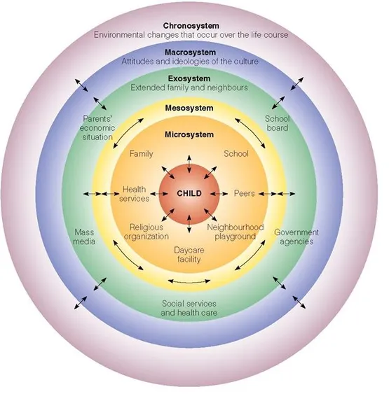
Bronfenbrenner’s Ecological Systems Theory (1979) concentrates on how influential the environment around children is and how it can affect their development. Ecological transitions form from change and illustrate how a person’s behaviour adapts and navigates through society as a result of experiencing unfamiliarity. Soyer (2019) highlights Bronfenbrenner’s theory by stating thorough observation of an individual must take place in order to determine influencing factors of development. As stated by (Elliot and Davis, 2020) “The ecological framework enables the mapping of information about individuals and their contexts over time in order to understand their diverse systemic interconnections.” Early Years Matters (2022) highlights the importance of creating a nurturing environment for children to feel safe and encouraged to explore their surroundings through curiosity of sight, touch, maneuvers and manipulation. It also suggests the environment in the early year’s foundation stage is made up of three elements: The emotional environment, the outdoor environment and the indoor environment.
(Source: https://www.simplypsychology.org/Bronfenbrenner.html, 2020)

The emotional environment
The emotional environment refers to how an atmosphere in a child’s surroundings can affect their feelings. There are multiple elements that could influence a child’s emotions. Children could be affected by factors such as the behaviour of other children, how a classroom is presented or whether it provides sufficient resources. It could also depend on whether the staff are effectively interacting and including each child to make them feel valued. “The strength or otherwise of our emotional health will influence the level of tolerance to minor and major upsets and our ability to overcome them.” (Robinson, 2008, page 5) A child will instantaneously pick up on the mood of the room which will then determine how they will feel in that moment, along with their general attitude and behaviour towards the staff and the setting.
The outdoor environment
The outdoor environment encourages children through sensory exploration and the engagement with natural elements to enable the stimulation of independence through self-lead activities and risk taking. The outdoor environment also creates opportunities for children such as the ability to discover wildlife or how to learn to grow and care for plants, all whilst developing their capabilities and widening their imaginations through interactions with other children. It is also a chance for children to build strength and enhance their coordination through fine and gross motor skills such as running and climbing or using chalks to write on the ground and popping bubbles. Ouvry and Furtado (2020) explain how opportunities may be missed if outdoor experiences do not differentiate from what activities children learn indoors.
The indoor environment
The indoor environment creates a safe space for children to develop their knowledge, express thoughts and interact with other children. It also enables children to engage with their surroundings through the provision of appropriate resources that they can access and utilize comfortably. Essex County Council (2022) express how children may see school as a second home and so by providing reassurance and support it will allow them to settle in their environment.

The role of the adult

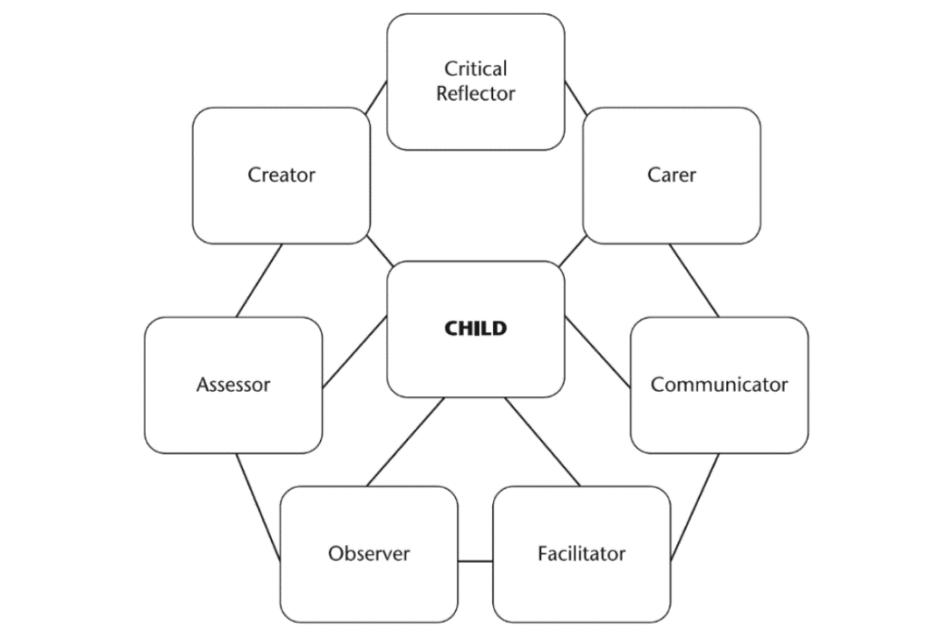
(Source: Rose and Rogers, 2012, Page 2)

As a responsible adult it is important to set a good example when working with young children, with the aim to present yourself as a good role model.
A practitioner’s duty is to be the primary source of care and trust so that children can receive the help and attention they need whilst they are apart from their caregivers. Dowling (2010) expresses how influential practitioners are to a child’s life not only through teaching children what to say or do, but also how to behave and how to express themselves.
“The practitioner will have been a different ‘self’ or a combination of different ‘selves’ depending on what the responsibility or activity entailed.” (Rose and Rogers, 2012, page 1)

Partnerships

Children and their families are the main focal point when preparing for transitions. As stated on GOV.UK research shows the importance of working with parents and carers throughout a child’s life in order to observe development and progression. Parents and carers are the first form of education children receive and so it is important to integrate all areas of knowledge for children to maximise their success. The website also highlights the effectiveness of getting to know children before starting in a new setting whether it be through topics such as culture, abilities or their likes and dislikes.


As the (Welsh Government 2015, page 2) suggests “Everyone should be able to see the contribution that they are making to influencing these outcomes.” This statement highlights the importance of communication and building relationships with not only the children and their families with their best interests in mind but also the key workers and other professional sources as they all play an impactful role in a child’s learning life.
(Source: Word, 2022)

A child’s wellbeing is the priority in any setting you enter. Waltham Forest Council (2019) highlight the rise in numbers of children that speak a foreign language whilst at home. Having an awareness and finding solutions on how to communicate with families whose English may be minimal also requires patience and understanding from practitioners. It is important to make every family feel respected and have the same equal opportunities of input on their child’s transition into education by having regular interactions with parents and families. As a practitioner it is your duty to create positive partnerships by having effective communication and regularly keeping in contact with parents and other professionals that may be present in a child’s life.
Interventions

There are multiple early interventions that practitioners can put into place to result in a smooth transition for children starting school. Firstly, practitioners can arrange a home visit prior to starting to have informal discussions with the child and their family in an environment they feel relaxed in. This is also an opportunity to give children activities such as a ‘get to know me’ sheet so that practitioners can find out what each child’s interest are. The option of settling in sessions, open visits and virtual tours will help children gain a sense of familiarity with the environment before starting at a setting. Children may also be offered staggered starting dates so that they don’t feel too overwhelmed. It is important to acknowledge every child that enters the setting and address them by their name as it enables positive relationships and security to form at the very beginning of the transition process.
“Early interventions can help children and young people to develop the skills they need to live happy healthy and successful lives. It can improve the quality of children's home lives and family relationships, increase educational attainment and support good mental health.”
(Early Intervention Foundation, 2020)
It is important for practitioners to allocate time to prepare and plan with staff and parents along with outside professionals to ensure smooth transitions. Planning the environment is a key factor to making children feel welcomed into the setting by having accessible resources to encourage children to pursue their own interests independently. Sharing information through elements such as repetition or visual timetables enable structure and reassurance to young learners whilst allowing them to feel a sense of control. Practitioners should encourage parents to stay and play to enhance and support children’s progression. It is also important as a practitioner to be mindful of a child’s development stage instead of only catering to a specific age group. Formosinho and Pascal (2016) explain the importance of using holistic approaches through the observation of children’s development as an individual instead of only witnessing fragmented elements.

Proposed outcomes

The desired outcomes resulting from a smooth transition will be visibly noticeable. Indicators such as body language, facial expressions and emotions will ultimately tell whether children are happy or not to be left at the setting.
Children will feel more relaxed in their environment knowing they can predict the routine of the day, allowing them the ability to explore resources independently and confidently interact with practitioners and other children in the class to form and develop healthy relationships.
“Self-esteem is not fixed; it can change according to the people we are with and the situations that we find ourselves in.” (Dowling, 2010, page 14)
Children will form an awareness of their environment and will feel excited to explore and face new challenges. Ultimately children will enjoy coming to school and will be able to confide in practitioners for comfort and support knowing they have a safe space to learn and grow in.

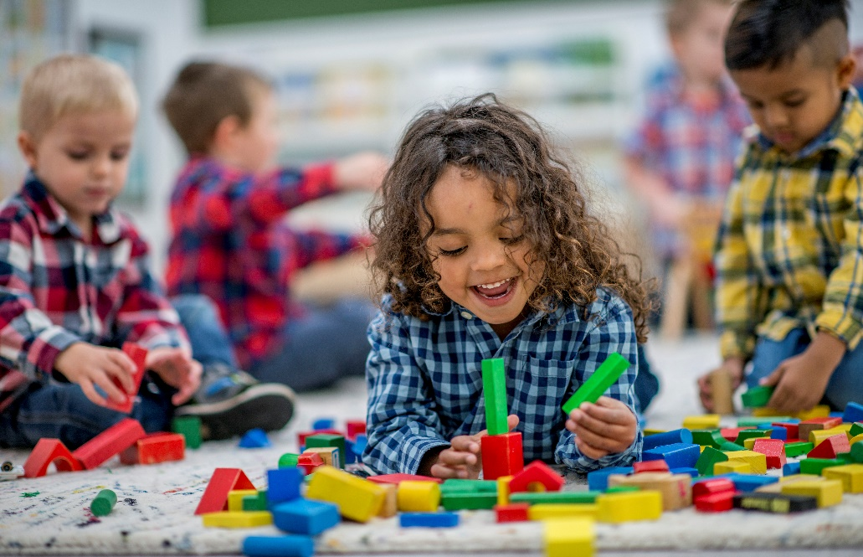
(Source: Word, 2022)

Reference list

A summary of su the UN convention on the rights of the child - UNICEF (no date). Available at: https://www.unicef.org.uk/wp-content/uploads/2019/10/UNCRC_summary-1_1.pdf. (Accessed: November 17, 2022).
Bronfenbrenner’s Hierarchy of Needs [Image] Available at: https://www.bravehearteducation.co.uk/whats-hierarchy-needs/ (Accessed: 19th November 2022)
Cambridge University Press (2022) Available at: https://dictionary.cambridge.org/dictionary/english/holistic (Accessed: November 20th 2022)
Curriculum for Wales 2022 (2022) NDNA. Available at: https://ndna.org.uk/ndna-cymru/curriculum-for-wales-2022/ (Accessed: November 17, 2022).
Dowling, M. (2010) Young Children's personal, social and emotional development. 3rd edn. London: SAGE Publications Ltd.
Dreamstime (2000) [Image] Available at: https://www.dreamstime.com/stock-illustration-school-happy-children-picture-kids-playing-near-kids-drawing-style-image56394870 (Accessed: 11th November 2022)
Early Intervention Foundation, (2022) Why early intervention matters. Available at: https://www.eif.org.uk/why-it-matters/why-is-it-good-for-children-and-families (Accessed: 13th November 2022)
Early Years Matters (2022) Enabling Environments. Available at: https://www.earlyyearsmatters.co.uk/our-services/school-and-nursery-improvement-partner/enabling-environments/ (Accessed: 17th November 2022)
Early Years outcomes: Framework (2015) GOV.WALES. Available at: https://gov.wales/early-years-outcomes-framework (Accessed: 12th November 2022).
Elliott, S. and Davis, J.M. (2020) “Challenging taken-for-granted ideas in early childhood education: A critique of Bronfenbrenner’s ecological systems theory in the age of post-humanism,” Research Handbook on Childhood nature, pp. 1119–1154. Available at: https://doi.org/10.1007/978-3-319-67286-1_60 (Accessed: 16th November 2022)
Essex County Council (2022) Effective indoor environments. Available at: https://eycp.essex.gov.uk/the-early-years-foundation-stage/how-do-i-provide-a-rich-learning-environment/effective-indoor-environments/ (Accessed: 18th November 2022)
Farquhar, S. and White, E.J. (2013) “Philosophy and pedagogy of early childhood,” Educational Philosophy and Theory, 46(8), pp. 821–832. Available at: https://doi.org/10.1080/00131857.2013.783964. (Accessed 17th November 2022)
Flaherty, S.C. and Sadler, L.S. (2011) “A review of attachment theory in the context of adolescent parenting,” Journal of Paediatric Health Care, 25(2), pp. 114–121. Available at: https://doi.org/10.1016/j.pedhc.2010.02.005. (Accessed: 17th November 2022)
Formosinho, J and Pascal, C. (2016) Assessment and evaluation for transformation in early childhood. London: Routledge.
Frost, A. et al. (2013) Observing children with attachment difficulties in preschool settings: A tool for identifying and supporting emotional and social difficulties. Philadelphia, PA: Jessica Kingsley.
Hammond, W.K. and Hammond C. (2013) Abraham Maslow and the pyramid that beguiled business, BBC News. BBC. Available at: https://www.bbc.co.uk/news/magazine-23902918 (Accessed: 16th November 2022).
Healthychildren.org (2022) [Image] Available at: https://www.healthychildren.org/English/ages-stages/toddler/Pages/Soothing-Your-Childs-Separation-Anxiety.aspx (Accessed: 19th November 2022)
Jigsaw stock image [image] Available on Word. (Accessed: 15th November 2022)
Lillemyr, O.F., Dockett, S. and Perry, B. (2013) Varied perspectives on play and learning: Theory and research on early years education. Charlotte, NC: Information Age Pub.
Lindon, J (2012). Understanding child development 0-8 years (3rd ed.) Hodder Education
Maslow’s Hierarchy of Needs (2022) [Image] Available at: simplypsychology.org/maslow (Accessed: 18th November 2022)
McLeod, S. (2007, updated 2014) [Lev Vygotsky’s sociocultural theory], Lev Vygotsky's Sociocultural Theory - Simply Psychology. Available at: http://www.simplypsychology.org/vygotsky.html.
Ouvry, M and Furtado, A (2020) Exercising Muscles and Minds, 2nd ed. London: Jessica Kingsley Publishers
Parent and child stock image [Image] Available on word. (Accessed: 15th November 2022)
Robinson, M (2008) Child development from birth to eight. Berkshire: Open University Press
Rose, J. and Rogers, S. (2012) The role of the adult in early years settings. Berkshire: McGraw-Hill.
Saracho, O.N. (2021) “Theories of child development and their impact on early childhood education and care,” Early Childhood Education Journal [Preprint]. Available at: https://doi.org/10.1007/s10643-021-01271-5. (Accessed: 16th November 2022)
Schemas: Learning through play (no date) Schemas: learning through play | Learning at home | Parent Zone. Available at: https://education.gov.scot/parentzone/learning-at-home/schemas/. (Accessed: November 15th 2022)
Simplypsycology (2020) Bronfenbrenner's Ecological Systems Theory [Image] Available at: https://www.simplypsychology.org/Bronfenbrenner.html (Accessed: 16th November 2022)
Soyer, G.F. (2019) Urie Bronfenbrenner: The Ecology of Human Development Book Review, Journal of Culture and Values in Education. Available at: https://www.cultureandvalues.org/index.php/JCV/article/view/37. (Accessed: November 16, 2022).
Stoi︠a︡nov Stoi︠a︡n (2017) An analysis of Abraham Maslow's a theory of human motivation. London, England: Routledge.
The hub (2019) Working in Partnership with Parents | The Hub - Waltham Forest Education Hub. Available at: https://thehub-beta.walthamforest.gov.uk/working-partnership-with-parents. (Accessed: November 17, 2022).
Transition (no date) transition_1 noun - Definition, pictures, pronunciation and usage notes Available at: https://www.oxfordlearnersdictionaries.com/definition/english/transition_1?q=transition (Accessed: 9th November 2022).
Transition information for early years (no date) Rhondda Cynon Taf County Borough Council. Available at: https://www.rctcbc.gov.uk/EN/Resident/SchoolsandLearning/AccessandInclusiontoEducation/WorkinginPartnershipwithParents/SchoolTransitionAdvice/TransitioninformationforEarlyYears.aspx (Accessed: November 13, 2022).
Watts, M (2021) Friedrich Froebel: interpolation, extrapolation. Available at: https://www.tandfonline.com/doi/full/10.1080/03004430.2021.1881077 (Accessed: 17th November 2022)
Why is it good for children and families? (2020) Early Intervention Foundation. Available at: https://www.eif.org.uk/why-it-matters/why-is-it-good-for-children-and-families. (Accessed 20th November 2022)
Working in partnership with parents and Carers (no date) GOV.UK. Available at: https://help-for-early-years-providers.education.gov.uk/get-help-to-improve-your-practice/working-in-partnership-with-parents-and-carers (Accessed: 16th November 2022).
Young children stock image [Image] Available on word: (Accessed 22nd November 2022)

