Using body awareness techniques to help students release unnecessary tension while meeting the demands of singing

Lourdes M. González-Caraballo
2318051
Module 1 Assignment
Word Count: 4,111

Introduction
I am a private voice teacher and cater to students of all ages and levels. One of the major difficulties that I have observed in my students relates to upper body tension, which causes difficulty breathing and forced voices. In my personal development as a singer, I have found that using body awareness techniques like mindful breathing and Alexander Technique poses, help me free my voice from tension. Although I am not an Alexander Technique (AT) or mindfulness instructor, I have studied both on-and-off for several years. I have incorporated what I’ve learned with my students and obtained successful results. I started researching posture, Alexander Technique and voice. However, I shifted when I realized that the demands that singing exerts on the body are very different from that of the speaking voice. Since the same muscles that are involved in posture are also involved in voice production, I hypothesized that posture has an even greater effect in the quality of sound when singing (Johnson and Skinner, 2009). With this study, I aim to evaluate and reflect on literature pertaining to how using body awareness techniques can help students release unnecessary tension while meeting the demands of singing. For this purpose, I will start by giving a brief overview of the Alexander Technique and its relationship to mindfulness. I will then discuss demands that singers exert on their body and voices, explaining the anatomic components and how posture may affect their mechanism. I will also suggest some ways to reduce the stresses faced by singers during a singing lesson.
I have decided to use Dewey’s 5 step Model (Dewey, 1933) (Figure 1) to reflect on this process and the literature that I have encountered. I have chosen this model because it closely resembles the Scientific Method (Hébert, 2015). I come from a science background (B.S. in biology) so this easily resonates with me, and I find that I naturally use it to approach any problems I encounter in my voice and my teaching. It feels very familiar and directs me to solutions easily. Since it is a very straightforward and a bit dry, I will complement it with Gibb’s reflective cycle to incorporate more of my thoughts and feelings (Gibbs, 1988) (Figure 1). At the end of my analysis and reflection, I will propose a strategy for incorporating these techniques in a voice lesson, focusing on releasing tension in 3 areas: thorax (breathing), neck and jaw. This strategy will serve as the proposed solution to the problem. In the future, I would like to test out these strategies and measure their effectiveness.

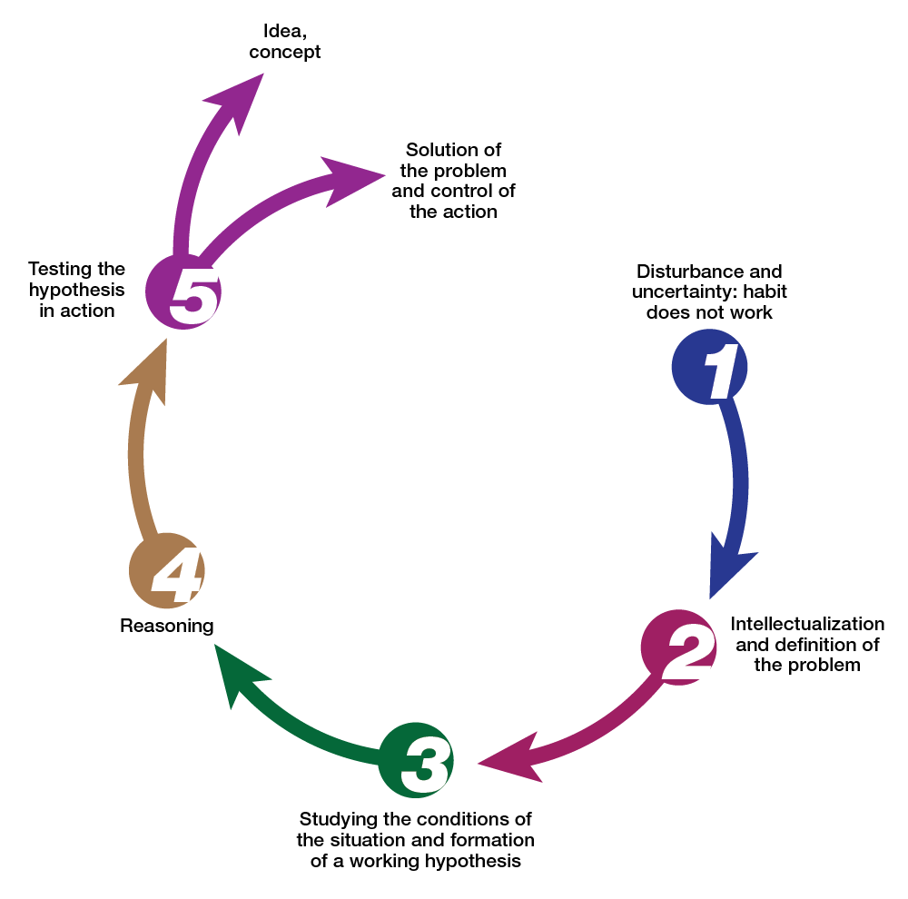
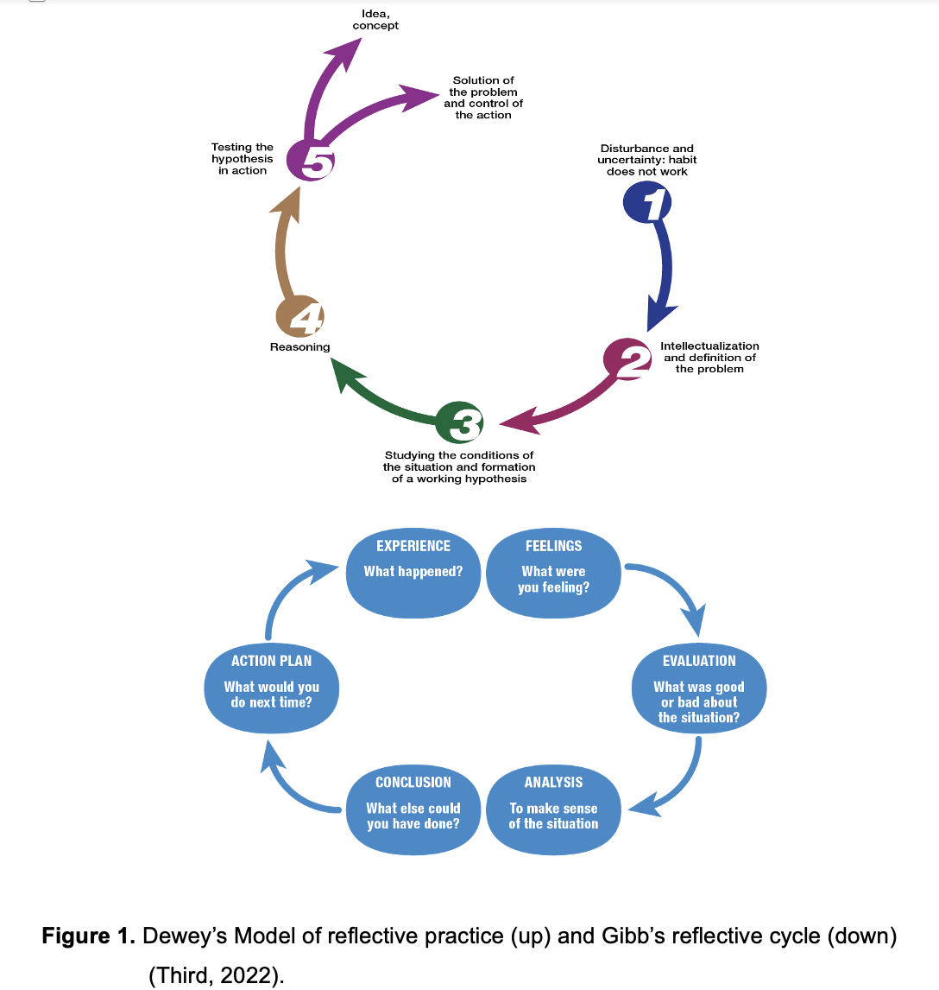
Mindfulness and the Alexander Technique
One of the difficulties I have found in guiding my students is that when I ask them what they’re feeling or doing I often get ‘I don’t know’ as an answer. I believe that it is because most of us are not very connected to our bodies and are often on ‘auto-pilot’. One of the things that we are often unaware of is the way we use our body, our posture. The definition of ‘good posture’ has changed throughout the years due to advances in scientific research and understanding of the anatomy and physiology of the human body (Roth and Verdolini Abbott, 2014). Some verbal instructions that singing teachers give to students include ‘chest to be kept high’, ‘the pelvis is to be tilted slightly forward as to reduce the small of the back‘, ‘lift the sternum’, ‘tuck your chin and tailbone’, ‘throw your shoulders back and open your chest’ (García, 1847; Christy, 1967; Vennard, 1967; Miller, 1986; Doscher, 1994; McKinney, 1994; Nair, 2007). These often contradictory and tension-building instructions have confused and even created more tension in students. All these statements emerge from the notion that good posture is a position that should be locked in when achieved (Miller, 1986). Thanks to scientific advances and influences of methods like Feldenkrais and Alexander Technique, we now view posture as a direction (Bunch Dayme, 2005) and non-static alignment but a structure that responds to the forces of gravity (Heirich, 2005). While each pedagogue has had a different notion of what good posture looks like, they all agree that it is crucial to singing (Miller, 1986; Doscher, 1994; McKinney, 1994; Brown, 1996; Bunch Dayme, 2005; Chapman, 2005; Nair, 2007). Maintaining common misalignments like forward head posture, rounded shoulders, and sway back posture (Appendix 1) for extended periods of time cannot only decrease voice efficiency but can contribute to a variety of voice disorders like dysphonia (O’Sullivan et al., 2006; Hodges, Sapsford and Pengel, 2007; Wilson Arboleda and Frederick, 2008; Staes et al., 2011; Franco et al., 2014; Kennard et al., 2015; Jintae et al., 2016; Kim and Kim, 2016; Mahdavie, Rezasoltani and Simorgh, 2017). This has been corroborated in more recent times by scientific studies that have looked at the impact of alignment and posture on the structures involved in singing (McClean, Brilleman and Wye, 2015) by measuring different sound qualities (Cardoso, Lumini-Oliveira and Meneses, 2019).
To sing efficiently, we must be very conscious of our bodies and changes in alignment (Neely, 2016), which is exactly what the Alexander Technique teaches. I have chosen to integrate mindful breathing and body awareness in the context of Alexander’s directions and poses. I acknowledge that these are not the only techniques that can be implemented in a voice lesson like body mapping, yoga, the Feldenkrais Method and Estill Voice Training (Jain, Janssen and DeCelle, 2004; Peterson, 2008; Paparo, 2022). I’m also aware that some individuals may benefit from one more than the other (Peterson, 2008). While I have experiemented with some yoga poses with my students, I am not very familiar with the other techniques mentioned and have not had the chance to experience them myself. This is why I have chosen something that is more familiar to me and that has resulted in good outcomes for my voice.
Mindfulness is experiencing the present moment without judgment. This awareness technique has been proven to reduce stress anxiety and depression (Fjorback et al., 2011; Baer, Carmody and Hunsinger, 2012), increase cognitive abilities (Dunning et al., 2019; Mirabito and Verhaeghen, 2023) and contribute to neuroplasticity (Yu et al., 2021; Mora Álvarez et al., 2023). However, there hasn’t been a lot of research on what it means when learning music, specifically singing (Czajkowski, Greasley and Allis, 2021). The few studies that have been done on mindfulness and singing have found positive results like an improvement in breath awareness and efficiency, focus, reducing extraneous tension, enhanced aural and physical awareness, easier learning, better sound production and improved teacher/student relationships (Czajkowski and Greasley, 2016; Tan, Diaz and Miksza, 2020; Czajkowski, Greasley and Allis, 2021). One study found no correlation between mindfulness training and vocal proficiency (Ornoy and Cohen, 2021) so further investigation must be conducted. Respiration is greatly influenced by our nervous system. Using mindfulness exercises that calm the mind and slow down our heart rate can increase breathing and learning efficiency (Moss, 2022a) (Appendix 5).
The Alexander technique teaches people how to avoid unnecessary muscular and mental tension during their everyday activities. It is an educational process (Woods, Glover and Woodman, 2020) rather than a relaxation technique or exercise. Alexander developed the technique’s principles as a personal tool to alleviate breathing problems and hoarseness during public speaking (Alexander, 1932). Finding the right amount of effort is something that mindfulness techniques promote (Elliot, 2010). The key to Alexander Technique is awareness (Brennan, 2016), as its approach emphasizes mindful action and kinesthetic awareness (Cotik, 2019). Alexander stressed the importance of inhibition to alter routine movement. He stated that by stopping a movement from occurring, one could reset the action and redirect motion to function more naturally (Mayers and Babits, 1987; Cacciatore, Johnson and Cohen, 2020). The technique is applied dynamically to everyday movements, as well as actions selected by students that are tailored to their interests or work activities, such as singing (Alexander, 1932; Jain, Janssen and DeCelle, 2004; Heirich, 2005). The result may include improvement of movement, posture, tension release, and voice quality (Bosanquet, 1987; Little et al., 2008; MacPherson et al., 2013; Ying et al., 2015; Lauche et al., 2016; Essex et al., 2017; Davies, 2020; Becker et al., 2021).
Alexander believed the dynamic relationship between the head, neck, and spine was crucial to a person’s overall well-being (Jain, Janssen and DeCelle, 2004). For this, Alexander devised three basic instructions: (1) Allow the neck to be free so that (2) the head can go forward and upwards in order that (3) the back can lengthen and widen. These instructions must be given in this order as one informs the next. For example, we need to release excessive tension in the neck so that the head can be free. When we allow the head to go forward and up, the back (and the whole body) will lengthen (Brennan, 2016). Complementary instructions can be given to the student to work in other areas (Table 2). The most common position to be in when thinking about these instructions is the semi-supine position (Figure 2). This constructive rest pose allows your spine to release with the help of gravity (Heirich, 2005). This can also be considered a mindfulness exercise since it also makes you aware of muscle tension, especially in the upper body, and allows you to release it.

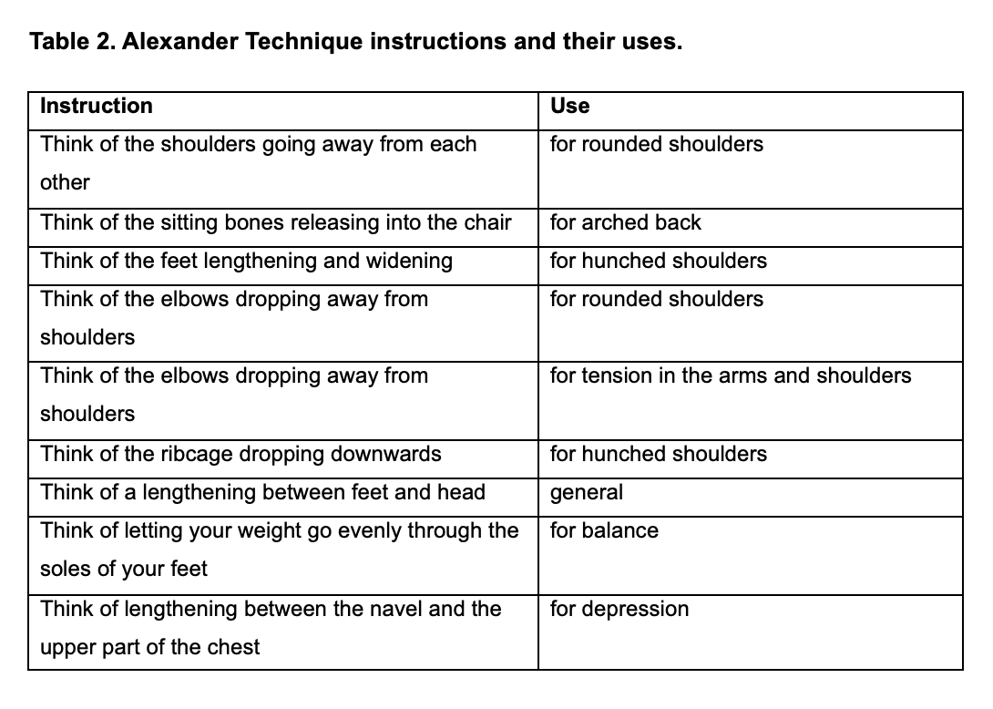
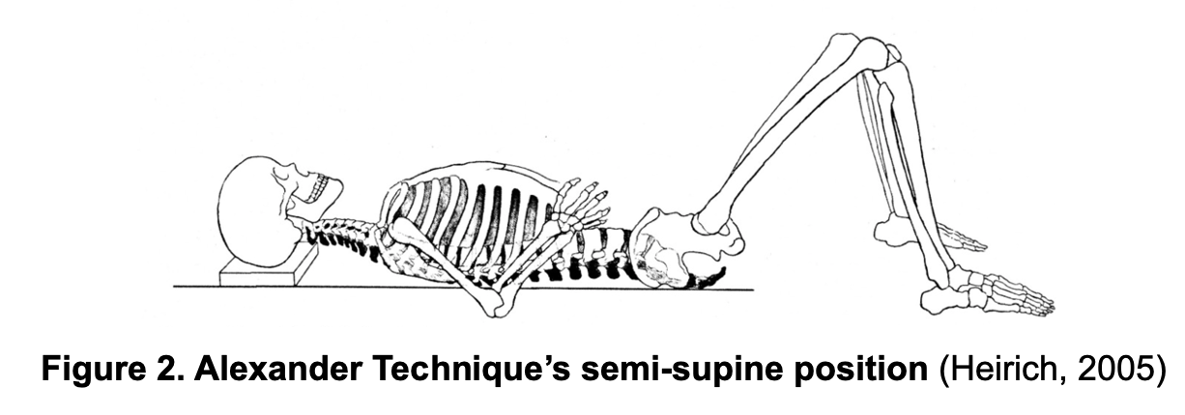
Since I am not a certified AT instructior, I will only be incorporating these instructions at the beginning of my lessons to create an initial awareness in my students. I will also add some mindful breathing in this part to prepare them for singing (Appendix 5). I have decided to use Lindsay Wagstaff’s model of 5 Alexander instructions for singers (Appendix 1). She is an experienced AT and voice teacher and her instructions encompass the most important awareness areas for voice students. I will return to these instructions anytime I need to redirect my student to be more aware of his/her body. Her awareness reminders for singers are also very useful. She states that it is helpful to direct students to ask themselves: 1. Am I balanced? 2. Am I breathing? 3. Am I seeing? I believe these are great for students who might lose some focus during the lesson and need to be reminded to bring awareness to their bodies and breath. I will have them written in my studio so that my students can see them during their lessons.

Demands of singing on the body and voice
The first problem that I identified while conducting my research was that the literature focuses on the Alexander Technique and the speaking voice, not singing. Another difficulty is that the mechanisms involved in singing are much more complex than those involved in speech. Therefore, I had to dig deeper into understanding the demands that singing exerts on a person’s body and how complex of a task it is. I also found that a lot of teachers base their methods on old, non-scientific beliefs about sound production and the body. This led me to research more current literature that incorporates scientific aspects of singing and movement. For this I greatly drew upon what I had learned at the Vocal Anatomy Course from Vocal Health Education as well as Heidi Moss’ course in Applied Neuroscience and Voice and Kerrie Obert’s Vocal Pedagogy course from the Voice Study Center as well as the literature.
Singing and The Brain
Singing is a very complex process, especially because the components of our ‘musical instrument’ are inside us, we cannot manipulate them as we would an external source of sound like a piano. This involves several parts of the brain that work in tandem with one another to be able to produce sound (phonation), pitch, dynamics, rhythm, words and expressiveness all at the same time (Jürgens, 2009; Zarate, 2013) (Figure 3). The areas of the brain that are mostly active during singing are Brocca’s area, Wernicke’s area, the motor strip, the auditory cortex (partially), the Laryngeal Motor Cortex (LMC) and the superior temporal gyrus (STG) (Figure 4) (Moss, 2023).

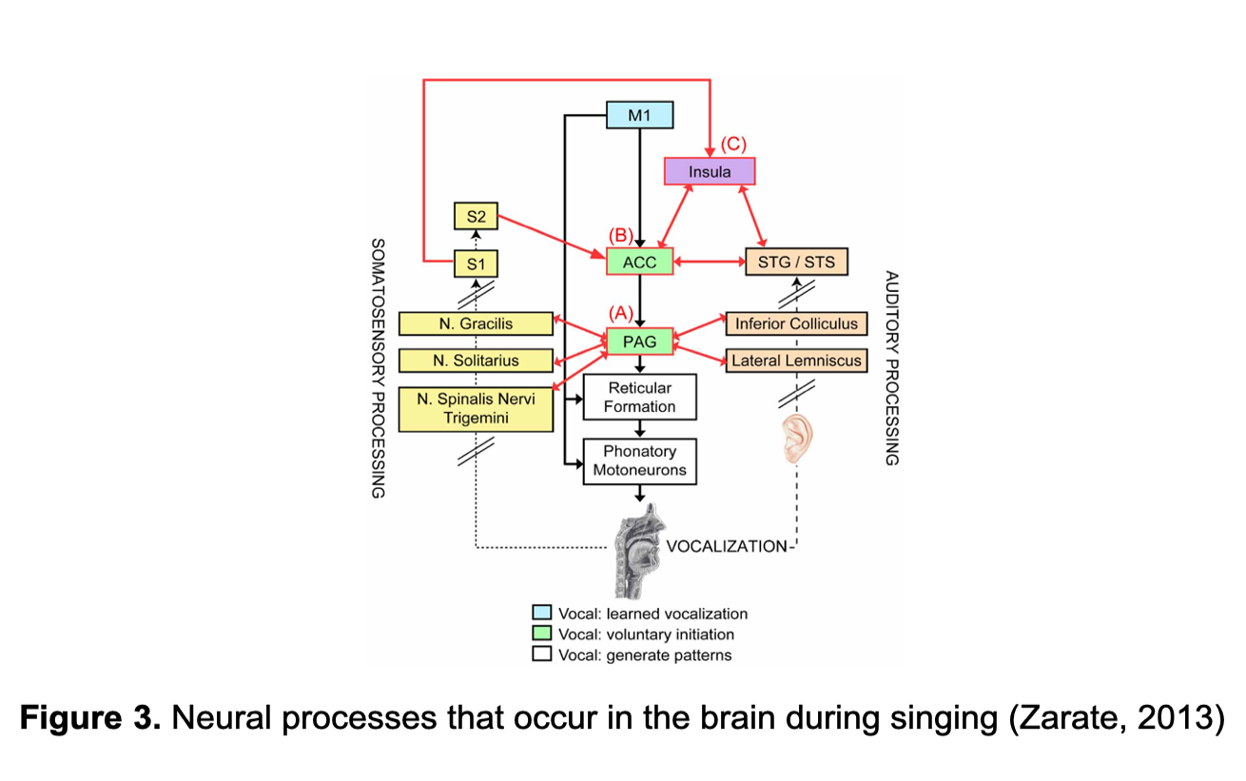
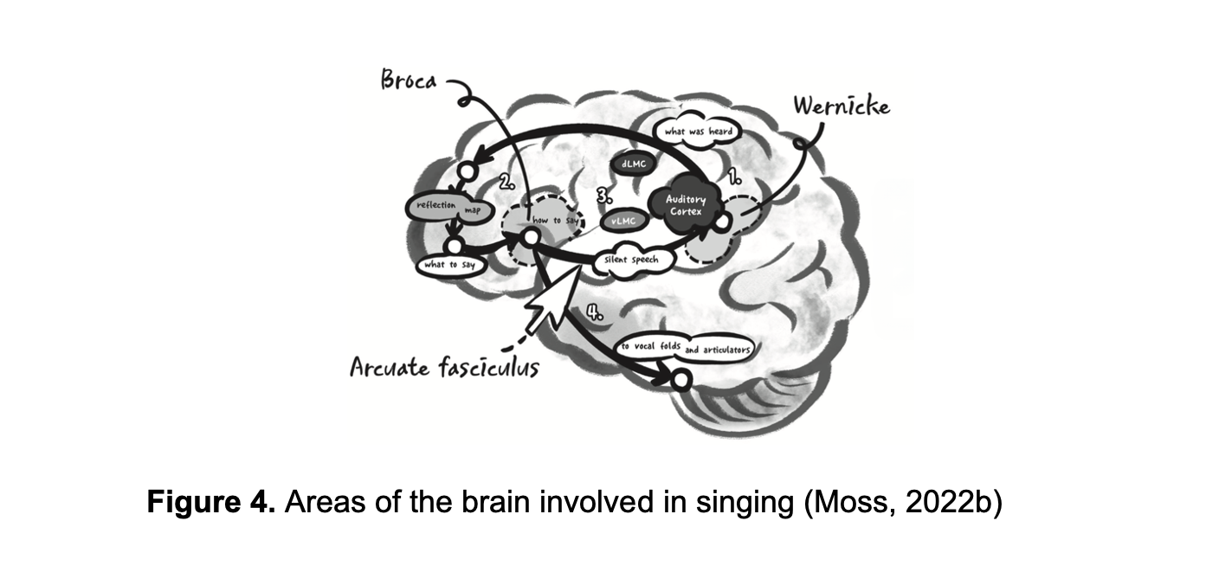
Brocca’s area is involved mainly in language production, retrieving a word’s phonological representation, translating it into an articulatory code and coordinating the fine motor movements of the vocal articulators. Wernicke’s Area is responsible mostly for language comprehension (sounds and meanings) (Jarvis, 2019). In order to sing, we also need to control and feel movements. The motor strip controls the voluntary movements of skeletal muscles; the sensory strip registers sensation connected to specific body parts or functions. The auditory cortex responds to tonality, relative pitch and minute sequential differences in sound. Another important area in voice production is the laryngeal motor cortex (LMC), of which some parts are also involved in auditory pitch related responses (Belyk et al., 2021). The superior temporal gyrus (STG) decodes acoustic-phonetic features of consonants and vowels and dynamic cues for intonational pitch responses (Dichter et al., 2018; Moss, 2023). The involvement of the LMC and STG in auditory responses is due to the fact that the auditory cortex is suppressed during vocalization (Moss, 2023). This last fact is very significant for singers. I’ve always been told by teachers to try to not ‘listen’ to myself while singing. The explanation that I was given was that the acoustics were different and so what we hear is not accurate. The fact that the auditory process is actually suppressed highlights even more the need to be aware of the sensations in our body since we cannot rely on our hearing. Thus, finding strategies to increase body awareness is very important for singers.

The Larynx and Pelvic FLoor
I’ve always been very curious about the relationship between the voice and the pelvic floor. I relate ‘support’ with pelvic floor activation and, while I knew that it worked, I did not understand the physiology of it very clearly. The larynx and pelvic floor have the same origins in embryonic development as well as identical hormone receptors.
The larynx is responsible for changes in pitch and registers (Dimon, 2018). It was my understanding that the different places of resonance (chest/head) made it difficult to maintain a uniform sound and we must train our voice to mix evenly throughout our register. While learning how to ‘mix’ your registers is a good goal to have, I was not aware of the specific muscles that were involved in the process. One of the things that I learned during this research was that the thyroarytenoid (TA) muscle is mostly engaged at lower frequencies and that the only way to reach higher frequencies is by releasing the TA and increasing cricoarytenoid activity. If this happens in an abrupt way, a break or yodel occurs. In order to achieve mixed voice, we need to achieve the skill to control TA and CT engagement in a smooth way (Dimon, 2018). This is very fascinating to me and, while I cannot tell my students to consciously control these muscles, I feel that having them visualize it and think of it in a more conscious way, can help them achieve a smoother register change. This could be done by using mindfulness to visualize the movement of the larynx and feeling the different sensations in their vocal apparatus while singing. They might also get less frustrated if they understand that we are training these muscles and that it takes time and practice to do so. While a lot is known about how different registers are produced, there are some gaps in the scientific knowledge such as exactly how whistle tones are produced (Titze, 2008). There is also very little literature of how certain head or neck positions may influence pitch control and other vocal sound qualities (Scotto DiCarlo, 2002). Using mindfulness and AT poses like the monkey (Appendix 3), can help release the larynx and create a smoother register change.

The Diaphragm
The diaphragm is another essential anatomical component of respiration. We need muscular freedom in order to breathe efficiently (Moss, 2022a). Within my studies, I also learned about the pelvic floor’s relationship to the diaphragm and how they both move in the same direction during respiration, being mirror images of each other. The fact that they attach to the same ribs was also very fascinating (Dimon, 2018). I also realized even more how important it is that they are all coordinated when singing. I think that most people are unaware of these relationships. Posture and everyday habits have interrupted some of these connections and how these muscles and processes coordinate and interact. Being aware of their natural mechanisms can help students work mindfully to re-train their body. This can help them release unwarranted tension and make respiration and phonation more efficient (Appendix 4). While some of these mechanisms and evolutionary origins are well studied, there are still gaps in the knowledge, such as the role of the psoas muscle in voice production (Bartoskova, 2021).

The Jaw and The Tongue

The jaw and tongue are two other areas that my students would often describe as having ‘tension’ in. I have suffered from jaw and experimented with various solutions, including a mouthguard and relaxation techniques (Ingawalé and Goswami, 2009a, 2009b; Bae and Park, 2013). Of these, relaxation has made the most impact on my well-being. I am a Music Therapist and have tried and have had some success with doing some relaxation exercises focused on the jaw before singing. Being aware of the muscles that are involved when the jaw is tight, led me to better understand the directions given me by one of my voice teachers to ‘make space between the back molars’. Finding that back opening is sometimes difficult for students to understand (and for teachers to explain). I believe that aiming to relax the muscles around the TMJ might help singers relax the lower jaw and make space for more resonance. Students that keep the back of the mouth restrained often have difficulty with higher pitches and have a nasal quality in their sound, as there is hardly any resonance in the space at the back (Dimon, 2018; Clukey and Meadows, 2022). Massaging these muscles as part of the stretch routine before singing seems very important to ensure that the whole body is ready. This is something that I will incorporate into my lessons as well (Appendix 5).
I have to admit that I was one of those people who thought of the tongue as mostly being ‘in the way’ but I have changed my way of thinking after learning all the wonderful things that we can do with our voice with the help of the tongue. I was not very conscious of the interconnection between the larynx and the tongue. I hadn’t studied how the muscles of the tongue attached to the epiglottis and how that changes the shape and position of the larynx (Dimon, 2018). I find it odd that that fact is not so commonly known by singers or taught by singing teachers. This is especially important since it directly influences pitch control. The fact that was most surprising to me was that we can independently control regions of the tongue that can be used to shape voice quality by changing the relative strength of the harmonics to create a variety of sounds and timbre changes (Obert, 2022). I believe that focusing on mindfully controlling the movement of the tongue can be a great way of helping a student who has trouble with pitch. Something that I’m adding to my classes is taking a few minutes as part of our body stretch to stretch out the tongue and be aware of how it feels in the mouth (Appendix 5). I think the fact that it is the most flexible structure in the vocal tract should be emphasized more and given more teaching attention. I am moving past my old belief that the tongue must always remain low when singing (Dimon, 2018) and I will experiment more with tongue positions and movements when warming-up the voice so that the student can become aware of the changes in pitch and timbre that it can provoke. I am very interested in this subject so I will keep studying it and trying out different approaches to the problems that my students (or I) encounter. The tongue is a fascinating organ and I believe that being more aware of its effect on the voice can make singers feel more in control of their instrument and create beautiful and varied sounds.

The Monkey in Alexander Technique
One of Alexander’s postures is what is referred to as the ‘monkey’. The monkey is a natural human position in which all the parts are in dynamic balance. It is also known as a position of mechanical advantage, as it is an efficient mechanical position for performing any task. The monkey is not a fixed position, but is part of basic human moving patterns. There are different degrees of “deepness” for this posture (Appendix1). Alexander used it extensively as a way of “organizing” or aligning his student’s body in a natural and effective manner (Heirich, 2005; de Veer, 2009).
The monkey pose is great for achieving the necessary relaxation to sing adequately and without restrictions. In general, this posture is ideal for aligning the column, which is directly linked to the skull and the sound-producing structures in our body. When the upper vertebrae (just behind the larynx) are not aligned correctly, they create tension in the structures that are connected to it, which includes the larynx and the jaw (Appendix 1). The same thing happens with the lower vertebrae, which are connected to the ribs and have a direct effect on breathing (Heirich, 2005). The Monkey Position helps release the ribcage, lungs, diaphragm, larynx, and jaw, which are the main components of the vocal apparatus (Heirich, 2005). It is extremely helpful, and it serves to re-educate our body as to how to emit sound in a natural, easy, and healthy way. My students have reported easier breathing, less neck and jaw tension and a freer voice that helps them achieve more extreme notes in their ranges. After singing in this position, I often instruct them to start coming out of the position gradually (Appendix 5). This helps them keep the balance they achieve while singing in the more natural standing position. Movement has also been proven to be very beneficial in vocal learning, so moving from one posture to another (Moss, 2022b) can also help the student.

Conclusion
I started my study with a hypothesis that posture and awareness were important in singing and that using mindfulness and the Alexander Technique aids with both. As I went through my research, I encountered some problems and found many gaps in my knowledge. Throughout this process I managed to fill most of those gaps but am aware that I still have a lot to learn and experience. While I am not an Alexander Technique instructor, I have taken enough lessons to feel confident enough to use some of these positions with my students. I suggest that voice teachers experiment with these techniques themselves and decide if this is something that they want to employ in their studios. However, there are some ethical implications as the Alexander Technique often requires the instructor to direct the student by touching. This might be something that the student and/or teacher might not be comfortable with. Also, if the teacher is not a Certified Alexander Technique instructor, it is not advised that he or she intervenes in such an active way. This is why I only recommend verbal instructions and modeling. I also suggest facilitating a workshop with an AT instructor as well as private AT lessons for the teacher looking to use this in their studio. Further studies are needed to assess the full effects of the Alexander Technique in singers as there is a great gap in the literature (Kinsey, Glover and Wadephul, 2021).
In the future, I would like to measure parameters of voice quality and student’s perception quantitatively and qualitatively. This will help inform the efficacy of using the Alexander Technique in voice lessons and encourage voice teachers to try this and other methods of body awareness. After completing my research, analysis, and reflection, I have devised a strategy for using these techniques in the voice studio (Appendix 3). I hope to use it consistently with my students and use them as the framework for an experimental research study. This will test my hypothesis and give me a clear idea of how my hypothesis will work in real life. I hope to be able to test it and be able to draw some new conclusions and contribute to the scientific and holistic approach to vocal pedagogy.

Appendices:

Appendix 1: Common misalignments and their effect in the voice
- Forward Head Posture (Kyphosis / FHP)
- Definition: the structural forward positioning of the head away from the centerline of the body, where lower cervical vertebrae are bent and upper cervical vertebrae are extended, and the weight of the head supported by the neck is increased (Kim and Kim, 2016)

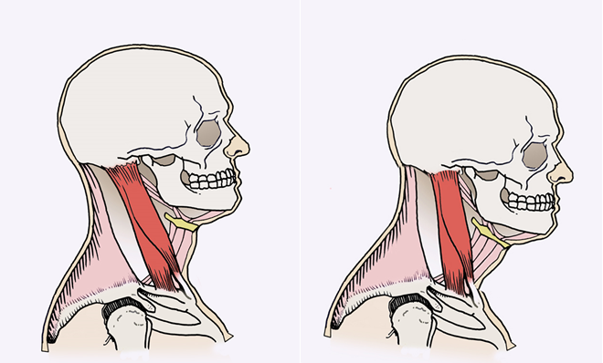
Figure 1. Aligned neck and head (left) and forward head posture (right) (Fitzgordon, 2024)
- Effects on the body
    - negative effect on respiration by inducing a weakening of the accessory muscles and a decline of thoracic mobility (Jintae et al., 2016).
    - weakens and shortens muscles in the neck that lead to laryngeal elevation, narrowing of the pharynx and changes in the shape of the vocal tract (Jintae et al., 2016; Kim and Kim, 2016).
    - weakens and shortens muscles in the neck that lead to laryngeal elevation, narrowing of the pharynx and changes in the shape of the vocal tract (Jintae et al., 2016; Kim and Kim, 2016)
- Consequences on the voice
    - decrease in muscle efficiency, changes in resonance and possible difficulties in pitch elevation (Kennard et al., 2015).
- Rounded Shoulders
- Definition: Individuals who maintain their shoulders in a rounded forward position (Wilson Arboleda and Frederick, 2008)
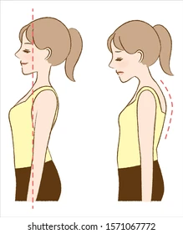

Figure 2. Runded shoulders (Stock Image)
b. Effects on the body
    - tightness of pectoral and abdominal muscles as well as weakening of the scapular muscles (Wilson Arboleda and Frederick, 2008a).
    - shortens intercostal and pectoral muscles, hindering respiration (Wilson Arboleda and Frederick, 2008).
c. Consequences on the voice
i. decrease in respiratory function and an increase in vocal fatigue (Wilson Arboleda and Frederick, 2008a).

3. Sway back posture
- Definition: anterior translation of the pelvis and hip joints, beyond the center gravity line, a flatted curve in the lumbar region and overextended hip and knee joints (Mahdavie, Rezasoltani and Simorgh, 2017).
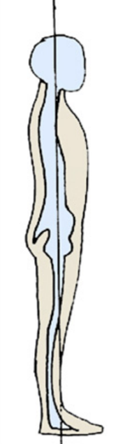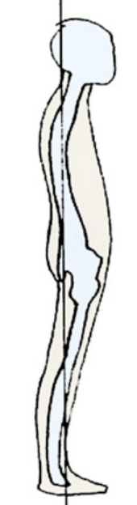
Figure 1. Balanced posture (left) and sway back posture (right) (Wilson Arboleda and Frederick, 2008)
- Effects on the body
    - decreases the activity of lumbar and pelvic floor muscles shortens intercostal and pectoral muscles (O’Sullivan et al., 2006)
    - increases the activity of some abdominal muscles (O’Sullivan et al., 2006)
    - reduces the diameter of the thorax (O’Sullivan et al., 2006)
c. Consequences on the voice
i. hinders respiration (Staes et al., 2011)
ii. decreases voice support (Staes et al., 2011)

Appendix 2: Alexander Technique instructions for voice students (Walgstaff)

- Let my neck be free in such a way that my
- Head can go forward and up
- Allowing my back to lengthen and widen,
- My shoulders to move apart,
- And my knees to go forward and away

Appendix 3. Depthness of the Monkey Position
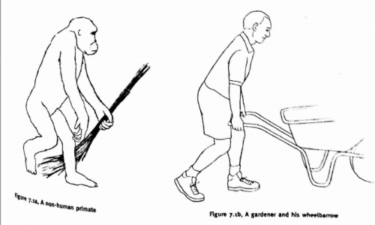
Figure 1. The ‘monkey’ of the Alexander Technique (Heirich, 2005)

- Shallow Monkey: 2. Moderate monkey:
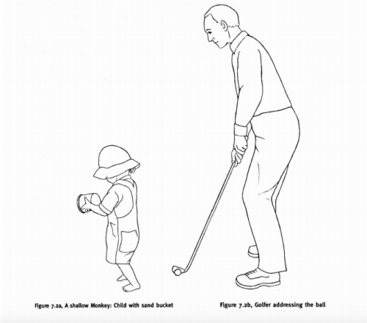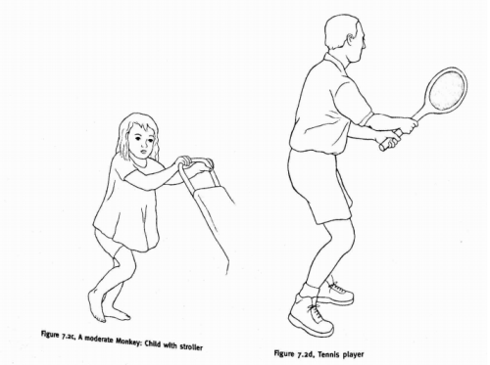
3. Deep monkey: 4. Deeper monkey:
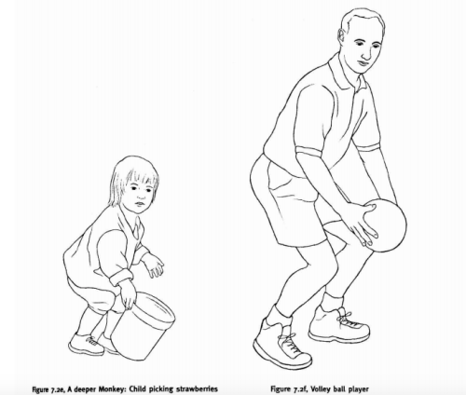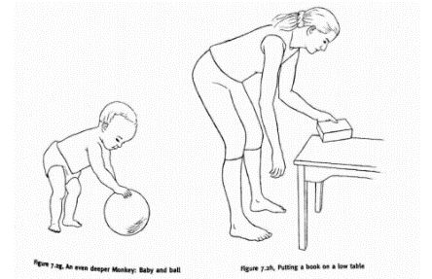
Figure 2. Degrees of deepness in the monkey position (Heirich, 2005)

Appendix 4. Effects of the Monkey Position on the Vocal Apparatus

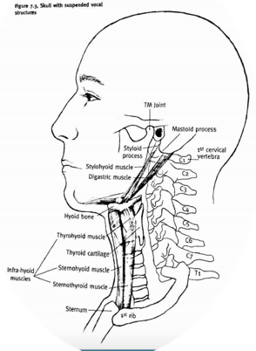
Figure 1. Relationship of the vertebrae to the vocal apparatus (Heirich, 2005).

- Respiration:
The monkey frees the rib cage from all tension so the ribs, intercostal muscles, lungs and diaphragm move in a more natural, non-restricted way, aided by the force of gravity (Figure3). Once we get used to singing in this position in which breathing is easier and is not forced, breathing in other positions will be freer and more efficient (Heirich, 2005; de Veer, 2009).

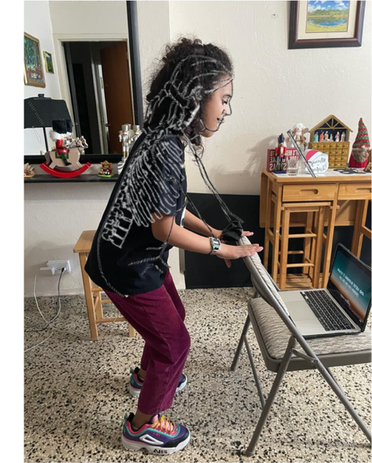
Figure 4. Student in the monkey position while singing. Superimposed is a drawing from Heirich (2005) showing the position.

- Jaw
One of the things singers should be very aware of is maintaining a relaxed jaw. If the muscles in the jaw are tense we create tension in the other structures related to sound production. Also, if we clench the jaw we can’t create the necessary space for air to flow freely. We should let the lower jaw drop in order to obtain free movement when singing and the monkey helps the jaw hang freely from the base of the skull (if we allow it and don’t pull it forward) (Heirich, 2005).

3. Larynx
The larynx, where the vocal cords reside, have a tendency to tense and go up (especially in the higher pitches), limiting the space available for the air to flow freely, producing a small and tight sound. Lowering the larynx in a forceful and excessive manner can also create tension and damage the vocal health and quality of the singer. When singing in this pose, the larynx hangs naturally (aided by gravity), which facilitates sound production (Figure 4) (Heirich, 2005).
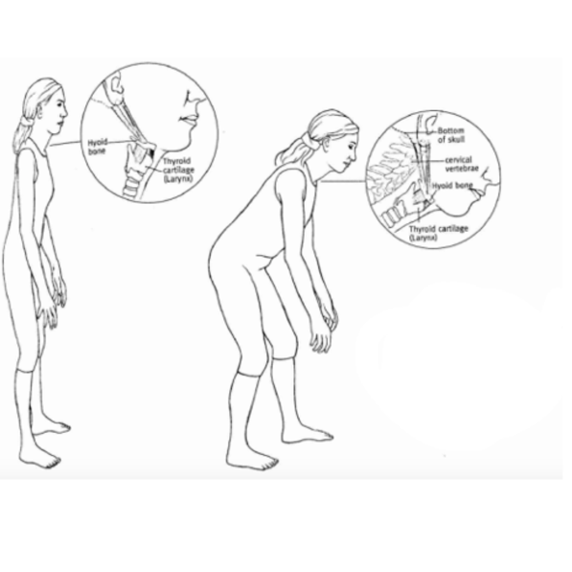
Figure 5. Larynx hanging from hyoid bone in shallow (left) and deep (right) monkey position (Heirich, 2005).

Appendix 5. Suggestions for strategy in the voice studio

- Preparing your body and mind
  - Start by stretching the legs, back, shoulders and neck with some movements of your choice that are suited to the student’s capabilities.
  - Give a gentle massage to your face and stretch your tongue.
  - Have the student acquire a comfortable position. This can be standing, sitting or in Alexander’s semi-supine position.
  - Read Alexander’s 5 directions to the student in a slow and relaxed voice.
  - Do some guided breathing exercises. Doing them in Alexander’s semi-supine position can give extra sensory feedback to the student as they feel their back pushing the ground and are better aware of any neck movements.
- Preparing your voice
  - Start doing some light vocalizations in the monkey position. Be aware of how it feels: what muscles are engaged, where tensions begin to arise, how the voice feels.
  - Play with alternating between monkey and upright position until you feel that you can maintain the same relationship and freedom standing up.
- During the lesson
  - Always be aware of your body, respiration, and sensations in your vocal apparatus. The teacher must be very observant as well.
  - Go back to any of the previously discussed exercises if at any moment you feel disconnected from your body or mind; or if you encounter some difficulty in your voice.

Appendix 6. Personal Development Plan (PDP)
Goal | Aim | Expected outcome | Actions | Timeline
Complete Vocal Rehabilitation Specialist (VRS) Certification | Be able to evaluate and rehabilitate clients with voice disorders | Increase skills and clients | 1. Summer in UK to complete 3 courses  2. Complete online courses (3)  3. Complete practice | May 2026
Redact ethical guidelines for music therapists in Puerto Rico | Have guidelines for Puertorican Music Therapists that are comparable to those of other countries | Have a reference point with which to guide my practice and other music therapists in Puerto Rico | 1. Research ethical guidelines for music therapists in other countries  2. What applies in Puerto Rico?  3. Research ethical guidelines for other therapists in Puerto Rico | May 2024
Redact ethical guidelines for my practice as a voice teacher, Music Therapist and Vocal Habilitation Professional | Have clear guidelines for my practice | Be able to guide myself in my practice and future research in preparation for Module 3 | Research ethical guidelines for each specialization | May 2024
Redact ethical guidelines for my practice as a VRS | Have guideline in place for when I finish my certification | Be able to guide myself in my practice and future research | Complete courses and research ethical guidelines | July 2026
Increase media presence | Reach more people | Increase passive income | 1. Learn how to use whatsapp business  2. Learn about TikTok and Youtube videos and courses  3. Finish my website  4. Start making videos | August 2024
Increase my student’s understanding of the Alexander Technique | Have all students start at the same level of knowledge before doing my study | Have a good baseline for my studies | Coordinate a workshop with a certified AT teacher for my students | December 2024
References

Alexander, F.M. (1932) The Use of the Self.
Bae, Y. and Park, Y. (2013) ‘The Effect of Relaxation Exercises for the Masticator Muscles on Temporomandibular Joint Dysfunction (TMD)’, Journal of Physical Therapy Science, 25(5), pp. 583–586.
Baer, R.A., Carmody, J. and Hunsinger, M. (2012) ‘Weekly Change in Mindfulness and Perceived Stress in a Mindfulness-Based Stress Reduction Program’, Journal of Clinical Psychology, 68(7), pp. 755–765. Available at: https://doi.org/10.1002/jclp.21865.
Bartoskova, M. (2021) ‘The Role of the Psoas Major Muscle in Speaking and Singing’, Voice and Speech Review, 15(2), pp. 200–210. Available at: https://doi.org/10.1080/23268263.2021.1891738.
Becker, J.J. et al. (2021) ‘Alexander technique vs. Targeted exercise for neck pain—a preliminary comparison’, Applied Sciences (Switzerland), 11(10). Available at: https://doi.org/10.3390/app11104640.
Belyk, M. et al. (2021) ‘Human larynx motor cortices coordinate respiration for vocal-motor control’, NeuroImage, 239. Available at: https://doi.org/10.1016/j.neuroimage.2021.118326.
Bosanquet, R.C. (1987) ‘The Alexander Principle and its Importance to Music Education’, British Journal of Music Education, 4(3), pp. 229–242. Available at: https://doi.org/10.1017/S0265051700006069.
Brennan, R. (2016) Alexander Technique : An Introductory Guide to Natural Poise for Health and Well-Being. La Vergne, UNITED STATES: Pavilion Books. Available at: http://ebookcentral.proquest.com/lib/trinity/detail.action?docID=5525297.
Brown, O. (1996) Discover Your Voice: How to Develop Healthy Voice Habits.
Bunch Dayme, M. (2005) The Performer’s Voice: Realizing Your Vocal Potential.
Cacciatore, T.W., Johnson, P.M. and Cohen, R.G. (2020) ‘Potential mechanisms of the alexander technique: Toward a comprehensive neurophysiological model’, Kinesiology Review, 9(3), pp. 199–213. Available at: https://doi.org/10.1123/KR.2020-0026.
Cardoso, R., Lumini-Oliveira, J. and Meneses, R.F. (2019) ‘Associations between Posture, Voice, and Dysphonia: A Systematic Review’, Journal of Voice. Mosby Inc., pp. 124.e1-124.e12. Available at: https://doi.org/10.1016/j.jvoice.2017.08.030.
Chapman, J.L. (2005) Singing and Teaching Singing : A Holistic Approach to Classical Voice.
Christy, V.A. (1967) Expressive Singing: A Textbook for School Or Studio Class Or Private Teaching.
Clukey, J.L. and Meadows, A. (2022) A Voice Teacher’s Guide to Temporomandibular Disorders, ProQuest Dissertations and Theses. Available at: https://www.proquest.com/dissertations-theses/voice-teachers-guide-temporomandibular-disorders/docview/2669104471/se-2?accountid=130472.
Cotik, T. (2019) ‘Concepts of the Alexander Technique and Practical Ideas for Musicians’, American String Teacher, 69(2), pp. 33–36. Available at: https://doi.org/10.1177/0003131319835543.
Czajkowski, A. and Greasley, A. (2016) ‘Mindfulness for Singers: The effects of a targeted mindfulness course on learning vocal techniques’, British Journal of Music Education, 33(3), p. 347. Available at: https://doi.org/10.1017/S0265051716000097.
Czajkowski, A.M.L., Greasley, A.E. and Allis, M. (2021) ‘Mindfulness for Singers: A Mixed Methods Replication Study’, Music and Science, 4. Available at: https://doi.org/10.1177/20592043211044816.
Davies, J. (2020) ‘Alexander Technique classes improve pain and performance factors in tertiary music students’, Journal of Bodywork and Movement Therapies, 24(1), pp. 1–7. Available at: https://doi.org/10.1016/j.jbmt.2019.04.006.
Dewey, J. (1933) How We Think. Chicago: Henry Regnery Co.
Dichter, B.K. et al. (2018) ‘The Control of Vocal Pitch in Human Laryngeal Motor Cortex’, Cell, 174(1), pp. 21-31.e9. Available at: https://doi.org/10.1016/j.cell.2018.05.016.
Dimon, T. (2018) Anatomy of the Voice : An Illustrated Guide for Singers, Vocal Coaches, and Speech Therapists. Berkeley, California: North Atlantic Books. Available at: https://ezproxy.uwtsd.ac.uk/login?url=https://search.ebscohost.com/login.aspx?direct=true&db=nlebk&AN=1571344&site=ehost-live.
Doscher, B. (1994) The Functional Unity of the Singing Voice.
Dunning, D.L. et al. (2019) ‘Research Review: The effects of mindfulness-based interventions on cognition and mental health in children and adolescents – a meta-analysis of randomized controlled trials’, Journal of Child Psychology and Psychiatry and Allied Disciplines. Blackwell Publishing Ltd, pp. 244–258. Available at: https://doi.org/10.1111/jcpp.12980.
Elliot, M. (2010) ‘Mindfulness and Singing’, Journal of Singing, 67(1), pp. 35–40.
Essex, H. et al. (2017) ‘An economic evaluation of Alexander Technique lessons or acupuncture sessions for patients with chronic neck pain: A randomized trial (ATLAS)’, PLoS ONE, 12(12). Available at: https://doi.org/10.1371/journal.pone.0178918.
Fitzgordon, J. (2024) https://www.corewalking.com/the-pelvis-and-forward-head-posture-2/.
Fjorback, L.O. et al. (2011) ‘Mindfulness-based stress reduction and mindfulness-based cognitive therapy - a systematic review of randomized controlled trials’, Acta Psychiatrica Scandinavica, pp. 102–119. Available at: https://doi.org/10.1111/j.1600-0447.2011.01704.x.
Franco, D. et al. (2014) ‘Is the sagittal postural alignment different in normal and dysphonic adult speakers?’, Journal of Voice, 28(4), pp. 523.e1-523.e8. Available at: https://doi.org/10.1016/j.jvoice.2014.01.002.
García, M. (1847) Tratado completo del arte del canto (Ed.).
Gibbs, G. (1988) Learning by Doing: a guide to teaching and learning methods. London: FEU.
Hébert, C. (2015) ‘Knowing and/or experiencing: a critical examination of the reflective models of John Dewey and Donald Schön’, Reflective Practice, 16(3), pp. 361–371. Available at: https://doi.org/10.1080/14623943.2015.1023281.
Heirich, J. (2005) Voice and the Alexander Technique.
Hodges, P.W., Sapsford, R. and Pengel, L.H.M. (2007) ‘Postural and respiratory functions of the pelvic floor muscles’, Neurourology and Urodynamics, 26(3), pp. 362–371. Available at: https://doi.org/https://doi.org/10.1002/nau.20232.
Ingawalé, S. and Goswami, T. (2009a) ‘Temporomandibular joint: Disorders, treatments, and biomechanics’, Annals of Biomedical Engineering, 37(5), pp. 976–996. Available at: https://doi.org/10.1007/s10439-009-9659-4.
Ingawalé, S. and Goswami, T. (2009b) ‘Temporomandibular joint: Disorders, treatments, and biomechanics’, Annals of Biomedical Engineering, 37(5), pp. 976–996. Available at: https://doi.org/10.1007/s10439-009-9659-4.
Jain, S., Janssen, K. and DeCelle, S. (2004a) ‘Alexander technique and Feldenkrais method: A critical overview’, Physical medicine and rehabilitation clinics of North America, 15, pp. 811–825, vi. Available at: https://doi.org/10.1016/j.pmr.2004.04.005.
Jain, S., Janssen, K. and DeCelle, S. (2004b) ‘Alexander technique and Feldenkrais method: A critical overview’, Physical Medicine and Rehabilitation Clinics of North America, 15(4), pp. 811–825. Available at: https://doi.org/10.1016/j.pmr.2004.04.005.
Jarvis, E.D. (2019) ‘Evolution of vocal learning and spoken language’, Science, 366, pp. 50–54. Available at: http://science.sciencemag.org/.
Jintae, H. et al. (2016) ‘Effects of forward head posture on forced vital capacity and respiratory muscles activity’, The Journal of Physical Therapy Science, 28, pp. 128–131.
Johnson, G. and Skinner, M. (2009) ‘The demands of professional opera singing on cranio-cervical posture’, European Spine Journal, 18(4), pp. 562–569. Available at: https://doi.org/10.1007/s00586-009-0884-1.
Jürgens, U. (2009) ‘The Neural Control of Vocalization in Mammals: A Review’, Journal of Voice, pp. 1–10. Available at: https://doi.org/10.1016/j.jvoice.2007.07.005.
Kennard, E.J. et al. (2015) ‘A Preliminary Comparison of Laryngeal Manipulation and Postural Treatment on Voice Quality in a Prospective Randomized Crossover Study’, Journal of Voice, 29(6), pp. 751–754. Available at: https://doi.org/10.1016/j.jvoice.2014.09.026.
Kim, E.-K. and Kim, J.S. (2016) ‘Correlation between rounded shoulder posture, neck disability indices, and degree of forward head posture’, The Journal of Physical Therapy Science, 28, pp. 2929–2932.
Kinsey, D., Glover, L. and Wadephul, F. (2021) ‘How does the Alexander Technique lead to psychological and non-physical outcomes? A realist review’, European Journal of Integrative Medicine. Elsevier GmbH. Available at: https://doi.org/10.1016/j.eujim.2021.101371.
Lauche, R. et al. (2016) ‘Efficacy of the Alexander Technique in treating chronic non-specific neck pain: A randomized controlled trial’, Clinical Rehabilitation, 30(3), pp. 247–258. Available at: https://doi.org/10.1177/0269215515578699.
Little, P. et al. (2008) ‘Randomised controlled trial of Alexander technique lessons, exercise, and massage (ATEAM) for chronic and recurrent back pain’, BMJ, 337(7667), pp. 438–441. Available at: https://doi.org/10.1136/bmj.a884.
MacPherson, H. et al. (2013) ‘Alexander Technique Lessons, Acupuncture Sessions or usual care for patients with chronic neck pain (ATLAS): Study protocol for a randomised controlled trial’, Trials, 14(1). Available at: https://doi.org/10.1186/1745-6215-14-209.
Mahdavie, E., Rezasoltani, A. and Simorgh, L. (2017) ‘The Comparison of the Lumbar Multifidus Muscles Function Between Gymnastic Athletes With Sway-Back Posture and Normal Posture’, International journal of sports physical therapy, 12(4), pp. 607–615.
Mayers, H. and Babits, L. (1987) ‘A Balanced Approach: The Alexander Technique’, Music Educators Journal, 74(3), pp. 51–54. Available at: https://doi.org/10.2307/3397943.
McClean, S., Brilleman, S. and Wye, L. (2015) ‘What is the perceived impact of Alexander technique lessons on health status, costs and pain management in the real life setting of an English hospital? the results of a mixed methods evaluation of an Alexander technique service for those with chronic back pain’, BMC Health Services Research, 15(1). Available at: https://doi.org/10.1186/s12913-015-0966-1.
McKinney, J.C. (1994) The Diagnosis and Correction of Vocal Faults A Manual for Teachers of Singing and for Choir Directors.
Miller, R. (1986) Structure of singing.
Mirabito, G. and Verhaeghen, P. (2023) ‘The Effects of Mindfulness Interventions on Older Adults’ Cognition: A Meta-Analysis’, Journals of Gerontology - Series B Psychological Sciences and Social Sciences. Gerontological Society of America, pp. 394–408. Available at: https://doi.org/10.1093/geronb/gbac143.
Mora Álvarez, M.G. et al. (2023) ‘Effects of web-based mindfulness training on psychological outcomes, attention, and neuroplasticity’, Scientific Reports, 13(1). Available at: https://doi.org/10.1038/s41598-023-48706-0.
Moss, H. (2022a) ‘A Copernican Shift: Reframing How We Think About Breath in Singing’, Journal of Singing, 79(2), pp. 233–242. Available at: https://doi.org/10.53830/iwvk1586.
Moss, H. (2022b) ‘Vocal Learning and Songbirds: An Evolutionary Tale of Singing’, Journal of Singing, 79(1), pp. 87–94. Available at: https://doi.org/10.53830/xhji5745.
Moss, H. (2023) ‘What Garcia Got Right: Understanding Cortical Signaling of the Glottis’, Journal of Singing, 79(3), pp. 379–385.
Nair, G. (2007) The Craft of Singing.
Neely, D.W. (2016) ‘Body Consciousness and Singers: Do Voice Teachers Use Mind-Body Methods with Students and in Their Own Practice?’, Journal of Singing, 73(2), pp. 137–147.
Obert, K. (2022) ‘A Tonguecentric Conversation About This Important Structure’, Voice Study Center [Preprint].
Ornoy, E. and Cohen, S. (2021) ‘The effect of mindfulness meditation on the vocal proficiencies of music education students’, Psychology of Music [Preprint]. Available at: https://doi.org/10.1177/03057356211062262.
O’Sullivan, P. et al. (2006) ‘Lumbopelvic Kinematics and Trunk Muscle Activity During Sitting on Stable and Unstable Surfaces’, J Orthop Sports Phys Ther, 36, pp. 19–25. Available at: www.jospt.org.
Paparo, S.A. (2022) ‘Singing with awareness: A phenomenology of singers’ experience with the Feldenkrais Method’, Research Studies in Music Education, 44(3), pp. 541–553. Available at: https://doi.org/10.1177/1321103X211020642.
Peterson, P.H. (2008) ‘ON THE VOICE: Alexander Or Feldenkrais: Which Method Is Best? ’, Choral Journal, pp. 67–72.
Roth, D.F. and Verdolini Abbott, K. (2014) ‘Vocal Health and Singing Pedagogy: Considerations from Biology and Motor Learning’, in S.D. Harrison and J. O’Bryan (eds) Teaching Singing in the 21st Century. Dordrecht: Springer Netherlands, pp. 69–89. Available at: https://doi.org/10.1007/978-94-017-8851-9_6.
Scotto DiCarlo, N. (2002) ‘X-Ray Study of a Professional Soprano’s Postural Strategy for Increasing Laryngeal Mobility’, Folia Phoniatrica et Logopedia, 54, pp. 165–170.
Staes, F.F. et al. (2011) ‘Physical therapy as a means to optimize posture and voice parameters in student classical singers: A case report’, Journal of Voice, 25(3). Available at: https://doi.org/10.1016/j.jvoice.2009.10.012.
Tan, D., Diaz, F.M. and Miksza, P. (2020) ‘Expressing emotion through vocal performance: Acoustic cues and the effects of a mindfulness induction’, Psychology of Music, 48(4), pp. 495–512. Available at: https://doi.org/10.1177/0305735618809873.
Titze, I. (2008) ‘A hypothesis about whistle voice’, Journal of Singing, 64(4), pp. 473–475.
de Veer, C. (2009) ‘Peer Reviewed Article The Alexander Technique: Rehearsal Tools For Releasing the Actor’s Voice’, Voice and Speech Review, 6(1), pp. 31–37. Available at: https://doi.org/10.1080/23268263.2009.10761502.
Vennard, W. (1967) Singing: The Mechanism and the Technique.
Wilson Arboleda, B.M. and Frederick, A.L. (2008) ‘Considerations for Maintenance of Postural Alignment for Voice Production’, Journal of Voice, 22(1), pp. 90–99. Available at: https://doi.org/10.1016/j.jvoice.2006.08.001.
Woods, C., Glover, L. and Woodman, J. (2020) ‘An Education for Life: The Process of Learning the Alexander Technique’, Kinesiology Review, 9(3), pp. 190–198. Available at: https://doi.org/10.1123/kr.2020-0020.
Ying, L.F. et al. (2015) ‘Tension Release in Piano Playing: Teaching Alexander Technique to Undergraduate Piano Majors’, Procedia - Social and Behavioral Sciences, 174, pp. 2413–2417. Available at: https://doi.org/10.1016/J.SBSPRO.2015.01.910.
Yu, J. et al. (2021) ‘Mindfulness intervention for mild cognitive impairment led to attention-related improvements and neuroplastic changes: Results from a 9-month randomized control trial’, Journal of Psychiatric Research, 135, pp. 203–211. Available at: https://doi.org/10.1016/j.jpsychires.2021.01.032.
Zarate, J.M. (2013) ‘The neural control of singing’, Frontiers in Human Neuroscience [Preprint], (JUN). Available at: https://doi.org/10.3389/fnhum.2013.00237.

