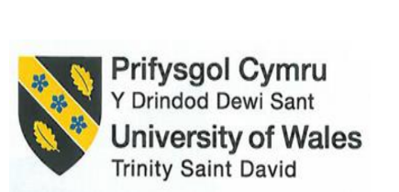

BMIH5005
Personnel Resourcing and Development
Title: Discuss how the evolution of HRM facilitates the strategic development of an international hotel brand through workforce planning, recruitment and selection.
Student name: | Valentina Matei | Student ID number: | 2221642
Programme: | BA (Hons) International Hotel Management
Module: | Personnel Resourcing and Development
Module code: | BMIH5005 | Contribution to Overall Module Assessment (%): | 50
Lecturer: | Helen Lee | Internal Verifier: | Kathryn Roberts
Assignment Title: | Essay: Discuss how the  evolution of HRM | Word count (or equivalent):
 | facilitates the strategic
 | development of an
 | international hotel brand
 | through workforce
 | planning, recruitment and
 | selection.
Submission deadline: | Monday 5th February 2024 by 23.59 | Return date of provisional marks | 4th March 2024
 | Assessment drop ins WC 29th | & written feedback:
 | January 2024

Introduction
An organisation's success depends on its Human Resource Management (HRM). HRM tasks include planning the workforce, hiring people, and choosing the best ones. Organisations can reach their objectives by strategically assigning their employees through workforce planning (Wayne, 2020). Picking and hiring the best people is what recruitment and selection are all about. It's been a long time since HRM (Human Resource Management) was created. How well an international hotel brand handles these changes will determine whether it succeeds or fails.
The strategic importance of human resource management is looked at in the 138 countries and territories where Marriott International has hotels. How good HR practices have helped an international hotel brand stay successful will require us to look at how HRM has changed over time and how that has affected planning the workforce, hiring people, and picking them. Learning about HRM can help a business grow in a planned way by looking at Marriott International. A 92% rating meant that companies care about their workers.
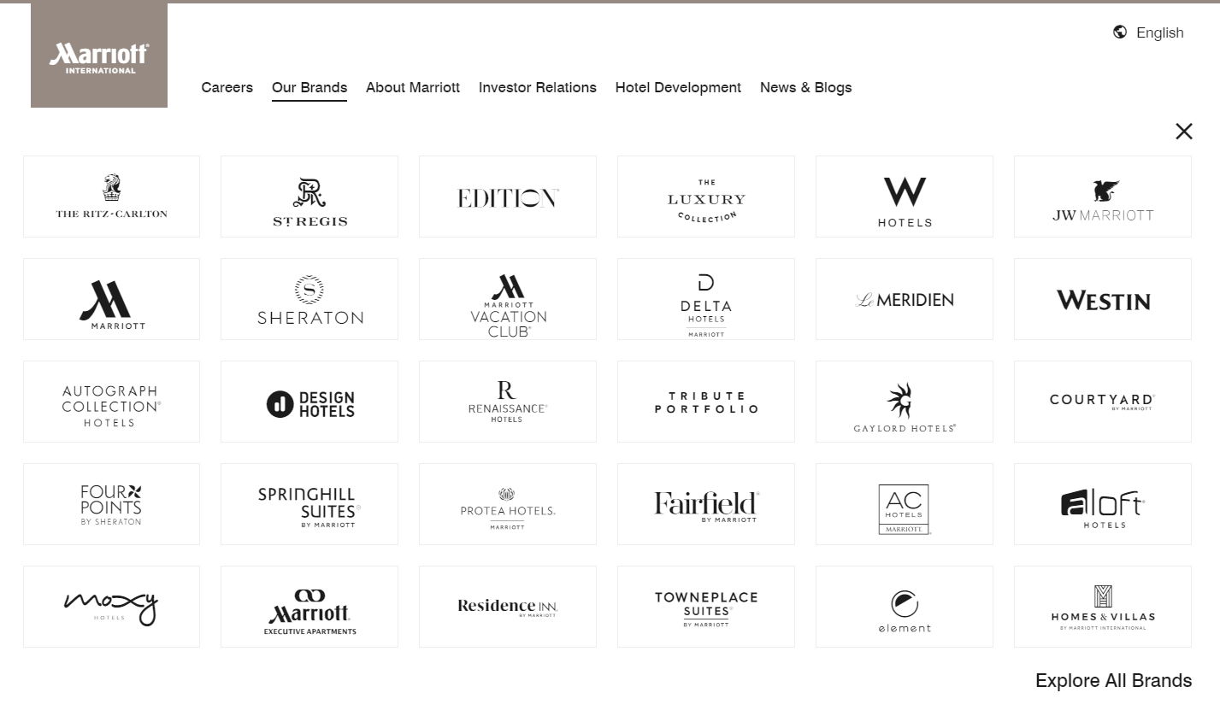
Figure 01: Brands of Marriott International
Source: (Marriott International, 2023)

Evolution of HRM
The field of Human Resource Management has been changed by history, business needs, and social trends. Before the industrial revolution, human resource management (HRM) was mostly about paying workers and making sure they did what they were supposed to do. Business roles in this field have grown.
In the late 20th century, worker laws made human resources management look a lot like personnel management (Dunlop and Galenson, 2021). The most important things were keeping track of employee information and following the rules at work. When businesses understood how crucial their workers were to their overall success, Human Resource Management (HRM) grew.
At the end of the 20th century, people began to think about strategic management of human resources (Hamilton, 2021). HRM helps businesses plan and decide what to do. Now HRM is in charge of managing employees, helping businesses grow, and making sure that business plans are in line with human capital.
There were many things that led to the growth of HRM. Companies like Marriott International have had to change their human resource management (HRM) to work with workers from all over the world and follow the complicated rules of international labour law because of globalisation. HR has changed because of tools that make it easier to hire people, keep track of their work, and get them involved (Bhattacharyya, 2022).
The focus of HRM has shifted to the worker as their health and happiness have grown in importance. Having a nice place to work is important for modern HR management, as the fact that 92% of Marriott International employees are pleased with their jobs shows (GPW, 2019).
Human Resource Management has changed along with business and society. HRM, or Human Resource Management, used to be just paperwork, but now it's a key part of running a business. Marriott International can learn more about how it hires people, makes plans, and staffs its businesses by looking at how HRM has changed over time.

Strategic Role of HR Functions
Organisational strategic planning relies on Human Resource Management (HRM). For example, hotels that offer services are in a very competitive field. By helping employees understand and support the company's goals, organisational management helps it stay ahead of other companies that do similar work. Consequently, a useful workforce is established.
Strategic development uses human resource management (HRM) to bring about new ideas and reform. Adopting workforce planning is a key strategic issue that makes sure the business has the right people to meet its current and future needs (Tyagi et al., 2023). Rapid action is needed for hotels and resorts to be successful. That's something that Marriott International knows and values about its workers. Smart strategic planning includes knowing how the global market is changing and adapting the company's staff to fit those changes (Garcia and Fisher, 2023). The company's attention to this matter makes this clear.
Human resource management (HRM) needs to be completely in line with a business's main goals in order to be a part of its overall strategy (Gupta, 2020). For example, it includes ways to make big strategic decisions as well as basic office work. Marriott International's HRM manages performance and sets goals as an example of this. Ultimately, Human Resources (HR) sets goals that improve the overall experience of guests and make operations run more smoothly. Personnel issues are an important part of the organisation's overall success, which is why they aren't handled separately (Bannister, 2020).
Hospitality businesses are great examples of how HR tasks directly help with long-term goals. For Marriott International to grow, human resources are all about finding and hiring good people. Employers spend a lot of time and money on thorough hiring processes to find people who not only have the right skills but also care about making guests happy and believe in the same values as the brand (Tyson, 2020). By organising the hiring process in this meaningful way, Marriott directly raises its reputation around the world for having great customer service.
Providing great service is important, so Human Resource Management (HRM) also affects hotel management. Managers of human resources are in charge of helping to create training programmes that enhance workers' knowledge (Chelladurai and Kerwin, 2018). Marriott's ongoing training and development programmes help employees adapt to the changing needs of guests, which directly supports the company's long-term goal of remaining the market leader.
Within Marriott International, the Human Resources department is in charge of creating a pleasant work environment that encourages and motivates workers. Labour management programmes that prioritise workers' health and happiness are effective, as shown by the 92% satisfaction rating of employees. Another way to improve the overall experience of guests is to create a positive workplace culture. Hardworking and motivated employees are easy to keep.
The hotel business, according to Marriott International, has a strategic role for HR functions that go beyond normal HR techniques. Employees are a big part of an organisation's success, so strategic goals need to be realigned with human capital initiatives (Ain, 2019). HRM has become an important part of how well international hotel brands do as they've grown and become more competitive. Human resource management (HRM) helps companies hire new people, keep current employees busy, and develop top talent (Stewart and Brown, 2019).

Strategic HR Planning Process
Strategic HR Planning is an ever-changing process that makes sure that human resources projects are in line with the goals of the organisation (Ackermann, 2020). It involves figuring out how many workers will be needed in the future, setting HR goals, and putting programmes in place to help reach strategic goals. A broad and adaptable framework connects Marriott International's Human Resource (HR) initiatives to the company's overall goals through its strategic Human Resource (HR) planning process. This makes sure the company's success because the hospitality business is always changing.
Before planning its human resources, Marriott makes educated guesses about how many workers it will need and how many will be available. The company uses a lot of different tools and methods to forecast the workforce accurately. This includes using workforce analytics, keeping an eye on trends, and planning for different outcomes. The tools give Marriott the ability to control the number of employees it has, make the most of its resources, and accurately predict when it will need to hire more people. There are 138 countries and territories where Marriott has stores, so it is especially affected by globalisation's effects on the need for workers. Companies ensure they have a diverse workforce for their global operations by adapting their forecasting methods to take into account variations in law, culture, and market conditions.
Marriott plans its human resources strategically so that HR goals are in line with the company's overall goals. Human Resources goals that help the company stay open for a long time or a short time are very important to the company. Being clear about its commitment to helping people and the environment shows that Marriott connects its HR goals to its bigger business goals. According to the organisation's main mission and vision, human resources projects directly support them.
Human resource planning strategies must be put into action and then evaluated at Marriott International. For businesses to reach their long-term goals, employment programmes that help develop human resources (HR) can be successful (Praz, 2022). They include programmes that help workers do their jobs better, get healthier, and support acceptance and diversity. This program's success can be seen by checking key performance indicators, HR metrics, and employee feedback on a regular basis. An example of an 92% employee satisfaction rate shows that the company's HR programmes are clearly making the workplace a great place to be.
Because Marriott International is committed to using its employees to ensure long-term success, it has a strategic HR planning process that includes making accurate predictions, coordinating goals, and putting programmes into action. By tackling the challenges of globalisation, setting clear HR goals, and regularly putting programmes into action and reviewing them, A Brand becomes a leader in the hospitality industry and keeps a dynamic, involved staff that supports the company's overall strategic goals (Roberts and Newell, 2022).

Recruitment Stages and Selection Process
Hotels giant Marriott International wants to hire and keep the best employees. As a result, it has a strict hiring process that makes sure all of its employees share its dedication to quality and customer satisfaction.
In order to find and hire the best people in the business, Marriott has a deliberate hiring process. Marriott has many different ways of hiring people. Such methods include job postings online, career fairs, hiring on college campuses, and working with schools to make hiring easier. The business spends a lot of time and effort getting to know potential employees and publicising its different brands and unique ways for workers to advance within the business (Freedley, 2021). Numerous skilled individuals apply for jobs at Marriott because the company widely posts job openings and gets to know applicants at all stages of their careers.
Choosing employees is a big part of how Marriott International creates its famous service culture. In addition to traditional skill tests, personality fit, customer focus, and dedication to the brand's values are also important in picking the best candidates. Additionally, Marriott is seeking individuals who not only possess the required technical skills but also fully embody the company's commitment to providing exceptional hospitality. Staying true to the high standards of service that make the Marriott experience unique requires this careful selection process.
Marriott cares about hiring people from a variety of backgrounds and for welcoming reasons. Companies actively encourage a welcoming work environment because they value people with various backgrounds and points of view (Torrington et al., 2020). Through hiring people from different backgrounds, Marriott hopes to make its staff a good reflection of the places it works around the world. With its diverse staff, Marriott makes the workplace friendly and helpful, which promotes teamwork, creativity, productivity, and flexibility.
These duties don't just include hiring and picking out workers at Marriott International. They were made as part of the company's HR master plan to help business units grow. Starbucks carefully hires the right people so that every business unit has workers who can help the company reach its goals. In order to meet the needs of different markets, Business can hire new people who can help it reach its clear business goals (Armstrong and Taylor, 2020). All in all, this makes every business unit better at what it does.
How Marriott International chooses and hires workers will affect how well the company keeps its reputation for great customer service. By focusing on cultural fit and actively promoting diversity and inclusion, Marriott makes sure that the hiring, planning, and selection processes for HR directly help the functional areas grow and be successful.

Conclusion
A global hotel brand with properties in 138 countries and territories, Marriott International, is briefly discussed in this essay along with Human Resource Management (HRM) and its important role. The way the company tries to make sure that HR goals are in line with overall organisation goals was looked at. Human Resource Management (HRM) has become a strategic function. For example, Marriott guesses how many jobs will be needed, sets goals, and starts programmes as part of its strategic planning for human resources. They also make sure they hire and keep a diverse staff by looking closely at the hiring and selection process.
It's clear that strategic HRM functions help the hotel business grow because 92% of employees are happy with their jobs at Marriott International. Because it can change with the times, align HR goals with business goals, and promote a positive work environment, the company has stayed ahead in the hospitality industry and was able to stay competitive. Marriott's business runs better and guests have a better time thanks to human resources management (HRM).

Reference
Ackermann, M. (2020). How to develop a Human Resource Strategic Plan. GRIN Verlag.
Ain, A.J. (2019). WorkInspired : how to build an organization where everyone loves to work. New York: Mcgraw-Hill Education.
Armstrong, M. and Taylor, S. (2020). Armstrong’s handbook of strategic human resource management : improve business performance through strategic people management. New York: Kogan Page.
Bannister, D. (2020). Issues and Approaches in Personal Construct Theory.
Bhattacharyya, D.K. (2022). Statistical Tools and Analysis in Human Resources Management. IGI Global.
Chelladurai, P. and Kerwin, S. (2018). Human Resource Management in Sport and Recreation. Human Kinetics.
Dunlop, J.T. and Galenson, W. (2021). Labor in the Twentieth Century. Academic Press.
Freedley, E.T. (2021). A Practical Treatise on Business: Or, How to Get, Save, Spend, Give, Lend, and Bequeath Money.
Garcia, S. and Fisher, D. (2023). The End of Leadership as We Know It. John Wiley & Sons.
GPW, G.P. to W. (2019). Marriott International, Inc. [online] Great Place To Work United States. Available at: https://www.greatplacetowork.com/certified-company/1000152.
Gupta, A.D. (2020). Strategic Human Resource Management. CRC Press.
Hamilton, G.G. (2021). Cosmopolitan Capitalists. University of Washington Press.
Marriott International (2023). About Marriott International | Corporate Information. [online] Marriott.com. Available at: https://www.marriott.com/marriott/aboutmarriott.mi.
Praz (2022). Link Technology to Your Long-Term Business Goals. Apress.
Roberts, J.T. and Newell, P. (2022). The globalization and environment reader. Malden, Ma: Wiley Blackwell.
Stewart, G.L. and Brown, K.G. (2019). Human resource management : linking strategy to practice. Hoboken, Nj: John Wiley & Sons, Inc.
Torrington, D, Hall, L, Atkinson, C, and Taylor, S (2020), Human Resource Management PDF EBook, Pearson Education, Limited, Harlow. Available from: ProQuest Ebook Central.
Tyagi, P., Naveen Chilamkurti, Grima, S., Sood, K. and B. Balamurugan (2023). The Adoption and Effect of Artificial Intelligence on Human Resources Management. Emerald Group Publishing.
Tyson, E. (2020). Personal finance in your 20s & 30s. Hoboken, Nj: John Wiley & Sons, Inc.
Wayne, R. (2020). Human Resource Management. 14th ed. Harlow: Pearson Education Limited.

