Activity 1: Write a script to classify numbers as positive, negative, or zero.

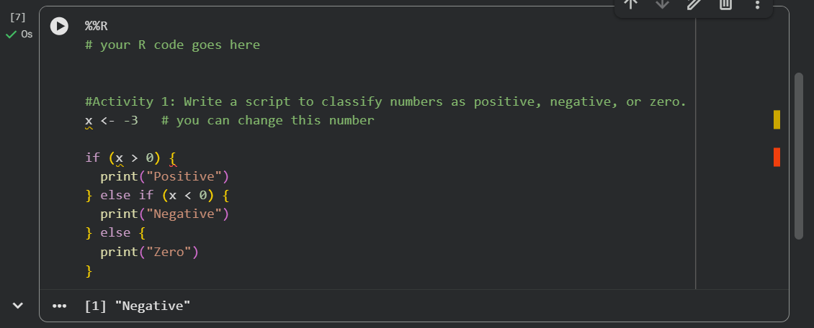

Activity 2: Use a loop to sum numbers from 1 to 100.
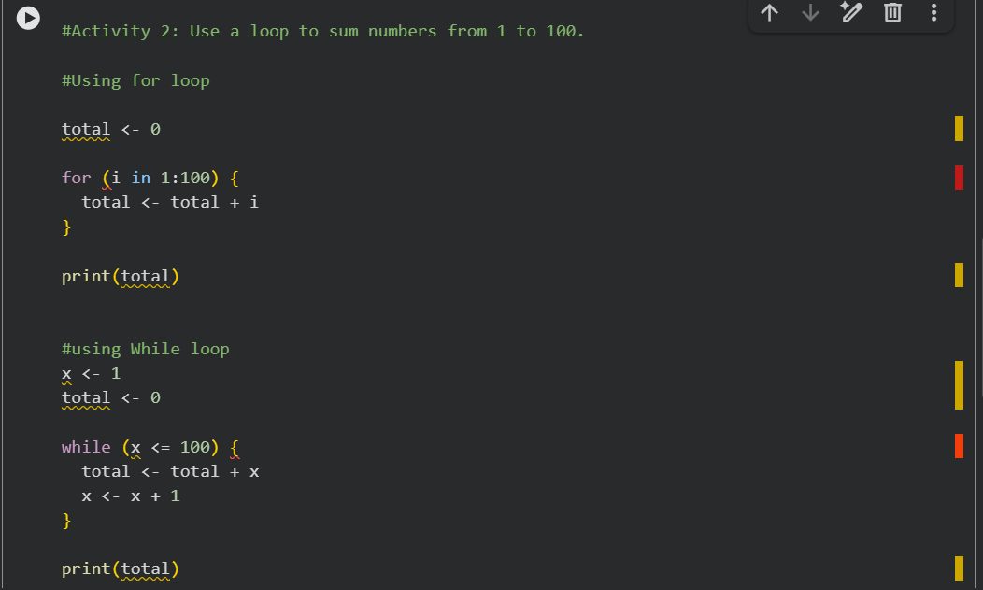

Output:


Activity 3: Generate and print random numbers until one is greater than 0.9.

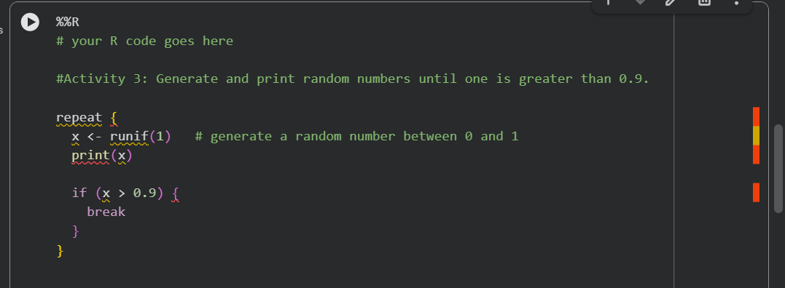

Output:
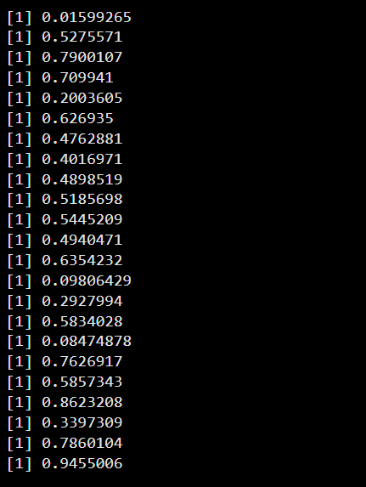

Activity 4: Rewrite a loop using vectorisation.


