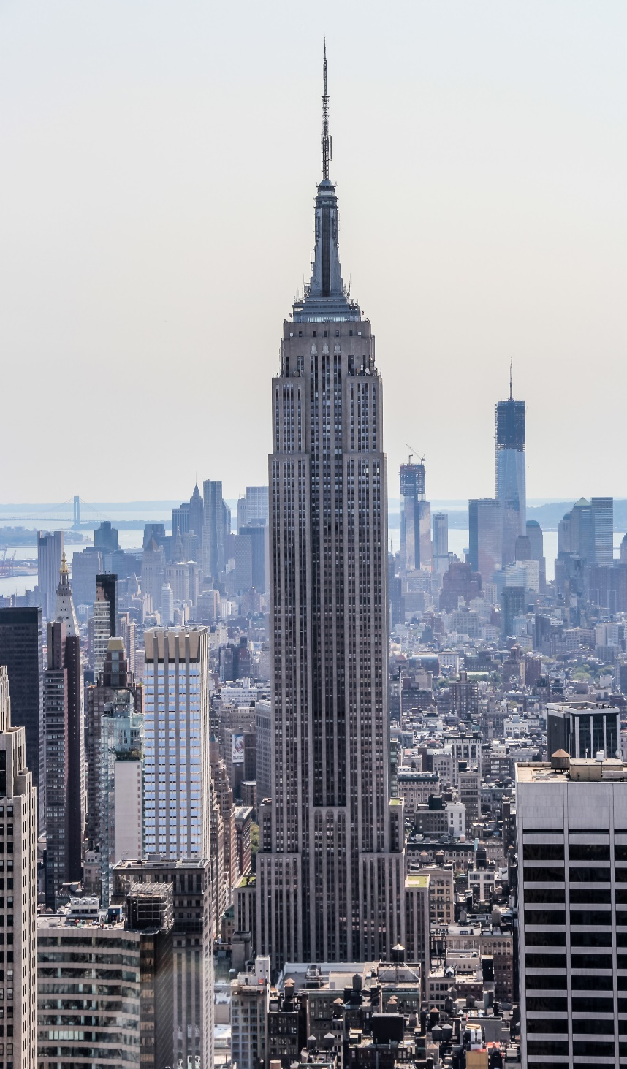


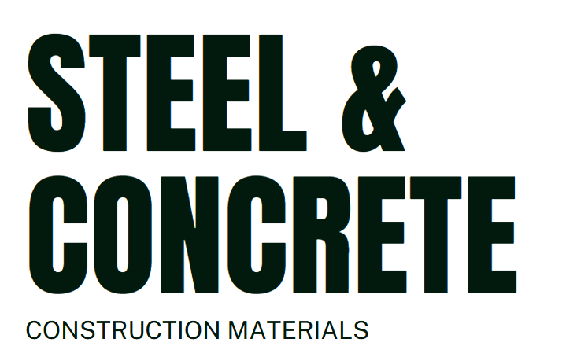

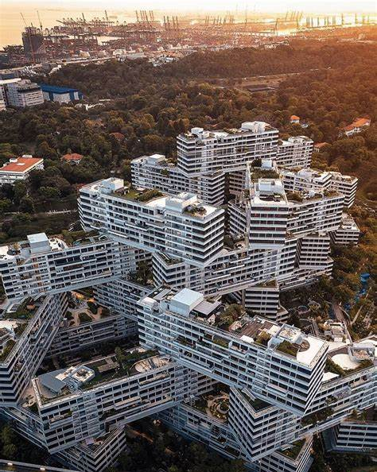

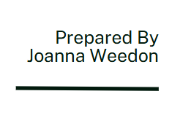

Empire State Building
The Empire State Building was completed in 1931, during the Great Depression. This building remains one of the most iconic skyscrapers in the world. Standing over 381 meters and 443 meters including the antenna, it held the title of the tallest building for nearly 40 years. The building was designed by a Shreve, Lamb & Harmon in a Art Deco stye, its stepped form and limestone façade became a symbol of American ambition. The success of the building was down to the material choice – A572 Grade 50 steel, allowing the construction phase to rise rapidly and withstand significant wind and seismic loads (Willis, 1995).. To create this structure over 60,000 tones of steel were used, and riveted connections enabled modular, floor-by-floor assembly. This groundbreaking building was completed in just over a year, whereas other skyscrapers in 1931 would typically be twice as long. Additionally showcasing construction innovation, the project provided thousands of jobs, proving vital economic relief during the Depression. (Tauranac, 1995)


Figure 1 - (Paul & Paul, 2023)

The Framing Material Choice, in relation to strength, durability and climatic resistance, given the environmental conditions it is exposed to at the site

For its time the Empire State Building was considered one of the “Seven Wonders of the Modern World” by the American Society of Civil Engineers (ASCE 1997). The building was designed and constructed using A572 Grade 50 steel (Finnigan et al. 2015). This type of steel was, and is, a powerhouse in the world of structural materials and is renowned for its high strength, offering exceptional strength-to-weight ratios (ASTM 1982; Universal Steel America n.d.). We will explore the strength, durability and climatic resistance of this material (McClements 2023) and consider the building’s exposure to the neighbouring environmental conditions. Further, we will explore the production process for the steel fabrication (McClements 2023), its impact on the area and how adaptable it has been in terms of durability (Universal Steel America n.d.).
The strength of A572 Grade 50 Steel plays a crucial role in the stability and safety of the Empire State Building. It is widely recognized for its exceptional balance of strength and lightweight design, managing to support the heavy loads of the building’s 88 floors, observatories, and the 203-foot spire. This type of steel has a yield strength of 50,000 psi (345 MPa) (ASTM, 1982), and its use in the skyscraper helps the building to withstand high winds and seismic activity (McClements, 2023; Universal Steel America, n.d.).

The chemical composition of A572 steel establishes its strength and structural integrity. It is composed chiefly of iron (98%) with the addition of the following elements:
Carbon (0.21%–0.23%): this single element is the one that turns pure iron into steel, increasing the metal's hardness and yield strength of 42 ksi.
Manganese (1.35%–1.65%): enhances toughness and wear resistance, minimising the risk of cracking during production/hot rolling.
Phosphorus/Sulfur (0.03%): kept at minimal levels to avoid brittleness.
Silicon (0.15%–0.40%): removes oxygen from the molten metal during production, improving the hardness and stability.
Vanadium (0.1%–0.15%): improves the steel’s strength and wear resistance while enhancing its ability to withstand high temperatures
(ASTM, 1982; McClements, 2023; Universal Steel America, n.d.).

The metal has a tensile strength ranging from 60 ksi to 80 ksi. Tensile strength is sometimes called ‘breaking strength’, and the measurement is the force that the steel grade can endure before breaking—important factors in a building coping with high wind loads and vibrations from nearby traffic (Xometry, 2023; ASTM, 1982).
In addition, A572 steel’s physical properties further enhance its performance:
Density: to find the density of a metal, we divide mass by volume. A572 steel’s density is approximately 0.282 lb/in³ or 7.80 g/cm³ (MatWeb, n.d.).
Melting Point: a metal’s melting point determines what processes can be used to manufacture, shape and cut it and what applications it can be used for. A572’s melting point is around 2,500–2,759°F (1,370–1,510°C) (AZoM, 201
New York City is situated close to saltwater, and the Empire State Building has been subjected to urban pollution and acid rain. To manage the damage to its steel frame, the A572 Grade 50 steel was galvanised. These coatings work to protect the steel from rusting – ensuring longevity for the building’s skeleton (Universal Steel America, n.d.; McClements, 2023).
The weakness endurance of A572 Grade 50 steel is fundamental because of the Empire State Building’s height and wind and traffic vibrations. This type of steel is able to absorb the cyclical loads it is subject to without failure, giving the building stability and safety (ASTM, 1982; Lee and Choi, 2021). The structure’s ability to repel these continual tensions has been crucial for the endurance of this iconic building.
One of the great differences between cast-iron construction and steel frame construction was literally nuts and bolts. The elements of a cast-iron building were bolted, but no bolt has the strength of a rivet. Steel-framed buildings were riveted. Driven red-hot into the punch holes, rivets fill up every interstice. When they cool, they are at one with beams and columns—an integral part—and beam and column become one with each other (Tauranac, 1995).

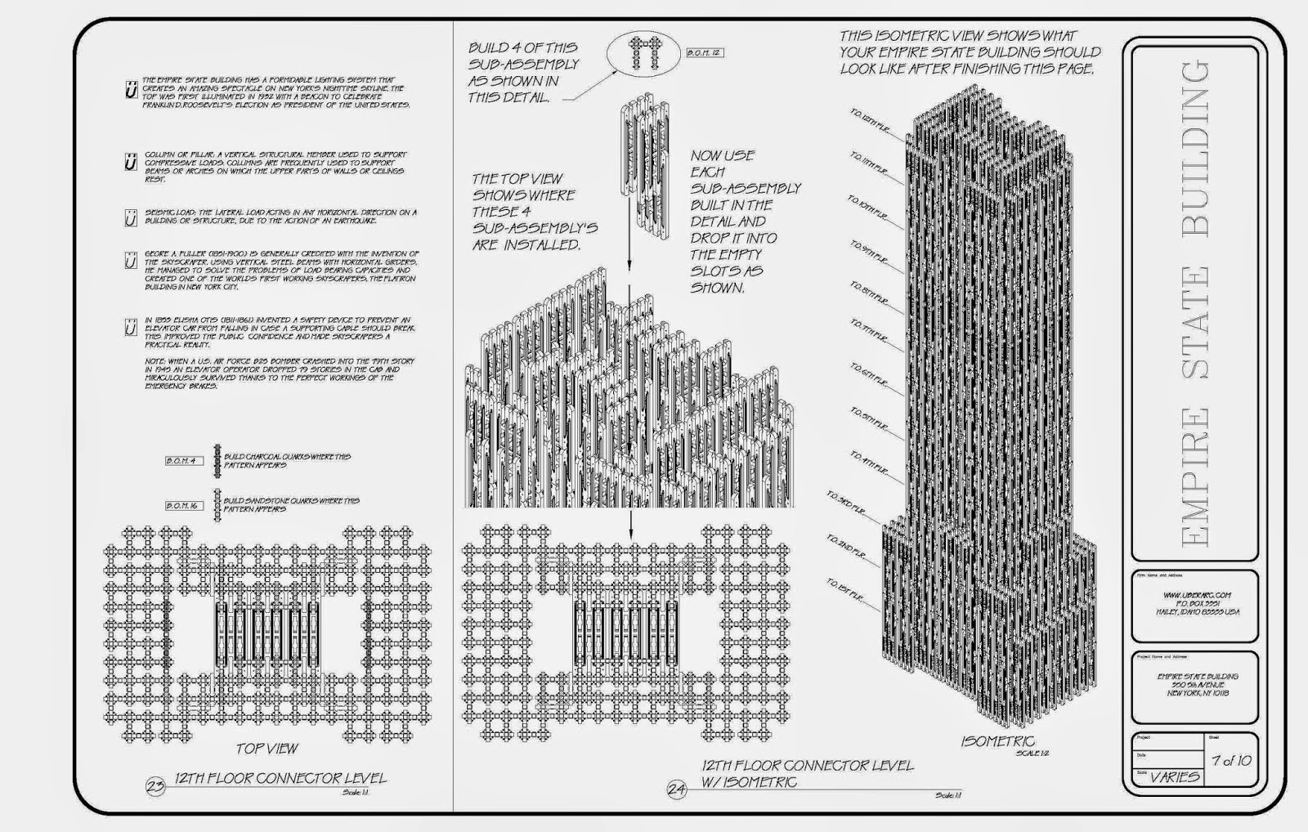

Architecture Nest: Structure System of Empire State Building

The impact of the framing material’s original production process, to community and to the environment.

Work on the giant frame started on March 17th, 1930, and soon the steel framework had begun to fill the whole site area. A continuous stream of girders flowed in from Pittsburgh, 440 miles away. The American Bridge and McClintock-Marshall supplied the steel for alternating sections that ranged from six to eight stories each. The steel was shipped first to a waterfront supply yard near Bayonne, New Jersey, from which the amount needed for two floors would be withdrawn in a single requisition and delivered to the site (Tauranac, 1995).
This steel production required large amounts of labour, which encouraged much-needed stimulation for the steel mills and the construction industry. America was suffering from the Great Depression, and the building of the Empire State Building created thousands of jobs – from steelworkers to labourers – all of which helped to relieve the damaging economic difficulties in New York City (Tauranac, 1995; ASCE, 1997).
With the rapid pace of construction – 14 floors were completed in just 10 days – the local supply chain benefitted from the demand for materials, stimulating growth in the local economy (Tauranac, 1995).

The Frames easy of assembly and the potential ease of its adaptationto different building shape and building use, within the life cycle of the building
Steel framing systems, such as those using A572 Grade 50, are widely praised for their ease of assembly and flexibility during construction. Prefabricated steel components can be quickly erected on-site, reducing construction time and improving efficiency compared to traditional materials (Gibbons, 2017). The high strength-to-weight ratio of A572 Grade 50 steel allows for lighter structural elements, simplifying transportation and handling during assembly (McClements, 2023). Furthermore, steel frame structures offer excellent adaptability over the building’s life cycle. Their modular design and open-plan capabilities make them well-suited to changing uses, such as converting office space to residential units or integrating new technologies and mechanical systems (Gorgolewski, 2008). This adaptability supports the long-term sustainability and economic viability of buildings constructed with steel frames, enhancing their potential for reuse and redevelopment (Menzies and Warden, 2011).
The use of steel framing structures are known for their flexibility and for the smooth assembly process during the construction phase. The pre-fabricated parts are able to be erected fast on site. This method is a highly efficient means of construction compared to alternative materials (Gibbons, 2017). The quality of high strength-to-weight ratio of A572 Grade 50 steel has the properties to allow for a lighter structural quality aiding with transportation and handling (McClements, 2023).
Steel frame buildings are highly adaptable over the life-cycle of the structure. The sectional layouts allow for use-change – for example changing spaces from offices to apartments or for installation of upgraded mechanical systems (Gorgolewski, 2008).

The Interlace, Singapore

Designed by Ole Scheeren in collaboration with the Office for Metroplitan Architecture the Interlace was completed in 2013. The Interlace has redefined residential urbanism through its radical horizontal village concept. The structure consists of 31 six – storey blocks stacked in a hexagonal arrangement. This site is spread over 8 – hectare, which allowed for open courtyards and communal green spaces. Due to Singapore’s tropical climate, reinforced concrete was chosen as the primary structural material. The use of prefabricated concrete elements allowed for efficient assembly. Concrete’s production is carbon-intensive, its long service life, thermal mass properties, and ability to incorporate recycled aggregates improve its sustainability profile (Pacheco-Torgal et al., 2013
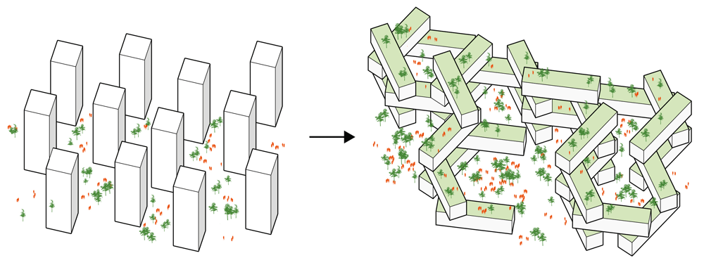
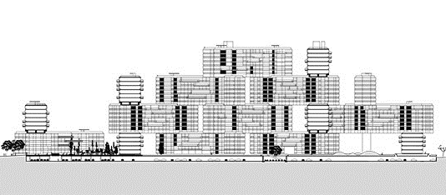
Figure 2https://www.architectural-review.com/today/the-interlace-in-singapore-by-oma-ole-scheeren

Figure 3https://www.pawelpaniczko.com/works/the_interlace#gallery
The framing material choice, in relation to strength, durability climatic resistance, given the environmental conditions it is exposed to at the site.
Singapore’s climate is tropical – high humidity, heavy rainfall and high to warm temperatures all year round. The building materials chosen by Ole Sheeren – Architect – would have to take full consideration of these challenges. The choice of the principal material for building the Interface was reinforced concrete.
Reinforced concrete is concrete in which steel has been embedded with the two materials acting together in resisting forces. The steel acts to absorb the tensile (stretch or pulled without breaking), shear (resistance to wind) and sometimes the compressive stresses in a concrete structure with regard loadings. These properties in reinforced concrete work in tandem to allow the materials to sustain these stresses over substantial spans. Further, reinforced concrete performs well in humid conditions and will maintain its look and properties because of its resistance to corrosion and weathering. Reinforced concrete | Definition, Properties, Advantages, & Facts | Britannica
What kind of reinforced concrete was used???
The impact of the framing material’s original production process, to community and the environment?
Singapore is heavily reliant on imported sand, cement and aggregates for the larger construction projects. It is likely that countries such as Malaysia, Indonesia, Vietnam or Thailand supplied the cement for the Interlace given that Singapore does not have any significant reserves of limestone. Supply of sand is a challenge in the country due to environmental fears over excessive mining of the material.
It is possible that the components were mixed and delivered in Singapore but we cannot find any reference to whether this was the case.
At every step of the process cement production has an environmental impact. Mining for the aggregates, sand and limestone produce airborne pollutants as well as the negative impact of blasting and machinery noise.
The Environmental Benefits of Concrete Construction - CA Pro Concrete
Concrete buildings are exceptionally durable and long lived often lasting for decades and even centuries. Less frequent reconstruction or replacement is necessary reducing the demand for raw materials to maintain the structures.
Because of the excellent thermal mass of the material allowing it to absorb, store and release heat slowly concrete buildings will use less energy to either keep the building cool or warm. Such efficiencies can help to significantly reduce the energy consumption of the development leading to lower greenhouse gas emissions and by default a small carbon footprint throughout the lifetime of the building.
Concrete has high albedo (light or radiation properties) that enables the material to reflect solar radiation. This is extremely useful in such a built up environment as Singapore. Light coloured concrete – as is present in the Interlace – reflects back the sunlight into the atmosphere reducing the heat-impact in a built up area.
We can conclude from our research that whilst concrete is a poor material from an environmental perspective to produce the lifetime of a building made with concrete mitigates the initial impact through the ability to provide high u values, less maintenance and in a hot climate the ability to reflect solar rays.
A bit about using the local supply chain to build?
The frames ease of assembly, and the potential ease of its adaptations to different building shape and building use, within the life cycle of the building
A key strength of The Interlace lies in its capacity for architectural adaptability, a quality that future-proofs the development against obsolescence. Its design follows principles of open building, allowing for flexible use and change without compromising the structure’s integrity (Kendall & Teicher, 2000). The large, column-free floor plates within each unit enable reconfiguration of interior spaces—allowing, for example, a transformation from single-family units to shared living arrangements or even small offices, depending on shifting urban needs. This supports mixed-use possibilities without major structural intervention. Additionally, the horizontal stacking of volumes, rather than a conventional vertical tower form, facilitates easier access to individual modules for maintenance, retrofitting, or conversion. This contrasts with traditional high-rises, where changes often require disruptive, building-wide interventions.
Furthermore, the use of prefabricated concrete modules not only accelerated the initial construction but also enables selective disassembly or replacement of components. This supports partial upgrades or extensions, a key feature in Design for Disassembly (DfD) frameworks, where buildings are viewed as evolving systems rather than static entities (Guy & Kibert, 1998). From a planning perspective, the design allows for the possible integration of additional floors or bridging elements between blocks, offering vertical or lateral growth options if land-use regulations allow. This level of long-term spatial flexibility is essential in dense urban environments like Singapore, where land is scarce and urban needs evolve rapidly.
Ultimately, The Interlace demonstrates how adaptable architecture—supported by thoughtful spatial planning and material systems—can lead to longer building life spans, greater user satisfaction, and reduced environmental impact through reuse and reconfiguration rather than demolition and rebuild.

Framing Material Comparison: Empire State Building vs. The Interlace

Steel vs. Concrete – Advantages & Disadvantages
Aspect | Steel (A572 Grade 50) | Concrete (Reinforced) | Comparison Summary
Tensile Strength | ✅ Very high (~450–550 MPa) | ❌ Very low (~2–5 MPa); needs rebar | Steel clearly superior in tension; concrete is weak without reinforcement
Compressive Strength | ✅ Strong (~250–400 MPa) | ✅ Strong (~25–50 MPa); suited for vertical loads | Both perform well in compression, but concrete is more cost-efficient here
Durability | ✅ Long-lasting if protected (75–100+ years) | ✅ Also long-lasting (50–100+ years) | Both materials durable with maintenance
Fire Resistance | ❌ Loses strength quickly in fire; needs coating | ✅ Inherently fire-resistant | Concrete wins for fire performance
Corrosion Resistance | ❌ Prone to rust unless galvanized or painted | ❌ Rebar can corrode, causing cracking (spalling) | Both need care; steel rusts, concrete cracks if rebar is exposed
Thermal Performance | ❌ Conducts heat rapidly; poor insulation | ✅ High thermal mass; stores heat and slows temperature swings | Concrete is better for thermal regulation
Construction Speed | ✅ Fast due to prefabrication | ❌ Slower due to curing time | Steel is ideal for rapid construction
Weight/Density | ❌ Very heavy (7,850 kg/m³) | ✅ Lighter (2,400 kg/m³) | Concrete is easier to transport in bulk
Design Flexibility | ✅ Highly adaptable; easy to modify | ❌ Limited adaptability after curing | Steel offers greater reuse and reconfiguration
Environmental Impact | ❌ High embodied energy; ♻️ 100% recyclable | ❌ High CO₂ from cement production; some recycled content possible | Both have environmental costs; steel can be reused, concrete has thermal efficiency
Cost | ❌ More expensive material & protective treatments | ✅ Generally cheaper per unit mass | Concrete is more affordable, especially for foundations & walls
Sustainability | ♻️ Fully recyclable with low lifecycle waste | ♻️ Can be downcycled into aggregate; long life helps offset high CO₂ | Steel is better for circular economy; concrete for passive sustainability

References
American Society of Civil Engineers (ASCE), 1997. Seven Wonders of the Modern World. ASCE.
ASTM, 1982. Standard Specification for High-Strength Low-Alloy Columbium-Vanadium Structural Steel. ASTM A572 / A572M – 18, ASTM International.
Britannica, 2023. Reinforced Concrete: Definition, Properties, Advantages, & Facts. [online] Encyclopedia Britannica. Available at: <https://www.britannica.com/technology/reinforced-concrete> [Accessed 27 Mar. 2025].
Empire State Realty Trust, 2011. Empire State Building Sustainability Retrofit. [online] Available at: <https://www.esbnyc.com/about/sustainability> [Accessed 27 Mar. 2025].
Finnigan, B., Marquez, C. and Sellers, D., 2015. High-Strength Steels and their Use in Modern Structures. Journal of Structural Engineering, 141(4), pp.1–10.
Gibbons, M., 2017. Steel Structures: Construction and Design Manual. DOM Publishers.
Gorgolewski, M., 2008. Designing with Reused Building Components and Materials. International Journal of Environmental, Cultural, Economic, and Social Sustainability, 4(3), pp.195–206.
Guy, B. and Kibert, C., 1998. Developing Indicators of Sustainability for the Built Environment: A Focus on Design for Deconstruction and Material Reuse. Building Research & Information, 26(3), pp.169–174.
Kendall, S. and Teicher, J., 2000. Residential Open Building. E&FN Spon.
Landau, S.B. and Condit, C.W., 1996. Rise of the New York Skyscraper: 1865–1913. Yale University Press.
Lee, J. and Choi, K., 2021. Cyclic Load Behavior of High-Strength Steel. Engineering Structures, 244, p.112710.
MatWeb, n.d. Material Property Data: A572 Steel. [online] Available at: <https://www.matweb.com/search/datasheet.aspx?matguid=1a3de9c3c8914aa2b1e66e70ae6e9424> [Accessed 27 Mar. 2025].
McClements, J., 2023. Structural Steel Applications in High-Rise Buildings. Journal of Construction and Material Science, 5(2), pp.78–93.
Menzies, G. and Warden, P., 2011. Sustainable Refurbishment of Existing Buildings. Building Research & Information, 39(3), pp.231–238.
Pacheco-Torgal, F., Jalali, S., Labrincha, J. and John, V., 2013. Eco-Efficient Concrete. Woodhead Publishing.
Paul & Paul, 2023. Empire State Building Structural Diagram. [image] Available at: <https://www.paulandpaul.com/empire-structure> [Accessed 27 Mar. 2025].
Scheeren, O., 2015. The Interlace Project Overview. [online] OMA & Ole Scheeren. Available at: <https://www.architectural-review.com/today/the-interlace-in-singapore-by-oma-ole-scheeren> [Accessed 27 Mar. 2025].
Tauranac, J., 1995. The Empire State Building: The Making of a Landmark. Scribner.
Universal Steel America, n.d. A572 Steel Plate – Properties and Uses. [online] Available at: <https://www.universalsteelamerica.com/a572-steel/> [Accessed 27 Mar. 2025].
Willis, C., 1995. Form Follows Finance: Skyscrapers and Skylines in New York and Chicago. Princeton Architectural Press.
Xometry, 2023. Mechanical Properties of A572 Grade 50 Steel. [online] Available at: <https://www.xometry.com/resources/materials/a572-grade-50-steel/> [Accessed 27 Mar. 2025].

