ACBA 5004
Cerith Edwards
Work Based Project DR Deborah Hughes
11/14/2023
TARMAC MY FORECOURT
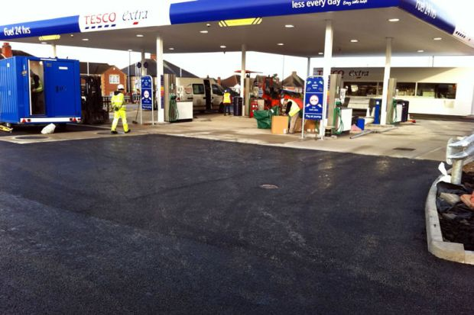
Table of Contents
1. Provisional Title of Work Based Project 2
2. Abstract 2
3. Introduction and background 2
4. Aims and objectives 2
Aim 2
Objective 2
What do you aim to achieve and how? 3
What do you know about the topic? 3
How are you going to find the answers to your questions? 4
Why will it benefit me to do this research? 5
5. Literature Review 5
6. Research Methodology(ies) and Justification: 5
6. Primary Research (e.g. Interviews, Questionnaires etc.): 5
References 5

Tarmac
Hand lay v machine lay
Build ups
Forecourt
Types of tarmac
Colours
HRA v SMA
Price V value for Money
Longevity
Questionnaires
Interviews
Customer care and guarantees.
Stone and build up
Pros and cons of materials
IHE – DEB IS A MEMBER, look at their website
Conclusion

HOMEWORK – FIND A PAPER WITH AIMS AND OBJECTIVES ON SPECIALIST FIELD

1. Provisional Title of Work Based Project

The UK’s best Tarmac option for Petrol Forecourts

2. Abstract

3. Introduction and background
Dealing with a wide range of clients within the fuel industry, each client has different specifications for different works that are carried out on a forecourt. When it comes to tarmac works, they all have different specifications. I want to identify what tarmac is best suited for a petrol forecourt. Almost every project I am involved with requires a tarmac finish, I want to identify which one is the best option.

4. Aims and objectives

Aim
Working for premier forecourts, our skillset covers all aspects of forecourt construction and maintenance (Premier Forecourts and Construction, 2023). In this research project, the aim is to identify the best type of tarmac works for a petrol forecourt. This involves understanding the various options available to the client to complete tarmac works. The below research will identify what type will offer the overall best value.

Objective

- Finding tarmac works that can withstand heavy traffic, frequent vehicle movement.
- Identifying tarmac works that offer the best balance between long-term performance and initial cost, ensuring value for money over the tarmac lifetime.
- Determining tarmac works that can handle the day-to-day requirements of a petrol forecourt, including the weight of fuel tankers, drainage systems, and any specialized equipment.
- Ensuring that the chosen tarmac works meet all relevant regulatory requirements, such as local council regulations or industry standards for petrol station construction.
- Considering the visual appeal of the tarmac works, as it can contribute to the overall impression of the forecourt and the company's brand image.
- Evaluating the level of upkeep and maintenance needed for different tarmac works options, including regular inspections, repairs, or resurfacing, to minimize disruptions to operations.
- Identifying tarmac works with a proven track record of durability and longevity, reducing the need for frequent replacements or refurbishments.
- Considering the impact of the tarmac works for customers.

What do I aim to achieve and how?
In this research project, the aim is to identify the best type of tarmac works for a petrol forecourt. This involves understanding the various options available for tarmac works, such as materials, thickness, and surface treatments, and determining which ones would be most suitable for a petrol forecourt based on key factors like durability, maintenance requirements and cost-effectiveness.

What do I know about the topic?

In honesty I don’t know much about the chosen field, however majority of our sites (forecourts) do require a tarmac finish as per design specification. I have all the information I need to ensure the correct tarmac is being laid. I want to become a subject matter expert within the company, becoming the go to person if there are any tarmac queries. I want to know why we are using certain build ups, why we are using certain materials and is there a more viable product to be used.

Regarding tarmac types I know HRA (hot rolled asphalt) and SMA (stone mastic asphalt) are both types of asphalt that is used in road construction. However I’m unsure on which one is best for a forecourt and offers the best value, this is also the same for the build-up of tarmac. Often when replacing trenches on site there is a request for HRA while if covering larger or more substantial areas there is preference of using the SMA option. I believe this is because HRA is a better wearing material that allows vehicles to easily turn on, which avoids the tarmac breaking up, however is not as aesthetically pleasing as the SMA option, which is known for tearing up or wearing away when used for trenches. However SMA is preferred for larger areas of the tarmac, I believe this is down to it being a cheaper, yet a more aesthetically pleasing product, hopefully I will find and work this out with the below research.

The Two main clients I price forecourts renovations for are two major companies in the fuel industry. Combined they are responsible for thousands of UK petrol forecourts. This figure constantly rising as they continue to purchase more petrol stations/forecourts. With the NET 0 goal the company are installing electronical vehicle charging points as well as maintaining and installing fuel lines, majority if not all of our projects require a tarmac finish.

The clients all have different tarmac specifications. Company 1 want a 130/30 finish load on top of a 150mm of whacked/rolled type 1. The 130mm is a superstructure coat built up of a 20mm coarse aggregate which is followed by a 30mm thick SMA (Stone mastic asphalt) which has 10mm granite stone in the build-up, this is rolled to the site specific plan. Company 2 have a greater build up which is a 150/60/40 finish. This is made up of 150mm thick macadam road base that has 28mm size aggregate. The 60mm is a hot rolled asphalt base course with 20mm (max) sized stone aggregate, then the 40mm finish will be hot rolled SMA with an aggregate size stone ranging between 10mm and 14mm.

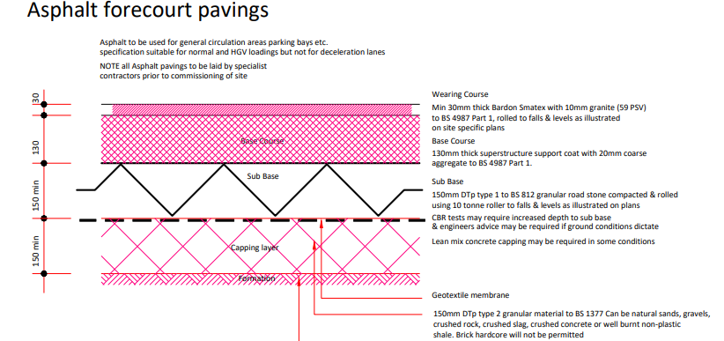
Figure 1 - Taken from personal communication (Company 1, 2023)

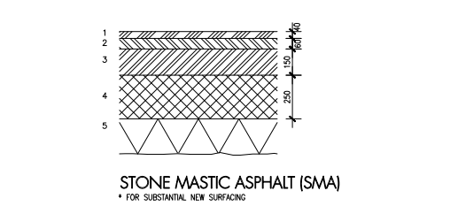
Figure 2 - Taken from personal communication (Company 1, 2023)

How are you going to find the answers to your questions?
To find answers to my research questions, I will adopt various approaches. This will include reviewing existing literature, articles, reports, and studies on tarmac works for petrol forecourts (although early signs have shown that there is limited reading lists, I can reference or use for this specific research purpose). I may have to research alternative tarmac works for other industries such as tarmac works in airports, carparks and roads. I will then transfer these finding and make it specific to the forecourt.

Additionally consulting with experts in the field, such as experienced staff members within my company or contractors/clients that specialise in petrol forecourt construction, as well as tarmac contractors that I have used in the past. These stakeholders can provide valuable insights.

I will conduct site visits to existing petrol forecourts to observe and gather information about the performance of different tarmac works as seeing this first hand will be beneficial.

Why will it benefit me to do this research?
Engaging in this research project can bring several benefits. Firstly, it allows for an informed decision-making process when selecting the best type of tarmac works for a petrol forecourt. This means the forecourt will be designed and constructed to meet specific requirements, ensuring optimal performance and durability. Moreover, by gaining knowledge on tarmac works, I will develop a more comprehensive understanding of construction materials and techniques, which can be applied to future projects. Lastly, conducting research demonstrates my ability to critically analyse and evaluate various options, enhancing expertise in this field.

5. Literature Review

6. Research Methodology(ies) and Justification:
Litreature teview

6. Primary Research (e.g. Interviews, Questionnaires etc.):

References
Company 1. (2023, November 11). Asphalt standard detail . Company 1 - Standard detail. Premier forecourts.
Motor Fuel Limited 2023. (2023, November 13). The Largest Independent Forecourt Operator In The UK. Retrieved from MFG : https://www.motorfuelgroup.com/
Premier Forecourts and Construction. (2023, November 06). Forecourt. Retrieved from Premier Forecourts and Construction: https://www.premierforecourtsandconstruction.com/forecourt/

