Research in Practice

BA Illustration: Research in Practice (ADAD5004)
Word Count: 2433
Name: Lauren Rees (2204075)
Lecturer: Delyth Lloyd-Evans

3 Keywords: Escapism Personification Floriography

In this essay I aim to make links between the keywords: Escapism, Personification and Floriography and discuss how they make us feel connection and validation as humans through a biophilic, fiction-based and psychological lens. Escapism and Personification (or anthropomorphism) already have association, as humanising the non-human is just suspending your acknowledgment of reality for the sake of attempting to relate to inanimate and non-sentient things. Floriography – the language of flowers – comes into play with personification, not only within my practice, but how we have taken flowers throughout history and made them a method of communicating a myriad of complex human emotions without saying anything. Artists like Mary Blair and J.J. Grandville have aided my practice and research through their respective explorations of personified flowers, and thinkers including Sigmund Freud and Xenophanes have provided me with theoretical perspectives in relation to our desire to connect.

Escapism
Escapism is a relevant term today; it essentially serves as a distraction from reality. Many people engage in a variety of activities that aid in escapism like reading fiction, watching TV shows or films, making art, or simply daydreaming. It is healthy and quite necessary in moderation, as it serves as a break and self-preservation from fatigue and stress. Danger comes when it is sought after constantly as it can cause people to lose touch with reality, relationships, and responsibilities. Excessive and more self-destructive and addiction-based escapist behaviours can be observed in people suffering from mental issues like anxiety and depressive disorders because they desperately want a shift from long-lasting and severe psychological distress. In these cases, reality becomes something people just cannot face anymore even if it is necessary towards recovery (Parsons, 2023).
The healthier route in escapism is using media like books and narratives to ‘[...] explore certain themes from a safe distance through the eyes of the of the protagonist [...]’ (Shah, 2022) utilising a break from everyday life as a tool to learn how to deal with and feel validated of hard situations, emotions and become better at being critical when it comes to turning ones’ mind back to fact. Additionally, this can temporarily shift feelings of isolation, as narratives with true-to-life conflicts can make us feel ‘[...] we have been empathised with, understood, heard and even validated – and hence unconsciously we may be drawn to fiction stories that resonate with our own experience’ (Shah, 2022).
‘Realistic constructions [...] become touchstones for readers’ understanding of the world outside the fiction’ (Attebery, 2022).
This instinctual desire to escape derives from Freud’s ‘Pleasure Principle’ theory in which we seek out pleasure and fulfilment of our needs and try to avoid discomfort and pain as much as possible. Procrastination is so appealing and habitual to many, as we experience the pleasure immediately even at the detrimental cost of looming deadlines and expectations. Children are more clearly susceptible to this principle, finding it very distressing if they cannot have their needs met as soon as possible; we get better at managing this as we develop and gain the ability of self-control (Cherry, 2023).
Freud even addressed escapism itself, stating:
‘[T]hey cannot subsist on the scanty satisfaction they can extort from reality’ (Kalia, 2021).
This suggests we need a means of escapism for optimal happiness, as being wholly in-touch with reality is tiring and comes with a lot of dissatisfaction that we often cannot control. In our own specific escapist worlds, we get to control what we are taking in.

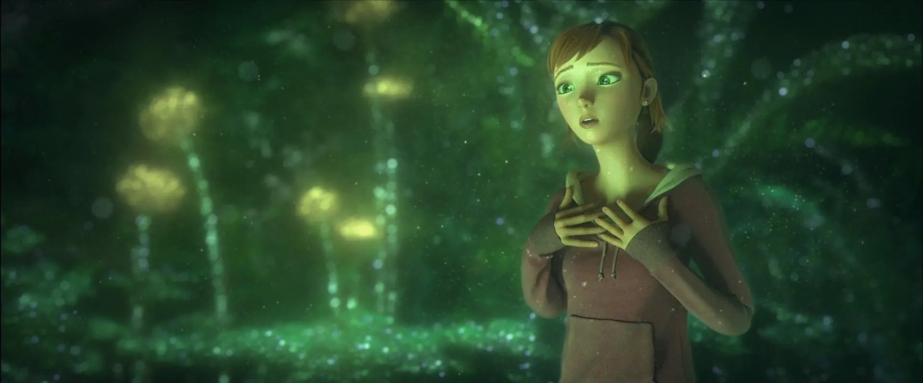
Figure 1: Epic (2013)
Media can use effective tactics to make the narrative itself feel escapist. Take for example Dreamworks’ Epic (2013) in which the fantasy world’s intrigue is elevated by first showing the protagonist’s (Mary Katherine, or M.K.) experience in the real-world in which she suffers from a strained relationship with her father but must live with him. She then gets involved in the society of small “leafmen” and “flower jinn.” The father can arguably be presented as someone who has gone too far into escapism, his scientific endeavours into finding the small people having destroyed his career and marriage and it being all he focuses on. When M.K. is shrunken down to the small people’s size, this is where you see the much-awaited transition from the mundane reality to the fantasy world.

Personification
Personification – also synonymous with anthropomorphism – is the practice of assigning humanlike attributes to the non-human and the inanimate. For example; ‘[...] wearing clothing, walking on two legs, or having a humanlike personality’ (Chen, 2023). We have been personifying and anthropomorphising things for thousands of years – it is not new. For instance, in Greek mythology the gods were often portrayed as humanoid. It is everywhere and is ever-present in media like children’s shows. Beloved animated and stop-motion shows like Fifi & the Flowertots (2005), Bill and Ben [The Flowerpot Men] (2001), Angelina Ballerina (2002) and Thomas the Tank Engine (1984) all revolve around anthropomorphised characters like flowers, animals, and vehicles. These shows either present the characters in the environment that they would still be in even if they were inanimate (the engines in the Thomas franchise) or in a society identical to ours in which the characters (most commonly animals) replace humans (the mice in Angelina Ballerina).
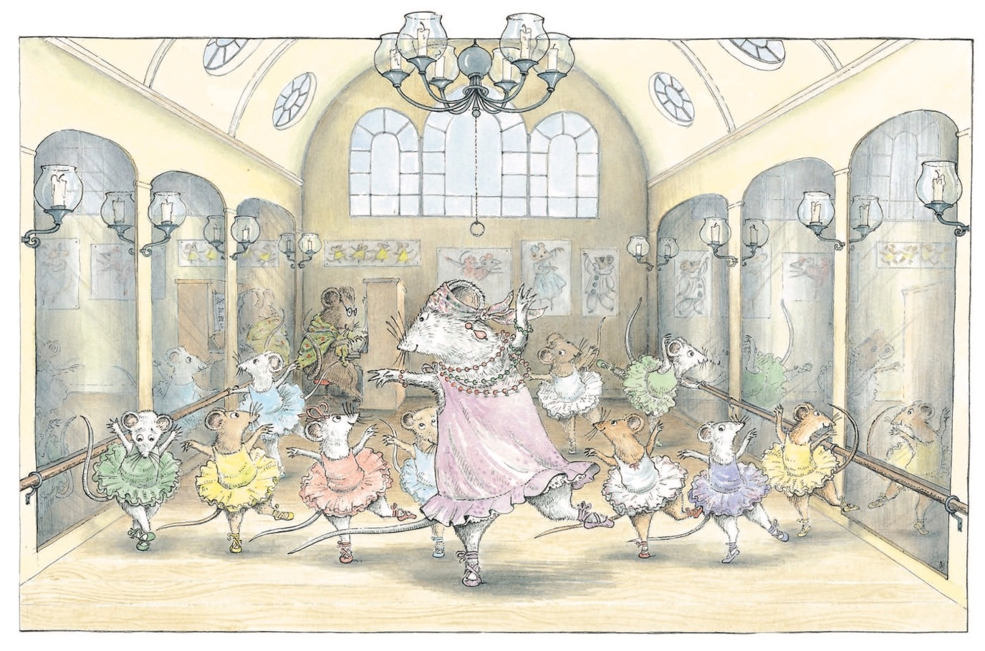Figure 2: Katharine Holabird, Angelina Ballerina
(Helen Craig, 1983)
Our tendency to do this, either within character design or just projecting onto whatever we are observing is ‘[...]a very natural way for humans to view, understand and interact with the world of objects.’ We give roles, intentions, emotions, and identities to objects, as it makes us feel connected to what we otherwise could not possibly relate to, and it makes us feel less lonely (Luu, 2016).
French artist, J.J. Grandville, a caricaturist, and proto-surrealist illustrator utilised a lot of anthropomorphism in his bodies of work, notably his series of illustrations within the book “Les Fleurs Animées” or “The Flowers Personified” written by various authors (Alphonse Karr Et al., 1830-67). Grandville illustrates these flowers as women, dressed and presented like they would have been during the 1840’s, again nodding to our projection onto objects based on what we observe from our own species. Praise has been given to Grandville for his ‘[...] effort to penetrate to the meaning of objects like an “intellectual miner” [...]’ (Ray, 1982)
Mary Blair, American artist, animator, and established Walt Disney employee also has works of personified flowers, namely from her conceptual paintings for Alice in Wonderland (1951) in which the various talking flowers from the Disney classic are explored through surreal, abstract compositions. Her work was so influential that a lot of her concepts were ‘pretty much translated into [...]’ films like - the previously mentioned - Alice in Wonderland and Cinderella (1950) (Bové and Disney Plus, 2022)

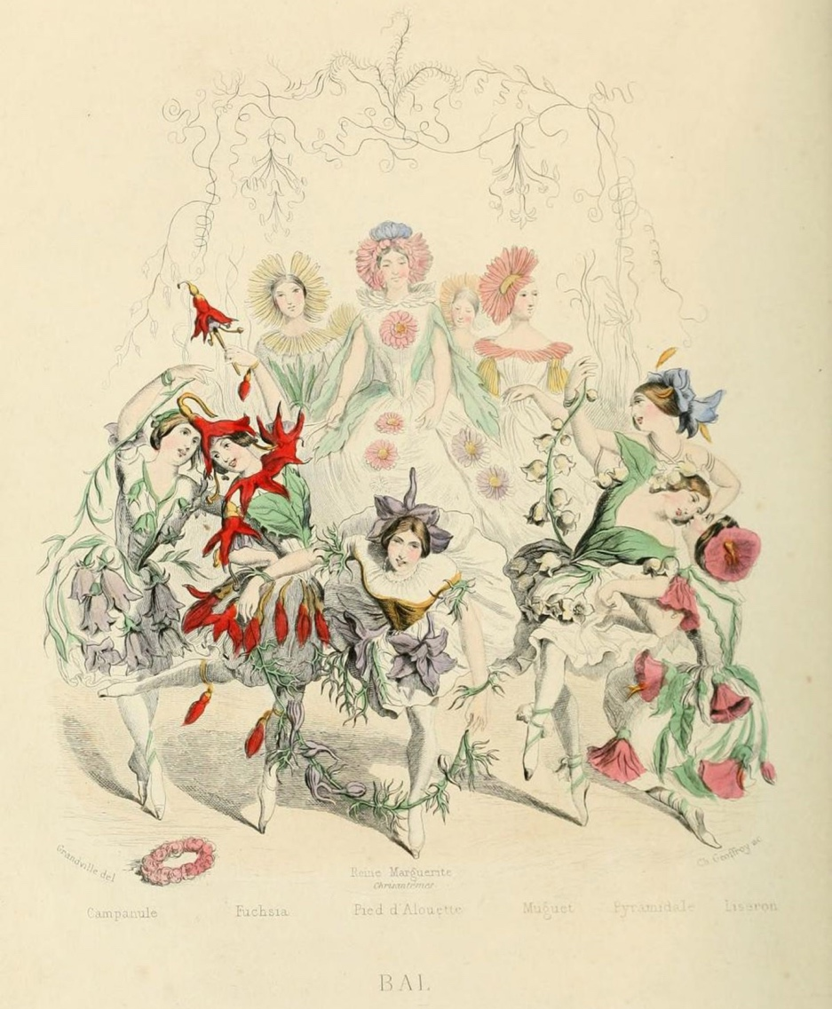
Figure 3: 'Bal' (The Ball)
(J.J. Grandville, 1846)
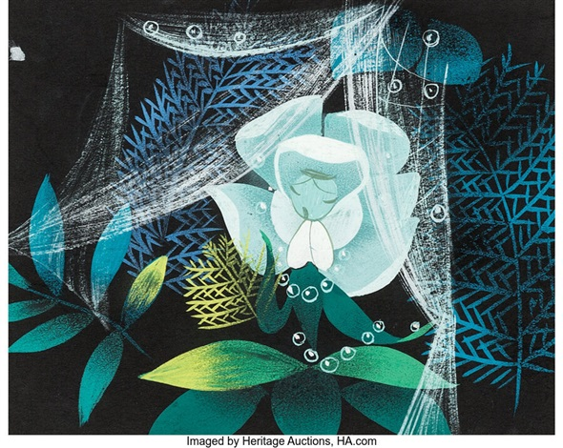
Figure 4: White Rose Concept/Colour Key Painting
(Mary Blair, 1951)
Contrary to widespread belief, there is a danger to anthropomorphism, especially with animals. Often, we look at the expressions or body language of animals and wildly misinterpret it as many subconsciously assign our own behaviour patterns to them. For example, photographs of primates “grinning” are found amusing to many, as it looks like they are happy, but often the baring of their teeth and squinting of their eyes conveys feeling threatened and defensive (Lathe, 2016). Greg Couch, the production designer for Epic throughout the conceptual stages said, ‘I finally realised it’s not that they’re people who wear plants. They’re plants behaving like people’ (Friedman, 2014). This displays awareness that sometimes the humanisation of the inanimate causes us to almost forget about the facts of their original non-living states. Therefore, as much as we mean well when projecting ourselves onto other species, the unbreaking assumption that we are “all the same” can ultimately cause more disconnect.
Returning to Greek anthropomorphisation, discussions of this practice were had also, particularly from philosophers and theorists such as Xenophanes. He called out how people frequently gravitated towards humanising the Gods:
But if horses or oxen or lions had handsor [sic] could draw with their hands and accomplish such works as men, horses would draw the figures of the gods as similar to horses, and the oxen as similar to oxen, and they would make the bodiesof [sic] the sort which each of them had. — Fragment 15
(Buckingham, 2021)
Representations of Gods are seen in old Greek art, architecture, and landmarks like the Siphnian treasury; human figures of gods like Aphrodite, Apollo, and Zeus sculpted into the relief along its frieze (Gagarin, 2010). Humans anthropomorphising is inevitable, even on the topic of all-powerful, incomprehensible being like religious figures, gods, and higher powers. This falls into a subgenre of anthropomorphisation coined by American philosopher Mourelatos - ‘epistemic anthropo-philautia'.
[...] the species-philautia [philautia meaning self-love] we indulge in when we project upon the cosmos structures and forms that cognitively afford special intuitive appeal to us human beings
(Coope, 2021).
We are so different in form and power from these gods that it is very tempting to portray them in our image, lest it make us feel isolated and small.
Floriography
The Roman Goddess of Flowers – Flora – as depicted in art as far back as the 1st Century, represented fertility, nature, and flowers. The word flora as a scientific umbrella term for the plants of a specific area even derived from her name, connecting her to the practice of botany.
Cultivating women, cultivating science (1996, pp. 156-7) tells how English botanist, John Lindley, made it a goal to separate men and women in the practice of botany, suggesting people had considered it ‘an amusement for ladies rather than an occupation for the serious thoughts of man’. His speech, rampant with blatant misogyny, wished for practices of botany to become purely professional, scientific, and exclusive to men.
‘The link between women and botany was to be severed [...] Flora was once again to be expelled [...]’ (Howard-Borjas, 2001).
Flora’s initial “expulsion” likely referred to puritans’ attempts to crack down on and criticize festivals such as May Day. This has some Roman origins from Floralia (a festival in which Flora was celebrated and honoured in the hopes of floral and agricultural prosperity) which often featured nudity, indulgence, and “blasphemy” (Carr, 2022).

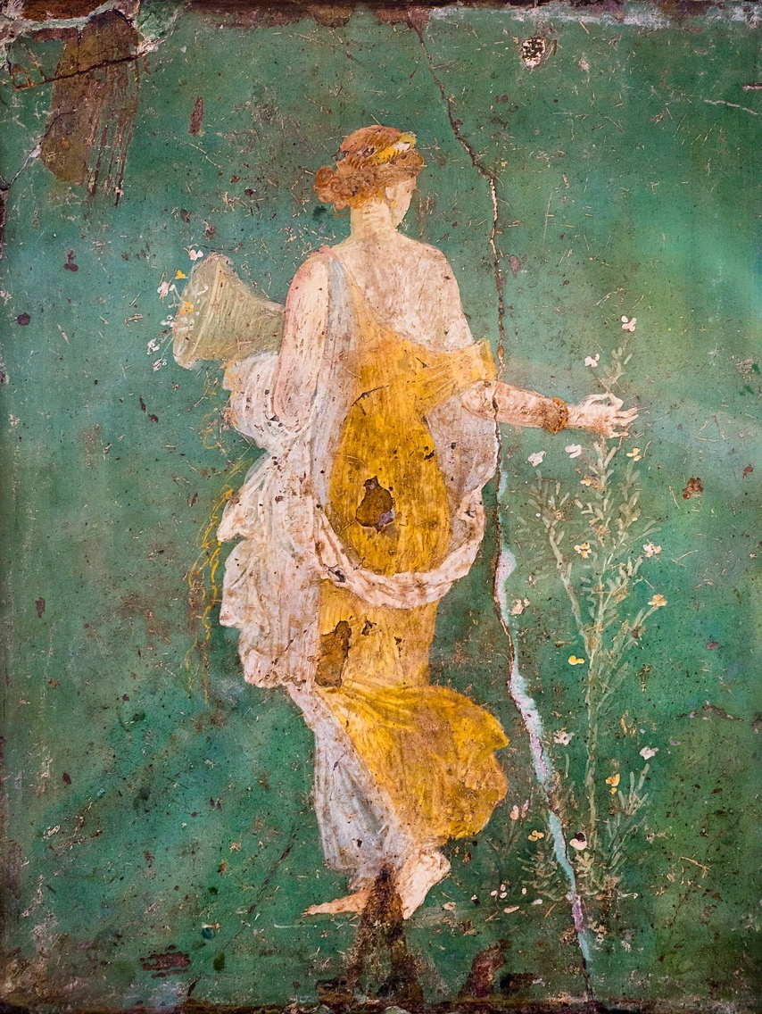

Figure 5: Cosiddetta Flora
(c. 15-45 AD)
‘Our love affair with flowers is deeply rooted in our history’ (Flying Flowers, n.d.). Alongside the popularization of botany in the 18th and 19th centuries came floriography or “the language of flowers”. English writer and poet, Lady Mary Wortley Montagu, wrote of a Turkish game called “Sélam” in which women gifted each other objects that rhymed with the message they were trying to convey. Although Montagu slightly misinterpreted this practice, her letters influenced the resurging popularity of floriography years later in the 19th Century (Weiner, 2021).
This is why books like “Les Fleurs Animées” existed (Les Fleurs Animées being more of a satire of flower books) (Vanderbilt University, 2020). Handbooks for decoding floral arrangements were available like “The artistic language of flowers” (1888), detailed with illustrations of flowers and complete lists of feelings and statements that each flower symbolised, even down to the different colour variations of one type of flower. Floriography was a way to be evasive in the Victorian era, as expression of affection or any extreme feelings was very taboo (Chatterton, 2020). Flower symbolism is also used in country emblems. Each country has their own National Flower, so flowers’ meanings have various contexts; The Daffodil is the National Flower of Wales, but in the language of floriography, it stands for: Unrequited love; regard; chivalry (Paul, J et al. No date).
Floriography and symbolism especially influenced pre-Raphaelite artworks, a famous example being Millais’ Ophelia;
Fidelity to botanic detail was an essential feature in the interpretation of Ophelia’s tragedy. Her withering flowers forecasted her doom, and when her seemingly senseless chatter gave way to deathly silence, they gave pitiful testimony to all that she had lost
(Mancoff, 2003).

In a lot of these paintings' symbolism – particularly flower symbolism - is used to emphasize the meaning, tone and narrative whilst maintaining realism, accuracy to life, and observation of nature as that is what the pre-Raphaelites strived for in their beliefs of what art should be (Tate, 2017).
John Ruskin, philosopher, and art historian told artists of this pre-Raphaelite mindset to 'go to nature in all singleness of heart [...]’ (Chatfield, 2019). It can be argued that the pre-Raphaelites ran on quite a biophilic approach to their art, taking the observation and inclusion of nature very seriously and wanting to paint botanical aspects as accurately as possible. The theory of Biophilia is of our innate desire to interact with nature; another way for us to feel connected to our surroundings. Philosophers and naturalists, Erich Fromm, and Edward O Wilson both discussed this hypothesis, Wilson’s being more exclusively based in nature and sociobiology, but Fromm’s drawing an additional connection to people and love, describing it as ‘[...] the wish to further growth [...]’ (Ludewig, 2023). As explored before, our biophilic nature shows through art, our subconscious anthropomorphisation of nature and our desire to escape; since interaction with nature is often encouraged when dealing with overstimulation and stress (British Heart Foundation, 2023).

Through my research I have found that we can use escapism as a tool to explore topics and emotions indirectly, and that Freud’s pleasure principle is what makes our desire to escape so instinctual and strong. Personification has similar effects on us; we anthropomorphize to feel less lonely, even if we know it is not realistic. Floriography and botany presented me with the personified Goddess Flora whose presence in roman religion connected humans with the land, the language of flowers and how it connected and allowed the Victorians to voice intimate feelings, and how pre-Raphaelites had biophilic mindsets towards their research and observation methods when it came to perfecting the botanical features of their works.

After this initial exploration, I propose this question for my independent project:
Stepping into the Fairy Circle: Why do we desire an escape so much and reject reality so often; is a biophilic approach to this desire better than or equal to the use of fictional storytelling to feel satisfied?
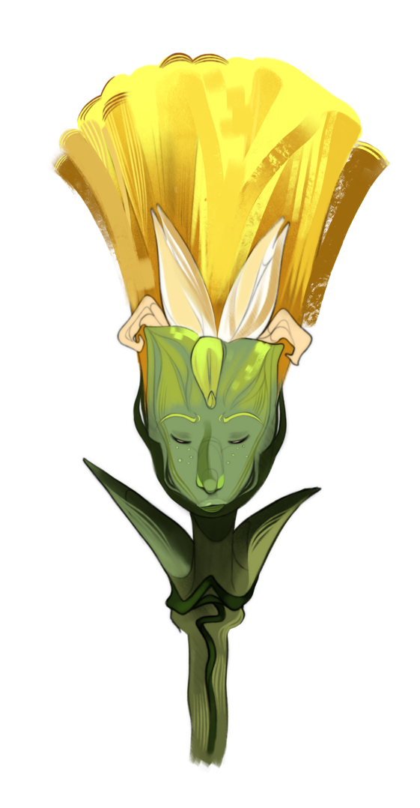
Figure 6
For my practice, I want to design Illustrated flower seed packaging. Each seed packet will be for different flowers, and each illustration will be a personified character design of whatever flower the seeds will grow. Character design is an integral part of my illustrative brand, so this will be best suited. I also wanted my practice to be a little more unique, as flower seed packaging in the mainstream market is not particularly illustrative.

Reference list
(author unknown) (1888) ‘The Artistic language of flowers’. London & New York: G. Routledge & sons.

Attebery, B. (2022) Fantasy: How it works. Oxford, England: Oxford University Press.

British Heart Foundation (2023) 7 ways to reduce your stress by enjoying nature, BHF. Available at: https://www.bhf.org.uk/informationsupport/heart-matters-magazine/wellbeing/ways-to-reduce-stress-by-enjoying-nature (Accessed: 21 April 2024).

Buckingham, W. (2021) Xenophanes on gods and horses: Will buckingham, Xenophanes on gods and horses | Will Buckingham. Available at: https://www.willbuckingham.com/xenophanes/ (Accessed: 12 March 2024).

Carr, H. (2022) What is the history behind May Day and why do we celebrate it?, HistoryExtra. Available at: https://www.historyextra.com/period/medieval/may-day-history-origins-celebrate-pagan-bank-holiday-maypole-facts-explain/ (Accessed: 21 April 2024).

Chatfield, S. (2019) “Go to nature in all singleness of heart”, Pre-Raphaelite Sisterhood. Available at: https://preraphaelitesisterhood.com/go-to-nature-in-all-singleness-of-heart/ (Accessed: 21 April 2024).

Chatterton, M. (2020) Decoding the victorian flower language: A floriography guide, Lillicoco. Available at: https://www.lillicoco.com/blogs/love-lillicoco-blog/decoding-the-victorian-flower-language-a-floriography-guide (Accessed: 12 March 2024).

Chen, C.-Y. and Zhunag, X.-Q. (2023) ‘The image ratios for designing cute nonhuman anthropomorphic characters’, Entertainment Computing, 47. doi:10.1016/j.entcom.2023.100586.

Cherry, K. (2023) How Freud’s Pleasure Principle Works, Verywell Mind. Available at: https://www.verywellmind.com/what-is-the-pleasure-principle-2795472 (Accessed: 13 April 2024).

Disney+ (2022) The Art of Disney Legend Mary Blair | Women's History Month | Disney+. Available at: https://www.youtube.com/watch?v=klznaOeSdpI (Accessed: 13 April 2024).

Flying Flowers (no date b) Guide to national flowers, Flying Flowers. Available at: https://www.flyingflowers.co.uk/page/flowers/national-flowers (Accessed: 24 April 2024).

Friedman, J.S. (2014) The Art of Blue Sky Studios. San Rafael, California: Insight Editions.
Gagarin, M. (2010) The Oxford Encyclopedia of Ancient Greece and Rome Vol 1. Oxford: Oxford University press.
Howard, P.L. (2001) Women in the plant world: the significance of women and gender bias for botany and for bio-diversity conversation, Wageningen university. Available at: https://edepot.wur.nl/234682 (Accessed: 02 March 2024).

kalia, S. (2021) Escapism is a way to cope under stress. but it can also become a tool for self‑deception, The Swaddle. Available at: https://www.theswaddle.com/escapism-is-a-way-to-cope-under-stress-but-it-can-also-become-a-tool-for-self-deception (Accessed: 13 April 2024).

Karr, A. et al. (1867) Les Fleurs animées. Paris, France: Blot.

Lathe, S. (2016) The dangers of anthropomorphism, Vet Tails. Available at: https://www.vettails.com/vettails/2016/3/4/the-dangers-of-anthropomorphism (Accessed: 13 April 2024).

Ludewig, J. (2023) Erich Fromm’s biophilia, NiCHE. Available at: https://niche-canada.org/2023/07/06/erich-fromms-biophilia/#:~:text=His concept of “biophilia” exemplifies,” (1973%2C 366). (Accessed: 21 April 2024).

Luu, C. (2016) Personification is your friend: The language of inanimate objects, JSTOR Daily. Available at: https://daily.jstor.org/personification-is-your-friend-the-amazing-life-of-letters/ (Accessed: 19 February 2024).

Mancoff, D.N. (2003) Flora symbolica : flowers in Pre-Raphaelite art. Munich, Germany: Prestel.

Manty, K. (2020) The wonderfully odd world of French artist J. J. Grandville, Kovels Antique Trader. Available at: https://www.antiquetrader.com/art/the-wonderfully-odd-world-of-french-artist-j-j-grandville (Accessed: 04 March 2024).

Parsons, M. (2023) Escapism: When it’s healthy, when it harms, The Meadows Malibu. Available at: https://meadowsmalibu.com/escapism-when-its-healthy-when-it-harms/ (Accessed: 13 April 2024).

Paul, J. and Dusseault, T. (No date) ‘Victorian Floral Code’. Eugene: Creative Graphics Floral Gifts.

Ray, G.N. (1982) The art of the French illustrated book, 1700-1914. New York: The Pierpont Morgan Library.

Sattler, B.M. and Coope, U. (2023) ‘Chapter 4 - Anthropomorphism and Epistemic Anthropo-philautia: The Early Critiques by Xenophanes and Heraclitus’, in Ancient ethics and the natural world. Cambridge, England: Cambridge University Press.

Shah, B. (2022) Why fiction as escapism is healthy, Book Therapy. Available at: https://www.booktherapy.io/blogs/book-therapys-ask-the-bibliotherapist-blog/why-fiction-as-escapism-is-healthy (Accessed: 19 March 2024).
Shteir, A.B. (2005) Cultivating women, Cultivating science: Flora’s daughters and botany in England, 1760 to 1860. New York: ACLS History E-Book Project.

Tate (2017) Pre-Raphaelite, Tate. Available at: https://www.tate.org.uk/art/art-terms/p/pre-raphaelite (Accessed: 21 April 2024).

Vanderbilt University (no date) Les Fleurs animées, Fables Fantasies The Illustrations of JJ Grandville. Available at: https://exhibitions.library.vanderbilt.edu/grandville/item/les-fleurs-animees/#:~:text=The stories are parables of,leaf%2C and the cactus flower (Accessed: 13 April 2024).

Weiner, E. (2021) FLORIOGRAPHY: The Secret Language of Flowers, Erica Weiner. Available at: https://www.ericaweiner.com/history-lessons/floriography-the-secret-language-of-flowers#:~:text=Floriography allowed the Victorians to,without saying anything at all.&text=Floriography%2C the cryptological communication through,originated a bit before then. (Accessed: 04 March 2024).

Bibliography
(author unknown) (1888) ‘The Artistic language of flowers’. London & New York: G. Routledge & sons.

(author unknown) (2016) The evolution of anthropomorphism in animated movies, Sweet Animated Films. Available at: https://sweetanimatedfilms.wordpress.com/2016/03/13/the-evolution-of-anthropomorphism-in-animated-movies/ (Accessed: 12 March 2024).

Aloi, G. (2019) Why look at plants?: The Botanical Emergence in contemporary art. Leiden, Netherlands: Brill Rodopi.

Art of Mourning (2022) Jewels, symbolism, botany and Floriography, Art of Mourning. Available at: https://artofmourning.com/understanding-symbolism-botany-and-floriography/ (Accessed: 04 March 2024).

Attebery, B. (2022) Fantasy: How it works. Oxford, England: Oxford University Press.
British Heart Foundation (2023) 7 ways to reduce your stress by enjoying nature, BHF. Available at: https://www.bhf.org.uk/informationsupport/heart-matters-magazine/wellbeing/ways-to-reduce-stress-by-enjoying-nature (Accessed: 21 April 2024).

Brunetti, I. (2011) Cartooning: Philosophy and practice. New Haven, Connecticut: Yale University Press.

British Heart Foundation (2023) 7 ways to reduce your stress by enjoying nature, BHF. Available at: https://www.bhf.org.uk/informationsupport/heart-matters-magazine/wellbeing/ways-to-reduce-stress-by-enjoying-nature (Accessed: 21 April 2024).

Buckingham, W. (2021) Xenophanes on gods and horses: Will buckingham, Xenophanes on gods and horses | Will Buckingham. Available at: https://www.willbuckingham.com/xenophanes/ (Accessed: 12 March 2024).

Byron’s Muse (2023) J.J. Grandville: Flowers personified (Les Fleurs Animées). Available at: https://byronsmuse.wordpress.com/2023/05/28/j-j-grandville-flowers-personified-les-fleurs-animees/ (Accessed: 13 April 2024).

Carr, H. (2022) What is the history behind May Day and why do we celebrate it?, HistoryExtra. Available at: https://www.historyextra.com/period/medieval/may-day-history-origins-celebrate-pagan-bank-holiday-maypole-facts-explain/ (Accessed: 21 April 2024).

Chatfield, S. (2019) “Go to nature in all singleness of heart”, Pre-Raphaelite Sisterhood. Available at: https://preraphaelitesisterhood.com/go-to-nature-in-all-singleness-of-heart/ (Accessed: 21 April 2024).

Chatterton, M. (2020) Decoding the victorian flower language: A floriography guide, Lillicoco. Available at: https://www.lillicoco.com/blogs/love-lillicoco-blog/decoding-the-victorian-flower-language-a-floriography-guide (Accessed: 12 March 2024).

Chen, C.-Y. and Zhunag, X.-Q. (2023) ‘The image ratios for designing cute nonhuman anthropomorphic characters’, Entertainment Computing, 47. doi:10.1016/j.entcom.2023.100586.

Cherry, K. (2023) How Freud’s Pleasure Principle Works, Verywell Mind. Available at: https://www.verywellmind.com/what-is-the-pleasure-principle-2795472 (Accessed: 13 April 2024).

Disney+ (2022) The Art of Disney Legend Mary Blair | Women's History Month | Disney+. Available at: https://www.youtube.com/watch?v=klznaOeSdpI (Accessed: 13 April 2024).

Dukes, H. (2012) J. J. Grandville’s illustrations from the Flowers personified (1849), The Public Domain Review. Available at: https://publicdomainreview.org/collection/the-flowers-personified-1847/ (Accessed: 13 April 2024).

Flying Flowers (no date b) Guide to national flowers, Flying Flowers. Available at: https://www.flyingflowers.co.uk/page/flowers/national-flowers (Accessed: 24 April 2024).

Friedman, J.S. (2014) The Art of Blue Sky Studios. San Rafael, California: Insight Editions.

Gagarin, M. (2010) The Oxford Encyclopedia of Ancient Greece and Rome Vol 1. Oxford: Oxford University press.

Grandville et al. (1867) Les Fleurs animées. Paris, France: Blot.

Heller, S. (2008) In praise of the anthropomorphic, Design Observer. Available at: https://designobserver.com/feature/in-praise-of-the-anthropomorphic/7537 (Accessed: 12 March 2024).

Howard, P.L. (2001) Women in the plant world: the significance of women and gender bias for botany and for bio-diversity conversation, Wageningen university. Available at: https://edepot.wur.nl/234682 (Accessed: 02 March 2024).

Inner Mastery Hub (2023) Escaping Reality — Avoidance Or Healing?, Medium. Available at: https://medium.com/@mehwishqurayshi/escaping-reality-avoidance-or-healing-ac780ed475 (Accessed: 12 March 2024).

kalia, S. (2021) Escapism is a way to cope under stress. but it can also become a tool for self‑deception, The Swaddle. Available at: https://www.theswaddle.com/escapism-is-a-way-to-cope-under-stress-but-it-can-also-become-a-tool-for-self-deception (Accessed: 13 April 2024).
Karr, A. et al. (1867) Les Fleurs animées. Paris, France: Blot.
Kuntjara, H. and Almanfaluthi, B. (2021) ‘Character design in games analysis of character design theory’, Journal of Games, Game Art, and Gamification, 2(2), pp. 42–47. doi:10.21512/jggag.v2i2.7197.

Lathe, S. (2016) The dangers of anthropomorphism, Vet Tails. Available at: https://www.vettails.com/vettails/2016/3/4/the-dangers-of-anthropomorphism (Accessed: 13 April 2024).

Leonardo (2020) The importance of immersive character design and world-building, Demodern. Available at: https://demodern.com/blog/the-importance-of-immersive-character-design-and-world-building (Accessed: 12 March 2024).

Ludewig, J. (2023) Erich Fromm’s biophilia, NiCHE. Available at: https://niche-canada.org/2023/07/06/erich-fromms-biophilia/#:~:text=His concept of “biophilia” exemplifies,” (1973%2C 366). (Accessed: 21 April 2024).

Luu, C. (2016) Personification is your friend: The language of inanimate objects, JSTOR Daily. Available at: https://daily.jstor.org/personification-is-your-friend-the-amazing-life-of-letters/ (Accessed: 19 February 2024).

Mainardi, P. (2018) Grandville, visions, and dreams, The Public Domain Review. Available at: https://publicdomainreview.org/essay/grandville-visions-and-dreams/ (Accessed: 13 April 2024).

Mancoff, D.N. (2003) Flora symbolica : flowers in Pre-Raphaelite art. Munich, Germany: Prestel.
Manty, K. (2020) The wonderfully odd world of French artist J. J. Grandville, Kovels Antique Trader. Available at: https://www.antiquetrader.com/art/the-wonderfully-odd-world-of-french-artist-j-j-grandville (Accessed: 04 March 2024).

Mapplethorpe, R. et al. (1990) Flowers. Boston, Massachusetts: Bulfinch Press, an imprint of Little, Brown and Company.

Mario, A. (2023) Exploring cartoons as a form of escapism: The Escapist Symphony, Toons Mag. Available at: https://www.toonsmag.com/cartoons-as-a-form-of-escapism/ (Accessed: 12 March 2024).

Martinelli , O.G. (2022) Anthropomorphism in art, Artmajeur Online Art Gallery. Available at: https://www.artmajeur.com/en/magazine/5-art-history/anthropomorphism-in-art/331981 (Accessed: 02 March 2024).

mecc interiors (2022) Why introduce biophilic art to your home now?, mecc interiors inc. Available at: https://meccinteriors.com/designbites/introduce-biophilic-art-to-your-home/ (Accessed: 06 February 2024).

Norman, P. (no date) Biophilia – what is it and why is it important?, Planteria. Available at: https://www.planteriagroup.com/blog/biophilia-what-is-it-and-why-is-it-important/ (Accessed: 06 February 2024).

Parsons, M. (2023) Escapism: When it’s healthy, when it harms, The Meadows Malibu. Available at: https://meadowsmalibu.com/escapism-when-its-healthy-when-it-harms/ (Accessed: 13 April 2024).

Paul, J. and Dusseault, T. (No date) ‘Victorian Floral Code’. Eugene: Creative Graphics Floral Gifts.

Ray, G.N. (1982) The art of the French illustrated book, 1700-1914. New York: The Pierpont Morgan Library.

Sattler, B.M. and Coope, U. (2023) ‘Chapter 4 - Anthropomorphism and Epistemic Anthropo-philautia: The Early Critiques by Xenophanes and Heraclitus’, in Ancient ethics and the natural world. Cambridge, England: Cambridge University Press.

Schiebel, T. et al (2022) ‘Testing the biophilia theory: Automatic approach tendencies towards nature’, Journal of Environmental Psychology, 79. doi:10.1016/j.jenvp.2021.101725.

Shah, B. (2022) Why fiction as escapism is healthy, Book Therapy. Available at: https://www.booktherapy.io/blogs/book-therapys-ask-the-bibliotherapist-blog/why-fiction-as-escapism-is-healthy (Accessed: 19 March 2024).

Shapiro, H.A. (1993) Personifications in Greek art: The representation of abstract concepts, 600-400 B.C. Zürich, Switzerland: Akanthus Verl.

Shteir, A.B. (2005) Cultivating women, Cultivating science: Flora’s daughters and botany in England, 1760 to 1860. New York: ACLS History E-Book Project.

Something Curated (2023) On anthropomorphism in art, Something Curated. Available at: https://somethingcurated.com/2023/09/05/on-anthropomorphism-in-art/#:~:text=Contemporary theologians have asserted that,language represents an anthropomorphic proclivity (Accessed: 02 March 2024).

Spec (2012) From the stacks: Grandville’s Les Fleurs Animées (the flowers personified), Walter Havighurst Special Collections The University Archives Preservation. Available at: https://spec.lib.miamioh.edu/home/from-the-stacks-grandvilles-les-fleurs-animees-the-flowers-personified/ (Accessed: 13 April 2024).

Tate (2017) Pre-Raphaelite, Tate. Available at: https://www.tate.org.uk/art/art-terms/p/pre-raphaelite (Accessed: 21 April 2024).

Tate (no date) How to paint a flower like a pre-raphaelite, Tate. Available at: https://www.tate.org.uk/art/art-terms/p/pre-raphaelite/how-to-paint-a-flower-like-a-pre-raphaelite#:~:text=The Pre-Raphaelites were greatly,a character’s mood or circumstance (Accessed: 04 March 2024).

Thornton, R.J. (1812) The temple of Flora. London, England: Dr. Thornton.

Vanderbilt University (no date) Les Fleurs animées, Fables Fantasies The Illustrations of JJ Grandville. Available at: https://exhibitions.library.vanderbilt.edu/grandville/item/les-fleurs-animees/#:~:text=The stories are parables of,leaf%2C and the cactus flower (Accessed: 13 April 2024).

Weiner, E. (2021) FLORIOGRAPHY: The Secret Language of Flowers, Erica Weiner. Available at: https://www.ericaweiner.com/history-lessons/floriography-the-secret-language-of-flowers#:~:text=Floriography allowed the Victorians to,without saying anything at all.&text=Floriography%2C the cryptological communication through,originated a bit before then. (Accessed: 04 March 2024).

Whelan (2021) Flora, goddess of spring, and her festival floralia, Classical Wisdom Weekly. Available at: https://classicalwisdom.com/mythology/gods/flora-goddess-of-spring-and-her-festival-floralia/ (Accessed: 21 April 2024).

Wikipedia (2024) Flora (mythology), Wikipedia. Available at: https://en.wikipedia.org/wiki/Flora_(mythology) (Accessed: 21 April 2024).

Wikipedia (2024) Floralia, Wikipedia. Available at: https://en.wikipedia.org/wiki/Floralia (Accessed: 21 April 2024).

Wilson, E.O. (1984) Biophilia. Cambridge, Massachusetts: Harvard University Press.

List of Figures

Fig 1, Epic (2013) animationscreencaps.com. Available at: https://animationscreencaps.com/epic-2013/page/34#google_vignette (Accessed: 13 April 2024).

Fig 2, Craig, H. (1983) Angelina Ballerina [watercolour and ink on paper]. Available at: https://www.npr.org/2022/09/25/1122951295/angelina-ballerina-katharaine-holabird-helen-craig (Accessed: 19 March 2024).

Fig 3, Grandville, J.J. (1846) 'Bal' (The Ball) [colour lithograph]. Available at: https://arthive.com/sl/grandville/works/553175~A_ball_of_flowers_The_series_Animate_Flowers (Accessed: 14 March 2024).

Fig 4, Blair, M. (1951) White Rose Concept/Colour Key Painting [designers’ gouache]. Available at: https://www.artnet.com/artists/walt-disney-studios/mary-blair-alice-in-wonderland-white-rose-F5rxkMi5wsxDeiZHtOC62Q2 (Accessed: 13 April 2024).

Fig 5, (artist unknown) (c. 15-45 AD) Cosiddetta Flora [wall Fresco]. Available at: https://en.wikipedia.org/wiki/Flora_(mythology) (Accessed: 13 April 2024).

Fig 6, Rees, L. (2023) Personified Daffodil [Digital painting]

