Personal Evaluation – to support your academic progress, we are interested to read your own assessment of this work as a measure of your own effort and in order that we may comment on your strengths and weaknesses.
Please ensure you complete this assessment before submitting your work.
What do you consider are the best aspects of this piece of work? | Good use of supporting evidence
Which aspects do you consider could have been improved in this piece of work? | Write more critically
What have you found most satisfying whilst undertaking this submission? | Learning about the differences between leadership and management and how they can be influenced
What were your previous targets? Explain how you have addressed these in this piece of work. | To improve time management. Managed my time far more effectively by being organised with tasks and setting goals

SJED7040 1402362
Assignment 1

This case study aims to critically reflect on the Successful Futures report and ideas of Donaldson in regard to the need for changes to the curriculum in Wales. It will analyse the implementation of the initiative whilst evaluating the leadership and management approaches that are or may be used to initiate the change and the demands this has placed on educational leaders.
There was an urgent need for changes to the curriculum in Wales after both poor Programme for International Student Assessment (PISA) results and inspection reports (Estyn, 2014-2015; Egan, 2017) which brought about the Donaldson Successful Futures report which was published on the 25th February 2015 (Donaldson, 2015a). The report suggests necessary curriculum changes needed in Wales to allow children to become more adaptable and motivated to continue learning new skills that employers want to see as the world changes. In his report, Donaldson (2015b) proposed that the curriculum in schools should contain four embedded purposes to improve the future of Welsh learners which are; to create ambitious, capable learners that are creative thinkers and healthy, confident individuals who are ethical, informed citizens. Donaldson (2015b) also suggests that improvements would also require new assessment arrangements with digital competency being added to the curriculum and holding as much importance as literacy and numeracy as one of the basic foundations needed for success. Donaldson (2015b) suggests that the new curriculum should be broad, balanced, inclusive and challenging and should give a wide range of both experiences and opportunities to encourage creative, connected learning through his six suggested areas of learning and experience which are, expressive arts, health and well-being, humanities, languages, literacy and communication, mathematics and numeracy and science and technology (Welsh Government, 2017).
After the Successful Futures report it was determined that changes were needed in the Welsh curriculum to provide children with the tools they needed to be successful in today’s society and since the report the Welsh Government (2017) have begun to develop a new curriculum for Wales and claims that a first draft will be available by April 2019 with the final version being published by January 2020. The Welsh Government (2017) is aiming to have this new curriculum actively used throughout Wales by 2022 and the intention of this case study is to not only reflect on the need for the change but also analyse and evaluate the difficulties the new implementation may create and how educational leaders can successfully overcome these barriers.
As mentioned in the introduction the need for changes in the Welsh Curriculum were noticed after the poor results from PISA tests (Egan, 2017). PISA is a study performed worldwide by the Organisation for Economic Co-operation and Development (OECD) to compare the performance of 15 year olds in areas of mathematics, science and reading and its aim is to enable countries to make improvements to their education systems and their outcomes by measuring problem solving and cognition skills in everyday life situations (Berger, 2013; Rey, 2010; OECD, 2016). International assessments of educational attainment are being increasingly utilised world-wide to improve educational policies with many countries using PISA to develop more appropriate National assessment procedures and educational policies (Rey, 2010; Breakspear, 2012). It appears to have been widely accepted by education policy makers, including those for Wales, that PISA is a reliable and valid tool for benchmarking international performance and a considerable number of countries have begun to reform their education policies in response to PISA results regardless as to whether they have scored a high, low or average score (Breakspear, 2012).
After a considerably low score for Wales in the PISA 2009 and 2012 results the Education Minister for Wales called upon Graham Donaldson to conduct a report to enhance the educational achievements and futures of the children of Wales (Donaldson, 2015a). The report, from the very beginning recognises and expresses the importance of the need for change in education to allow education to adapt to the changes in the world and society (Donaldson, 2015b) an important factor that is also recognised by OECD (2017) and Williams and Rowlands (2017). Donaldson (2015b) suggests that the curriculum has become heavily out dated and in his report, makes sixty eight recommendations for the new curriculum in Wales. The recommendations of Donaldson in this review are most certainly relevant to the learning requirements of today’s children but it is important to consider here the reality of creating an educational reform, not only in Wales but anywhere. The ideas of the new curriculum are made very clear by Donaldson (2015b) through the use of the four main objectives of the new curriculum that young people are expected to become successful learners, confident individuals, responsible citizens and effective contributors through their education and are supported by OECD (2017) but criticized by writers such as Watson (2010) who claims that the objectives are less to do with what children should know and more about how they should act.
It is also important to consider the validity of the findings from PISA during this case study as they are predominantly what have influenced this education reform in Wales. Research suggests that there are a number of issues with the survey methodology used to obtain the PISA data and criticisms of its methodology began near enough at the same time as the first tests when Prais (2003) began to question the use of inappropriate samples due to the fact that in the 2000 tests included pupils over the age of fifteen as well as some students that had re-sat the year suggesting that the inappropriate methodology used in fact showed a false improvement in the attainment of British students in comparison to their Swiss and German counterparts. Together with the criticisms of Prais (2003) there are criticism regarding the sampling used by a number of different theorists. One of these criticisms is that it is not possible to achieve balanced sampling by using either age or grade based sampling (Strietholt. Rosen and Bos, 2013) and there are flaws in the evaluative design as although sociological variables are included in the design there is no inclusion of psychological, cultural or pedagogical variables which earlier researchers consider of great importance in such studies (Wang, Haertel & Walberg, 1993). These criticisms suggest that although PISA has generated large amounts of useful research and is an international evaluative macro-study it is important to use caution to not solely use these results to influence any educational reform.
There have also been a number of questions raised by education experts with regard to the PISA assessments in more recent years with headlines in The Guardian (2014) claiming that Pisa assessments are actually damaging education throughout the world in the publication of a letter from a number of education experts who claim that the PISA tests have encouraged more testing increasing the reliance of quantitative research in education as appose to qualitative which is seen by many as important in education research (Alasuutari, 2010; White, 2011; Maxwell, 2012). It is important here to mention that the PISA test results were not the only reason behind the call for the successful futures report there was calls for changes in the curriculum due to advances and more usage of technology, economic pressure and poor GCSE results issues that Donaldson (2015b) has recognised and attempted to tackle in his successful futures report.
It is extremely important to consider the role of not only educational leaders in the reform but also the teachers and as suggested by Supovitz (2008) the issue of the gap between the intention of the policies and the actual practice within the classroom is a gap that relies on the capability of the teachers to close (Osbourne, Croll, Broadfoot, Pollard, McNess and Triggs, 1997) and in order to incorporate the advice given by Donaldson (2015b) in his report to improve the outcomes for Welsh children there will need to be an organizational, sustainable change throughout Welsh schools led by appropriate leaders.
Despite the urgency of the need for change in the Welsh curriculum for it to be done appropriately and successfully it is going to take a considerable amount of time and Doanaldson (2015b) respects the fact that it is going to take time to implement it in schools and suggests that it be done in a very patient manner with discussions between teachers, school leaders, parents and pupils. Donaldson suggests that assessment should not be the purpose of the learning but should be used to support it. He believes that there is an inappropriate balance between the curriculum and assessment which he attempts to rectify in his report. There are many sound suggestions in the Successful futures report for educating young people for the 21st century but the job of implementing it will be that of the educators through successful leadership and management (Hughes, 2015).
A number of sources suggest that in order for change to be implemented successfully then there must be solid, successful leadership and management in place (DuFour and Mattos, 2013; Fullan, 2002; Fullan 2011; Morrison 1998; Wells and Feun 2013) and it is important to prioritise the development of educational staff that show signs of potential for becoming good leaders (Beare, Caldwell and Millikan, 1989). The focus needs to shift from single person leadership to collaborative or distributed leadership in order for the proposed changes to be successful and leaders will need to be flexible in their approaches (DuFour and Mattos, 2013; Hallinger and Heck, 2010; Mendels and Mitgang, 2013) it is imperatively important that all educational staff are on board with the changes to be made in order for there to be a successful change in the curriculum (Bush, 2011; Morrison, 2013). Despite the numerous sources suggesting that distributed, collaborative leadership is key for the successful implementation of change it is argued by Morrison (2013) that there is a lack of credible evidence to support this theory along with little evidence to suggest that it supports student learning any better than other leadership methods. Suggestions can also be found that the concentration needs to focus on how things are done as appose to what is being done and that the maintenance of good working conditions, motivation and commitment are key responsibilities of leaders who must be responsive during the change and after (Leithwood, Harris and Hopkins, 2008).
To enable the implementation of Donaldson’s suggestions in the successful futures report there is going to have to be a successful management and leadership structure in place as Kotterman (2006) suggests that for an organisation to be well balanced it needs a mixture of both good managers and leaders. It is important to define the differences between the two in order for this to be done flourishingly. This is done in multiple ways by different researchers Kotter (2011) for example suggests that leaders are responsible for setting directions, motivating, inspiring and aligning people whereas the role of managers is to achieve goals through organisation, planning and budgeting whilst Capowski (1994) adds that a leader should be flexible, innovative, independent and courageous and a manager needs to be deliberate, analytical, stabilizing and authoritative to ensure the success of an organisation and although it can be difficult to view the education system in the same way as a business it is in fact that as although there is the need for great leaders to motivate and inspire there is also a need for great managers to budget and control costs to enable changes to be sustainable for the future which is an important point to consider when discussing the implementation of Successful Futures.
The Successful future report has called for a huge organizational change and it would be naive to assume that this is going to be an easy transition for anyone involved. The Welsh Government have to persuade educational leaders of the need for this change and in turn they have to persuade teachers and parents. Change needs to be managed effectively and management are required to obtain the commitment of everyone within the organization in order for the change to be successfully implemented and involves adapting the organization to external changes (Recklies, 2001). As discussed earlier there is a significantly large time gap between the release of the report and final implementation of the new curriculum but theory and research suggest that it is better to not rush any organisational change and ensure that appropriate steps are taken to influence the smoothest transition possible which it would appear that the Welsh Government are attempting to do with the new curriculum implementation. Johnson, Zorn, Tam, Lamontagne and Johnson (2003) along with other researchers discuss the issues that management face when attempting to get the whole of the organization to participate in a change, they advise that organizations should identify and discuss any issues or challenges that may be faced from the outset clearly defining the goals and anticipated outcomes of the effort (Hoel, 1998; Chiat and Mickiewicz, 1999) this is supported by Cohen and Mankin (2002) who suggest it is necessary to have a clear structure with established goals, roles responsibilities and tasks which can be suggested has been done by Graham Donaldson and the Welsh Government through the development of the Successful futures report and any recommendations from the Welsh Government. The responsibility is now to be passed down to school teachers to manage the change within individual schools, a task that will not be easy and brings us back to the topic of successful management and leadership.
It is important to stress here that throughout the literature it is suggested that there are significant links between successful implementation of change and a reciprocal relationship between leadership and management (Morrison, 2013) and whilst both hold different tasks described appropriately in Bush and Glover (2003) as leadership initiating the change and management maintaining it a change cannot be successfully implemented without correlations and good communication between both on not only the macro level but the micro also especially when implementing a change on such a large scale as that of the Successful Futures report. An important part of obtaining full participation is knowing employees motivators to obtain desired results (Rad, 2006).
Since the publication of the Successful Futures report there seems to have been a general understanding, primarily so from Donaldson himself, about the difficulties that will be faced in implementing the curriculum changes none more so than the issue of resistance to change as it is a well-known fact that individuals can be resistant to change for a number of reasons including the feeling of losing control, uncertainty, embarrassment of previous failures that they were part of, concerns over their competency, the fear of a larger work load, to name but a few and when implementing any change it is important that leaders plan the change and recognise any possible reasons for resistance before attempting to implement the change to enable them to be responsive to any resistance at the earliest opportunity (Dent and Gallaway Goldberg, 1999; George and Jones, 2001; Kanter, 2012).
The literature ascertains that in order for the new curriculum to be introduced and sustained successfully excellent leadership and management of the effort will need to be initiated as these have become important traits for schools in the 21st century (Bush, 2009). The role of leaders in education is becoming more and more relevant as we move through time and there are a number of different opinions on what makes good leaders but their responsibilities as leaders are somewhat agreed upon. Whereas the management role may be seen as a role for maintenance the role of the leader is more to influence the change (Cuban, 1988; Bush, 2009). Although there is importance for both leadership and management within schools the role of leaders has become far more predominantly important in recent years in the plight for an improvement in schools (Harris, 2004; Beare, Caldwell and Milikan, 1992) making it extremely relevant for the implementation of the new curriculum with its main objective of improving outcomes for children in the 21st century. One of the main attributes that good leaders need that are talked about in the literature is their ability to have a clear vision that they can communicate in an excellent manner to obtain commitment from all the affiliates of the organisation (Beare et al,1992; Bennis and Nanus, 1985; Bush, 2009). which in this case would be the head teachers, teachers and parents. In the case of the introduction of the new curriculum it is imperative that the hierarchy that is initiating this change commit to supporting head teachers throughout the process of choosing appropriate leaders as passed studies such as that of Kouzes and Posner (1996) have suggested that heads are uncomfortable with the challenge of inspiring a shared vision.
There are a number of theories on the successful implementation of change such as that of Kotter’s 8 step model of change (Kotter and Cohen, 2002) (see appendix 1 for image) who presents a model for both the understanding and management of change with each stage acknowledging key principles to peoples approaches and responses to change. Kotter and Cohen (2002) suggests that there are eight stages that an organisation or team of people have to go through to ensure that change is implemented and stuck to. These eight steps are grouped under three smaller steps which are creating a climate for change where the organisation shares the relevance of the change to enable others to identify the purpose of the change and realise the importance of acting quickly whilst identifying any risks or opportunities that may arise through establishing a group of leaders that are encouraged to work together as a team and possess the necessary skills to lead the change developing a vision and strategies to achieve that vision to implement the change. In the case of successful futures this would happen in two specific areas, firstly from Donaldson and the Welsh Assembly Government to the head teachers then from the head teachers to the teachers and teaching assistants as the teachers will be the leaders of the change as it will be the responsibility of the heads to manage the change because as mentioned previously there is a need for both managers and leaders within an organisation and schools are no exception to this rule (Bush, 2009). The next step in Kotter and Cohen (2002) model of change is to enable and engage the whole organisation which will involve communicating what the vision is and communicating this to as many people as possible, removing barriers and encouraging risk taking to empower those involved in the change and planning short term objectives for them to aim for to avoid overwhelming them. In relation to the implementation of the successful futures report this would be where head teachers will provide their team of leaders with the necessary tools to enable them to lead change. There will need to be open lines of communication between leaders and management in identifying and illuminating barriers one of which for example could be un happy parents that have issues with the curriculum change. The final step then in Kotter’s model of change is the full implementation and the sustainability of the change. Here schools will have to be determined to overcome obstacles and barriers with persistence to enable the new curriculum to be accepted and become the new way. Kotter and Cohen (2002) believes that there are a number of main reasons for the failure of change management which include the failure to understand the need for a clear vision and the failure to communicate that vision which is something that the head teachers will need to consider when they begin to implement the new curriculum as if things aren’t clear from the start it will create more barriers than is necessary.
When considering a change on such a large scale as this it is relevant to look at a number of models of change and Lewin’s model of change (see appendix 2 for image) is also one of some interest when discussing the implementation of a new curriculum in Wales and is one of the earliest change models to be developed (Carter, 2008). Force field analysis is a method consisting of three stages, unfreezing, freezing and refreezing which basically means preparing the current mindset for change to the actual change occurring and finally the acceptance of the new mindset (Carter, 2008). This method that is widely used in organisations as part of the planning and implementation process of change within an organization and again begins with the desired outcome or goal of the change but immediately deals with the issue of potential resistance. The model consists of two lists, one on the left that lists all the reasons for change and the driving forces and the one on the right lists any forces that are or may work against the change. This then leads to a discussion on how to push the driving forces for change forward and attempt to eliminate any forces that may be working against that change to develop solutions as to how to successfully implement and sustain the given change effort (Shein, 1996; Baulcomb, 2003; ODI, 2009). Despite being one of the first models of change to be developed it is important to question the relevance of this model when it comes to the implementation of the new curriculum in wales as a number of researchers have stated that the model is out dated (Dawson, 1994; Dent and Goldberg, 1999; Hatch 1997; Marshak 1993) and others suggesting that it is far too simplistic for this world as it is constantly changing (Dawson, 1994; Nonaka, 1988; Stacey, 1993; Wilson, 1992). It is also criticized for being inappropriate to be used for radical, transformational change (Dawson, 1994; Dunphy and Stace 1992; Harris, 1985) which raises questions as to its usefulness in the organisational change being discussed in this case study. However, there is evidence of these criticisms being refuted with researchers suggesting that Lewin’s conception of stability and change are on par with a number of complex theories (Elrod and Tippet, 2002; Back 1992; MacIntosh and MacLean, 2001) and others defending the latter criticism with responses suggesting that Lewin’s model concentrates on behavioural changes which is extremely important when dealing with large scale changes (Schein, 1996; Stace and Dunphy, 2001).
The world is changing rapidly and a change in the curriculum is a welcome one to ensure today’s children are educated appropriately for these changes. Previous research suggests that although improving a single school can be relatively simple, doing this across the board will be technically very complex (Fullan, 1991) with resistance to change on both a micro and macro level. As quickly mentioned earlier it is a well documented fact that people automatically have resistance to change for a number of reasons but the main reason for resistance factor in this case is going to be loss of control, concerns about competency and uncertainty (ODI, 2009) and these will come from both micro and macro areas. The successful futures report is bringing a large number of changes to the Welsh curriculum (Donaldson, 2002b) which is bound to cause these reasons for resistance right from the educational leaders down to the parents of Welsh children as change is renowned for causing fear (Guskey, 2010; Bitner and Bitner, 2002).
There are positive and negative aspects, reviews and opinions on all theories for change but it is important to focus on the positives of these theory to allow them to lend a hand to organizational change. A change in the curriculum in Wales has been proven to be necessary and imminent and these theories can provide a great deal of help in implementing this change if used effectively and in correlation with excellent management and leadership skills. There is no rule stating that only one change model can be used throughout the process of an organizational change so it seems appropriate to use different models for different parts of the implementation of the new curriculum to ensure they are used effectively. The introduction of the change to head teachers is going to be somewhat different to that of the teachers and parents as whilst they will require the mentioned good leadership traits they are also going to be responsible for the management of the change. Lewins model of change through his force field analysis is said to be a more simplistic model of change (Dawson, 1994; Stacey, 1993; Wilson, 1992) and although this has in previous literature been seen as a criticism this appears to be an appropriate model to use for the introduction of the new curriculum to head teachers as it is argued to be just as useful as other complex theories but also deals with behavioural changes which is important when dealing with large scale changes such as this one. (Elrod and Tippett, 2002; MacIntosh and MacLean, 2001). The head teachers through using the Lewin’s model can then ascertain what type of leadership their school will require to successfully implement the change.
Another model of change to be considered as appropriate to be used for the introduction of the new curriculum is the ADKAR model of change (see appendix 3 for image) which not only focuses on the principles of change that are effective on an individual level but can also be applied to larger groups and even full organizations. This change model is relevant to changes such as the one being discussed in this paper as it focuses on how to change people as appose to things (Hiatt, 2006) and with all the changes in beliefs and attitudes of teachers that are going to need to take place this model could prove to be an extremely useful one indeed.
As important and useful as all these change models will be in the implementation of the new curriculum and in order to do it successfully without appropriate management and leadership any of these models will be useless. There are a number of different styles of leadership that can be adopted and like the change models they all have positive and negative aspects for example Caldwell and Spinks (1992) believe that that transformational leaders tend to gain higher levels of commitment from followers which in turn obtains higher levels of success but Allix (2000) would argue that transformational leaders are not appropriate for democratic organisations which is supported by Chirichello (1999) in Bush (2009) notion that they can be controlling. There is interpersonal leadership which concentrates on the importance of interpersonal relationships (Tuohy and Coghlan, 1997) which have been proven to be important in school management (Bennett, Crawford, Levacic, Glover and Earley, 2000). There is also participative leadership which can be successful as the leaders within the group are part of the decision making process which will make them more likely to accept and implement changes (Bush, 2009). Leadership types are inclusive but not exhaustive of these ones mentioned as there are numerous styles of leadership but the author feels that to favour one over another would be both unfair and unprofessional as they all hold both positive and negative aspects and agrees with Lambert (1995) that there is no particular best practice but the practice that is best suited to the organisation or individual should be sort after.
There is sufficient evidence to suggest that there was a call for change in the Welsh curriculum as there were a number of drivers, as discussed in this paper, that led to the move for change which was Donaldson’s Successful Futures report (2015b). This is an organizational change that will take place on both a macro and micro level as the whole Welsh curriculum will be changing and individual schools alongside that will need to independently go through their own organizational changes also for which appropriate and excellent management and leadership skills will be essential. Whilst the models of change and management and leadership theories can appear somewhat simple in description applying them in reality is always going to bring about challenges due to differences in personalities and beliefs. Due to this the implementation of the new curriculum is going to be a timely one that can in no way be rushed in order for it to be implemented successfully and sustained and educational leaders are going to need to be flexible in their approaches to the change to ensure a suitable process is followed on an individual level to achieve the same objective.

References
Alasuutari, P. (2010) ‘The rise and relevance of qualitative research’, International Journal of Social Research Methodology, Vol.13(2), pp.139-155.
Allix, N.M. (2000) ‘Transformational leadership: democratic or despotic?’, Educational Management and Administration, Vol. 28(1) pp.7–20.
Back, K. W. (1992).‘This business of topology’, Journal of Social Issues, Vol. 48(2) pp 51–66.
Baulcomb, J. S. (2003) ‘Management of change through force field analysis’, Journal of Nursing Management, Vol. 11 pp.275–280
Beare, H., B. Caldwell, and R. Millikan (1989) Creating an Excellent School: Some New Management Techniques, London: Routledge.
Beare, H., Caldwell, B. and Millikan, R. (1992) Creating an Excellent School, London: Routledge.
Bennis, W. and Nanus, B. (1985) Leaders, New York: Harper and Row.
Bennett, N., Crawford, M., Levaic, R., Glover, D. and Earley, P. (2000) ‘The reality of school development planning in the effective primary school: technicist or guiding plan?’, School Leadership and Management, Vol. 20(3) pp.333–51.
Berger, K, S. (2013) Invitation to the Life Span, New York: Worth Publishers
Bitner, N. and Bitner, J. (2002) ‘Intergrating Technology into the Classroom: Eight Keys to Success’, Journal of Technology and Teacher Education, Vol. 10(1) pp.95-100
Breakspear, S. (2012), "The Policy Impact of PISA: An Exploration of the Normative Effects of International Benchmarking in School System Performance", OECD Education Working Papers, No. 71, OECD Publishing, Paris
Bush, T. (2009) Leadership and Management Development in Education, London: Sage
Bush, T. (2011) Theories of Educational Leadership and Management. 4th edn. London: Sage.
Caldwell, B. and Spinks, J. (1992) Leading the Self-Managing School, London: Falmer Press.
Capowski, G., (1994) ‘Anatomy of a leader: where are the leader of tomorrow?’, Management Review, Vol. 83(3,) pp.10-18
Carter, E. (2008) ‘Successful Change Requires More Than Change Management’, The Journal for Quality and Participation, Vol. 31(1) pp.20-23
Chiat, W., S. and Mickiewicz, M. (1999) “Collaboration for Success: Facilitating Large Group Interventions.” Quality Congress.
Cohen, S., G. and Mankin, D. (2002) ‘Complex Collaborations in the New Global Economy’, Organizational Dynamics, Vol. 31(2) pp.117–133.
Cuban, L. (1988) The Managerial Imperative and the Practice of Leadership in Schools, New York: State University of New York Press.
Dawson, P. (1994) Organizational Change: A Processual Approach, London: Paul Chapman Publishing.
Dent, E., B., Galloway Goldberg, S. (1999) ‘Challenging “Resistance to Change”’, The Journal of Applied Behavioural Science, Vol. 35(1) pp.25-41
Donaldson, G. (2015a) Graham Donaldson- Successful Futures. [online] Available at: https://www.ewc.wales/site/index.php/en/about/staff-room/son/43-english/about/blog-archive/91-graham-donaldson-successful-futures (Accessed: 21 January 2018)
Donaldson, G. (2015b) Successful Futures: Independent Review of Curriculum and Assessment Arrangements in Wales. [online] Available at: http://www.uwtsd.ac.uk/media/uwtsd-website/content-assets/documents/wcee/successful-futures.pdf (Accessed: 21 January 2018)
Drechsel, B., Carstensen, C. & Prenzel, M. (2011) ‘The role of content and context in PISA interest scales: A study of the embedded interest items in the PISA 2006 science assessment’, International Journal of Science Education, Vol. 33(1), pp.73-95.
DuFour, R., and M. Mattos (2013) ‘‘How Do Principals Really Improve Schools?’’, Educational Leadership, Vol. 70 (7) pp.34-40
Dunphy, D. D. and Stace, D. A. (1992) Under New Management, Sydney: McGraw-Hill.
Egan, D. (2017) After PISA: A way forward for education in Wales. [online] Available at: https://www.bevanfoundation.org/wp-content/uploads/2017/01/After-PISA-Report.pdf (Accessed: 21 January 2018)
Elrod, P. D. II and Tippett, D. D. (2002).‘The “Death Valley” of change’’, Journal of Organizational Change Management, Vol. 15(3) pp.273–291.
Estyn (2014-2015) The Annual Report of HM Chief Inspector of Education and Training in Wales. [online] Available at: https://www.estyn.gov.wales/sites/default/files/documents/ESTYN_Annual%20Report%202016%20FINAL_ENGLISH_Accessible_WEB.pdf (Accessed: 21 January 2018)
Fullan, M. (1991) The Meaning of Educational Change. 2nd edn. USA: Teachers College Press
Fullan, M. (1992) Successful School Improvement, Buckingham: Open University Press.
Fullan, M. (2002) ‘The Change Leader’, Educational Leadership, Vol.59(8) pp.16-20.
Fullan, M. (2011) Change Leader: Learning to Do What Matters Most, San Francisco, CA: John Wiley and Sons.
George, J., M. and Jones, G., R. (2001) ‘Towards a Process Model of Individual Change in Organizations’, Human Relations, Vol. 54(4) pp.419-444
Gusky, T., R. (2010) ‘Professional Development and Teacher Change’ Teachers and Teaching; Theory and Practice, Vol. 8(3) pp.381-391
Hallinger, P., and R. H. Heck. (2010) ‘Leadership for Learning: Does Collaborative Leadership Make a Difference in School Improvement?’, Educational Management Administration & Leadership, Vol.38(6) pp.654-678.
Harris, P. R. (1985).Management in Transition. San Francisco, CA: Jossey Bass
Harris, A. (2004) ‘Distributed leadership and school improvement: leading or misleading?’, Educational Management, Administration and Leadership, Vol.32(1) pp.11–24.
Hatch, M. J. (1997) Organization Theory: Modern, Symbolic and Postmodern Perspectives, Oxford: Oxford University Press.
Hiatt, J. (2006) ADKAR: A Model for Change in Business, Government, and Our Community, Loveland CO: Prosci Research
Hoel, J., L. (1998) Cross-System Collaboration: Tools That Work, Child Welfare League of America.
Hughes, R. (2015) Donaldson Report: Rhetoric and reality. [online] Available at: https://www.ascl.org.uk/news-and-views/blogs_detail.html?shorturl=donaldson-report-rhetoric-and-reality (Accessed: 25 January 2018)
Johnson, L., J., Zorn, D., Kai Yung Tam, B, Lamontagne, M. and Johnson. S.,A. (2003). ‘Stakeholders’ Views of Factors That Impact Successful Interagency Collaboration’, Exceptional Children, Vol. 69(2) pp.195–209.
Kanter, R., M. (2012) Ten Reasons People Resist Change. [online] Available at: https://hbr.org/2012/09/ten-reasons-people-resist-chang (Accessed: 26 January 2018)
Kotter, J. P., (2001) ‘What leaders really do?’, Harvard Business Review, Vol. 79(11) pp.85- 96
Kotter J & Cohen D, (2002) The Heart of Change, Boston: Harvard Business School Press NHS Improvement Foundation
Kotterman, J., (2006) ‘Leadership vs Management: What’s the difference?’, Journal for Quality & Participation, Vol. 29(2) pp.13-17
Kouzes, J. and Posner, B. (1996) The Leadership Challenge, San Francisco, CA: Jossey-Bass.
Lambert, L. (1995) ‘New directions in the preparation of educational leaders’, Thrust for Educational Leadership, Vol. 24(5) pp.6–10.
Leading Change (2009) Kotter’s Change Model. [online] Available at: http://blogs.ubc.ca/etec530leadingchange/learning-topics/kotters-model/ (Accessed: 28 January 2018).
Leithwood, K., Harris, A., Hopkins, D. (2008) ‘Seven strong claims about successful school leadership’, School Leadership and Management, Vol. 28(1) pp. 27-42.
MacIntosh, R. and MacLean, D. (2001) ‘Conditioned emergence: researching change and changing research’, International Journal of Operations and Production Management, Vol. 21(10) pp.1343–1357.
Marshak, R. J. (1993) ‘Lewin meets Confucius: a re-view of the OD model of change’, The Journal of Applied Behavioral Science, Vol.29(4) pp.393–415
Maxwell, J. (2012) ‘The Importance of Qualitative Research for Causal Explanation in Education’, Qualitative Inquiry, Vol,18(8) pp.655-661.
Mendels, P., and L. D. Mitgang (2013) ‘Creating Strong Principals’, Educational Leadership, Vol. 70(7) pp.22-29.
Morrison, K. (1998) Management Theories for Educational Change, London: Paul Chapman.
Morrison, A. (2013) ‘Educational leadership and change: structural challenges in the implementation of a shifting paradigm’, School Leadership & Management, Vol. 33(4) pp.412-424.
Nonaka, I. (1988).‘Creating organizational order out of chaos: self-renewal in Japanese firms’, Harvard Business Review, November–December, pp.96–104
ODI (2009) Management Techniques: Force Field Analysis. [online] Available at: https://www.odi.org/publications/5218-force-field-analysis-decision-maker (Accessed: 26 January 2018)
Operation for Economic Co-operation and Development (2016) What is PISA?. [online] Available at: http://www.oecd.org/pisa/aboutpisa/ (Accessed: 21 January, 2018)
Operation for Economic Co-operation and Development (2017) The Welsh Education Reform Journey: A Rapid Policy Assessment. [online] Available at: https://www.oecd.org/edu/The-Welsh-Education-Reform-Journey.pdf (Accessed: 21 January 2018)
Osborn, M., Croll, P., Broadfoot, P., Pollard, A., McNess, E. & Triggs, P. (1997) Policy into practice and practice into policy: Creative mediation in the primary classroom. In G. Helsby & G. McCulloch (Eds.), Teachers and the national curriculum, London: Cassell.
Prais, S. J. (2003) ‘Cautions on OECD'S recent educational survey (PISA)’, Oxford Review of Education, Vol.29(2) pp.139-163.
Rad, M., M. (2006) ‘A study of relationship between managers’ leadership style and employees job satisfaction’, Leadership in Health Services, Vol. 19(2) pp.11-25

Recklies, O. (2001) Problems in managing change. [online] Available at: http://www.themanager.org/Strategy/Change_Problems.htm (Accessed: 26 January 2018)
Rey, O. (2010) The use of external assessments and the impact on education systems in CIDREE yearbook. [online] Available at: http://www.cidree.org/publications/yearbook_2010/?PHPSESSID=baip221utd9v77b89hov0s3al6 (Accessed: 21 January 2018)

Schein, E.H. (1996) ‘Kurt Lewin's change theory in the field and in the classroom: Notes toward a model of managed learning’, Systems Practice, Vol. 9(1) pp.27-47
Stace, D. and Dunphy, D. (2001) Beyond the Boundaries: Leading and Re-creating the Successful Enterprise. 2nd edn. Sydney: McGraw-Hill
Stacey, R. D. (1993) Strategic Management and Organisational Dynamics, London: Pitman.
Strietholt, R., Rosén, M. & Bos, W. (2013) ‘A correction model for differences in the sample compositions: the degree of comparability as a function of age and schooling’, Large-scale Assessments in Education, Vol.1(1)
Supovitz, J.A. (2008) Implementation as Iterative Refraction. In J.A. Supovitz & E.H. Weinbaum (Eds), The Implementation gap: understanding reform in high schools, New York: Teachers College Press
The Guardian (2014) OECD and Pisa tests are damaging education worldwide – academics. [online] Available at: https://www.theguardian.com/education/2014/may/06/oecd-pisa-tests-damaging-education-academics (Accessed: 23 January 2018)
Tremolada, G. (2015) Using a change model like ADKAR. [online] Available at: https://frontlinemanagementexperts.wordpress.com/2015/04/17/using-a-change-model-like-adkar/ (Accessed: 28 January 2018).
Tuohy, D. and Coghlan, D. (1997) ‘Development in schools: a systems approach based on organisational levels’, Educational Management and Administration, Vol. 25(1) pp.65–77.
Tutor2u (2015) Models of Change Management – Lewins Force Field Model. [online] Available at: https://www.tutor2u.net/business/reference/models-of-change-management-lewins-force-field-model (Accessed:28 January 2018).
Wang, M.C., Haertel, G.D. & Walberg, H.J. (1993) ‘Toward a knowledge base for school learning’, Review of Educational Research, Vol. 63(3) pp.249-294.
Watson, C. (2010) ‘Educational policy in Scotland: inclusion and the control society, Discourse’, Studies in the Cultural Politics of Education, Vol. 31 pp.93-104
Wells, C. M., and L. Feun. (2013) ‘Educational Change and Professional Learning Communities: A Study of Two Districts.’, Journal of Educational Change, Vol.14 (2) pp.233-257.
Welsh Government (2017) New School Curriculum. [online] Available at: http://gov.wales/topics/educationandskills/schoolshome/curriculuminwales/curriculum-for-wales-curriculum-for-life/?lang=en (Accessed: 21 January 2018)
Williams, K. and Rowlands, E. (2017) Drive to improve education at heart of Estyn review Welsh Assembly Government. [online] Available at: http://gov.wales/newsroom/educationandskills/2017/drive-to-improve-education-at-heart-of-estyn-review/?lang=en (Accessed: 21 January 2018)
Wilson, D. C. (1992) A Strategy of Change, London: Routledge
White, J. (2011) ‘Contemporary Qualitative Research: Relevance and Community’, Qualitative Research Journal, Vol.11(1) pp.1-2.

Bibliography
Bush, T., and Glover, D. (2012) ‘Distributed Leadership in Action: Leading High Performing Leadership Teams in English Schools’, School Leadership & Management, Vol. 32 (1) pp.21–36.
Bush, T., and Glover, D. (2013) School Leadership: Concepts and Evidence Revisited, Nottingham: National College for Teaching and Leadership.
Chapman, C., Lindsay, G., Muijs, D., Harris, A., Arweck, E. and Goodall, J. (2010) ‘Governance, Leadership and Management in Federations of Schools’, School Effectiveness and School Improvement Vol. 21(1) pp.53–74.
Hallinger, P. (2003) ‘Leading Educational Change: Reflections on the Practice of Instructional and Transformational Leadership’, Cambridge Journal of Education, Vol. 33(3) pp.329–352.
Hargreaves, A. (2004) ‘Inclusive and Exclusive Educational Change: Emotional Responses of Teachers and Implications for Leadership’, School Leadership & Management, Vol. 24(3) pp.287–309.
Lumby, J. (2009) ‘Collective Leadership of Local School Systems: Power, Autonomy and Ethics’, Educational Management, Administration and Leadership, Vol, 37(3) pp.310–328.
Rutherford, C. (2006) ‘Teacher Leadership and Organizational Structure: The Implications of Restructured Leadership in an Edison School’, Journal of Educational Change, Vol. 7(1–2) pp.59–76
West-Burnham, J. (1997) ‘Leadership for Learning: Re-engineering ‘Mind Sets’’, School Leadership & Management Vol. 17(2) pp.231–244.
Yukl, G., A. (2002) Leadership in Organizations. 5th edn. Upper Saddle River, NJ: Prentice-Hall.

Appendices
Appendix 1
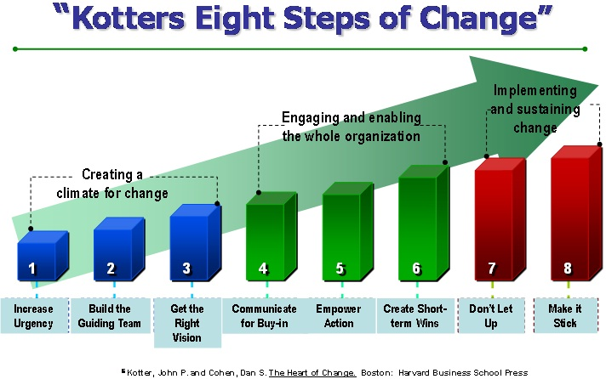
(Leading Change, 2009)

Appendix 2
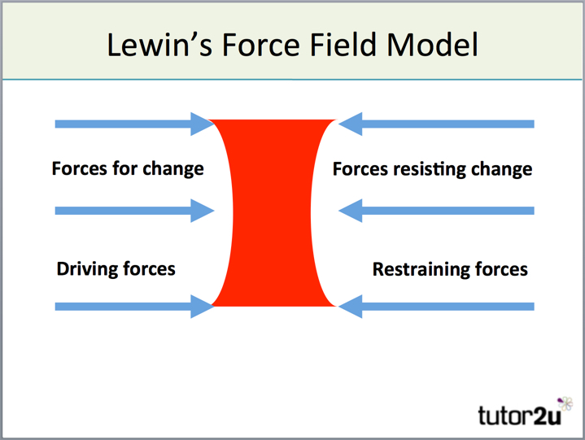
(Tutor2u, 2015)

Appendix 3
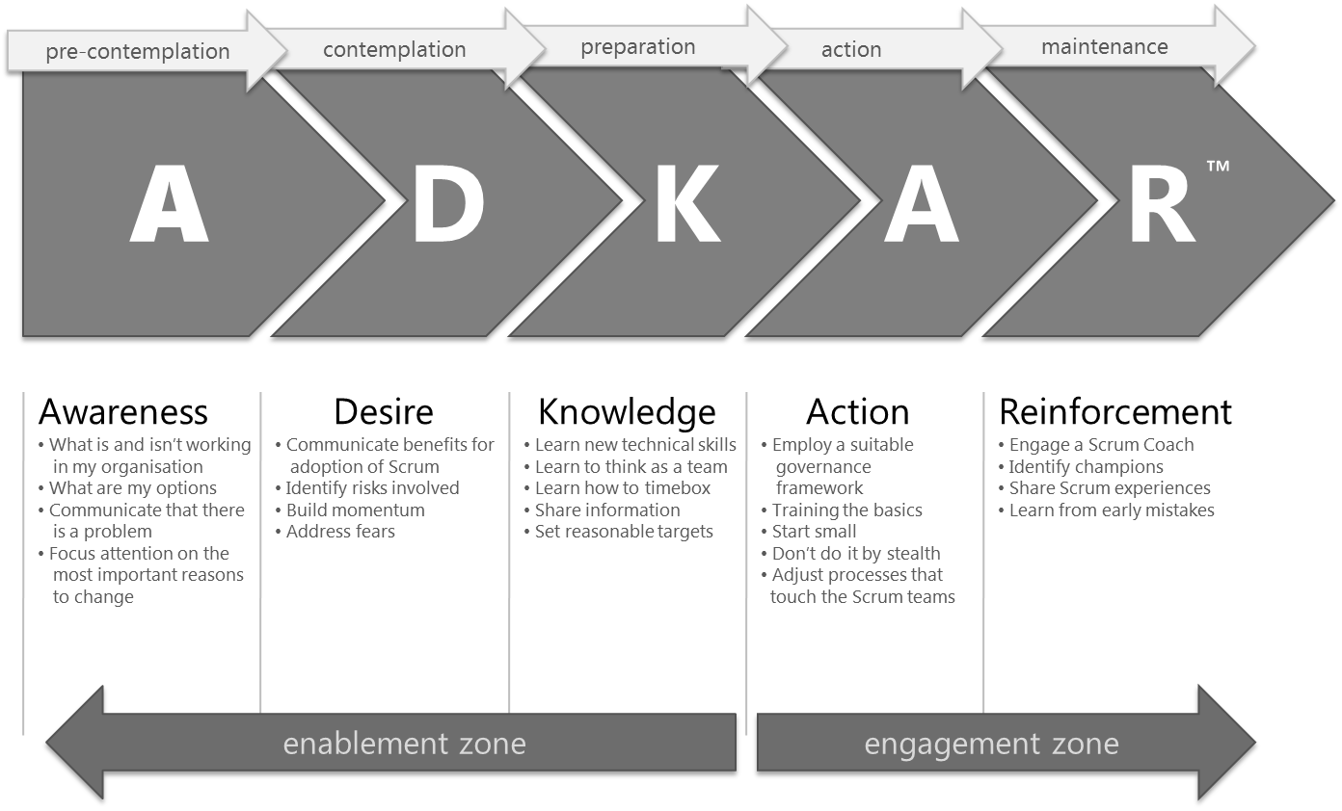
(Tremolada, 2015)

