  LOCATION Swansea | LLEOLIAD abertawe
LEVEL 6 | LEFEL 6
EXAMINATION PERIOD | CYFNOD ARHOLIADAU
May 2017 | Mai 2017

MODULE CODE: M3X8529
Embedded Microcontrollers

TIME: 2 Hours
answer all questions

Questions are not equally weighted - make note and distribute your time accordingly

Equipment or materials required – None
The Candidates are not permitted to bring calculators, dictionaries; text books/case studies or any other reference materials into the exam room.
Show any calculations in your exam book

ANSWER ALL QUESTIONS

QUESTION ONE (35 marks total)
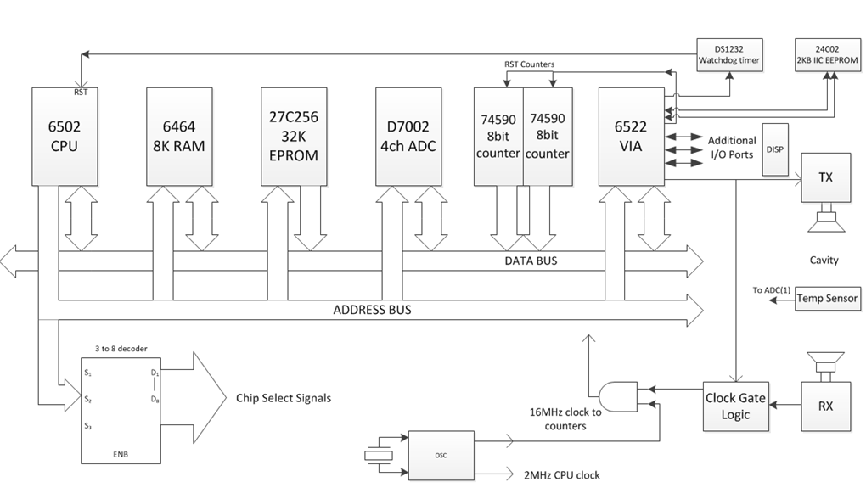

The system diagram above is of one of the case studies covered during the course of the term. It illustrates the design of a microprocessor controlled device that calculates the concentration of Carbon Dioxide in the air, based on time of flight information of an ultrasonic pulse sent through an air cavity but also utilising a compensation value from a temperature sensor.

- What is the purpose of the DS1232 watchdog timer? Explain its fundamental operation, and what needs to be incorporated into the final software code to ensure its intended function operates correctly. (7 marks)

- What is the purpose of the 3 to 8 address decoder chip? (3 marks)
- Given that the 6502 is an 8 bit device with a 16 bit address bus, sketch a typical memory map that one might find when all the devices shown in the circuit diagram are connected as above. Explain your reasoning. (10 marks)
- Imagine you are now given the task of updating the design to try and reduce the overall component count and base as much as possible around as inexpensive an embedded microcontroller. What would be your general considerations and thought processes when deciding on a suitable device? (15 marks)

QUESTION TWO (15 marks total)

- Many complex embedded systems require the use of an RTOS. Explain what is meant when one describes this type of Operating System as ‘Real Time’ , and what are the key characteristics of an RTOS.

QUESTION THREE (30 marks total)

- What type of system does the PC104 standard define? Produce a brief report explaining what it is and highlighting the general features available to the embedded systems designer.
(10 marks)

- The following circuit is typical of the type of design that could be employed to interface a custom I/O circuit (which would be located to the Right Hand Side), to the interface of a standard ISA based PC104 system (the Left Hand Side connection pins).
Attempt to reverse engineer the circuit and thus explain its general principle of operation and the function of each Integrated Circuit. (20 marks)

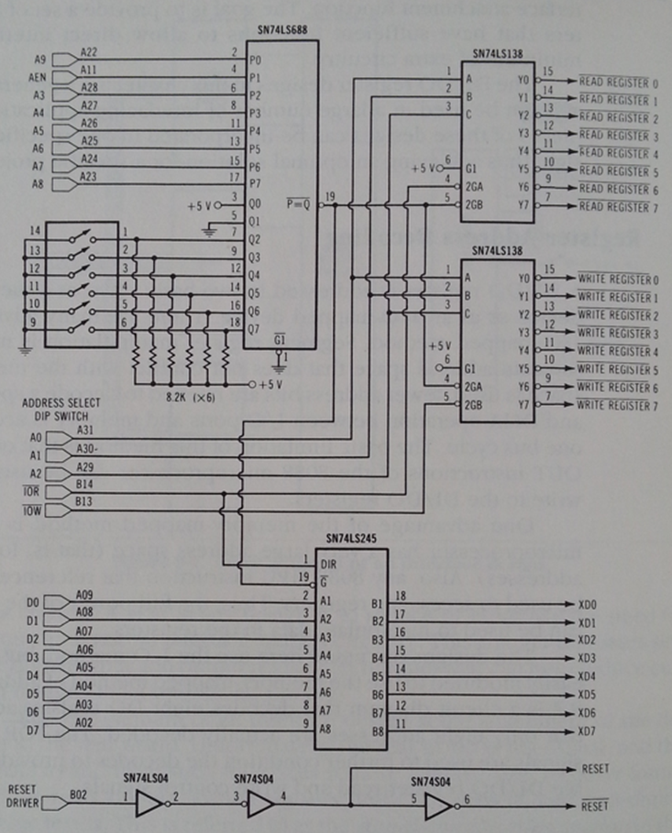

QUESTION FOUR (20 marks total)

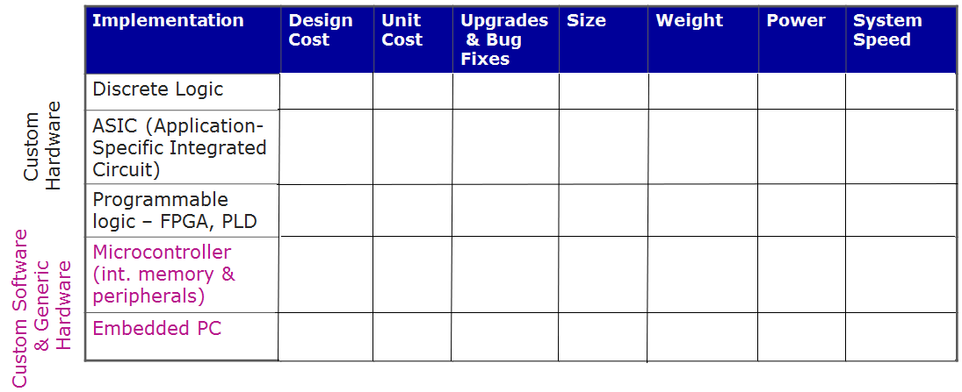

a)
The table above contains a matrix which can be used when trying to decide what approach to use when designing an embedded controller.
Reproduce the table in your answer book, filling in the blank matrix entries. The choices you have at your disposal for each column are:
Design Cost - Low, medium or high
Unit Cost – Very low, mid to low, mid, high
Upgrade & bug fixes – easy or hard
Size – microscopic, small, medium, large
Weight – very low, low, moderate to high, high
Power (consumption) – Variable, low, medium, medium to high
System Speed – slow to moderate, fast, very fast, extremely fast
(15 marks)

b)
For each of the five implementation types, give one example scenario of where you might choose it as the preferable option over the others. (5 marks)

