Culture – A briefing paper for organisations in a health care setting
  - Natalie Mills – 1451133
Word Count: 3841 not including references.

Introduction
This briefing paper intends to define what “culture” is and its importance to organisations, with a particular focus on Swansea Bay University Health Board (SBUHB). The paper will look to analyse SBUHBs culture and an evaluation of the organisation providing “good work”. This briefing paper will cover an analysis of strategic drivers within the organisation that perpetuates “good work” and wellbeing for the workforce. The briefing paper will conclude with recommendations for improvement. The anticipated audience is the senior management team within SBUHB and the paper has been ratified by internal Workforce (HR) colleagues and a selection of academics.

What is culture and why is it important for organisations?
When defining a culture within an organisation it can be composed of the values, beliefs, customs, and behaviours that can characterise an organisation (Young, J. No Date). There have been several academic definitions of culture including Balogun and Johnsons’ “the way we do things around here” (Balogun, J and Johnson, G. 2004) which highlights that culture influences the way work is structured and performed within an organisation. Other definitions include, “culture is the way a group of people solve problems”(Trompennars, F and Woolliams, P. 2002) and Hofstede’s “culture is the collective programming of the mind” (Hofstede, G. and Mintu, A. 1991) these definitions highlight there is no single accepted definition of culture.
Organisational culture can ‘cement confidence’ in employees work, ‘enhance motivation’ and ‘inspire employees to do their best’ (Morgan, P. 2022). Within a healthcare setting, having an organisational culture supports staff to feel psychologically safe to raise concerns, feel valued, motivated, inspired and respected is vital for prudent patient care and health outcomes. Within a healthcare , health boards are best described as being made up of a variety of “sub-cultures” which can be ‘driving forces for change or undermine quality improvement initiatives’, there is evidence that within a healthcare setting culture correlates to improved quality (Mannion, R and Davies, H. 2018) which highlights the importance of a good culture within healthcare organisations.
Culture within healthcare is often identified ‘as the primary culprit in healthcare scandals – in the 2018 Gosport report which looked into over 450 premature deaths at Gosport hospital mentions culture 21 times (Jones, J. 2018), the Francis report 2013 highlighting a “culture was focussed on doing the systems business – not that of the patients [and] an institutional culture which ascribed more weight to positive information about the service than to information capable of implying cause for concern” (Francis, R. 2013), similarly in the 2002 report “Learning from Bristol – The Department of Health’s response to the Report of the Public Inquiry into Childrens Heart Surgery at the Bristol Royal Infirmary 1984-1995” (Milburn, A. 2002) highlighted a culture where people were afraid to stand up and raise concerns. These reports and inquiries emphasise the importance of a positive organisational culture within healthcare settings to ensure employees feel supported when raising concerns which is vital for patient care.
Healthcare is a constantly changing landscape with new policies, ways of working and advances in medicines (Turner, P. 2018) (Prasad, G. 2023) (Flannery, E. 2024) means a constant flux with change becoming the norm. As such, it is imperative that SBUHB creates a learning culture that supports adequate time for teams to develop, ensure staff can learn from mistakes without punitive punishments and creates stability with behaviours and values. A learning culture is “that embeds learning into how things are done at an individual, team and organisational level” (CIPD, 2020) and healthcare organisations have implemented this type of culture have increased levels of psychologically safety amongst staff (Scholl, S et al. 2019), supports innovation (Andersson, T., Linnegusen, G., Holmen, M. and Kjellsdotter, A. 2023) and can heighten engagement (Bradford Publishing Group, 2022) these are vital components for employees to feel psychologically safe.
A learning culture not only supports psychological safety but can combat dissatisfaction and the negative effects of work on their mental health. In the CIPD ‘Good Work Index - Wales’ 2023, found public sector workers are more “dissatisfied than their private sector counterparts on both pay and non-pay issues, more likely to feel negative effects on their mental health, including excessive pressure and exhaustion and feel they have too great a workload” ,shown in figure 1 (Young, J. 2023). Psychologically safety is “a climate in which people are comfortable expressing and being themselves…can share concerns and mistakes without fear of embarrassment… confident to speak up…won’t be humiliated, ignored or blamed and can ask questions when unsure of something”, when an organisation has high levels of psychological safety “mistakes are reported quickly, there is prompt corrective action, innovations shared and increased team working” (Edmondson, A. 2019) which leads to better patient outcomes and are incredibly beneficial behaviours for staff within healthcare organisations (Ito, A., Sato, K., Yumoto, Y., Sasaki, M., & Ogata, Y. 2022) and can combat the behaviours and feelings experienced within the CIPD Good Work Index report.

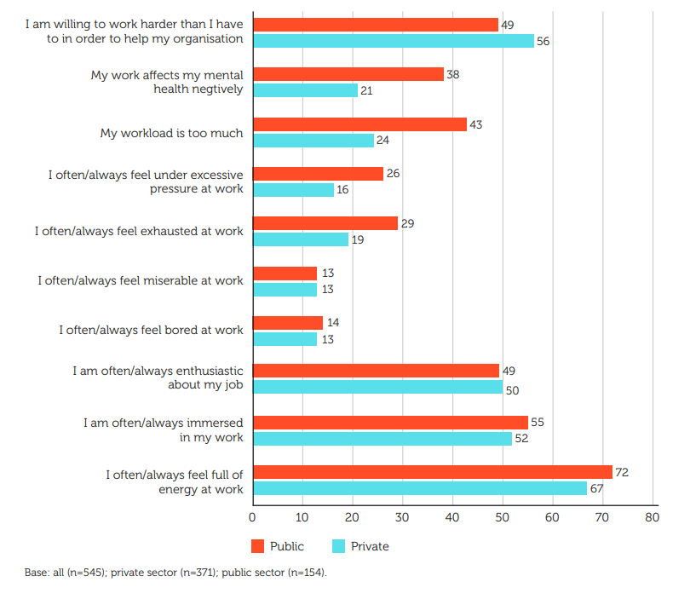
Figure 1 CIPD Good Work Index 2023 - Wales; Experiences of work in Wales, by sector (%) (Young, J. 2023)

Model to analyse culture within Swansea Bay University Health Board.
Swansea Bay University Health Board (SBUHB) is a NHS Wales Health Board provides healthcare services for the populations of Swansea and Neath Port Talbot, it has over 13500 staff working across three acute hospital sites and a variety of smaller satellite sites(SBUHB, no date). SBUHB looks to create a culture “is values driven and quality focussed” (Lloyd, J. 2023) and has recently undertaken two large cultural audits including “Our Big Conversation” which was centred around undertaking a series of listening sessions for staff members to anonymously raise “what Swansea Bay does well, what we could improve and how we can improve” (SBUHB, 2023a). SBUHB has recently undertaken the All-Wales Staff Survey in October 2023 which asked all healthcare staff across NHS Wales organisations a series of questions to determine the current organisational feeling and staff views (Shaw, R. 2023). These qualitative assessments have not yet published their findings and as such, there are academic models to analyse the current culture within SBUHB.
One model that organisation culture can be analysed is with Edgar Schein’s model where he describes three fundamental levels at which “culture manifests itself” (Schein, E. 1990). As shown in figure 2, Schein’s model there are three levels described as “artefacts may reflect culture (for example, symbols and language), norms and values about appropriate attitudes and behaviours (espoused or real) and underlying assumptions and beliefs (conscious or unconscious)” (Young, J. No Date), this model highlights culture is “a pattern of basic assumptions – invented, discovered, or developed by a group as it learns” (Tierney, G. 1986).

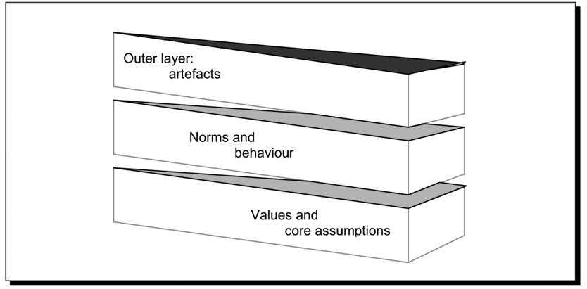
Figure 2 Edgar Schein's 3 Levels of Culture (University of Wales Trinity Saint David, 2024)
Within this model, the outer layer ‘artefacts’ are the visible aspects of the organisations culture. Within SBUHB the artefacts are represented by the physical layouts of the facilities including receptionist behind a desk and doctors in a consulting room (Mannion, R and Davies. H. 2018). This highlights to service users or those who do not work within the organisation the established practices of how “things” are done. Dress codes are an artefact for culture within the organisation, as different coloured scrubs relate to different staffing groups; for example a health care support worker will be in dark green scrubs, a student nurse will be in purple, a nurse will be in blue and a sister will be in dark blue (as shown in figure 3). These dress codes can show to service users a level of professionalism and be able to easily identify those who work within the hospital setting (West, M., Wantz, D., Campbell, P., Rosler, G., Troutman, D., Muthler, C. 2016), the scrubs contribute to professional identity and gives staff the “confidence to carry out their role and prepare psychologically for their work” (Shaw, K and Timmons, S. 2010), although as Newton and Chaney found in their 1996 article on professional image “that wearing a uniform does not automatically mean a nurse acts as a professional and is a good nurse” (Newton, M and Chaney, J. 1996).
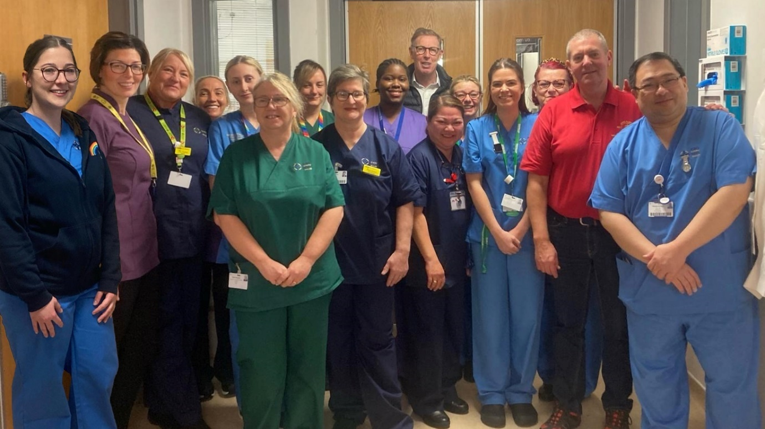
Figure 3 SBUHB Staff and their scrub colours (SBUHB, 2023b)
The second level of Schein’s model is the ‘norms and behaviours’, this can be described as the “appropriate behaviours and attitudes (espoused or real)” (Young, J. No Date). Within SBUHB, there is a behaviour and values framework staff members need to abide by, as shown in figure 4, these highlight the behaviours expected of staff for every interaction, both to patients and to staff. These include, caring for each other – not ignoring or being dismissive, working together – not letting people down or excluding others and always improving – not accepting second best or choosing a negative attitude (SBUHB, 2022a). Although, when organisations do not monitor behaviours and attitudes, a negative and egregious culture can form as documented in the 2013 Francis Inquiry and if there is a lack of goal setting the focus on the quality of care can be compromised (Dixon-Woods, M et al. 2013) which is evident in the results of the 2020 All Wales staff survey with 56% of respondents not looking forward to work, 33% of respondents were unhappy with the standard of care that SBUHB provides and 34% of respondents are unable to make improvements to their areas of work (LaChappelle, M. 2021). This highlights that although there are outlined appropriate and desirable behaviours the organisation promotes; these are not always experienced by staff members.
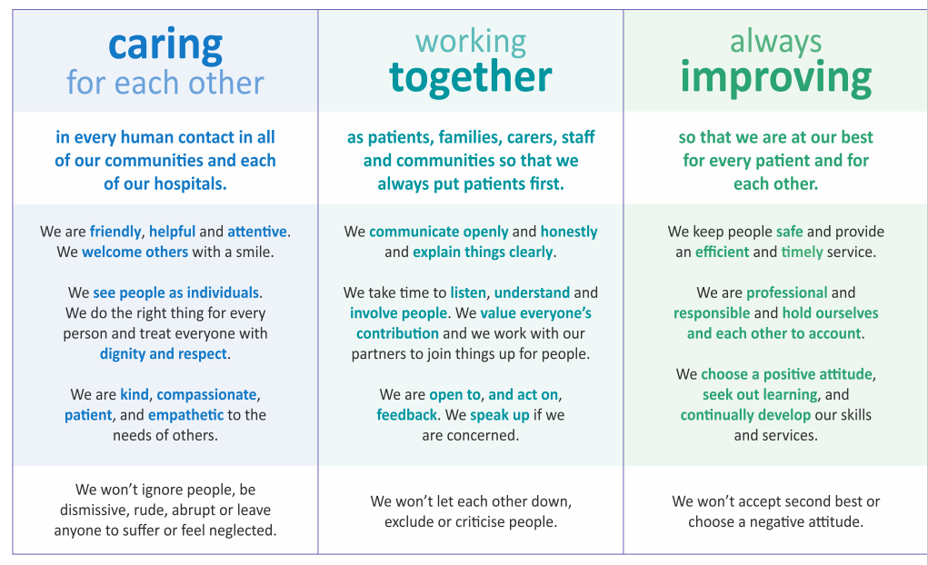
Figure 4 SBUHB Values and Behaviour Framework (SBUHB, 2022)
The third level of Shein’s model is the ‘values and assumptions’ segment which can be “conscious or unconscious” (Young, J. No Date) or “unconscious and unexamined" (Marrion, R and Davies, H. 2018), within SBUHB these may translate as the “ideas about appropriate professional roles, expectations about patients knowledge and assumptions about the relative power of healthcare professionals” (Marrion, R and Davies, H. 2018). Due to limited resources and an ageing population with complex medical needs, more healthcare professionals and organisations are relying on patient centred care. This is where health professionals work “collaboratively with patients to develop knowledge, skills and confidence to manage their health” (The Health Foundation, 2016) and by empowering patients at an early stage of a baseline condition it can support a patient to effectively manage it before it turns into a chronic condition (GSK, 2023). This knowledge sharing approach is to ensure there is not an untenable demand for services the NHS cannot supply, although as detailed in Mowbray, Moxley and Collins 1996 study of “Consumers as mental health providers” there are limitations to this patient centred approach where patients view medical interventions as “unhelpful” (Mowbray, C. Moxley, D and Collins, M. 1996) and patients can create “homegrown concerns and assumptions are created from a mixture of medical expertise and patient knowledge” (Pols, J. 2014) thus creating unfounded assumptions medical professionals need to dispel. This highlights when assumptions are left to grow unhindered within the organisation, it can create myths and untruths that can negatively affect patient outcomes.

Good Work and Swansea Bay University Health Board
The CIPD defines good work as “fundamental to individual wellbeing, supports a strong and fair society and creates motivated workers, productive organisations and a strong economy…good work is work that is; fairly rewarded, gives people means to securely make a living, provides opportunities to develop skills and gives a sense of fulfilment, delivers a supportive environment with constructive relationships, allows for work-life balance, physically and mentally healthy for people, gives people a voice to shape their working lives and is accessible to all” (CIPD, 2023). When looking at the seven indicators of “good work” SBUHB strives to ensure that the environment created and experienced by staff creates “good work”.
As SBUHB is a NHS organisation it is unable to influence the pay aspect of roles and bandings as these are set by Welsh Government (Morgan, E. 2023), as such, SBUHB needs to ensure there are intrinsic reward mechanisms for staff to feel rewarded such as local staff recognition (SBUHB, 2022b) and encourages staff to develop skills (SBUHB, 2024a)(SBUHB, 2024b) which can lead to a sense of fulfilment. Additionally, SBUHB has implemented the Guardian Service (Mills, N. 2023) and promotes a “Speaking Up Safely” culture and giving people a voice to shape their work. Although, there have been instances where SBUHB has been unable to provide a “good work” environment such as Korashi v Abertawe Bro Morgannwg 2011 (Predecessor Organisation) (Employment Case Update, No Date) where the claimant had raised concerns that were not listened to. Recently, a review has been launched into the standard of care within Midwifery (Thomas-Welch, D. 2023) where patient concerns have not been listened or addressed. Although SBUHB, strives to create an environment for “good work” there are still many aspects of the organisation that need to be bolstered to ensure that “good work” is felt by all.

Organisational Benefits of a Positive Culture
A positive culture within organisations can support staff engagement and retention, increased wellbeing, organisational effectiveness and increased job satisfaction (Cameron, K., Mora, C., Leutscher, T., and Calarco, M. 2011). A positive culture can “inspire, avoid blame, provide support and increase respect and gratitude” (Seppala, E and Cameron, K. 2015) which are imperative foundations for a health care organisation. There is a view that a positive culture relates to better patient outcomes due to staff feeling supported when needing to speak up and able to seek support for wellbeing due to the nature of the workload (Braithwaite, J. et al. 2017) and that when there is a strong influence of positive culture nursing performance is increased (Terzioglu, F., Temel, S. and Uslu Sahan, F. 2016) which leads to better patient outcomes.
Although, for a healthcare organisation to create and sustain a positive culture “all employees, on every level, are responsible for cooperating and working together to uphold the mission, vision and values of a positive organisational culture” (Lukich, N. 2020) and as shown in the CIPD “Good Work Index 2023 – Wales” public sector employees (NHS Staff fall within this category) are “less willing than those in the private sector to work harder than needed to help their organisation and are more likely to suffer from an excessive workload and feelings of exhaustion” (Young, J. 2023) which can be detrimental to creating and sustaining a positive culture in the organisation. As shown in the NHS Staff Survey figures for 2020, only 56% of staff look forward to coming to work and 34% of staff would not recommend SBUHB as a place of work (LaChappelle, M. 2021) this indicates that there are still opportunities to enhance a positive culture within SBUHB.

A Strategic Approach to Good Work and the Wellbeing of the Workforce – Swansea Bay University Health Board.
Within SBUHB, the newly launched People Strategy highlights seven areas that directly correlate to the areas of “good work” as defined by CIPD. The People strategy strategic aims are “an engaged, motivated and healthy workforce, attract and recruit, well planned, digitally ready, excellent learning and education, leaders that live our values and equality, diversity and belonging” (SBUHB, 2024c) these strategic drivers have been published to ensure that SBUHB retains its workforce, it becomes an employer of choice. By creating a strategy that promotes “good work” departments within SBUHB have a set of standards that have been endorsed at a senior level and creates an expectation for staff to commit and foster these standards. The People strategy has been implemented as a direct result of the findings from the 2020 NHS Wales staff survey and to combat disengagement. In a join study by Gallup and Queens School of Business, 2014, it was found that “disengaged workers had 37% higher levels of absenteeism, 49% more accidents, 60% more errors and 18% lower productivity” (Seppala, E and Cameron, K. 2015).
Disengagement and a negative culture can lead to poor employee wellbeing. Within the CIPD Good Work Index – Wales, as shown in figure 5, only 36% felt that work positively affected their mental wellbeing and 30% felt work positively affected their physical wellbeing (Young, J. 2023), although this study does not differentiate between public and private sector employees, by utilising the findings within the NHS Wales Staff Survey 2020, we can see a correlation between figures. In the staff survey over 44% of respondents did not feel their manager takes an interest in their wellbeing (LaChappelle, M. 2021), as such SBUHB has implemented a Post-Covid 19 Staff Wellbeing Strategy (SBUHB, 2021) which has highlighted the need for strong leadership, trauma support and increased support for both physical and mental health using evidence based support. By weaving wellbeing initiatives into strategies, it is hoped that this will bolster wellbeing for staff and communicate the support available for staff.
Although it is a positive step that these strategies have been implemented and that the ethos of “good work” is being woven into the fabric of SBUHB, it cannot be evidenced that these strategies have had a positive affect on staff until further research has been undertaken. The results of the 2023 Staff Survey and Our Big Conversation are due to be published in the coming months and this will provide an indication if the organisation has created a flourishing positive culture from these strategies.

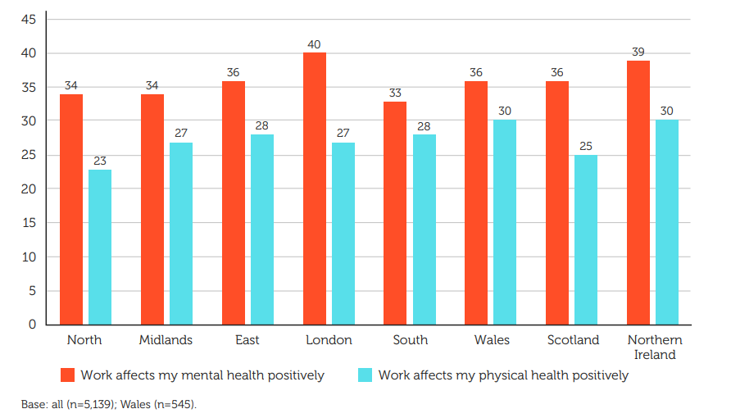
Figure 5 CIPD Good Work Index 2023 - Wales; Employee Wellbeing - Work affects my mental health and physical health positively percentages (Young, J. 2023)

Conclusion
In conclusion, SBUHB has taken steps to enhance its culture and embed “good work” into its strategic aims and practices. It has been evidenced from the staff survey figures and the work of the CIPD’s Good Work Index – Wales, that staff are feeling disengaged and reporting poor wellbeing, both physically and mentally, therefore there are still improvements to be made to implement a positive culture that is felt throughout the organisation. Through implementing the below recommendations, SBUHB has an opportunity to positively influence the culture of its staff which will positively influence patient outcomes.

Recommendations
From the findings of this briefing paper, I have proposed three recommendations for improvements within SBUHB. These recommendations are in order of importance and have been costed.
Recommendation 1: Enhance a speaking up culture within SBUHB through a series of engagement events highlighting the Guardian Service and the new “Speaking Up Safely Framework” (Welsh Government, 2023). This will promote a culture where staff feel supported to speak up when they see concerns and feel empowered that they will be supported by the organisation whilst raising these.
Costings for this will include a Band 7 facilitator to undertake at least three in person events per site at least 2 hours per session and will need to create a space that is psychologically safe for staff to express their view. There will be a need to hold at least two virtual sessions for corporate staff and any clinical staff who could not attend the in-person event. A communication strategy of support will need to be launched which will include internal bulletins, posters and literature to be distributed to wards and the facilitator to attend local team briefs to give a verbal update. The costings are detailed in table 1 below.
The impact of this will be staff understanding that the organisation supports a culture of speaking up, innovation and being able to understand when we are not performing and the reasons behind this. This intervention will have a large impact on staffing and the effects on culture, although this will have a high resource cost.
Action | Cost
9 in person sessions x 2hr sessions (3 per site – 3 main sites)  2 virtual sessions (4 hours total)  Preparation time (10 hours – research, booking of rooms, sourcing materials) | Band 7 hourly rate: £25.60ph (NHS Confed, 2022) x 22hrs = £563.20  Opportunity cost – the facilitator will need to be released from the substantive work to facilitate this session
Communication plan –  Intranet Bulletin – 1 hour  Posters/literature created – 2 hours  Disseminating Literature – 1 hour  Attending Team Briefs – 6 hours | Band 7 hourly rate: £25.60ph (NHS Confed, 2022) x 10hrs = £256  Opportunity cost – the facilitator will need to be released from the substantive work to facilitate this session
Total | £819.20 and the opportunity cost of the facilitator being released from substantive work
Table 1 – Costings for recommendation 1
Recommendation 2: The second recommendation from the findings of this briefing paper is for increased communication around the wellbeing offer for trauma support and mental and physical wellbeing support. This will promote a positive culture where employees feel supported and is directly linked to the positive effects of CIPD’s “Good Work”. A healthy and engaged workforce additionally links to the People Strategy that has been launched for the health board.
The costings for this will include a communication campaign including intranet bulletins, emails, posters and literature disseminated to wards. There will be a cost for a wellbeing representative to be on different hospital sites as a point of contact for queries that staff may have. There are already wellbeing offices on each site, this will mean a designated staff member working in a high traffic area, so they are visible to staff. Costings are detailed in table 2 below.
The impact of this will be an increased awareness for staff on the wellbeing offers within SBUHB and predicted uptake in wellbeing services which will support SBUHB in being an employer that supports “good work”.
Action | Cost
Communication Campaign  3 hrs for literature creation  3 hrs to disseminate to sites = 6hrs total | Can be undertaken by a Band 5 due to information gathering and subsequent creation of literature  Band 5 cost per hour £14.53ph (NHS Confed, 2022) x 6hrs = £87.18  Additional Opportunity cost of the band 5 being released from substantive workload
Staff Member more visible on site | No additional cost - wellbeing staff work across all sites, however there is an opportunity cost due to the staff member having to answer any queries that may arise which will take time away from substantive work.
Table 2 – Costings for recommendation 2
Recommendation 3 – The final recommendation is for work to be undertaken to understand the findings from the 2023 Staff Survey and the Our Big Conversation culture work. By undertaking an analysis of these findings, the organisation will be able to understand the current culture within the organisation and understand where the hotspot areas are that need specific cultural interventions.
The costings for this have already been accounted for as there is already an employed Band 7 facilitator that is to look at the actions from these surveys, however there is an opportunity cost to the organisation whilst SBUHB awaits the national organisations to finalise the results.
The impacts of this will be that the organisation will have a better understanding of the current culture within the organisation and be able to deploy specific interventions to hotspot areas that need bespoke cultural workshops.
If SBUHB undertakes the following recommendations, there could be a positive increase in staff engagement and retention which would ultimately lead to a more positive culture.

References:
Andersson, T., Linnegusen, G., Holmen, M. and Kjellsdotter, A. (2023) 'Nurturing innovative culture in a healthcare organisation – Lessons from a Swedish case study', Journal of Health Organization and Management, 37, 17-33. Available at: DOI 10.1108/JHOM-05-2021-0181
Balogun, J and Johnson, G. (2004) 'Organizational restructuring and middle manager sensemaking.', Academy of Management Journal, Vol 47, No 4. pp523-549
Bradford Publishing Group “Informal learning and work engagement among older workers: The importance of organizational culture” (2022) Development and learning in organizations, 36(2), pp. 48–50. Available at: https://doi.org/10.1108/DLO-08-2021-0144.
Braithwaite, J. et al. (2017) “Association between organisational and workplace cultures, and patient outcomes: systematic review,” BMJ open, 7(11), pp. e017708–e017708. Available at: https://doi.org/10.1136/bmjopen-2017-017708.
Cameron, K., Mora, C., Leutscher, T., and Calarco, M. . (2011) 'Effects of Positive Practices on Organizational Effectiveness', The Journal of Applied Behavioral Science, 47(3), 266-308
CIPD (2020) Creating Learning Cultures - Assessing the evidence. Place of publication: London. Chartered Institute of Personnel and Development. Available at: URL https://www.cipd.org/globalassets/media/knowledge/knowledge-hub/reports/creating-learning-cultures-1_tcm18-75606.pdf (Accessed: 01.02.2024).
CIPD (2023) CIPD Good Work Index. Available at: URL https://www.cipd.org/uk/knowledge/reports/goodwork/#:~:text=CIPD%20view%20on%20good%20work,to%20securely%20make%20a%20living (Accessed: 11.02.2024).

Dixon-Woods, M et al. (2013) Culture and behaviour in the
English National Health Service:
overview of lessons from a large multimethod study. BMJ Quality & Safety. British Medical Journal Available at: URL https://qualitysafety.bmj.com/content/qhc/early/2013/08/28/bmjqs-2013-001947.full.pdf (Accessed: 05.02.2024).

Edmondson, A.C. (2019) The fearless organization : creating psychological safety in the workplace for learning, innovation, and growth. Hoboken, New Jersey: John Wiley & Sons, Inc.
Employment Case Update (no date) Korashi v Abertawe Bro Morgannwg University Local Health Board UKEAT/0424/09/JOJ. Available at: URL https://employmentcasesupdate.co.uk/content/korashi-v-abertawe-bro-morgannwg-university-local-health-board-ukeat-0424-09-joj.dd50c68e9ea745099df84e64c2cdaf8c.htm (Accessed: 12.02.2024.
Flannery, E. (2024) EHRs to AI: The evolving landscape of healthcare IT . Available at: URL https://www.intelligenthealth.tech/2024/02/08/ehrs-to-ai-the-evolving-landscape-of-healthcare-it/ (Accessed: 01.02.2024).
Francis, R (2013) The Report of the Mid Staffordshire NHS Foundation Inquiry (The Francis Report). Available at: URL https://assets.publishing.service.gov.uk/media/5a7ba0faed915d13110607c8/0947.pdf (Accessed: 01/02/2024).
GSK (2023) A preventative patient-centred approach is key to transforming respiratory care and relieving struggling services. Available at:https://www.gsk.com/en-gb/behind-the-science-magazine/patient-centred-respiratory-prevention-asthma-copd-rsv/ URL (11.02.2024).

The Health Foundation (2016) Person-centred care
made simple What everyone should know about person-centred care The Health Foundation Available at: URL https://www.health.org.uk/sites/default/files/PersonCentredCareMadeSimple.pdf (Accessed: 10.02.2024).

Hofstede, G. and Mintu, A.T. (1992) “Cultures and organizations - software of the mind,” Journal of international business studies, pp. 361–361.
Ito, A., Sato, K., Yumoto, Y., Sasaki, M., & Ogata, Y. (2022). A concept analysis of psychological safety: Further understanding for application to health care. Nursing Open, 9, 467–489. https://doi.org/10.1002/nop2.1086
Jones, J (2018) The Report of the Gosport Independent Panel. Available at: URLhttps://www.gosportpanel.independent.gov.uk/media/documents/070618_CCS207_CCS03183220761_Gosport_Inquiry_Whole_Document.pdf (Accessed: 01/02/2024).
LaChappelle, M (2021) All Wales NHS Staff Survey 2020 - Findings. Swansea: Swansea Bay University Health Board. Available at: URLhttps://sbuhb.nhs.wales/about-us/key-documents-folder/board-papers/january-2021-health-board/2-4-nhs-staff-survey-and-appendices-pdf/ (Accessed: 10.02.2024).
Lloyd, J. (2023) Our Big Conversation. Swansea Bay University Health Board. Available at URL sbuhb.nhs.wales/about-us/key-documents-folder/workforce-and-od-committee-papers/workforce-and-od-committee-papers-february-2023/71-appendix-1-initital-draft-report-obc-phase-1pdf1/ (Accessed 02.02.2024)
Lukich, N. (2020) “The importance of a positive moral culture within healthcare organizations,” Healthcare management forum, 33(6), pp. 293–295. Available at: https://doi.org/10.1177/0840470420943406.
Mannion, R and Davies, H. (2018) 'Understanding Organisational Culture for Healthcare Quality Improvement', The British Medical Journal 2018;363:k4907
Milburn, A (2002) Learning from Bristol – The Department of Health’s response to the Report of the Public Inquiry into Childrens Heart Surgery at the Bristol Royal Infirmary 1984-1995
Available at: URL https://assets.publishing.service.gov.uk/government/uploads/system/uploads/attachment_data/file/273320/5363.pdf (Accessed: 01/02/2024).

Mills, N. (2023) Guardian Service - Annual Update. Swansea Bay University Health Board. Unpublished.
Morgan, E. (2023) Written Statement: NHS Pay award enhancement for 2022/2023 and pay award for 2023/24 Agenda for Change staff. Available at: URL https://www.gov.wales/written-statement-nhs-pay-award-enhancement-20222023-and-pay-award-202324-agenda-change-staff (Accessed: 12.02.2024).
Morgan, P. (2022) Understanding the Importance of Corporate Culture after the Great Resignation Available at: URL https://www.forbes.com/sites/paulamorgan/2022/08/19/understanding-the-importance-of-corporate-culture-after-the-greatresignation/?sh=3e8f08f018cd (Accessed: 01/02/2024)
Mowbray C, Moxley D, and Collins M. (1996) 'Consumers as mental health providers: first-person accounts of benefits and limitations.', J Behav Health Serv Res, 1998 Nov;25(4):, 397-411
Newton, M. and Chaney, J. (1996) “Professional image: Enhanced or inhibited by attire?,” Journal of professional nursing, 12(4), pp. 240–244. Available at: https://doi.org/10.1016/S8755-7223(96)80099-8.
NHS Confed (2022) Agenda For Change Pay Rates. NHS Confed Available at: URL https://www.nhsconfed.org/system/files/2023-04/AFC%20Wales%20offer%20for%202022_23%20and%202023_24%20x.pdf. (Accessed: 14.02.2024).
Pols, J. (2014) “Knowing Patients: Turning Patient Knowledge into Science,” Science, technology, & human values, 39(1), pp. 73–97. Available at: https://doi.org/10.1177/0162243913504306.
Prasad, G. (2023) Revolutionizing Healthcare: The Evolving Landscape of Medical Technology and Patient Care. Available at: URL https://www.linkedin.com/pulse/revolutionizing-healthcare-evolving-landscape-medical-gokul-prasad/ (Accessed: 01.02.2024).
SBUHB (No Date) About Us. Available at: URL https://sbuhb.nhs.wales/about-us/swansea-bay-uhb/) (Accessed: 02.02.2024).
SBUHB (2021) Post Covid 19 Wellbeing Strategy. Swansea Bay University Health Board Available at: URL https://sbuhb.nhs.wales/about-us/key-documents-folder/workforce-and-od-committee-papers/workforce-and-od-committee-papers-august-2021/4-3-appendix-1-pdf/. (Accessed: 14.02.2024).
SBUHB (2022a) The Swansea Bay Way. Swansea: Available at: URL https://sbuhb.nhs.wales/about-us/key-documents-folder/workforce-and-od-committee-papers/workforce-and-od-committee-papers-april-2022/3-1-presentation-the-swansea-bay-way-pdf/ (Accessed: 05.02.2024).
SBUHB (2022b) Record-breaking LOV Awards 2022 highlights staff achievements. Available at: URL https://sbuhb.nhs.wales/news/swansea-bay-health-news/record-breaking-lov-awards-2022-highlights-staff-achievements/ (Accessed: 12.02.2024).
SBUHB (2023a) Swansea Bay University Annual Report 2022-23. Swansea: Available at: URL (https://senedd.cymru/media/1f1p1kbt/agr-ld15978-w.pdf) (Accessed: 02.02.2024).
SBUHB. (2023b) 'Charitable Donation to Ward' [Twitter] 08.02.2024. Available at: URL https://twitter.com/SwanseabayNHS/status/1755667823186375157 (Accessed: 11.02.2024).
SBUHB (2024a) Passion for learning leads to nurse managing her own team. Available at: URL https://sbuhb.nhs.wales/news/swansea-bay-health-news/passion-for-learning-leads-to-nurse-managing-her-own-team/ (Accessed: 12.02.2024).
SBUHB (2024b) Lifelong learning champion leading by example. Available at: URL https://sbuhb.nhs.wales/news/swansea-bay-health-news/lifelong-learning-champion-leading-by-example/ (Accessed: 12.02.2024).
SBUHB (2024c) People Strategy. Swansea Bay University Health Board Available at: URL https://sbuhb.nhs.wales/about-us/key-documents-folder/board-papers/health-board-november-2023/4-3-appendix-1-pdf/#:~:text=Our%20people%20strategy%20aligns%20to,health%20system%20for%20our%20communities.&text=Our%20strategy%20is%20also%20aligned,facing%20challenges%20and%20changes%20ahead. (Accessed: 14.02.2024).
Schein, E. H. (1990). Organizational Culture. The American Psychologist, 45(2), 109–119. https://doi.org/10.1037/0003-066X.45.2.109
Seppala, E, and Cameron, K. (2015) 'Proof That Positive Work Cultures Are More Productive' Harvard Business Review. Available at: URL https://hbr.org/2015/12/proof-that-positive-work-cultures-are-more-productive (Accessed: 12.02.2024).
Shaw, K and Timmons, S. (2010) Exploring how nursing uniforms influence self image and professional identity. Nursing Times: Available at: URL https://www.nursingtimes.net/roles/nurse-educators/exploring-how-nursing-uniforms-influence-self-image-and-professional-identity-15-03-2010/ (Accessed: 04.02.2024).
Shaw, R. (2023) NHS Wales Staff Survey 2023. Swansea Bay University Health Board. Unpublished.
Sholl, S. et al. (2019) “Understanding the healthcare workplace learning culture through safety and dignity narratives: a UK qualitative study of multiple stakeholders’ perspectives,” BMJ open, 9(5), pp. e025615–e025615. Available at: https://doi.org/10.1136/bmjopen-2018-025615.
Terzioglu, F., Temel, S. and Uslu Sahan, F. (2016) “Factors affecting performance and productivity of nurses: professional attitude, organisational justice, organisational culture and mobbing,” Journal of nursing management, 24(6), pp. 735–744. Available at: https://doi.org/10.1111/jonm.12377.
Thomas-Welch, D. (2023) Patient safety concerns prompt Welsh Government to intervene in Swansea maternity service. ITV News Available at: URL https://www.itv.com/news/wales/2023-12-12/welsh-government-intervenes-in-maternity-service-after-patient-safety-concerns (Accessed: 12.02.2023).
Tierney, G. (1986) 'Organizational Culture and Leadership.', The Academy of Management Review, Vol 11, No 3. pp677-680
Trompenaars, F. and Woolliams, P. (2002) “A new framework for managing change across cultures,” Journal of change management, 3(4), pp. 361–375. Available at: https://doi.org/10.1080/714023847.
Turner, P. (2018) 'The Changing Landscape of Healthcare', Talent Management in Healthcare , Pp 15-37. Available at: DOI 10.1007/978-3-319-57888-0_2
University of Wales Trinity Saint David. (2024) 'Scheins 3 Levels of Culture', Shaping Cultures - Week 1. Available at: URLhttps://moodle.uwtsd.ac.uk/course/view.php?id=10933&section=2 (Accessed: 02.02.2024).
Welsh Government (2023) Speaking Up Safely Framework. Welsh Government Available at: URL https://www.gov.wales/nhs-wales-speaking-safely-framework. (Accessed: 14.02.2024).
West, M., Wantz, D., Campbell, P., Rosler, G., Troutman, D., Muthler, C. (2016) 'Contributing to a Quality Patient Experience: Applying Evidence Based Practice to Support Changes in Nursing Dress Code Policies', OJIN: The Online Journal of Issues in Nursing , Vol 21, 1.
Young, J (no date) Organisational climate and culture. Available at: URL https://www.cipd.org/uk/knowledge/factsheets/organisation-culture-change-factsheet/ (Accessed: 01/02/2024).
Young, J (2023) CIPD Good Work Index 2023: Wales. London: Chartered Institute of Personnel and Development Available at: URL https://www.cipd.org/globalassets/media/knowledge/knowledge-hub/reports/2023-pdfs/2023-cipd-good-work-index-wales-report-8407.pdf (Accessed: 01.02.24).

