
Violence Against Police, A Study into the Factors Involved In incidents of Assault on Police Officers Within South Wales Police.

Llyr Waltho Roberts
Student Number 2029327
BSC Professional Policing Practice

Acknowledgements
I would like to express my deepest gratitude to my family for their unwavering support and encouragement throughout the research process. Their understanding, patience and reassurance has been invaluable.
I also extend my heartfelt thanks to my colleagues for the support, motivation and advice when completing this project.
I have been fortunate to have such a supportive network behind me, and I am truly appreciative of the support during the development and completion of the research.
Declaration
This work has not previously been accepted in substance for any degree and is not being concurrently submitted in candidature for any degree.
Signed: Llyr Waltho Roberts
Date: 26/12/2023

STATEMENT 1
This dissertation is being submitted in partial fulfilment of the requirements for the degree of BA.
Signed: Llyr Waltho Roberts
Date: 26/12/2023

STATEMENT 2
This dissertation is the result of my own independent work/investigation, except where otherwise stated.
Other sources are acknowledged by footnotes giving explicit references. A bibliography is appended.
Signed: Llyr Waltho Roberts
Date: 26/12/2023

STATEMENT 3
I hereby give consent for my dissertation, if accepted, to be available for photocopying and for interlibrary loan, and for the title and summary to be made available to outside organisations.
Signed: Llyr Waltho Roberts
Date: 26/12/2023

STATEMENT 4
I hereby give consent for my dissertation, if accepted, to be available on the university’s IT system to those who have consent to use the system.
Signed: Llyr Waltho Roberts
Date: 26/12/2023
Abstract
The research conducted in this paper studies the ongoing challenge of violence against police officers within the South Wales Police force, addressing a critical societal issue. With 41,000 reported assaults on police officers in England and Wales in 2022, this study investigates the contributing factors by surveying 52 serving officers within South Wales Police. The findings reveal a concerningly high personal experience of assaults whilst on duty (98.1%), with 76.9% of respondents having experienced violence towards them on multiple occasions.
Exploring operational conditions, incident types, and perpetrator details, the study provides insights into officer injuries, assault methods and motivations along with perpetrator profile details. Emphasising the need for targeted safety measures and intervention strategies.
By examining officer perspectives on the Officer Safety Training (OST) provided by South Wales Police, the research identifies a nuanced satisfaction rate (67.3%), and highlighting areas of improvement with 28.8% of respondents finding the OST deficient. Furthermore, the study offers comprehensive insights into the multifaceted nature of assaults on police officers, providing a valuable resource for evidence-based policies and practices.
Despite having a limited sample size, the research serves as a useful foundation for further studies, contributing to the ongoing discourse on officer safety and the effectiveness of policing strategies.
Table of Contents

1. Chapter One: Introduction……………………………………………………………………………………………8
1.1. Objectives……………………………………………………………………………………………………………………..9
2. Chapter Two: Literature Review………………………………………………………………………………….10
2.1 Introduction………………………………………………………………………………………………………………….10
2.2 Forms of Violence Most Experienced by Police Officers………………………………………………..10
2.3 Factors Most Contributing to Violence Against Police Officers………………………………………11
2.4 Underlying Causes of Factors Most Associated with Violence Against Police Officers……12
2.5 Existing Policies and Procedures for Officers Attending Incidents…………………………………13
3. Chapter Three: Methodology………………………………………………………………………………………15
3.1 Introduction………………………………………………………………………………………………………………….15
3.2 Research Onion…………………………………………………………………………………………………………….15
3.3. Research Philosophy……………………………………………………………………………………………………16
3.4. Research Approach………………………………………………………………………………………………………17
3.5 Ethical Considerations…………………………………………………………………………………………………..18
3.6 Research Strategy and Choice……………………………………………………………………………………….18
3.7 Time Horizon………………………………………………………………………………………………………………..19
3.8 Techniques: Data Collection and Analysis……………………………………………………………………..19
3.9 Sample………………………………………………………………………………………………………………………….20
3.10 Reliability and Validity…………………………………………………………………………………………………20
3.11 Limitations…………………………………………………………………………………………………………………21
3.12 Conclusion………………………………………………………………………………………………………………….22
4. Chapter 4 Analysis of Results………………………………………………………………………………………23
4.1. Introduction…………………………………………………………………………………………………………………23
4.2 Participant Demographic Information…………………………………………………………………………..23
4.3 Assault Incidence………………………………………………………………………………………………………….24
4.4. Operational Conditions………………………………………………………………………………………………..24
4.5. Type Of Incidents…………………………………………………………………………………………………………25
4.6. Injuries And Assault Methods………………………………………………………………………………………25
4.7 Perpetrator Detail…………………………………………………………………………………………………………26
4.8 Assault Location……………………………………………………………………………………………………………27
4.9 Perceived Motivations for Assaults On Police Officers………………………………………………….28
4.10 Officer Safety (Ost) Satisfaction………………………………………………………………………………….29
4.11. Conclusion…………………………………………………………………………………………………………………30
5. Chapter 5. Recommendations And Conclusions…………………………………………………………..31
5.1 Recommendations………………………………………………………………………………………………………..31
5.1.1. Targeted Officer Safety Training (Ost)……………………………………………………………………….31
5.1.2. Substance Abuse Intervention…………………………………………………………………………..………31
5.1.3. Community Policing and Public Relations………………………………………………………………….32
5.1.4. Continuous Research and Data Collection…………………………………………………………………33
5.2 Limitations……………………………………………………………………………………………………………………33
5.3 Further Research…………………………………………………………………………………………………………..34
5.4 Achievement of Objectives……………………………………………………………………………………………34
5.5 Conclusion…………………………………………………………………………………………………………………….35
List of Figures

Figure 1.1 Annotated Diagram – The Research Onion showcasing the researcher’s chosen research process for this study (Source: Saunders, Lewis and Thornhill, 2009).
Figure 4.1 Results of Q.8 depicting responses of how officers were assaulted.
Figure 4.2 Results of Q.12 Showing the level of compliance first exhibited by the perpetrator.
Figure 4.3 Word Cloud of factors officers believed were associated with the perpetrator who assaulted them.
Figure 4.4 Word Cloud of officer satisfaction with OST provided by South Wales Police.
1. Chapter One: Introduction

Policing is widely considered a dangerous career, it plays an important role in upholding the law, maintaining social order, and safeguarding communities. In the course of their duties police officers are often exposed with a wide variety of risks and dangers. One of which being the risk or threat of violence. There have been high profile incidents of extreme violence against police officers in the media in recent times highlighting this such as the killings of Sergeant Matiu Ratana (BBC 2020) and Police Constable Andrew Harper and the subsequent introduction of ‘Harpers Law’ (BBC 2022).

Parpworth (2020) identified that the section 1 offence under the Assaults on Emergency Workers (Offences) Act 2018 was introduced as a direct response to significant increases in the number of assaults on emergency workers, and that Home Office figures from 2016-17 showed there were 24,000 assaults on police officers within England and Wales. In the latest available national statistic figures provided by the UK Government for the year ending March 2022 “there were just over 41,000 assaults on police officers in England and Wales (including British Transport)” (Home Office 2022), a significant rise in the figures from 2016-17, These figures further identify that 29,491 were crimes of assault without injury and 11,730 were assault with injury, resulting in an increase on the previous year of 11% and 2.6% respectively.

The College of Policing (2020) estimated that 71,308 workdays were missed due to sick leave as a result of assaults on duty. They further stated that although no national data was available on the related sickness absence costs of assaults on police, the total salary cost of sickness absence due to assaults was estimated to be £4.7 million. Furthermore, it was estimated that the total social-economic costs of assaults against police in 2018/19 amounted to £363 million.

According to the CPS (2018) the principles underlying the Assaults on Emergency Workers (Offences) Act 2018 were defined by The Minister of State at the Ministry of Justice as “An assault on an emergency worker is an assault on us all. These people are our constituted representatives. They protect society and deliver services on our behalf. Therefore, an attack on them is an attack on us and on the state”. Simply put, an assault on an emergency worker can be considered an assault on society and the United Kingdom as a whole.

Evidently, violence towards police officers is a societal issue with considerable implications for police forces, individual officer safety, and the community the police force serves. This research aims to contribute to the existing body of research relating to violence against police officers by identifying and investigating the factors which contribute to incidents of violence towards officers.

By identifying and understanding these factors this research can be used in order to develop effective procedures and strategies to mitigate or prevent such incidents of violence, in turn increasing the safety of both the officers and the communities in which they serve.

1.1 Objectives

- Identify the forms of violence most experienced by police officers.
- Identify the factors most commonly contributing to violence against police officers.
- Examine the underlying causes of risk factors most associated with violence against police officers.
- To evaluate the effectiveness of existing force policies and procedures for officers attending incidents resulting in assaults against them
2. Chapter Two: Literature Review

2.1 introduction

This literature review will consider previous existing research surrounding the subject of assaults on police. Whilst there is some existing research on the matter of violence against police officers, the majority of which focuses on the effect of a single factor such as the issuing of equipment or the implementation of force policies on the likelihood of an assault on an officer.

2.2 Forms of violence most experienced by police officers

Police officers within South Wales Police and the United Kingdom contend with a variety of violence that reflects the unique challenges of the profession. Whilst physical altercations during arrests or confrontations remain an ongoing concern, officers are increasingly confronted with verbal and psychological aggression. Research by Van Reemst and Jongerling (2021) and Mawby and Zemoi (2018) highlights the prevalence of this abuse, and the challenging dynamics officers navigate whilst trying to uphold the law and public safety.

Knife crime poses a significant threat, although figures obtained by the Home Office (2023) show that knife crime offence figures remain lower than before the Covid-19 pandemic, the year ending June 2023 included 50,833 offences involving knives – a 3% increase on the year prior. Knife crime contributes to a distinct form of violence as officers encounter situations where individuals may be armed with dangerous weapons.

The rise of terrorism adds another layer of complexity to policing duties and responsibilities (COP 2023), requiring officers with specialised training and increased vigilance. Moreover, police officers will often find themselves being required to manage public events, protests, and demonstrations. Gorringe and Rosie (2011) described the riots in English cities across August 2011 as “Spontaneous, contagious and uncontrollable”. It is in such situations where public tensions can escalate into violence directed towards police (Greer and Mclaughlin, 2010).

Further to this, balancing the need for effective policing with maintaining community trust is an ongoing challenge as “without public trust in police ‘policing by consent’ is difficult or impossible and public safety suffers” (Goldsmith, 2005). This is especially true in the face of societal issues that can contribute to a strained relationship between the police and public, exacerbated by factors impacting the public image of the force such as media coverage both in the traditional sense and more recently on social media platforms (Kira Vrist Rønn, 2023). Keane and Bell (2013) suggest that some police forces decisions are negatively impacted with considerations surrounding decisions around public safety being weighed against public image.

As the nature of the threats faced by officers within South Wales Police evolves, addressing these various forms of violence is crucial in ensuring the safety of police officers and developing a secure environment for both police officers and the communities they serve within South Wales Police.

2.3 Factors most contributing to violence against police officers

Ford (2000) reviewed a range of factors surrounding the victim, offender and location among other factors within South Carolina police officers and concluded the most commonly used methods of assault as using hands and feet by males under the influence of alcohol. Whilst the research conducted considered offences within South Carolina in the United States of America, it is important to consider that the identified factors are likely to be relatable to similar offences within the UK. Further to this, Anonymous 2004 reported that assaults on officers during arrest were the second most frequent after assaults on officers attending domestic disturbance calls.

Similar research by Johnson (2011) sets out to identify the characteristics of domestic batterers to aid in predicting whether the batterer is likely to assault attending officers and found that those who continued to present hostile behaviour following police attendance, were likely to escalate to physical violence towards the attending officers. Johnson (2015) develops this further by surveying officers who have experienced violence in their role in order to identify behaviours which can be used to predict imminent violence and found that “a boxer’s stance, invading personal space, placing hands in pockets, clenched hands, and threatening remarks were most associated with perceived impending violence”.

2.4 Underlying causes of factors most associated with violence against police officers.

High profile recent events such as the deaths George Floyd and the ensuing protests which made global news, along with the UK death of Dalian Atkinson have further “increased public scrutiny of criminal justice systems’ approach to police- suspects” Robertson (2018). As such, public attitude or perception of policing should also be considered as a factor leading to assaults on police officers. Research by Maguire et al (2021) identified that persons who perceive that police use unjust force are more likely to endorse the use of violence against police.

Gibbs et al (2018) considered the societal and community factors identified within incidents of assaults on Police, and identified “concentrated disadvantage measures (i.e. poverty, female-headed households, unemployment and residents under 18) as predictors for assaults where an officer was injured. This built on previous research by Kaminski, Jefferis and Gu (2003) who had identified that a higher density of persons who had previously been arrested resulted in an increased likelihood of assaults on police within that area.

Ozkan, Worrall and Piquero (2016) considered if increased minority representation within police would reduce assaults on police within ethnic minority communities and found that minority representation within the force did not eliminate assaults on police and posed that improving police-(minority) community relationships was key. This was further supported by Torres, D’Alessio and Stolzenberg (2021) who identified that neither black or white suspects were more likely to injure black or white police officers.

2.5 Existing policies and procedures for officers attending incidents.

South Wales Police operates on a policy of officers activating their Body Worn Video cameras on attendance to incidents. Research by Ariel et al (2016), Clare et al (2021) and Douglas (2021) focus on the introduction, or the use of police body worn video cameras when attending incidents and the effect of doing so on the number of assaults on police officers. All the above-mentioned research concluded that further research into the matter was required with Ariel et al (2016) stating that it was possible that the use of Body Worn Video cameras or (BWVs) “escalate an already inflamed police-public encounter”. Conversely, Douglas (2021) found that body worn video cameras “can be a protective factor for officers regarding both general assaults and firearm assaults”. The research by Clare et al (2021) found that the use of body worn cameras had no influence on rates of assault against police.

South Wales Police officers are deployed as double crewed units rather than lone officers, research by Houdmont, Elliot-Davies and Donnelly (2019) highlights a correlation between single crewing and the safety of police officers in England and Wales. Although it is stated that further research is required, it is argued that the initial findings suggest that any gains from single crewing officers “should be considered against possible negative implications for officer safety, health, and, by extension, operational effectiveness”. This is an important consideration given the demand placed on the available resources, and the possibility of being double crewed acting as a deterrent or protective factor when considering assaults on police.

This research paper will look to build on the prior and existing research by conducting it with officers from within South Wales Police making it relevant to those within the force in identifying the factors most contributing to assaults on police officers within the South Wales Police area.
3. Chapter Three: Methodology

3.1 Introduction

This chapter of the research details the methodology used to investigate the factors involved in incidents of assault on Police officers within South Wales Police. The objectives of this research are;
- Identify the forms of violence most experienced by police officers.
- Identify the factors most commonly contributing to violence against police officers.
- Examine the underlying causes of risk factors most associated with violence against police officers.
- To evaluate the effectiveness of existing force policies and procedures for officers attending incidents resulting in assaults against them.

3.2 Research Onion

Saunders, Lewis and Thornhill (2009) devised the Research Onion (Fig.1.1) which is one of the most used methods in academic writing in relation to the collection of primary data and the subsequent analysis of said data.
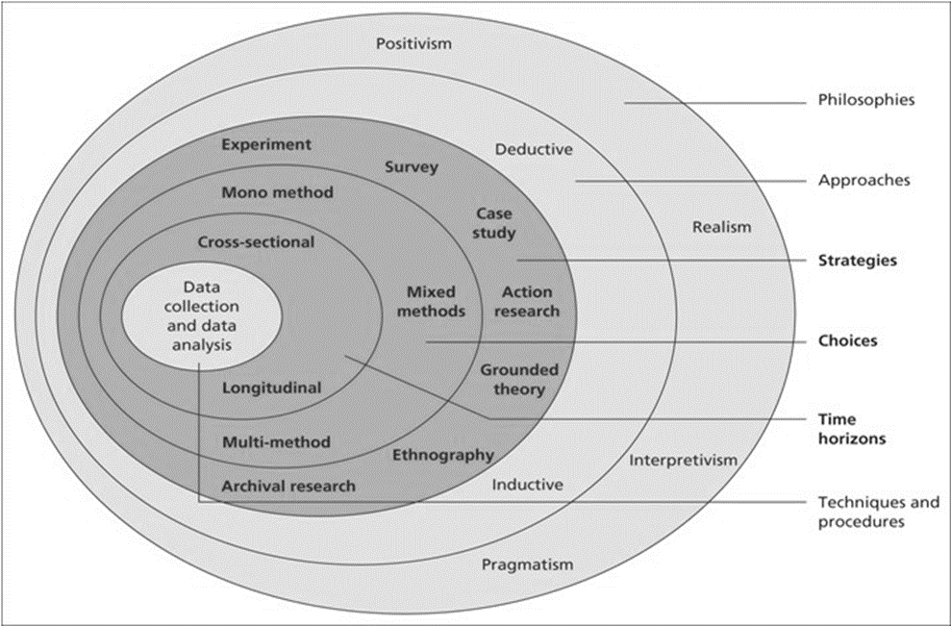
Figure 1.1 Annotated Diagram – The Research Onion showcasing the researcher’s chosen research process for this study (Source: Saunders, Lewis and Thornhill, 2009).

3.3 Research Philosophy

The first layer of the research onion consists of the research philosophy, which is considered to be the foundation of the study as it explains the set of beliefs the research is built upon (Jansen 2023). The philosophies within the first layer of the research onion consist of positivism, realism, interpretivism and pragmatism. Within this Positivism, Interpretivism and Pragmatism are considered the three main research philosophies (Phair and Warren, 2021). These three can be considered linked philosophies as they can fall within the larger Epistemology philosophy. Epistemology can be considered a theory relating to knowledge and is concerned with the mind’s relation to reality (Benton, 2017), that is how we obtain knowledge and then come to understand.
Bryman (2016) explains that Positivism poses that knowledge exists outside of what is being studied, and what is being studied can only be done so objectively and cannot include opinions or personal viewpoints. Interpretivism on the other hand places an emphasis on the impact both social and cultural factors can have on a person. Within interpretivism, the researcher actively draws a holistic view of the participant and their actions, thoughts, and meanings. Finally, Pragmatism approaches research from a practical perspective where the knowledge gained is constantly questioned and interpreted. This means that there is an element of researcher involvement and subjectivity when drawing conclusions from participants responses.
Within the pragmatic research approach, both quantitative and qualitative methods can be utilised, such as those used within a mixed-methods approach, as this research will utilise pre-existing figures collected by South Wales Police along with surveys involving both quantitative and qualitative questions the research philosophy utilised for this study will be Pragmatism.

3.4 Research Approach

There are two primary types of research approaches frequently used within academic writing, these being a deductive approach and an inductive approach, and are visible within Figure 1.1. According to Bryman (2016), these approaches differ significantly. Firstly, a deductive study starts with a theory, with the researcher’s objective being to either prove or disprove the initial theory or hypothesis. Conversely, Bryman (2016) describes an inductive study as effectively the reverse of a deductive one. Here the researchers may come by or identify findings and subsequently gather data with the aim of drawing a conclusion as to the underlying reasons behind the phenomena.
As such, this research project will utilise an inductive approach, with the specific goal of enhancing the comprehension of the underlying factors involved in assaults against police officers within the South Wales Police force.

3.5 Ethical Considerations

The research undertaken should not pose any ethical concerns since participation is entirely voluntary and will be restricted to individuals aged eighteen and above. Participants will have the ability to withdraw from the study at any point if they feel it is warranted. Participants will also be informed before commencing the survey of an estimated time-frame for completion in order to allow them to arrange a suitable time for completion.
Nonetheless, it is important to note that all gathered data will be treated with the utmost confidentiality and anonymity, primarily because the research employs formal online questionnaires where no personal data is retained. In order to safeguard the data collected from any potential misuse, stringent password protection and encryption methods will be used.

3.6 Research Strategy and Choice

The chosen approach by the researcher is to develop an online questionnaire that will be accessible through hyperlinks shared via South Wales Police force intranet and e-mail. This approach recognises the potential sensitivity of the subject matter, and that conducting face-to-face interviews may deter some participants. This online method aims to provide complete anonymity, thereby encouraging individuals who might otherwise hesitate to participate. A further advantage of completing the research using this method is that it is time efficient, the easier and quicker it is for participants to complete, the more likely it is that individuals will participate.
Additionally, this approach stands out as the most straightforward and cost-effective way to conduct the questionnaire. Given the need for a substantial volume of data, it offers the most efficient means of ensuring an adequate number of participants. The high number of participants will facilitate the collection of sufficient quantitative data to determine outcomes, alongside qualitative data, thereby enhancing the research’s reliability and validity.
An anticipated drawback of this method is that gathering and analysing the data obtained from the questionnaire responses may be time consuming and require substantial effort.

3.7 Time Horizon

Within the Research Onion two distinct time horizons exist, the longitudinal and cross-sectional approaches. A longitudinal approach to research permits the examination and comparison of behaviours over an extended duration. In contrast, a cross-sectional study design is an observational method that enables the analysis of data from participants at a particular moment, often through surveys or questionnaires (Sahay, 2016).
For this research project, the cross-sectional approach will be employed. This choice maintains the efficiency of the research as it is the most suitable model for population-based surveys (Kesmodel, 2018) and also suits the brief timeframe of this research.

3.8 Techniques: Data Collection and Analysis

The questionnaire will be distributed through an online form and exclusively to officers within South Wales Police. This approach aims to ensure that the responses originate from the individuals who are likely to have encountered violence against them within their roles.
To maintain anonymity, officers completing the questionnaire will provide minimal personal information, such as age, gender, and length of service. None of the questions will request any personal details that could potentially identify any individual.
In order to obtain a sufficient dataset, the research will aim to conduct 100 surveys. On completion, the quantitative data obtained will be analysed and displayed into various graphs and charts in order to show the findings and to potentially identify any patterns or recommendations to be made.

3.9 Sample

Jansen (2023b) defines identifying a sample as the process of defining a subgroup (sample) from the larger group of interest (population). Ghauri, Gronhaug and Strange (2020) posed that when conducting research, it becomes necessary to select a representative portion of the population, as studying the entire population would be impractical for comparison purposes. Nonetheless, it’s worth noting that sample sizes smaller than 25 will often yield results influenced by individual responses. In such instances, larger sample sizes lead to more dependable findings (Flick, 2011), particularly in quantitative research.
Quantitative research demands a larger number of participants to ensure the reliability of its findings. While sample characteristics remain significant in qualitative research, smaller samples are typically employed due to personal nature of this approach and its reduced reliance on extensive data from multiple sources.
In this research the aim is to target 100 respondents, all of which will be officers within South Wales Police force. This sample size will allow the researcher to capture individual perceptions of the issue of assaults against emergency workers effectively. This is also an optimal sample size as the research encompasses both quantitative and qualitative approaches.

3.10 Reliability and Validity

When assessing any data collection method within a study, two critical variables to consider are reliability and validity. Roberts and Priest (2006) emphasised the role of reliability and validity in demonstrating the rigour of the research processes and the credibility of the research findings.
Whilst the terms validity and reliability are often used interchangeably, they carry distinct meanings. Reliability signifies consistency, whereas validity assesses whether the tests effectively measure their intended variables (Drost, 2011).
In this study, adherence to a predetermined structure provided by the Research Onion will enhance the reliability and validity of results. Additionally, questionnaires are being utilised and are considered to be a trustworthy and valid means of data collection because they offer extensive insights into participants’ perspectives (Akinci and Saunders, 2015).
However, it is essential to acknowledge that Cohen, Manion and Morrison (2017) noted that complete elimination of threats to validity and reliability is unlikely, but their impact can be mitigated by maintaining a focus on validity and reliability throughout the research process.

3.11 Limitations

Whilst being beneficial for enhancing knowledge of the suspect of assaults on emergency workers within South Wales Police, having a target sample consisting solely of South Wales Police officers may also offer its own limitations. One of the reasons for this being that not only is it likely other students within the current university cohort completing research will use surveys or questionnaires sent to South Wales Police officers, but students within previous cohorts will have also used these methods. This in turn could lead to the targeted sample becoming overly saturated with requests for survey completion, which could result in surveys being avoided, overlooked, or not completed correctly. Consequently, the number of survey responses and the accuracy of results may be affected.
Furthermore, it is anticipated that despite efforts being made to ensure the participants understanding of the questions and completion of the survey, there is still the likelihood that some of the participants completing the survey may misinterpret or fail to understand what is being asked, again affecting the results.

3.12 Conclusion

Within this chapter the aspects of the research approach have been examined and clarified, the subsequent chapter aims to amalgamate, present, and investigate the outcomes from the collected data.
4. Chapter Four: Analysis of Results

4.1. Introduction

The previous chapter outlined the methodology for the research project, this chapter will attempt to provide the findings of the research project following the collection of data obtained from the researcher’s primary study method – a ‘Google Docs’ based online survey (Appendix 1) which was created to gather responses from a total of 52 police officers with the South Wales Police Force (Appendix 2). This chapter will then aim to analyse and examine the data collected, providing insights into the impacts of demographic, operational conditions, assault details as well as officers’ perspectives on Officers Safety Training in addition to their perspectives on why they were assaulted.
Briefly put, data analysis involves sorting, organising, and extracting information from a substantial dataset to highlight patterns or themes. Consistent or similar responses may potentially indicate answers to the research question. Throughout this chapter, the data analysis will aim to explore the factors influencing incidents of assaults on police officers within South Wales Police.

4.2. Participant Demographic Information

Respondents, comprising of 52 voluntary participants who are police officers from South Wales Police, were categorised by gender to explore potential differences in their views and experiences. The survey was shared through internal e-mail and the South Wales Police Intranet homepage, had 37 male and 15 female respondents. This question was included as the researcher wished to examine whether gender influenced the likelihood of assaults on police officers. Permission was obtained from all participants to use their questionnaire responses in this research.

4.3. Assault Incidence

The survey revealed a distressingly high rate of assaults on police officers, with 98.1% of the completing officers responding that they had personally experienced being assaulted whilst on duty. The remaining 1.9% stated that they had not been assaulted whilst on duty, however they had witnessed a colleague being assaulted. This prevalence of assaults on police emphasises the importance of identifying the factors contributing to the assaults and addressing them where possible.
Further to this a significant proportion of respondents (76.9%) reported that they had experienced assaults on more than one occasion, indicating a concerning pattern of recurrent violence against police officers. This in turn raises questions of the adequacy of current safety procedures or protocols implemented by South Wales Police, and also the potential long-term psychological impact on the officers that have been subjected to repeated assaults.

4.4. Operational Conditions

The majority of officers reported not being single-crewed at the time of the assault (96.2%), this highlights that assaults were not isolated to situations where officers were working alone and that even when not working as a lone officer, police officers are still vulnerable to violent incidents. This reinforces South Wales Police force policy decision of officers required to be deployed as a double-crewed unit when operational.
In terms of Personal Protective Equipment (PPE), 73.1% reported having standard PPE at the time they were assaulted, 25% reported having both standard PPE and a taser at the time. That only 1.9% of respondents stated that they were without any PPE at the time of the assault again demonstrates the compliance of officers in abiding by the South Wales Police force policy. These results also show that whilst PPE can be utilised in order to protect themselves or others, they cannot be considered a deterrent.
4.5. Type of Incidents

Officers were given a range of incidents to choose from, with the options being incident types by which incidents are categorised on Niche, the software used by South Wales Police when recording and investigating incidents. On reviewing survey results, officers within South Wales Police were more likely to be assaulted when attending incidents of violence against the person (23.1%), anti-social behaviour (15.4%) and domestic incidents (13.5%). However, it is worth noting the diverse range of incidents attended which demonstrates that whilst certain incident types may be more likely to lead to an officer being assaulted, assaults on police officers are not limited specific categories of policing incidents.

4.6. Injuries and Assault Methods

Almost half of the assaulted officers (46.2%) reported injuries which were consistent with common assault, 13.5% of respondents had injuries consistent with assault occasioning Actual Bodily Harm (ABH) and 3.8% reported being subjected to Grievous Bodily Harm (GBH). The remaining 36.5% reported receiving no injury as a result of the assault.
The methods of assault recorded (Fig.4.1) are reflective of the level of injuries sustained, with assaults involving weapons or projectiles being amongst the lowest with 4 respondents stating they were assaulted with a Weapon, 1 with an object or projectile, and 1 that responded other and elaborated they had been stabbed with a steel umbrella.
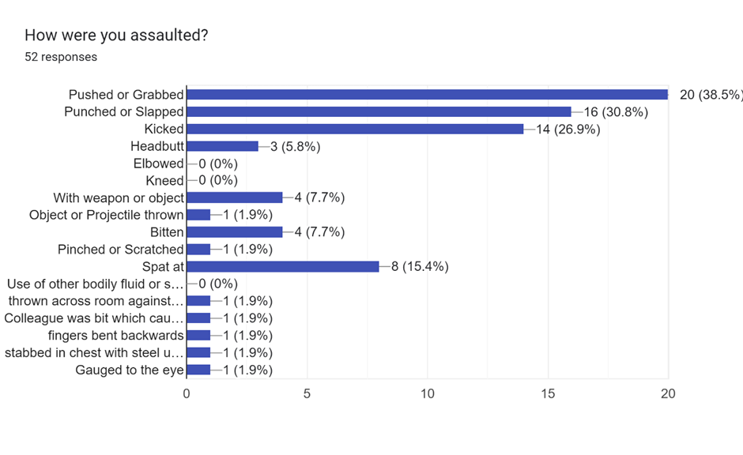
Figure 4.1 Results of Q.8 depicting responses of how officers were assaulted.

The above summary of methods of assaults, including physical actions and the use of weapons provides critical insight into the nature of these incidents of assaults on police. Having un understanding of the methods use will enable South Wales Police to design targeted defence and de-escalation strategies.

4.7. Perpetrator Details

The majority of perpetrators were male (76.9%), with ages predominantly falling within the 25-34 range (38.5%). These demographics offer insights into potential patterns in perpetrators of assaults on police, which in turn can be used to aid in the development of targeted preventive strategies.
The survey results also revealed that 71.1% of perpetrators were under the influence of alcohol, drugs, or both at the time of the assault. 21.2% of respondents stated that the person responsible was not under the influence of alcohol or drugs at the time, and the remaining 7.7% stated they did not know if the person responsible was under the influence. Further to this the survey revealed alcohol was the most prevalent factor here with it being involved in 65.3%. Again, this information is crucial in developing interventions to tackle substance abuse and misuse within communities, as the survey demonstrates a prevalence of both alcohol and drugs among perpetrators.
Officers were also asked the level of resistance exhibited by the perpetrator on their initial attendance at this incident.
Understanding the levels of resistance officers face, from compliance, verbal, passive, active, aggressive and serious resistance, will enable informed decision on officer training. The varied range of responses emphasizes the importance of adaptive response strategies in dynamic situations. (Fig. 4.2)
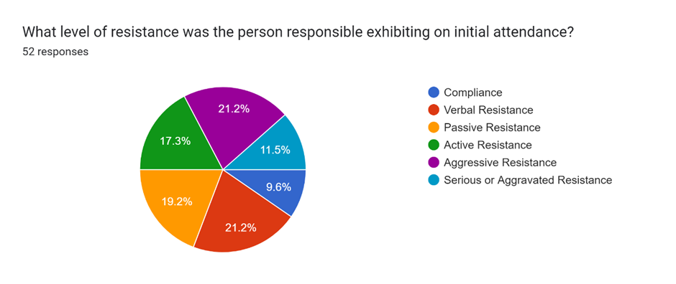
Figure 4.2 Results of Q.12 Showing the level of compliance first exhibited by the perpetrator.

4.8. Assault Location.

The majority of survey respondents (59.6%) had been assaulted in a public place, thus emphasising the need for vigilance and safety measures during officers’ routine policing activities. The next most frequent responses were the perpetrators home or residence (13.5%) followed by licenced premises (9.6%). Understanding where assaults on emergency workers are most likely to occur is crucial for identifying the areas of increased likelihood of an assault on a police officer as well as implementing preventative measures when attending potential hotspots.

4.9. Perceived Motivations for Assaults on Police Officers.

The survey allowed officers to provide qualitative insights into the motivations behind assaults. The responses were analysed, and common themes identified. The frequent themes included intoxication, dislike of the police, attempts to prevent arrest, and mental health issues. These findings underscore the multifaceted nature of the challenges faced by law enforcement officers. Additionally, the responses were entered into a word cloud processor for ease of viewing (Fig. 4.3).
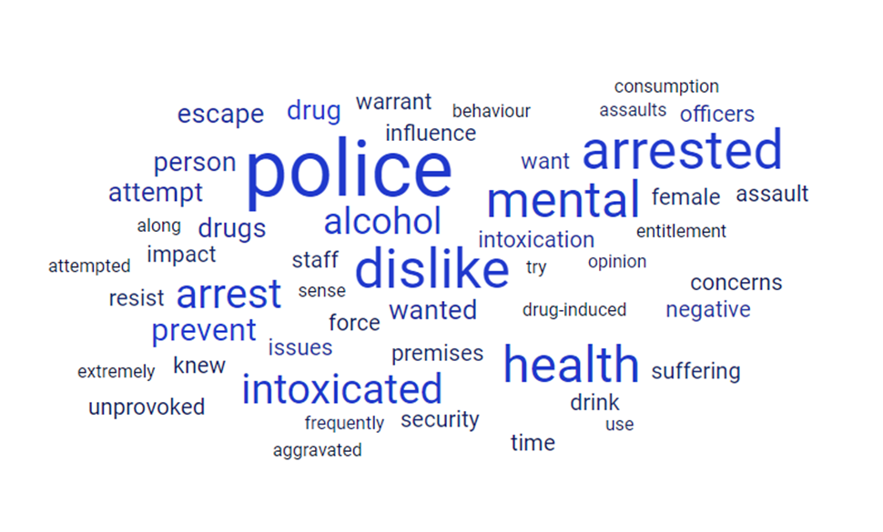
Figure 4.3 Word Cloud of factors officers believed were associated with the perpetrator who assaulted them.

4.10 Officer Safety Training (OST) Satisfaction

Officers were asked if they were satisfied with the OST provided by South Wales Police, and to provide a qualitative response clarifying their choice. While the majority of officers responding (67.3%) expressed satisfaction with the level of OST provided, a notable percentage of respondents (28.8%) reported dissatisfaction with the OST. It is worth considering that South Wales Police is in the process of implementing a new OST approach and that some of the respondents may have experienced this method, or be aware of its contents, whilst others may only have experience of the older model.
Responses regarding OST satisfaction provided valuable feedback on the current OST training methods. Officers highlighted the need for more realistic scenarios, additional focus on physical confrontation, and increased frequency of training sessions. Officers also noted that there were limitations as to what was realistically achievable in training scenarios and felt they prepared for real life situations as best as possible. Again, the responses were entered into a word cloud processor for ease of viewing (Fig. 4.4). Understanding officers' perspectives on OST is necessary in optimizing the training to align with the dynamic and evolving nature of policing challenges.
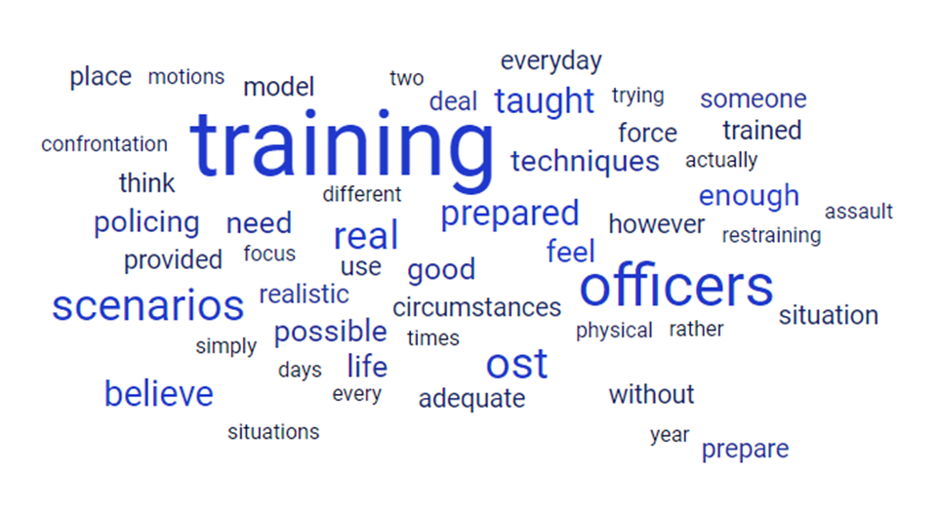
Figure 4.4 Word Cloud of officer satisfaction with OST provided by South Wales Police.
4.11. Conclusion

In conclusion, the survey results present an in-depth portrait of assaults on police officers within the South Wales Police force. These insights, ranging from demographic details to nuanced perceptions of safety training, collectively contribute to an understanding of the challenges faced by police officers within South Wales Police. Addressing these challenges requires a complex approach, encompassing safety procedures and protocols, targeted training, and community-based interventions aimed at mitigating the underlying causes of assaults on police officers, and ultimately contributing to the effectiveness of policing within the force.
This research may be limited in its number of respondents with 52 responses whilst South Wales Police has near to 3000 police officers. However, the data provided by this survey could serve as a valuable resource for shaping evidence-based policies and practices aimed at creating a safer working environment for police officers, especially if furthered on by additional larger scale research.
5. Chapter Five. Recommendations and Conclusions.

5.1. Recommendations

Based on the comprehensive analysis of the data collected, several recommendations can be proposed to enhance the safety of police officers within South Wales Police and mitigate the risk of assaults.

5.1.1 Targeted Officer Safety Training (OST)

Given the dissatisfaction with the current OST expressed by a notable portion of the officers surveyed, there is a need for a comprehensive review and enhancement of the training provided. This should include more realistic scenarios and simulations that more accurately reflect the dynamic and unpredictable nature of the situations faced by officers when carrying out their roles operationally. Additional emphasis on physical confrontation, de-escalation techniques, and regular, ongoing top up training sessions should be integrated. Furthermore, gathering feedback from officers at the conclusion of each session will further aid in refining the OST program continually. As previously noted, South Wales Police are currently in the process of implementing a new OST training program, the responses of participants who have experienced this program appear to be mostly satisfied with the new style and the added focus on confrontation.

5.1.2. Substance Abuse Intervention

The Survey revealed a significant association between assaults on officers and perpetrators under the influence of alcohol, drugs, or both. Developing and implementing community-based programs to address substance issues can be beneficial in reducing the number of persons with substance misuse issues within the community (Firesheets et al, 2012; Sloboda, 2009; Hawkins, Catalano and Miller, 1992). This in turn could contribute to reducing the incidents of assaults on officers. Collaboration with local authorities, healthcare providers and community organisations can help create or improve existing initiatives that promote responsible alcohol consumption and provide support to those individuals struggling with substance abuse and reducing crime in the community (Zgierska et al, 2021).

5.1.3. Community Policing and Public Relations

One of the most frequent motivations for assault on police officers identified by those completing the survey was a dislike of police. Strengthening community policing initiatives and improving public relations can assist in bridging the gap between the police service and the community which it serves. Engaging in community outreach procedures (Hobson et al, 2021), organising informational or educational events, and fostering positive interactions (Bradford, Jackson and Stanko, 2009; Connell, Miggans and McGloin, 2008) can contribute to changing negative perceptions and eventually, in reducing hostility towards police officers.
As addressing incidents where motivations include a dislike of police requires a proactive approach. One method of improving public relations is implementing and reviewing current cultural competency training within officer training programs (Moon, Morgan and Sandage, 2018). This can enhance officers’ ability to navigate interactions with diverse communities, reduce misunderstandings, and foster positive community relations. In time, cultural competency training can contribute to changing negative perceptions and building trust within those communities (Bullock and Johnson, 2018).

5.1.4. Continuous Research and Data Collection

The study involved a subset of the South Wales Police force, and the findings may not be fully representative of all officers in frontline roles within the force. Conducting regular and larger scale research on assaults against police officers can provide ongoing insights into evolving trends and issues, with improved result reliability, reduced error margins and lower standards of deviation. Larger scale research would also reduce the impact of outlier responses that would skew data in smaller research (Staller, 2021). Continuous data collection and analysis are essential for adapting strategies and policies to the dynamic nature of the challenges faced by police officers.

5.2. Limitations

Despite the valuable insights gained from the survey, it is essential that the limitations of this research are acknowledged. The relatively small sample size of 52 officers is unlikely to fully represent the diverse experiences of all South Wales Police officers. Furthermore, the self-reporting nature of the survey responses introduces the possibility of bias or inaccuracies in participants’ recollections (Fryer and Dinsmore, 2020).
Expanding data collection to include qualitative narratives from officers involved in assaults can provide deeper contextual information, capturing respondents’ perceptions, opinions, and emotions. It can also be used in combination with quantitative research in a combined approach in order to clarify or quantify the initial question (Aguis, 2013). In-depth interviews or focus group discussions with officers sharing their personal experiences could uncover nuances not captured by this predominantly quantitative survey. This qualitative approach can offer a more holistic understanding of the psychological and emotional impact (Savoiu, Cudanov and Tornjanski, 2023) of assaults on police officers as well as their insights as to why the assaults happened, which could further inform preventative strategies or inform strategies for support and rehabilitation following the incident.

5.3. Further Research

In order to further build on the findings of this study, further research is recommended to explore specific factors that influence assaults on police officers. Examination of the demographic patterns of persons involved in assaults on police officers reveals that the majority of assaults were caused by males within the age range of 25-34 who were under the influence of alcohol at the time, and in a public place. Understanding the factors contributing to this demographics propensity for violence towards officers is crucial. Further research could explore the socio-economic factors, educational backgrounds, and regional influences that may correlate with the group most frequently associated with assaults on police officers. Identifying these factors could aid in targeted preventative measures and community interventions.
Other further research which could be conducted can include a comparative research project where the findings are compared with similar studies conducted within other police forces, in turn offering a broader perspective to the underlying factors contributing to assaults against police. Identifying and understanding any variations in assault patterns, perpetrator demographics, and force policies and procedures such as officer safety training across differing forces will provide valuable insights. Comparative analysis would be beneficial in contributing to the development of universal best practices while acknowledging the unique challenges faced by specific police forces. This could also be completed internationally to benchmark South Wales Police practices against successful approaches in other countries or authorities, in turn fostering a shared global perspective on officer safety.

5.4. Achievement of Objectives

This research successfully achieved its objectives by identifying prevalent forms of violence against police officers. With the most common forms of assault being identified as pushing or grabbing (38.5%), a punch or slap (30.8%) and kicking (26.9%). Identifying the most common methods of assault is useful to South Wales Police as it will assist in designing and implementing tactics and techniques into officer training.
Further to this another objective of the survey was to identify the factors most commonly contributing towards violence against police officers. The survey identified demographic factors such as gender, age in addition to further factors such as intoxication, location, and level of resistance. Additionally, the survey allowed for qualitative examination into factors perceived by the officers as to why the individual responsible assaulted them.
The underlying causes of risk factors associated with violence against police officers were considered, with recommendations made for how to build on this research and delve deeper into the underlying factors responsible.
Finally, the research also evaluated the effectiveness of existing force policies and procedures for officers attending incidents resulting in assaults against them. South Wales Police policy of having officers double crewed at incidents was identified as being necessary, mainly due to the quantity of officers who completed the survey having been assaulted (98.1%) compared to the number assaulted despite being double crewed at the time (96.2%). Further to this, PPE policies were identified as remaining necessary with 98.1% of respondents being in possession of PPE at the time of the assault. The research identified that 28.8% of respondents were not satisfied with the OST provided by the force, and recommendations made on the improvements of this.

5.5. Conclusion

This concluding chapter of this research not only collates the analysis conducted on factors influencing assaults on police officers within the South Wales Police Force, but also provides a strategic roadmap for tangible improvements in officer safety. The challenges concerning assaults faced by officers in the process of carrying out their duties have been discussed. The recommendations outlined above target these challenges, advocating for a holistic approach encompassing officer training, substance abuse intervention, community engagement, and a commitment to continuous research and data collection.
Central to the proposed improvements is the need for enhanced training methodologies. The evolving nature of threats faced by police officers necessitates a proactive stance through continuous training. Ensuring that officers are not only well equipped with the latest PPE, and training techniques, but are instilled with a sense of preparedness. By investing in the professional development of officers, the South Wales Police Force can cultivate a service of police officers capable of navigating the complexities and inherent risks of their roles.
Furthermore, the importance of addressing substance misuse issues within the communities served by the force cannot be overstated. Recognising the potential correlation between substance abuse and assaults on police officers, the research recommends the integration of effective intervention programmes. This will not only serve as a preventative measure (Dorton and Semien, 2016) but will also contribute to the overall well-being and resilience of officers by combating the number of assaults they face.
The proposed recommendations extend beyond the internal dynamics of the force and encourage community engagement. Strengthening relationships between the police service and the community which it serves is identified as a pivotal requirement in encouraging a safer community and environment in which officers will be working. Positive interactions and understanding between officers and the public can act as a preventative measure against hostilities (Murphy, 2009), contributing to an atmosphere where both the community and officers can feel secure.
To conclude, the research and the recommendations identified when combined together can be used to form the basis of a strategy to enhance officer safety. Addressing the identified issues will position the force well to pro-actively navigate the ever-evolving complexities of policing the public within South Wales.

Bibliography.
- Agius, S.J. (2013) ‘Qualitative research: its value and applicability’, The psychiatrist, 37(6), pp. 204–206. Available at: https://doi.org/10.1192/pb.bp.113.042770.

- Akinci, C. and Saunders, M. (2015) Using questionnaire surveys for within-organisation HRD research: In Handbook of research methods on human resource development. London: Edward Elgar Publishing.

- Anonymous (2004) ‘Idaho: Assaults on Police Rise as Crime Rate Dips’ , Crime Control Digest, 38(22), p. 7–.

- Ariel, B. et al. (2016) ‘Wearing body cameras increases assaults against officers and does not reduce police use of force: Results from a global multi-site experiment’, European journal of criminology, 13(6), pp. 744–755. Available at: https://doi.org/10.1177/1477370816643734.

- BBC. (2020) Croydon police shooting: Man arrested over Sgt Matiu Ratana murder. Available at: https://www.bbc.co.uk/news/uk-england-london-54935429 (Accessed: 17 MAY 2023)

- BBC. (2022) Law in memory of PC Harper comes into force after wife's campaign. Available at: https://www.bbc.co.uk/news/uk-england-berkshire-61969724 (Accessed: 17 MAY 2023)

- Benton, M.A. (2017) ‘Epistemology Personalized’, The Philosophical quarterly, 67(269), pp. 813–834. Available at: https://doi.org/10.1093/pq/pqx020.

- Bradford, B., Jackson, J. and Stanko, E.A. (2009) ‘Contact and confidence: revisiting the impact of public encounters with the police’, Policing & society, 19(1), pp. 20–46. Available at: https://doi.org/10.1080/10439460802457594.
- Bryman, A. (2016) Social research methods. 5th ed. Oxford ;: Oxford University Press.

- Bullock, K. and Johnson, P. (2018) ‘Police engagement with Muslim communities: breaking out, breaking in, and breaking through’, Policing & society, 28(8), pp. 879–897. Available at: https://doi.org/10.1080/10439463.2017.1339706.

- Clare, J. et al. (2021) ‘The results of a randomized controlled trial of police body-worn video in Australia’, Journal of experimental criminology, 17(1), pp. 43–54. Available at: https://doi.org/10.1007/s11292-019-09387-w.

- Cohen, L., Manion, L. and Morrison, K., 2017. Validity and reliability. In Research methods in education (pp. 245-284). Routledge.

- College of Policing. (2020) Officer and Staff Safety Review A review of the arrangements to secure the safety of police officers and police staff engaged in frontline policing. Available at: https://assets.college.police.uk/s3fs-public/2020-09/CoP-NPCC-Officer-Staff-Safety-Review.pdf (Accessed: 17 MAY 2023)

- College of Policing (2023) Counter Terrorism: Authorised Professional Practice. Available at: https://www.college.police.uk/app/public-order-public-safety/developing-policing-plan/counter-terrorism (Accessed: December 2023)

- Connell, N.M., Miggans, K. and McGloin, J.M. (2008) ‘Can a Community Policing Initiative Reduce Serious Crime?: A Local Evaluation’, Police quarterly, 11(2), pp. 127–150. Available at: https://doi.org/10.1177/1098611107306276.

- Crown Prosecution Service. (2018) Assaults on Emergency Workers (Offences) Act 2018. Available at: https://www.cps.gov.uk/legal-guidance/assaults-emergency-workers-offences-act-2018 (Accessed: 16 MAY 2023)

- Dorton, H.E. and Semien, D.S. (2016) ‘“Collaborative Investment” instead of Community Policing: An Examination of an Innovative Drug Market Intervention Program in Southern Alabama’, Race, gender & class (Towson, Md.), 23(1–2), pp. 99–107.

- Douglas, S. (2021) ‘The Effects of Body-Worn Cameras on Violent Police Victimization’, Policing : a journal of policy and practice, 15(2), pp. 1399–1416. Available at: https://doi.org/10.1093/police/paaa032.

- Drost, E.A. (2011) ‘Validity and reliability in social science research’, Education, research and perspectives, 38(1), p. 1–.

- Firesheets, E.K. et al. (2012) ‘Community-Based Prevention Support: Using the Interactive Systems Framework to Facilitate Grassroots Evidenced-Based Substance Abuse Prevention’, American journal of community psychology, 50(3–4), pp. 347–356. Available at: https://doi.org/10.1007/s10464-012-9506-x.

- Flick, U., (2011). ‘A beginner’s guide to doing a research project’. Introducing Research.

- Ford, C.T. (2000) Violence Against Police: Felonious Killings of South Carolina Police Officers from 1962 to 1998 and Assaults Against South Carolina Police Officers in 1991 and 1997.

- Fryer, L.K. and Dinsmore, D.L., 2020. The Promise and Pitfalls of Self-report: Development, research design and analysis issues, and multiple methods. Frontline Learning Research.

- Ghauri, P., Gronhaug, K. and Strange, R. (2020) Research Methods in Business Studies. Cambridge University Press.

- Gibbs, J.C., Lee, J., Moloney, J. & Olson, S. (2018) Exploring the neighbourhood context of serious assaults on police, Policing and Society, 28:8, 898-914, DOI: 10.1080/10439463.2017.1333120

- Goldsmith, A. (2005) ‘Police reform and the problem of trust’, Theoretical criminology, 9(4), pp. 443–470. Available at: https://doi.org/10.1177/1362480605057727.

- Gorringe, H. and Rosie, M. (2011) ‘King Mob: Perceptions, Prescriptions and Presumptions about the Policing of England’s Riots’, Sociological research online, 16(4), pp. 1–6. Available at: https://doi.org/10.5153/sro.2521.

- Greer, C. and McLaughlin, E. (2010) ‘We Predict a Riot?: Public Order Policing, New Media Environments and the Rise of the Citizen Journalist’, British journal of criminology, 50(6), pp. 1041–1059. Available at: https://doi.org/10.1093/bjc/azq039.

- Hawkins, J.D., Catalano, R.F. and Miller, J.Y. (1992) ‘Risk and Protective Factors for Alcohol and Other Drug Problems in Adolescence and Early Adulthood: Implications for Substance Abuse Prevention’, Psychological bulletin, 112(1), pp. 64–105. Available at: https://doi.org/10.1037/0033-2909.112.1.64.

- Hobson, J. et al. (2021) ‘Are Police-Led Social Crime Prevention Initiatives Effective? A Process and Outcome Evaluation of a UK Youth Intervention’, International criminal justice review, 31(3), pp. 325–346. Available at: https://doi.org/10.1177/1057567718814891.

- Home Office. (2022) Annex: Statistics on the number of police officers assaulted in the year ending March 2022, England and Wales. Available at: https://www.gov.uk/government/statistics/police-workforce-england-and-wales-31-march-2022/annex-statistics-on-the-number-of-police-officers-assaulted-in-the-year-ending-march-2022-england-and-wales (Accessed: 17 MAY 2023)

- Home Office. (2023) Criminal Justice Bill: Knife Crime. Available at: https://www.gov.uk/government/publications/criminal-justice-bill-2023-factsheets/criminal-justice-bill-knife-crime (Accessed: December 2023)

- Houdmont, J., Elliott-Davies, M. & Donnelly, J. (2019) Single crewing in English and Welsh policing: frequency and associations with violence towards and injuries in officers, Policing and Society, 29:7, 820-833, DOI: 10.1080/10439463.2017.1417990 To link to this article: https://doi.org/10.1080/10439463.2017.1417990

- Jansen, D. (2023a) Research Philosophy & Paradigms Positivism, Interpretivism & Pragmatism, Explained Simply. Available at https://gradcoach.com/research-philosophy/ (Accessed September 2023)

- Jansen, D. (2023b) Sampling Methods & Strategies 101. Available at https://gradcoach.com/sampling-methods/ (Accessed September 2023)

- Johnson, R.R. (2011) ‘Predicting Officer Physical Assaults at Domestic Assault Calls’, Journal of family violence, 26(3), pp. 163–169. Available at: https://doi.org/10.1007/s10896-010-9346-0.

- Johnson, R.R. (2015) ‘Perceptions of Interpersonal Social Cues Predictive of Violence Among Police Officers Who Have Been Assaulted’, Journal of police and criminal psychology, 30(2), pp. 87–93. Available at: https://doi.org/10.1007/s11896-014-9145-2.

- Kaminski, R.J., Jefferis, E. and Gu, J. (2003) ‘Community Correlates of Serious Assaults on Police’, Police quarterly, 6(2), pp. 119–149. Available at: https://doi.org/10.1177/1098611103006002001.
- Keane, J. and Bell, P. (2013) ‘Confidence in the police: Balancing public image with community safety – A comparative review of the literature’, International journal of law, crime and justice, 41(3), pp. 233–246. Available at: https://doi.org/10.1016/j.ijlcj.2013.06.003.

- Kesmodel, U.S., 2018. Cross‐sectional studies–what are they good for?. Acta obstetricia et gynecologica Scandinavica, 97(4), pp.388-393.

- Kira Vrist Rønn (2023) ‘Mediated Proximity: Community Policing in the Digital Age’, Nordic Journal of Studies in Policing, 10(1), pp. 1–15. Available at: https://doi.org/10.18261/njsp.10.1.8.

- Maguire, E. et al. (2021) ‘Attitudes towards the Use of Violence against Police among Occupy Wall Street Protesters’, Policing : a journal of policy and practice, 14(4), pp. 883–899. Available at: https://doi.org/10.1093/police/pay003

- Mawby, R.C. and Zempi, I. (2018) ‘Police officers’ experiences as victims of hate crime’, Policing : an international journal of police strategies & management, 41(5), pp. 526–538. Available at: https://doi.org/10.1108/PIJPSM-12-2016-0176.

- Moon, S.H., Morgan, T. and Sandage, S.J. (2018) ‘The Need for Intercultural Competence Assessment and Training Among Police Officers’, Journal of forensic psychology research and practice, 18(5), pp. 337–351. Available at: https://doi.org/10.1080/24732850.2018.1510274.

- Murphy, K. (2009) ‘Public satisfaction with police : the importance of procedural justice and police performance in police-citizen encounters’, Australian & New Zealand journal of criminology, 42(2), pp. 159–178. Available at: https://doi.org/10.1375/acri.42.2.159.

- Ozkan, T., Worrall, J.L. and Piquero, A.R. (2016) ‘Does Minority Representation in Police Agencies Reduce Assaults on the Police?’, American journal of criminal justice, 41(3), pp. 402–423. Available at: https://doi.org/10.1007/s12103-016-9338-6.

- Parpworth, N. (2020). Sentencing Those Who Assault Emergency Workers: A Guideline-influenced Approach: R v Whelan [2020] EWCA Crim 195. The Journal of Criminal Law, 84(3), 255–258. https://doi-org.ezproxy.uwtsd.ac.uk/10.1177/0022018320924185

- Phair, D. and Warren, K. (2021) Saunders’ Research Onion: Explained Simply. Available at https://gradcoach.com/saunders-research-onion/ (Accessed September 2023)

- Roberts, P. and Priest, H. (2006) ‘Reliability and validity in research’, Nursing standard, 20(44), pp. 41–45. Available at: https://doi.org/10.7748/ns2006.07.20.44.41.c6560.

- Robertson, C.J. (2018) ‘Restoring Public Confidence in the Criminal Justice System: Policing Prosecutions When Prosecutors Prosecute Police’, Emory law journal, 67(4), pp. 853–887.

- Sahay, A., 2016. Peeling Saunder's research onion. Research Gate, Art, 3(2), pp.1-5.

- Saunders, M., Lewis, P. and Thornhill, A. (2009) Research methods for business students. England: Pearson Education Limited.

- Săvoiu, G., Čudanov, M. and Tornjanski, V., 2023. Does the Holistic Approach Constitute a Realistic and Possible Option for a Future of Profound Human Knowledge and for a Modern Scientific Research?. Econophysics, Sociophysics & Other Multidisciplinary Sciences Journal (ESMSJ), 12(1), pp.3-10.

- Sloboda, Z. et al. (2009) ‘The Adolescent Substance Abuse Prevention Study: A randomized field trial of a universal substance abuse prevention program’, Drug and alcohol dependence, 102(1), pp. 1–10. Available at: https://doi.org/10.1016/j.drugalcdep.2009.01.015.

- Staller, K. M. (2021). Big enough? Sampling in qualitative inquiry. Qualitative Social Work, 20(4), 897-904. https://doi.org/10.1177/14733250211024516

- Torres, C.E., D’Alessio, S.J. and Stolzenberg, L. (2021) ‘Race and the Probability of Police Injury’, Race and social problems, 13(3), pp. 215–225. Available at: https://doi.org/10.1007/s12552-020-09300-5.

- Van Reemst, L. and Jongerling, J. (2021) ‘Measuring and Modeling Exposure to External Workplace Aggression in Three Types of Emergency Responders’, Journal of interpersonal violence, 36(17–18), pp. 7978–8003. Available at: https://doi.org/10.1177/0886260519847780.

- Zgierska, A.E. et al. (2021) ‘Pre-arrest diversion to addiction treatment by law enforcement: protocol for the community-level policing initiative to reduce addiction-related harm, including crime’, Health & justice, 9(1), pp. 9–9. Available at: https://doi.org/10.1186/s40352-021-00134-w.
Appendix

Appendix 1 – Blank Copy of Survey Questionnaire issued to South Wales Police officers.

Appendix 2 – Results of completed surveys.

Appendix 3 – Wordcloud for Q.15 of survey.

Appendix 4 – Wordcloud for Q.17 of survey.
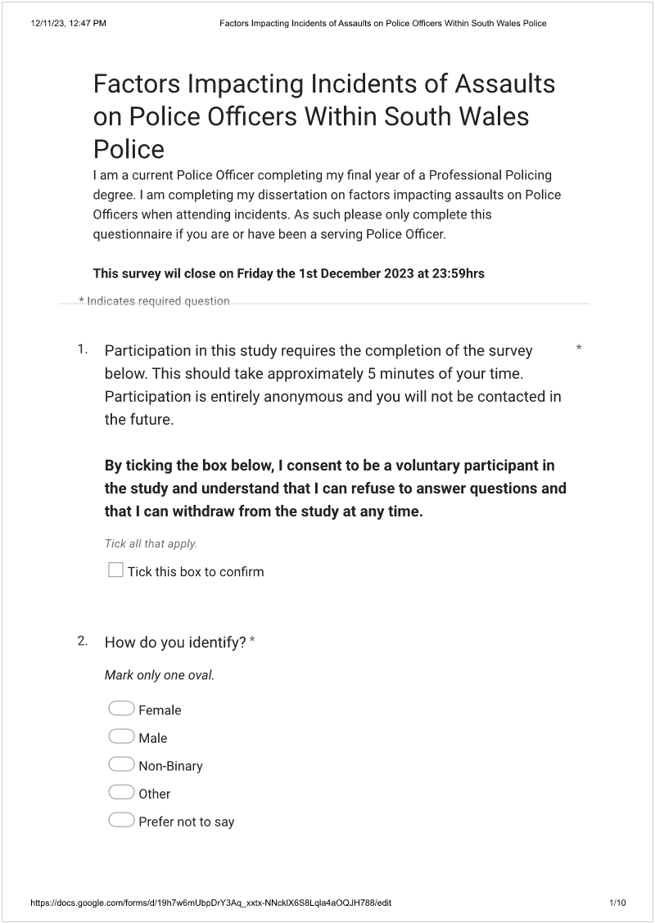
Appendix 1 – Blank Copy of Survey Questionnaire issued to South Wales Police officers.
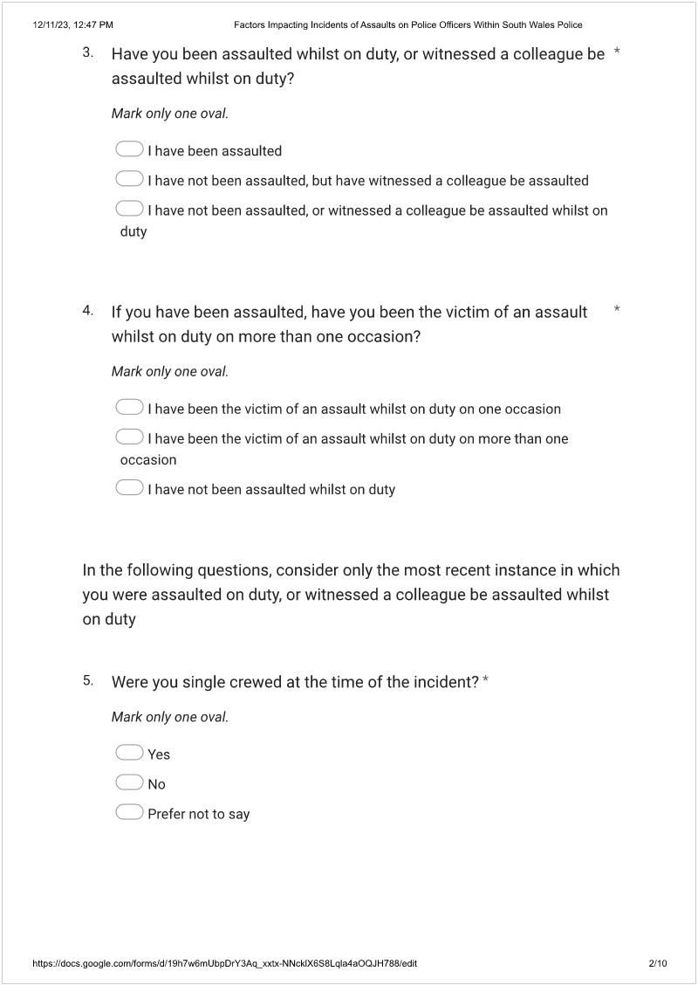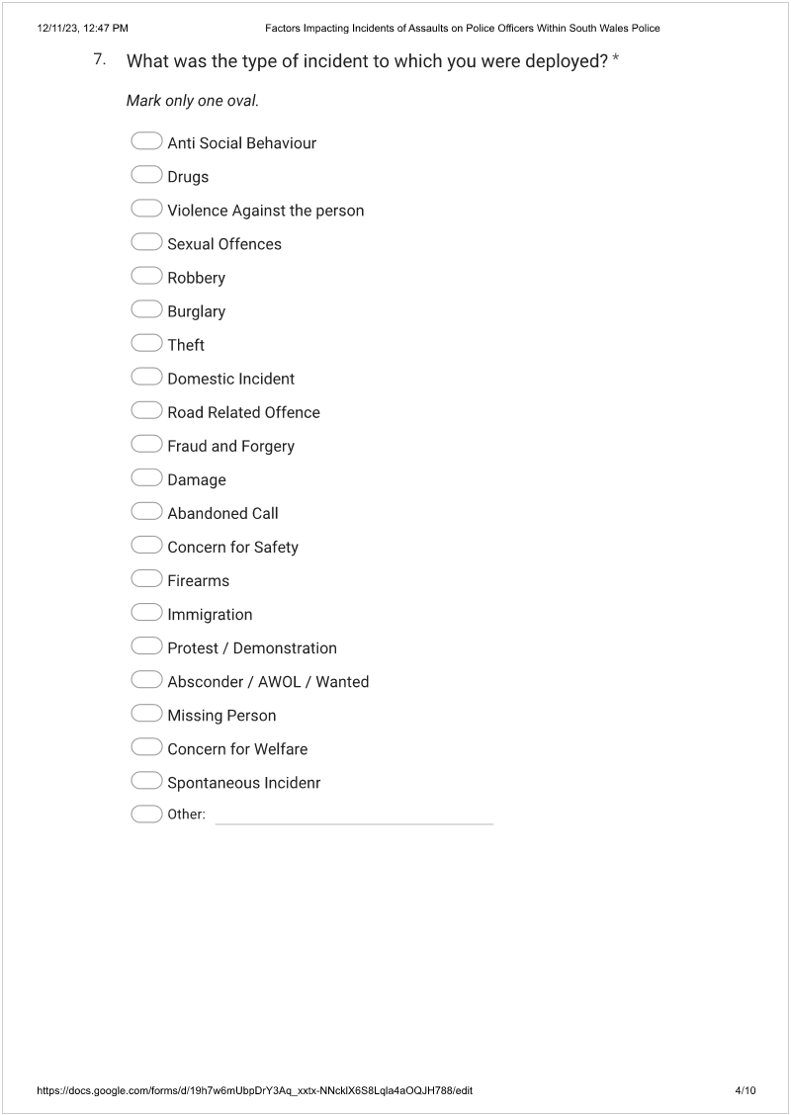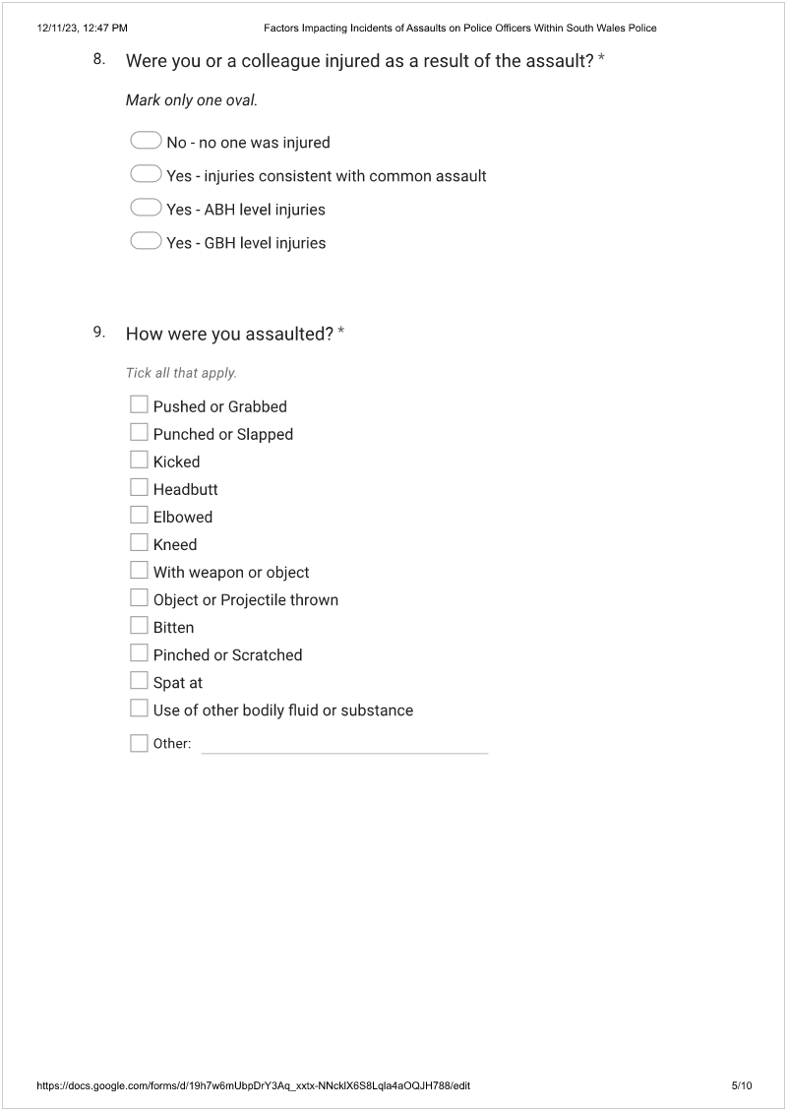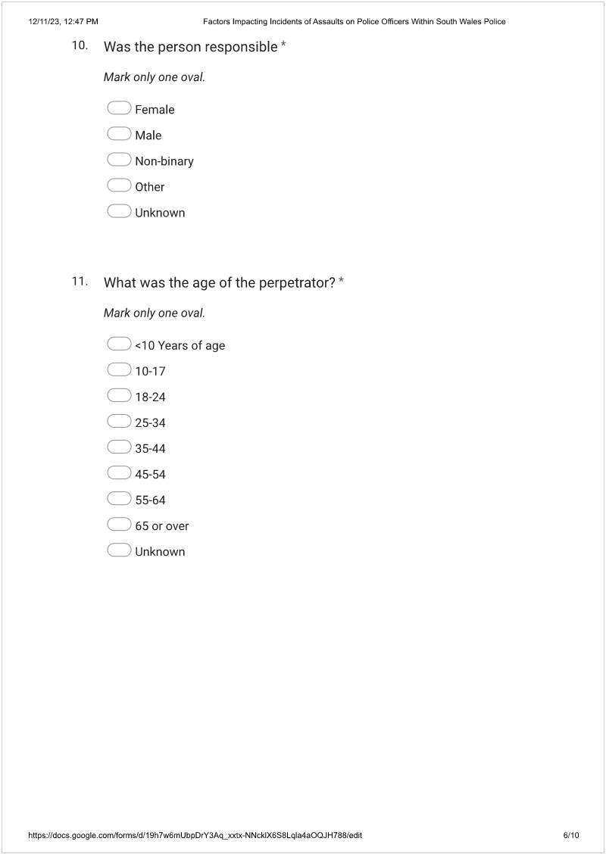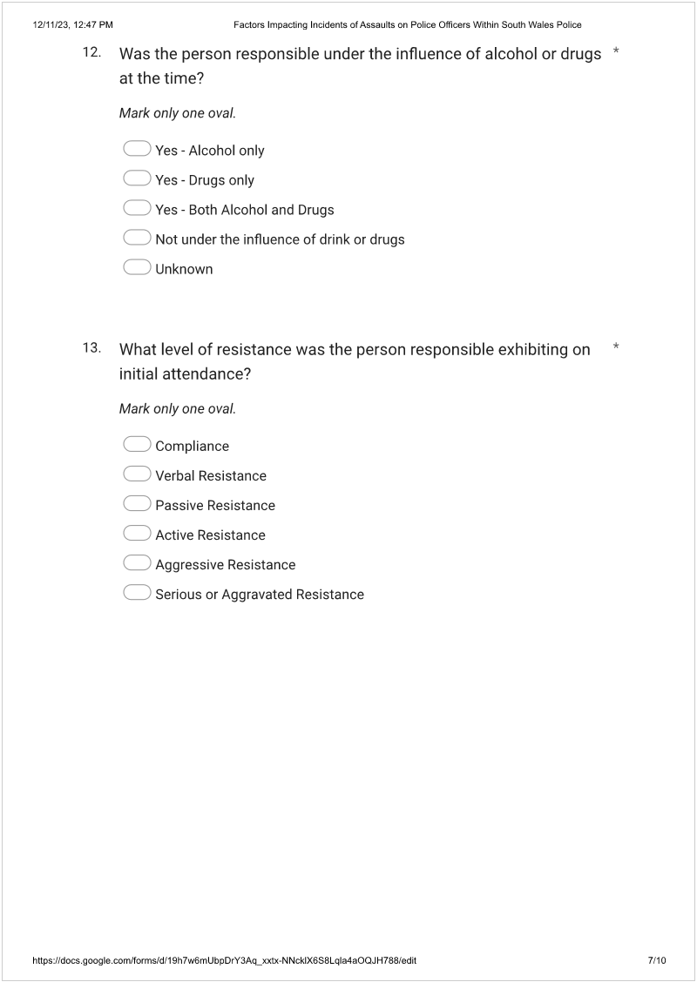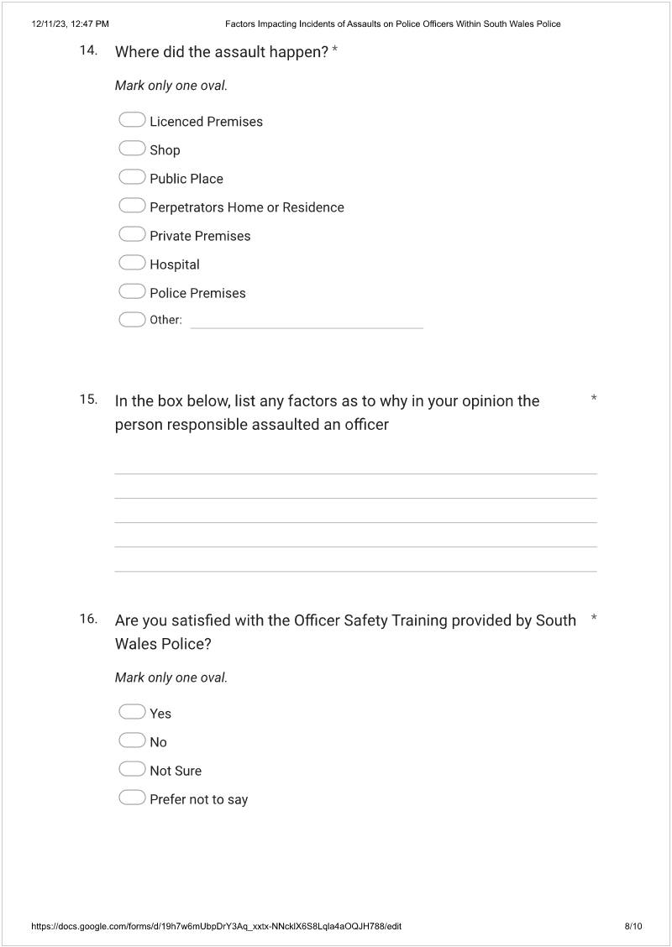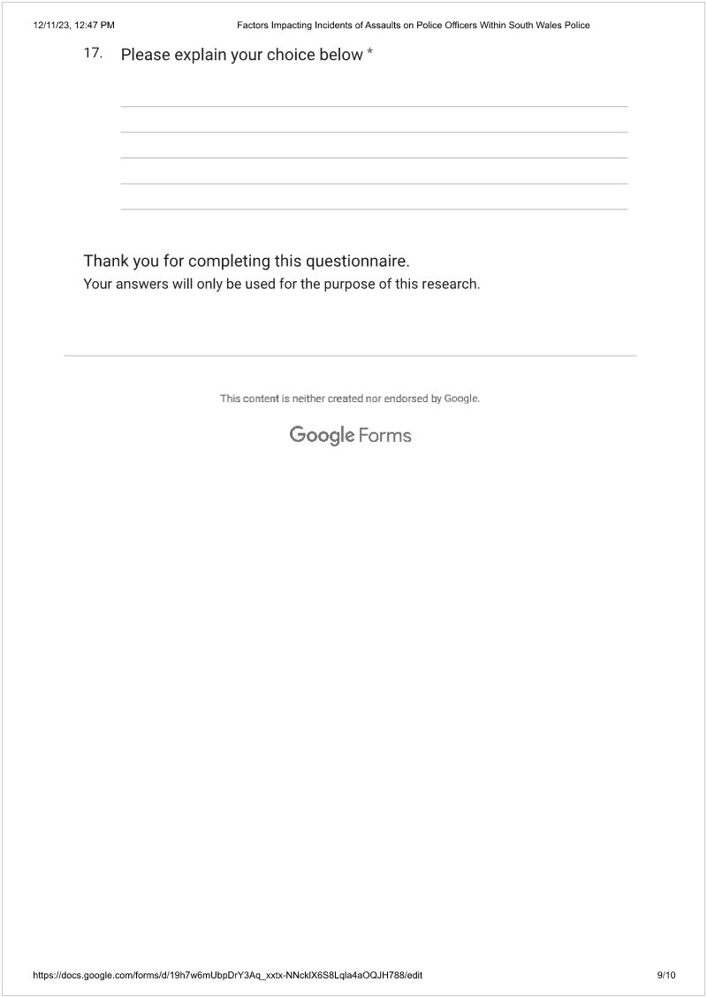

Appendix 2 - Results of completed surveys.
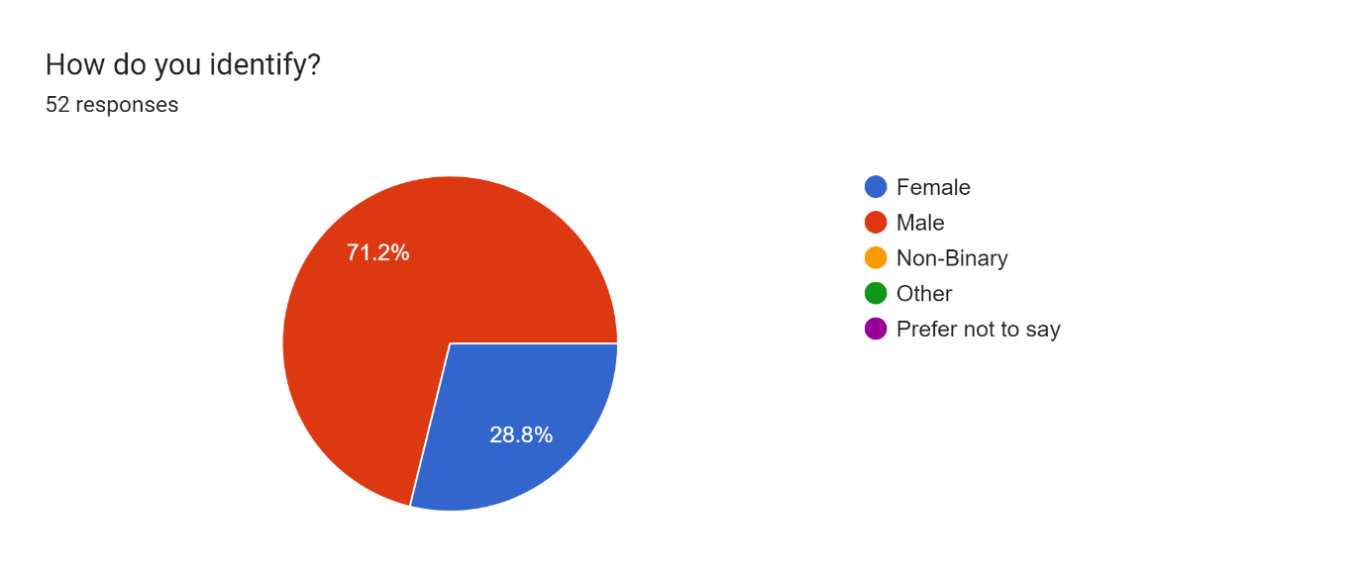

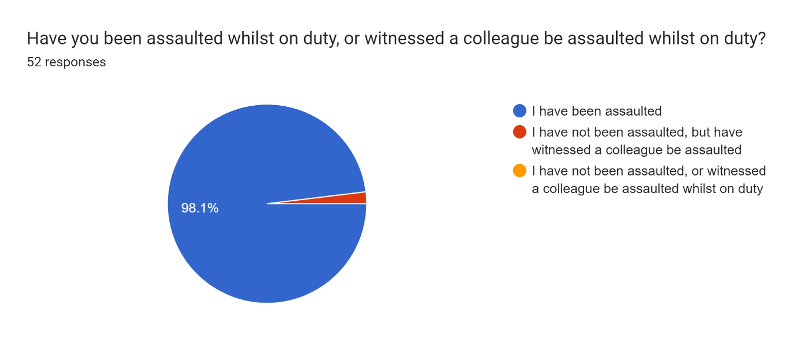
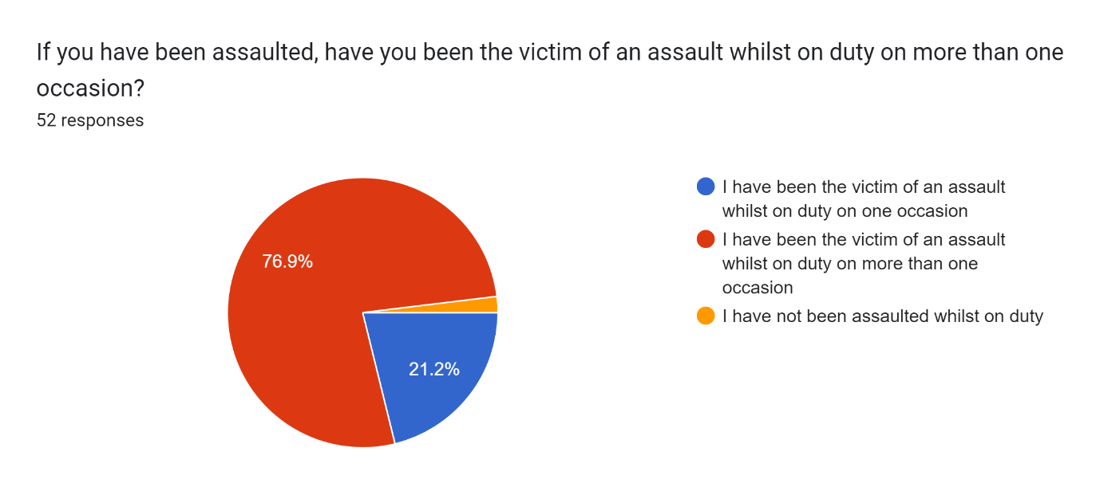
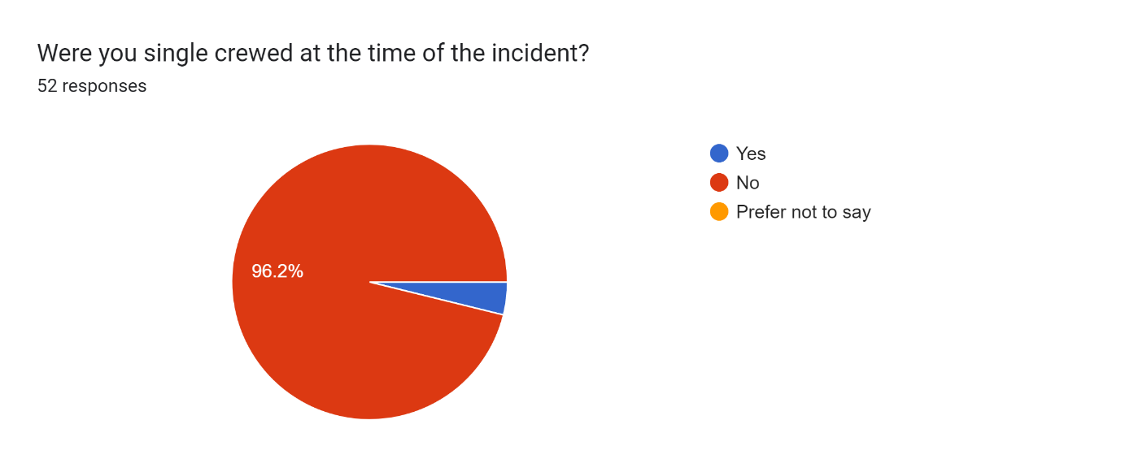
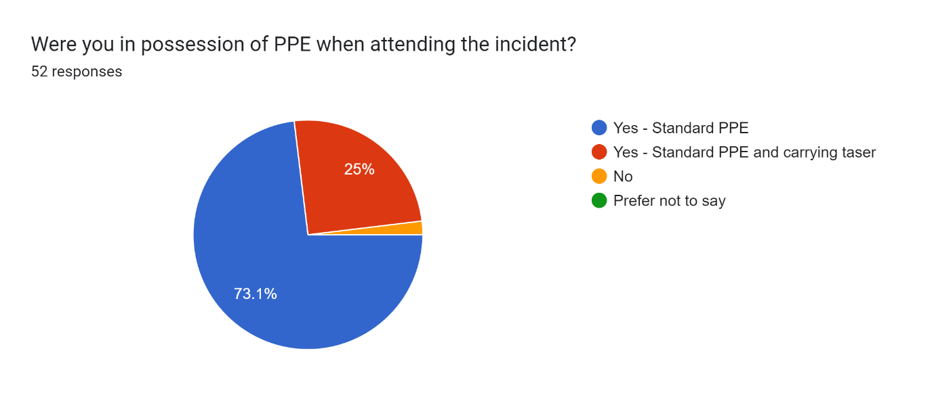
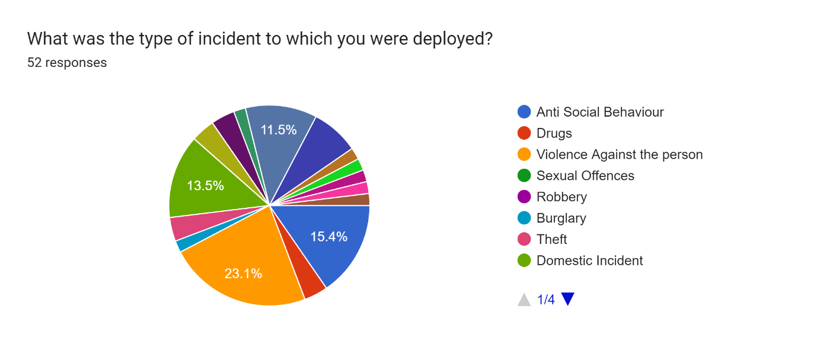
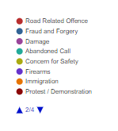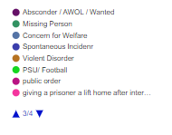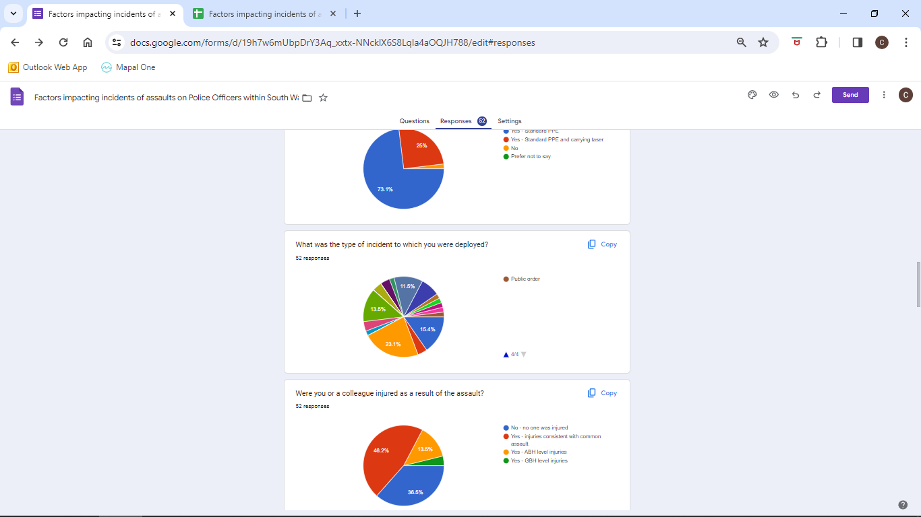

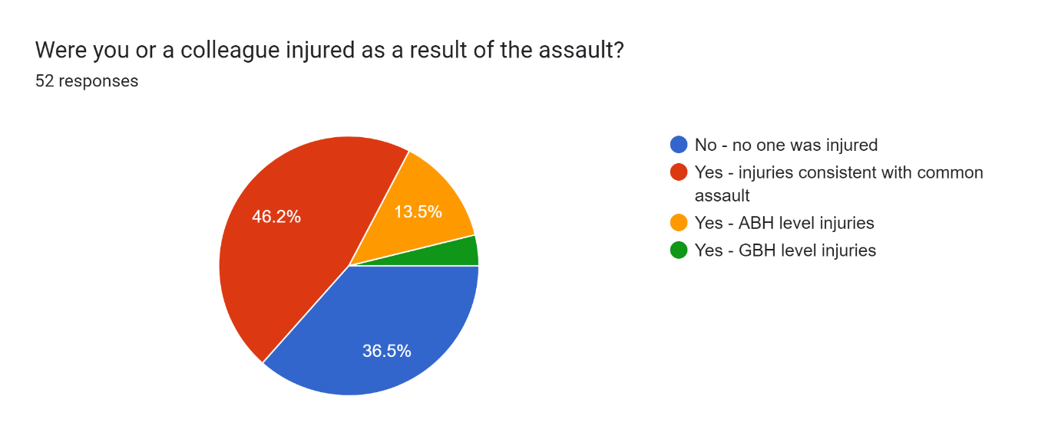

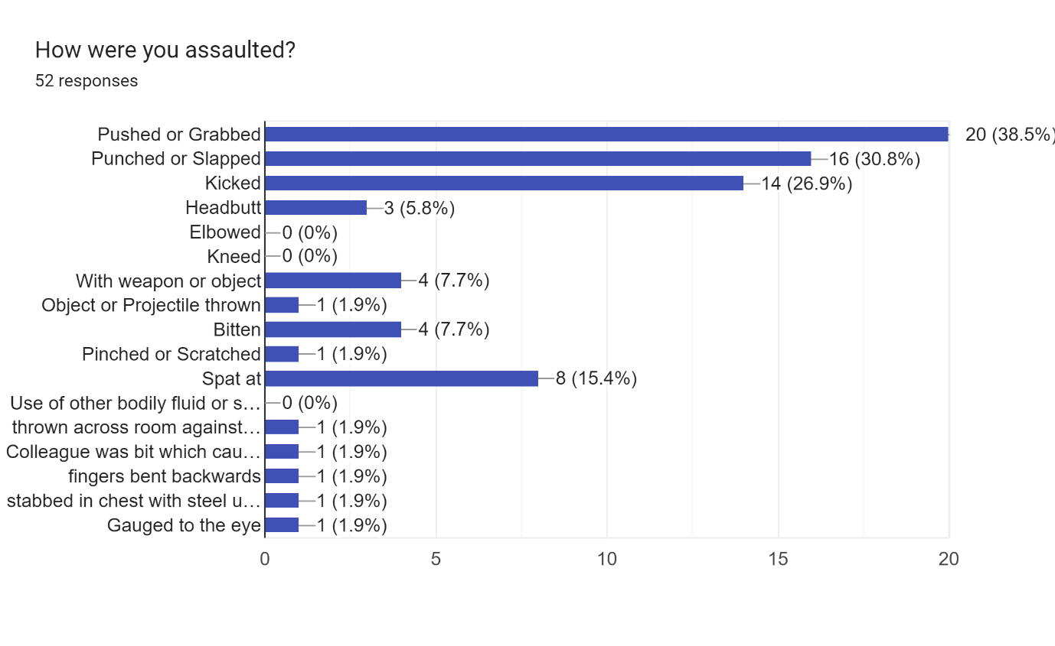
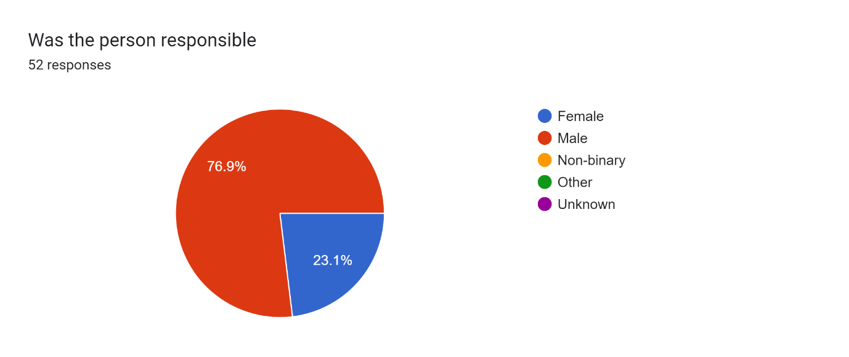
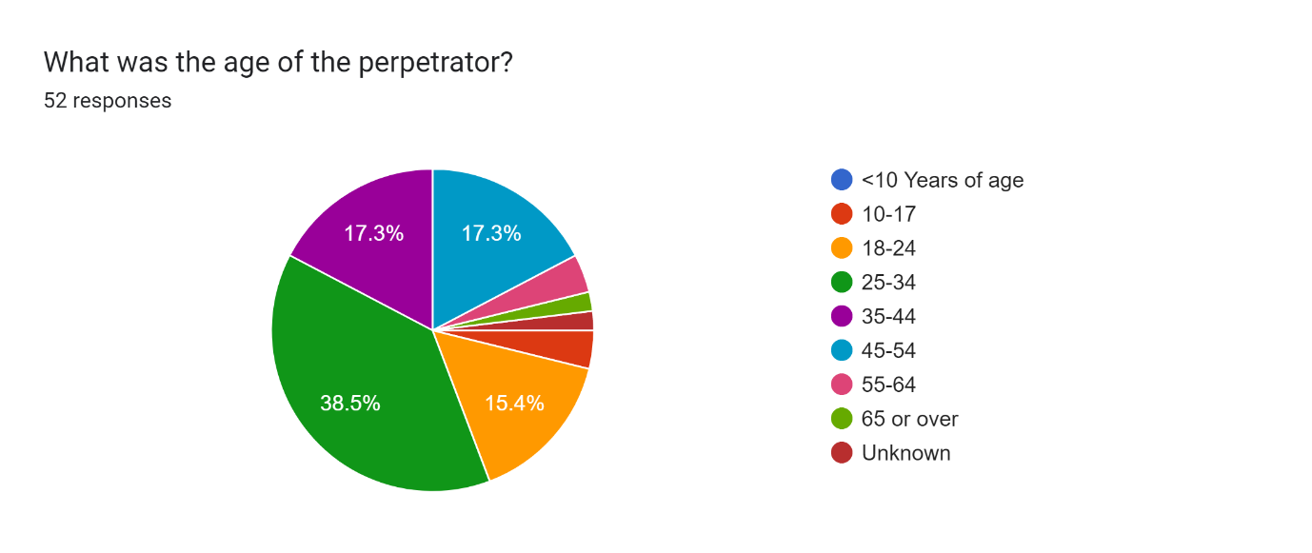
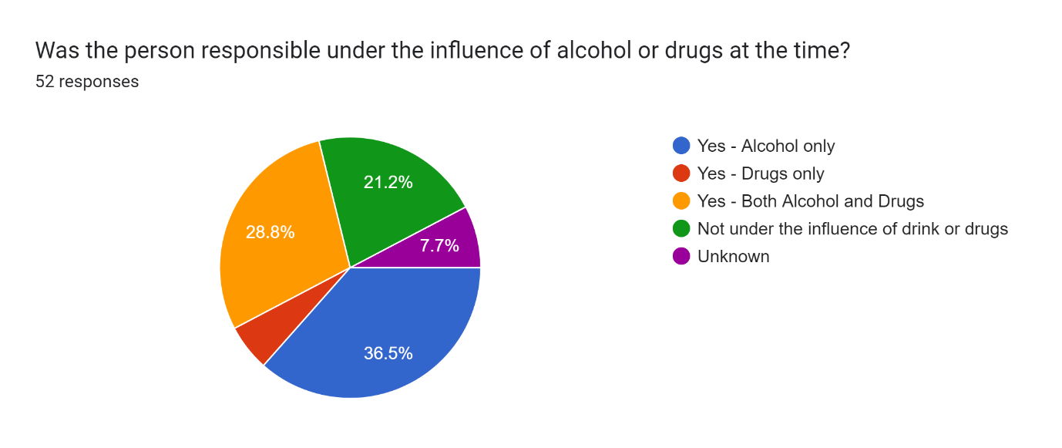
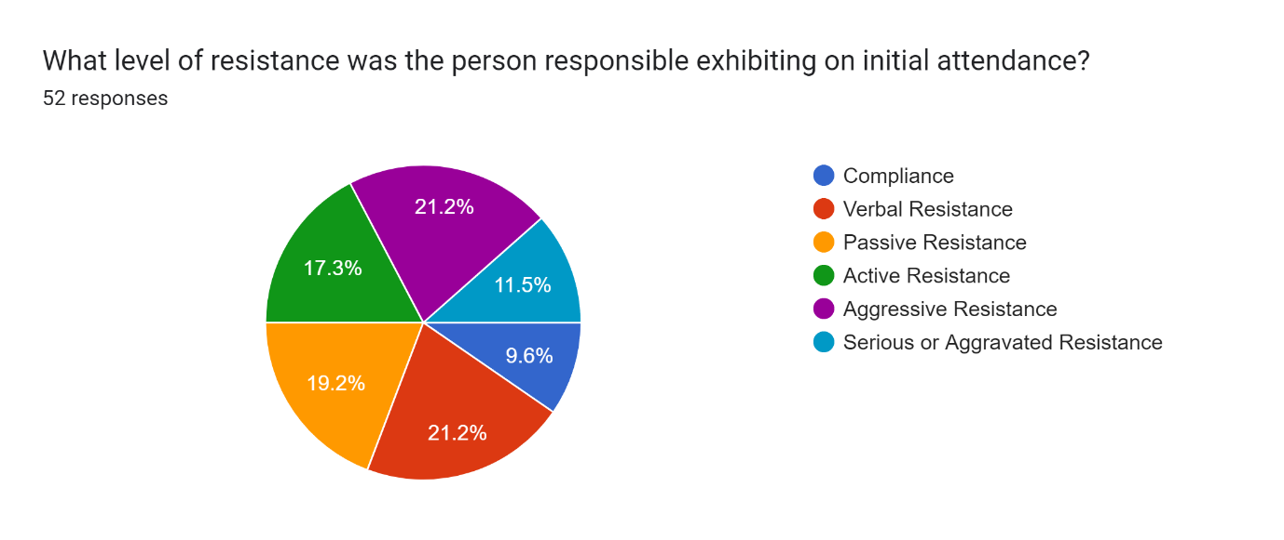
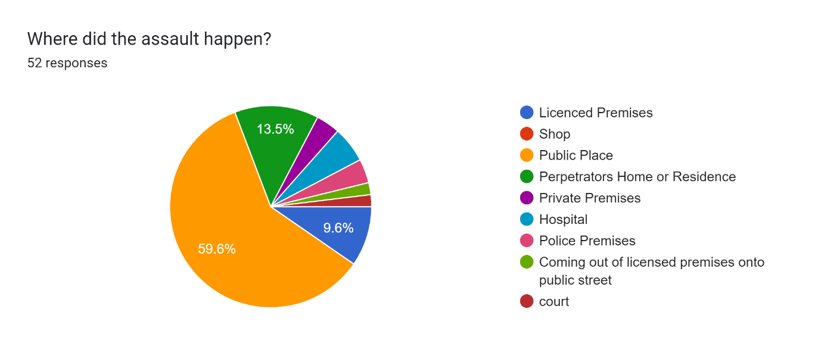

In the box below, list any factors as to why in your opinion the person responsible assaulted an officer.
52 responses
- Intoxication, Dislike of police
- Alcohol
- Because they did not want to be arrested
- .
- Prevent arrest, Dislike of police,
- Does not like police, frequently assaults officers
- Negative opinion of police
- Drug use and (drug-induced) mental health issues
- Behaviour aggravated by alcohol and drug consumption
- Intoxication
- Influence of drink / drugs
- The person was extremely intoxicated and attempted to resist arrest
- drugs, alcohol and the person was wanted on warrant.
- Intoxicated
- To try and prevent them being arrested
- refused to be arrested as he believed we did not have the power to enter his property without warrant, call was domestic related.
- Drug induced psychosis
- The female was highly intoxicated. She was arrested and upon immediately being arrested she began to attempt to exit the premises showing clear indication she wanted to escape. She was also in a group which could have had an impact on the matter.
- Suffering from mental health
- security/door staff at a licensed premises using excessive force on a MOP who they pushed with sufficient force to impact with me and cause me to hit the pavement and suffer back injuries and damage cruciate ligaments in one leg as a result.
- intoxicated
- Person had serious mental health concerns and was posing a risk to the public and court staff and could not be detained by security
- Unknown - unprovoked
- She was suffering with mental health issues and had a disregard to officers and showed no respect
- he wanted attention, knew he'd get arrested by asaulting me
- Disliked police
- Lost control and not thinking of their actions
- mental health
- n/a
- Because the sentence for Assault Police is an absolute joke and he probably knew he would get away with it, which he did!!
- They were under the influence of alcohol; They had had a negative interaction with door-staff a short time prior; They did not wish to comply with Police instructions.
- didn't like being confronted by a female
- known violent individual intoxicated with drink and drugs
- large aggressive drugged
- Didn't want to be arrested
- Attempt to escape
- Alcohol Resisting arrest
- Possible underlying mental health concerns or dislike of police as assault was sudden and unprovoked
- Distrust and dislike of Police Mental health episode
- Prevent arrest of sibling Dislike of Police
- Dislike of Police Dislike of females Resist arrest
- Mental health Not in right frame of mind
- Was irate at time In an attempt to prevent himself being arrested
- Attempting to escape arrest
- Intoxicated Dislike of police
- Anger towards Police Angry at being arrested Dislike of police

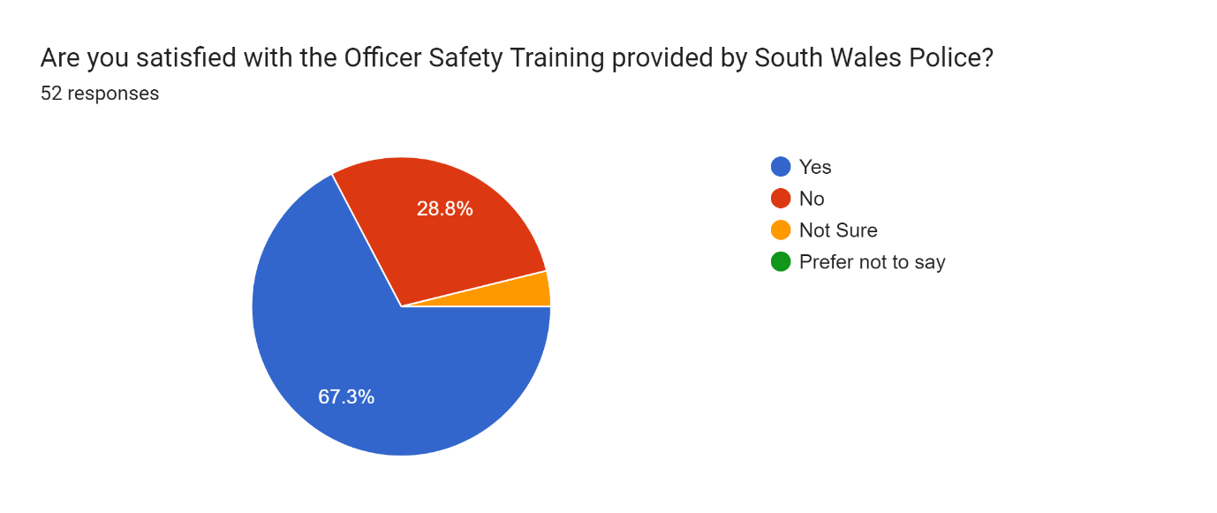

Please explain your choice below
52 responses
- .
- Does not fully prepare officers for physical confrontation when on duty
- Insufficient, scenarios not realistic enough seem to go through the motions
- More focus on physical confrontation and less on hitting bags or pads
- More training on restraining someone who’s actively trying to assault officers
- Police deal with the real world. There simply is no way to duplicate all the different situations we face in a training context.
- I feel the OST provided is sufficient, it has not caused me to feel I need additional training - however I often feel some younger in service officers are hesitant to use force where needed.
- OST could be improved to make it more realistic to circumstances dealt with as officers
- I believe that the training is set at standards across the UK in line with college of policing, however technics can vary when you are actually in that situation and at times do not work.
- Assault took place in confined area whilst trying to place straps on male's lower limbs. OST for this was adequate.
- no issues
- It teaches the basics but doesn't actually teach you how to fight someone who is properly kicking off
- The return to two days training is welcomed. I would prefer to see 1 day every six months rather than two days in January every year
- Good course
- OST is too short and too basic to cover most use of force scenarios
- I believe that the 'tactics' taught by SWP are not useful in everyday policing. I believe that techniques such as BJJ should be implemented into training which will be more useful in everyday policing.
- used the skills taught in officer safety training to detain the male safely without causing any injuries and handcuff to the rear at earliest possible opportunity.
- You can be trained for any eventuality but it goes out the window as no one incident is the same and you do what you can to the best of your ability and training.
- OST is of a relatively high standard and does prepare us with the "methodical" approach to detaining/restraining someone.
- I believe that initial training gives you the tools and knowledge. But given that speed in which the incident is happening normally have to react by instinct and what you have been taught sometimes does not come into play.
- No - think it is not good enough for what officers need to keep themselves and others safe. Think we need much more.
- It is proportionate to most requirements
- satisfactory
- I feel the training provides adequate techniques around restraint etc however i like a lot of officers do not like the role play scenarios as these do not resemble real life situations in my opinion
- Officer safety was adequate, the individual acted unexpectedly and without provocation
- Although we are trained well, I believe we would benefit from more realistic training
- yes, but need taser for all officers from the off. ost is not enough without a taser
- satisfied
- Helped with me deal with the situation correctly. I knew what to do to safely deal with the situation.
- The skills and tactics taught don't relate to everyday operational policing. They are outdated and taught from a textbook...Life on the streets is different!1
- Training should take place several times a year in order to maintain confidence and knowledge and to assist in imbedding training so that it becomes an almost automatic function rather than something a user needs to think about. Many of the techniques trained are rarely used, and as such may not be recalled correctly in the heat of the moment. Training on a regular basis and to a high standard would better equip officers and make use of force a safer tactic for officers and subject alike.
- i knew the techniques, but i was simply over powered by the male
- am satisfied -
- The training was as good as could be expected.
- I am happy with the training provided.
- OST provided tactical options
- Happier since the introduction of the new model, seems to be better focus on dealing with persons resisting officers
- Can only comment on the old model as I have not had the newer input. I found it to be too low of a intensity to reflect real circumstances. Very much just going through the motions
- Prepared as well as possible for real life circumstances
- Does Not sufficiently prepare for real scenarios
- New training course is much more suitable than the previous model
- Adequately prepared for the scenarios I've faced so far
- Prepared as much as possible for real life scenarios in a controlled environment
- Not good enough
- Sufficiently prepared for scenarios encountered
- Prepared as well as possible

Appendix 3 - Wordcloud for Q.15 of survey using https://www.freewordcloudgenerator.com/
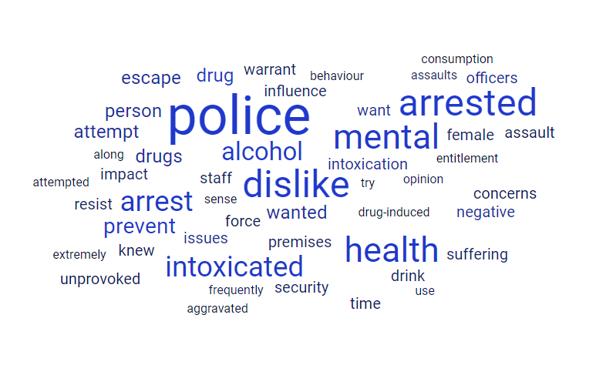
142 words in your word list
Frequency | Word
14 | police
9 | dislike
9 | arrested
8 | mental
8 | health
6 | arrest
6 | intoxicated
5 | alcohol
4 | prevent
3 | drug
3 | drugs
3 | person
3 | wanted
3 | attempt
3 | escape
2 | intoxication
2 | want
2 | officers
2 | negative
2 | issues
2 | influence
2 | drink
2 | resist
2 | warrant
2 | female
2 | premises
2 | impact
2 | suffering
2 | security
2 | staff
2 | force
2 | concerns
2 | unprovoked
2 | knew
2 | assault
2 | time
1 | frequently
1 | assaults
1 | opinion
1 | use
1 | drug-induced
1 | behaviour
1 | aggravated
1 | consumption
1 | along
1 | sense
1 | entitlement
1 | extremely
1 | attempted
1 | try
1 | refused
1 | believed
1 | power
1 | enter
1 | property
1 | without
1 | call
1 | domestic
1 | related
1 | induced
1 | psychosis
1 | highly
1 | upon
1 | immediately
1 | began
1 | exit
1 | showing
1 | clear
1 | indication
1 | group
1 | matter
1 | door
1 | licensed
1 | using
1 | excessive
1 | mop
1 | pushed
1 | sufficient
1 | cause
1 | hit
1 | pavement
1 | suffer
1 | back
1 | injuries
1 | damage
1 | cruciate
1 | ligaments
1 | one
1 | leg
1 | result
1 | serious
1 | posing
1 | risk
1 | public
1 | court
1 | detained
1 | unknown
1 | disregard
1 | showed
1 | respect
1 | attention
1 | asaulting
1 | disliked
1 | lost
1 | control
1 | thinking
1 | actions
1 | sentence
1 | absolute
1 | joke
1 | probably
1 | away
1 | interaction
1 | door-staff
1 | short
1 | prior
1 | wish
1 | comply
1 | instructions
1 | confronted
1 | known
1 | violent
1 | individual
1 | large
1 | aggressive
1 | drugged
1 | resisting
1 | possible
1 | underlying
1 | sudden
1 | distrust
1 | episode
1 | sibling
1 | females
1 | right
1 | frame
1 | mind
1 | irate
1 | attempting
1 | anger
1 | towards
1 | angry

Appendix 4 - Wordcloud for Q.17 of survey using https://www.freewordcloudgenerator.com/
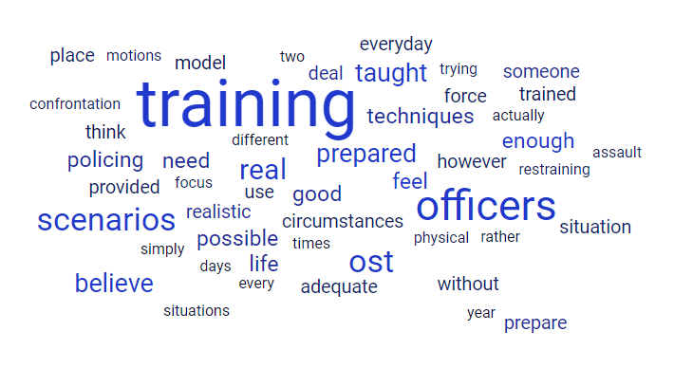

Word List
241 words in your word list
Frequency | Word
17 | training
10 | officers
7 | scenarios
7 | ost
6 | real
5 | believe
5 | taught
5 | prepared
4 | enough
4 | feel
4 | need
4 | policing
4 | good
4 | techniques
4 | possible
4 | life
3 | prepare
3 | realistic
3 | someone
3 | deal
3 | provided
3 | however
3 | use
3 | force
3 | circumstances
3 | situation
3 | place
3 | adequate
3 | everyday
3 | without
3 | trained
3 | think
3 | model
2 | physical
2 | confrontation
2 | motions
2 | focus
2 | restraining
2 | trying
2 | assault
2 | simply
2 | different
2 | situations
2 | actually
2 | times
2 | two
2 | days
2 | every
2 | rather
2 | year
2 | course
2 | tactics
2 | useful
2 | used
2 | skills
2 | officer
2 | safety
2 | male
2 | safely
2 | incident
2 | high
2 | standard
2 | knowledge
2 | play
2 | taser
2 | satisfied
2 | correctly
2 | knew
2 | better
2 | new
2 | sufficiently
1 | fully
1 | duty
1 | insufficient
1 | seem
1 | go
1 | less
1 | hitting
1 | bags
1 | pads
1 | actively
1 | police
1 | world
1 | duplicate
1 | face
1 | context
1 | sufficient
1 | caused
1 | additional
1 | often
1 | younger
1 | service
1 | hesitant
1 | needed
1 | improved
1 | dealt
1 | set
1 | standards
1 | across
1 | uk
1 | line
1 | college
1 | technics
1 | vary
1 | work
1 | took
1 | confined
1 | area
1 | whilst
1 | straps
1 | male's
1 | lower
1 | limbs
1 | issues
1 | teaches
1 | basics
1 | teach
1 | fight
1 | properly
1 | kicking
1 | return
1 | welcomed
1 | prefer
1 | see
1 | day
1 | six
1 | months
1 | january
1 | short
1 | basic
1 | cover
1 | swp
1 | bjj
1 | implemented
1 | detain
1 | causing
1 | injuries
1 | handcuff
1 | rear
1 | earliest
1 | opportunity
1 | eventuality
1 | goes
1 | window
1 | one
1 | best
1 | ability
1 | relatively
1 | methodical
1 | approach
1 | detaining
1 | initial
1 | gives
1 | tools
1 | given
1 | speed
1 | happening
1 | normally
1 | react
1 | instinct
1 | sometimes
1 | keep
1 | others
1 | safe
1 | proportionate
1 | requirements
1 | satisfactory
1 | provides
1 | around
1 | restraint
1 | etc
1 | lot
1 | role
1 | resemble
1 | opinion
1 | individual
1 | acted
1 | unexpectedly
1 | provocation
1 | although
1 | benefit
1 | yes
1 | helped
1 | relate
1 | operational
1 | outdated
1 | textbook
1 | streets
1 | several
1 | order
1 | maintain
1 | confidence
1 | assist
1 | imbedding
1 | becomes
1 | almost
1 | automatic
1 | function
1 | something
1 | user
1 | needs
1 | rarely
1 | recalled
1 | heat
1 | moment
1 | regular
1 | basis
1 | equip
1 | safer
1 | tactic
1 | subject
1 | alike
1 | powered
1 | expected
1 | happy
1 | tactical
1 | options
1 | happier
1 | introduction
1 | seems
1 | dealing
1 | persons
1 | resisting
1 | comment
1 | old
1 | newer
1 | input
1 | found
1 | low
1 | intensity
1 | reflect
1 | just
1 | going
1 | suitable
1 | previous
1 | adequately
1 | faced
1 | far
1 | controlled
1 | environment
1 | encountered

