EFFECTIVE TEAMWORK AND COMMUNICATION
Student’s Name: Sayed Miah
Student Number: 1707658
Lecturer’s Name: John Paul Okeke

Executive summary
In this report, the importance and significance of effective communication are discussed along with the definition and example of verbal and non-verbal communication. In addition to it, the model and theory of effective communication and teamwork are also discussed and its impact on the organization performed when implemented. The company Tesco is emphasized to make the discussed effective. At the end, the relevant outcome and benefit of effective communication and team work are stated.

Table of content
Introduction 4
Effective communication definition 4
Verbal and nonverbal communication 5
Workplace communication theories 6
Through effective communication improvement in the workplace productivity 11
Benefits that effective communication provides within workplace 12
Conclusion 13
Reference list 14
Appendix 16

Introduction
Communication is the significant tool that is used in the workplace to convey the messages effectively. In addition to it working in a team provides the significant benefits to the organization as it establishes the sense of group accomplishment and effective distribution of the responsibility. The significant teamwork and communication bring the positive result to the organization. It supports to improve the functionality and productivity of the firm. In this report, the brief definition of the effective communication will be present along with its advantage to the firm. Furthermore, the different type of verbal and nonverbal communication will be discussed along with the relevant example. The workplace communication theory of Belbin and Shannon Weaver Model of Communication 1948 will add value to the discussion made. The aim of the study is to determine the benefit which effective teamwork and communication provided to an organization to face the challenges and bring improvement in the performance. Thus, at the end of the report, the result and role which effective teamwork and communication play will be discussed in the conclusion (Sherman et al. 2017).

Effective communication definition
Effective communication is an interpersonal skill and it is the way by which the message is transmitted to a receiver and it is understood in the way it was intended. Communication is the two-way process and it is important to communication in an identical way with the intention to make the message understood by the end, the sender and the receiver. In an organization, it is important to conduct effective communication as it allows the company to operate significantly and to enhance the productivity. Effective communication provides the effective benefits to the team as it allows the team member to understand their role and responsibility and also to the other team member.
On the other hand, the effective communication also beneficial for working collaboratively as it opens the wide range of ways to work with other organization to enhance the quality of the product and service. In addition to that, it is also significant to deal with the issues related to confidential activities, share ownership and responsibility and thus it reduces the workforce and make the function more dynamic. In Tesco, the effective communication with the customers provides the identical benefit to the firm to maximise the profit and enhance customer’s loyalty. In addition to it, the company also introduced the new software to communicate effectively with the suppliers to enhance the quality of the service (Reising et al. 2017).

Verbal and nonverbal communication
Verbal communication: it is the exchange of information among the person by using words or speech. Some of the examples of verbal communication are meeting and interview. In order to negotiate and develop the idea, the verbal communication is the identical tool. It provides the effective benefit to reduce confusion and get the wide range of idea which is beneficial for the firm performance. A team comprises of numerous people and thus it brings the valuable and different form of the idea. By effective negotiation with the team, one can get across the new ideas that can enhance the overall performance of the business organisation. The new strategy and idea enhance the group negotiation help the firm to maximise the profit and quality of the service (Driskell et al. 2017).
Non-verbal communication: it is the exchange of information between the people by sending and receiving the wordless clues. The visual clues are used to communicate during non-verbal; communication such as shaking hands, facial expression, body language and so on. The benefits that non-verbal communication provides are it is short and brief, save time, to the point and many more. Furthermore, the key advantage that non-verbal communication provides is it helps to communicate in the place where there is mandatory to maintain the silence (Neill, 2017).
Verbal communication and nonverbal communication, both are practised in the workplace of Tesco. The verbal communication such as face to face communication, meeting helps to communicate important information within the workplace more significantly and easily. The difficulty that Tesco faces due to verbal communication is while dealing with the customers, as the customer might misinterpret the thing that the staff of Tesco communicated. Hence, this is the reason Tesco interdicted the training session for the staff to get the relevant skill to communicate with the customers and also among the team members (Sweet et al. 2017).

Workplace communication theories
For the effective communication in the workplace, the Tesco Company has been chosen to make the effective discussion. The Belbin theory is categories in the nine subheading such as Resource Investigator, Team Worker, Coordinator, Plant, Monitor Evaluator, Specialist, Shaper, Implementer and Completer Finisher. In this report, the focused will be made up of the team worker and coordinator subheading of Belbin theory for the effective team structure in the workplace. The team worker theory of Belbin helps the team to utilise the versatility to determine the work required and execute it on behalf of the team. Furthermore, the Belbin theory team workers are the people those are united in the team to work together (Enns et al. 2016).
The people of the team played the role of negotiator and are flexible, perceptive and diplomatic in nature. The people of these categories are popular as they have the capability to perform their own responsibility. Furthermore, the weakness of these team might be the tendency to be intensive and in making the decision and discussion to maintain uncommitted position. The Belbin theory plays the relevant role to understand the strength and weakness which organization comprises of. Furthermore, by effective determining the firm can effectively bring improvement to the performance if the team. Hence, the theory will also provide the significant support to the Tesco to bring improvement in the work and among the workers and also maximise the performance of the team (Burgoon et al. 2016).
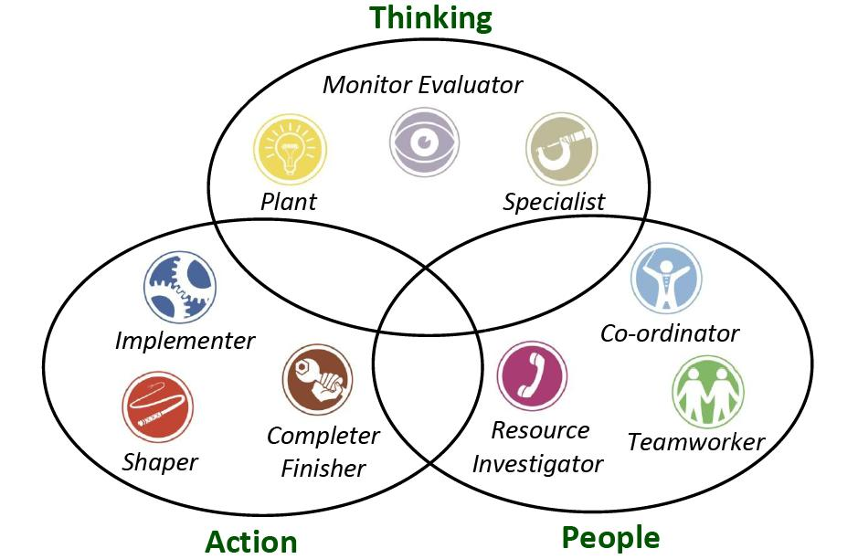
Figure 1: Belbin Theory of team structure
(Source: Bolman and Deal, 2017)
Group dynamic theories: The theory plays the significant role as it provides the reluctant support to the member to adopt the right approach to interact with the people. The theory plays the relevant role to communicate effectively in the workplace by conveying the significant message to the receiver. The group dynamic theory is divided into five sub-categories to bring the effective communication norms in an organization. The group dynamic theory is used by many industries and organization to enable the effective communication in the workplace. In Tesco working atmosphere the group dynamic theory of communication will provide the effective guidance to the employee to communicate with the customers effective and without getting misinterpreted (Bolman and Deal, 2017).
The group strategy helps the organization to improve the performance of the employees working within the team. As the strategy help to share the relevant objective among the team members and by the mutual agreement among the team members the strategy is implemented to fulfil the objectives of the firm at an estimated time. Hence in this place the group dynamic theory implementing plays the effective role in the better performance of the team (Weller and Civil, 2017).
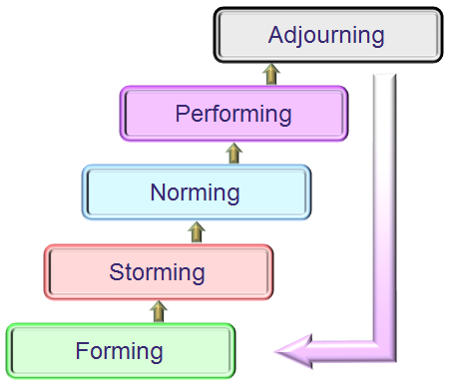
Figure 2: Group Dynamic Theory
(Source: Mathieu et al. 2017)

According to Shannon Weaver model of communication, the following concept must be followed in the workplace to bring effectiveness in the communication (Mathieu et al. 2017).
Sender: the person who makes the message, choose the identical channel and send the message. Example businessman
Encoder or transmitter: it is a person who uses the machine which significantly converts the message into binary or single data and it might also refer to the machine directly. Example telephone Network Company (Kasasbeh et al. 2017).
Channel: the medium that is used to convey the message appropriately example mobile network
Decoder or receiver: it is the machine that is used to convert the binary or single data into the message. Example mobile phone (Ghaferi and Dimick, 2016)
Receiver or destination: it is person or place where the message was supposed to reach. After understanding the message receiver the reserve provides the relevant feedback by using the appropriate channel. Example worker
Noise: it is said to be the physical disturbance that affects the intended message to get to the receiver, Example omission of the text due to disturbance (Gross et al. 2016).
By implementing the Shannon Weaver model of communication the Tesco might enhance the effective success, as it keeps the message secret and reduces the cause of confusion. Thought it is time-consuming but the process is affordable.
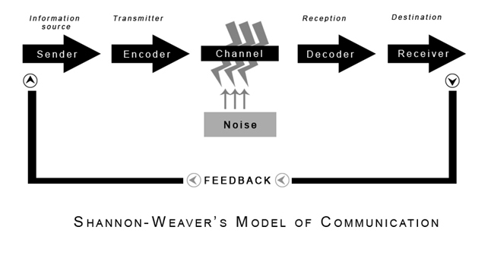
Figure 3: Shannon Weaver Model of Communication
(Source: Wang and Li, 2017)
Berol’s model of communication plays the effective role to bring the effective productivity in an organization. The model is divided into four categories sender, message, channel and receiver. By using the model one can conduct the effective communication and it created the significant impact upon the listener. The emotional aspect of the message is taken into account; hence by implementing it in the workplace the Tesco will get the ample amount of opportunity (Yadava et al. 2017).

Through effective communication improvement in the workplace productivity
The presence of effective communication skill within workplace helps the workers to keep one another accountable. The effective communication provides the clear instruction to the employees hence it makes clear that what organization expect from them (Hassell and Cotton, 2017). For the effective communication in the workplace, one can implement the interpersonal-communication skill such as active listening, body language, context awareness and personal presentation. It plays the significant role in an organization to enhance the productivity and also improve the performance as one get the relevant knowledge and skill to maximise the performance quality. The way to conduct the effective communication within an organization to enhance the productivity is written communication (Culache, 2017).
The written communication helps to know the gaol identically and each and every term are stated clearly so that the clear get the clear vision of the goal and strategy. Hence both the written and verbal communication plays the significant role if one adopts it to maximise and improve the productivity. Furthermore, in the written communication one must ensure that the strategy states are clear with no syntax, punctuation, grammar error to avoid misinterpretation and confusion. Communication can also be conducted with the audience by using the electronic and visual resource as it provides the effective advantage to the people those is way to reach significantly. The resource helps to convey the message without taking much time and in a significant way (Burke, 2017).

Benefits that effective communication provides within workplace
The effective communication plays the relevant role to maximise the benefit and productivity of the organization. The good communication makes the mission and vision statement of the organization closer to the employees and thus they put the effective effort to enhance it. Furthermore, it also helps to build the healthy workplace environment and employee feels satisfied with the job position. In addition to it, it also helps to minimise the cause of confusion among the employees and reduce the cause of stress due to miscommunication (Brock et al. 2017).
In an organization, there is barrier rated due to cultural and language difference hence the effective communication support to deal with the barriers appropriately. In order to build the high efficient team and effective relationship norms among the employees and manager, the pivotal role is played by the effective communication. Furthermore, it also helps to strengthen the morality of the employee and nourishes the skills and knowledge. It reduces the unnecessary competition among the department and keeps the team united and makes them work with harmony. Therefore, it is important for the manager of the organization to follow the effective communication norms with the employee to maximise productivity and do the level of frustration in the organization atmosphere (Mesmer-Magnus et al. 2017). Within the team, it is the responsibility of the leader to conduct the effective communication for the efficient performance of the entire team member and for the organization excellent performance. The Tesco enhance the effective opportunity by implementing the strategy of effective communication within the workplace (Yadava et al. 2017)

Conclusion
The above study clearly states that in an organisation the effective communication is vital to maximise the productivity and success of the organization. In order to serve the customers well it is important for the employees to use the ethical terms while communicating as it might be the cause of misinterpretation and thus might harm the reputation of the organization. In addition to it, in the report, the effective communication theory and model are used to add value to the discussion. Thus, the effective communication helps to maximize the productivity and also build the ethical working environment. In this report, the Tesco Company is focused to maximise the productivity and customers’ satisfaction by implementing the strategy of effective teamwork and communication. Hence, for the entire study material, it can be said that effective communication is vital to the excellent performance of the employees and organization.

References:
Bolman, L.G. and Deal, T.E., 2017. Reframing organizations: Artistry, choice, and leadership. John Wiley & Sons.
Brock, S.E., Brock, S.E., McAliney, P.J., McAliney, P.J., Ma, C.H., Ma, C.H., Sen, A. and Sen, A., 2017. Toward more practical measurement of teamwork skills. Journal of Workplace Learning, 29(2), pp.124-133.
Burgoon, J.K., Guerrero, L.K. and Floyd, K., 2016. Nonverbal communication. Routledge.
Burke, W.W., 2017. Organization change: Theory and practice. Sage Publications.
Culache, O., 2017. SHIFTING FROM CHANNELS AND CODES TO MODES: A RECONCEPTUALIZATION OF BRAND COMMUNICATION VIA MULTIMODALITY. TICS, p.717.
Driskell, T., Driskell, J.E., Burke, C.S. and Salas, E., 2017. Team Roles: A Review and Integration. Small Group Research, p.1046496417711529.
Enns, L.N., Barrieau, L.E., Stack, D.M., Serbin, L.A., Ledingham, J.E. and Schwartzman, A.E., 2016. Verbal and nonverbal communication in at-risk mother-child dyads: Implications for relationship quality and developing positive social behaviours in middle-childhood. European Journal of Developmental Psychology, 13(1), pp.1-19.
Ghaferi, A.A. and Dimick, J.B., 2016. Importance of teamwork, communication and culture on failure‐to‐rescue in the elderly. British Journal of Surgery, 103(2).
Gross, A.H., Leib, R.K., Tonachel, A., Tonachel, R., Bowers, D.M., Burnard, R.A., Rhinehart, C.A., Valentim, R. and Bunnell, C.A., 2016. Teamwork and Electronic Health Record Implementation: A Case Study of Preserving Effective Communication and Mutual Trust in a Changing Environment. Journal of oncology practice, 12(11), pp.1075-1083.
Hassell, M.D. and Cotton, J.L., 2017. Some things are better left unseen: Toward more effective communication and team performance in video-mediated interactions. Computers in Human Behavior, 73, pp.200-208.
Kasasbeh, M.A.M., McCabe, C. and Payne, S., 2017. Action learning: an effective way to improve cancer‐related pain management. Journal of clinical nursing.
Mathieu, J.E., Hollenbeck, J.R., van Knippenberg, D. and Ilgen, D.R., 2017. A century of work teams in the Journal of Applied Psychology. Journal of Applied Psychology, 102(3), p.452.
Mesmer-Magnus, J., Mesmer-Magnus, J., Niler, A.A., Niler, A.A., Plummer, G., Plummer, G., Larson, L.E., Larson, L.E., DeChurch, L.A. and DeChurch, L.A., 2017. The cognitive underpinnings of effective teamwork: a continuation. Career Development International, 22(5), pp.507-519.
Neill, S., 2017. Classroom nonverbal communication. Routledge.
Reising, D.L., Carr, D.E., Gindling, S., Barnes, R., Garletts, D. and Ozdogan, Z., 2017. Team Communication Influence on Procedure Performance: Findings From Interprofessional Simulations with Nursing and Medical Students. Nursing education perspectives, 38(5), pp.275-276.
Sherman, J.M., Chang, T.P., Ziv, N. and Nager, A.L., 2017. Barriers to Effective Teamwork Relating to Pediatric Resuscitations: Perceptions of Pediatric Emergency Medicine Staff. Pediatric emergency care.
Sweet, B.V., Madeo, A., Fitzgerald, M., House, J.B., Pardee, M., Zebrack, B., Sweier, D., Hornyak, J., Arslanian-Engoren, C., Mattison, D. and Dubin, L., 2017. Moving from individual roles to functional teams:.
Wang, N. and Li, B., 2017, June. Proceedings a Model of Deceitful Information Communication: Some Views on Theory and Practice of Semantic Information. In Multidisciplinary Digital Publishing Institute Proceedings (Vol. 1, No. 3, p. 127).
Weller, J. and Civil, I., 2017. Teamwork and healthcare simulation. Healthcare Simulation Education: Evidence, Theory and Practice, pp.127-134.
Yadava, U., Eswara, H.E. and Rahim, A., 2017. Unit-2 Models of Communication.

Appendix
Berol’s model of communication


Presentation:

