

Programme: Master of Business Administration
Module: Financial Management
Module Code: LCMB7002

Assignment Title: Financial Performance and Management

Student Name: Jainil Kanubhai Patel
Student ID: 2519957
Group: 3

Executive Summary
This report is an assessment of the financial performance of the Hyundai Motor Company and offers strategic financial advice. The analysis indicates that revenue, profitability, and asset base have strongly grown due to the entry into electric vehicles and international markets. The profitability and liquidity ratios demonstrate better performance and short-term stability, whereas the efficiency ratios demonstrate decreasing operational effectiveness. Rising leverage and negative cash flow ratios highlight increasing financial risk and reliance on external financing. The working capital analysis shows an extended cash conversion cycle, which shows increased capital requirements. The recommendations of strategic restructuring are on how the debt is handled, optimisation of the assets, and better financing methods. The results of investment appraisal indicate that none of the proposed projects have a positive NPV and do not demonstrate the necessary return, but Project C has a rather good performance. Hyundai has good growth potential but needs to improve financial efficiency and risk management in the long run.
Table of Contents
1.0 Introduction 7
1.1 Overview of Hyundai Motor Company: Global EV Transition 7
1.2 Role of CFO in strategic decision-making 7
1.3 Purpose of Report 8
1.4 Structure of Report 8
2.0 Financial Health Check 9
2.1 Overview of Financial Performance of Hyundai Motor Company 9
Statements of Financial Position for Five Years 9
Statements of Income for Five Years 9
Statements of Cash Flows for Five Years 9
2.2 Ratio Analysis 10
Profitability Ratios 10
Liquidity Ratios 11
Efficiency Ratios 12
Gearing Ratios 13
Investment Ratios 14
Cash Flow Ratios 15
2.3 Identify Trends, Strengths, and Threats 15
Identified Trends 15
Identified Strengths 16
Identified Weaknesses 16
3.0 Working Capital Management 17
3.1 Cash Operating Cycle Analysis 17
3.2 Evaluation of Current Working Capital Efficiency 17
Liquidity Position and Short-Term Stability 17
Efficiency of Working Capital Components 18
Overall Working Capital Performance 18
3.3 Improvement Strategies 18
Inventory Optimisation Strategies 18
Receivables Management Improvement 19
Payables and Financing Strategies 19
3.4 Financing Options 19
Short-Term Financing Options 19
Long-Term Financing Options 19
Evaluation and Strategic Recommendation 20
4.0 Strategic Financial Restructuring Plan 20
4.1 Identification of Financial Problems 20
Rising Leverage and Financial Risk 20
Declining Working Capital Efficiency 20
Cash Flow Constraints and Liquidity Pressure 21
4.2 Proposed Restructuring Strategies 21
Debt Restructuring and Capital Rebalancing 21
Asset Rationalisation and Divestment 21
Strategic Partnerships and Investment Optimisation 21
4.3 Impact Evaluation 22
Impact on Shareholder Value 22
Impact on Financial Risk and Debt Structure 22
Impact on Operational Flexibility and Growth 22
4.4 International & Ethical Considerations 23
Global Financial Risks and Currency Exposure 23
Regulatory and Taxation Considerations 23
Ethical Responsibility and Sustainability (CSR) 23
5.0 Investment Appraisal & Capital Budgeting 24
5.1 Overview of Investment Appraisal as well as Capital Budgeting 24
5.2 Investment Projects 25
Payback Period (PBP) of Projects A, B, and C 25
Accounting Rate of Return (ARR) of Projects A, B, and C 26
Net Present Value (NPV) of Projects A, B, and C 27
Profitability Index (PI) of Projects A, B, and C 28
Internal Rate of Return (IRR) of Projects A, B, and C 28
5.3 Results Comparison 28
5.4 Decision Making 29
5.5 Capital Rationing Decision 29
5.6 Risk Analysis 30
6.0 Conclusion 30
6.1 Summary of Findings 30
6.2 Final Investment Recommendation 31
7.0 Reference List 32
8.0 Appendices 35
Appendix A: Statements of Financial Position of Hyundai Motor Company for Five Years 35
Appendix B: Statements of Income of Hyundai Motor Company for Five Years 38
Appendix C: Statements of Cash Flows of Hyundai Motor Company for Five Years 41
Appendix D: Ratios and CCC of Hyundai Motor Company for Five Years 44
Appendix E: Projects A, B, and C 48

1.0 Introduction

1.1 Overview of Hyundai Motor Company: Global EV Transition
Hyundai Motor Company is a major automotive manufacturer in the world that is in the process of a strategic shift to electric vehicles (EVs) and sustainable mobility. The company has significantly increased investments in EV technology, battery innovation, and digital transformation to remain competitive in the evolving automotive industry (Hyundai, 2024). Global environmental policies, shifting consumer tastes, and technology are factors that drive this transition. The entry into the EV markets has intensified the growth of revenues and the global presence of Hyundai, as well as capital intensity and financial complexity.

1.2 Role of CFO in strategic decision-making

Figure 1: Mr. Wangdo Hur (CFO)
(Source: Hyundai, 2026)
The Chief Financial Officer (CFO) is an important strategic decision-maker since they oversee financial planning, risk management, and capital allocation. The CFO measures financial performance, manages to efficiently utilise resources, and assists in making investment choices based on organisational goals. The CFO in the case of Hyundai must manage the trade-offs between investing in EVs to grow the business and financial stability, working capital, and sustainable financing approaches (Hyundai, 2026). This is a critical position in improving shareholders' value and sustaining long-term financial sustainability.

1.3 Purpose of Report
The purpose of the report is to analyse Hyundai's financial performance, as well as to make a strategic financial decision recommendation.

1.4 Structure of Report
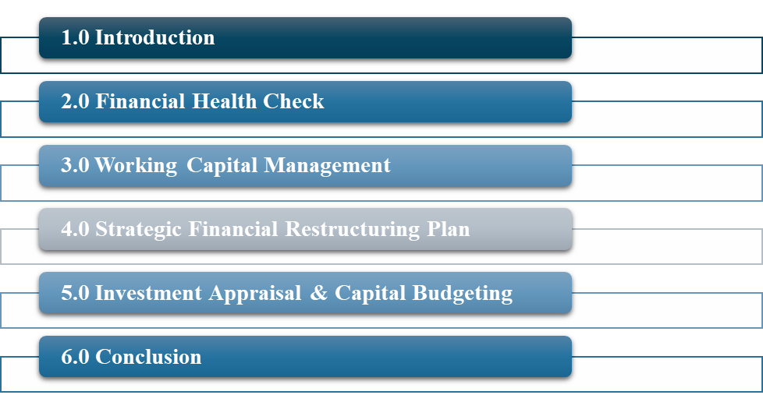
Figure 2: Report Structure
(Source: Self-Created)
The report is divided into six major sections. It opens by giving an introduction, and then a financial health check where performance and ratios are examined. It then analyses working capital management, gives a strategic financial restructuring plan, and analyses investment appraisal decisions. Lastly, the report will end with important findings and strategy recommendations.

2.0 Financial Health Check

2.1 Overview of Financial Performance of Hyundai Motor Company

Statements of Financial Position for Five Years
The financial position of Hyundai Motor Company displays great growth over a period of five years. Total assets increased from ₩209,344,212 million (2020) to ₩339,798,429 million (2024), indicating expansion driven by EV investments and asset accumulation. Total equity rose from ₩76,340,970 million to ₩120,275,933 million, reflecting improved retained earnings. However, total liabilities also increased significantly from ₩133,003,242 million to ₩219,522,496 million, suggesting higher leverage (Hyundai, 2024; Hyundai, 2022; Hyundai, 2020). Capital-intensive development of EVs, international expansion, and the need to finance its activities with more capital are the primary reasons for this growth, balancing profitability with an escalating financial risk.

Statements of Income for Five Years
The income statement of Hyundai Motor Company depicts a high growth in revenue and profits within a period of five years. Sales increased significantly from ₩103,997,601 million (2020) to ₩175,231,153 million (2024), driven by EV demand and global expansion. Operating profit rose from ₩2,394,671 million to ₩14,239,592 million, indicating improved operational efficiency. Profit for the year grew from ₩1,924,553 million to ₩13,229,908 million (Hyundai, 2024; Hyundai, 2022; Hyundai, 2020). This positive trend is explained by the growth of the sales volumes, improved cost management, and improved investment returns, although increasing expenses slightly softened profit margins in recent years.

Statements of Cash Flows for Five Years
The cash flow position of Hyundai Motor Company reflects an increasing strength of operations under the pressure of further investment. Operating cash flow increased from negative ₩(409,807) million (2020) to ₩(5,661,641) million (2024), reflecting stronger earnings but rising working capital outflows. Investing cash outflows expanded significantly from ₩(9,337,596) million to ₩(14,623,489) million due to heavy capital expenditure in EV and technology (Hyundai, 2024; Hyundai, 2022; Hyundai, 2020). Financing inflows grew to ₩19,493,291 million (2024), indicating reliance on external funding. Stable cash balances indicate balanced liquidity in spite of aggressive expansion strategies.

2.2 Ratio Analysis

Profitability Ratios
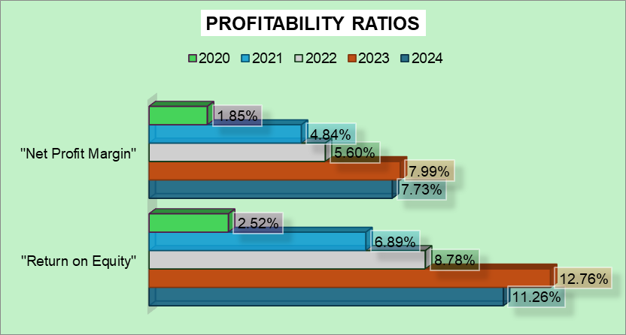
Figure 3: Profitability Ratios of Hyundai
(Source: Excel)
The profitability ratios are indicative of the efficiency of a firm in terms of profitability against equity and sales, showing financial efficiency and returns to shareholders. Turnover of the funds of the shareholders has also improved with Hyundai increasing its Return on Equity to 11.26% (2024) as compared to 2.52% (2020), although in 2024 it decreased slightly. Increasing the Net Profit Margin to 7.73% as opposed to 1.85%, the control of costs and revenue growth was stronger. These gains are fuelled by increased sales of EV, efficiency in operations, and increased global market performance (Jo et al., 2023).

Liquidity Ratios
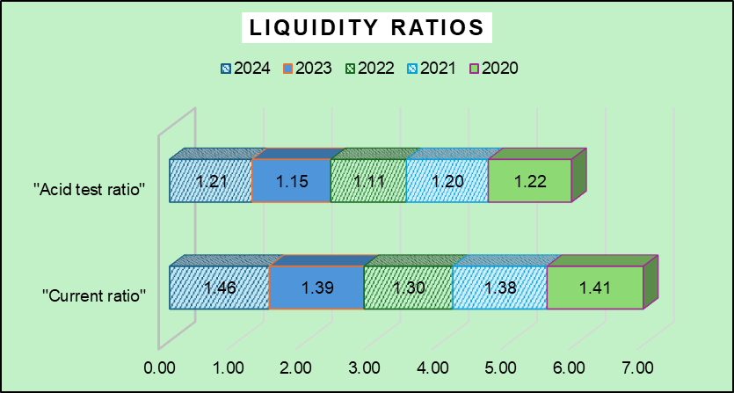
Figure 4: Liquidity Ratios of Hyundai
(Source: Excel)
Liquidity ratios estimate how a firm will cover its short-term commitments, and this means that it is financially stable and is not exposed to risk. The current ratio of Hyundai has increased to 1.46 (2024) compared to 1.41 (2020), which indicates sufficient short-term solvency. The acid-test ratio also stood unchanged at 1.21 (2024) with adequate liquid assets minus inventories. This stability is propelled by growing current assets and cash flows, but growing liabilities somewhat dampen the strength of liquidity (Rahman, 2023).

Efficiency Ratios
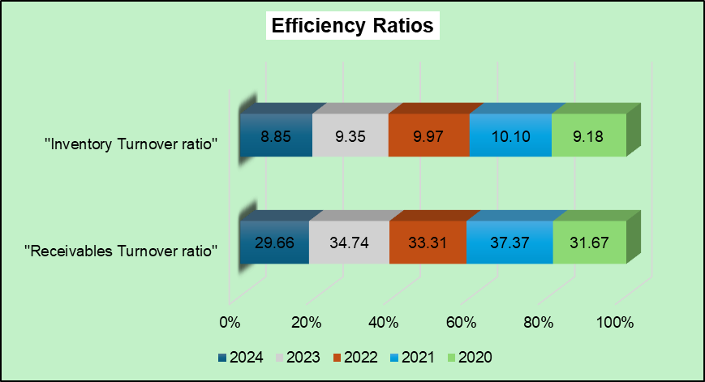
Figure 5: Efficiency Ratios of Hyundai
(Source: Excel)
Efficiency ratios evaluate the use of resources by a company to bring in revenue (Higgins, 2022). The turnover of Hyundai receivables decreased to 29.66 (2024) compared to 37.37 (2021), as the company is collecting the receivables more slowly. The inventory turnover was also reduced to 8.85, which was lower than 10.10, indicating that there was slower movement of inventory. These patterns demonstrate expansion pressures and increased inventory levels associated with the production of EVs, which affect operational efficiency even with the increasing sales (Rahman, 2022).

Gearing Ratios
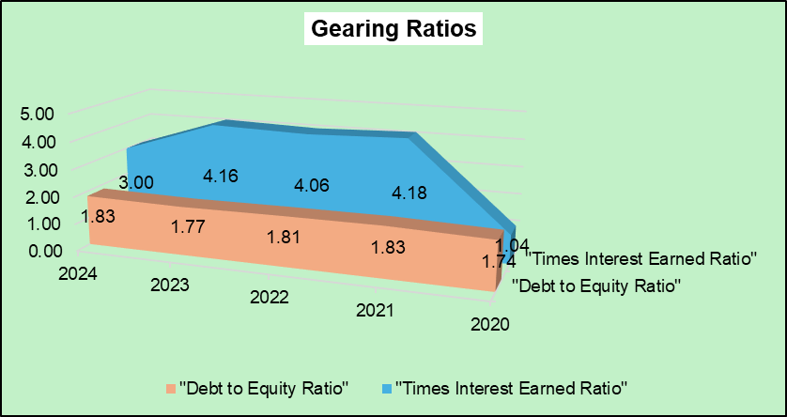
Figure 6: Gearing Ratios of Hyundai
(Source: Excel)
Gearing ratios assess the financial leverage and long-run solvency risk of a firm. Hyundai has a high debt-to-equity ratio, which ranges between 1.74 (2020) and 1.83 (2024), which means it uses debt to finance its activities. The times interest earned ratio rose to 3.00 (2024) in comparison to 1.04 (2020), indicating an increased capacity to pay interest. This is an indicator of higher profits, yet a growing debt to finance EVs keeps finances at risk (Ryu and Do, 2023).

Investment Ratios
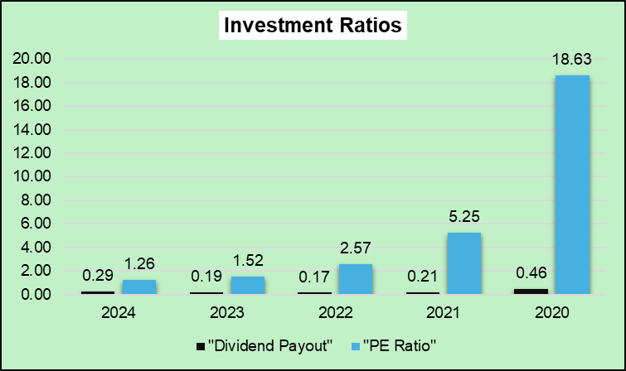
Figure 7: Investment Ratios of Hyundai
(Source: Excel)
The ratios of investments evaluate the returns to shareholders and market value. The dividend payout in Hyundai decreased to 0.29 (2024) compared to 0.46 (2020), which shows that the company has been retaining its earnings to grow. The P/E ratio dropped sharply to 1.26, where it was 18.63, indicating that the market expectations were low in spite of increasing earnings. This could be an indication of investor apprehension towards EV transition risks and macroeconomic uncertainty (Chen et al., 2023).

Cash Flow Ratios
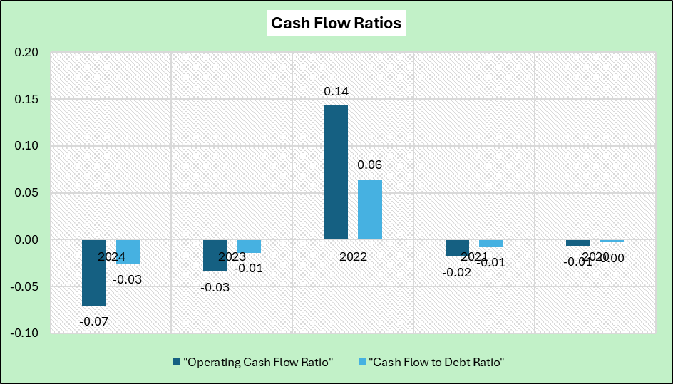
Figure 8: Cash Flow Ratios of Hyundai
(Source: Excel)
The cash flow ratios estimate the capacity of the firm to produce cash to cover obligations. The operating cash flow ratio of Hyundai varied between -0.01 (2020) and -0.07 (2024), which shows a low short-term cash coverage. In the same manner, the cash flow to debt ratio was also low (-0.03 in 2024), and this means that the company depended on outside financing. These dynamics are supported by the high capital expenditure and the working capital variations in spite of the high growth in the profitability (Haralayya, 2022).

2.3 Identify Trends, Strengths, and Threats

Identified Trends
The Hyundai Motor Company has a clear positive trend in terms of revenue, profitability, and growth of assets in a period of five years. The sales grew considerably, which was facilitated by the growth of electric vehicles and international markets (Hyundai, 2024; Kiymaz et al., 2024). The profitability ratios like ROE and net profit margin were steadily increasing, whereas the growth in the assets and liabilities indicates capital-intensive growth. Nevertheless, operational pressures are indicated by cash flow volatility and the falling efficiency ratios. These trends are indicative of a shift to an innovation-driven growth, which is becoming increasingly complex in terms of finances.

Identified Strengths
The strengths of Hyundai are its high rate of growth in profits and strategic orientation towards electric vehicles. The net profit and operating profit have grown significantly, which has contributed to higher shareholder returns, measured by better ROE (Jo et al., 2023; Chen et al., 2023). The firm also has a high revenue increase and expansion on a global scale. Also, the liquidity ratios are stable, which means that the company is solvent in the short-term. These are backed by effective production mechanisms and technology, which have seen Hyundai compete favorably in the world automotive market.

Identified Weaknesses
In spite of the growth, Hyundai has weaknesses associated with increasing leverage and falling efficiency. The debt-to-equity ratio is still high, which means that it is more financially risky because of a significant investment in EV infrastructure. The efficiency ratios, including receivables and inventory turnover, indicate decreasing tendencies, which indicates slower asset utilisation (Tarkom, 2022; Rahman and Acharya, 2022). Also, there are negative ratios in cash flows, which show that there is a strain on liquidity and dependency on external funding. These problems indicate operational and financial restraints with regard to rapid expansion strategies.

3.0 Working Capital Management

3.1 Cash Operating Cycle Analysis
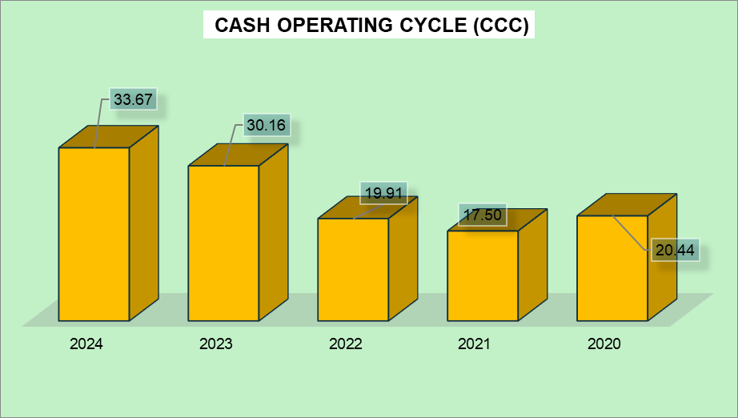
Figure 9: Cash Operating Cycle of Hyundai
(Source: Excel)
Cash operating cycle (CCC) is the period needed to turn inventory and receivables into cash, which indicates the efficiency of working capital and liquidity management. The CCC of Hyundai rose to 33.67 days (2024) against 20.44 days (2020), which shows that it is slowing down cash conversion. This increase is because of increased inventory days (41.22) and receivable days (12.31), with a decrease in payable days to 19.86. The trend indicates more working capital needs because of EV growth and production capacity, which could strain liquidity as sales increase (Hyundai, 2024).

3.2 Evaluation of Current Working Capital Efficiency

Liquidity Position and Short-Term Stability
The liquidity position of Hyundai Motor Company is relatively stable, as evidenced by current and acid-test ratios that are higher than 1.0, which means that the firm can settle short-term liabilities. The negative operating cash flow ratios over the last several years indicate that the liquidity will depend more on the external sources of financing than on the cash resources generated internally (Kiymaz et al., 2024; Hyundai, 2024). This imbalance underscores the possible short-term financial strain despite a satisfactory accounting liquidity status.

Efficiency of Working Capital Components
The effectiveness of working capital has deteriorated over the years, based on rising inventory days (41.22 days in 2024) and receivable days (12.31 days). The trends signify a slow movement of inventory and slow payment of customers, which decreases operational efficiency (Karim et al., 2024). Also, decreasing payable days (19.86 days) indicates that the company is settling its suppliers at faster rates, further constraining cash flow. These trends show the lack of efficiency in operational cycle management.

Overall Working Capital Performance
The working capital efficiency of Hyundai is deteriorating as cash conversion cycles are growing, and additional operating needs are emerging. International expansion and shift towards electric vehicles have raised inventory and capital intensity, which extends the cash cycle (Tarkom, 2022; Rahman, 2023). Although growth strategies boost long-term performance, they also lead to the amplification of short-term liquidity risks and working capital pressures.

3.3 Improvement Strategies

Inventory Optimisation Strategies
Hyundai Motor Company needs to upgrade its inventory management through the adoption of superior demand forecasting and “just-in-time (JIT)” systems. The minimization of unnecessary inventory can reduce the inventory days and improve the cash conversion cycle (Kiymaz et al., 2024; Jo et al., 2023). Digital supply chain technologies and data analytics can be used to match production and demand, especially in EV segments. Effective inventory management saves holding costs and enhances liquidity.

Receivables Management Improvement
The collection of receivables should be enhanced to hasten inflows of cash. Hyundai ought to intensify credit regulations, set tougher payment conditions, and employ digital invoice solutions to lessen the days of receivables. Early payment discounts and improved customer credit checks can also enhance the efficiency of collection (Karim et al., 2024; Rahman, 2022). The measures assist in minimising working capital invested in receivables and increase stability in the cash flows.

Payables and Financing Strategies
Hyundai can streamline the payable management process by negotiating longer credit terms with suppliers without hurting the relationship. This will enhance retention of cash, and pressure on liquidity will diminish. Moreover, the working capital requirements can be better addressed by balancing between short-term and long-term financing (Tarkom, 2022; Kiymaz et al., 2024). The financial flexibility and sustainability can be improved through strategic financing decisions, which are coupled with better working capital policies.

3.4 Financing Options

Short-Term Financing Options
Short-term financing that Hyundai Motor Company can use to address urgent working capital requirements includes bank overdrafts, trade credit, and commercial paper. These facilities offer adaptability and fast availability of funds, assisting in covering temporary liquidity constraints brought about by larger inventory and receivables (Tarkom, 2022; Kiymaz et al., 2024). Nonetheless, overdependence on short-term funding can escalate the risk of refinancing and interest costs, especially in times of economic instability.

Long-Term Financing Options
Issuing long-run financing can be in the form of bonds, equity financing, and long-term loans. These are sources that favor capital-heavy investments, particularly in the development of electric vehicles and international growth (Zaramella, 2023; Celestin, 2024). Equity financing minimizes the financial risk because it decreases the leverage, whereas the long-term debt is stable with the arranged repayment schedules. Nonetheless, the increased debt level can lead to augmented gearing and financial commitments.

Evaluation and Strategic Recommendation
A balanced financing strategy is essential for Hyundai. Combining short-term liquidity solutions with long-term capital funding can optimise financial stability. The firm needs to minimize the reliance on short-term debt and enhance equity funding to sustain growth and risk management (Awodire et al., 2023; Purnamasari and Adriza, 2024). This would help increase the flexibility of finances and fit the long-term strategic goals.

4.0 Strategic Financial Restructuring Plan

4.1 Identification of Financial Problems

Rising Leverage and Financial Risk
The financial risk of Hyundai Motor Company is increasingly becoming risky with the increase in leverage, as indicated by a steadily high debt-to-equity ratio of approximately 1.83 in 2024. It means that to finance its growth, the company heavily depends on debt financing, especially in the development of electric vehicles (EVs) (Zaramella, 2023; Celestin, 2024). Although debt is a good strategy to grow, too much leverage can lead to higher interest rates and financial exposure, particularly in a recession.

Declining Working Capital Efficiency
The working capital efficiency of the company has deteriorated, as shown by increasing cash conversion cycle and increasing inventory and receivable days. This indicates reduced cash flows and increased capital investments in operation (Kiymaz et al., 2024; Karim et al., 2024). Moreover, decreasing payable days decreases the capacity of the firm to use supplier financing, which further strains liquidity and working cash flows.

Cash Flow Constraints and Liquidity Pressure
Hyundai has negative operating cash flow ratios over the last several years, which means it has not generated enough internal cash to meet its short-term liabilities, although they are very profitable. It generates the reliance on external financing and questions the sustainability of liquidity (Tarkom, 2022; Hyundai, 2024). They are largely propelled by the heavy capital spending and entering the EV markets, which demand high initial investment.

4.2 Proposed Restructuring Strategies

Debt Restructuring and Capital Rebalancing
Hyundai Motor Company needs to focus on reorganising its debt structure by refinancing high-cost borrowings with long-term, low-cost instruments. Prolonging the debt maturities would help to alleviate the short-term repayment pressure and enhance the liquidity (Zaramella, 2023; Celestin, 2024). Moreover, the capital structure can be rebalanced by such partial deleveraging as equity financing, which reduces financial risk and increases creditworthiness. This type of strategy promotes sustainable financial viability and allows growth potential.

Asset Rationalisation and Divestment
Dividing the non-core or poorly performing assets will help the company to enhance its financial efficiency. Asset rationalisation enables Hyundai to release capital, simplify operations, and shift resources to high-growth areas like electric vehicles and digital technologies (Awodire et al., 2023; Ryu and Do, 2023). This strategic focus enhances operational efficiency and supports long-term value creation.

Strategic Partnerships and Investment Optimisation
Capital burden can be minimized through forming strategic alliances or joint ventures, and innovation can be accelerated. Financial risk can be shared in collaborations in EV technology, battery development, and global distribution, and the competitiveness can be enhanced (Purnamasari and Adriza, 2024; Awodire et al., 2023). Moreover, disciplined capital budgeting practices will help ensure that investments are geared to profitability and long-term strategic goals, enhancing financial performance.

4.3 Impact Evaluation

Impact on Shareholder Value
The restructuring plans offered are likely to boost shareholder value through profitability and minimizing financial risk. The reduced level of debt and enhanced capital efficiency can raise the level of return on equity and investor confidence (Purnamasari and Adriza, 2024; Awodire et al., 2023). Additionally, focusing investments on high-growth areas such as electric vehicles can generate sustainable returns and long-term value creation.

Impact on Financial Risk and Debt Structure
The restructuring of debts and rebalancing of capital will greatly decrease financial risk through decreasing leverage and interest payments. Prolongation of debt maturity increases liquidity and minimizes the refinancing risk. Nevertheless, equity financing can also water down the ownership of current shareholders (Zaramella, 2023; Celestin, 2024). On the whole, a balanced capital structure enhances financial stability and resilience to economic uncertainties.

Impact on Operational Flexibility and Growth
Asset rationalisation and strategic alliances enhance business flexibility through the redistribution of resources to strategic business segments. This will help Hyundai be more responsive to changes in the market and technological progress (Ryu & Do, 2023; Kiymaz et al., 2024). Moreover, efficient investment choices improve efficiency and contribute to long-term expansion, especially in the competitive EV market, and uphold financial discipline.

4.4 International & Ethical Considerations

Global Financial Risks and Currency Exposure
Hyundai Motor Company has several foreign markets that it operates in, and this has subjected it to the risks of currency fluctuations and macroeconomic risks. The volatility of the exchange rate has the potential to impact revenue, cost, and profitability, especially in an export-based operation. Financing costs and investment decisions are also affected by inflation and different interest rates in different regions (Kiymaz et al., 2024; Hyundai, 2024). The global financial risks mentioned need to be addressed through effective hedging strategies and diversified market operations.

Regulatory and Taxation Considerations
International business demands the adoption of various regulations, such as taxation policies, environmental regulations, and financial reporting standards. The profitability and efficiency of operations may be affected by changes in trade policies and international taxation (Celestin, 2024; Zaramella, 2023). Hyundai should make sure that it complies with these rules to prevent legal fines and preserve its international image.

Ethical Responsibility and Sustainability (CSR)
Ethics are of paramount importance to Hyundai in strategic decisions, especially in sustainability and corporate social responsibility (CSR). Electric cars are a sign of a desire to be environmentally friendly (Ryu and Do, 2023; Chen et al., 2023). Open governance, transparent financial management, and responsible use of resources will increase stakeholder confidence and long-term sustainability, which is taking on more significance in global markets.
The analysis reveals major financial issues of Hyundai Motor Company such as increasing leverage, decreased working capital efficiency and continuous cash flow limitation. There has been high reliance on debt financing which has led to higher financial risk, and long cash conversion cycle is an indicator of inefficiency in utilizing operational resources (Purnamasari and Adriza, 2024). Though the profitability is good, the presence of negative operating cash flows indicates liquidity strains and dependence on outside financing. In response to these problems, a number of restructuring plans are suggested, such as debt refinancing, equity rebalancing, asset rationalisation, and strategic partnerships. These are done to enhance liquidity, minimize financial risk and increase operational efficiency (Phan et al., 2025). The analysis indicates that these strategies can enhance shareholder value, maximise the capital structure and be more financially resilient (Awodire et al., 2023). Besides, global and ethical factors underline addressing currency risks, regulatory compliance, and sustainability practices. The emphasis on the electric vehicles and responsible governance helps Hyundai to become competitive in the long-term. In general, the restructuring plan enhances the financial stability, flexibility and sustainability of growth in a dynamic global environment.

5.0 Investment Appraisal & Capital Budgeting

5.1 Overview of Investment Appraisal as well as Capital Budgeting
Investment appraisal and capital budgeting are key financial management tools employed to assess the feasibility and profitability of long-term investment choices. The methods are used to assist organisations to determine whether the proposed projects will pay off adequately against the cost and risks involved. The most popular ones are Net Present Value (NPV) and Internal Rate of Return (IRR), Payback Period (PBP), Accounting rate of return (ARR), and Profitability Index (PI). Of these NPV is said to be the most effective, because it quantifies value creation by discounting cash flows in the future at a cost of capital. Capital budgeting is the process of investing scarce financial resources in competing investment opportunities to maximise shareholder value (Zaramella, 2023). It involves a keen evaluation of cash flows, risk determinants, and strategic orientation with organisational goals. The concept of capital budgeting in relation to Hyundai Motor Company is critical in assisting the investments in electric vehicles and technology (Haralayya, 2022). Efficient investment appraisal will facilitate the allocation of resources towards the project that maximize profits in the long-run, financial stability and competitive advantage in a dynamic global environment.

5.2 Investment Projects

Payback Period (PBP) of Projects A, B, and C
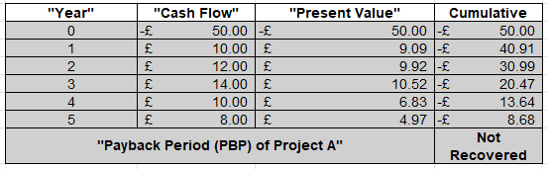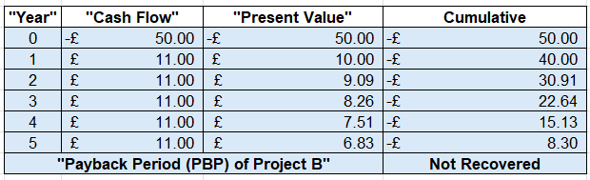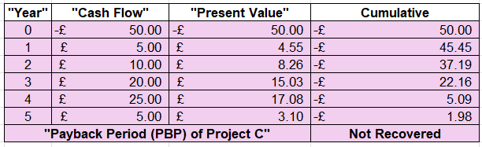
Figure 10: Payback Period (PBP)
(Source: Excel)
The payback period is a measure of the speed of the initial investment recovery. None of the three projects (A, B, and C) recovers the investment of £50 million in five years because the cumulative discounted cash flows are negative (A: -£8.68, B: -£8.30, C: -£1.98). Project C is somewhat more advantageous in terms of greater cash inflows in the future, yet it does not recover completely. This implies increased risk and reduced liquidity creation for any projects.

Accounting Rate of Return (ARR) of Projects A, B, and C
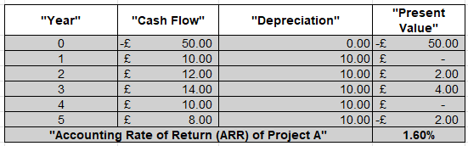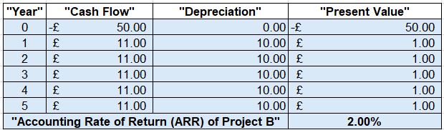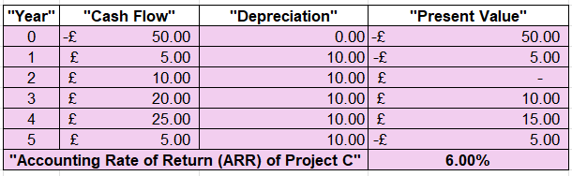
Figure 11: Accounting Rate of Return (ARR)
(Source: Excel)
The ARR is the ratio of average accounting profitability to investment. Project C has the most ARR of 6.00%, and then Project B has 2.00%, and lastly Project A with 1.60%. This suggests Project C generates better average returns from accounting profits. The increased ARR of Project C is influenced by increased mid-term cash flows, whereas Projects A and B depict lower profitability given the reduced incremental gains over time.

Net Present Value (NPV) of Projects A, B, and C
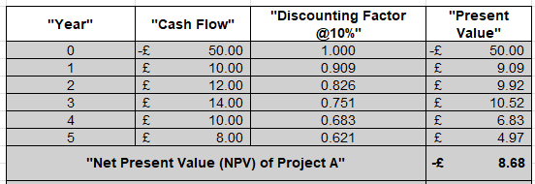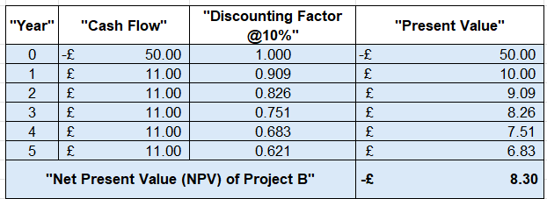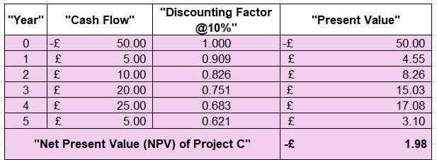
Figure 12: Net Present Value (NPV)
(Source: Excel)
NPV evaluates the value generated by a project after discounting the cash flows. All projects show negative NPVs (A: -£8.68, B: -£8.30, C: -£1.98), indicating they do not meet the required 10% return. Project C has the least negative NPV, implying that it is closest to value creation. This is because it has greater cash inflows towards the end years, unlike Projects A and B, which have inadequate discount returns.

Profitability Index (PI) of Projects A, B, and C
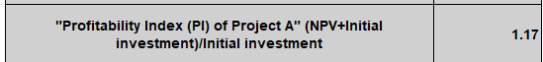
Figure 13: Profitability Index (PI)
(Source: Excel)
The profitability index is used to measure the value earned in relation to the investment unit. The PI of Projects A and B is 1.17, and the PI of Project C is lower at 1.04. All projects have a value that is greater than 1.0, which shows that they are marginally acceptable, but Projects A and B seem more effective in terms of returns per pound invested. This can be misleading since their NPVs are still negative, constraining financial appeal.

Internal Rate of Return (IRR) of Projects A, B, and C
IRR is the discount rate where NPV is zero. The IRR of Project C is the highest, being 8.59%, then Project B with 3.26%, and lastly, Project A has 2.72%. Although Project C is doing better than the rest, all IRRs are lower than 10% cost of capital, which means that none of the projects are economically viable. The IRR of Project C is relatively higher due to high cash flows during later years.

5.3 Results Comparison
The comparative analysis of Projects A, B, and C indicates that there are considerable differences among the appraisal methods. Every project has a negative NPV (A: -£8.68, B: -£8.30, C: -£1.98), which means that the project is destroying value at a 10% discount rate. Project C is comparatively better with the highest IRR (8.59%) and ARR (6.00%), whereas Projects A and B have a higher PI (1.17). Nonetheless, none of them has the required minimum return, implying low financial appeal overall.

5.4 Decision Making
Financially, none of the projects may be accepted since none of them meet the positive NPV and above 10% cost of capital IRR. Nevertheless, Project C can be deemed as the most feasible alternative because it has a relatively higher IRR (8.59%) and the lowest negative NPV (-£1.98). The strategic factors also need to be incorporated in the decision-making process, including the potential of future growth and compatibility with the Hyundai EV-expansion strategy (Purnamasari and Adriza, 2024; Hyundai, 2024).

5.5 Capital Rationing Decision
In capital rationing, Hyundai Motor Company has to choose the mix of projects that will optimise returns given the constraint of the 100 million pounds. Only two projects can be undertaken since each project needs £50 million. According to the analysis, all projects have negative NPVs (A: -£1.868, B: -£1.830, C: -£1.98), and consequently none of them can generate shareholder value at the 10% cost of capital. Capital rationing involves choosing the least value destroying alternative with regard to relative performance. According to financial indicators, a combination of Projects B and C might be the best option, as they have a relatively higher IRR and PI than Project A. Nevertheless, since the NPVs of all the projects are negative, the capital rationing must focus on the projects with the least value erosion and strategic fit (Hieu and Trang, 2022).
Project C has the best financial profile, indicating the highest IRR (8.59%), highest ARR (6.00%), and lowest negative NPV (-£1.98). Project B is also relatively superior to Project A, having a higher IRR (3.26%), and a lower negative NPV (-£8.30). Projects A and B have higher profitability index (1.17), but this is deceptive because of their negative NPVs, which mean that they erode value. Thus, the best combination when taking capital rationing into consideration is Projects B and C, because this combination will lead to the minimal amount of value loss in total, compared to other combinations. This choice offers a more normalized balance between good returns and lower financial risk. It should be mentioned, though, that even this combination does not meet the financial acceptability criteria altogether. In turn, strategic alignment, especially long-term investment of Hyundai in electric vehicles, should also be taken into consideration (Celestin, 2024). Using strict financial standards, all projects would be better postponed or rejected in order to maintain shareholder value.

5.6 Risk Analysis
The investment projects pose many financial and operational risks. Negative NPVs imply a high possibility of value loss, whereas low IRRs imply low returns compared to the cost of capital. Also, a cash inflow delay raises the risk of liquidity since the payback is not achieved within five years (Tarkom, 2022; Hyundai, 2024). There are external threats like market uncertainties, technological uncertainties in EV adoption, and macroeconomic factors that add more risk to the project, and this should be critically evaluated in the strategy.

6.0 Conclusion

6.1 Summary of Findings
The evaluation reveals that Hyundai Motor Company has been able to show excellent financial performance through growing sales, profitability, and strategic diversification into electric vehicles. Financial ratios indicate an increase in profitability and stable liquidity, but efficiency has decreased because of increased inventory and receivables. The level of leverage is high, and negative cash flow ratios suggest higher financial risk and reliance on external financing. The working capital analysis indicates that the cash conversion cycle is increasing, indicative of operational strains. Moreover, the outcomes of the investment appraisal indicate that all of the proposed projects have negative NPVs, which implies a low financial viability. The performance of Hyundai indicates a balance between good growth potential and increased financial complexity, which means that the strategic financial management should be taken care of to secure long-term sustainability.

6.2 Final Investment Recommendation
According to financial analysis, Hyundai Motor Company is advised not to venture into any of the suggested investment projects since they all have negative NPVs and IRRs lower than the required cost of capital of 10 per cent. But when strategic considerations require an investment, then Project C can be seen as the most possible choice since it has a relatively high IRR (8.59) and the lowest negative NPV (-1.98). The firm must focus on initiatives that are consistent with its long-term EV strategy and provide financial discipline. Moreover, Hyundai needs to tighten capital budgeting procedures and concentrate on investments that yield positive cash flows and sustainable returns to improve shareholder value and financial stability.

7.0 Reference List
Awodire, M., Agboola, O., Ogundojutimi, O. and Odumuwagun, O., 2023. Capital budgeting and financial investment appraisal: A review of archival literature. American Journal of Multidisciplinary Research in Africa, 3(10.58314). https://www.academia.edu/download/115377930/Capital_Budgeting_and_Financial_Investme.pdf
Celestin, P., 2024. The Impact of Corporate Bankruptcy Laws on Financial Restructuring and Business Continuity Strategies. Mbonigaba, The Impact Of Corporate Bankruptcy Laws On Financial Restructuring And Business Continuity Strategies (October 30, 2024). https://papers.ssrn.com/sol3/Delivery.cfm?abstractid=5188095
Chen, Y., Bush, J., Nguyen, T., Harp, T. and Lahiji, N., 2023. Economic Contribution Study of Hyundai Motor America’s US Operations. Center for Automotive Research. https://www.hyundainews.com/assets/documents/original/57081-EconomicContributionStudyofHyundaiMotorAmericasUSOperations.pdf
Haralayya, B., 2022. Working capital management in hyundai showroom bidar. Iconic Research And Engineering Journals, 5(9), pp.299-308. https://www.researchgate.net/profile/Dr-Haralayya/publication/359186994_Working_Capital_Management_in_Hyundai_Showroom_Bidar/links/622c485f3c53d31ba4bcf7a3/Working-Capital-Management-in-Hyundai-Showroom-Bidar.pdf
Hieu, L.Q. and Trang, T.D., 2022. Analysis of Marketing Strategy and Successful Leadership in a Case of Hyundai Motor Company. Mediterranean Journal of Basic and Applied Sciences (MJBAS) Volume, 6, pp.36-47. https://papers.ssrn.com/sol3/Delivery.cfm?abstractid=4116810
Hyundai. 2020. Annual report of HYUNDAI MOTOR COMPANY of 2020. Available at: https://www.annualreports.com/HostedData/AnnualReportArchive/h/OTC_HYMTF_2020.pdf [Accessed 18th April 2026]
Hyundai. 2021. Annual report of HYUNDAI MOTOR COMPANY of 2021. Available at: https://www.annualreports.com/HostedData/AnnualReportArchive/h/OTC_HYMTF_2021.pdf [Accessed 18th April 2026]
Hyundai. 2022. Annual report of HYUNDAI MOTOR COMPANY of 2022. Available at: https://www.annualreports.com/HostedData/AnnualReportArchive/h/OTC_HYMTF_2022.pdf [Accessed 18th April 2026]
Hyundai. 2023. Annual report of HYUNDAI MOTOR COMPANY of 2023. Available at: https://www.annualreports.com/HostedData/AnnualReportArchive/h/OTC_HYMTF_2023.pdf [Accessed 18th April 2026]
Hyundai. 2024. Annual report of HYUNDAI MOTOR COMPANY of 2024. Available at: https://www.annualreports.com/HostedData/AnnualReports/PDF/OTC_HYMTF_2024.pdf [Accessed 18th April 2026]
Hyundai. 2026. Corporate Governance - Hyundai India. Available at: https://www.hyundai.com/in/en/investor-relations/corporate-governance/committees [Accessed 18th April 2026]
Jo, H.J., Jeong, J.H. and Kim, C., 2023. An Overview of Hyundai Motor’s Production System. Agile Against Lean: An Inquiry into the Production System of Hyundai Motor, pp.65-116. https://link.springer.com/chapter/10.1007/978-981-99-2042-6_2
Karim, R., Mamun, M.A.A. and Kamruzzaman, A.S.M., 2024. Cash conversion cycle and financial performance: evidence from manufacturing firms of Bangladesh. Asian Journal of Economics and Banking, 8(1), pp.67-82. https://www.emerald.com/ajeb/article-pdf/8/1/67/9525823/ajeb-03-2022-0033.pdf
Kiymaz, H., Haque, S. and Choudhury, A.A., 2024. Working capital management and firm performance: A comparative analysis of developed and emerging economies. Borsa Istanbul Review, 24(3), pp.634-642. https://www.sciencedirect.com/science/article/pii/S2214845024000462
Phan, T.D., Nguyen, M.H. and Thanh, N.N.T., 2025. Working capital management and profitability: Cash threshold effects in Vietnam's transportation sector. Investment Management & Financial Innovations, 22(3), p.293. https://search.proquest.com/openview/d159a7dd71a3a32a58cf0a5d3c28e690/1?pq-origsite=gscholar&cbl=4368392
Purnamasari, P. and Adriza, 2024. Capital budgeting techniques and financial performance: a comparison between SMEs and large listed firms. Cogent Economics & Finance, 12(1), p.2404707. https://www.tandfonline.com/doi/pdf/10.1080/23322039.2024.2404707
Rahman, A. and Acharya, P., 2022. An examination of five financial ratios: The Altman Z Score is a technique used to assess the creditworthiness of selected passenger car companies. International Journal of Multidisciplinary Research and Explorer, 2(1), pp.1-6. https://www.academia.edu/download/79702829/IJMRE_V2N1AI217_published_paper.pdf
Rahman, A., 2022. Relationship between working capital management and profitability of Indian automobile manufacturers. Available at SSRN 4173907. https://papers.ssrn.com/sol3/Delivery.cfm?abstractid=4173907
Rahman, A., 2023. Impact of working capital ratios on profitability in selected four-wheeler automobile companies. The Lumbini Journal of Business and Economics, 11(1), pp.100-115.https://nepjol.info/index.php/ljbe/article/download/54320/40697
Ryu, C. and Do, S., 2023. A Method for Managing Software Assets in the Automotive Industry (Focusing on the Case of Hyundai Motor Company and Parts Makers). Applied Sciences, 13(7), p.4174. https://www.mdpi.com/2076-3417/13/7/4174
Tarkom, A., 2022. Impact of COVID-19 exposure on working capital management: The moderating effect of investment opportunities and government incentives. Finance Research Letters, 47, p.102666. https://pmc.ncbi.nlm.nih.gov/articles/PMC8721513/pdf/main.pdf
Zaramella, G., 2023. Financial Restructuring: analysis and applications. https://unitesi.unive.it/bitstream/20.500.14247/4284/1/872666-1280209.pdf

8.0 Appendices

Appendix A: Statements of Financial Position of Hyundai Motor Company for Five Years
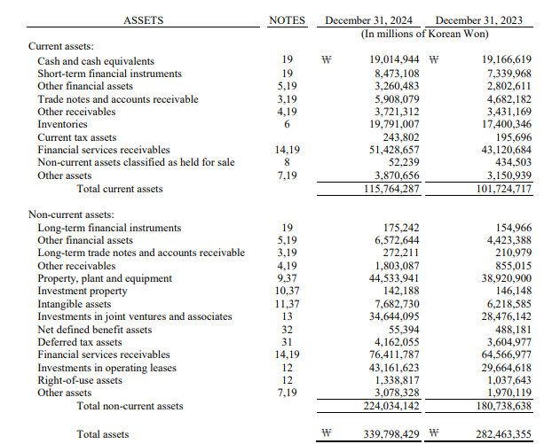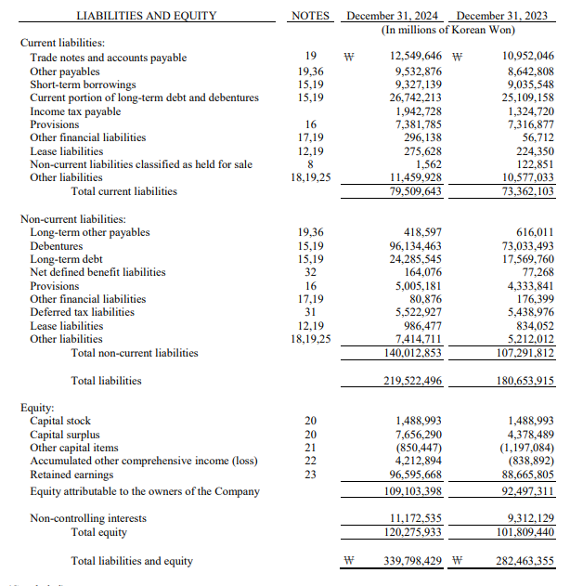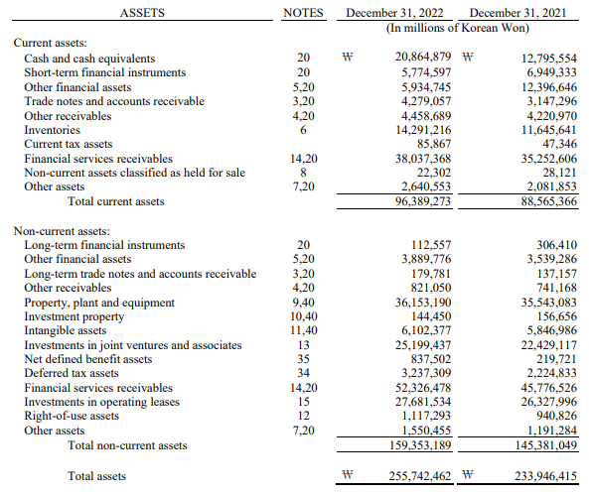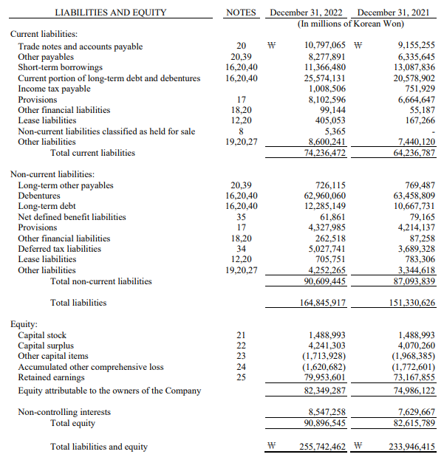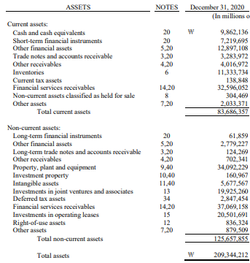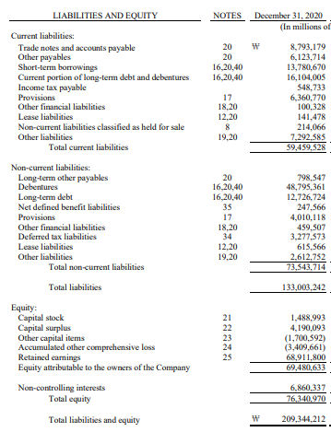
(Source: Hyundai, 2024; Hyundai, 2022; Hyundai, 2020)

Appendix B: Statements of Income of Hyundai Motor Company for Five Years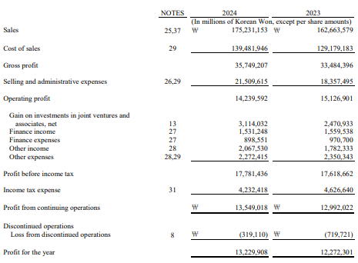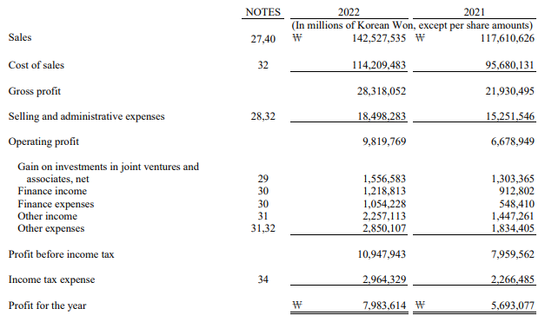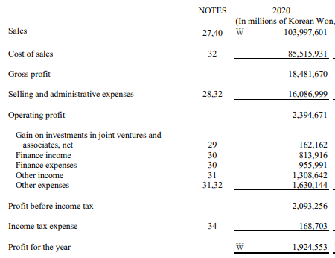
(Source: Hyundai, 2024; Hyundai, 2022; Hyundai, 2020)

Appendix C: Statements of Cash Flows of Hyundai Motor Company for Five Years
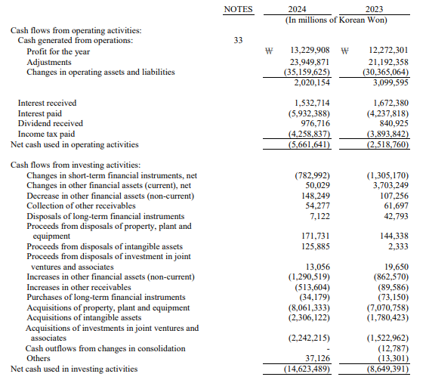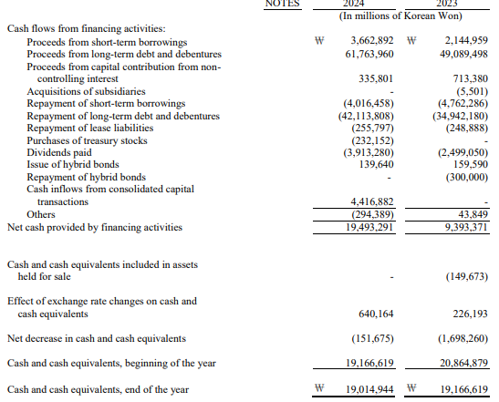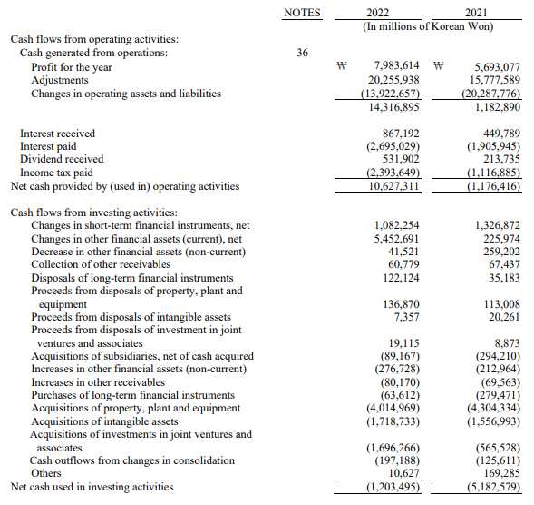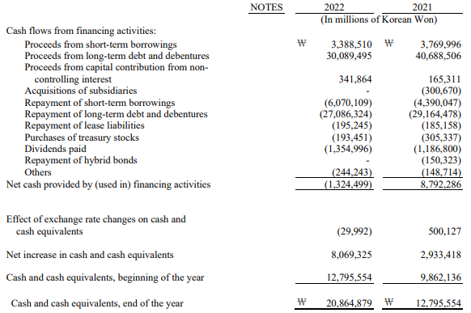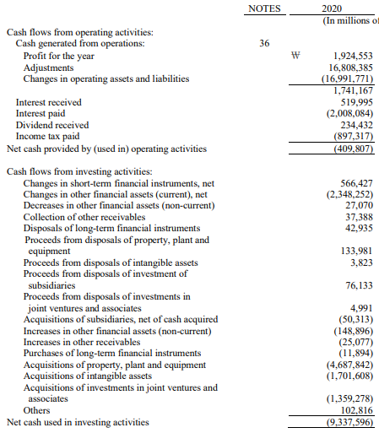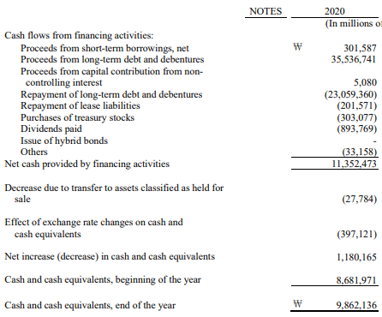
(Source: Hyundai, 2024; Hyundai, 2022; Hyundai, 2020)

Appendix D: Ratios and CCC of Hyundai Motor Company for Five Years
HYUNDAI MOTOR COMPANY’S FINANCIAL RATIOS
"Profitability Ratio" |  |  |  |  |  |  | "Gearing Ratio"
"Return on Equity" |  |  |  |  |  |  | "Debt to Equity Ratio"
"Financial aspects" | "Formula" | 2024 | 2023 | 2022 | 2021 | 2020 | "Financial aspects" | "Formula" | 2024 | 2023 | 2022 | 2021 | 2020
"Net Income" | "(Net income/Shareholders equity)" | ₩ 1,35,49,018.00 | ₩ 1,29,92,022.00 | ₩ 79,83,614.00 | ₩ 56,93,077.00 | ₩ 19,24,553.00 | "Total Debt" | "(Total debt/Total equity)" | ₩ 21,95,22,496.00 | ₩ 18,06,53,915.00 | ₩ 16,48,45,917.00 | ₩ 15,13,30,626.00 | ₩ 13,30,03,242.00
"(/): Shareholders Equity" | "(Net income/Shareholders equity)" | ₩ 12,02,75,933.00 | ₩ 10,18,09,440.00 | ₩ 9,08,96,545.00 | ₩ 8,26,15,789.00 | ₩ 7,63,40,970.00 | "(/): Total Equity" | "(Total debt/Total equity)" | ₩ 12,02,75,933.00 | ₩ 10,18,09,440.00 | ₩ 9,08,96,545.00 | ₩ 8,26,15,789.00 | ₩ 7,63,40,970.00
"Return on Equity" | "(Net income/Shareholders equity)" | 11.26% | 12.76% | 8.78% | 6.89% | 2.52% | "Debt to Equity Ratio" | "(Total debt/Total equity)" | 1.83 | 1.77 | 1.81 | 1.83 | 1.74
"Net Profit Margin" |  |  |  |  |  |  | "Times Interest Earned Ratio"
"Financial aspects" | "Formula" | 2024 | 2023 | 2022 | 2021 | 2020 | "Financial aspects" | "Formula" | 2024 | 2023 | 2022 | 2021 | 2020
"Net Income" | "(Net income/Sales)" | ₩ 1,35,49,018.00 | ₩ 1,29,92,022.00 | ₩ 79,83,614.00 | ₩ 56,93,077.00 | ₩ 19,24,553.00 | "EBIT" | "(EBIT/Interest payable)" | ₩ 1,77,81,436.00 | ₩ 1,76,18,662.00 | ₩ 1,09,47,943.00 | ₩ 79,59,562.00 | ₩ 20,93,256.00
"(/): Sales" | "(Net income/Sales)" | ₩ 17,52,31,153.00 | ₩ 16,26,63,579.00 | ₩ 14,25,27,535.00 | ₩ 11,76,10,626.00 | ₩ 10,39,97,601.00 | "(/): Interest Payable" | "(EBIT/Interest payable)" | ₩ 59,32,388.00 | ₩ 42,37,818.00 | ₩ 26,95,029.00 | ₩ 19,05,945.00 | ₩ 20,08,084.00
"Net Profit Margin" | "(Net income/Sales)" | 7.73% | 7.99% | 5.60% | 4.84% | 1.85% | "Times Interest Earned Ratio" | "(EBIT/Interest payable)" | 3.00 | 4.16 | 4.06 | 4.18 | 1.04
"Liquidity ratio" |  |  |  |  |  |  | "Investment ratio"
"Current ratio" |  |  |  |  |  |  | "Dividend Payout"
"Financial aspects" | "Formula" | 2024 | 2023 | 2022 | 2021 | 2020 | "Financial aspects" | "Formula" | 2024 | 2023 | 2022 | 2021 | 2020
"Current assets" | "Current assets/Current liabilities" | ₩ 11,57,64,287.00 | ₩ 10,17,24,717.00 | ₩ 9,63,89,273.00 | ₩ 8,85,65,366.00 | ₩ 8,36,86,357.00 | "Dividend" | "(Net income/Outstanding shares)" | ₩ 39,13,280.00 | ₩ 24,99,050.00 | ₩ 13,54,996.00 | ₩ 11,86,800.00 | ₩ 8,93,769.00
"(/): Current Liabilities" | "Current assets/Current liabilities" | ₩ 7,95,09,643.00 | ₩ 7,33,62,103.00 | ₩ 7,42,36,472.00 | ₩ 6,42,36,787.00 | ₩ 5,94,59,528.00 | "(/): "Net Income" | "(Net income/Outstanding shares)" | ₩ 1,35,49,018.00 | ₩ 1,29,92,022.00 | ₩ 79,83,614.00 | ₩ 56,93,077.00 | ₩ 19,24,553.00
"Current ratio" | "Current assets/Current liabilities" | 1.46 | 1.39 | 1.30 | 1.38 | 1.41 | "Dividend Payout" | "(Net income/Outstanding shares)" | 0.29 | 0.19 | 0.17 | 0.21 | 0.46
"Acid test ratio" |  |  |  |  |  |  | "PE Ratio"
"Financial aspects" | "Formula" | 2024 | 2023 | 2022 | 2021 | 2020 | "Financial aspects" | "Formula" | 2024 | 2023 | 2022 | 2021 | 2020
"Current assets" | "(Current assets-Inventories)/Current liabilities" | ₩ 11,57,64,287.00 | ₩ 10,17,24,717.00 | ₩ 9,63,89,273.00 | ₩ 8,85,65,366.00 | ₩ 8,36,86,357.00 | "Market Price of Share" | "(Market price of share/EPS)" | ₩ 60,008.00 | ₩ 69,283.00 | ₩ 73,316.00 | ₩ 99,610.00 | ₩ 1,01,626.00
"(-): Inventories" | "(Current assets-Inventories)/Current liabilities" | ₩ 1,97,91,007.00 | ₩ 1,74,00,346.00 | ₩ 1,42,91,216.00 | ₩ 1,16,45,641.00 | ₩ 1,13,33,734.00 | "(/): EPS" | "(Market price of share/EPS)" | ₩ 47,615.00 | ₩ 45,703.00 | ₩ 28,521.00 | ₩ 18,979.00 | ₩ 5,454.00
"Difference" | "(Current assets-Inventories)/Current liabilities" | ₩ 9,59,73,280.00 | ₩ 8,43,24,371.00 | ₩ 8,20,98,057.00 | ₩ 7,69,19,725.00 | ₩ 7,23,52,623.00 | "PE Ratio" | "(Market price of share/EPS)" | 1.26 | 1.52 | 2.57 | 5.25 | 18.63
"(/): Current Liabilities" | "(Current assets-Inventories)/Current liabilities" | ₩ 7,95,09,643.00 | ₩ 7,33,62,103.00 | ₩ 7,42,36,472.00 | ₩ 6,42,36,787.00 | ₩ 5,94,59,528.00
"Acid test ratio" | "(Current assets-Inventories)/Current liabilities" | 1.21 | 1.15 | 1.11 | 1.20 | 1.22
"Efficiency ratio" |  |  |  |  |  |  | "Cash Flow Ratios"
"Receivables Turnover ratio" |  |  |  |  |  |  | "Operating Cash Flow Ratio"
"Financial aspects" | "Formula" | 2024 | 2023 | 2022 | 2021 | 2020 | "Financial aspects" | "Formula" | 2024 | 2023 | 2022 | 2021 | 2020
"Sales" | "(Sales/Account Receivables)" | ₩ 17,52,31,153.00 | ₩ 16,26,63,579.00 | ₩ 14,25,27,535.00 | ₩ 11,76,10,626.00 | ₩ 10,39,97,601.00 | "Operating Cash Flow" | "(Operating Cash Flow/Current Liabilities)" | -₩ 56,61,641.00 | -₩ 25,18,760.00 | ₩ 1,06,27,311.00 | -₩ 11,76,416.00 | -₩ 4,09,807.00
"(/): Accounts Receivable" | "(Sales/Account Receivables)" | ₩ 59,08,079.00 | ₩ 46,82,182.00 | ₩ 42,79,057.00 | ₩ 31,47,296.00 | ₩ 32,83,972.00 | "(/): Current Liabilities" | "(Operating Cash Flow/Current Liabilities)" | ₩ 7,95,09,643.00 | ₩ 7,33,62,103.00 | ₩ 7,42,36,472.00 | ₩ 6,42,36,787.00 | ₩ 5,94,59,528.00
"Receivables Turnover ratio" | "(Sales/Account Receivables)" | 29.66 | 34.74 | 33.31 | 37.37 | 31.67 | "Operating Cash Flow Ratio" | "(Operating Cash Flow/Current Liabilities)" | -0.07 | -0.03 | 0.14 | -0.02 | -0.01
"Inventory Turnover ratio" |  |  |  |  |  |  | "Cash Flow to Debt Ratio"
"Financial aspects" | "Formula" | 2024 | 2023 | 2022 | 2021 | 2020 | "Financial aspects" | "Formula" | 2024 | 2023 | 2022 | 2021 | 2020
"Sales" | "(Sales/Inventories)" | ₩ 17,52,31,153.00 | ₩ 16,26,63,579.00 | ₩ 14,25,27,535.00 | ₩ 11,76,10,626.00 | ₩ 10,39,97,601.00 | "Operating Cash Flow" | "(Operating Cash Flow/Total Debt)" | -₩ 56,61,641.00 | -₩ 25,18,760.00 | ₩ 1,06,27,311.00 | -₩ 11,76,416.00 | -₩ 4,09,807.00
"(/): Inventories" | "(Sales/Inventories)" | ₩ 1,97,91,007.00 | ₩ 1,74,00,346.00 | ₩ 1,42,91,216.00 | ₩ 1,16,45,641.00 | ₩ 1,13,33,734.00 | "(/): Total Debt" | "(Operating Cash Flow/Total Debt)" | ₩ 21,95,22,496.00 | ₩ 18,06,53,915.00 | ₩ 16,48,45,917.00 | ₩ 15,13,30,626.00 | ₩ 13,30,03,242.00
"Inventory Turnover ratio" | "(Sales/Inventories)" | 8.85 | 9.35 | 9.97 | 10.10 | 9.18 | "Cash Flow to Debt Ratio" | "(Operating Cash Flow/Total Debt)" | -0.03 | -0.01 | 0.06 | -0.01 | 0.00
(Source: Excel)
"Cash Operating Cycle"
"Financial aspects" | "Formula" | 2024 | 2023 | 2022 | 2021 | 2020
1. Inventory Days (Inventory Holding Period) | (Inventory/Sales)*365
Inventory | (Inventory/Sales)*365 | ₩ 1,97,91,007.00 | ₩ 1,74,00,346.00 | ₩ 1,42,91,216.00 | ₩ 1,16,45,641.00 | ₩ 1,13,33,734.00
(/): Sales | (Inventory/Sales)*365 | ₩ 17,52,31,153.00 | ₩ 16,26,63,579.00 | ₩ 14,25,27,535.00 | ₩ 11,76,10,626.00 | ₩ 10,39,97,601.00
Inventory Days | (Inventory/Sales)*365 | 41.22 | 39.04 | 36.60 | 36.14 | 39.78
2. Receivable Days (Debtor Collection Period) | (Accounts Receivable​/Sales)*365
Accounts Receivable​ | (Accounts Receivable​/Sales)*365 | ₩ 59,08,079.00 | ₩ 46,82,182.00 | ₩ 42,79,057.00 | ₩ 31,47,296.00 | ₩ 32,83,972.00
(/): Sales | (Accounts Receivable​/Sales)*365 | ₩ 17,52,31,153.00 | ₩ 16,26,63,579.00 | ₩ 14,25,27,535.00 | ₩ 11,76,10,626.00 | ₩ 10,39,97,601.00
Receivable Days | (Accounts Receivable​/Sales)*365 | 12.31 | 10.51 | 10.96 | 9.77 | 11.53
3. Payable Days (Creditor Payment Period) | (Accounts Payable​/Sales)*365
Accounts Payable​ | (Accounts Payable​/Sales)*365 | ₩ 95,32,876.00 | ₩ 86,42,808.00 | ₩ 1,07,97,065.00 | ₩ 91,55,255.00 | ₩ 87,93,179.00
(/): Sales | (Accounts Payable​/Sales)*365 | ₩ 17,52,31,153.00 | ₩ 16,26,63,579.00 | ₩ 14,25,27,535.00 | ₩ 11,76,10,626.00 | ₩ 10,39,97,601.00
Payable Days | (Accounts Payable​/Sales)*365 | 19.86 | 19.39 | 27.65 | 28.41 | 30.86
Calculate Cash Operating Cycle (CCC) | Inventory Days+Receivable Days−Payable Days | 33.67 | 30.16 | 19.91 | 17.50 | 20.44
(Source: Excel)

Appendix E: Projects A, B, and C
"Year" |  |  | "Cash Flow" |  |  | "Discounting Factor @10%" |  |  | "Present Value"
0 |  |  | -£ 50.00 |  |  | 1.000 |  |  | -£ 50.00
1 |  |  | £ 10.00 |  |  | 0.909 |  |  | £ 9.09
2 |  |  | £ 12.00 |  |  | 0.826 |  |  | £ 9.92
3 |  |  | £ 14.00 |  |  | 0.751 |  |  | £ 10.52
4 |  |  | £ 10.00 |  |  | 0.683 |  |  | £ 6.83
5 |  |  | £ 8.00 |  |  | 0.621 |  |  | £ 4.97
"Net Present Value (NPV) of Project A" |  |  |  |  |  |  |  |  | -£ 8.68
"Profitability Index (PI) of Project A" (NPV+Initial investment)/Initial investment |  |  |  |  |  |  |  |  | 1.17
"Year" |  |  | "Cash Flow" |  |  | "Present Value" |  |  | Cumulative
0 |  |  | -£ 50.00 |  |  | -£ 50.00 |  |  | -£ 50.00
1 |  |  | £ 10.00 |  |  | £ 9.09 |  |  | -£ 40.91
2 |  |  | £ 12.00 |  |  | £ 9.92 |  |  | -£ 30.99
3 |  |  | £ 14.00 |  |  | £ 10.52 |  |  | -£ 20.47
4 |  |  | £ 10.00 |  |  | £ 6.83 |  |  | -£ 13.64
5 |  |  | £ 8.00 |  |  | £ 4.97 |  |  | -£ 8.68
"Payback Period (PBP) of Project A" |  |  |  |  |  |  |  |  | Not Recovered
Year |  |  | Cashflow |  |  | "Discounting Factor @10%" |  |  | Present value
0 |  |  | -£ 50.00 |  |  | 1.000 |  |  | -£ 50.00
1 |  |  | £ 10.00 |  |  | 0.909 |  |  | £ 9.09
2 |  |  | £ 12.00 |  |  | 0.826 |  |  | £ 9.92
3 |  |  | £ 14.00 |  |  | 0.751 |  |  | £ 10.52
4 |  |  | £ 10.00 |  |  | 0.683 |  |  | £ 6.83
5 |  |  | £ 8.00 |  |  | 0.621 |  |  | £ 4.97
"Internal Rate of Return (IRR) of Project A" |  |  |  |  |  |  |  |  | 2.72%
"Year" |  |  | "Cash Flow" |  |  | "Depreciation" |  |  | "Present Value"
0 |  |  | -£ 50.00 |  |  | 0.00 |  |  | -£ 50.00
1 |  |  | £ 10.00 |  |  | 10.00 |  |  | £ -
2 |  |  | £ 12.00 |  |  | 10.00 |  |  | £ 2.00
3 |  |  | £ 14.00 |  |  | 10.00 |  |  | £ 4.00
4 |  |  | £ 10.00 |  |  | 10.00 |  |  | £ -
5 |  |  | £ 8.00 |  |  | 10.00 |  |  | -£ 2.00
"Accounting Rate of Return (ARR) of Project A" |  |  |  |  |  |  |  |  | 1.60%
"Year" |  | "Cash Flow" |  |  | "Discounting Factor @10%" |  |  | "Present Value"
0 |  | -£ 50.00 |  |  | 1.000 |  |  | -£ 50.00
1 |  | £ 11.00 |  |  | 0.909 |  |  | £ 10.00
2 |  | £ 11.00 |  |  | 0.826 |  |  | £ 9.09
3 |  | £ 11.00 |  |  | 0.751 |  |  | £ 8.26
4 |  | £ 11.00 |  |  | 0.683 |  |  | £ 7.51
5 |  | £ 11.00 |  |  | 0.621 |  |  | £ 6.83
"Net Present Value (NPV) of Project B" |  |  |  |  |  |  |  | -£ 8.30
"Profitability Index (PI) of Project B" |  |  |  |  |  |  |  | 1.17
"Year" |  | "Cash Flow" |  |  | "Present Value" |  |  | Cumulative
0 |  | -£ 50.00 |  |  | -£ 50.00 |  |  | -£ 50.00
1 |  | £ 11.00 |  |  | £ 10.00 |  |  | -£ 40.00
2 |  | £ 11.00 |  |  | £ 9.09 |  |  | -£ 30.91
3 |  | £ 11.00 |  |  | £ 8.26 |  |  | -£ 22.64
4 |  | £ 11.00 |  |  | £ 7.51 |  |  | -£ 15.13
5 |  | £ 11.00 |  |  | £ 6.83 |  |  | -£ 8.30
"Payback Period (PBP) of Project B" |  |  |  |  |  |  |  | Not Recovered
Year |  | Cashflow |  |  | "Discounting Factor @10%" |  |  | Present value
0 |  | -£ 50.00 |  |  | 1.000 |  |  | -£ 50.00
1 |  | £ 11.00 |  |  | 0.909 |  |  | £ 10.00
2 |  | £ 11.00 |  |  | 0.826 |  |  | £ 9.09
3 |  | £ 11.00 |  |  | 0.751 |  |  | £ 8.26
4 |  | £ 11.00 |  |  | 0.683 |  |  | £ 7.51
5 |  | £ 11.00 |  |  | 0.621 |  |  | £ 6.83
"Internal Rate of Return (IRR) of Project B" |  |  |  |  |  |  |  | 3.26%
"Year" |  | "Cash Flow" |  |  | "Depreciation" |  |  | "Present Value"
0 |  | -£ 50.00 |  |  | 0.00 |  |  | -£ 50.00
1 |  | £ 11.00 |  |  | 10.00 |  |  | £ 1.00
2 |  | £ 11.00 |  |  | 10.00 |  |  | £ 1.00
3 |  | £ 11.00 |  |  | 10.00 |  |  | £ 1.00
4 |  | £ 11.00 |  |  | 10.00 |  |  | £ 1.00
5 |  | £ 11.00 |  |  | 10.00 |  |  | £ 1.00
"Accounting Rate of Return (ARR) of Project B" |  |  |  |  |  |  |  | 2.00%
"Year" | "Cash Flow" |  |  | "Discounting Factor @10%" |  |  | "Present Value"
0 | -£ 50.00 |  |  | 1.000 |  |  | -£ 50.00
1 | £ 5.00 |  |  | 0.909 |  |  | £ 4.55
2 | £ 10.00 |  |  | 0.826 |  |  | £ 8.26
3 | £ 20.00 |  |  | 0.751 |  |  | £ 15.03
4 | £ 25.00 |  |  | 0.683 |  |  | £ 17.08
5 | £ 5.00 |  |  | 0.621 |  |  | £ 3.10
"Net Present Value (NPV) of Project C" |  |  |  |  |  |  | -£ 1.98
"Profitability Index (PI) of Project C" |  |  |  |  |  |  | 1.04
"Year" | "Cash Flow" |  |  | "Present Value" |  |  | Cumulative
0 | -£ 50.00 |  |  | -£ 50.00 |  |  | -£ 50.00
1 | £ 5.00 |  |  | £ 4.55 |  |  | -£ 45.45
2 | £ 10.00 |  |  | £ 8.26 |  |  | -£ 37.19
3 | £ 20.00 |  |  | £ 15.03 |  |  | -£ 22.16
4 | £ 25.00 |  |  | £ 17.08 |  |  | -£ 5.09
5 | £ 5.00 |  |  | £ 3.10 |  |  | -£ 1.98
"Payback Period (PBP) of Project C" |  |  |  |  |  |  | Not Recovered
Year | Cashflow |  |  | "Discounting Factor @10%" |  |  | Present value
0 | -£ 50.00 |  |  | 1.000 |  |  | -£ 50.00
1 | £ 5.00 |  |  | 0.909 |  |  | £ 4.55
2 | £ 10.00 |  |  | 0.826 |  |  | £ 8.26
3 | £ 20.00 |  |  | 0.751 |  |  | £ 15.03
4 | £ 25.00 |  |  | 0.683 |  |  | £ 17.08
5 | £ 5.00 |  |  | 0.621 |  |  | £ 3.10
"Internal Rate of Return (IRR) of Project C" |  |  |  |  |  |  | 8.59%
"Year" | "Cash Flow" |  |  | "Depreciation" |  |  | "Present Value"
0 | -£ 50.00 |  |  | 0.00 |  |  | -£ 50.00
1 | £ 5.00 |  |  | 10.00 |  |  | -£ 5.00
2 | £ 10.00 |  |  | 10.00 |  |  | £ -
3 | £ 20.00 |  |  | 10.00 |  |  | £ 10.00
4 | £ 25.00 |  |  | 10.00 |  |  | £ 15.00
5 | £ 5.00 |  |  | 10.00 |  |  | -£ 5.00
"Accounting Rate of Return (ARR) of Project C" |  |  |  |  |  |  | 6.00%
(Source: Excel)

Appendices

