

Methods and Search Strategy Academic Poster

Student name: Fiquriyah Maflahi
Student ID: 2313052

Module name: Independent Project element 2 poster
Module code: (BMHP6020_BIRM)

An Analysis of Factors Contributing to The Impact of Burnout and Stress Rates Of Health Care Assistants In The Accident And Emergency Department (A&E) Within The NHS.

01 Introduction and Research Aim  This poster details the methods employed in a secondary literature-based study into health care assistants' burnout and stress in NHS Accident and Emergency departments. The methods section explains how research is systematically designed, sourced and analysed to explain its process of experimentation transparently and reliably. This research aims to explore how a lack of staff affects HCA workload, burnout levels, service efficiency, and patient care outcomes in the emergency healthcare system. | 02 Search Strategy  Secondary research requires a search strategy, which is a logical plan used to identify relevant academic literature through keywords and databases to provide a comprehensive and focused search process (Macfarlane et al, 2022). This study employed structured keywords, including "HCA burnout", "A&E staffing shortages", and "NHS emergency workload", with the use of Boolean operators AND, OR, and NOT to provide greater accuracy in the search.
03 Searching for Information  Data from PubMed, CINAHL, Google Scholar, and ScienceDirect have been used. A general search was conducted and then filtered by publication date, peer-reviewed, English language and relevance to the UK. Titles and abstracts were initially screened and then full-text review for relevance. Search terms were refined over and over to provide greater accuracy and minimise irrelevant results. A structured source tracking table was used to ensure organisation and transparency during the key findings. | 04 Picture / Graph / Visual Aid / Statistics  Staff member scores in the NHS Staff survey graph were also lower than the best scores in the future intentions, work pressure and stressors section, indicating ongoing stress for NHS bank workers (NHS, 2026). This is consistent with the idea that workload and poor wellbeing are factors that can lead to burnout and retention issues.  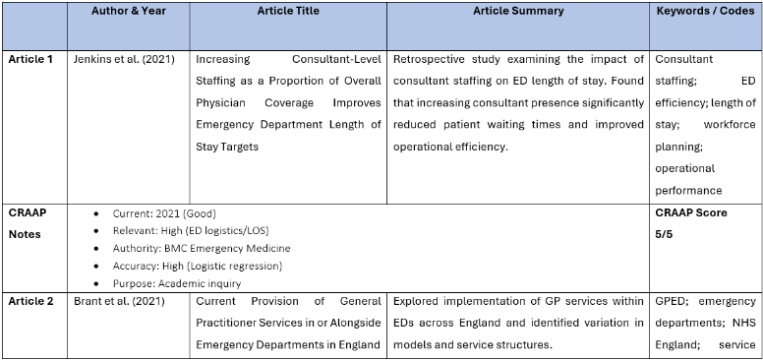  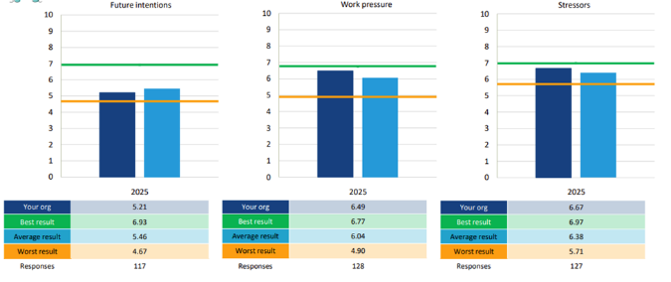  Figure 1: Morale At NHS (NHS, 2026)
05 Research Validation and Analysis
Validation is an assessment of whether sources are credible, accurate, and reliable in secondary research. Writing evaluation of authority, currency, and accuracy makes academic integrity Atikuzzaman and Yesmin, 2023). The CRAAP test was used to evaluate sources (REF) in this study. Thematic analysis was used to interpret the data by identifying any repeated patterns between studies and categorising these into key themes for Chapter 4. All published literature has a degree of bias, and different studies may use different methodologies.
06 Inclusion Criteria  Peer-reviewed papers published in the last 10 years, in English, available online, and specifically based on the context of the NHS or equivalent healthcare emergency service, including with reference to burnout, staffing, or workload pressures. | 07 Exclusion Criteria  Studies published more than 10 years ago, non-English articles, opinion articles, inaccessible full texts, and research that does not address emergency care or healthcare workforce issues were excluded.
08 Ethical Considerations
Ethics in Secondary Research is the responsible use of published data and academic honesty or academic integrity (Zhaksylyk et al., 2023). All sources are properly cited and paraphrased in this study to prevent plagiarism. All sources were freely available academic and policy materials, allowing transparency and respect for the original authors' work.

References
Atikuzzaman, M. and Yesmin, S., (2023). Authority concerns regarding research students’ academic dishonesty: A case study for promoting academic integrity in a public university in Bangladesh. Journal of Academic Ethics, 21(4), pp.591-607. https://doi.org/10.1007/s10805-023-09474-8?urlappend=%3Futm_source%3Dresearchgate.net%26utm_medium%3Darticle
MacFarlane, A., Russell-Rose, T. and Shokraneh, F., (2022). Search strategy formulation for systematic reviews: Issues, challenges and opportunities. Intelligent Systems with Applications, 15, p.200091. https://doi.org/10.1016/j.iswa.2022.200091
NHS (2026). Kingston and Richmond NHS Foundation Trust 2025 NHS Staff Survey for Bank Only Workers Benchmark Report. [online] NHS. Available at: https://cms.nhsstaffsurveys.com/app/reports/2025/RAX-bank-2025.pdf [Accessed 4 Jun. 2026].
Zhaksylyk, A., Zimba, O., Yessirkepov, M. and Kocyigit, B.F., (2023). Research integrity: where we are and where we are heading. Journal of Korean medical science, 38(47). https://doi.org/10.3346/jkms.2023.38.e405

