Table of Contents
1.0 Introduction 2
1.1 What is Meningitis 2
1.2 Causes of Meningitis 3
1.3 Symptoms of Meningitis 3
1.4 Vaccination 4
1.5 Design Requirements 5
1.6 Data Acquisition Methods 5
2.0 Literature Review 7
2.1 What is GIS 7
2.2 What is SDSS 7
2.3 Principles of thematic mapping and data visualisation 9
2.4 Theory of Geovisualization 9
2.5 Cartographic representation 9
3.0 Findings 11
Reference 13

Introduction

1.1 What is Meningitis

Meningitis is an inflammation of the meninges that is identified by an abnormal number of white blood cells in Celebrospinal fluid. It is a serious disease where bacterial infection causes inflammation of the meninges. Bacterial meningitis can be fatal. There are up to 70% of cases of death caused by meningitis when left untreated. There are five types of meningitis – viral, bacterial, fungal, parasitic, and non-infectious meningitis. The most common type of meningitis is viral meningitis. Viruses such as coxsackievirus A, coxsackievirus B, and echoviruses cause 85% of cases. That is, according to Centers for Disease under Control and Prevention area, about 10 to 15 million infections and tens of thousands of hospitalizations each year in the United States. Other viruses that can cause virus meningitis include; West Nile virus, influenza, mumps, HIV, measles, herpes viruses, and Coltivirus. Bacteria that causes bacterial meningitis are; Streptococcus pneumoniae, Neisseria meningitidis, Haemophilus influenza, Listeria monocytogenes, and Staphylococcus aureus. Bacterial meningitis is contagious. Viral and bacterial meningitis cannot be differentiated in the absence of a lumbar puncture [1]. Fungal meningitis on the other hand, is a rare type of meningitis. Primary fungi, such as Cryptococcus, Blastomyces, Histoplasma, and Coccidioides and secondary fungi, such as Aspergillus, and Candida, infects central nervous system, causing life-threatening diseases, such as fungal meningitis. Cryptococcal meningitis is a type of fungal meningitis. It is a common unscrupulous infection in AIDS patients. Parasitic meningitis is caused by parasites. It is not infectious from person to person, but it infects an animal and hide out on food that human eats. Non-infectious meningitis is a type of meningitis that’s caused by either lupus, a head injury, brain surgery, cancer or certain medications. It is not infectious.

1.2 Causes of Meningitis

Meningitis is commonly caused by viral infections. Each type of meningitis has different cause. Viral meningitis is caused by viruses that triggers inflammations in the brain and spinal cord. It could be caused by herpes, flu and measles. Viral meningitis is not contagious. Meningococcal bacteria, which causes bacterial meningitis, is commonly brought by humans. About 10% of the population of the world is carrying these particular bacteria. Contact with meningococcal bacteria will not make a person ill. It is possible to carry the bacteria in your throat or nose even when it does not affect that person. Meningococcal bacteria are not infectious just by being near to somebody who has it because it does not survive for along time outside the body. The bacterial meningitis can be spread by; kissing, sharing cutlery, coughing, or sneezing. As aforementioned, fungal meningitis is usually caused by cryptococcus fungus. It is contracted by inhaling spores that live in the soil. These spores then cause inflammation through spreading into blood and spinal cord. It is also not contagious. However, it is possible for a person to suffer from meningitis without infecting it from someone else. These phenomena happen by triggers such as; head injuries, brain surgery, cancer, lupus or reaction to certain drugs.

1.3 Symptoms of Meningitis

Meningitis have a number of symptoms. The most noticeable symptom is the meningitis rash. It usually starts as small, red pinpricks. These rashes spread quickly and turns red or purple blotches over time. This symptom can be checked by pressing the side of a clear glass firmly on the skin. If the rashes fade, it means that the person does not suffer from meningitis. If it fades, then it is a sign of blood poisoning. Blood poisoning is caused by meningitis. For darker skin, it is better to check on areas such as palms of the hands, soles of the feet, tummy, inside the eyelids, and roof of the mouth. Apart from the noticeable symptoms, there are other less obvious symptoms of meningitis. These include; a high body temperature (38 Celsius or above), feeling sick, irritable and lack of energy, headache, muscle and joints ache, rapid breathing, cold hands and feet, pale and mottled skin, stiff neck, drowsiness, seizures, and confusion. Since meningitis often occur to babies, there are some symptoms that only babies may experience. Babies may; refuse feeds, be agitated, be unresponsive, and have a stiff body if they are suffering from meningitis.

1.4 Vaccination

There is vaccination provided for different types of meningitis. Bacterial meningitis is known as the “more dangerous” type of meningitis, as it threatens life if it’s not diagnosed and treated quickly. Therefore, there are two vaccines for bacterial meningitis; meningococcal conjugate vaccine, and Meningitis B vaccine. Meningococcal conjugate vaccine targets the most common types of bacterial serotypes. It offers great protection, only if you maintain booster shots. The vaccine’s long-term effectiveness remains unknown. Children aged 5 months to 18 years vaccinated proven to be highly effective. But, the effectiveness of the vaccine lasts for one year for children vaccinated in the infant immunisation programme [2].

1.5 Data Acquisition Methods

Health-related datasets were obtained from https://www.healthmapswales.wales.nhs.uk/IAS/home/. The website contains various Welsh resident data including health. Variety of health indicators by area can be explored from the website. Health Map Wales has datasets from various health-related categories;
- Cancer,
- Common procedures,
- Communicable diseases,
- Demography,
- Dental and oral health,
- Diseases of the circulatory system,
- Disease of the digestive system,
- Diseases of the genitourinary system,
- Diseases of the respiratory system,
- Endocrine, nutritional and metabolic diseases,
- External causes of morbidity and mortality,
- Hospital Admissions,
- Maternity & Child health,
- Mental and behavioural disorders,
- Mortality,
- Outpatients,
- Profiles, and
- Substance misuse.
In order to obtain datasets related to meningitis, I browse through “Maternity & Child Health” category. There are a few subcategories suggested; births and babies, births, general fertility rate, immunisations, and immunisations – data to 2012/13. The statistics needed to gather would be for areas at OA, LSOA and MSOA level according to census boundaries, therefore, data based on MSOA level was chosen. It is important to choose datasets related to meningitis. Children receive HIB and MMR to prevent meningitis and septicaemia. HIB vaccine is an injection given to 1-year old babies to protect themselves against Haemophilus influenzae and meningitis. It is part of the childhood vaccination programme, where babies are given various different vaccines in order to protect themselves from different life-threatening diseases. Children receive 6-in-one vaccine, pneumococcal jab, rotavirus vaccine, MenB vaccine, HIB vaccine, MMR vaccine, children’s flu vaccine, 4-in-1 pre-school booster and HPV vaccine in this programme. Apart from HIB vaccine, MMR vaccine also played a big role in protecting human from highly infectious conditions such as measles, mumps and rubella, that could lead to complications such as meningitis, encephalitis, and deafness. This information is gathered through a dataset that contains type of vaccination, number of doses, age, and period of time. The uptake is calculated by percentage. The time period for the data gathered is from 2003 until 2013. To calculate the Townsend index, different datasets were obtained. The datasets were obtained from UK Data Services, under INFUSE. Data collected to calculate the Townsend index include;
- People aged 16-74: Economically active: Employees Part-time
- People aged 16-74: Economically active: Employees Full-time
- People aged 16-74: Economically active: Self – employed
- People aged 16-74: Economically active: Unemployed
- People aged 16-74: Economically active: Full-time student
- Households: Owner occupied: Owns outright
- Households: Owner occupied: Owns with a mortgage or loan
- Households (number of cars or vans): None
- All households
The Townsend index was calculated using calculation that is provided in the assignment guideline.

Literature Review

2.1 What is GIS

Geographic Information System, also known as GIS, is a form of data visualization. It is a computer-based tool that analyzes, stores, manipulates and visualizes geographic information in a map [3]. It was introduced by Dr John Snow who used mapping to illustrate a disease which was centered around a water pump. Based on the illustration, John Snow noticed that that disease was commonly found along the water line. The GIS back in 1854, GIS was used for basic analysis. Data analyzation is made easy using GIS as it analyses spatial location and layers of information can be organized and transformed into visualizations using maps. These visualizations appear as layers on the map, allowing people to understand the information that is important. The main function in GIS is connecting data with geography. In GIS, users create geographic data, manage it, analyse it, and display it on a map. With spatial and attribute data, GIS can solve problems through spatial analysis. Attribute data is additional information about every spatial feature. Spatial data is the actual location of a place. GIS stores information as thematic layers. Its data is stored as rasters and vectors. There are 2 rasters – continuous rasters and discrete rasters. Continuous rasters are grid cells with gradual changing data while discrete rasters have distinct themes or categories [4]. Vectors may be points, lines and polygons.

2.2 What is SDSS

Spatial Decision Support System (SDSS) is a software that is intuitively obvious to use, solves specific problems efficiently, and delivers immediate results [5]. It solves spatial problems while assisting decision-making using a system that models decisions. Mathematical calculations weigh various choices of a decision based on different criteria and evaluations. The integration between Decision Support Systems (SDSS) and GIS solves spatial decision problem. It usually includes a user interface for communication purposes. The SDSS assists, analyses, and processes data before being presented in a user-friendly form. There are two techniques suitable to stimulate land use dynamics – cellular automaton and agent-based models. Cellular automaton, also known as cellular spaces, is a discrete model. It consists of a consistent grid of cells. The grid can be in any finite number of dimensions. The agent-based model on the other hand, is a class of computational models for simulating actions and interactions of autonomous agents. Spatial decision problems are also often characterized by uncertainty and conflicts between various stakeholders interested in the process. The most important parts in decision alternatives and potential outcomes can vary spatially [6]. An iterative process is done to guide further analyses. A simple combination of facilitating the mutual reinforcement of the abilities of humans and computers. Providing computer support to solve space-related decision problems is one of the ways to solve spatial decision problems.

2.3 Principles of Thematic Mapping and Data Visualization

Thematic map is a map emphasizing on a particular theme or a specific topic. It shows the natural features such as rivers, cities, political subdivisions and highways. There are three models for creating a thematic map; object-based model, evolutionary model, and framework model. Abstraction, structural design, unification, and user’s comfort are the main principles of thematic mapping. Data visualization is the science of visual representation of data, which was abstracted into schematic form. Both thematic mapping and data visualization are concerned with the visual representation of quantitative and categorical data, despite being driven by different goals.

2.4 Theory of Geovisualization

Geographical trends using socio-demographic, health and economic data can be displayed through Geovisualization. Geographical analysis of these data is based on a combination of indicators of attributes on health, poverty, or demography. Extractions of patterns and discoveries of new knowledge can be reached by geovisualization [7]. Graphical representations used to depict general structure and cluster data are able to explore the relationships among different variables. Using socio-demographic data, it is possible for detail exploration of correlation and relationships among attributes such as age, gender, ethnicity, education level, income, type of client, years of experience, and location to be discovered. These data can be resulted in useful geographic data which can help analyse geographical trends.

2.5 Cartographic Representation

Cartography is the study and practice of creating maps to communicate spatial, topographic, and geographic information effectively. Collaboration between cartographic and GIS enables spatial relationships to be in structured formal representations. A reusable rule-based map symbology is created using cartographic representations. In order to optimize map production workflows, cartographic representations’ concepts can be applied. Cartography representations can improve the display of feature geometry. There are a few differences of conventional symbology and representation symbology.

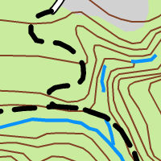
Figure 2.7.1

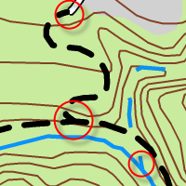
Figure 2.7.2

Figure 2.7.1 shows trails, roads, and rivers drawn with conventional symbology while figure 2.7.2 shows the same trails, roads, and river drawn with representation symbology. The line features drawn in representation symbology shows unambiguous connections.

3.0 Findings

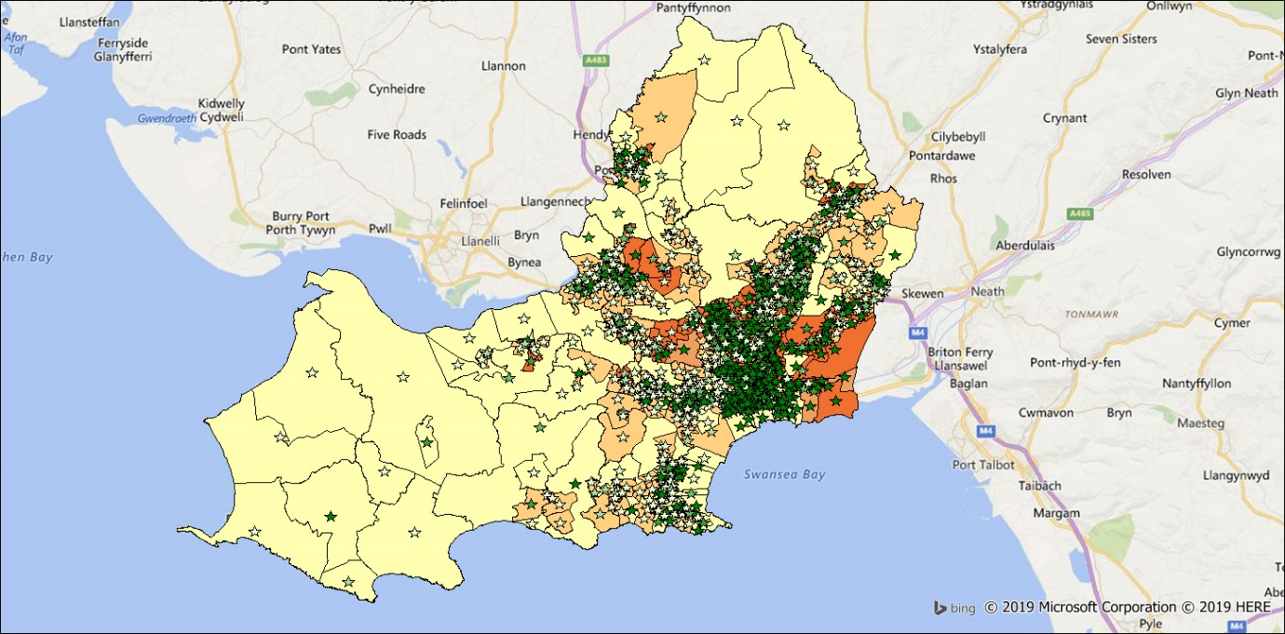
Figure 4.1
Figure 4.1 shows the GIS produced based on socio-demographic and geographic data. The output of GIS shows various areas with different deprivation index and concentration of people who maintains good health. The base layer of GIS targets on different areas in Swansea county. The colours on the map shows the type of area. Deprived area has darker orange colour to differentiate them from other less deprived area. Deprived areas are usually located in the sub urban areas of the city. There are less people residing in the countryside, making it a less deprived area. The deprivation index is derived from percentage of overcrowding, unemployment, and Z-Scores. People aged 16 to 76 who maintains good health or fairly good health are shown through a layer and is indicated by a star symbol. The shade of green shows the number of people who maintains good or fairly good health according to their areas. The darker the green shade, the greater number of people that maintains good or fairly good health in that area. Living in less deprived areas are proven to be able to maintain good health. Therefore, people living in deprived areas are recommended to uptake the new meningitis vaccination.

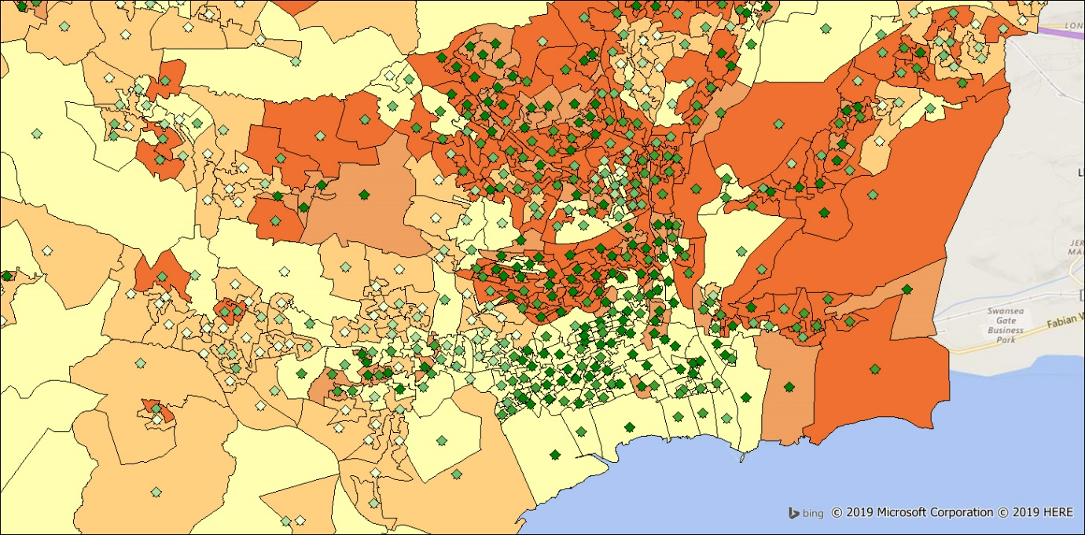

Swansea City Centre is less deprived; therefore, it is labelled as light yellow. However, it is surrounded by deprived areas, especially in Winch Wen, Llansamlet, and Penllergaer. This map shows a more detailed and clear view of the GIS in the city centre area.

Reference

- D. Hayes, "Viral meningitis in adults", Nursing, vol. 41, no. 4, p. 41, 2011. Available: 10.1097/01.nurse.0000395204.80613.2c.
- C. Trotter, N. Andrews, E. Kaczmarski, E. Miller and M. Ramsay, "Effectiveness of meningococcal serogroup C conjugate vaccine 4 years after introduction", The Lancet, vol. 364, no. 9431, pp. 365-367, 2004. Available: 10.1016/s0140-6736(04)16725-1.
- "What is Geographic Information Systems (GIS)? - GIS Geography", GIS Geography, 2019. [Online]. Available: https://gisgeography.com/what-gis-geographic-information-systems/. [Accessed: 06- Jan- 2019].
- C. Dempsey, "What is Geographic Information Systems (GIS)? - GIS Geography", GIS Geography, 2019. [Online]. Available: https://gisgeography.com/what-gis-geographic-information-systems/. [Accessed: 25- Jan- 2019].
- M. Crossland, B. Wynne and W. Perkins, "Spatial decision support systems: An overview of technology and a test of efficacy", Decision Support Systems, vol. 14, no. 3, pp. 219-235, 1995. Available: 10.1016/0167-9236(94)00018-n.
- R. Sugumaran and J. Degroote, Spatial decision support systems. Boca Raton, FL: CRC Press, 2011.
- S. Asthana, "The demographic and social class basis of inequality in self reported morbidity: an exploration using the Health Survey for England", Journal of Epidemiology & Community Health, vol. 58, no. 4, pp. 303-307, 2004. Available: 10.1136/jech.2002.003475.

