Introduction
The group has been asked to design a line launcher capable of firing a projectile from a fixed position on top of a table. The table will be 600 x600 mm in size and the launcher will attached to the table by a location pin situated 100mm from the back edge of the table. The target will be made up of a series of circular rings upon a container, each area of the rings will be scored with the outer being 1 point and the center being 5 points.
The launch location pin will consist of a 50mm M10 bolt glued to the table with approx. 30mm of thread exposed. The device will be secured on to the location pin using a 10mm washer and wing nut which will be provided. The launcher must be able to fire a yellow dot squash ball with a line attached approximately to its center, the other end of the line will have a loop in the end to be attached to the launcher its self and the line will be approximately 9.5M long.
The device itself must meet the device regulations set by the governing body, the device must be regarded as safe by the foreman of the group with a risk assessment taken on the possibility of entanglement or entrapment of the line. The device must have a safety mechanism fitted to prevent it from accidentally being fired once primed. The device must not exceed 600 x 600 x 600mm in size and must sit upon and not overhang the table at any point during the competition.
The device must always be attached to the location pin using the 10mm washer and wing nut during the competition if the launcher comes loose and breaks free the group will not receive any points for the attempt. It must have a quick and simple method of attaching and detaching the line, which doesn’t need tools. This will be up to the group’s discretion, but any couplings must not violate the control volume dimensions. The group has been advised to pay close attention to line management during the launch sequence, line management devices can be reloaded, reused or replaced during a heat or the final. The device will be fired remotely via a low voltage electrical switch with a minimum cable length of 3m. The firing switch and wiring are the only components excluded from the firing area. Parts from existing firing devices such as triggers, barrels and breaches are not permitted. The device has a £30 maximum spend limit set so recycling and reusing parts is a good option for the group and will also benefit the environment. (engineers, 2019)

Current Existing designs
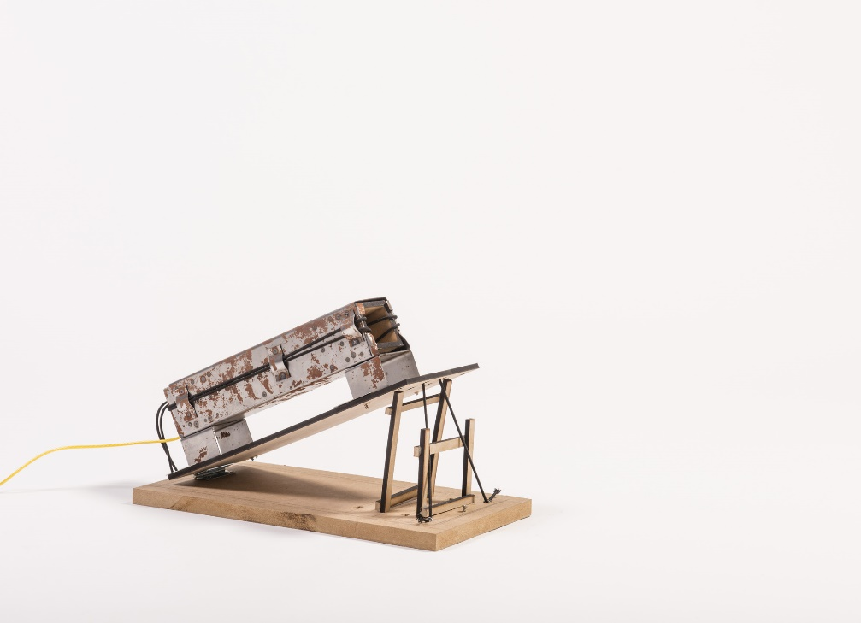
(Diskinson, 2016)
Pros Cons
Robust design hard to see how the line would travel freely
Simple firing heavy
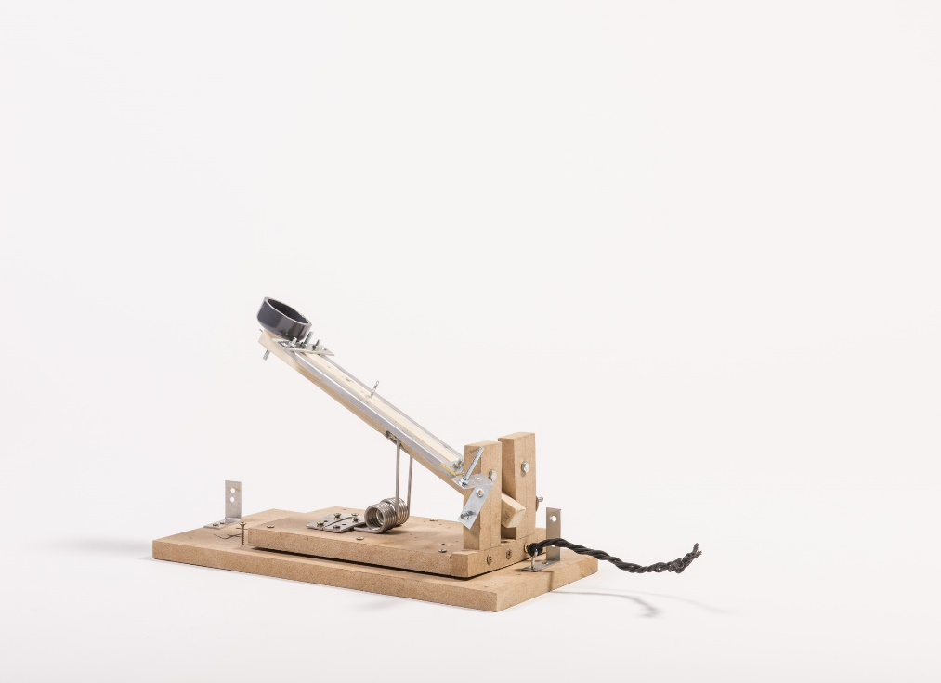
(Diskinson, 2016)
Pros Cons
Simplistic design difficult to gain good firing accuracy
Cheap to produce no accommodation for a line

Design Specification
A design specification has been produced to help pick a winning design to put forward to the other members of the group, these other members will also pick a winning design each and all final concepts will be further analysed. the concept Ideas will be judged on:
- weight – must be light enough to move but heavy enough to stay in position
- aesthetics – must look good whilst remaining practical
- firing range – projectile must be able to reach the set target
- cost - £30 limit for materials
- accuracy - must be able to fire accurately at the set target from distance
- ease of use – must be easy to load and fire
- able to hold position before firing – this will be the safety mechanism

Concept Designs
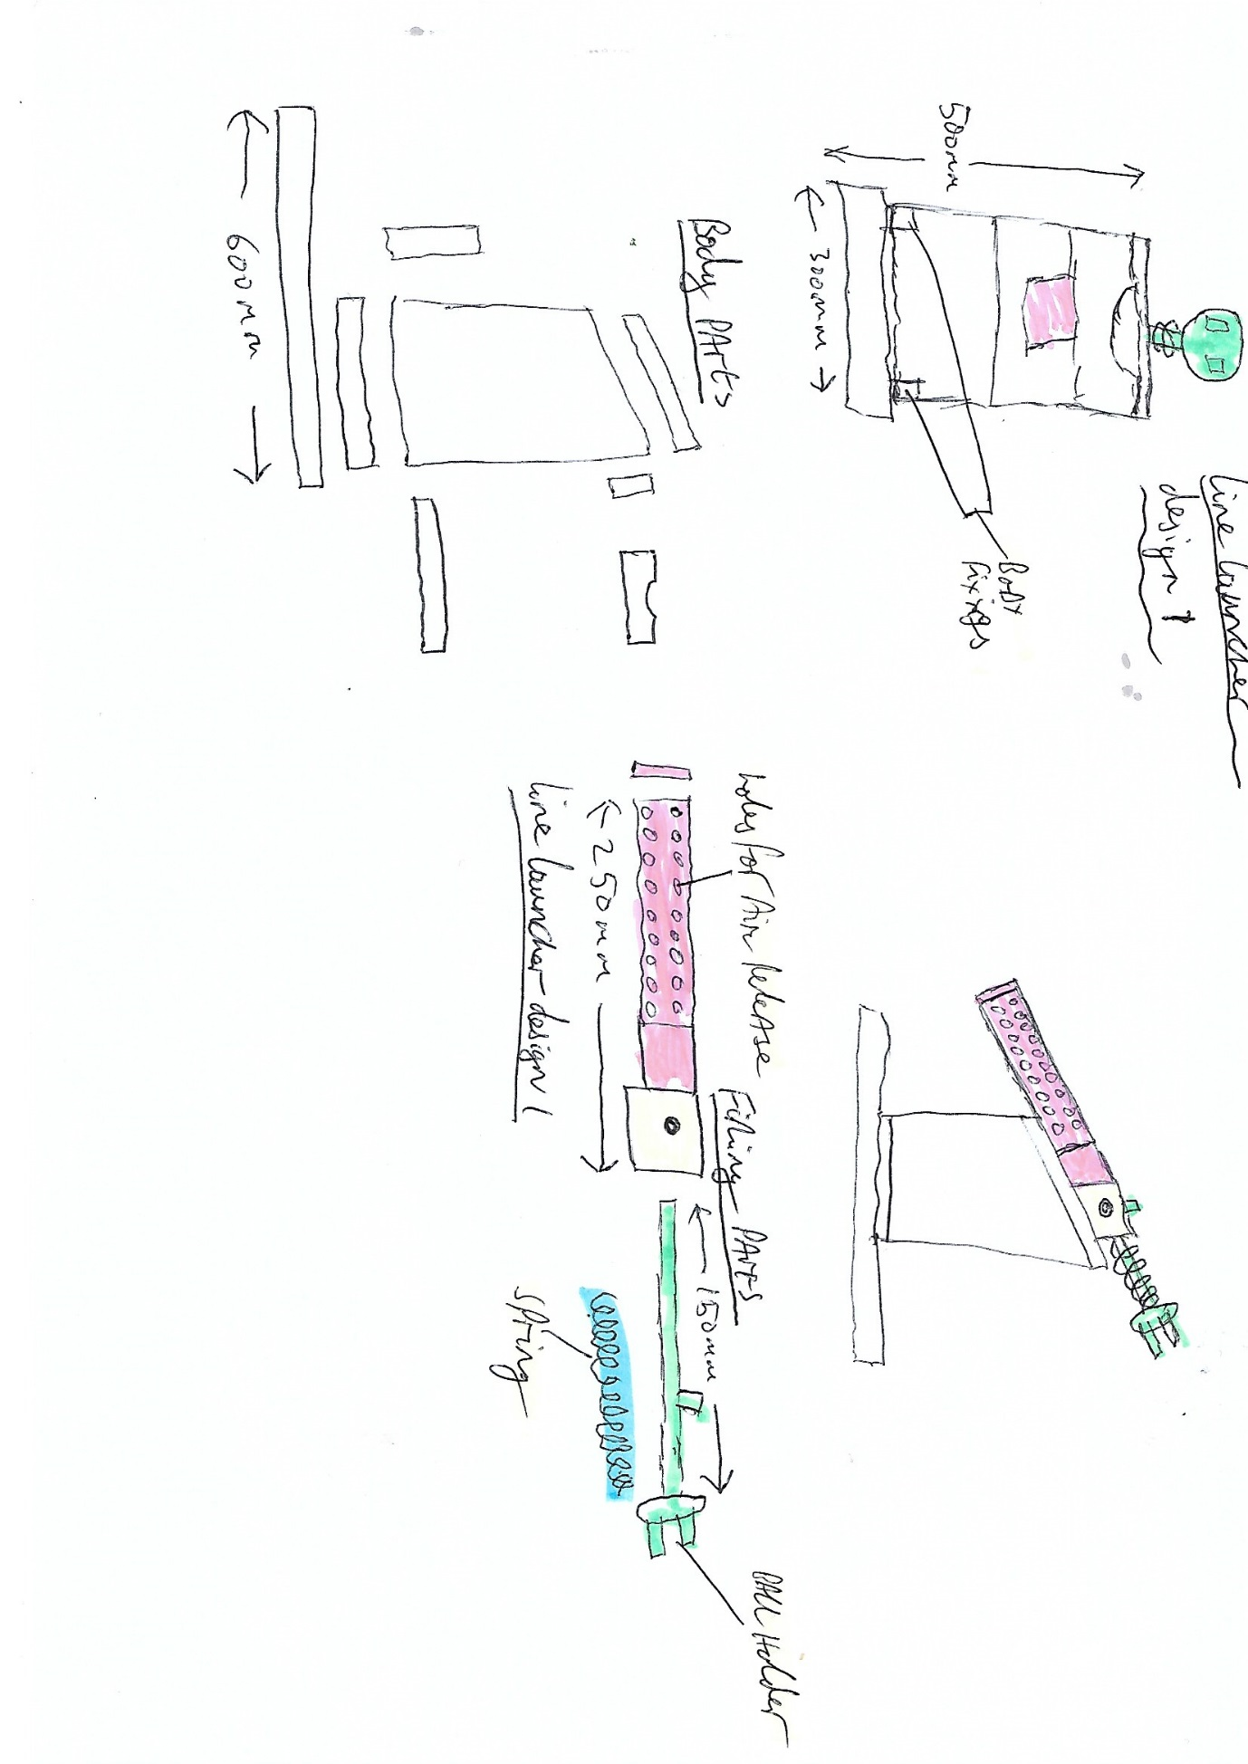
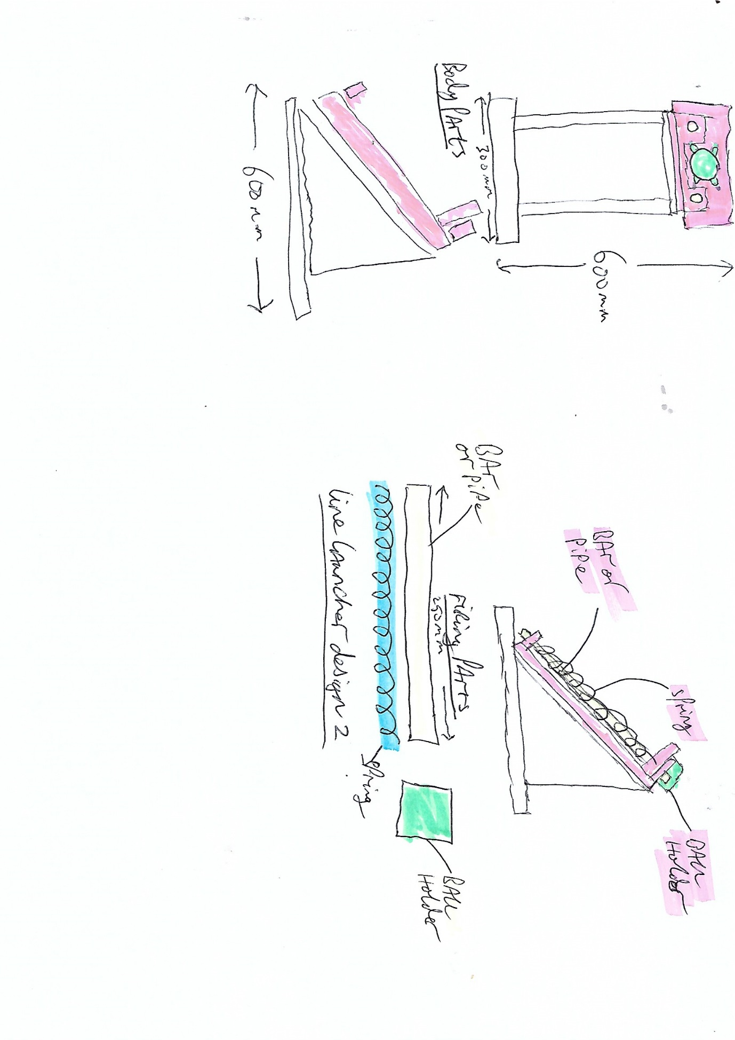

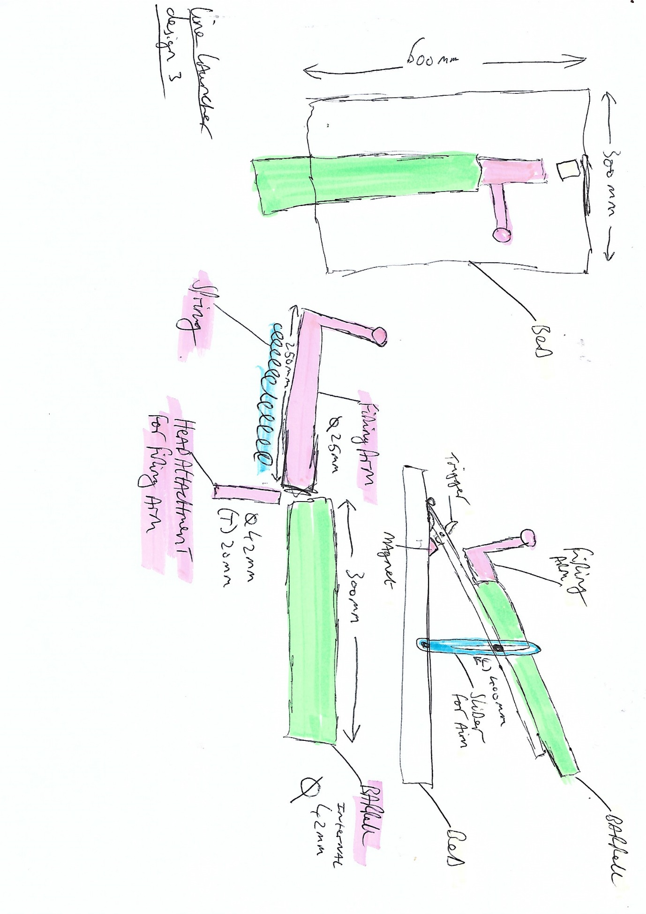

Design 1
The first concept design consists of a body made of 9mm mdf sections, these will be glued and screwed together. The firing mechanism consists of a barrel made of either metal or plastic, with holes drilled in so that the projectile may be fired with ease by a firing arm with attached spring. This firing arm will have a plate fitted with holding pegs in place to keep the projectile in place.

Pros
- Sturdy design
- Good projectile support during firing
- Powerful firing potential
Cons
- No scope for accuracy
- Potentially expensive
- Awkward firing mechanism

Design 2
The second concept design consists of a body made from 9mm mdf sections, these will be glued and screwed together. The firing mechanism is made by using either 2 lots of pipe of bar with springs fitted on both whist a section of mdf is fitted with a plastic holder for the projectile to sit in. the mdf section is drawn back and released, the springs force the mdf section forward and stopping on the shoulders of the body forcing the projectile forward.

Pros
- Cheap to make
- Simple design
- Good firing range
Cons
- Poor strength in body
- No scope for accuracy
- Poor draw back for firing mechanism

Design 3
The third concept design consists of a body made up of 9mm mdf sections these will be hinged together for ease of movement to provide greater accuracy along with 2 sliding arms to set the firing angle, the firing mechanism will consist of a barrel made out of either metal of plastic pipe, with a plate fitted at the back, this plate will have a hole drilled into it for the firing arm to be inserted into. Once inserted a spring is fed onto the arm and another plate is fixed onto the front of the arm. To fire the projectile is placed into the barrel and the arm is drawn back and will click into place onto a trigger. The trigger consists of a sliding piece of metal in a housing on a spring, underneath is a magnet wired to a button, once the button is pressed the magnet turns on pulling the trigger down releasing the firing arm and the launcher is then fired.

Pros
- Very accurate
- Powerful firing
- Good safety mechanism
cons
- Possibly pricey to make
- A lot of components
- Possibly too powerful for close range targets

Design Analysis
spec | weighting | Design 1 | Design 2 | Design 3
weight | 5 | 2 | 3 | 4
aesthetics | 5 | 2 | 2 | 4
firing range | 10 | 5 | 6 | 9
cost | 7 | 2 | 4 | 5
accuracy | 10 | 5 | 4 | 8
ease of use | 9 | 5 | 7 | 8
able to hold position before firing | 10 | 4 | 6 | 9
 | Total | 25 | 32 | 47

Materials
Body work
There is a budget for the project of £35, so resourcing the right materials is critical. The ideal choice to the main structure of the line launcher would be timber sheet material. Most timber sheet materials are inexpensive but structurally strong, and can be laminated together to add strength. Below is a table with potential timber sheet materials:

sheet Material | price (inc VAT) | Size | thickness | Pros | Cons
MDF | £9.36 | 4ft x 4ft | 9mm | cheap | May need reinforcing
Ply (hardwood) | £10.62 | 4ft x 4ft | 9mm | good flexibility | expensive
OSB | £12.74 | 8ft x 4ft | 9mm | Cheap | not structurally strong

After performing research it has been decided that the main body of the line launcher will be made out of 9mm mdf. It is an inexpensive material and if required can easily be laminated together to add strength.

Barrel

Piping material | Price (inc VAT) | Size | pros | cons
Plastic | 4.36 | 3 m | cheap | brittle
galve | 11.86 | 3 m | strong | expensive
copper | 14.67 | 3 m | strong | expensive

After performing research plastic piping has been chosen to make the barrel, this is because it’s a cheap material and could withstand the work required from it.
Firing arm
The firing arm will be made from cheap metal bar this will be acquired from a scrap merchant for little more than £1, any other parts will be upcycled or sourced for free.

Individual team member parts
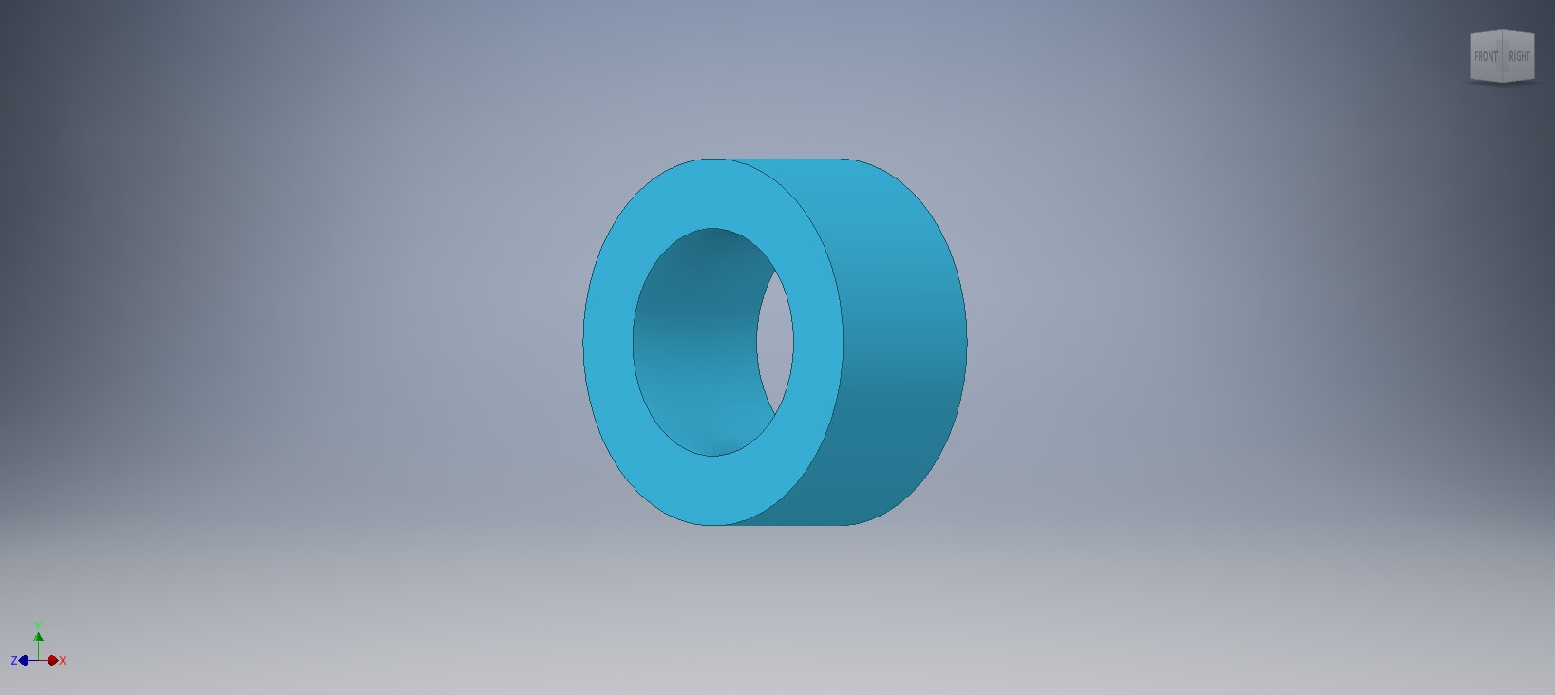
Above is a model of the barrel plate that sits inside the barrel, this will stop the firing arm going to far forward and also keeps the spring in place.

Below is the barrel, this is the housing for the main firing mechanisms, it is designed to be slightly bigger than the projectile.
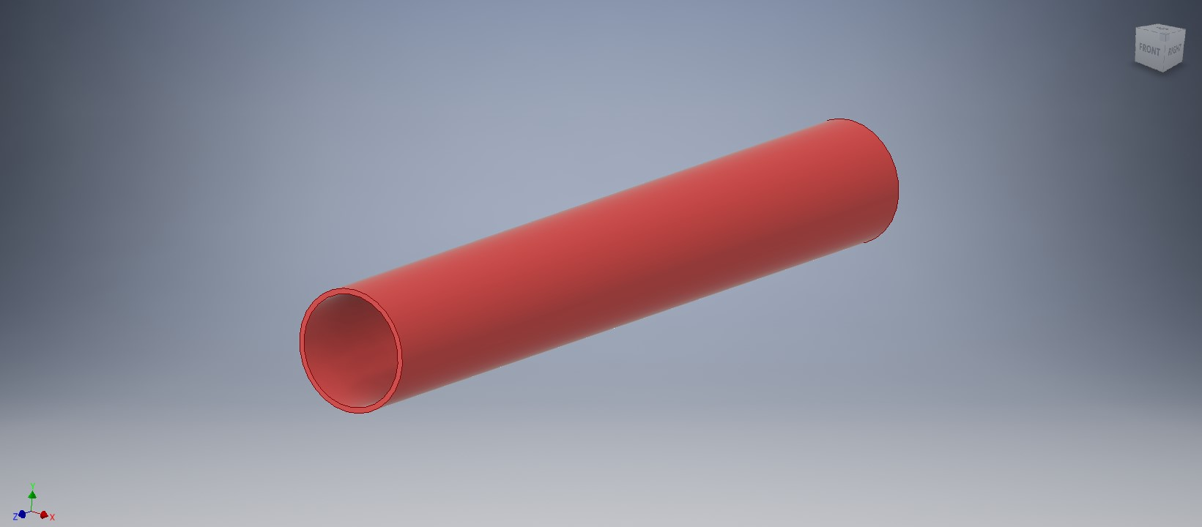

Bibliography
Diskinson, D. A. (2016). https://uosdesign.org/designshow2016/year-1/line-launcher/.
engineers, i. o. (2019). https://www.imeche.org/docs/default-source/1-oscar/challenges/design-challenge/2020/imeche-1st-year-design-challenge---project-specification-2020---v1-2.pdf?sfvrsn=2.

