digtal skills

Talib Ben Jones student I.D 1803664
Renuga Jayakumar

Table of Contents
Introduction 1
Table of Contents 2
iCloud Dropbox Information 3
Maxiseries Innovation and Creativity 4
Advantages of Technology 5
Technology Produces Mobility 6
Disadvantages of Technology in the Workplace …………………………………………………………………………… 7
Causes Distraction at Work …………………………………………………………………………………………………………. 8
Maintenance of your device ………………………………………………………………………………………………………… 9
Employees becoming complacent ……………………………………………………………………………………………… 10
The Risk ……………………………………………………………………………………………………………………………………. 11
Conclusion ………………………………………………………………………………………………………………………………… 12
References ………………………………………………………………………………………………………………………………… 13

Introduction
This report will be focusing on modern technology and how digital skills are used and highly required within the workplace today. This report will be highlighting the advantages and disadvantages of technology in the 21st century. Giving an academic analysis on two storage devise’s and how they function, also the effective use of web conferences.
iCloud Dropbox Information.
Back in August 2012 the apple iCloud business company’s value exceeded the world record of which is 624 billion dollars this evaluates in today’s current market in English pounds as 489 billion. iCloud is one of apples leading applications that grants the options for users to store information on remote computer servers external from the devise, the user can then upload information to retrieve as required via their device which is compatible with the iOS system. The iCloud arrangement delivers users with the capability to download many forums data melodies to accounts, pictures, files, all iCloud accounts offer 5 gig of permitted storage space that is free, additional space can be brought in ten, twenty or fifty GB.
Additional extras that an application holds such as “Find My Phone” this allows users to track the exact location of their iOS registered device. Find My Friends is also another application which enables operators to share their location. My Mac is a product on the iCloud that permits operators to login from a remote location to other computers installed with the software or even logging in via the website to access your data previously stored all that’s needed is the same Apple Identification. iTunes - one of Apples newest feature within this storage application, clients can familiarise and scan tracks from CDs or different applications and then listen to the same tracks on iTunes platform free of expenses. This is supported by (Gil L) (19.5th.2018) iCloud key opponents include Amazon Cloud Drive, Box. net, Dropbox, and Microsoft SkyDrive. Amazon Cloud Drive is a storage component similar to the iCloud, this was released in March 2011 by Amazon , similar to iCloud it offers 5 GB of free storage, any extra storage can be acquired, the price is one pound per GB for a year, which is a lot cheaper than the product that Apple Inc. offers. Dropbox is a file hosting service operated by Dropbox Inc. which offers customer software, file synchronization and cloud storage.
Dropbox permits users to create a distinct folder on each individual computer that they have, which then Dropbox synchronizes so that the binder and its contents can be observed on every PC or mobile phone devices which is synchronized with the device. Different to Apple and Amazon, Dropbox only offers 2 GB of free space, although the waged Pro account offers up to 100 GB. Dropbox works with IOS, Android and Tablets for mobile users this is also on Windows, Mac and Linux operating systems. This is truly amazing because it is one of the few storage services that can be operated on numerous software platforms. Box.net has been operating on the market since 2005 and has been a dynamic force in this segment of storage devices.
We our looking at YouTube as a platform and the individuals that use this for marketing purposes. We are providing and analysis on how they market works within this sector. Individuals upload their own videos blogs or images. In return for revenue the original producer is given incentive such as monetized adds that makes revenue. When an individual subscriber, likes and comments this is also beneficial to the revenue. YouTube is a platform which is built within its creators’ content the most successful YouTube producers are mostly individual with hi content application
Multiple companies and organizations are using different ways to communication within the work place sector. Technology has changed the way workers interact and communicate while in the work place. Employees can use many forums of communicational tools to interact and exchange data in the work base. Employees from different departments in a business may use text messaging application or video conferencing tools in the likes of Skype individuals share an exchange of data knowledge and material. Important messaging sites similar to Skype can be accessed for screen sharing and this assists employees to share business plans while in different locations or places in the world, the same methods may be accessed to backing a group conclusion making with the assistance of skype and skype services. Communication technologies may be utilized in the customer service department to aid clients promptly. This is now seen as a faster and safer way to communicate and also saves companies and organization currency within their postal system. These views are supported by (Chron. James T ).
Maxiseries Innovation and Creativity
Workforces may practice different corporations’ technologies to generate and innovative occupational notions which may be used in commercial development and growth within the business spectrum. Many corporations generate technological tests and reward workers whom pop up with inventive notions using technological structures and strategies. Workers may access internet technology to modernize fresh outlooks in endorsing a corporation online. Social initiative platforms of the likes of (Facebook) may be used by workers to mix an network with other original workers from different establishments, locations even countries, this contact will consequence into information transfer which also enhance brain storming ideas on several work-related matters in today’s work environment.
Technology presents in the work environment has changed the way human resources directors form their profession. This progresses on the strenuous methods of screening, employing and appointing new workers. Many HR staff and directors are using internet to advertise job opportunities. This is a very smart marketing tool as applicants will apply for a potential position online via company websites along with other very popular site such as CV Library, Reed and Indeed to name a few, by uploading their CV to the appropriate resource management team. This process reduces time and allows the appropriate resource manager to work efficiently. Technology can be used to trail performance and production of each employee and their work ethos. Once employees are aware that they are being monitored, their productivity may well increase. This is according to( frobes 2018 )
Advantages of Technology
Technology may be operated to assist various assignments in the workplace, this computerization will assurance productivity and will also increase on efficiency in the workplace. The use of smart devices to achieve specific responsibilities in the work place which products space of making alterations instantaneously this also reduces work clerical faults. With databases to upload and store information can enable rapid immediate decisions making at the workplace. Employees can easily access business material via this individual database. This information can be edited and saved for future use at induvial household or at the work place. Custom usage of inside networks within the workplace can assist in distribution of gadget alike laser printer and scanners, so workers don’t have to go to seprate departments to share technological apparatuses. This is according to (information age Ismail N) (2017)
Technology Produces Mobility
With the use of the internet alongside computers in the workplace this has reduced space and time boundaries are more flexible. Employees can operate their responsibilities from anywhere at any time, this mobility makes employees stay in control of their occupations. Technological tools such as virtual meeting conference calling applications save employers and employees time. individuals don’t have to be in work meetings physically, yet information and data will be shared in same-time. For example, mobile digital platforms like (skype) that grants subordinates access to present time work instructions and share information when they’re in the work environment.

Drawbacks of modern Technology in the Workplace
Reasons for Distractions in the Workplace
There are countless times technology confuses staff within the workplace. With social networking sites in the workplace may cause much interruption, and potentially disturbs the efficiency of workers. Many corporations have chosen to restricted admission to specific networking social sites for example Instagram, Snapchat and YouTube, as of the limitless disruption that these sites can cause. Similar corporate technologies that cause interruption with in the workplace include Iphones, Laptops and virtual conferencing apps on Skype.
Maintenance of your device.
It can be expensive to purchase technology and is also pricey to maintain. Many smaller industries cannot afford the price of appointment a full-time or part time computer software specialist. This is a role for very technical individual, so they option to employ agency staff technology contractors, these subordinates and pay them just for they work they undertaken. If corporate technology tools like computers are not look after to, their performance will deteriorate and the process of buying new a computer or any additional corporate technology adaptation will be more expenses to replace.
Workers becoming complacent
According to (Lipman.V) 2017 many elements are automated by modern technology, many employees become complacent at the work place has technology as replaced many tasks that were manually done by a co-worker or subordinates, technology slows down employee’s creativity skills. Tasks like calculating sales and tracking inventory organizing and storing accurate information. Computers are now programed to work on an automated system far more advance than many human minds within this field of expertise. So, individual will find that workers will not use their intelligence to their full potential within the work place, coworkers’ subordinates find it way simpler in solving problematic work related issues because a computer or software program will solve with no extra expense or man hours.
Employees can communicate through many forums of modern technology smart phones, text messages, email or virtual video conferencing tools. This type of messaging technology eliminates first instance workplace interaction and social dialog. Interpersonal communications are significant in creating work based connections because workers will get a opportunity to identify each other in person, occasionally they can even share non-work-related data, this kind of interaction has sometimes abolished original forums communication as technology applications evolved. Workers are more lackadaisical and egocentric they become over whelmed into individauls work commitments which can be of great damaging to their corporate prospects.
The Risk:
Individuals may have the rewards that originate with technology within the workplace , sometimes this can be hazardous, specifically referring to online and offline security data. Workers will be included in significant policymaking roles and will need access to private corporation info. This may imply as an issue, it can be very problematic to monitor the usage and confidentiality within this source of data. Numerous workers can use storage devices at the workplace, so they can allocate vital corporations information and put in practice for their individual advances.
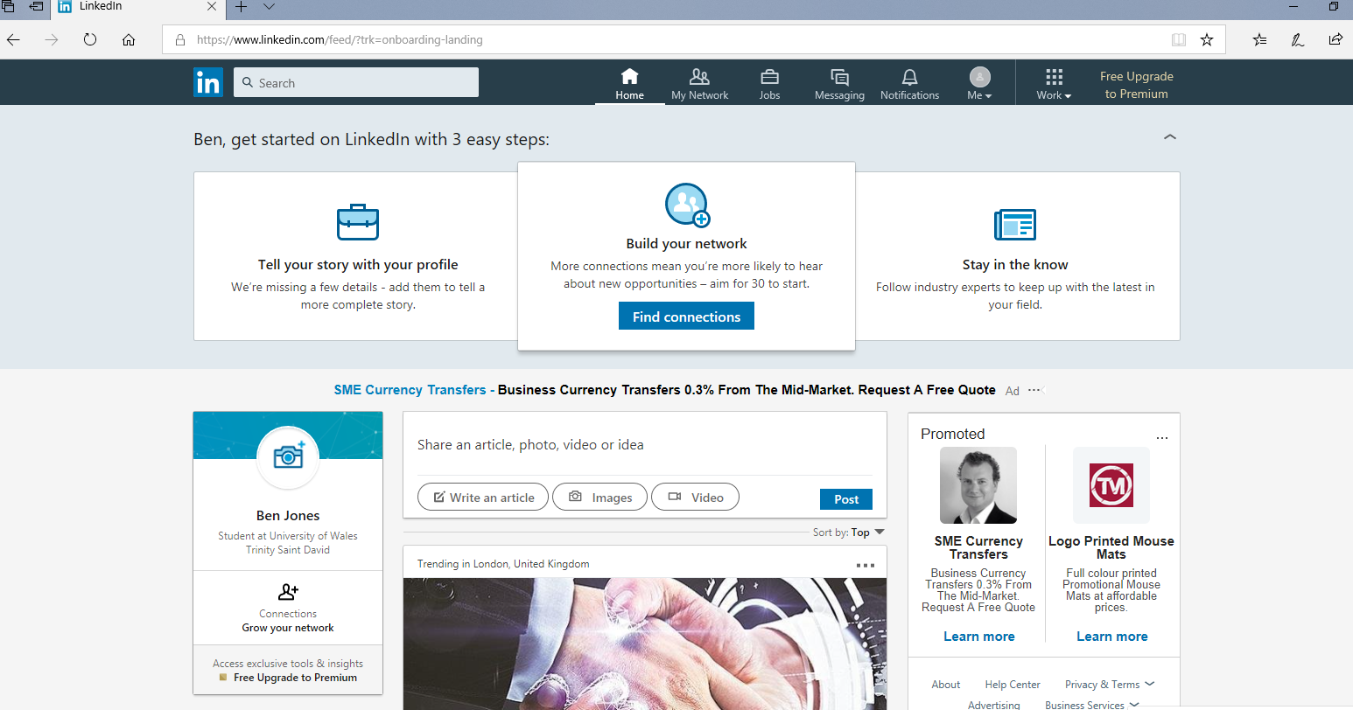
Conclusion.
I have based my findings on digital skills and how it effects employers and employees in the work place and have focused my findings on iCloud storage, drop box and skype. I have given much insight into these credible skills which are relevant in today’s employment sector, these skill sets are paramount in the 21st century workplace. I have given a credible positive and negative analysis of employment skills that are currently required in the workplace environment today. But also analysed how technology is incorporated within the workplace and to a user but also its impact on the company, no matter if it is a small sole-trader to a larger international franchise - technology can speed up production, increase accuracy and efficiency but also enhance communication, assist in marketing and boost team building and a working ethos. The impact of technology today is expediential and a necessity today working environment.

References
[Gil.l](2018)iCloud the ultimate guide: Available at :https://www.google.uk/amp/s/www.imore.com/icloud%3famp (Accessed 23th August 2018)
[Lipman.v] (2017) Forbes media are your employees engaged or happily complacent. Available at:
https://www.google.co.uk/amp/s/www.forbes.com/victorlipman/2017/09/20/are-your-employees-engaged-or-happily-complacent/amp/ (Accessed 24th august 2018)
[James T](2018) How does skype work and is it expensive to use. Available at
https: ://smallbusiness.chron.com/skype-work-expensive-use-61381.html
(Accessed 22nd august 2018)
[Information/Age][ismail N] Morden technology advantages and disadvantages.Available at https://www.information-age.com/morden-technology-advantages-disadvantages-123465637/
(Accessed 24th august 2018)

