Module: Organisational Culture
Module code: LCLM 5005
Organisational Culture at Tesco PLC: A Critical Analysis Using Schein's Model
Student ID: 2412985
Student Name: Maria Diana Iubis

Abstract
Several models are available for evaluating organizational culture, including Schein's model, which has been used in this study because it provides a critical analysis of Tesco PLC's organizational culture, the largest grocery retailer in the United Kingdom. It has been used to examine the effect of culture on Tesco's structure and decision-making process, as well as to identify the predominant culture using Schein's three levels of artifacts, espoused values, and basic assumptions. Next, the economic and technological components of the PESTEL are explored, and how Tesco utilizes its culture to counteract a cost-of-living squeeze, competition from discounters, and the accelerated rate of digitalization is explored. It also recognizes that culture can be either a barrier or enabler and provides suggestions based on theory—culture will need to be strengthened through middle management, balanced personalization is to be increased, empowering the front line is based on data, and conducting regular culture audits are to keep Tesco's competitive offering sustainable in the long-term.

Table of Contents
1. Introduction 3
2. Organisational Culture, Structure and Decision-Making 3
3. Identifying Tesco's Culture Through Schein's Model 5
4. Adapting to the External Environment: Economic and Technological Factors 7
5. Culture as Barrier or Enabler 10
6. Impact on Performance and Recommendations 11
7. Conclusion 12
Reference List 14

1. Introduction
A very common way of working and culture concurs with the statement of Mullins and Christy (2016); as organizations become more global and diverse, then how the decision-making and structure are done and how groups behave and manage control take over. This observation is very relevant in the case of Tesco PLC, which is a grocery store based in Welwyn Garden City that has operations in the United Kingdom, the Republic of Ireland, and Central Europe (Tesco, 2025). Tesco is the biggest grocery retailer in Great Britain with a grocery market share of about 27% to 28%, and the grocery market consists of a competitive and cost-sensitive market where discounters are posing a heavy threat and inflation and rapid technological transformation is on the rise (Kantar Worldpanel, 2026).
For Tesco, with its business size and different establishments, which are hundreds of thousands of employees and thousands of stores, it is very important that there should not be any variability in the values and shared assumptions to ensure its organization of employees' behavior in a few cases where direct management is unavailable (Tesco, 2025). Thus, in this report culture, structure and environment are deemed to be interdependent variables, with structure being a reflection of the underlying cultural variables and the three having to continually “mutualize” themselves with the changing economic and technological environment in order to maintain a competitive product. As a result, the report examines the interdependencies between culture and structure and decision-making within Tesco; applies Schein's model to determine Tesco's dominant culture; takes a narrower look at the impact of the PESTEL matrix on the culture, considers the elements of culture as barriers or enablers to effective functioning; and concludes with evidence-based, theory-informed recommendations for strengthening organizational performance in the future.

2. Organisational Culture, Structure and Decision-Making
Tesco has developed a culture based upon the selling point ‘every little helps'—a customer-focused mission that is amplified by the Tesco culture through its slogan ‘no one tries harder for customers’. It is part of Tesco's purpose, which was cascaded from the board of the PLC to the regions and country management, and every store team is identified and drawn attention to this and referred to it as ‘the Tesco Way'. Tesco considers, on an organizational level, the choice of which type of market to use the project, the space reconfiguration and the promotion of the project in different cases, with staff based on the context of each market.
In fact, the data being collected from the Clubcard system is responsible for over 82% of sales in the UK nation and is a key intelligence component in decision-making at giant retailer Tesco (Kizhakedath, 2026). This data dependence is enabling a slowly evolving culture of decision-making to move from judgment based on intuition and experience to evidence-based and analytics-driven decisions—in such fields as demand forecasting, personalized pricing, and product range planning. A change can cause tension between the older members who are socialized towards decision-making systems based on rules and the newer data and digital members who make decisions based on more algorithmic rules (Luong, Kumar and Lang, 2026). The relationship between them can thus be understood as proposed by Mullins and Christy (2016), where 'culture shapes structure and structure shapes culture.' In this instance, a centralized, hierarchical structure ensures uniformity of the corporate brand in the more than 3000 stores, and what is stated as a part of the culture, that everything is done in the name of the customer (Tesco, 2019), ensures uniformity of values in relation to customers, an aspect of Tesco's centralized, hierarchical structure. Tesco's structure is therefore divisional with adaptations, rather than divisional, with geography as a key focus—the UK, the Republic of Ireland and central Europe—and a functional focus, the challenge being that there is a single overarching culture that can be adapted, to a certain extent, to the market needs of each of the divisions Tesco is operating within without breaking that overarching brand.
This approach is also evident within the governance structure, set up by Tesco. The decisions on capital investment, technology investment, and category strategy are made within the Group and executive committee and subsequently pushed downwards in the regional structure into individual store programs—this situation is typical of large-scale multinational retailers, where a tall hierarchy with functional organization is typical (Nauhaus, Luger and Raisch, 2021). In the same way, Tesco, too, has regularly slashed through byproducts of head-office directives, such as cost savings, to eliminate overheads and allow quicker decision-making; hence, structure design can also act as a mechanism to bring about different kinds of values with respect to efficiency. Appropriate only when the mindset of colleagues at all levels is aligned with the partnerational mindset of "serving customers a little better," this approach enhances a structure that enables decision-making prowess upwards and operational decision-making downwards.

3. Identifying Tesco's Culture Through Schein's Model
One of the better-known models in organizational behavior is Schein's model of organizational culture, which assumes there are three interrelated levels of culture: artifacts and behaviors that can be seen, values expressed by the group, and underlying assumptions (Somers, 2023). The model can be applied in Tesco and can gain some advantages in finding the Tesco organization's culture in a structural way, not by impression.
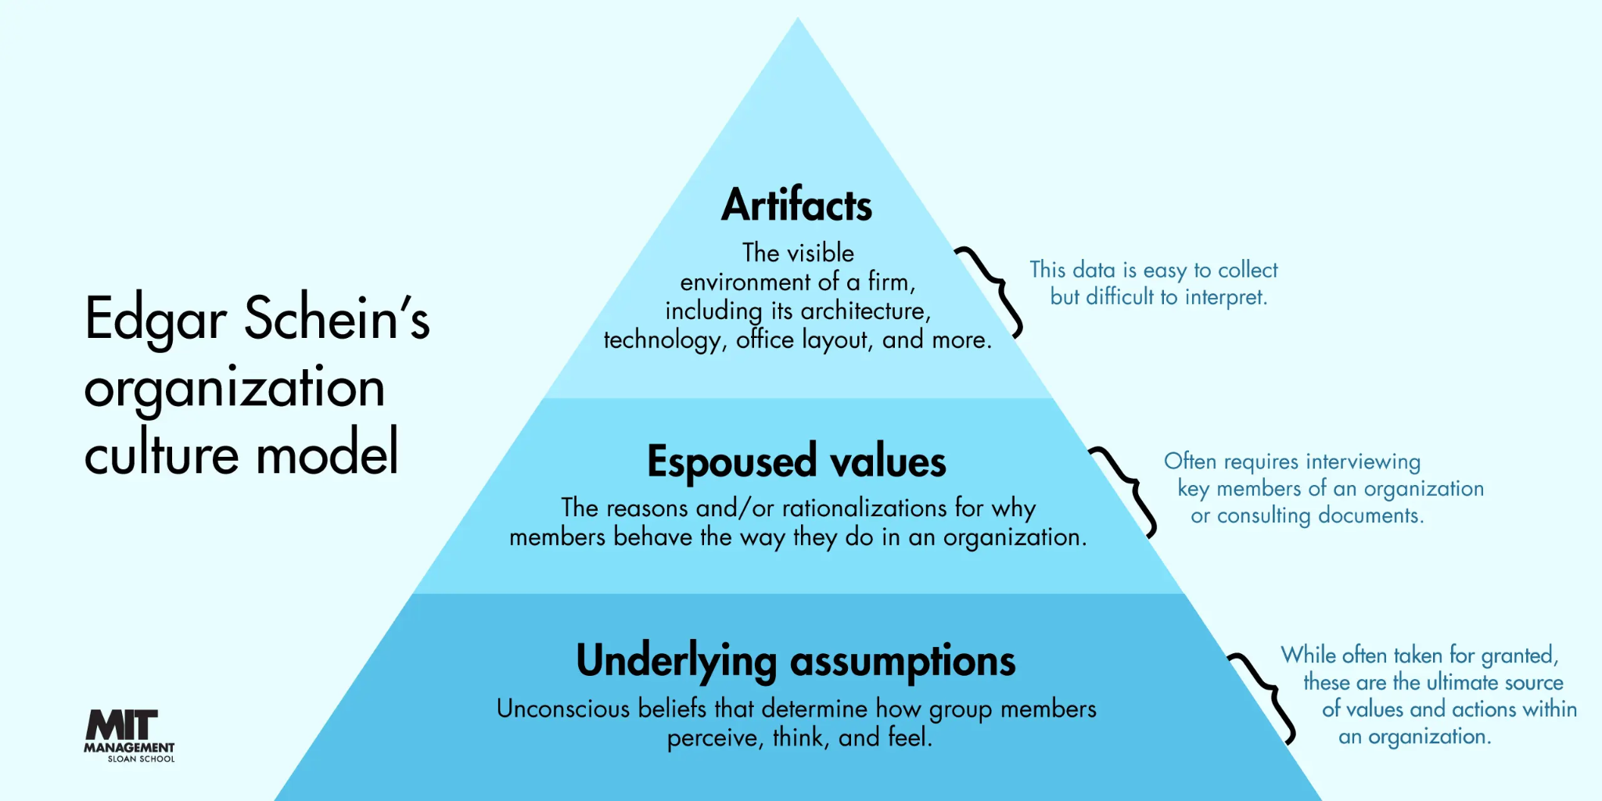
Figure 1: Schein’s Model of Organizational Culture
Source: (Somers, 2023)
Culture is reflected at the artifact level, as it can be seen and heard in many aspects of Tesco's business, including the concept of how they name their employees (colleagues) to how they refer to it (as the tesco way) in training literature. When one works at Tesco, they consistently wear the same branding along with the Clubcard scheme (Tesco, 2023).
Tesco has clearly declared that it will provide customers a little more each day, treat people the way they want to be treated, and ensure the company's pricing will be transparent so that customers can live in trust. It should be noted that these ‘Values' are consistently referred to in Tesco's annual reports, in recruitment policy and promotions, and in the internal communications; however, they should be predispositions that have to underpin all actions taken by Tesco through the markets that it operates internationally.
Basic assumptions are thought to be "universal truths" with little or no questioning, yet strong impact upon actions. BUT for Tesco, one of these stakeholders was merely the desire to maximize scale and efficiency – sophisticated paths towards achieving an affordable product/service, with negative impact on face-to-face contact with colleagues – and such impact was apparently worth continuing to invest in automated SCKs and centralized buying. But the second assumption here is that data-driven personalisation is a desirable feature of a customer relationship; one that is understandably widely adopted, with offers based on data from a customer's Club card and other AI tools, with little public discussion of the data personalization trade-offs (Kazmi et al., 2025).
One of the main advantages of Schein's model, over simpler approaches, is that it places attention not only on what an organization says about itself but also on what the members in the organization believe to actually be the case, as for instance when a premise of ‘colleague empowerment' exists along with the habitual practice of standardized and centrally monitored processes. All three levels have been on an ongoing basis applied to Tesco, and this also raises the potential disconnect between what it claims as values and the lived assumptions, which assume that efficiency and scale don't need people, so often when desires clash, this comes at the expense of commercial performance.
Level | Description | Evidence at Tesco
Artefacts and behaviours | Visible structures, symbols, language, and practices. | Store branding, Clubcard scheme, "Aldi Price Match" signage, "colleague" terminology, Tesco Way training materials (LSE, 2025).
Espoused values | Declared beliefs and principles communicated to stakeholders. | "Serving customers a little better every day"; commitments to trust, transparent pricing, and treating people well.
Basic assumptions | Deep, taken-for-granted beliefs guiding behavior. | Scale and efficiency legitimately serve customers; data-driven personalization is inherently beneficial and commercially necessary.
Table 1: Schein's Three Levels of Organisational Culture Applied to Tesco PLC
Source: (Self-Created)
The outcomes of the application of Schein's model are summarised in table 1 and demonstrates that Tesco has a customer-oriented and performance-driven dominant culture with an increasing level of task and data orientation between what Mikušová, Klabusayová and Meier (2023) term a "role culture," which is characterized by hierarchical structures and standardized procedures and tasks, and the parts of "task culture" that are present in project-oriented organization processes in the digital and sustainability field (Tesco PLC, 2020).

4. Adapting to the External Environment: Economic and Technological Factors
Organizational culture is part of a larger system—it must continually adapt to remain competitive within an external learning culture (Mullins and Christy, 2016). In this case study, Tesco is interested in using culture to mobilize to respond to the challenges at hand; specifically, two PESTEL factors will be relevant for consideration: economic and technological factors.
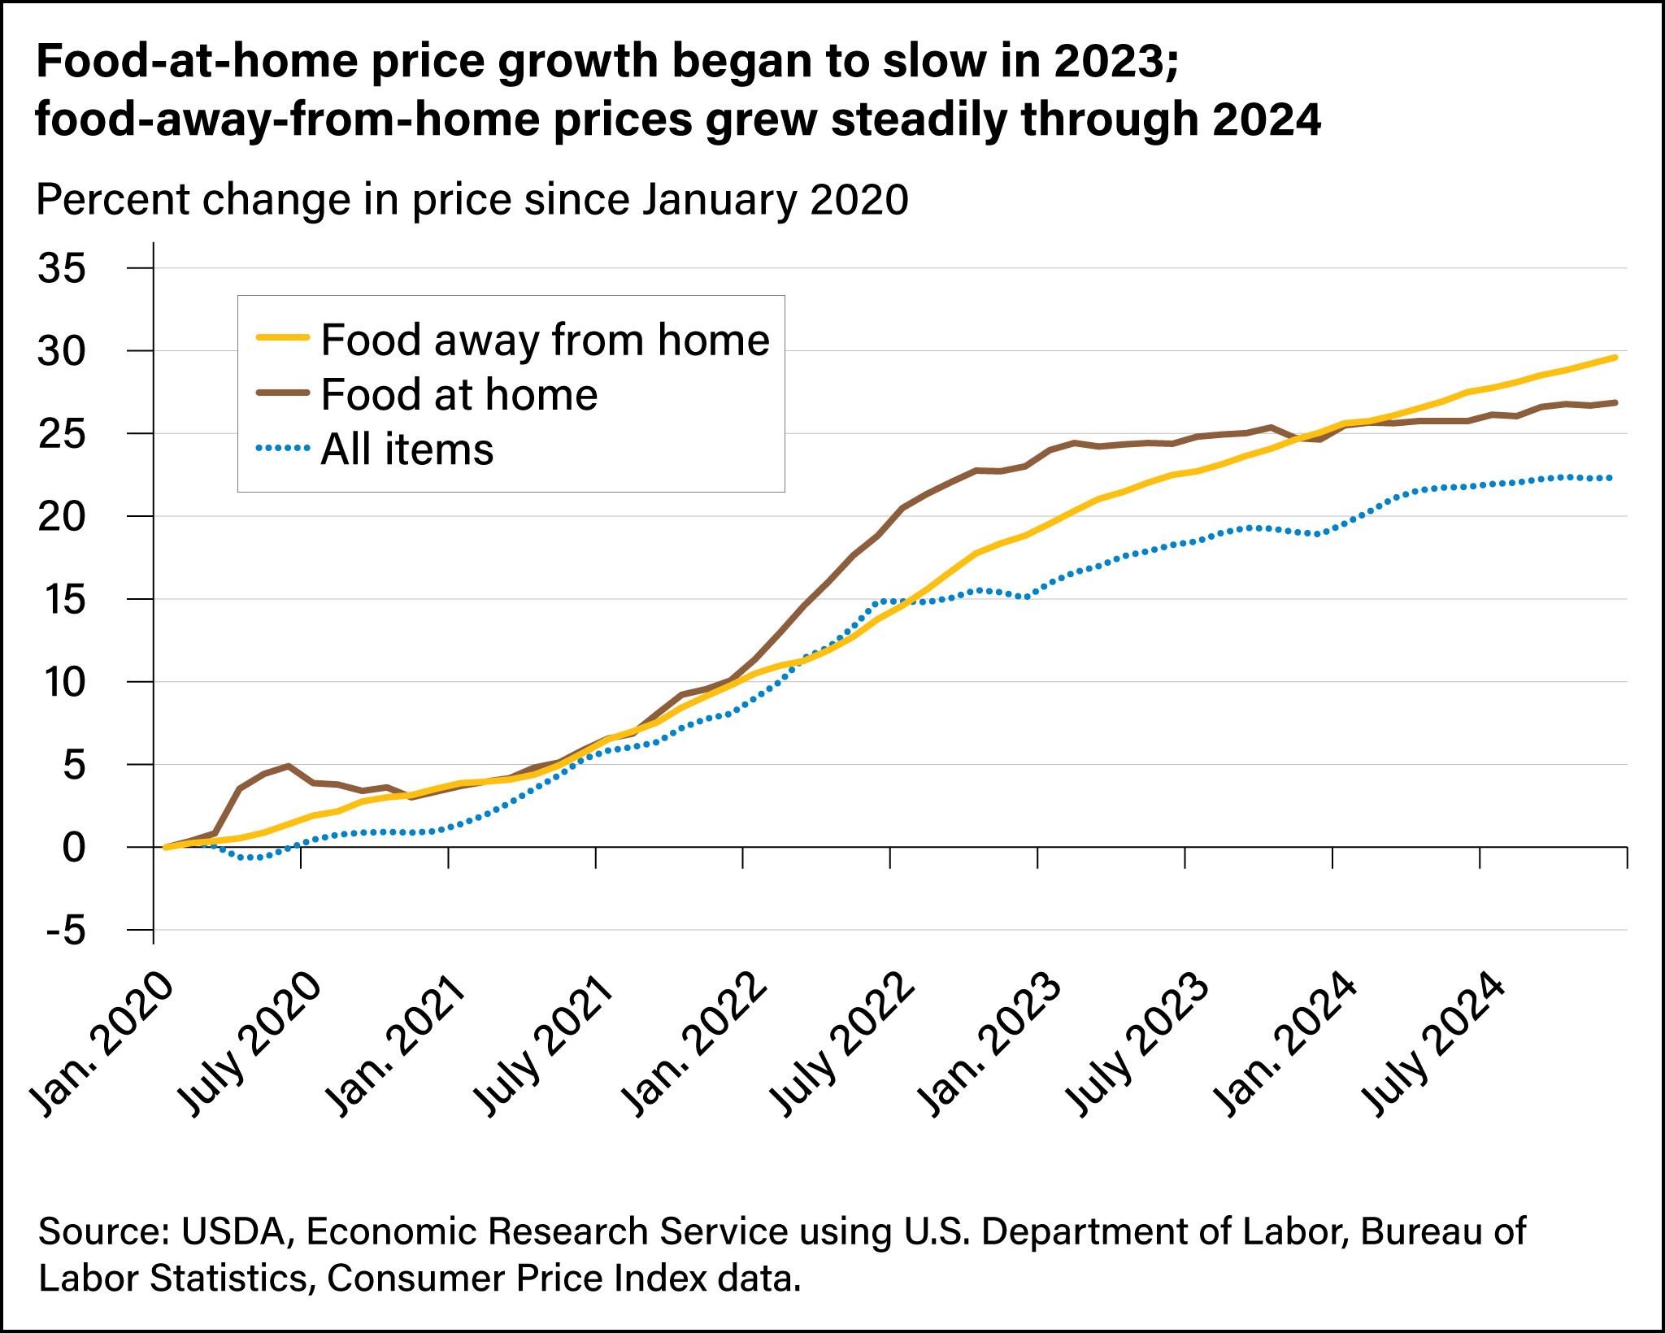
Figure 2: Food-at-home price growth
Source: (Davidenko, Sweitzer and Norton, 2023)
Economically, as shown in Figure 2, the UK grocery sector has been influenced by a sustained cost of living crisis which saw food price inflation peak at almost 19 percent in 2023 but steadily declined, with ongoing cost pressures for operating the business being driven by core inflation and increased employer National Insurance contributions levied from April this year (Davidenko, Sweitzer and Norton, 2023). Despite the absence of inflationary pressures, the Bank of England, keeping its base rate at 3.75%, has continued to restrain spending, which has led to the UK's savings rate hovering at high levels, up to 9-10%, as consumers have been careful not to succumb to prurient spending (Tmhcc.com, 2026). The real value message (Aldi Price Match and recently Clubcard Prices) seems to have gathered momentum, and Geyskens and Dekimpe (2026) reckon that the discount food retailers (Aldi and Lidl) will be even more of a challenge since their share will increase from around 10% in 2017 to over 18% in 2026, putting increasing pressure on the margins of Tesco.
Yet, Tesco has been able to streamline its business proposition without an effective, resilient strategy and, despite a large business in what is a relatively stable grocery market (27/28% despite growth from discounters), has stood up to the challenge. That Tesco is an illustration of how every little help has been a success for the company, and the company has dodged the "poorly differentiated" Asda and Morrisons being "taken down" by private-equity loans during the economic storm, as the mantra, it is believed, has been consistent since 2002. Further sector data suggests real-term sales for the UK in supermarkets will be a little lower in 2026-27 as headline prices go up; but it does bring in another aspect of how to keep sales, not just margins, on the case in terms of price, which suggests that Tesco is not just focused on margin but also on keeping people in the store and maintaining the basket.
Tesco is moving towards more customization and automation on a technological basis, with the help of data. More than 82% of sales of Clubcard in the UK are through the Clubcard channel, and there is a commitment to work with Adobe in 2026, which will use their AI services to provide further personalization. This collaboration will create more than 4.5 million unique digital coupons and Clubcard Challenges a month. The group has also tested an AI-powered shopping assistant that assists over 280,000 employees with their meal planning, basket building, and set to be rolled out to consumers in the near future, while the company continues to benefit from its growing online sales, which increased by 11% YOY, and its fast-speed delivery service, Tesco Whoosh, which saw the group expand by 51 percent (Tescoplc.com, 2026).
Factor | Key Development | Cultural Implication for Tesco
Economic — cost-of-living pressure | The food inflation has reached almost 19% (2023), and core inflation and labor costs have been high into 2026. | Reinforces value-for-money as a core cultural artifact and strategic necessity, not optional marketing.
Economic—discounter competition | Aldi and Lidl combined market share rose from ~10% (2017) to over 18% (2026). | Lack of important support for the culture of footfall and price matching (rather than margin-driven pricing).
Technological — data and AI | 82%+ of the UK's sales are made via Clubcard. Clubcard has tested an AI shopping tool and integrated it with Adobe's AI product. | Embraces the principle of personalization based on information as a principle and the principle of decision-making on the company level.
Technological — digital/online growth | Tesco Whoosh rapid delivery becomes 11% bigger online and approaches 51% compared to a year ago. | This is only further proving the customer is first in Tesco's eyes and adds to an even more convenient, but in addition, quicker experience.
Table 2: Economic and Technological PESTEL Factors and Their Cultural Implications for Tesco
Source: (Self-Created)
Table 2 summarizes the main economic and technological factors that are relevant to the company Tesco and their cultural relevance.

5. Culture as Barrier or Enabler
Tesco's culture may be a barrier or enabler depending on the level of organization at which it is thought of. Strategic level: Majority enabling role – culturally. It has developed a high-quality Value for Money (VfM) and a customer-centric strategy ensure Tesco will act cohesively and resourcefully in times of economic pressure, and it is helping to introduce new technologies into the retail business, such as retail media and AI testing, that can be rapidly adopted, based on a data-driven approach to every decision in the retail sector. The link between culture, strategy, and external factors has allowed Mullins and Christy (2016) to argue that a well-developed and integrated culture enhances the organization's adaptability.
At the operational and colleague level, though, other aspects of this culture can become an impediment. Targeted, data-driven, and financially centered decision-making can also have a company-wide detrimental impact on frontline employee engagement by having employees observe decisions being made more algorithmically and using data (Abhari, 2025). For Tesco, that has reduced the chain of command to a single individual, basic assumptions of efficiency and automation imply that morale and extra effort can be sacrificed as well, undermining the “customer service spirit” of the espoused values. In addition, personalization based on the collection of customer information may heighten potential risks in terms of privacy and ethics, which can potentially result in a loss of customers for Tesco if it is not managed well.
This duality also affects how change is managed at Tesco. An existential barrier is more challenging to identify and to rectify than a purely structural barrier: assumptions that may be stated as values for achieving efficiency may not be recognized as a barrier to adaptation by the organizations' members or managers. Tesco's culture can therefore be termed as Conditional enabler: Enabling strategic and competitive adaptation can, at the same time, pose performance risk over a long-term period and test the culture unless managed appropriately.

6. Impact on Performance and Recommendations
Recent performance would seem to indicate that there is some consistency in Tesco's economic and technological environments and their culture. Tesco's latest preliminary results for the year 2025/26 indicate a like-for-like sales increase of 3.5%, a rise in the UK's customer satisfaction score to a record level, and about 28.5% market share, the highest level for 10 years (Tesco, 2025b). It is an approach based on communication with value, and it's customized with data that's significant in this challenging macroeconomic environment, in which it is a step towards real commercialization.
However, to maintain such performance, Tesco must address the above-mentioned tensions. The first point relates to the cultural reinforcement of middle management; however, Tesco should ensure that, when it comes to making decisions at the store level, the values are not effectively undermined by the unspoken but fundamental view of what is efficient, which is primarily expressed through the actions of store or regional managers who are required to be more active interpreters, bringing values to life in daily actions rather than relying on central data systems (Tesco, 2025a). Secondly, with the rising number of automation and AI assistants across stores, Tesco should be considering more robust methods of colleague voice; regular forums to connect front-line input with product/tech or store strategy design teams would be an example. Third, any gathering and use of Clubcard data that is not communicated to the customer and is unclear is potentially an ethics issue but also an additional opportunity to maintain the value-for-money culture that needs to be questioned; in other words, it should not be an avenue to undermine the reputation or be a black box that Tesco must inform the customer about.
Recommendation | Tension Addressed | Expected Benefit
Strengthen middle-management cultural reinforcement | Central data systems overriding local, colleague-level judgment. | Preserves customer-facing discretion alongside data-driven efficiency.
Expand structured colleague-voice mechanisms | Declining engagement as automation and AI expand. | Protects morale and discretionary effort; improves change acceptance.
Embed transparent data-use communication | Privacy and ethical risk from Clubcard/AI personalization. | Converts a vulnerability into reinforced customer trust.
Formalise periodic Schein-based culture audits | Hidden drift between espoused values and basic assumptions. | Enables early detection before engagement or trust is damaged.
Table 3: Theory-Informed Recommendations for Sustaining Tesco's Culture-Performance Alignment
Source: (Self-Created)
These theory-based recommendations, including the proposed cultural and performance benefits, are summarized in Table 3, which also shows how the recommendation relates back to the tension.

7. Conclusion
As in this report, Tesco's culture is one of efficiency and value to their customers, which underpins the centralized decision-making and level of strategic control, which have been coupled with the idea of devolved decision-making and operational responsibility in their organization. A customer orientation was found to be influential, as were the effectiveness values of efficiency, while the basic assumption of scale-driven and data-driven personalization was effectively responsive to the economic pressures and rapid technological changes reflected in the narrowed economic and technological PESTEL factors. While this culture is mainly used as a strategic stimulator, the degree to which it is met depends on how operational aspects of employee engagement and data ethics are handled, with most markets witnessing consistently strong market share performance and worker satisfaction. Overall, the analysis does indicate that the cultural-organisational performance link for Tesco is not automatic, but conditional and needs to be constantly optimized and managed and can't be assumed to be based on the historical strength of the culture.

Reference List
Abhari, K. (2025). Employee Participation in Digital Transformation: From Digitalization Sentiment to Transformation Predisposition. Information & Management, [online] p.104212. doi:https://doi.org/10.1016/j.im.2025.104212.
Davidenko, V., Sweitzer, M. and Norton, W. (2023). Food Price Inflation Slowed in 2023 and 2024 | Economic Research Service. [online] Usda.gov. Available at: https://www.ers.usda.gov/amber-waves/2025/june/food-price-inflation-slowed-in-2023-and-2024 [Accessed 4 Jul. 2026].
IBISWorld (2025). Supermarkets in the UK - Market Research Report (2014-2029). [online] Ibisworld.com. Available at: https://www.ibisworld.com/united-kingdom/industry/supermarkets/2915/ [Accessed 4 Jul. 2026].
Johnson, K. (2024). How Assumptions Impact Organizational Culture - Management Concepts. [online] Management Concepts. Available at: https://www.managementconcepts.com/resource/how-assumptions-impact-organizational-culture/ [Accessed 4 Jul. 2026].
Kazmi, S.Q., Kazmi, Bano, S. and Malik, K. (2025). "The Role of AI-Driven Personalization in Enhancing Customer Experience and Purchase Intentions: Exploring... [online] ResearchGate. Available at: https://www.researchgate.net/publication/392323837_The_Role_of_AI-Driven_Personalization_in_Enhancing_Customer_Experience_and_Purchase_Intentions_Exploring_the_Impact_of_Consumer_Data_Privacy_Concerns [Accessed 4 Jul. 2026].
Kizhakedath, B. (2026). Tesco Digital Transformation 2026: AI, Clubcard Data, £1.5 bn Capex Drive Growth and £500 mn Savings - InfotechLead. [online] InfotechLead. Available at: https://infotechlead.com/cio/tesco-digital-transformation-2026-ai-clubcard-data-1-5-bn-capex-drive-growth-and-500-mn-savings-95179 [Accessed 4 Jul. 2026].
LSE (2025). London Stock Exchange | London Stock Exchange. [online] Londonstockexchange.com. Available at: https://www.londonstockexchange.com/news-article/TSCO/tesco-plc-preliminary-results/16415646 [Accessed 4 Jul. 2026].
Luong, A., Kumar, N. and Lang, K.R. (2026). Human–Machine Collaboration and Algorithmic Decision-Making: The Role of Organizational Incentives and AI Capabilities. Information & Management, [online] p.104384. doi:https://doi.org/10.1016/j.im.2026.104384.
Mikušová, M., Klabusayová, N. and Meier, V. (2023). Evaluation of organisational culture dimensions and their change due to the pandemic. Evaluation and Program Planning, [online] 97, p.102246. doi:https://doi.org/10.1016/j.evalprogplan.2023.102246.
Mullins, L.J. and Christy, G. (2016). Management and Organisational Behaviour. 11, illustrated ed. [online] Google Books, Pearson, 2016, pp.649 pages. Available at: https://books.google.co.in/books/about/Management_and_Organisational_Behaviour.html?id=SH0PswEACAAJ&redir_esc=y [Accessed 4 Jul. 2026].
Nauhaus, S., Luger, J. and Raisch, S. (2021). Strategic Decision Making in the Digital Age: Expert Sentiment and Corporate Capital Allocation. Journal of Management Studies, [online] 58(7), pp.1933–1961. doi:https://doi.org/10.1111/joms.12742.
Plas, J. van der , Geyskens, I. and Dekimpe, M.G. (2026). The brand-equity implications of selling through hard discounters. International Journal of Research in Marketing. [online] doi:https://doi.org/10.1016/j.ijresmar.2026.01.005.
Somers, M. (2023). 5 enduring management ideas from MIT Sloan’s Edgar Schein. [online] MIT Sloan. Available at: https://mitsloan.mit.edu/ideas-made-to-matter/5-enduring-management-ideas-mit-sloans-edgar-schein [Accessed 4 Jul. 2026].
Tesco (2023). Serving our customers, communities and planet a little better every day. Annual Report and Financial Statements 2023. [online] Available at: https://lexismarkettracker.lexisnexis.com/documents/0039/39110/180879/www_tescoplc_com_media_u1wlq2qf_tesco_plc_annual_report_2023_Tesco%20plc.pdf [Accessed 1 Jul. 2026].
Tesco (2024). SUSTAINABILITY FACTSHEET 2023/24. [online] Available at: https://www.tescoplc.com/media/3zef0bvr/tesco_factsheets_colleagues.pdf [Accessed 4 Jul. 2026].
Tesco (2025a). About Us. [online] Tesco PLC. Available at: https://www.tescoplc.com/about [Accessed 4 Jul. 2026].
Tesco (2025b). Preliminary Results 2025/26 PUTTING CUSTOMERS FIRST, WELL-PLACED FOR LONG-TERM GROWTH Performance highlights (52-week comparable basis). [online] Available at: https://www.tescoplc.com/media/ch1fbgss/tesco-plc-preliminary-results-statement-fy26.pdf [Accessed 4 Jul. 2026].
Tesco PLC (2020). Annual Report and Financial Statements 2020 Serving shoppers a little better every day. Contents. [online] Available at: https://www.tescoplc.com/media/755761/tes006_ar2020_web_updated_200505.pdf [Accessed 4 Jul. 2026].
Tescoireland.ie (2026). Core purpose and values. [online] tescoireland.ie. Available at: https://tescoireland.ie/about-us/how-we-do-business/core-purpose-and-values [Accessed 2 Jul. 2026].
Tescoplc.com (2019). Serving shoppers a little better every day. Annual Report and Financial Statements 2019. [online] Available at: https://www.tescoplc.com/media/476422/tesco_ara2019_full_report_web.pdf [Accessed 4 Jul. 2026].
Tescoplc.com (2022). Serving our customers, communities and planet a little better every day. [online] Available at: https://www.tescoplc.com/media/759006/tes018_2022-ara_hires.pdf [Accessed 4 Jul. 2026].
Tescoplc.com (2026). Tesco launches large-scale colleague trial of new AI assistant, designed to lighten the load for customers. [online] Tescoplc.com. Available at: https://www.tescoplc.com/tesco-launches-large-scale-colleague-trial-of-new-ai-assistant-designed-to-lighten-the-load-for-customers/ [Accessed 3 Jul. 2026].
Tmhcc.com (2026). UK Retail Sector Report: February 2026. [online] Tmhcc.com. Available at: https://www.tmhcc.com/en/news-and-articles/thought-leadership/uk-retail-sector-report-february-2026 [Accessed 4 Jul. 2026].
Umbrex (2026). Tesco Strategy and Business Model. [online] Independent Management Consultants. Available at: https://umbrex.com/resources/company-profiles/tesco-plc/ [Accessed 1 Jul. 2026].

