EFFECTIVE TEAM WORKING
AND
COMMUNICATION

CLASS: BMSW4002

STUDENT NAME: MARINELA CAMELIA CRACIUNEL
STUDENT ID: 1818825
GR: 6
LECTURER: GULNAR ALI

Table of contents

- Introduction
- How can communication be made effective in a business organisation?
  - Relevant theories on Communication
  - Importance of Effective Communication
  - Methods of communication
  - How does Communication work between Management and Employees
- Conclusion
- Recommendation
  - Action Plan
- Reference List
- Appendices
  - Appendix A:
  - Appendix B:
  - Appendix C:
  - Appendix D:

1. Introduction
The exchange of information between two parties through written, verbal or other medium is the basic understanding of communication. In a digital age context, the sending and receiving of data through computers and telephones are also a form of communication. In this report, however, the focus is made on organizational communication that the company management uses to transfer views, ideas and information within and outside the organization (Men, 2014). Apart from business organizations, communication is also effectively used by educational and healthcare institutes and even in government agencies. In order to achieve organizational goals and objectives and operate organizational activities, effective communication is a necessity.
In business organizations, the management uses effective communication for a number of purposes. The primary use of communication is the transfer of strategy and vision to the employees. In order to build strong bonds and relationships with colleagues and increase the productivity level, effective communication is necessary (Austin and Pinkleton, 2015). In a globalised world, the multigenerational and cross-cultural work environment can be operated smoothly through effective organizational communication. The company management often promotes communication among employees to improve their problem-solving skills.
Both scholarly and literary sources have been used in my report as references to determine the effective use of communication in a business organization. My report will show the significance of communication, team working and group dynamics at a workplace by linking them with several communication theories. Some of the in-class exercises performed by my friends and me have been used as practical, real-life scenarios of the theories mentioned. A recommendation section has also been added to the report, which contains an action plan that would help me improve my team working and communication skills. The following is my report on effective Communication and Team Working.

2. How can communication be made effective in a business organisation?
Business organizations use multiple effective communication strategies within the workplace to achieve their organizational goals and objectives. These organizational strategies will be discussed to understand why effective communication is necessary for the workplace. Primarily, a standard of communication for employees to interact with each other and the management is set. In this strategy, the employees are the main focus, and the information transferred to them are decided. The time and process of transferring the information are also included in this strategy. In the next step, digital communication infrastructure is built for allowing employees to experience a modern communication process (Chatalalsingh and Reeves, 2014). Promoting a platform for the employees to share their ideas and views helps in maintaining a consistent communication process. However, there are some shortcomings of the organization leaders and managers when communicating the new ideas to the employees. Often, they fail to explain the reason for performing the ideas to the employees (Berger, 2018). It is imperative that employees should know what they are performing as well as why they are performing it. This can be promoted in the workplace by encouraging listening to one another in a one on one conversation between the employer and employee. Moreover, company management should keep in mind that one-way communication can lead to disastrous results (Goetsch and Davis, 2014). To prevent such one-way communication, organizations should develop speaking forums where employees can offer their feedback and ask necessary and relevant questions to the organization management. This process of effective organizational communication can be further improved with the help of open communication, focusing on result-driven interaction in meetings and making the planning process inclusive for the employees.

2.1 Relevant theories on Communication
Shannon-Weaver Model
Claude Elwood Shannon and Warren Weaver developed the Shannon-Weaver model of communication in 1948 using a mathematical perspective, which was far better than all the other previously existing linear models (Rogers and Valente, 2017). The best part of this theory was that it included the technological factors that might affect the communication process between the involved entities. Primarily, the model consists of six factors upon which the communication is based. This included the sender, receiver, encoder, decoder, channel and noise. The person responsible for creating the message, selecting the channel and sending it is the sender. This message is then converted into binary data by the encoder and transmitted through a chosen medium known as the channel (Rogers and Valente, 2017). On the other end of the channel, the decoder converts the binary data back to the message and receiver receives the message in the final destination. The final component is the noise, which can include all physical disturbances like nearby people or the surrounding environment that might distort the original message and the receiver can receive the wrong message. All these six components can vary depending on the scenario of the communication.
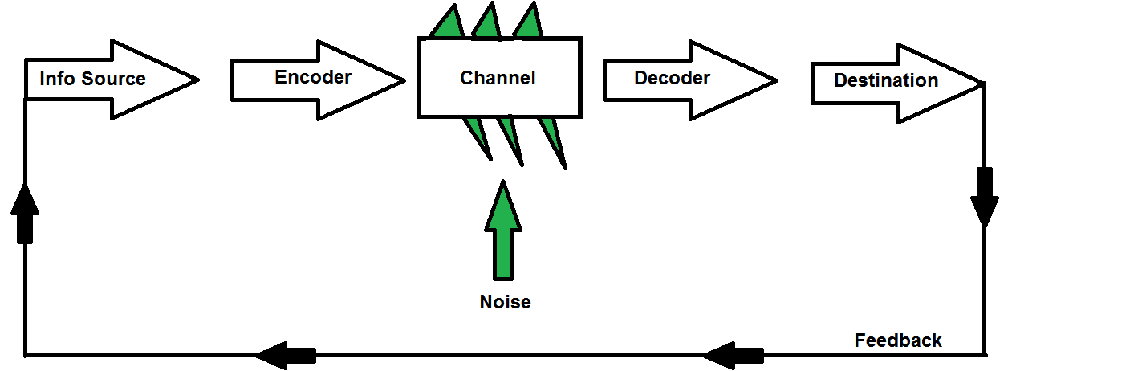
Figure 1: Shannon-Weaver Model of Communication
(Source: Rogers and Valente, 2017)
Schramm’s Model
Wilber Schramm developed another effective communication theory in 1954 based on the Shannon-Weaver model. Unlike the Shannon-Weaver model, where the noise was the main component, the encoding and decoding of the message is the primary focus in this model. It also suggested that it is necessary for the receiver of the message to give some feedback of the original message or else it would be incomplete (Watsonand Hill, 2015). In this model, the noise component also includes social, educational and language difficulties between the sender and receiver. However, these differences can be easily avoided with the help of the feedback from the receiver.
Berlo’s Model
The third theory of communication mentioned in the report is Berlo’s Sender-Message-Channel-Receiver (SMCR) theory, developed by David Berlo in 1960 from the Shannon-Weaver model (Turaga, 2016). The noise component in this model is not that significant and is based on the four major components, source, message, channel and receiver. Both the sender and receiver might be affected by the same set of factors like attitudes, communication skill, culture, knowledge and social system. The message component can also be affected by its own set of factors like structure, treatment, code, content and elements (Turaga, 2016). The factors affecting the channel component are touching, smelling, hearing, seeing and tasting. Distortion of any of these factors might disrupt the message and prevent effective communication between the sender and the receiver.
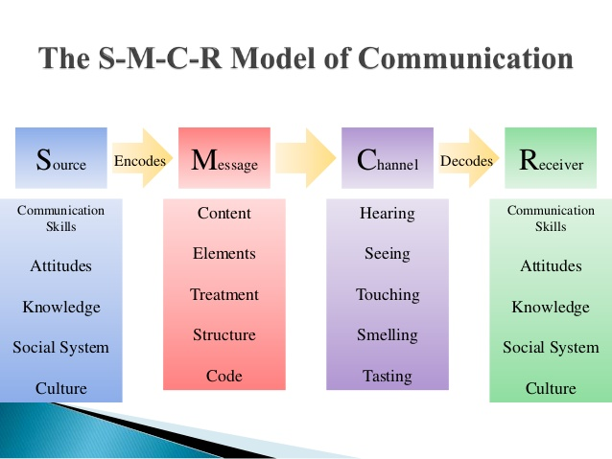
Figure 2: Berlo’s Model of Communication
(Source: Turaga, 2016)
Berlo’s communication model can be better understood with the help of the in-class exercise named “The Professor and the Village”. The exercise depicts the story of a Welsh University professor who lived in a house near a village (Appendix B). The professor had nothing in common with people living in the village who were uneducated. Once the professor's house was on fire, and he reached out to the people in the village for help. He used extremely polished and sophisticated English words to explain the situation, but the people, being uneducated, we're unable to comprehend what the professor said. As a result of this, none of the people helped the professor in putting out the fire. In this scenario, factors like social skill, culture and knowledge played an important role in distortion of the message and the sender and receiver were unable to communicate effectively.

2.2. Importance of Effective Communication
- The various in-class exercises performed by me, helped to establish the necessity of effective communication based on practical, real-life scenarios. In one of the in-class exercises, I was the Director of Communications in a company and had to write an email to Jack Daniels, one of the employees. I had to convince Jack to join our communication training team due to his excellence and expertise in communication skills (Appendix A). When performing this in-class exercise, I was able to evaluate my own written communication skills and was also able to identify the areas of communication and teamwork that I need to improve for improving my communication skills.
- Another group in-class exercise was performed by my colleagues where we were divided into groups and acted as the various stakeholders in a huge BMW dealership in London and me. The exercise also involved a Chinese electric car brand, which was culturally different from the BMW dealer company (Appendix C). The exercise demanded developing communication strategies to interact with the different stakeholder groups and helped us evaluate our communication, team working and group dynamics skills. The areas where I lack effective communication skills will be considered in the action plan provided at the end of the report.
- Additionally, the necessity of effective communication in the workplace has been explained with the help of a story from my own work experience.
As a supervisor in a gambling shop, I work with a team to deal with customers with gambling addiction. Due to continuous interaction with my team members and customers, this job requires high levels of communication skills. As the supervisor, it is my duty to assign tasks to my team members. Once I asked one of my new colleagues to do a task in place of another team member as I had already assigned her to a different task. However, despite asking her to do the task politely, she was willing to do the task only if the other team member would be assigned the same task with her. The staff member working on a different task was trainee supervisor and was willing to do any task I assigned for her. However, the new employee had a 20hr shift contract in customer service but was incapable of performing her own job properly. Later, I found out that she was upset with her assigned task and avoided communication with the other staff member. She even went on to complain about my manager by compartmentalizing the information and stated my voice tonality was rude, which had upset her. As I had communicated with her politely, I was surprised at what had resulted in this situation. However, later, I understood that English is not her mother tongue, and she is also from a very different cultural background than my own. For this reason, she was unable to understand her contractual job requirements properly, and I was also unable to convey what I wanted her to do properly. This resulted in some miscommunication, which made it tough to carry out tasks in my workplace.

2.3. Methods of communication
Communication can be performed with the help of four methods, namely verbal, non-verbal, written and visual. Speaking directly to the other parties is considered as verbal communication, while body language, gesture, facial expressions and emotions are used in non-verbal communication.
Communicating through symbols, numbers and writing form of language is included in the written method and is generally done through books, letters and pamphlets (Fan et al. 2015). Using art, photographs, drawings, graphs and charts are used in the visual communication method. In real-life scenarios, two or more of these methods are often combined to explain the message to the audience with better precision.
The process of effective organizational communication can be improved with the help of open communication, focusing on result-driven interaction in meetings and making the planning process inclusive for the employees.

2.4. How does Communication work between Management and Employees
Effective communication is essential in an organization for the exchange of information and ideas between the employees and management. The effectiveness of these interactions is impacted by choice of language, level of formality and tone of voice (Mishra et al. 2014). However, the main purpose of promoting collaboration between the employee and management is rightfully fulfilled with the help of effective communication. Furthermore, employees feel motivated and work with increased efficiency if they can be informed using effective communication while also increasing their problem-solving skills.

3. Conclusion
To summarize, it can be said that the report provides a detailed overview of the factors impacting effective communication in an organization with the help of communication theories and models. The in-class exercises provide hypothetical scenarios which are necessary to understand the importance of effective communication in such real-life scenarios. Hence, it is evident that effective communication is the key to successful business operation in organizations.

4. Recommendation
The following action plan has been developed to help me improve my effective communication skills based on the evaluation of the in-class exercises. Apart from the exercise, my own workplace experience has also been used to develop an action plan.

4.1. Action Plan
Skills | How to Improve | Time Required
Team Working Skills | In the context of my workplace experience, I was unable to effectively convey my ideas to my team members and hence should try to be a better team player. | 3-4 months
Verbal Communication | From the group project, I understood that I need to improve my verbal communication skills to better interact with others. | 6 months
Group Dynamics | I should also work more on my group dynamics to work collaboratively. | 3-4 months
Table 1: Action plan for improving my communication skills
Source: Created by author

5. Reference List
- Austin, E.W. and Pinkleton, B.E., (2015). Strategic public relations management: Planning and managing effective communication campaigns. Routledge.
- Berger, A.A., (2018). Media and communication research methods: An introduction to qualitative and quantitative approaches. Sage Publications.
- Chatalalsingh, C. and Reeves, S., (2014). Leading team learning: what makes interprofessional teams learn to work well?. Journal of interprofessional care, 28(6), pp.513-518.
- Fan, S.P., Liberman, Z., Keysar,B. and Kinzler, K.D., (2015). The exposure advantage: Early exposure to a multilingual environment promotes effective communication. Psychological Science, 26(7), pp.1090-1097
- Goetsch, D.L. and Davis, S., (2014). Quality management for organisational excellence: Introduction to total quality.
- Maund, A., Schriek, M., and Tinkler, P.K, (2019). Certificate in Higher Education: Skills for the Workplace Student Year Book. Communication. Sage Publications.
- Man, L.R., (2014). Strategic internal communication: Transformational leadership, communication channels, and employee satisfaction. Management Communication Quarterly, 28(2), pp.264-284.
- Mishra, K., Boynton, L. and Mishra, A., (2014). Driving employee engagement: The expanded role of internal communications. International Journal of Business Communication, 51(2), pp.183-202.
- Rogers, E.M. and Valente, T.W., (2017). A history of information theory in communication research. In Between communication and information (pp. 35-56). Routledge.
- Turaga, R., (2016). Organizational models of effective communication. IUP Journal of Soft Skills, 10(2), p.56.
- Watson, J. and Hill, A., (2015). Dictionary of media and communication studies. Bloomsbury Publishing USA.
- 8 simple and effective ways to improve team communication: 2019. https://blog.azendoo.com/8-ways-to-improve-team-communication/. Accessed: 2019- 08- 29.
- Importance of Team Communication Skills: 2019. https://smallbusiness.chron.com/importance-team-communication-skills-3079.html. Accessed: 2019- 08- 29.

AppendixA: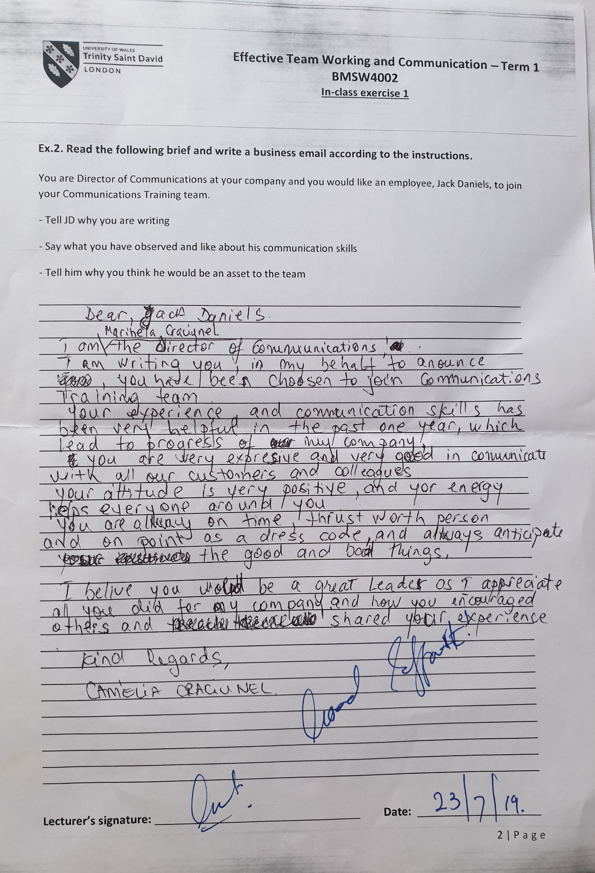
Appendix B:
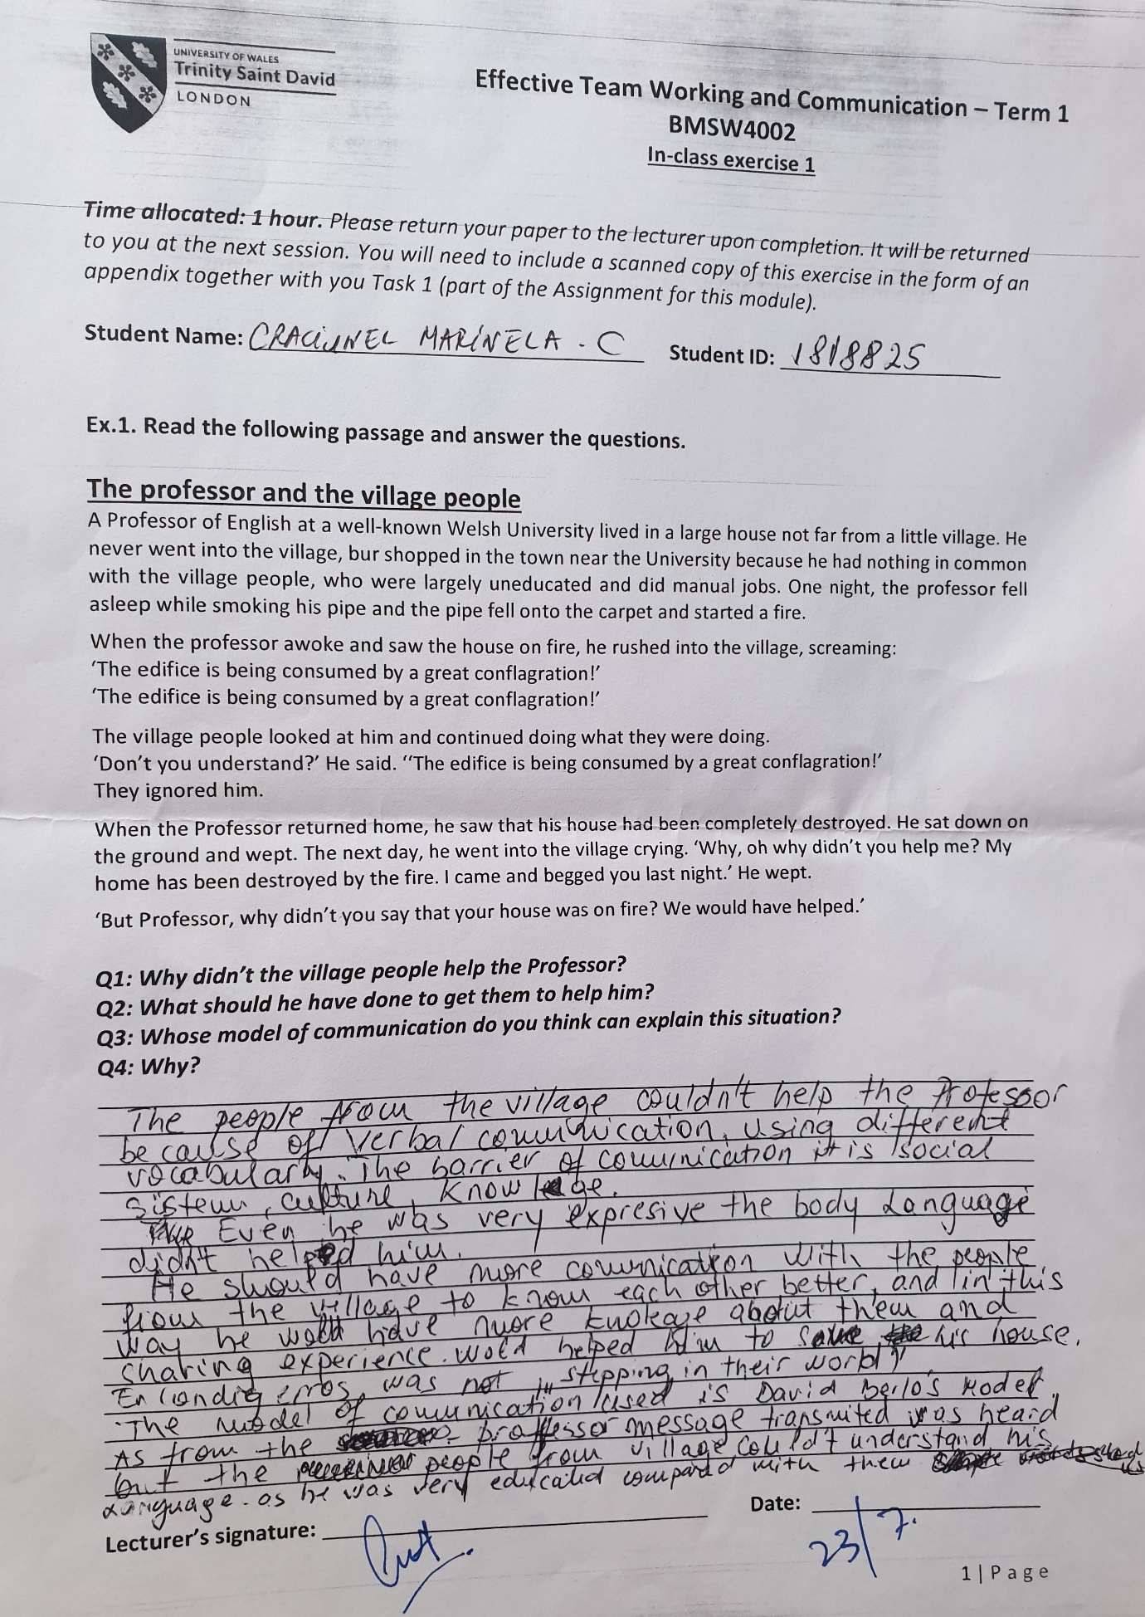

Appendix C:
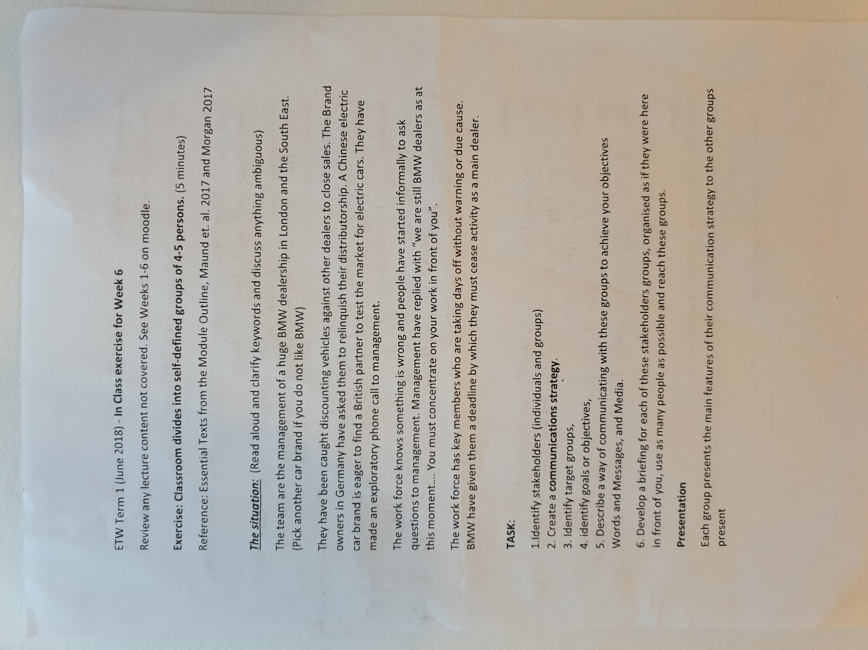

Appendix D:


