Marketing Fundamentals

Task 1

GROUP BLOG POST

Posted By:

Elena Petrescu(GL), ID:1814733

Corina Bardan, ID:1813607

Mihaela Filimon, ID:1813660

Laura Basa, ID:1805644

Assessment 1- Blogging to communicate

History of Heinz (Author: Elena Petrescu)
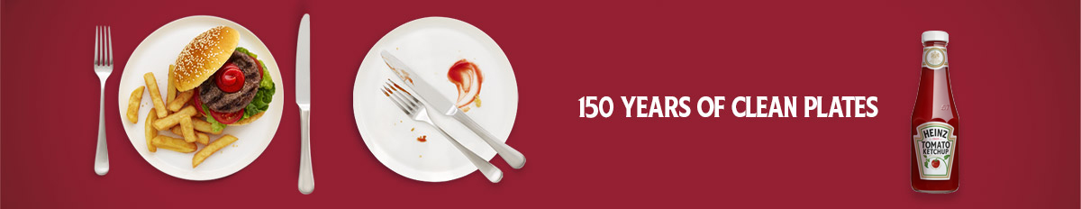
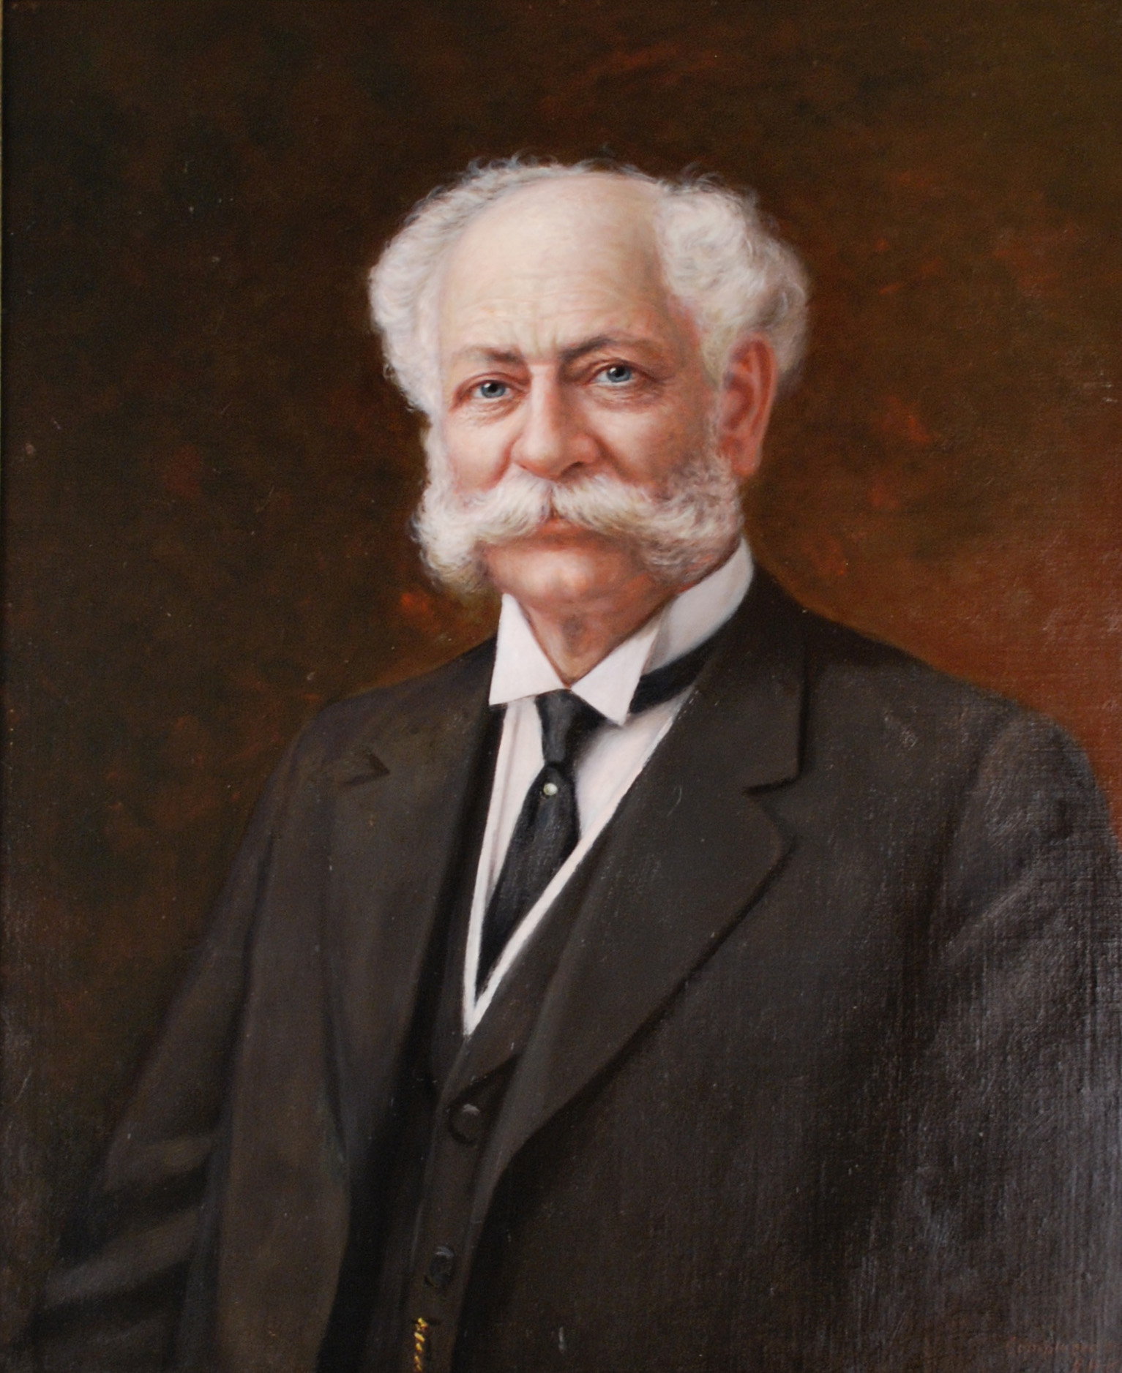
Heinz started its journey in 1869 and became the most loving brands among food lovers by providing foods and verities. The company was named after former founder Henry J Heinz who was an American businessman. He launched the business with the innovative idea with his co-founder L Clarence Noble as Heinz & Noble where their first products were one kind of pure gas that was bottled to serve the purity. Henry as a manager brought the tomato ketchup in his business in 1886 and launched the business in the United Kingdom. Now the popularity of Heinz in the UK and Ireland is better than any other country. Several consumer surveys revealed that Heinz is the most trusted brand in the supermarket and people love their iconic products very much (Heinz UK, 2019).

The company has the largest European food factory in Kitt Green, situated near North West of England which produce over 1 billion cans per year. The innovative engine of Heinz successfully created diversified taste in more than 100 products with new recipes and attractive packaging. Some of the successful items are Heinz Cup Soup, Heinz Hot Sauces, Heinz Five Beans and Heinz Snap Pots. Heinz is not only growing sales but also enjoy its strong position in the heart and mind of their consumer. Heinz has recently reached to its 150 years of success in business (www.statista.com, 2019).
Heinz is highly responsible for health and environmental issues. As a part of this responsibility, the company launched a 25 years programme on the reduction of sugar and gradual salt from recipes which has won the reward and praise from the Department of Health and Food Standard Agency.

Facts and Figures:
- The headquarter of Heinz is located in 32 London Bridge Street, London, SE1 9SG
- Heinz sells more than 1.5 million Bean each day to serve the people of the UK which is the bean eating nation in the world.
- More than 2100 people are employed by Heinz in the UK and Ireland

Want to dive into our prestigious history and know more?
Here is the link: https://www.heinz.co.uk/our-company/about-heinz/heinz-story

New Product in Heinz (Mihaela Filimon)
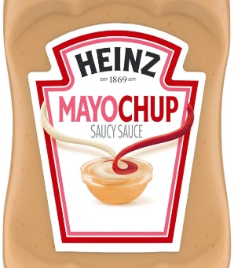
We highly care about the interest of our consumers to make any new recipes or bring any food items. The positive response from social media pools inspired us to bring a new item which can fulfil the taste of both the mayonnaise and the ketchup. This is our new product combined with a different taste. The name of the product is Heinz Mayochup that can be served with breakfast items or any types of snakes to bring a richer level taste (Earle and Anderson, 2018). We wish to make the dream of all saucy lover come true with our Mayochup.
Our considerations to develop Mayochup
- Idea and Concept Generation and Testing
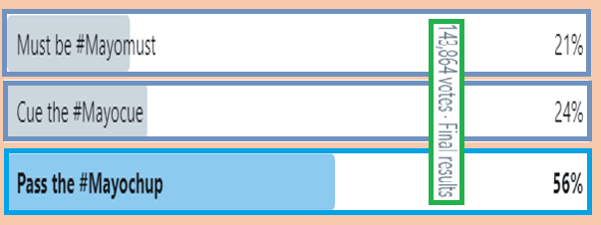
To get the idea what our consumer wants from us, we kept a twitter pool for one year whether they are satisfied with existing sausages or want some changes in the recipes. We offered them some blends such as "Mayo + Ketchup = Mayochup", "Mayo + Barbecue = Mayocue" and "Mayo + Mustard = Mayomust" to get the right recipe. The pooled result was surprisingly going to the Mayochup which is 56%. Though the other two blends have some consumers, we are prepared to launch the Mayochup and gave them the option to get our existing ketchup so that they can enjoy their favourite meal by mixing their favourite sausage.
- Marketing Strategy and Business Analysis
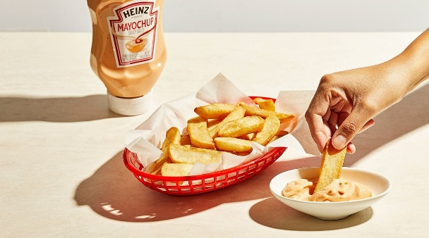
Heinz offers true information and features for our valuable customers and we highly value the feedback from our consumers. The customer base of our products is available on social media which let us follow digital marketing to ensure better communication with them. The feedback and information we found from the social media carry great values to develop our product and we analyse the market by considering their interest in our products (Gattiker, 2015). We found that 56%of the consumer wants us to produce something new that can fulfil their interest. So, we found the Mayochup much favourable to our business which can provide daily needs to our customer. The poll also shows us that 21% of the consumer is interested in the Mayomust and 24% of the consumer wants to have Mayocue as they prefer mayo and barbecue with sauce.
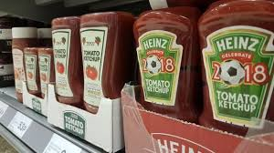
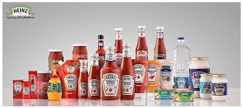
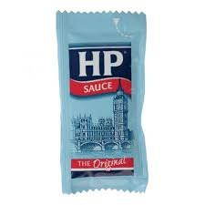
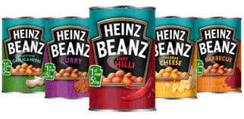
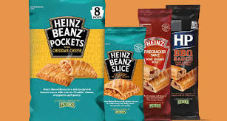
- Product Development (Mayochup)
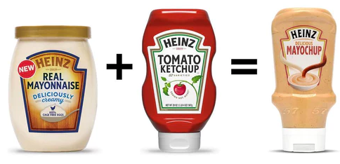
The trend of mixing various condiments among sauce lovers to bring new combination and taste appreciate us to try some blends which created three unique flavours such as Mayocue, Mayomust and Mayochup. Mayocue is the blend of mayo with barbecue and Mayomust is blended of mayo with mustard (Bhasin, 2019). Among them, Mayochup is the most successful and highly demanded product which combines mayonnaise with tomato ketchup. According to our marketing director Nicole Kulwicki, Mayochup is the ultimate sauce blend we ever created.
- Product Launch and Commercialisation
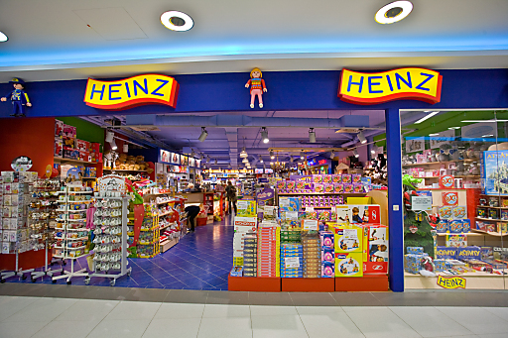
Mayochup is going to be rolled out in different retailers in various region. The food factory in Kitt Garden is going to produce this lovely sauce item and it will be available at the different grocery shop and e-commerce sites including McDonald, Amazon and E-bay. The positive response on social media about this encouraged us to launch this product. This product will be available national wide later after fluffing the demand in the regional stores (Anderson, 2018).

- Products Features
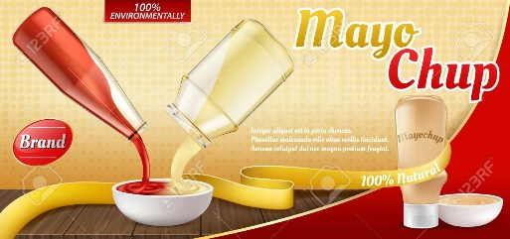
All the ingredients of Mayochup are 100% natural and come from a healthy environment. Heinz always takes responsibility to maintain the quality and serve the best item to its consumer. We always care about the health and environmental issues while preparing our foods.

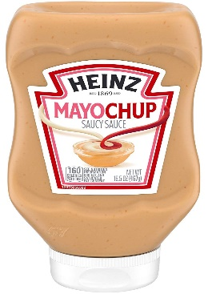
- Packaging Design
Heinz ensures safe portability for carrying and presenting their product in its design, the packaging of Mayochup is bottled in 16.5-ounce for each bottle of Mayochup sauce which provide both safety and comfortability in term of carrying or using the packages. The bottle is designed with an attractive and eye-catching shape covering a level of product information in it. Each pack of the retail package contains 6 bottles of Mayochup.
Visit here to know all our products: https://www.heinz.co.uk/Products

Heinz Prices and Pricing Strategy (Author: Corina Baldan)

We consider customer’s benefit instead of our profit while going to make any pricing. Besides, the quality of the product is maintained according to the price ratio. Our authority is eager to listen to the customer’s sides while pricing any of our food items. We highly value the economic sacrifice of our consumer for the product we serve.
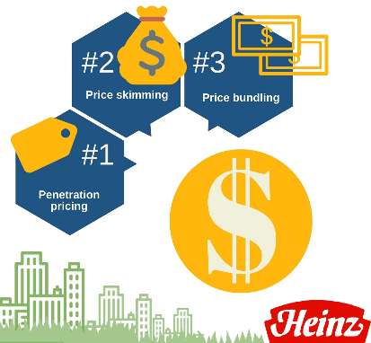
Heinz Pricing Strategy
We always seek information and compare the price of our competitors to set the best prices to our products. Though we lower the price, we don’t bother reducing the quality of our products. Our profit may decrease but we ensure high-quality ingredients and serving procedure as Heinz highly maintain healthy food. We follow some pricing strategy to mitigate with our competitors and consumer.
Heinz applies Penetration Pricing to attract new customer and try its product so that they can get the chance to measure the quality. According to this strategy, the price of any new product is set low to get competitive advantages over the competitors (Titman, 2016). This allows us to penetrate the market and inject our brand value.
We also try to avoid Price Skimming; our marketing department is always keen to know the consumer advantages instead of our personal profit. Though we follow this strategy at some point, we don’t set our price intentionally. On the contrary, we lower the price if we get customer satisfaction and minimum economic growth.
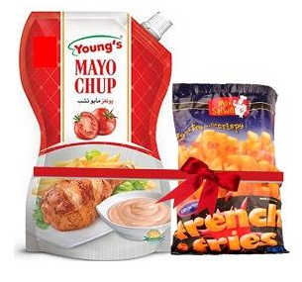
Price of our new Product
The price of our newly launched Mayochup is not only lower but also best quality sauce combined with mayonnaise and tomato ketchup. We used price bundling strategy to offer our consumer extra facilities with this product where one bottle of Mayochup is only £2.79 where one packet French fries is free. We offer different types of packages for different category customer to ensure everyone can afford to enjoy our products.
We highly care about the quality of our material so that our consumer doesn’t feel financially wasted. Hence our pricing is directly related to our quality. We offer a diversified range of packages in the different grocery shop and online retailers.
Contact us to know more about our price, go to this link: https://www.heinz.co.uk/Contact

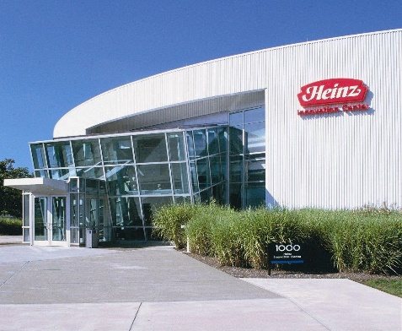
Place - Find Heinz Products (Author: Laura Basa)
Heinz is a popular multinational food processing company mainly running its business in many countries of Europe and America. It has the largest food factory in Kitt Garden which produces more than 1 billion can per year. There are two more factories in Telford and Worcester that assist in regnal production (Heinz UK, 2019).
Our vision is to ensure proper food and nutrition supply around the world so that people can buy quality food without spending much money. We have many distribution teams who contribute to reaching all the retailers and groceries to get our products and help us reach the consumers. There are more than 2100 employees in the United Kingdom and Ireland to serve our foods and verities to the local people and distribute the products.
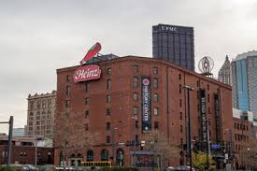

We use regional retail and e-commerce business to distribute our Mayochup and other sauce categories from where consumers can buy from online (Layton and Stanton, 2017). The largest ketchup factory is located at Ohio where fresh and thick tomatoes are collected and produce ketchup and other blends including Mayocue and Mayomust. The global headquarter in the United States manage all the distribution process with the help regional offices located in Pittsburgh, Pennsylvania.
Heinz is also available in many other countries to serve our consumers. There is Australian head office in Melbourne where the main product is Beanz Meinz Heinz, one kind of baked bean with sauces. But we also export Mayochup there as the demand is increasing globally. There is a Tomato processing plant in Ontario, Canada which fulfils the dire need of tomato ketchup. Besides, there are outlet and branches in India, Netherland, Indonesia and China to redistribute our food items and fulfil the local needs.
We are expanding our distributor around the world and responded to the impact of globalisation to increase worldwide food services. You can always find a retailer near you by searching on the web.
To communicate with us and share your feedback, please join our social media from the link below:
Twitter: https://twitter.com/heinzuk || Facebook: https://www.facebook.com/HeinzUK/


Heinz Promotions (Author: Elena Petrescu & Mihaela Filimon)
We are dedicated to promoting our products using true information and honest review. We don’t advertise any false information regarding our products while communicating with our customer. We are proud that our consumers have faith in us as we maintain fair communication. We care about consumer benefits and provide satisfactory offers to promote our products. Heinz does not follow any ways that do not bring any goods. For example, we could use celebrity endorsement to boost up the publicity on social media or TV advertisement. But this doesn’t benefit the consumers from this promotion directly or indirectly (Bryant, 2019). We offer discount and advertise our packages which directly brings advantages to the consumers. We maintain ethical manner in our promotions and retrain us doing any harm to the culture, society, health or environment.
To promote our newly launched Mayochup, we offer the following facilities to our customers:
- Free Shipping
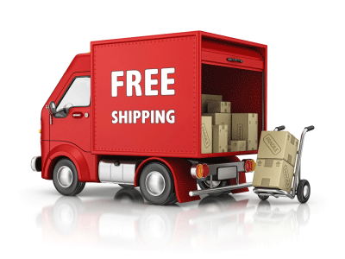
We offer free shipping and delivery based on the quantity or amount of order. If any customer orders above 100, we carry the shipping charge for any place in the world. Free shipping directly reduces the expense on the customer side and encourage them to buy the product in a larger amount or larger quantity.
- Regional Competition
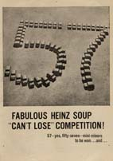
Heinz started giving-away 57 mini-minors in a soup competition in England in 1961 and still, it provides 57 carnivals and the same number of extra holidays for their employees. The main motto of this competition is “Nothing can stop their giving-away”. We will announce in social media when we are ready to arrange this competition for Mayochup.

- Social Media
We always use social media to inform our consumer and get feedback from our customer. Please tune to our social media platform to help us fulfil your demands and let us know how you enjoy your favourite Mayochup that was developed by analysing the poll result and customers opinion. We will engage ourselves in digital marketing on this platform.
Heinz also offers sale promotion, personal selling and TV advertisement to attract our valuable customer so that they can interact on our behaviour and send feedback using the website or social media.
To communicate with us, please feel free to contact us: https://www.heinz.co.uk/Contact
Hotline: 0800 5285757

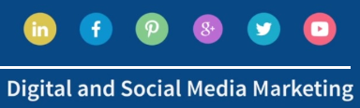
Heinz Social Media and Digital Marketing (Author: Corina Baldan & Laura Basa )
Impact of Social Media on Heinz
Heinz uses the social media platform to share information and get feedback from different consumers. It is an active media of communication where consumers are free to share their opinions without being forced. Hence the effectiveness of social media is highly important for both our food industry and food-loving people.

Importance of different Social Media platform in Heinz

Brand Awareness: Social media helps us to share our business ideas and know our potential customer (Gattiker, 2015). We used twitter poll to know what our customer wants and which product is more successful. The blend of mayonnaise and ketchup was favourable for the most consumer which helped us to launch Mayochup. This ensures an active communication between the Brand and the customer.
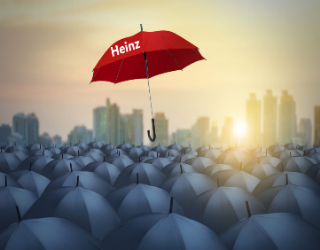
Authenticity and Authority: Customers search in the web to get verified social media platform and official website to justify the authenticity. They observe whether we shine with our post or kept sitting in a corporate office. Heinz has an authentic social platform to interact with its customers. The data analysis about Mayochup is the real example of a social media platform (Earle and Anderson, 2018).


Provide support and grow affordability: Heinz is always keen to listen to their customer and provide support. The communication in this platform is interactive and dynamic where authority need not any huge investment. The company can grow faster and invest in Digital marketing for making advertisement using AdSense which is very effective in the modern age.

The marketing manager of Heinz is Joel Hughes who always investigate and analyse social media to know the customer response and meet their demands. So, feel free to contact on the social media platform to share your opinion directly which can help us to improve the relationship between the customer and the authority.

Twitter: https://twitter.com/heinzuk
Facebook: https://www.facebook.com/HeinzUK/
Instagram: https://www.instagram.com/heinz_uk/
Website: https://www.heinz.co.uk/ ||| Customer Service: 0800 5285757

References:
- Bhasin, H. (2019). Marketing Mix Of Heinz - Heinz Marketing Mix and 4 P's. [online] Marketing91. Available at: https://www.marketing91.com/marketing-mix-heinz/ [Accessed 21 Jul. 2019].
- Bryant, C. (2019). Kraft Heinz: This Marketing Strategy Will Help Your Stock | Digital Marketing Review. [image] Available at: https://www.youtube.com/watch?v=J6-8_aYXk18 [Accessed 21 Jul. 2019].
- Earle, M. and Anderson, A. (2018). Food product development. 8th ed. Boca Raton, Fla.: CRC Press.
- Facebook.com. (2019). Heinz UK. [online] Available at: https://www.facebook.com/HeinzUK/ [Accessed 21 Jul. 2019].
- Gattiker, U. (2015). Social media audit. 5th ed. New York: Springer.
- Heinz UK. (2019). Heinz | Heinz Story. [online] Available at: https://www.heinz.co.uk/our-company/about-heinz/heinz-story [Accessed 21 Jul. 2019].
- Heinz UK. (2019). Heinz | Products. [online] Available at: https://www.heinz.co.uk/Products [Accessed 21 Jul. 2019].
- Instagram.com. (2019). Heinz UK (@heinz_uk) • Instagram photos and videos. [online] Available at: https://www.instagram.com/heinz_uk/ [Accessed 21 Jul. 2019].
- Layton, R. and Stanton, W. (2017). Marketing Fundamentals: How Marketing Mix Works. 7th ed. Sydney: McGraw-Hill.
- Twitter.com. (2019). Heinz (@HeinzUK) on Twitter. [online] Available at: https://twitter.com/heinzuk [Accessed 21 Jul. 2019].
- www.statista.com. (2019). Topic: Condiments and seasoning market in Europe. [online] Available at: https://www.statista.com/topics/4185/condiments-and-seasoning-market-in-europe/ [Accessed 22 Jul. 2019].

