Financial Management for the Hotel Industry
BMIH5007
Student Number:2212736
Student ID: Violeta-Ionela Necsoi
Lecturer Name: Tristan Hawkins
[Word Count: 2000]

Table of Contents
1 Introduction 3
2 Financial Analysis over the Past Three Years 3
2.1 Income Statement 3
2.2 Balance Sheet 4
3 Key Reasons behind the Decline in Profitability 4
4 Turnaround Strategy 6
5 Conclusion 8
6 References 10

Introduction
The report discusses about how The Seacrest Lodge is having trouble with falling revenues, less and unsatisfied visitors. There is a lot of tough competition from newer locations, which has hurt the finance of the lodge. The report also discuss the financial records and the current state of the market to try to figure out why profits have dropped so quickly. This all-around plan for recovery will help the resort to get back on growth in terms of financial and regain its image as a top holiday spot. To improve the image of The Seacrest Lodge and long-term success, the main goal of the reports to find ways to address guests' changing needs and concerns about the quality of care they receive.

Financial Analysis over the Past Three Years

Income Statement
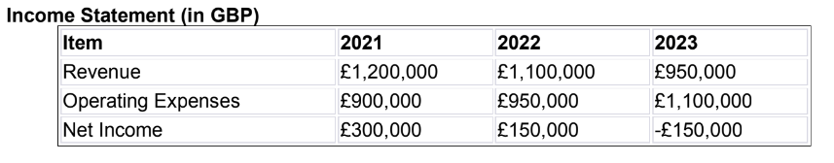
The income statement shows that the financial position of The Seacrest Lodge goes down from 2021 to 2023. The business had a net income of £300,000 in 2021, after taking out £900,000 in running costs, there were £1,200,000 in sales for the year. The running costs rose from £1,100,000 in sales to £950,000 in 2022, which caused net income to drop by 50% to £150,000. In 2023, operating costs rose to £1,100,000, while income was only £950,000, leaving a debt of £150,000. Some of the things that caused this downward trend are poor management and decline in sales. Since the company went from making money to losing money in just two years, it is clear that there are major operating problems that need to be fixed. If the company wants to turn around the downward trend and stay in business in the long term, it needs to carefully examine its processes, find ways to cut costs wherever possible, and come up with ways to get business and generate more profit (Arvidsson and Dumay, 2022; Dai et al., 2023).

Balance Sheet
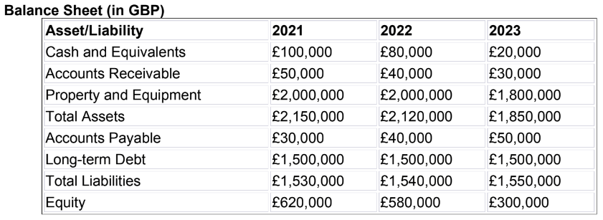
The financial statement of The Seacrest Lodge for the three years from 2021 to 2023 shows a lot of interesting trends. As of 2021, the company had a good amount of £100,000 in cash on hand, and most of its £2,000,000 in assets were property and equipment. Because of drops in P&E and cash and equivalents, total assets fell to £1,850,000 in 2023. On the other hand, liabilities had slowly risen. For example, accounts payable had grown every year, and by 2023, long-term debt reached £1,500,000 and short-term debt reached £50,000. This trend could lead to more debt and trouble with cash flow, among other things. Equity dropped sharply from £620,000 in 2021 to £300,000 in 2023. This shows that capital value has dropped a lot over the last three years. The balance sheet shows that the prices of assets are going down, liabilities are going up, and ownership is going down (Wood, 2020).

Key Reasons behind the Decline in Profitability
It has become less profitable for The Seacrest Lodge because of a number of problems that have hurt their income, rental rates, and customer satisfaction. The competitive seaside market has become tougher for The Seacrest Lodge since newer, more modern motels have opened nearby. Travellers looking for the newest trends in hospitality can be interested in updated benefits, high-tech facilities, and unique experiences. Because of this, The Seacrest Lodge has more competition for guests, and it can find it hard to stand out in a market that is already full (Tan and Despotis, 2021). Before the 2020 coronavirus outbreak, the restaurant and food service business in the UK was making good profit (Razzak et al., 2023). Before the pandemic in 2018 and 2019, it was already hard for many places to stay open. Oversaturation in the market in recent years, falling customer spending, and rising costs are the main reasons why many large chain restaurants have closed and small restaurants have gone bankrupt (Girdzijauskas et al., 2022). The future of the business is less clear because of Brexit and a sudden outbreak that has caused a lot of uncertainty. People who work in the food business assume that sales would drop by 33% in 2020 but fully return by 2024. The reason why The Seacrest Lodge is making loss is that customers' tastes are changing. Experiences that fit the hobbies and tastes of modern tourists are becoming more and more important (González Morales and Cavero Rubio, 2023). Modern comforts, individual service, and one-of-a-kind activities are some of the things the customers look for (Hossain et al., 2023). The Seacrest Lodge has not changed with the times to keep up with changing customer tastes and market trends. As a result, it has fewer guests and making less income. The amount spent on restaurants and hotels in the UK fell sharply from 2019 to 2020. Consumer spending was 42% less than the previous year, at 77.45 billion British pounds (Statista, 2024). Because of the strict quarantines put in place to try to control the COVID-19, people in the UK spent a lot less on eating out and staying in hotels. People spent a huge amount of money in 2021 which is almost $117 billion (Statista, 2024).
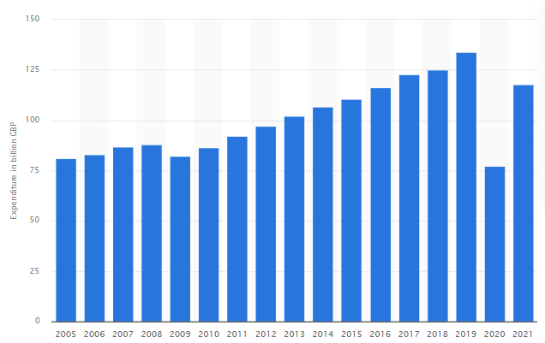
Figure 1: Consumer spending on restaurants and hotels in the United Kingdom (UK) from 2005 to 2021
Source: Statista (2024)
Customer reviews showed that the level of service was getting worse and the buildings were getting old, which made it very hard for The Seacrest Lodge to run its business. In the competitive hotel market of today, making sure guests are satisfied is the key to keep them coming back (Balinado et al., 2021; Hassanein and Özgit, 2022). Poor service, boring facilities, and old-fashioned features can make people not want to return to the location, which can impact its image over time. There could be less availability and less income at The Seacrest Lodge if unsatisfied guests leave to stay somewhere else.

Turnaround Strategy
The Seacrest Lodge is planning to use sustainable methods and starting projects that are good for the environment as a way to get back on its feet financially and become a top tourist spot again. The Seacrest Lodge can potentially draw more eco-friendly tourists, if it moves to ecological methods. The eco-friendly resorts, can be able to attract people similar to the ones that care about the environment (Аль-Алави, 2021; Ko et al., 2023). Through its positioning on the trend of eco-friendly visitors, The Seacrest Lodge is able to have a competitive edge against others. Because of its improved strategy The Seacrest Lodge will be able to generate good revenue and become more efficient and eco-friendly. The examples of eco-friendly methods include the use of solar cells, LED lamps, and appliances that use less water. The resolution to use solar panels, energy efficient lights and appliances, and other green energy sources can lower the power costs of the lodge attracting people who are environmentally conscious (Abdou et al., 2022).
The Seacrest Lodge, which can be both more cost effective and help do more good for the environment, can be able to do this if it can better control its wastes and use less energy. This underlines the importance of waste and garbage management; recycling programs will help decrease pollution and loss of resources if implemented properly (Demir et al., 2021). Organic trash waste in a separate transfer bin would save the lodge on tipping costs and recycling further (Mbama et al., 2023; Le Pera et al., 2023). This demonstrates that the lodge is determined to operate its business in a manner that is environmentally transited. People who care about the environment can be attracted by The Seacrest Lodge showing their dedication to sustainability through such green initiatives as organizing eco-friendly activities and providing eco-friendly services (Kim et al., 2021). A special feature of the lodge is its great location, which increases its popularity in the market and makes guests identify it with good memories for a long time. It is the responsibility of The Seacrest Lodge to make sure no damage is caused to the environment. The Seacrest Lodge can be able to reach some of its long-term financial and environmental goals only if the lodge start to follow the eco-friendly strategy (Yu et al., 2020). For example, the lodge could start to reduce its waste and energy to minimize the impact on the environment. Efficient waste management systems as well as green energy and eco-friendly buildings can make the lodge a shining example of eco-friendly hospitality within the industry, and save money and resources at the same time.
By including sustainability in its business plan, The Seacrest Lodge can stay ahead of the competition in the fast-paced hotel business (Poretti et al., 2024). By investing money into eco-friendly technologies and methods, The Seacrest Lodge can lead the way in sustainability in the hotel business and around the world. By committing to sustainability in this way, it can get partners, workers, and guests involved in conservation efforts and build a good company culture that values teaching about the environment and being responsible (González-Rodríguez et al., 2020).
After the above mentioned turnaround strategy, the financial projection for upcoming years are mentioned below;
Income Statement (in GBP):
Item | 2024 | 2025 | 2026 | 2027
Revenue | £1,000,000 | £1,150,000 | £1,300,000 | £1,400,000
Operating Expenses | £950,000 | £900,000 | £850,000 | £800,000
Net Income | £50,000 | £250,000 | £450,000 | £600,000

Balance Sheet (in GBP):
Asset/Liability | 2024 | 2025 | 2026 | 2027
Cash and Equivalents | £30,000 | £50,000 | £70,000 | £100,000
Account Receivables | £35,000 | £45,000 | £60,000 | £80,000
Property and Equipment | £1,800,000 | £1,900,000 | £2,000,000 | £2,100,000
Total Assets | £1,865,000 | £1,995,000 | £2,130,000 | £2,280,000
Account Payable | £45,000 | £40,000 | £35,000 | £30,000
Long-term Debt | £1,500,000 | £1,450,000 | £1,400,000 | £1,350,000
Total Liabilities | £1,545,000 | £1,490,000 | £1,435,000 | £1,380,000
Equity | £320,000 | £505,000 | £695,000 | £900,000

Since the turnaround strategy is implemented, the financial predictions of The Seacrest Lodge have been going up. Revenue and net income are expected to go up, which will help the lodge become financially stable and make it more competitive in the hospitality business. Due to the steps taken to improve the general guest experience and attract more guests, income should level off and then slowly rise over the next few years. The Seacrest Lodge is improving its rooms, focusing on being eco-friendly, and adapting to new customer tastes. All of these changes should result in steady income growth. Operating costs should go down because of careful cost management, which will then increase profits. By improving its energy use, trash management, and working efficiency, the lodge can be able to keep its costs low in the long term. This will make it easier to use resources wisely and make the most money possible. The Seacrest Lodge is in better financial shape because its cash savings and asset prices are expected to grow (Yu et al., 2020). The lodge will have a better chance of spending in future changes, taking advantage of growing possibilities, and solving future problems if it has more cash and better assets.
At The Seacrest Lodge, the needs of guests, new ideas, and protecting the environment must always come first if the business wants to keep doing well. For long-term success and to stay competitive, it is essential to use sustainable methods, train staff, and make the guest experience better. Forecasts for the future show that The Seacrest Lodge will have a bright future because the rescue plan worked to improve the finances of the company and make it a top hotel business again. The Seacrest Lodge's unwavering dedication to quality and environmental responsibility sets it up to do well in the constantly evolving hotel business.

Conclusion
It has been concluded that The Seacrest Lodge turned its downfall around financially and set itself up for future success in the hotel business by adopting eco-friendly methods. The lodge will be able to increase sales, lower costs, and strengthen its position in the market by investing in eco-friendly technologies, cost-cutting programmes, and events that focused on guests. The Seacrest Lodge is ready to do well in the modern hotel industry because of its eco-friendly methods to satisfy the changed taste of the customers who care about the environment and make sure every guest has a great stay.

References
Abdou, A.H., Hassan, T.H., Salem, A.E., Albakhit, A.I., Almakhayitah, M.Y. and Salama, W., 2022. The Nexus between Environmentally Sustainable Practices, Green Satisfaction, and Customer Citizenship Behavior in Eco-Friendly Hotels: Social Exchange Theory Perspective. Sustainability, 14(19), p.12791.
Arvidsson, S. and Dumay, J., 2022. Corporate ESG reporting quantity, quality and performance: Where to now for environmental policy and practice?. Business Strategy and the Environment, 31(3), pp.1091-1110.
Balinado, J.R., Prasetyo, Y.T., Young, M.N., Persada, S.F., Miraja, B.A. and Redi, A.A.N.P., 2021. The effect of service quality on customer satisfaction in an automotive after-sales service. Journal of Open Innovation: Technology, Market, and Complexity, 7(2), p.116.
Dai, J., Hu, N., Huang, R. and Yan, Y., 2023. How does credit risk affect cost management strategies? Evidence on the initiation of credit default swap and sticky cost behavior. Journal of Corporate Finance, 80, p.102401.
Demir, M., Rjoub, H. and Yesiltas, M., 2021. Environmental awareness and guests’ intention to visit green hotels: The mediation role of consumption values. Plos one, 16(5), p.e0248815.
Girdzijauskas, S., Streimikiene, D., Griesiene, I., Mikalauskiene, A. and Kyriakopoulos, G.L., 2022. New approach to inflation phenomena to ensure sustainable economic growth. Sustainability, 14(1), p.518.
González Morales, M. and Cavero Rubio, J.A., 2023. Impact of Digitalization of Sales on the Profitability of the Restaurant Industry during COVID-19. Economies, 11(11), p.283.
González-Rodríguez, M.R., Díaz-Fernández, M.C. and Font, X., 2020. Factors influencing willingness of customers of environmentally friendly hotels to pay a price premium. International Journal of Contemporary Hospitality Management, 32(1), pp.60-80.
Hassanein, F. and Özgit, H., 2022. Sustaining human resources through talent management strategies and employee engagement in the Middle East hotel industry. Sustainability, 14(22), p.15365.
Hossain, M.S., Sambasivan, M., Abuelhassan, A.E. and Khalifa, G.S.A., 2023. Factors influencing customer citizenship behaviour in the hospitality industry. Annals of Leisure Research, 26(1), pp.65-88.
Kim, A., Kim, K.P. and Nguyen, T.H.D., 2021. The green accommodation management practices: The role of environmentally responsible tourist markets in understanding tourists’ pro-environmental behaviour. Sustainability, 13(4), p.2326.
Ko, Y.H., Son, J.H. and Kim, G.J., 2023. An exploratory study of changes in consumer dining out behavior before and during COVID-19. Journal of Foodservice Business Research, 26(5), pp.700-718.
Le Pera, A., Sellaro, M., Sicilia, F., Ciccoli, R., Sceberras, B., Freda, C., Fanelli, E. and Cornacchia, G., 2023. Environmental and economic impacts of improper materials in the recycling of separated collected food waste through anaerobic digestion and composting. Science of The Total Environment, 880, p.163240.
Mbama, C.A., Otegbulu, A., Beverland, I. and Beattie, T.K., 2023. Solid waste recycling within higher education in developing countries: a case study of the University of Lagos. Journal of Material Cycles and Waste Management, 25(2), pp.886-898.
Poretti, C., Weisskopf, J.P. and de Régie, P.D.V., 2024. Innovative business strategies, corporate performance, and firm value in the travel and leisure industry. International Journal of Hospitality Management, 118, p.103683.
Razzak, B.M., Idris, B., Hasan, R., Saridakis, G. and Hansen, J.M., 2023. The impact of Covid-19 on struggling ethnic minority entrepreneurs' business strategy: the case of Bangladeshi curry houses in the United Kingdom. International Journal of Entrepreneurial Behavior & Research, 29(8), pp.1837-1866.
Tan, Y. and Despotis, D., 2021. Investigation of efficiency in the UK hotel industry: a network data envelopment analysis approach. International Journal of Contemporary Hospitality Management, 33(3), pp.1080-1104.
Wood, R.C., 2020. Perspectives on hospitality industry trade unionism in the UK and beyond. Research in Hospitality Management, 10(2), pp.137-147.
Yu, J., Ariza-Montes, A., Hernández-Perlines, F., Vega-Muñoz, A. and Han, H., 2020. Hotels’ eco-friendly physical environment as nature-based solutions for decreasing burnout and increasing job satisfaction and performance. International Journal of Environmental Research and Public Health, 17(17), p.6357.
Аль-Алави, А.Д., 2021. Eco-Friendly System: Resort. In Jounal of Hotel, Green practices, pp. 14-20).

