Assignment Title: Building Evaluation
Module: Construction Technology 2



Prepared for:
R. Thomas

Created by:
H. Johal

Date completed:
12th January 2025

Table of Contents
Page Number
1.0 Executive Summary 3
2.0 Site Context and Environmental Considerations 4
2.1 Site Location and Surroundings 4
2.2 Local Climate and Weather Conditions 4
2.3 Ground Conditions and Geotechnical Considerations 4-5
2.4 Site Constraints and Opportunities 5
3.0 Structural Frame and Foundations 5
3.1 Design Requirements for a Medium- to High-Rise Hotel 5
3.2 Structural Frame Options 6
3.3 Selected Structural Frame and Justification 6-7
3.4 Foundation Options for the Site 7
3.5 Selected Foundation Solution and Justification 7
3.6 Structural Stability and Lateral Load Resistance 8
3.7 Fire Safety Considerations 8
4.0 Prefabrication and On-Site Construction Methods 8-9
5.0 Sustainability and Environmental Impact 9
5.1 Embodied and Operational Carbon 9
5.2 Sustainable Material Selection 9
5.3 Waste Reduction and Resource Efficiency 10
5.4 Long-Term Environmental Performance 10
6.0 Conclusion 10
7.0 References 11
7.0 References

- Executive Summary
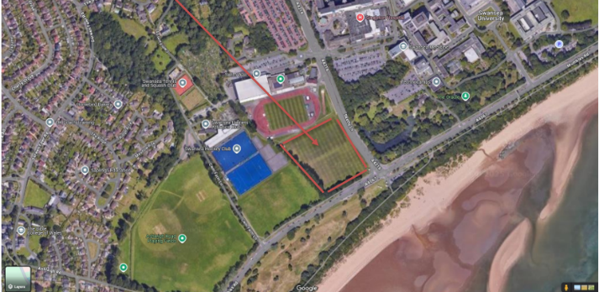
This report has been written as a result of a client proposal for the construction of a medium- to high-rise hotel on a site close to Singleton Hospital in the region of Swansea. This client is not experienced in construction technology, and as a result, professional advice on construction technology for their proposed scheme is required. This report will specifically address and justify construction technologies for achieving both safety and aesthetic considerations, as well as environmental factors for the site and purpose of construction.
The proposed project is situated in a waterfront area, and this brings with it a set of challenges that include high wind exposure, driving rain, salty air, and varying ground conditions characteristic of the Swansea region. These variables contribute substantially to the choice of the structural system and the foundation design, in addition to the envelope design of the structure. Since this project will serve as a medium to high-rise structure, the emphasis will be on the stability and resistance, in addition to the fire-safety requirements for a hotel accommodation
The report assesses appropriate structural frame options, considering reinforced concrete, steel, and hybrid systems, as well as foundation solutions based on likely ground conditions and load requirements. The building envelope strategy is developed to provide weather resistance, thermal efficiency, and acoustic performance that are durable in the long term, while also being positive contributors to the architectural character of the hotel. Materials and construction methods will be assessed in relation to buildability, maintenance, and sustainability objectives.
It also addresses the use of prefabrication and off-site construction techniques versus traditional on-site methods. The analysis addresses programme efficiency, quality control, health and safety, environmental impact, and logistical constraints associated with site location. It presents a balanced approach whereby it identifies building elements that are better suited to off-site manufacturing while recognising where on-site construction remains more appropriate.
This report sums up, in general, a structured and justified approach to construction technology decision-making for the proposed hotel development. The recommendations are geared towards delivering a safe, durable, and sustainable building that meets regulatory requirements and the client's expectations while responding effectively to the environmental conditions and constraints of the Swansea site.

2.0 Site Context and Enviromental Considerations
2.1 Site Location and Surroundings
The hotel site in consideration is in the region of Swansea in South Wales. This is a very densely populated region consisting of a range of health and education-focused development activity as well as residential zones. The presence of a major site activity in the vicinity of the hotel site in the form of Singleton Hospital and the presence of a university indicates the requirement for a design that considers the context or the surrounding development in a sensitive manner in the context of minimizing disruption to the site activity due to the hotel construction process as indicated in (Chudley & Greeno 2020).
Because it is in an urban area, it is likely that made ground deposits exist beneath it as a result of previous development work. Such situations can influence foundation design and construction techniques, as challenging ground conditions can necessitate specialized ground investigation work.
2.2 Local Climate and Weather Conditions
Swansea experiences a temperate maritime climate (Köppen Cfb) with relatively mild temperatures year-round, frequent rainfall, and moderate wind speeds owing to its coastal location on Swansea Bay (Weather Atlas, 2026). Monthly rainfall averages are consistently moderate, contributing to moist atmospheric conditions and high relative humidity, which can influence material durability and external moisture management strategies. For example, average rainfall in the region typically ranges between approximately 59 mm and 123 mm per month, indicating a requirement for robust weatherproofing and drainage detailing within the building envelope (Weather Atlas, 2026).
Coastal winds are also a key design consideration. Long-term climate data for the Swansea Bay area indicate average monthly wind speeds of approximately 8–11 knots, with higher wind pressures experienced at increased building heights (Met Office, 2026). For medium- to high-rise structures, this necessitates careful consideration of wind loading in both structural frame design and façade detailing to control lateral movement, occupant comfort, and wind-driven rain penetration.

2.3 Ground Conditions and Geotechnical Considerations
The geology of the Swansea area is characterised by sedimentary bedrock formations associated with the Devonian and Carboniferous periods, including mudstones, sandstones, and coal measures, overlain in places by superficial deposits such as glacial till and alluvium (British Geological Survey, 2016). These materials can exhibit variable strength and compressibility characteristics, particularly where superficial deposits or artificial ground are present.
Urban development in Swansea has historically involved extensive ground modification, and the presence of made ground is therefore likely. Made ground can present challenges due to inconsistency in composition and compaction, increasing the risk of differential settlement if not appropriately addressed. For a medium- to high-rise hotel, accurate assessment of soil stratigraphy, groundwater conditions, and bearing capacity is essential. Consequently, detailed ground investigation data, including borehole logs, will be required to inform foundation design and ensure structural safety and serviceability.
2.4 Site Constraints and Opportunities
The site’s proximity to Singleton Hospital and surrounding occupied buildings introduces constraints related to access, noise, vibration, and construction traffic management. Construction activities must be carefully planned to minimise disruption to hospital operations and neighbouring land uses. Additionally, exposure to coastal weather conditions may affect construction sequencing and temporary works, particularly during periods of high wind or heavy rainfall.
Despite these constraints, the site offers several opportunities. Its location near major institutions and transport routes enhances the commercial viability of the hotel development. Furthermore, the relatively flat terrain common to coastal Swansea reduces the need for extensive cut-and-fill operations, offering potential programme and cost efficiencies. The site also provides an opportunity to deliver a visually prominent building that contributes positively to the local urban environment through considered architectural design and material selection.
3.0 Structural Frame and Foundations
3.1 Design Requirements for a Medium – to High-Rise Hotel
The proposed development is a medium- to high-rise hotel located in a coastal urban area of Swansea, close to Singleton Hospital and Swansea University. The structural system must therefore respond not only to building height and occupancy type, but also to local environmental conditions, surrounding building typologies, and site constraints.
Hotel buildings are subject to relatively high imposed loads due to bedroom occupancy, circulation areas, services, and plant. In addition, the height of the building increases exposure to wind actions, which are more pronounced in Swansea due to its coastal position along Swansea Bay. Wind loading therefore becomes a governing design factor, influencing both structural stability and serviceability criteria such as lateral deflection and occupant comfort (EN 1991-1-4).
Fire safety is also critical due to the sleeping risk associated with hotel use. Structural elements are required to achieve extended periods of fire resistance under UK Building Regulations, typically 60–120 minutes depending on height, which directly influences material selection and construction method (HM Government, 2019).
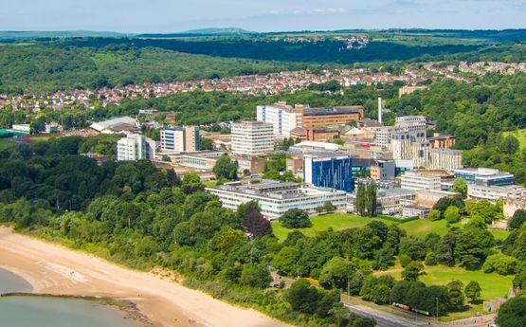
3.2 Structural Frame options
A review of nearby medium- and large-scale buildings provides useful precedent for appropriate structural systems in the local context. Developments such as Singleton Hospital, Swansea University campus buildings, and the Meridian Tower predominantly utilise reinforced concrete frames or concrete core systems. These structures demonstrate that concrete is a proven and durable solution within Swansea’s coastal environment.
Reinforced concrete frames are widely used locally due to their robustness, inherent fire resistance, and ability to resist lateral loads effectively. The mass and stiffness of concrete structures help to limit wind-induced movement, which is particularly beneficial in exposed coastal locations. Additionally, concrete provides good acoustic separation, an important consideration in hotel buildings where guest comfort is a priority (Mosley, Bungey and Hulse, 2019).
Structural steel frames are also used within Swansea, particularly for low- to medium-rise commercial buildings. However, in coastal environments, steel requires enhanced corrosion protection and applied fire protection, increasing both initial cost and long-term maintenance requirements. These factors reduce its suitability for a hotel building of this scale and location (Lawson et al., 2018).
Hybrid systems, combining reinforced concrete cores with steel or concrete floor systems, are often used in taller buildings to balance speed of construction and structural performance. While viable, such systems still rely on concrete cores for stability, reinforcing the appropriateness of concrete as the primary structural material.
3.3 Selected Structural Frame and Justification
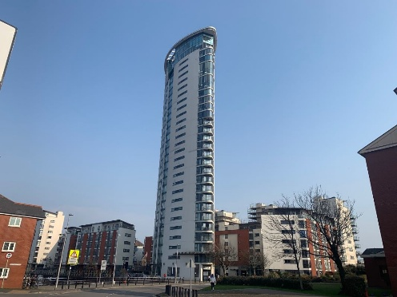
`Based on the site location, surrounding building precedent, and environmental exposure, a reinforced concrete frame with a reinforced concrete stability core is selected for the proposed hotel. This choice reflects established construction practice in Swansea for buildings of similar scale and function.
The concrete frame provides the stiffness required to resist wind loads arising from the coastal climate, while the central core offers an efficient means of resisting lateral forces and providing protected escape routes. The durability of reinforced concrete is particularly advantageous in Swansea’s maritime environment, where salt-laden air can accelerate corrosion in exposed steel elements if not rigorously protected.
From a construction perspective, reinforced concrete is well suited to repetitive hotel floor layouts and allows effective integration with prefabricated elements such as bathroom pods and service risers. This approach supports programme efficiency while maintaining high levels of structural robustness and fire performance.
3.4 Foundation Options for the site
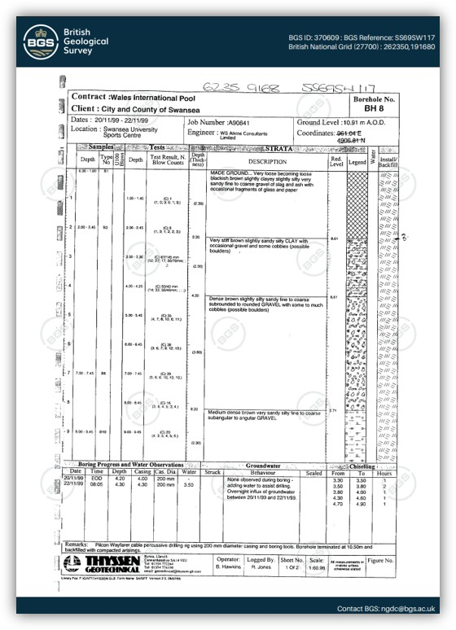
Foundation selection has been informed directly by the British Geological Survey borehole log BH8, located at the nearby Swansea University Sports Centre. This site is geographically close to the proposed hotel plot and therefore provides a credible representation of local ground conditions.
The borehole log records:
- A shallow layer of made ground
- Underlying stiff silty clay
- Dense to very dense sandy gravel strata from approximately 2.8 m depth
- Groundwater encountered at approximately 3.5–4.0 m below ground level
These conditions are typical of coastal Swansea and have significant implications for foundation design. Made ground and variable cohesive soils are unsuitable for supporting high structural loads using shallow foundations due to settlement risk and groundwater-related construction challenges (Craig, 2018).
3.5 Selected Foundation Solution and Justification
Given the identified ground conditions and the structural demands of a medium- to high-rise hotel, a bored reinforced concrete piled foundation system is proposed. This solution allows loads to be transferred through weaker near-surface materials and into the dense gravel strata identified in the borehole log.
Bored piles are particularly appropriate for this site due to:
- The presence of groundwater, which complicates shallow excavation
- The need to minimise noise and vibration close to Singleton Hospital
- The proven performance of piled foundations in nearby developments, including the Wales International Pool
This approach demonstrates a clear response to both site-specific ground conditions and local environmental and operational constraints.
3.6 Structural Stability and Lateral Load Resistance
Lateral stability will be provided by the reinforced concrete core, working in conjunction with floor slabs acting as horizontal diaphragms. This system is commonly employed in medium- and high-rise buildings in coastal South Wales due to its effectiveness in resisting wind actions.
Eurocode guidance identifies wind as a dominant load case for buildings in exposed locations, particularly at height (EN 1991-1-4). The selected concrete frame and core system provides sufficient stiffness to control deflection and reduce the risk of occupant discomfort, which is a critical consideration for hotel accommodation.
3.7 Fire Safety Considerations
Reinforced concrete provides excellent inherent fire resistance and is widely used in hotel and healthcare buildings across Swansea for this reason. The material’s performance under fire conditions reduces reliance on applied fire protection systems and enhances long-term reliability.
The proposed structure can readily achieve the fire resistance periods required under Approved Document B for buildings containing sleeping accommodation. The concrete core also functions as a protected escape route, supporting both life safety and regulatory compliance.
4.0 Prefabrication and On-Site Construction Methods
Modern Methods of Construction (MMC) are increasingly adopted within hotel developments due to their ability to improve programme certainty, quality control, and sustainability performance. For the proposed medium- to high-rise hotel near Singleton Hospital, a hybrid approach combining off-site prefabrication with traditional on-site construction is considered the most appropriate solution.
Given the constrained urban location adjacent to healthcare and university facilities, construction activities must minimise noise, vibration, and disruption. Off-site manufacture allows significant elements to be produced in controlled factory environments, reducing the duration and intensity of on-site works (NHBC, 2020). This is particularly beneficial within the Swansea context, where site access is limited and neighbouring uses are sensitive.
Prefabrication is especially suitable for non-structural and repetitive elements, which are common in hotel developments. Bathroom pods are widely used in the UK hotel sector due to their standardised layouts and high service density. Factory-built pods improve quality assurance, reduce on-site labour requirements, and significantly shorten fit-out programmes (Lawson, Ogden and Goodier, 2014). For this project, bathroom and service pods can be craned into position once the reinforced concrete frame has been completed, reducing internal trades overlap and improving health and safety performance.
Similarly, prefabricated façade panels may be adopted to improve build quality and weather resistance. Given Swansea’s exposed coastal climate, factory-finished cladding panels provide superior tolerances and consistent airtightness compared to traditional blockwork façades constructed entirely on site (CIRIA, 2019). This approach also reduces weather-related delays, which are common in South Wales due to high rainfall and wind exposure.
Despite these advantages, the primary structural frame and foundations are best constructed on site. The reinforced concrete frame, stability core, and bored pile foundations require adaptation to variable ground conditions identified in the BGS borehole log and must be integrated with site-specific sequencing and temporary works. In-situ construction allows greater flexibility in responding to groundwater conditions and unforeseen ground variability, which is critical for managing geotechnical risk (Tomlinson and Woodward, 2015).
From a sustainability perspective, prefabrication contributes to reduced material waste, improved resource efficiency, and lower embodied carbon through optimised manufacturing processes (WRAP, 2021). When combined with local sourcing of concrete materials and efficient logistics planning, the hybrid construction strategy supports both environmental and programme objectives.
Overall, the proposed approach balances engineering practicality, programme efficiency, site constraints, and sustainability, making it well suited to the Swansea hotel development.
5.0 Sustainability and Environmental Impact
Sustainability is a key consideration for the proposed medium- to high-rise hotel development, particularly given Swansea’s coastal location and Wales’ commitment to reducing carbon emissions within the built environment. This section evaluates both embodied and operational environmental impacts, focusing on material selection, construction methods, and long-term building performance.
5.1 Embodied and Operational Carbon
The embodied carbon associated with construction materials represents a significant proportion of a building’s total lifecycle emissions. Reinforced concrete, while carbon intensive, offers long-term durability, inherent fire resistance, and thermal mass, which can reduce operational energy demand through improved temperature regulation (Institution of Structural Engineers, 2020). By specifying concrete mixes incorporating Ground Granulated Blast-furnace Slag (GGBS) or pulverised fuel ash, embodied carbon can be reduced by up to 50% compared to traditional Portland cement concrete (WRAP, 2021).
Operational carbon is addressed through a high-performance building envelope, including enhanced insulation levels, airtight construction, and high-performance glazing. These measures are particularly important in Swansea’s cool, wet, and wind-exposed climate, where heat loss and weather ingress can significantly increase energy consumption if poorly controlled (Met Office, 2023).
5.2 Sustainable Material Selection
Material selection prioritises durability, longevity, and reduced maintenance requirements. The use of robust façade materials such as rainscreen cladding systems and high-quality glazing reduces lifecycle costs and the need for premature replacement. Where possible, materials sourced within the UK reduce transportation emissions and support regional supply chains (BRE, 2019).

5.3 Waste Reduction and Resource Efficiency
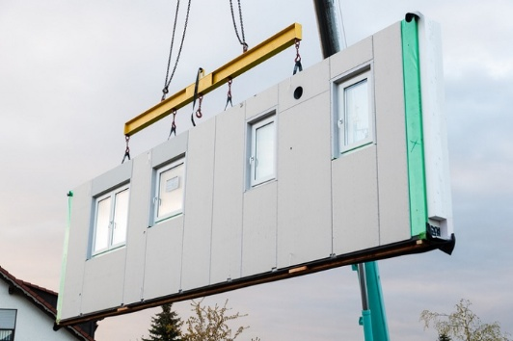
The adoption of prefabricated elements, including bathroom pods and façade panels, significantly reduces material waste and improves resource efficiency. Off-site manufacturing allows precise material quantities to be used, reducing on-site waste generation by up to 90% compared to traditional construction methods (WRAP, 2021). This approach also supports improved site safety and reduced disruption to neighbouring facilities.
5.4 Long-Term Environmental Performance
The proposed design strategy supports long-term environmental performance through durability, adaptability, and reduced operational energy demand. Together, these measures contribute to a lower whole-life carbon footprint and align with UK sustainability targets and best practice guidance for hotel developments.
6.0 Conclusion
This report has justified the selection of a reinforced concrete structural frame supported by bored pile foundations as the most appropriate solution for a medium- to high-rise hotel development near Singleton Hospital, Swansea. The chosen approach responds effectively to local ground conditions, coastal climate exposure, and urban site constraints. A robust building envelope and a hybrid construction strategy incorporating prefabricated elements improve build quality, programme efficiency, and sustainability performance. Overall, the proposed design demonstrates a balanced integration of structural performance, fire safety, durability, environmental responsibility, and practical constructability, ensuring a resilient and efficient hotel development suited to its context.

7.0 References
British Geological Survey (2016) Geology of the Swansea district: Sheet 247 Swansea – bedrock and superficial deposits. British Geological Survey. Available at: https://nora.nerc.ac.uk/id/eprint/14859 / (Accessed on 5th January 2026).
Chudley, R. and Greeno, R. (2020) Building Construction Handbook. 12th edn. Abingdon: Routledge.
Met Office (2026) Location-specific long-term climate averages: Mumbles Head. Available at: https://www.metoffice.gov.uk/research/climate/maps-and-data/location-specific-long-term-averages/gcjjm7j5g (Accessed on 5th January 2026).
Weather Atlas (2026) Swansea climate and monthly weather. Available at: https://www.weather-atlas.com/en/united-kingdom/swansea-climate (Accessed on 5th January 2026).
R.F, C. (2018). Craig’s Soil Mechanics. [online] Available at: https://priodeep.weebly.com/uploads/6/5/4/9/65495087/craig_s_soil_mechanics_2_.pdf (Accessed on 5th January 2026).
European Committee for Standardization (CEN) (2005) EN 1991-1-4: Eurocode 1 – Actions on structures – Wind actions. Available at: https://eurocodes.jrc.ec.europa.eu/showpage.php?id=138 (Accessed on 5th January 2026).
HM Government (2019) Approved Document B: Fire safety – Volume 2 (Buildings other than dwellinghouses). Available at: https://www.gov.uk/government/publications/fire-safety-approved-document-b (Accessed on 5th January 2026).
Lawson, R.M., Ogden, R.G. and Bergin, R. (2018) Application of modular construction in high-rise buildings. Journal of Architectural Engineering, 24(4). Available at: https://ascelibrary.org/doi/10.1061/(ASCE)AE.1943-5568.0000332 (Accessed on 5th January 2026) .
Mosley, B., Bungey, J. and Hulse, R. (2019) Reinforced Concrete Design to Eurocode 2. 7th edn. London: Palgrave Macmillan. Available at: https://doi.org/10.1007/978-1-137-49380-9 (Accessed on 5th January 2026).
Swansea.ac.uk. (2026). Singleton Campus Student Spaces - Swansea University. [online] Available at: https://hwb.swansea.ac.uk/student-spaces/singleton-campus (Accessed 7th January 2026).
@FPFoshAuctions. (2026). Meridian Tower, Trawler Road, Maritime Quarter, Swansea, SA1 1JN - Online Auctions. [online] Available at: https://paulfosh.eigonlineauctions.com/lot/details/69871 (Accessed 7th January 2026).
British Geological Survey (2019). British Geological Survey (BGS). [online] Bgs.ac.uk. Available at: https://www.bgs.ac.uk/ (Accessed 8th January 2026)
CIRIA (2019) Guide to modern methods of construction. London: CIRIA.
Available at: https://www.ciria.org/ItemDetail?iProductCode=C777 (Accessed: 8th January 2026).
NHBC (2020) Modern methods of construction: Building on experience.
Available at: https://www.nhbc.co.uk/binaries/content/assets/nhbc/tech-zone/modern-methods-of-construction.pdf (Accessed: 8th January 2026).
Tomlinson, M. and Woodward, J. (2015) Pile design and construction practice. 6th edn. London: CRC Press.
Available at: https://www.routledge.com/Pile-Design-and-Construction-Practice/Tomlinson-Woodward/p/book/9780415738383 (Accessed: 8th January 2026).
WRAP (2021) Reducing waste through offsite construction.
Available at: https://wrap.org.uk/resources/guide/reducing-waste-through-offsite-construction (Accessed: 8th January 2026).
BRE (2019) Environmental profiles and the Green Guide to Specification.
Available at: https://www.bregroup.com/insights/environmental-profiles-and-the-green-guide/
(Accessed: 8th January 2026).
Institution of Structural Engineers (2020) How to calculate embodied carbon.
Available at: https://www.istructe.org/resources/guidance/how-to-calculate-embodied-carbon/
(Accessed: 8th January 2026).
Met Office (2023) UK climate averages – Wales.
Available at: https://www.metoffice.gov.uk/research/climate/maps-and-data/uk-climate-averages
(Accessed: 8th January 2026).
Group, H.L.N. (2019). A Guide to Modern Methods of Construction (MMC). [online] HLN Engineering. Available at: https://www.hlnengineering.co.uk/modern-methods-construction-mmc/. (Accessed 9th January 2026)

