Management Accounting

Module code: LCBB5002

Student name: Natalia Dimitrova

Student number: 1922172

Part A:
i)

Monthly Control Report

ii)
According to control report, the performance of Amana LTD is not good. The selling price per units should be improved when comparing to previous reports. There is a major issue appearing in its costs, which should be under control because they show a major change as compare to budgets. In addition, there are many lacks in the performance of Amana’s business and almost every area needs some improvement. The fixed costs of the company are so far under control. It is very important to make realistic budget according to previous actual performance to consider that how much the company has capability to meet its targets and how they can be improved effectively. During year 2020, the performance of Amana LTD went down as well as their profitability level which also gone down. Prices and costs need to be looked into firstly because wrong estimations are leading to bad performance of the company and the long term performance can be catastrophic due to these errors. All the costs (variable and fixed) needs to be revised. The budget sector of the company is showing less costs but in real company has to bear huge costs. This will automatically reduce the profitability and also the performance goes down.
So first of all, company has to make realistic targets and budgets which can be fixed really quick and easy. Once that’s done, Amana LTD needs to be properly managed and control to be taken of the costs and expenses which creates a big impact in the finance of company. Then set the prices accordingly so they can easily fit in the market and more people will be attracted and will be willing to purchase their products if the prices are more reasonable. After all those adjustments, there might be a chance that the profit of the company will increase in the near future and losses will be set to minimum.
iii)
Amana LTD has to manage its operations and increase the sales per units which will be helpful in order for all costs to be covered. The company should control its variable costs so that the operation activity will be performed profitability. The CEO of the Amana has to consider some recommendations to make the performance level of company much better.
Key recommendations for future improvements:
- Understanding the customers and focusing on their needs – Customer feedback must be a big priority for any business. Communicating with customers will help with understanding what went wrong and will bring up new ideas on future improvements for the business. All functions within the business should be equally important which will help for the performance of Amana.

- Alternative ways of selling need to be discussed to allow people to obtain the products easily - As with the COVID-19 pandemic a lot of business changed the way they operate and sell their products, Amana LTD need to step forward and change the way they operate. As there are not many tourists visiting the souvenir shops it would be a good idea if some of them close down and to create an online store. This will reduce the rent costs significantly and the money can be invested into online marketing and advertising. Since the pandemic there were significant losses for many businesses across the world and a lot of stores had to be permanently closed. At the same time in very short period the online sales were drastically increased and other organisations managed to double up the sales using the online platforms. The other downside of physical stores is that there are more staff members needed which leads to more expenses for the company. If there is an online shop in place it will be way easier to manage, less staff members needed and more clients to be able to purchase items from all over the world.

- Focus on reducing the costs and improving the sales – All costs need to be revised and looked into seriously in order for the company to get back on its feet. If that’s not improved in the near future, Amana will be facing more losses. With all restrictions due to the pandemic the company needs to change the way it operates and to adapt to the current situation. Realistic budgets and targets must be the first priority. Costs must be minimised accordingly which will support the company and help to increase the future profits. With all restrictions due to the pandemic the company needs to change the way it operates and to adapt to the current situation.

- They may have to be consider exchanging providers as fetched of materials have gone up- Suppliers are also a very important part of the company. The increase in prices of materials also leads to an increase in the price of the product. However, this also can have a bad impact on the company’s customers. It is good to reconsider the suppliers and if necessary to change them and find some backup suppliers. You can also talk to your suppliers about to arrange an amplified period of cost legitimacy or arrange rebates on ensuing orders. It is also very important to preserve the quality of the materials because the quality of the product will remain good. Reviewing suppliers will also help for reducing the costs which has already mentioned. This will improve the company’s performance and allow for greater profit. It is also important, as I said, to maintain the quality of the product because reducing the costs should not be at the cost of quality.

- Continuous improving the methods of operating - The management is a key factor that determines the success of the company. In order for the Amana to be successful in their product sales there is a need of a strong leadership. Once that’s in place the methods that the company uses will be reviewed and improved for better results and higher profits. Once that happens there will be new ideas on how to reduce the costs and the sales to be boosted.

Part B:
Nowadays more and more customers are shopping online. The online platform allows people to shop whenever they want to instead of spending the day walking around the stores. Another great benefit is that all products are delivered straight to your door at convenient time. Online products have a lot more information written about them and with Amana Souvenirs customers can read a lot more about the products and the company and to really understand what the business is all about instead of just looking at the products in a store without knowing much about them. Web store will allow a lot more different products to be displayed as sometimes stores are not big enough to be able to display all items. This will also reduce the rent costs as products can be stored in one warehouse and dispatched worldwide.
Mr.Amana wants to expand its business and earn more profit as compare to their current condition. The decision of shifting their sales to online is a good decision because with the time change, more people willing to use internet and prefer the purchase all the products through online. So the decision of shifting 50% sales from offline route to online is very efficient and good for the company. His company Brighton, Birmingham city centre and Manchester city centre branches would be able to manage limited number of people. While Amana souvenirs could entertain a huge loyalty according to presence of its stores in the city but their major task is to search new customers which are quite difficult task but its relevant expenses of the stores are high which have to pay at any cost. Amana Souvenirs has to chances to increase exponentially its customers base and market share by capturing the market of UK, Europe and US by shifting half of its sales to online and enhance its level of communication with its customers in all around the countries.
In order to capture the domestic costumers and their loyalties, company can manage its strategies according to its reposition about all the offline stores and try to bring more advancement in its local costumer’s relationship.
During the selection of online sales channel, Mr. Amana has two different options provided according to their requirement and need. in option one, when the company decide to sell the product as online stores which provide guarantee sales of 100000 units annually, for this company has to face high setup cost GBP 200000 and annual recurring cost GBP 35000. These costs company have to pay for shifting its sales online and this decision will provide huge profit with the increase of sales. In the second option, when company select Amazon to sell its products, the company has to face recurring cost GBP 50000 which give the guarantee of sales 65000 units annually. These two decisions show a huge difference in cost as well as a huge difference in sales units.
Company has to face marketing expenses because in different regions of UK, US and Europe, the brand awareness is very low and for attracting more and more customers, company spend money on the marketing strategies to bring brand awareness to more and more people. The operations of offline stores are very limited in different regions and to attract more customers through online, marketing strategies need to be implemented in most effective way. Company has to take a decision of investment on the above given two options and consider the marketing expenses during the selection of any option. Marketing techniques help the company to bring awareness about the brand to multiple customers who use internet and wants to purchase the products online. So by any mean, company has to pay marketing expenses and manage all the needs in most effective way.
In the current market scenario, the best decision for Mr. Amana is the select the selling of products through Amazon from 1 to 2 years to observe its sales through online system. A huge competition is already present in the market where many other companies sell their products online. By adopting the Amazon option, the company would understand the seller space and obtain real feedback about the level of acceptance of the products in the specified markets and regions. This will also help to develop a marketing campaigns according to customers’ demand and bring them more awareness about the product to develop long term loyalty with the customers. It is very important to keep all the relevant factors in mind while taking the decision. This would be helpful for the company, that after 1 to 2 years through Amazon, the brand awareness would be increase among customers and a strong loyalty develops with customers. In different target markets, the company make its position strong among other competitors and after some specific time, the company can follow the online store option instead of Amazon and make its one online selling track successfully.
The chart below shows how much and more constant users traffic the Amazon platform has. That why this “traffic” is very important in the world of online shopping because it increases sales and helps the development of many companies.(https://www.helium10.com/blog/selling-on-amazon-vs-your-own-site/ )

Selling on Amazon can provide to the company a large audience of customers. In summary, both options are good for the company but opening an own website is riskier than selling on Amazon. In order to avoid unwanted losses for the company it’s better to start selling on Amazon and get to know the market and customers and then develop through own website.

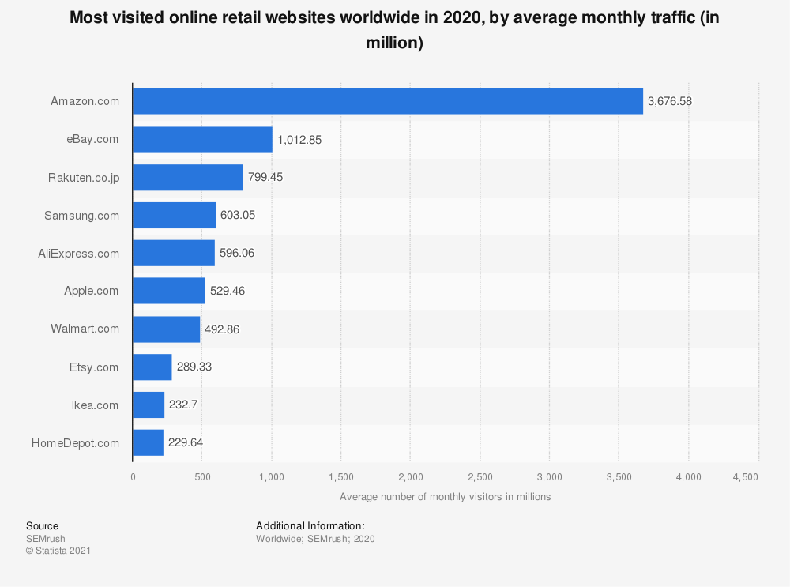
https://www.helium10.com/blog/selling-on-amazon-vs-your-own-site/

It is very important to understand all the techniques and areas that support the business for long term and take right decision which will help to move in future with cost saving strategies and bring more brand awareness through using effective marketing strategies.

Price x unit 20£
100,000x 20=2,000,000
2,000,000- (150,000+50,000+35,000) = 1,765,000 x year for the own website
65,000x20= 1,300,000
1,300,000- 50,000= 1,250,000 x year for selling their products directly on Amazon

Reference:
https://www.helium10.com/blog/selling-on-amazon-vs-your-own-site/

https://www.webfx.com/blog/marketing/sell-on-amazon-or-own-website/

