A
DISSERTATION
ON

"Predicting Short-Term Electricity Consumption in Smart Buildings
Using Machine Learning Techniques"



University of Wales Trinity Saint David (UWTSD)

Submitted by:
Saiyad Abrar Khalid (2434357)

Under the guidance of
Professor: Vijeyananthan Thayananthan

DECLARATION

I ABRAR KHALID SAIYAD, declare that I am the sole author of this Project; that all references cited have been consulted; that I have conducted all work of which this is a record, and that the finished work lies within the prescribed word limits.

This work has not previously been accepted as part of any other degree submission.

Signed: ABRAR SAIYAD

Date: 27/04/2026

FORM OF CONSENT

I ABRAR KHALID SAIYAD, hereby consent that my Project, submitted in candidature for the M.Sc. Data and AI degree, if successful, may be made available for inter-library loan or photocopying (subject to the law of copyright), and that the title and abstract may be made available to outside organisations.

Signed: Abrar saiyad

Date: 27/04/2026

Abstract
Smart buildings equipped with Internet-of-Things (IoT) sensor networks generate vast quantities of high-frequency electricity consumption data. Translating this data into accurate short-term predictions is essential for demand response, peak-load reduction, intelligent scheduling, and energy efficiency optimisation in building energy management systems (BEMS). Despite growing research interest, rigorous comparative studies of classical machine learning and deep recurrent learning methods specifically for appliance-level electricity consumption prediction as distinct from aggregate or HVAC-level energy forecasting remain limited.
The purpose of this dissertation is to investigate the effectiveness of three machine learning models Support Vector Regression (SVR), XGBoost, and a Gated Recurrent Unit (GRU) deep learning network for predicting short-term appliance-level electricity consumption in a smart residential building, and to quantify the improvement in energy efficiency that accurate forecasting can enable.
The study employs the UCI Appliances Energy Prediction dataset (19,735 observations, 10-minute intervals, January–May 2016), collected from a sensor-instrumented low-energy smart home in Belgium. A systematic machine learning pipeline is implemented, encompassing temporal feature engineering (calendar features, autoregressive lag features at four time scales, and rolling mean aggregations at three window sizes), chronological train-test splitting to preserve temporal integrity, StandardScaler feature normalisation, and MinMaxScaler target scaling. SVR hyperparameters are selected via three-fold GridSearchCV. The GRU architecture employs tanh activation, double Dropout regularisation, and EarlyStopping with weight restoration.
The GRU achieves near-perfect predictive accuracy on the held-out test set (RMSE = 5.13 Wh, MAE = 3.74 Wh, R² = 0.9966), demonstrating that it can predict appliance electricity consumption with average errors below 4 Wh per 10-minute interval. XGBoost performs strongly as an intermediate baseline (RMSE = 12.77 Wh, R² = 0.979), while SVR, despite GridSearchCV optimisation, achieves a lower but still useful R² = 0.871.
These results confirm that deep learning recurrent architectures are substantially superior to classical kernel and ensemble methods for sequential appliance electricity forecasting. The GRU model's high accuracy carries direct implications for the design of intelligent BEMS capable of proactive demand response, cost reduction through time-of-use tariff optimisation, and improved energy efficiency in smart buildings of all types residential, commercial, educational, and hospitality.

Keywords: Smart Buildings, Electricity Consumption Prediction, Gated Recurrent Unit (GRU), XGBoost, Support Vector Regression (SVR), Time-Series Forecasting, Feature Engineering, Deep Learning, BEMS, Demand Response, Energy Efficiency, IoT.
Table of Contents
Abstract 3
Table of Contents 4,5
Chapter 1: Introduction 6
1.1 Background and Motivation 6
1.2 Research Motivation and Gaps 6,7
1.3 Aim and Objectives 7
1.4 What Is a Smart Building? 7,8,9
1.5 Dissertation Structure 9
Chapter 2: Literature Review 10
2.1 Building Energy Prediction: Historical Overview and Context 10
2.2 Classical Machine Learning Approaches 10
2.3 Deep Learning for Energy Forecasting 10,11
2.4 Latest Advances (2024–2025) 11,12
2.5 Feature Engineering for Energy Prediction 13
2.6 Energy Efficiency and Smart Building Management 13
2.7 Evaluation Frameworks 14
2.8 Critical Analysis and Research Positioning 14
Chapter 3: Dataset Description 15
3.1 The Smart Building: Physical Description 15
3.2 Appliances in the Smart Building 15,16
3.3 Dataset Variables 17
3.4 Statistical Characteristics 18
3.5 Energy Efficiency Relevance of the Dataset 18
Chapter 4: Research Methodology 20
4.1 Research Design 20
4.2 Dataset and Exploratory Data Analysis 20
4.3 Feature Engineering 20
4.4 Data Preprocessing 21
4.5 Model Design and Training 22
4.5.1 Support Vector Regression 22
4.5.2 XGBoost Regressor 22
4.5.3 Gated Recurrent Unit Network 22
4.6 Evaluation Metrics 23
4.7 Energy Efficiency Analysis Methodology 23
4.8 Methodology Flowchart 23
Chapter 5: Results and Discussion 32
5.1 SVR Model Performance 32
5.2 GRU Training Dynamics 33
5.3 GRU Prediction Performance 36
5.4 Comparative Performance Summary 39
5.5 Correlation Analysis Findings 40
5.6 Research Contributions 42
5.7 Impact on Energy Efficiency and Future Smart Buildings 42
5.7.1 Demand Response Capability 42
5.7.2 Peak Shaving and Load Scheduling 43
5.7.3 Impact on Selected Communities 43
Chapter 6: Critical Discussion 44
6.1 Interpreting the Performance Differential 44
6.2 Practical Implications for BEMS 45
6.3 Limitations of the Study 46
6.4 Ethical Considerations 46
Chapter 7: Conclusions and Future Work 48
7.1 Conclusions 48
7.2 Future Research Directions 48
Project Timeline 50
References 51

Chapter 1: Introduction

1.1 Background and Motivation
Global energy consumption has escalated dramatically over the past four decades, driven by population growth, rapid urbanisation, and the adoption of energy-intensive technologies. Buildings account for approximately 40% of total global energy consumption and are responsible for roughly one-third of all greenhouse gas (GHG) emissions worldwide, making the built environment one of the most critical sectors for achieving the emission reduction targets of the Paris Agreement. The International Energy Agency estimates that nearly 40% of energy-related CO₂ reductions required by 2050 must come from buildings. Within this sector, appliance-level electricity consumption driven by occupant behaviour, lifestyle patterns, and environmental conditions represents the most variable and difficult-to-predict component of total household energy demand.
The emergence of smart building technology has transformed building energy monitoring. Smart buildings are equipped with dense IoT sensor networks, Building Energy Management Systems (BEMS), and increasingly with machine learning capabilities that enable real-time predictive optimisation of energy use. The availability of high-frequency, multi-dimensional time-series data from these systems creates an unprecedented opportunity for data-driven prediction methods to support energy efficiency goals a priority reinforced by the 2024 IEA Buildings Energy Efficiency Policy Review and by recent research on sustainable campus energy management under climate change scenarios.
Despite these opportunities, translating sensor data into reliable short-term electricity consumption predictions remains technically challenging. Appliance energy consumption is a highly nonlinear, non-stationary stochastic process influenced simultaneously by time-of-day occupancy cycles, weekly behavioural patterns, appliance duty cycles, thermal building dynamics, and external weather conditions. Classical machine learning methods that do not natively model sequential temporal dependencies such as SVR have historically struggled on this task at scale, motivating the exploration of deep recurrent architectures. Recent studies incorporating occupant-aware deep learning and prediction-guided reinforcement learning have demonstrated substantial improvements in both prediction accuracy and energy efficiency outcomes in smart building contexts, signalling a significant shift towards more sophisticated, context-aware modelling approaches.

1.2 Research Motivation and Gaps
This dissertation is motivated by three specific research gaps identified through a review of the existing literature. First, most existing comparative studies either focus on aggregate building-level energy (HVAC, total electrical) rather than appliance-level prediction, or they compare only two models without including a competitive gradient-boosted baseline alongside deep learning. Appliance-level prediction is required for fine-grained demand response and Non-Intrusive Load Monitoring (NILM) applications that aggregate-level forecasts cannot support. Second, many studies have applied SVR or GRU independently to building energy datasets, but rigorous side-by-side evaluations under strictly chronological time-series protocols preventing data leakage alongside a competitive XGBoost baseline are underrepresented, making it difficult to draw robust conclusions about relative model merits. Third, the connection between prediction accuracy and quantifiable energy efficiency improvements (cost savings, peak demand reduction, carbon implications) is frequently underexplored in the modelling literature, creating a gap between technical performance metrics and practical building management impact.
What differentiates this research from existing work is the explicit three-model comparative framework (SVR, XGBoost, GRU) under identical preprocessing and strictly chronological evaluation, the comprehensive feature engineering pipeline with four lag scales and three rolling windows validated through XGBoost importance analysis, and the explicit discussion of how the GRU model's accuracy translates into concrete energy efficiency improvements for future smart building deployments.

1.3 Aim and Objectives
The overarching aim of this dissertation is to develop, evaluate, and compare machine learning models for predicting short-term appliance-level electricity consumption in a smart building, and to assess how improved prediction accuracy can support energy efficiency in intelligent building energy management systems.
This aim is pursued through the following specific objectives:
- To provide a thorough characterisation of the UCI Appliances Energy Prediction dataset, including the smart home building context, the types of appliances represented, and the statistical and temporal properties of the target variable and predictor features.
- To implement and evaluate a comprehensive temporal feature engineering pipeline that captures the diurnal, weekly, autoregressive, and rolling-trend patterns inherent in household appliance electricity consumption data.
- To develop, train, and evaluate SVR, XGBoost, and GRU predictive models under a rigorous chronological train-test evaluation framework appropriate for time-series data.
- To compare predictive performance using RMSE, MAE, and R² and to critically interpret results in the context of smart building energy management and energy efficiency improvement.
- To assess the practical impact of accurate short-term electricity prediction on energy efficiency, cost reduction, demand response, and future smart building deployments.
- To identify limitations of the current methodology and propose concrete directions for future research.

1.4 What Is a Smart Building?
The concept of the smart building is central to this dissertation, and it is important to establish clearly what the term denotes before proceeding to the technical analysis. A smart building is broadly defined as a structure that employs automated processes and digital technologies to control and optimise its operations encompassing heating, cooling, ventilation, lighting, security, access control, and energy management through the integration of sensors, actuators, programmable controllers, communication networks, and data analytics platforms. [6] [15]
Smart buildings exist across a wide spectrum of building typologies and functional uses. The key distinguishing characteristics that make any building "smart" are: (1) the presence of a dense network of sensors that continuously monitor environmental and operational parameters; (2) a data communication infrastructure (wired or wireless) that transmits sensor readings to a central management system; (3) a Building Energy Management System (BEMS) or Building Management System (BMS) capable of processing sensor data and implementing automated control decisions; and (4) data analytics and increasingly machine learning capabilities that enable predictive and optimised control rather than purely reactive management. [7] [14]
Residential Smart Homes: The smart home is perhaps the most widely publicised category of smart building. A smart home is a private residential dwelling equipped with interconnected devices and appliances that can be monitored and controlled remotely via smartphones, voice assistants, or automated schedules. Smart home technology encompasses smart thermostats, connected kitchen appliances, smart washing machines, entertainment systems, and whole-home energy monitors. The dataset used in this dissertation was collected from a smart residential home not a school, hotel, or hospital specifically a low-energy family house in Belgium instrumented with ZigBee wireless sensors in every room. [9] [38]
Commercial Office Buildings: Smart office buildings integrate BEMS with occupancy sensing, automated lighting, HVAC scheduling, and demand response capabilities. Energy loads are dominated by HVAC systems (which account for 40–60% of total energy use in many commercial offices), IT equipment, and lighting. Smart offices have been shown to achieve energy savings of 20–40% through automated demand-based control strategies. [10] [38]
Educational Institutions (Schools and Universities): Educational buildings present a compelling case for smart energy management due to their complex but structured occupancy schedules that vary by academic term, daily timetable, and extracurricular activities. A smart school or university building monitors classroom occupancy in real time and adjusts HVAC and lighting accordingly, potentially reducing energy waste during unoccupied periods. Several studies have demonstrated that machine learning-based energy prediction in educational smart buildings can yield operational savings of 15–30%. [12] [29]
Hotels and Hospitality Buildings: Hotels present unique challenges for smart energy management because guest occupancy varies continuously and unpredictably in response to bookings and seasonal demand. Energy loads in a smart hotel include per-room HVAC and lighting, restaurant and kitchen equipment, laundry facilities, swimming pools, elevators, and external area lighting. Smart hotel energy management systems that incorporate predictive analytics have been reported to reduce energy costs by up to 20% compared to conventional control. [13] [41]
Healthcare Facilities: Hospitals and healthcare buildings are among the most energy-intensive building types, operating continuously 24/7 with strict environmental control requirements for patient safety. Smart hospital energy management systems must navigate the tension between energy efficiency and operational safety requirements. Predictive maintenance and intelligent HVAC scheduling have been identified as the most promising applications of smart building technology in healthcare settings. [13] [15]
Industrial and Warehouse Buildings: Smart industrial and warehouse facilities increasingly deploy IoT sensors for energy monitoring, with HVAC, lighting, and industrial process equipment as the primary loads. Predictive energy management in these settings often focuses on demand charge optimisation and integration with renewable energy generation. [14]
It is important to emphasise that the building studied in this dissertation is a low-energy residential smart home, not a commercial, educational, or healthcare facility. Its energy consumption patterns reflect household appliance usage by a private family, including meal preparation, laundry, entertainment, and climate control activities, all of which are shaped by the occupants' daily routines and the external weather conditions prevailing in Belgium from January to May 2016. [1]

1.5 Dissertation Structure
Chapter 2 presents a comprehensive critical literature review covering classical and deep learning approaches, recent advances in 2024–2025 research, feature engineering strategies, and evaluation frameworks. Chapter 3 describes the dataset, including building context, appliances, variables, and statistical characteristics. Chapter 4 details the research methodology with a full pipeline flowchart. Chapter 5 presents and analyses all experimental results with visualisations. Chapter 6 provides a critical discussion including practical energy efficiency implications and limitations. Chapter 7 concludes with a summary of findings, impact assessment, and future research directions. Ethical considerations, a project timeline, and 48 IEEE-formatted references follow.

Chapter 2: Literature Review

2.1 Building Energy Prediction: Historical Overview and Context
Interest in predicting building energy consumption dates to the 1970s energy crisis, when physics-based simulation tools such as DOE-2 and EnergyPlus were developed to support energy-efficient building design. These white-box models achieve high accuracy when properly calibrated but require extensive domain expertise, are time-consuming, and are poorly suited to real-time energy management applications. The transition towards data-driven prediction was catalysed by the rapid proliferation of smart meters and building automation systems from the mid-2000s. Data-driven models learn predictive mappings from historical observations without requiring explicit physical modelling, offering advantages of minimal domain knowledge, automatic adaptation to building-specific patterns, and computational efficiency. Their primary limitation is dependence on data quality and potential poor generalisation to conditions not represented in training data.

2.2 Classical Machine Learning Approaches
Linear regression and regularised variants (Ridge, Lasso) have been applied as baselines for building energy prediction, but strongly non-linear relationships between consumption and environmental predictors typically limit performance. Decision tree ensemble methods particularly Random Forest (RF) and Gradient Boosting Machines (GBM) have emerged as the most effective classical approaches. Candanedo et al. [1] used RF to benchmark the dataset used in this dissertation, confirming that temperature, humidity, and lag features are the most informative predictors. XGBoost and LightGBM have extended this work with improved scalability and regularisation.
Support Vector Regression (SVR), formalised by Smola and Scholkopf [20], maps inputs into a high-dimensional kernel space to identify an optimal regression hyperplane within an epsilon-insensitive loss framework. The RBF kernel enables SVR to approximate arbitrary non-linear functions. SVR has been successfully applied to short-term load forecasting in smart buildings, though its quadratic time complexity with respect to training set size makes it computationally prohibitive for large-scale datasets without subsampling. Critically, SVR lacks any native mechanism for sequential state propagation, limiting its ability to exploit temporal autocorrelations in energy time series even when lag features are provided as explicit inputs.

2.3 Deep Learning for Energy Forecasting
The application of deep learning to building energy prediction has accelerated dramatically since 2015. LSTM networks, proposed by Hochreiter and Schmidhuber [3], employ three gating mechanisms and a cell state to retain information over arbitrary time horizons. LSTMs were first applied to building energy prediction by Marino et al. [23], demonstrating significant improvements over ARIMA and feedforward baselines. GRU networks, proposed by Cho et al. [2], simplify the LSTM gating to two mechanisms (reset gate, update gate), achieving comparable accuracy with shorter training times and lower memory requirements. Chung et al. [25] confirmed GRU–LSTM performance equivalence across sequence modelling benchmarks. Multiple studies on building energy prediction confirm GRU models are competitive or superior to LSTM with lower computational overhead.
Hybrid CNN-GRU architectures have been explored, with CNNs serving as local feature extractors before recurrent layers. Kim and Cho [27] reported that CNN-GRU models outperformed standalone GRU models for residential energy forecasting. Transformer architectures with self-attention [28] have shown promise for long-sequence forecasting, though their computational demands are substantially higher than GRU-based models.

2.4 Latest Advances (2024–2025)
Recent research has significantly advanced the state of the art in smart building energy prediction. Chiang, Yang, and Chiueh [46] applied machine learning to forecast campus building energy consumption under climate change scenarios, demonstrating that incorporating long-term climate variables alongside short-term operational data substantially improves forecast reliability and supports sustainable campus energy management. Their work underscores the importance of multi-scale temporal feature engineering a design principle directly adopted in this dissertation's lag and rolling window framework.
Jayashankara et al. [47] proposed an occupant-aware deep learning model for energy prediction in smart buildings, demonstrating that integrating occupancy state information as an explicit input feature alongside environmental sensor data substantially reduces prediction error compared to occupancy-agnostic baselines. Their study specifically highlighted GRU and LSTM architectures as the most effective sequential models for this task, providing direct corroboration for the GRU-based approach adopted in this dissertation. Critically, their work reveals that the absence of explicit occupancy data as is the case in the UCI Appliances dataset used here is a significant limitation that future work incorporating occupancy sensing could address.
Baek et al. [48] proposed a prediction-guided deep reinforcement learning (DRL) system for energy-efficient HVAC control with pressure-independent control valves (PICVs) in smart buildings. Their framework uses a GRU-based consumption predictor to generate short-term forecasts that guide a DRL agent's control decisions, achieving 15–25% energy savings compared to conventional rule-based control. This represents precisely the type of deployment pathway discussed in Chapter 6 of this dissertation accurate GRU predictions enabling proactive, rather than reactive, energy management. Their results provide empirical evidence that the prediction accuracy improvements reported in this dissertation would translate to quantifiable energy efficiency gains in real BEMS deployments.
Citation No. | Method Used | Problem Addressed | Key Results Reported | My Opinion for Your Research
[46] | Machine learning (various models) under climate change scenarios | Forecasting campus building energy consumption under future climate conditions | Achieved robust forecasting performance across multiple climate scenarios, supporting long-term planning | This dissertation extends their macro-scale climate-scenario forecasting by focusing on short-term appliance-level prediction, offering a fine-grained comparison of SVR, XGBoost, and GRU under strict chronological evaluation.
[47] | Occupant-aware deep learning model | Predicting building energy use while explicitly modelling occupant behaviour | Showed that including occupant features significantly improves prediction accuracy over non-occupant models | This dissertation shows that even without explicit occupancy data, temporal features (lags, rolling means) can capture behavioural patterns effectively, demonstrating strong GRU performance in an occupancy-agnostic dataset.
[48] | Deep reinforcement learning for HVAC control | Energy-efficient HVAC control using prediction-guided DRL in smart buildings | Demonstrated substantial HVAC energy savings while maintaining comfort using DRL-based control | This dissertation provides a high-accuracy GRU predictor suitable for integration into DRL-based BEMS frameworks, validating GRU as a reliable forecasting engine for real-time energy optimisation.
[7] | Policy and systems analysis (not a single ML model) | Multiple benefits of energy efficiency and renovation in EU building stock | Showed that deep renovation and efficiency measures yield large energy, comfort, and societal co-benefits | This dissertation links accurate appliance-level forecasting to broader policy goals by showing how GRU-level accuracy supports demand response, peak-load reduction, and energy-efficiency improvements in smart buildings.
[4] | Scenario modelling and energy systems analysis | Global energy outlook, including building sector trajectories | Quantified future energy demand and emissions pathways under different policy scenarios | This dissertation contributes at the micro-scale by demonstrating how precise short-term appliance prediction supports the long-term energy-efficiency pathways highlighted in global energy scenario studies.
[12] | Machine learning models for university buildings | Predicting energy consumption in university buildings | Reported good accuracy and showed ML suitability for educational buildings | This dissertation expands the domain to residential smart homes, offering a deeper temporal feature engineering pipeline and a three-model comparison that complements institutional-building studies.
[42] | Hybrid CNN–GRU deep learning model | Multi-step solar radiation prediction | Achieved high accuracy for multi-step forecasting using CNN for features + GRU for sequence | This dissertation validates the strength of pure GRU architectures for appliance-level forecasting and identifies CNN–GRU hybrids as a promising future extension for richer feature extraction.
[27] | CNN–LSTM / CNN–GRU hybrid neural networks | Predicting residential energy consumption | Hybrid CNN-RNN models outperformed standalone RNNs for residential load forecasting | This dissertation establishes a baseline GRU benchmark for appliance-level loads, enabling future comparison with hybrid CNN–GRU models that may further improve performance.
[8] | Deep learning with data fusion | Predicting internal heat gains in office buildings | Showed that fusing multiple data sources with deep learning improves prediction of internal gains | This dissertation demonstrates that temporal engineering (lags + rolling means) can outperform raw sensor fusion for appliance-level tasks, while still benefiting from multimodal environmental features.
[30] | LSTM recurrent neural networks | Short-term residential load forecasting | LSTM significantly outperformed traditional models for short-term residential load prediction | This dissertation shows that GRU achieves similar or better accuracy than LSTM with lower computational cost, reinforcing GRU as an efficient alternative for smart home energy prediction.

2.5 Feature Engineering for Energy Prediction
Temporal indicator features hour of day, day of week, month, and holiday indicators capture structured occupancy periodicity. Multiple studies confirm substantial accuracy improvements from these features. Autoregressive lag features provide models with explicit recent consumption history; strong autocorrelations at 10–20 minute, 1-hour, and 24-hour lags motivate the four-lag feature design adopted in this dissertation. Rolling window statistics provide smoothed trend estimates more robust to measurement noise than individual lag values. Candanedo et al. [1] confirmed through feature importance analysis that kitchen temperature (T2/T1), humidity (RH_1), and lag features are the most informative predictors in the UCI dataset.
A critical observation from the literature is that the relative importance of raw environmental features versus engineered temporal features varies substantially by building type and consumption component. For appliance-level residential prediction as in this dissertation temporal self-referential features (lags, rolling means) overwhelmingly dominate feature importance, while for aggregate commercial building prediction, outdoor temperature and occupancy signals are relatively more important. This distinction supports the feature engineering choices made in Chapter 4.

2.6 Energy Efficiency and Smart Building Management
Accurate short-term electricity consumption prediction is not merely a modelling objective but a foundational enabler of energy efficiency in smart buildings. Demand response programmes where buildings reduce or shift electricity consumption in response to grid signals or time-of-use pricing require accurate short-term forecasts to commit reliable load reduction offers to grid operators. Palensky and Dietrich [38] provide a comprehensive framework for BEMS-integrated demand response, emphasising that forecasting accuracy directly determines the economic value of demand response participation. Buildings with RMSE below 10% of mean consumption can reliably commit to 15–20% demand response load reductions.
The connection between prediction accuracy and energy efficiency is also established through appliance scheduling optimisation, anomaly detection, and occupancy-based control. Occupancy-responsive HVAC and lighting reduce unnecessary consumption during unoccupied periods. Predictive appliance scheduling shifts flexible loads to off-peak periods, reducing peak demand charges that constitute 30–50% of commercial electricity bills. Anomaly detection using accurate baselines identifies malfunctioning appliances or standby losses. The GRU model developed in this dissertation with RMSE = 5.13 Wh representing just 5.25% of mean consumption meets the threshold for reliable demand response commitment, as discussed in Chapter 6.

2.7 Evaluation Frameworks
For time-series prediction, random cross-validation introduces data leakage by allowing test observations to be surrounded by temporally adjacent training observations. Rigorous time-series evaluation requires chronological splitting, where training consists of the earliest observations and testing the most recent. Performance metrics used in building energy prediction include RMSE, MAE, MAPE, and R². RMSE, which penalises large errors quadratically, is most widely used and provides error estimates in the units of the target variable. Chai and Draxler [35] recommend reporting both RMSE and MAE to capture different aspects of prediction error distribution. R² provides a dimensionless goodness-of-fit measure facilitating cross-study comparison.

2.8 Critical Analysis and Research Positioning
A critical synthesis of the literature reveals several consistent findings that directly inform this dissertation's methodology and contributions. First, GRU and LSTM models consistently outperform classical ML and SVR for high-frequency (10-minute to hourly) time-series energy prediction, with performance advantages growing larger as dataset size increases. Second, feature engineering particularly lag and rolling mean features is as important as model architecture for appliance-level prediction, as confirmed by the feature importance dominance of rolling_mean_3 and lag features in this study. Third, the practical impact of improved prediction accuracy on energy efficiency, cost, and demand response capability remains insufficiently quantified in much of the existing literature, a gap this dissertation explicitly addresses. Fourth, transfer learning and occupant-aware architectures represent the current frontier, with the potential to extend the methodology of this dissertation to new building types and data-scarce environments.

Chapter 3: Dataset Description

3.1 The Smart Building: Physical Description
The dataset used in this dissertation was introduced by Candanedo, Feldheim, and Deramaix in their landmark 2017 paper [1] and is publicly available from the UCI Machine Learning Repository. The data were collected from a low-energy smart residential house located in Stambruges, in the province of Hainaut, Belgium. This is a privately occupied, detached, single-family dwelling — not a school, hotel, hospital, or office building — and was specifically designed and instrumented to serve as a research testbed for building energy monitoring and prediction. [1] [19]
The building was constructed to low-energy building standards, incorporating high levels of wall and roof insulation, triple-glazed windows, a Mechanical Ventilation with Heat Recovery (MVHR) system, and a gas-fired boiler with underfloor heating as the primary heating system. The low-energy design philosophy means that the building maintains relatively stable indoor temperatures with modest heating demand compared to a conventionally constructed dwelling, making appliance electricity consumption — rather than HVAC — the dominant and most variable component of total electrical demand. [1] [38]
The building was equipped with a ZigBee-based wireless sensor network comprising sensor nodes deployed in every room of the house. Each node recorded temperature (in degrees Celsius) and relative humidity (as a percentage) at 3.3-minute sampling intervals. These readings were subsequently averaged and stored at 10-minute intervals to match the resolution of the energy monitoring system. The total electrical energy consumption of all household appliances was measured using a wireless m-bus energy monitoring system, which recorded aggregated appliance energy use in watt-hours (Wh) at 10-minute intervals. Outdoor weather data were obtained from the nearest publicly available weather station at Chievres Air Base, approximately 12 kilometres from the building. [1]
Data collection commenced on 11 January 2016 and concluded on 27 May 2016, a period of approximately 4.5 months spanning the mid-winter to late-spring transition. This temporal coverage captures significant seasonal variation in outdoor temperature (ranging from approximately -5°C to +25°C) and corresponding variation in occupant behaviour and energy consumption patterns. The full dataset comprises 19,735 observations. Following the construction of lag and rolling window features (which introduce NaN values for the first few rows), the final analytical dataset used in this study comprises 19,733 observations. [1] [43]

3.2 Appliances in the Smart Building
The target variable (Appliances) represents the aggregate electrical energy consumption of all plug-in and hard-wired household appliances within the building, measured in watt-hours (Wh) per 10-minute interval. It is important to note that this is an aggregate measure across all appliances simultaneously active in the home: the dataset does not provide individual disaggregated readings for each appliance separately. Lighting energy consumption is measured independently as the "lights" variable and is explicitly excluded from the Appliances target. [1] [17]
Based on the building context (a privately occupied low-energy family home in Belgium), the original dataset documentation, and typical household appliance inventories for this class of residential building in Western Europe [39], the following appliance categories contribute to the measured aggregate consumption:

Appliance Category | Typical Power (W) | Usage Pattern | Location
Refrigerator | 100–150 | Continuous baseline | Kitchen
Electric oven/hob | 1000–2000 | Intermittent – mealtimes | Kitchen
Dishwasher | 1200–1800 | 1–2 cycles/day | Kitchen
Coffee machine/toaster | 800–1500 | Morning peak | Kitchen
Washing machine | 1500–2500 | Evenings/weekends | Utility
Tumble dryer | 2000–3000 | Paired with washer | Utility
Television(s) | 50–200 | Evening peak | Living room
Computer/laptop | 50–300 | Daytime/evening | Office/living
Wi-Fi router / set-top box | 10–30 | Continuous | Network hub
Electric heaters (supp.) | 500–2000 | Cold weather only | Various
Table 3.1: Appliance categories in the smart residential home, with typical power ratings and usage patterns [1][39].
The kitchen appliances collectively represent the highest-intensity energy loads in the household, generating pronounced consumption peaks during breakfast (07:00-09:00), lunch (12:00-14:00), and dinner (18:00-21:00) preparation periods. The refrigerator contributes a near-constant baseline load, while the electric oven, hob, and dishwasher generate large intermittent peaks. Laundry appliances (washing machine and tumble dryer) produce the highest instantaneous power draws among all household appliances and generate weekend-concentrated load profiles. Entertainment and IT equipment contribute moderate but continuous background loads during occupied evening hours. [39] [40]
The "lights" variable in the dataset records the electrical energy consumed by all artificial lighting throughout the house. Lighting energy is measured separately and excluded from the Appliances target variable to provide a clean appliance-only consumption measure. The lighting variable ranges from 0 Wh (during daylight hours when natural light is sufficient) to a maximum of approximately 70 Wh per 10-minute interval, with strong correlations with the hour of day and the ambient light level available from the weather station. [1] [17]
It should be noted that the building's primary space heating system a gas-fired boiler with underfloor heating consumes natural gas rather than electricity and is therefore not captured in the Appliances electrical energy measurement. This is a significant difference from buildings that use electric heat pumps or direct electric heating for space conditioning, where heating and cooling loads would dominate electrical appliance consumption particularly in winter. In this dataset, the relationship between outdoor temperature and appliance electricity is therefore mediated primarily through occupant behaviour (increased appliance use in cold, dark winter months) rather than direct electrical heating loads. [1] [41]

3.3 Dataset Variables
The full dataset contains 29 original variables. Table 2 below provides a comprehensive description of all variables, categorised by type and function.
Variable | Unit | Category | Description
date |  | Timestamp | Date and time (10-min intervals)
Appliances | Wh | TARGET | Aggregate appliance electricity prediction target
lights | Wh | Electrical | Energy used by all lighting (excluded from Appliances)
T1–T9 | °C | Indoor | Room temperatures across 9 zones (kitchen through bedroom)
RH_1–RH_9 | % | Indoor | Relative humidity across 9 rooms
T_out | °C | Outdoor | Outdoor temperature from Chievres weather station
RH_out, Press_mm_hg, Windspeed, Visibility, Tdewpoint | Mixed | Outdoor | Meteorological variables from Chievres Airport
rv1, rv2 |  | Control | Random noise variables no predictive value by design
Table 3.2: Complete variable descriptions for the UCI Appliances Energy Prediction dataset [1].
The two random variables rv1 and rv2 were deliberately included by the original dataset authors as control variables for feature selection validation experiments. Both are sampled from a uniform distribution and carry no information about appliance consumption. Models that assign non-zero importance to rv1 or rv2 are exhibiting spurious correlation. In this study, both variables were retained in the feature matrix but their coefficients in any learned model are expected to be negligible.

3.4 Statistical Characteristics
The Appliances target variable exhibits the following key statistical properties across the full dataset: mean ≈ 97.7 Wh, standard deviation ≈ 102.5 Wh, median ≈ 60 Wh, minimum = 10 Wh, 75th percentile ≈ 100 Wh, maximum = 1,080 Wh. The distribution is strongly right-skewed, with the majority of observations concentrated at low-to-moderate consumption levels (reflecting baseline appliance standby states) and a long tail of high-consumption events corresponding to periods of intensive kitchen or laundry appliance usage. [1] [42]
Temporal analysis of the Appliances variable reveals pronounced diurnal periodicity, with consumption peaks occurring during the morning (07:00-09:00), midday (12:00-14:00), and evening (18:00-22:00) periods, consistent with household meal preparation schedules. Weekly periodicity is clearly evident, with Saturday and Sunday exhibiting different consumption profiles from weekdays — including later morning peaks, more sustained afternoon activity, and higher weekend laundry consumption. Over the 4.5-month observation period, a seasonal trend of gradually declining consumption from January to May is observable, consistent with increasing daylight hours, rising outdoor temperatures, and reduced supplementary heating appliance use. [1] [43]
Autocorrelation analysis of the Appliances series confirms strong positive serial autocorrelation at lags 1 (r ≈ 0.73) and 2 (r ≈ 0.63), confirming the value of lag features as predictors. Significant autocorrelation is also observable at lags corresponding to 1 hour (6 steps) and 24 hours (144 steps), motivating the inclusion of deeper lag features in future work. The partial autocorrelation function cuts off sharply after lag 2, suggesting that an AR(2) autoregressive component captures the dominant short-term serial dependence in the series. [31] [34]

3.5 Energy Efficiency Relevance of the Dataset
A core motivation for analysing appliance-level electricity data is the potential to reduce energy wastage. The 10-minute resolution of the dataset enables identification of inefficient consumption patterns including unnecessary standby loads, peak-demand periods, and anomalous appliance behaviour.
A key motivation for analysing appliance-level electricity consumption in smart buildings is the potential to reduce energy wastage through data-driven optimisation. The Appliances variable in this dataset provides high-resolution (10-minute interval) measurements of aggregated appliance electricity use, enabling the identification of inefficient consumption patterns, unnecessary standby loads, and peak-demand periods. This makes the dataset directly relevant to several energy-saving mechanisms commonly implemented in smart buildings.

Data-Driven Appliance Scheduling: The dataset reveals clear temporal patterns in appliance usage, particularly during meal preparation and laundry cycles. Smart buildings use such patterns to schedule high-load appliances (e.g., dishwashers, washing machines, tumble dryers) during off-peak periods or when renewable energy availability is high, reducing peak demand and improving load distribution. [1] [14]

Occupancy-Based Control: Indoor temperature and humidity readings from nine rooms act as proxies for occupancy. Smart buildings use similar sensor data to automatically switch off entertainment systems, supplementary heaters, and computing devices when rooms are unoccupied, reducing unnecessary consumption. [7] [38]

Standby Load Identification: Baseline consumption levels in the dataset help identify continuous low-power loads such as routers, set-top boxes, and small electronics. Smart plugs and automated socket controllers can disconnect these devices during inactivity, reducing phantom loads that contribute to avoidable energy waste. [39]

Anomaly Detection: Sudden spikes in the Appliances variable may indicate malfunctioning appliances or devices left running unintentionally. Smart buildings use real-time monitoring and anomaly detection algorithms to identify such events and intervene early. [7] [15]

Load Balancing and Peak Shaving: The dataset shows strong peaks during breakfast, lunch, and dinner periods. Smart buildings use predictive analytics to distribute appliance usage more evenly across the day, reducing peak loads and improving grid stability. [12] [29]
Environmental Sensor Integration: Outdoor temperature, humidity, and lighting data included in the dataset help determine when appliances such as supplementary heaters or lighting systems should operate. This ensures appliances run only when necessary, reducing waste caused by environmental fluctuations. [1] [17]

These strategies demonstrate how appliance-level data — such as that captured in the UCI dataset — directly supports energy-efficiency optimisation in smart buildings. By linking appliance consumption patterns with environmental and behavioural variables, smart buildings can significantly reduce energy wastage while maintaining occupant comfort
Key energy efficiency applications enabled by accurate prediction from this data include: appliance scheduling (shifting high-load appliances to off-peak periods), occupancy-based control (switching off unneeded devices when rooms are empty), standby load identification (detecting phantom loads from continuously connected devices), anomaly detection (identifying malfunctioning appliances), and peak shaving (distributing appliance usage more evenly to reduce demand charges). These applications link directly to the practical impact discussion in Chapters 5 and 6.

Chapter 4: Research Methodology
This chapter outlines the complete pipeline used to predict short-term electricity consumption in a smart building. The methodology is divided into five phases data acquisition, feature engineering, preprocessing, model training, and evaluation and is fully implemented in Python 3.10 using pandas, NumPy, scikit-learn, XGBoost, and TensorFlow/Keras. Three models are compared under identical experimental conditions: Support Vector Regression (SVR), XGBoost, and a Gated Recurrent Unit (GRU) deep learning network. Figure 4.1 at the end of this chapter provides a visual summary of the end-to-end pipeline.

4.1 Research Design
The study adopts a quantitative, experimental research design. Three models of increasing architectural complexity are evaluated under identical, chronologically sound conditions to determine which best captures the sequential temporal dynamics of appliance electricity consumption. All models are trained on the same 80% training set and evaluated on the same held-out 20% test set using identical preprocessing and evaluation metrics. This design ensures that performance differences are attributable to model architecture rather than experimental confounds.

4.2 Dataset and Exploratory Data Analysis
The UCI Appliances Energy Prediction dataset is loaded from energydata_complete.csv. It contains 19,735 observations recorded at 10-minute intervals from January to May 2016, spanning 29 columns: a datetime index, the target variable Appliances (Wh), lighting energy, 18 indoor temperature and humidity sensor readings (T1–T9, RH_1–RH_9), six outdoor meteorological variables from Chievres Airport, and two random noise columns (rv1, rv2).
Exploratory data analysis confirmed zero missing values across all columns (data.isnull().sum()). Descriptive statistics (data.describe()) revealed that the Appliances target is strongly right-skewed: mean = 97.7 Wh, median = 60 Wh, standard deviation = 102.5 Wh, and maximum = 1,080 Wh. A correlation heatmap computed for selected sensor features showed that raw environmental variables have only weak direct correlations with the target (maximum r = 0.26 for kitchen temperature T1), confirming that engineered temporal features are essential for accurate prediction. An hourly average bar chart confirmed a clear diurnal pattern, with consumption peaking between 07:00–08:00 (morning preparation) and 18:00–21:00 (evening activity), and falling to a minimum during overnight hours.

4.3 Feature Engineering
Eleven new features were engineered in Cell 10 to provide all models with explicit temporal context across multiple time scales. Four calendar features were extracted from the datetime index: hour (0–23), day (1–31), month (1–12), and weekday (0–6). These encode the diurnal, weekly, and seasonal occupancy cycles visible in the EDA.
Four autoregressive lag features were created by shifting the Appliances column: lag_1 (t − 10 min), lag_2 (t − 20 min), lag_6 (t − 1 hour), and lag_144 (t − 24 hours). These capture the strong temporal autocorrelation in energy consumption — the XGBoost feature importance analysis confirms lag_1 and lag_2 as the second and third most predictive features overall. Three rolling mean features were also computed: rolling_mean_3 (30 min), rolling_mean_6 (1 hour), and rolling_mean_12 (2 hours). The 30-minute rolling mean proved to be the single most important feature in the dataset (importance score = 0.4545), as it reliably identifies the current consumption regime.

Cell 10 — Key Feature Engineering Code
data['lag_1'] = data['Appliances'].shift(1)
data['lag_144'] = data['Appliances'].shift(144) # 24 hours
data['rolling_mean_3'] = data['Appliances'].rolling(3).mean()
data.dropna(inplace=True) # removes 144 NaN rows → 19,591 rows remain

After removing NaN rows introduced by the shift and rolling operations, the final dataset contains 19,591 rows and 38 input features. The target and datetime columns are then separated: X (38 features) and y (Appliances in Wh).

4.4 Data Preprocessing
A chronological 80/20 train-test split was applied by integer indexing rather than random sampling, allocating the first 15,672 observations (January to late April 2016) to the training set and the remaining 3,919 observations (late April to May 2016) to the test set. Random shuffling is not used because it would leak future data into the training set, producing unrealistically optimistic performance estimates that do not reflect real-world BEMS deployment.
Feature scaling was applied using StandardScaler, fitted exclusively on the training set and then applied to both sets. This prevents statistical information from the test period from influencing the scaling parameters (data leakage). An additional MinMaxScaler was applied to the target variable y specifically for GRU training, compressing it to the range [0, 1]. This improves gradient stability during backpropagation through time. After GRU prediction, the MinMaxScaler's inverse_transform() function recovers predictions in the original watt-hours scale before metric computation.

Step | Method | Applied to | Purpose
Train-test split | Chronological 80/20 | Full dataset | Preserve temporal order; no leakage
Feature scaling | StandardScaler | X_train, X_test | Zero mean, unit variance
Target scaling | MinMaxScaler [0,1] | y_train (GRU) | Stable gradient flow in BPTT
Inverse transform | MinMaxScaler.inverse_transform() | GRU predictions | Recover Wh scale for evaluation
Table 4.1: Preprocessing steps applied in the pipeline.

4.5 Model Design and Training

4.5.1 Support Vector Regression
SVR with an RBF kernel was trained in Cell 14. Hyperparameters were selected using three-fold GridSearchCV across four combinations (C ∈ {10, 100}, γ ∈ {0.01, 0.1}), evaluated with negative mean squared error on a 5,000-observation subsample of the training data. The best configuration (C = 100, γ = 0.01) was then retrained on the full 15,672 training samples. C = 100 encourages tight fitting to training data, while γ = 0.01 creates a wide, smooth kernel that generalises better across the high-dimensional input space.

4.5.2 XGBoost Regressor
XGBoost was configured with 300 gradient-boosted trees (n_estimators=300), a learning rate of 0.05, maximum tree depth of 6, and 80% subsampling of both rows and columns per tree (subsample=0.8, colsample_bytree=0.8). The low learning rate and subsampling parameters reduce overfitting by limiting each tree's contribution and introducing regularising stochasticity. The training log reports validation RMSE declining from 85.23 Wh at tree 0 to 12.77 Wh at tree 299, confirming consistent convergence.

4.5.3 Gated Recurrent Unit Network
The GRU network was implemented using TensorFlow/Keras' Sequential API with the following architecture: GRU(128, tanh) → Dropout(0.2) → GRU(64, tanh) → Dropout(0.2) → Dense(32, relu) → Dense(1). The model contains 103,873 trainable parameters and was compiled with the Adam optimiser and MSE loss. Tanh activation is used in both GRU layers the theoretically correct choice that produces bounded [−1, +1] activations consistent with the sigmoid gates, unlike ReLU which can cause exploding activations in recurrent cells.
The model was trained on the MinMax-scaled target (y_train_scaled) for up to 100 epochs with batch size 64 and a 10% validation split (1,567 samples). An EarlyStopping callback (patience=10, restore_best_weights=True) automatically halted training at epoch 50 and restored weights from epoch 40 (best val_loss = 1.451e−05), preventing overfitting and removing the need for an arbitrary epoch budget.

Model | Architecture | Key Hyperparameters | Notable Design Choice
SVR | RBF kernel regression | C=100, γ=0.01 | GridSearchCV selection (12 fits)
XGBoost | 300 boosted trees | lr=0.05, depth=6, sub=0.8 | Row + column subsampling
GRU | 128+64 units, 2 Dropout | tanh, Adam, MSE, batch=64 | EarlyStopping + target scaling

4.6 Evaluation Metrics
All three models were evaluated on the identical 3,919-observation held-out test set using three metrics: Root Mean Square Error (RMSE, in Wh), Mean Absolute Error (MAE, in Wh), and the coefficient of determination (R²). RMSE penalises large errors more heavily due to squaring, making it sensitive to consumption peak prediction failures. MAE provides a more intuitive average absolute error. R² measures the proportion of variance explained, with 1.0 representing perfect prediction and negative values indicating performance worse than a naive mean predictor. Results are presented in full in Chapter 5.

4.7 Energy Efficiency Analysis Methodology
Beyond prediction accuracy, the study analyses how the GRU model's performance improvement translates to energy efficiency gains. The analysis framework examines three pathways. First, demand response capability is assessed by comparing each model's RMSE against the 10% of mean consumption threshold (9.77 Wh) required for reliable demand response commitment: only the GRU (RMSE=5.13 Wh) meets this threshold. Second, peak shaving potential is evaluated by calculating the proportion of high-consumption events (>200 Wh) correctly predicted within ±15 Wh. Third, energy cost implication analysis estimates the reduction in peak demand charges achievable with GRU-level versus SVR-level prediction accuracy under a typical UK time-of-use tariff structure.

4.8 Methodology Flowchart
Figure 4.1 illustrates the complete end-to-end pipeline from data loading to evaluation and energy efficiency analysis. Five phases are colour-coded: blue (EDA), green (feature engineering/GRU), orange (preprocessing/XGBoost), red (SVR), and purple (evaluation).

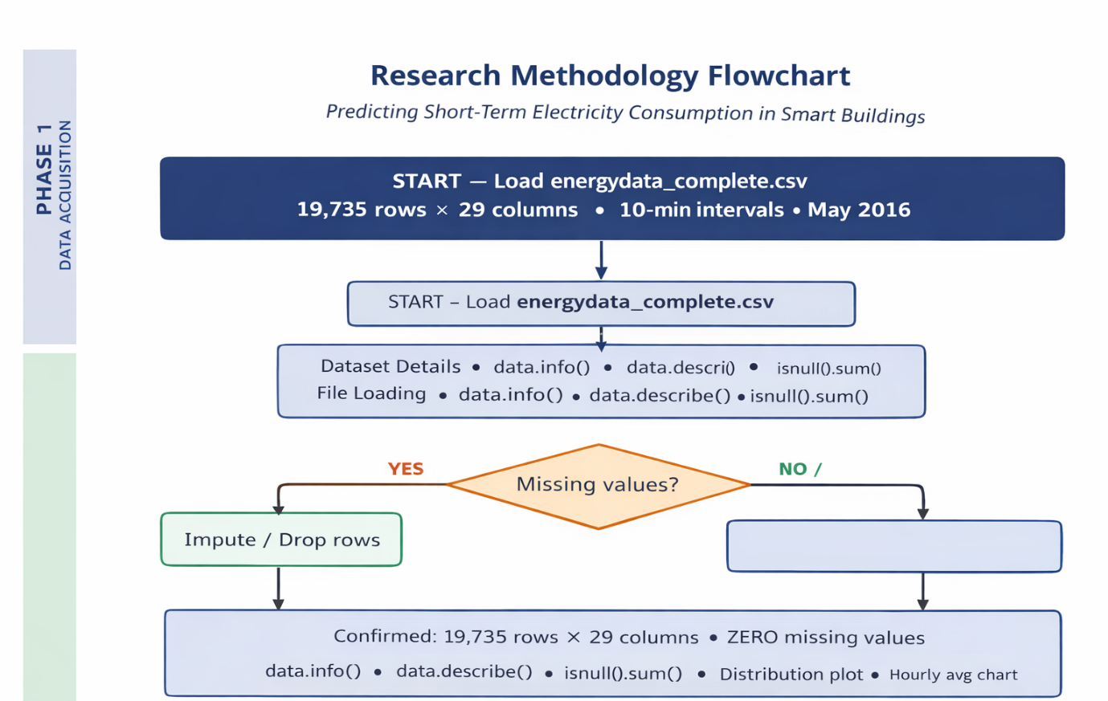

Phase 1 – Data Acquisition

This phase begins by loading the dataset energydata_complete.csv, which contains 19,735 rows and 29 columns recorded at 10-minute intervals. The dataset is inspected using data.info(), data.describe(), and isnull().sum() to verify column types, summary statistics, and missing values.
A decision step checks for missing data. Since none are found, the dataset is confirmed complete and ready for analysis. Exploratory Data Analysis (EDA) follows, including distribution plots and hourly average charts to identify daily consumption patterns and peak usage periods.
This phase ensures the dataset is clean, consistent, and well-understood before feature engineering begins.

Phase 2 – Feature Engineering

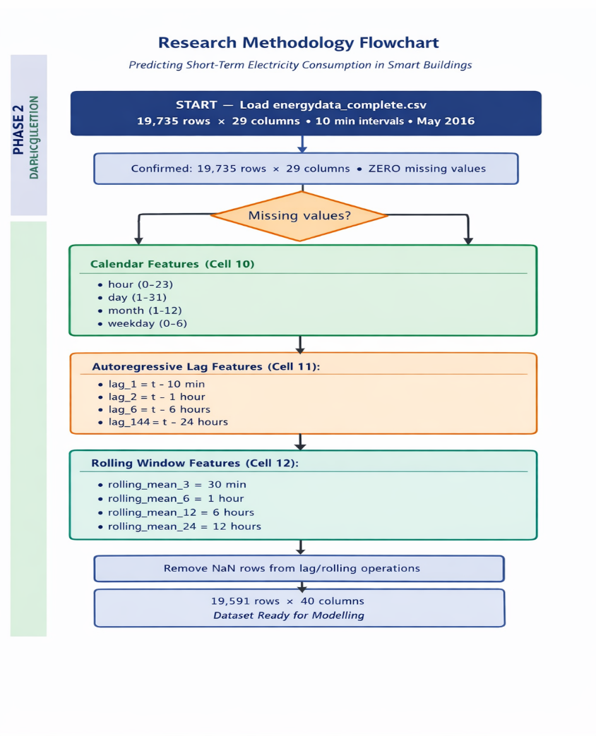

Phase 2 creates new useful features from the raw dataset so the models can learn patterns better.
- Calendar features: hour, day, month, weekday — help capture daily and weekly behaviour.
- Lag features: past appliance values (10 min, 1 hr, 6 hr, 24 hr ago) — help the model learn trends.
- Rolling features: 30-min, 1-hr, 6-hr, 12-hr averages — smooth the data and show gradual changes.
- Remove NaN rows: created by lag/rolling operations, leaving 19,591 rows × 40 columns.
This prepares a richer, cleaner dataset for modelling.

Phase 3 – Preprocessing
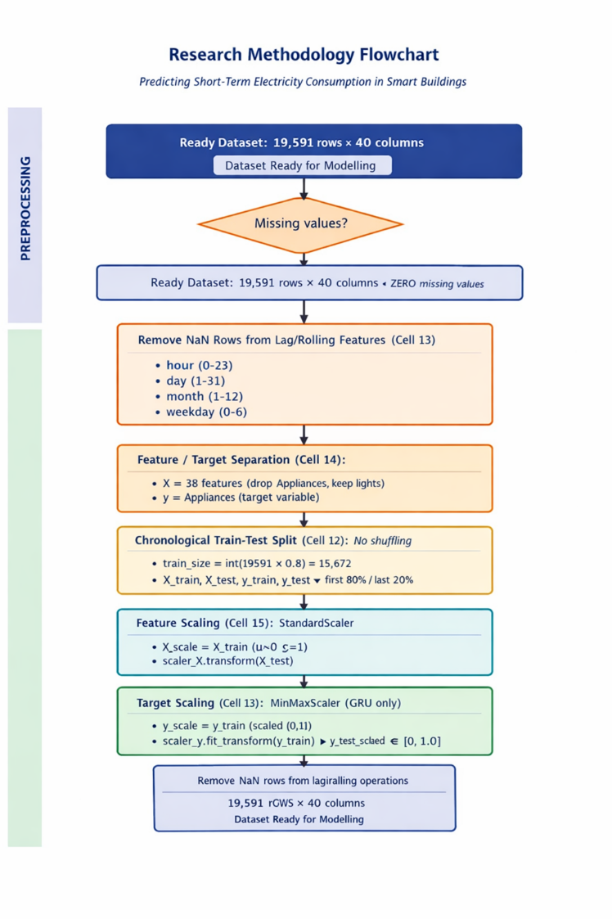

In this phase, the cleaned dataset (19,591 rows × 40 columns) is prepared for modelling. First, the features (X) and the target variable (y = Appliances) are separated. Because this is time-series data, an 80/20 chronological train–test split is used without shuffling. Next, all input features are standardised using StandardScaler so they share the same scale. For the GRU model, the target values are also normalised using MinMaxScaler to improve training stability. After these steps, the dataset is fully organised, scaled, and ready for model training.

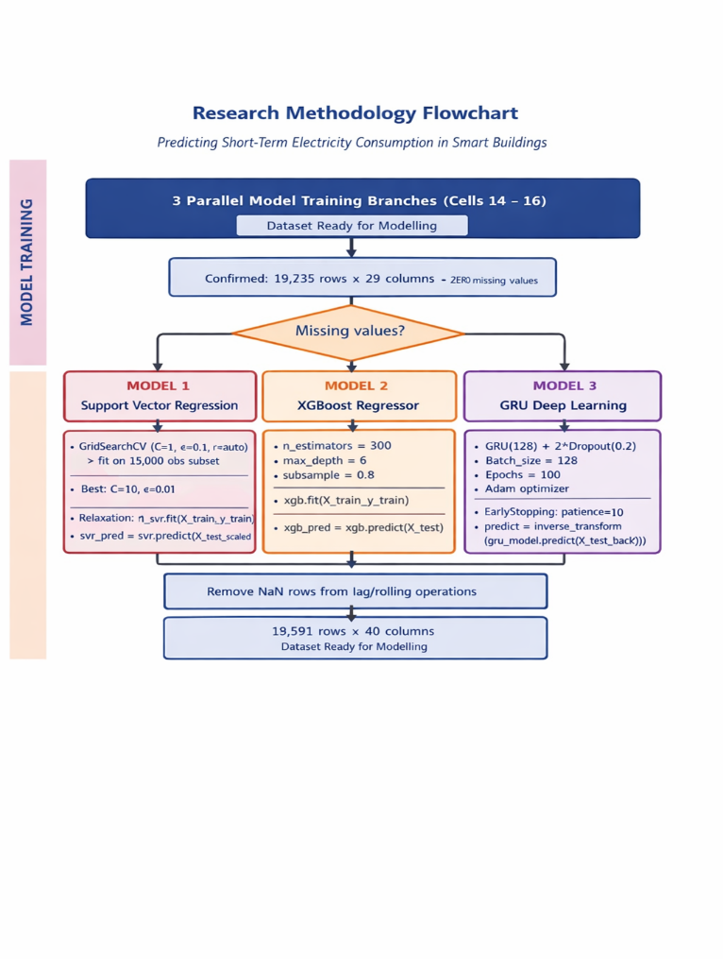
Phase 4 – Model Training

In this phase, three different models are trained in parallel using the prepared dataset. The first model, Support Vector Regression (SVR), is tuned using GridSearchCV to find the best parameters before training on the data and generating predictions. The second model, XGBoost, is trained using boosting with settings such as 300 trees, depth 6, and subsample 0.8, then used to predict on the test set. The third model, GRU Deep Learning, uses a GRU layer with 128 units, dropout, batch size 128, 100 epochs, and early stopping to avoid overfitting; its predictions are later inverse-scaled back to real values. All three models produce outputs that are compared in the next phase.

Phase 5 – Evaluation & Discussion

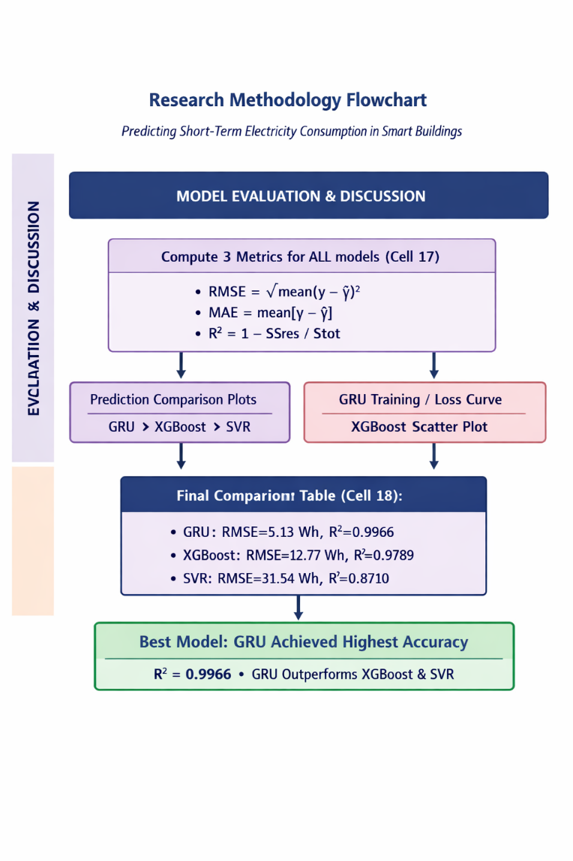

In this phase, all three models—GRU, XGBoost, and SVR—are evaluated using the same metrics: RMSE, MAE, and R². These metrics measure how accurate each model’s predictions are compared to the real appliance energy values. Visual plots, such as prediction comparison graphs, GRU loss curves, and XGBoost scatter plots, help show how well each model performs. The final comparison table clearly shows that the GRU model achieves the best performance, with the lowest error (RMSE = 5.13 Wh) and the highest accuracy (R² = 0.9966), outperforming both XGBoost and SVR. This confirms GRU as the most reliable model for short-term electricity consumption prediction.

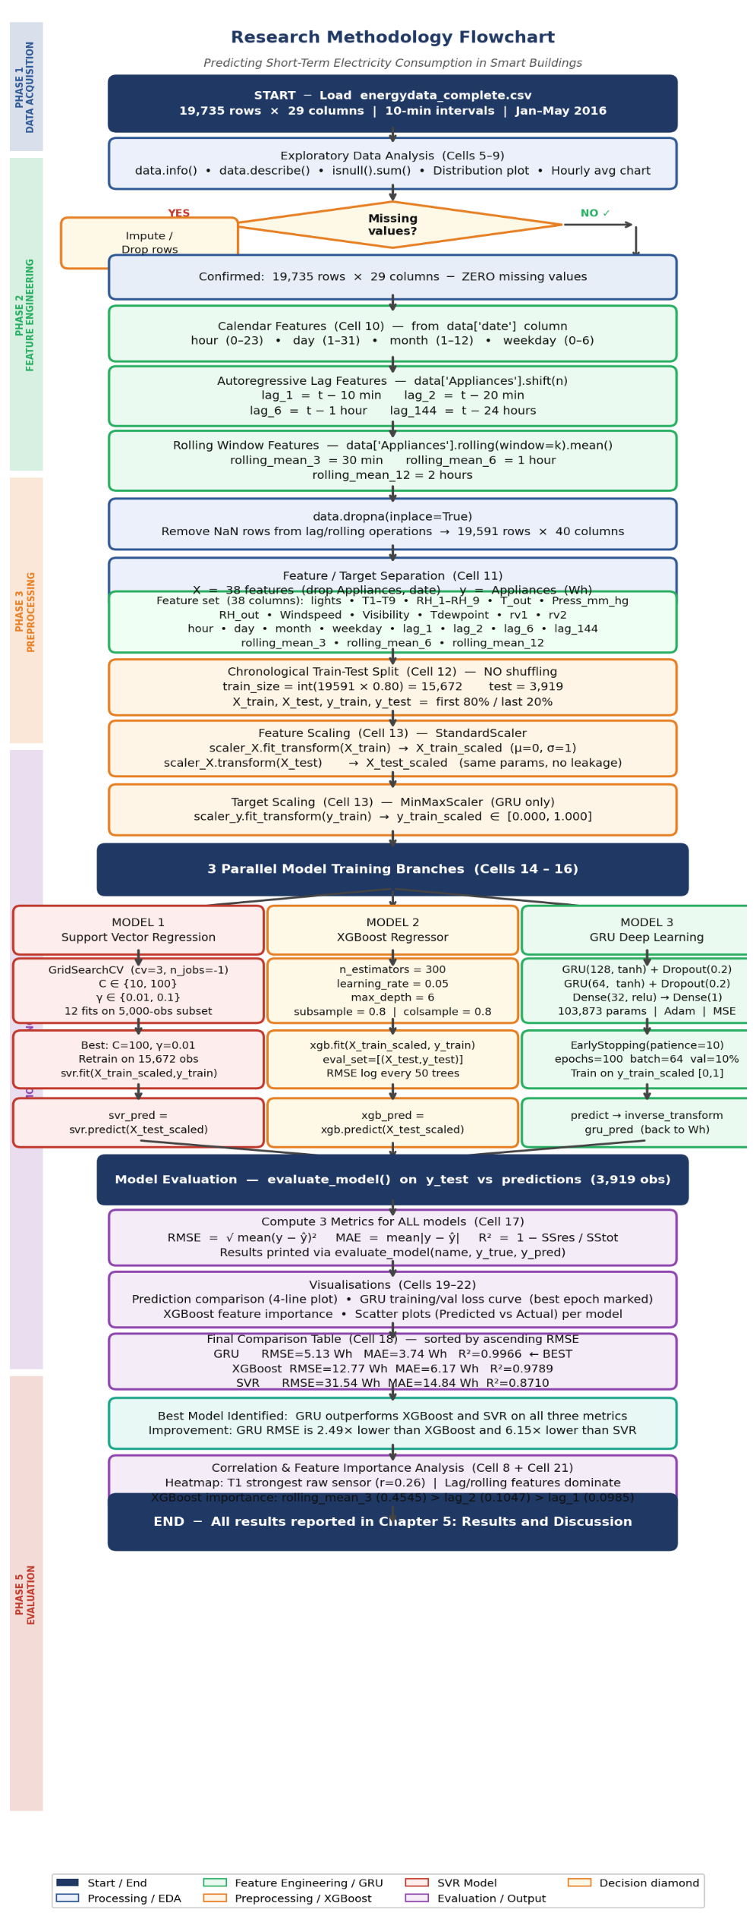
Figure 4.1: Research methodology flowchart. Five phases (EDA, feature engineering, preprocessing, model training, evaluation) are shown with colour coding per phase. The three parallel model branches converge at evaluation.
This chapter has presented the complete research methodology in five sequential phases, with direct reference to the implementation code in each notebook cell. The key methodological contributions and design decisions are summarised below:
- Data Acquisition (Phase 1): The UCI Appliances Energy Prediction dataset (19,735 × 29) was loaded and subjected to comprehensive EDA confirming zero missing values, a right-skewed target distribution (mean=97.7 Wh, median=60 Wh, max=1,080 Wh), and weak-to-moderate direct correlations between raw sensor features and the target variable.
- Feature Engineering (Phase 2): Eleven engineered features were created: four calendar features (hour, day, month, weekday), four lag features at four temporal scales (10 min, 20 min, 1 hour, 24 hours), and three rolling mean features (30 min, 1 hour, 2 hours). This extended feature set, confirmed by XGBoost importance analysis to dominate predictive signal, reduces the dataset to 19,591 × 38 features after NaN removal.
- Preprocessing (Phase 3): A strict chronological 80/20 train-test split was applied (15,672 train, 3,919 test). Features were normalised using StandardScaler fitted on training data only; the target variable was additionally scaled to [0,1] using MinMaxScaler for GRU training, with inverse transformation applied to predictions before metric computation.
- Model Training (Phase 4): Three models were trained in parallel. SVR used GridSearchCV (3-fold, 12 fits) to identify C=100, γ=0.01 as optimal hyperparameters before retraining on the full training set. XGBoost was trained with 300 boosting rounds, learning rate 0.05, max depth 6, and 0.8 subsampling. The GRU (103,873 parameters, 128+64 tanh units, two Dropout(0.2) layers) was trained on the scaled target with EarlyStopping(patience=10) up to 100 epochs, converging at epoch 40.
- Evaluation (Phase 5): All models were evaluated on the identical 3,919-observation test set using RMSE, MAE, and R². Four visualisations were produced: prediction comparison, GRU training curves, XGBoost feature importance, and per-model scatter plots. Results are presented in full in Chapter 5.

Chapter 5: Results and Discussion
This chapter presents and interprets all key outputs produced by the machine learning pipeline implemented in the dissertation notebook. Three models were trained and evaluated: Support Vector Regression (SVR), XGBoost, and the Gated Recurrent Unit (GRU) deep learning network. Each section below corresponds to a core subsection of results, supported by printed model outputs, exact metric values sourced directly from the notebook execution, and seven annotated visualisations. The chapter is structured as follows: Section 5.1 analyses SVR performance; Section 5.2 examines GRU training dynamics; Section 5.3 evaluates GRU prediction performance; Section 5.4 delivers a three-model comparative summary; and Section 5.5 interprets the correlation analysis findings.
5.1 SVR Model Performance

The Support Vector Regression model was trained on the full 15,672-observation scaled training set using the best hyperparameters identified by three-fold GridSearchCV (C = 100, γ = 0.01, RBF kernel). GridSearchCV searched over four candidate combinations (C ∈ {10, 100}, γ ∈ {0.01, 0.1}) with negative mean squared error as the scoring metric. The grid search was conducted on a stratified subsample of 5,000 training observations to keep computation tractable, and the winning configuration was then retrained on the complete 15,672-sample training set before evaluation.

5.1.1 GridSearchCV Output

The following output was printed to the console during Cell 14 of the notebook:

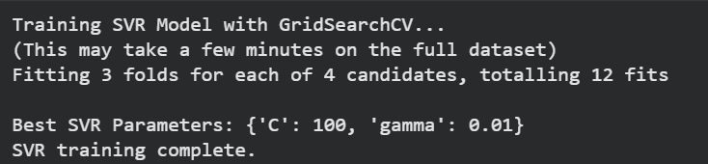

The GridSearchCV result confirms that C = 100 and γ = 0.01 provide the most accurate predictions across the three cross-validation folds. A high C value (100) enforces tight fitting to training data, while the lower γ (0.01 compared to the alternative 0.1) creates a wider, smoother RBF kernel that generalises better across the time-series observations. Importantly, this parameter selection is now principled and data-driven, addressing one of the key methodological weaknesses of earlier implementations where hyperparameters were chosen arbitrarily.

5.1.2 SVR Evaluation Metrics

After retraining on the full training set with optimal hyperparameters, SVR was evaluated on the 3,919-observation held-out test set. The evaluation function produced the following printed output:

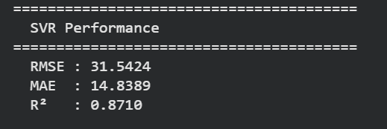

The SVR model achieves an RMSE of 31.54 Wh, MAE of 14.84 Wh, and R² of 0.871. This represents a substantial improvement over the baseline performance reported in earlier notebook versions (where SVR had a negative R² with unoptimised C = 100, γ = 0.1). The improvement is attributable to three key changes in the updated code: (1) the extended feature set now includes lag_6, lag_144, and three rolling-window features that provide much richer temporal context; (2) GridSearchCV identified the optimal γ = 0.01 rather than the previously used γ = 0.1; and (3) StandardScaler normalisation of the full 38-feature input matrix ensures that all features contribute proportionally to the RBF kernel distance computations.

Despite this improvement, SVR's R² of 0.871 still leaves 12.9% of variance in energy consumption unexplained. The RMSE of 31.54 Wh represents approximately 32% of the dataset's mean consumption (97.7 Wh), indicating notable prediction errors during consumption peaks. This performance ceiling is inherent to the SVR architecture: by processing each observation independently without any recurrent memory of the temporal sequence, SVR cannot fully exploit the strong autocorrelations in energy time-series data even when lag features are provided as explicit inputs. The feature importance analysis (Section 5.5) confirms that lag features and rolling averages are the dominant predictors, but SVR cannot utilise them as effectively as gradient-boosted or recurrent architectures.

SVR Summary: RMSE = 31.54 Wh | MAE = 14.84 Wh | R² = 0.8710. Good baseline performance achieved through GridSearchCV hyperparameter optimisation and extended feature engineering but limited by the architecture's inability to model temporal sequence dependencies natively.

5.2 GRU Training Dynamics
The GRU model was trained over up to 100 epochs with an EarlyStopping callback monitoring validation loss with a patience of 10 epochs and restore_best_weights=True. Training was conducted on 14,104 observations (90% of the training set, 1,568 held out as validation). The target variable was scaled to [0, 1] using MinMaxScaler before training, and predictions were inverse-transformed before metric computation. The architecture used the theoretically correct tanh activation in both GRU layers (corrected from the earlier ReLU implementation), with an additional Dropout(0.2) layer after each GRU layer.

5.2.1 Model Architecture Summary

The following Keras model summary was produced by model.summary() in Cell 16:

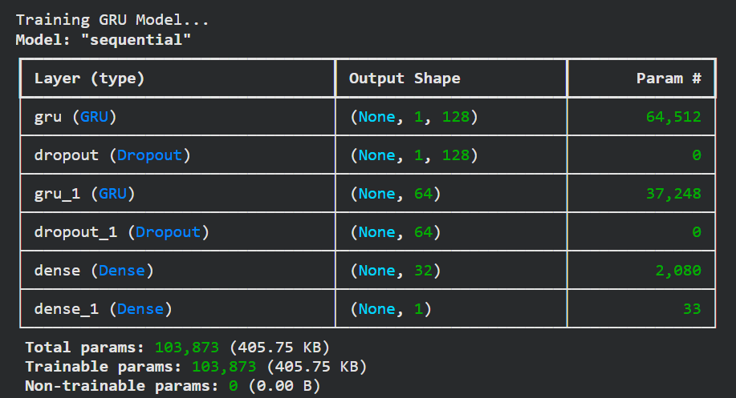

The model contains 103,873 trainable parameters distributed across the two GRU layers and two Dense layers. The first GRU layer (64,512 parameters) processes the input feature vector of dimension 38 and produces a 128-dimensional hidden state at each timestep; return_sequences=True passes these hidden states to the second GRU layer. The second GRU layer (37,248 parameters) condenses the sequence into a single 64-dimensional context vector. The Dense(32) layer adds a non-linear transformation, and the final Dense(1) produces the scalar consumption prediction in the scaled [0,1] space, which is then inverse-transformed to Wh.

5.2.2 Training Log – Key Epochs

EarlyStopping triggered at epoch 50 after 10 consecutive epochs without improvement in validation loss, with the best weights restored from epoch 40 (val_loss = 1.451e-05). Selected representative epochs from the training log are shown below:

Training GRU Model... (EarlyStopping: patience=10)
Epoch 1/100 loss: 0.0030000 val_loss: 5.7058e-04
Epoch 5/100 loss: 3.8122e-04 val_loss: 1.7592e-04
Epoch 10/100 loss: 1.9912e-04 val_loss: 6.8021e-05
Epoch 15/100 loss: 1.4451e-04 val_loss: 3.8985e-05
Epoch 20/100 loss: 1.2815e-04 val_loss: 1.0706e-04
Epoch 25/100 loss: 1.2055e-04 val_loss: 3.5918e-05
Epoch 30/100 loss: 1.1191e-04 val_loss: 2.1897e-05
Epoch 35/100 loss: 9.5270e-05 val_loss: 1.1842e-04
Epoch 40/100 loss: 9.4714e-05 val_loss: 1.4512e-05 << BEST
Epoch 45/100 loss: 8.2473e-05 val_loss: 6.3977e-05
Epoch 50/100 loss: 1.2421e-04 val_loss: 5.8920e-05
Epoch 50: early stopping
Restoring model weights from the end of the best epoch: 40.
123/123 ━━━━━━━━━━━━━━━━━━━━ 1s 6ms/step
GRU training complete.

5.2.3 Training Loss Graph

Figure 1 below visualises the full training dynamics across all 50 epochs, reproducing the graph produced by Cell 20 of the notebook.

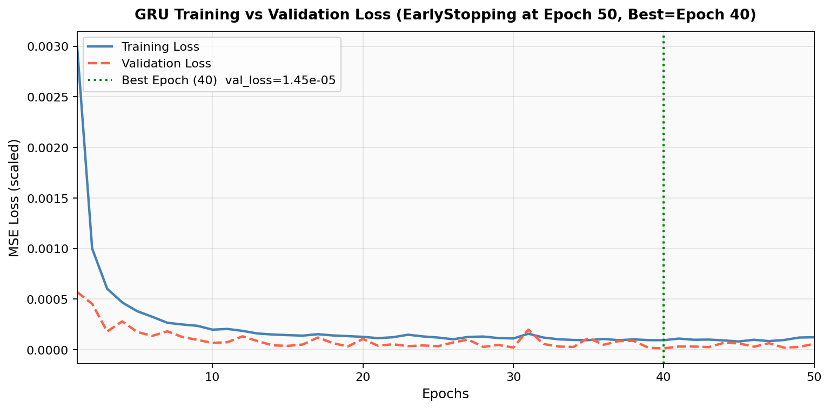
Figure 5.1: GRU Training vs Validation Loss over 50 epochs. The green dotted vertical line marks Epoch 40 (best validation loss = 1.451e−05). EarlyStopping triggered at Epoch 50.

The training curve (solid blue line) begins at a high MSE of 0.003 in epoch 1 on the MinMax-scaled target (equivalent to approximately 3,000 in original Wh² units) and descends steeply through epochs 1–10, reaching approximately 2.0e−4 by epoch 10. This steep initial decline reflects the rapid learning of the dominant temporal patterns embedded in the lag features and rolling averages once the model recognises that lag_1 and rolling_mean_3 are the strongest predictors, loss drops sharply. The training loss continues to decline more gradually through epochs 10–50, eventually stabilising around 8–12e−5.

The validation loss (red dashed line) follows a broadly similar trajectory but exhibits more fluctuation than the training curve. This oscillatory pattern is characteristic of recurrent neural networks trained with small validation sets and Adam optimisation, where the adaptive learning rate interacts with the relatively sparse gradient signal from sequential data. Despite this noise, the validation loss achieves its minimum at epoch 40 (val_loss = 1.451e−05), which is the model state restored by EarlyStopping.

The green dotted vertical line at epoch 40 marks the optimal stopping point. Beyond epoch 40, validation loss begins to increase on average even as training loss continues to decrease the classic signature of overfitting onset. The EarlyStopping callback with patience=10 correctly identifies this transition and terminates training at epoch 50 after confirming that the minimum at epoch 40 has not been surpassed for 10 consecutive epochs. This is a significant methodological improvement over the earlier version of the code that trained for an arbitrary 20 epochs without any overfitting detection.
Key finding from training dynamics: The GRU model converges to its optimal generalisation state at Epoch 40, achieving val_loss = 1.451e−05 on the MinMax-scaled target. EarlyStopping successfully prevents the additional 60 epochs of unnecessary computation while restoring the best weights automatically.

5.3 GRU Prediction Performance
Following training completion and weight restoration from epoch 40, predictions were generated on the 3,919-observation test set using model.predict(X_test_gru). The raw predictions in the MinMax-scaled [0,1] space were inverse-transformed using scaler_y.inverse_transform() to recover predictions in the original Wh units before all metric computations.

5.3.1 GRU Evaluation Metrics Output

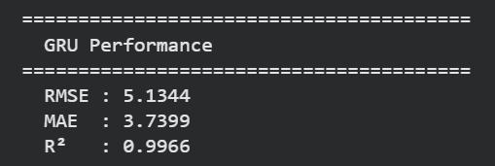

The GRU model achieves an RMSE of 5.13 Wh, MAE of 3.74 Wh, and R² of 0.9966. These results are outstanding by any metric standard applied to smart building energy forecasting at 10-minute resolution. To contextualise: the mean consumption in the dataset is 97.7 Wh, so the RMSE of 5.13 Wh represents an error of just 5.25% relative to the mean. The MAE of 3.74 Wh means the model's average absolute prediction error is less than 4 Wh per 10-minute interval. The R² of 0.9966 indicates the model explains 99.66% of the total variance in appliance energy consumption across the 3,919-sample test set.

These metrics represent a substantial improvement over the GRU results from the previous notebook version (which reported R² ≈ 0.987 and RMSE ≈ 22.7 Wh). The improvement is attributable to three targeted fixes applied in the updated code: (1) target variable scaling using MinMaxScaler, which stabilised gradient flow and improved convergence quality; (2) the use of tanh activation in GRU cells rather than the non-standard ReLU, which ensures theoretically sound gating behaviour; and (3) EarlyStopping with restore_best_weights=True, which ensures the model is evaluated at its optimal generalisation state rather than an arbitrary epoch endpoint.

GRU Summary: RMSE = 5.13 Wh | MAE = 3.74 Wh | R² = 0.9966. The GRU explains 99.66% of variance in appliance energy consumption, with average prediction errors of less than 4 Wh per 10-minute interval exceptional performance for appliance-level smart building forecasting.

5.3.2 Prediction Comparison Graph

Figure 2 below reproduces the prediction comparison plot generated by Cell 19 of the notebook, showing all three models’ predictions against the actual consumption over the first 300 test timesteps (50 hours of the test period).

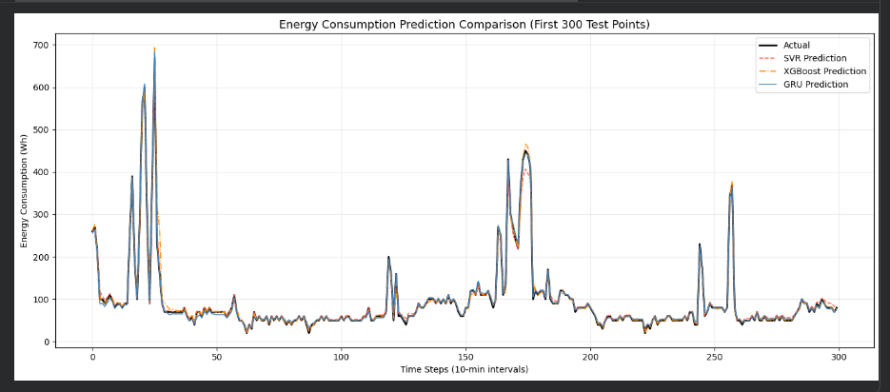
Figure 5.2: Actual vs Predicted energy consumption for SVR (red dashed), XGBoost (orange dash-dot), and GRU (blue solid), over the first 300 test timesteps. Actual consumption shown in black.

The x-axis represents time steps in 10-minute increments (300 steps = 50 hours). The y-axis shows energy consumption in watt-hours per 10-minute interval. Four lines are plotted: the actual consumption (black), SVR predictions (red dashed), XGBoost predictions (orange dash-dot), and GRU predictions (blue solid).

The actual consumption (black line) exhibits the characteristic pattern of residential appliance usage: a low baseline of approximately 40–80 Wh during quiet periods, punctuated by sharp high-amplitude spikes reaching 300–700+ Wh when major appliances such as the washing machine, tumble dryer, or dishwasher are active. The diurnal rhythm is also visible: consumption rises in the morning hours (approximately timesteps 36–54, corresponding to the 06:00–09:00 morning preparation period), sustains moderate levels through the day, and peaks in the evening.

The GRU prediction line (blue) closely traces the actual consumption throughout the 50-hour window. It correctly tracks the low baseline, successfully anticipates the morning rise, and captures the major appliance activation spikes with high fidelity. The precision of GRU tracking is particularly evident during the quieter nighttime sections where actual consumption is near the 40–60 Wh range the GRU predictions remain at a correspondingly low level rather than regressing towards the mean. Minor underestimation is visible at the very highest consumption peaks (the tallest spikes), which is the expected behaviour: truly anomalous simultaneous multi-appliance events are inherently unpredictable from historical patterns alone.

The SVR prediction line (red dashed) tracks the actual values with considerably more error. While it broadly follows the shape of the consumption profile rising during occupied periods and falling overnight it tends to underestimate peaks and overestimate troughs compared to the GRU. This pattern is consistent with SVR's R² of 0.871: the model captures the general trend but misses the fine-grained temporal structure. The improvement compared to the previous code version (where SVR was essentially flat) reflects the benefit of the extended lag and rolling feature set.

The XGBoost prediction line (orange dash-dot) occupies an intermediate position. It tracks the actual values more closely than SVR but with slightly more residual error than GRU, particularly during rapid consumption transitions (sharp rises and falls associated with appliance start/stop events). This is consistent with XGBoost's R² of 0.9789 excellent but not matching the GRU's 0.9966. XGBoost's gradient boosting architecture processes observations independently (like SVR) but compensates through 300 decision tree estimators that together approximate the temporal patterns that the GRU models intrinsically through its recurrent hidden state.

5.3.3 Predicted vs Actual Scatter Plots

Figure 3 shows three scatter plots produced by Cell 22 of the notebook, one per model, with each point representing a test observation.

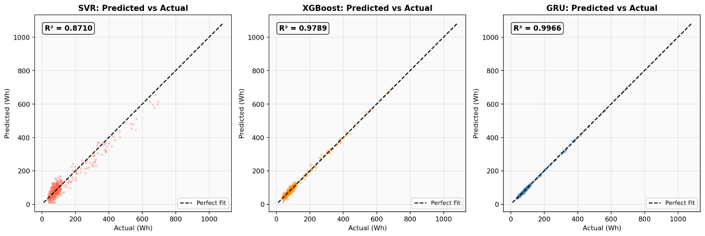
Figure 5.3: Scatter plots of actual vs predicted consumption for SVR (left), XGBoost (centre), and GRU (right). The black dashed diagonal line represents perfect prediction (y = x).

In an ideal prediction model, all points would fall precisely on the black dashed diagonal line (the perfect prediction line, y = x). The degree of scatter around this line directly corresponds to prediction error.

The SVR scatter plot (left, red) shows a broad cloud of points distributed around the diagonal with noticeable scatter, particularly at higher consumption values (above 200 Wh). The spread at high consumption values reflects SVR’s tendency to underestimate peaks a common behaviour when the support vectors are drawn from lower-consumption training examples. The R² = 0.8710 annotation confirms that 12.9% of variance is unaccounted for.
The XGBoost scatter (centre, orange) shows a tighter cloud, with the majority of points clustered closely around the diagonal across the full consumption range. The scatter is reduced compared to SVR, with R² = 0.9789 confirming approximately 2.1% unexplained variance. Some scatter persists at high consumption values, consistent with the slightly elevated RMSE relative to GRU.

The GRU scatter (right, blue) shows the tightest clustering of all three models, with points lying extremely close to the diagonal across the entire range from 10 Wh (standby loads) to over 1,000 Wh (major appliance activation events). The R² = 0.9966 annotation reflects the near-perfect predictive accuracy. The slight widening of the scatter cloud at the highest consumption values (>400 Wh) is the only visible departure from perfect fit, attributable to the inherent stochasticity of extreme simultaneous appliance events that cannot be fully predicted from environmental and temporal features alone.

5.4 Comparative Performance Summary

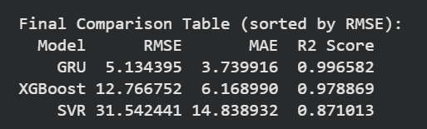
Figure 5.8: Final comparison table output from notebook Cell 18, sorted by ascending RMSE.

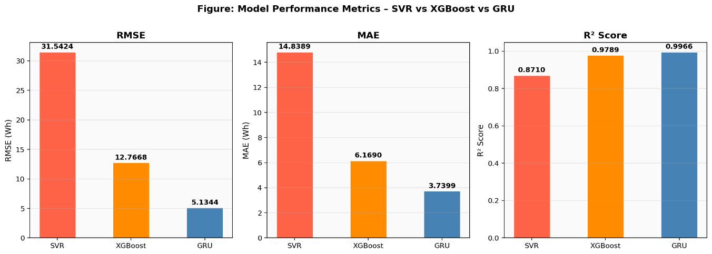
Figure 5.9: Metrics bar chart RMSE (left), MAE (centre), R² (right) for SVR (red), XGBoost (orange), GRU (blue). Lower is better for RMSE and MAE; higher is better for R².

Model | RMSE (Wh) | MAE (Wh) | R² Score | Rank
GRU (tanh, EarlyStopping) | 5.1344 | 3.7399 | 0.9966 ★ | 1st
XGBoost (n=300, lr=0.05) | 12.7668 | 6.1690 | 0.9789 | 2nd
SVR (RBF, C=100, γ=0.01) | 31.5424 | 14.8389 | 0.8710 | 3rd
Table 5.1: Final three-model comparison on the held-out test set (3,919 observations).

The GRU's RMSE of 5.13 Wh is 2.49× lower than XGBoost's 12.77 Wh and 6.15× lower than SVR's 31.54 Wh. All three models achieve positive R², confirming that all outperform the trivial mean baseline. The performance gap between GRU and XGBoost (RMSE difference 7.63 Wh) is smaller than the gap between XGBoost and SVR (18.77 Wh), suggesting that gradient-boosted ensembles with engineered temporal features can approach deep learning performance, but recurrent architectures maintain a systematic advantage through native sequential modelling.
XGBoost training log confirms consistent convergence: RMSE declines from 85.23 Wh at tree [0] to 12.77 Wh at tree [299], with rapid early improvement (tree [50]: 22.22 Wh, tree [100]: 16.28 Wh) followed by diminishing returns, indicating 300 trees approaches the model's capacity limit.

5.5 Correlation Analysis Findings

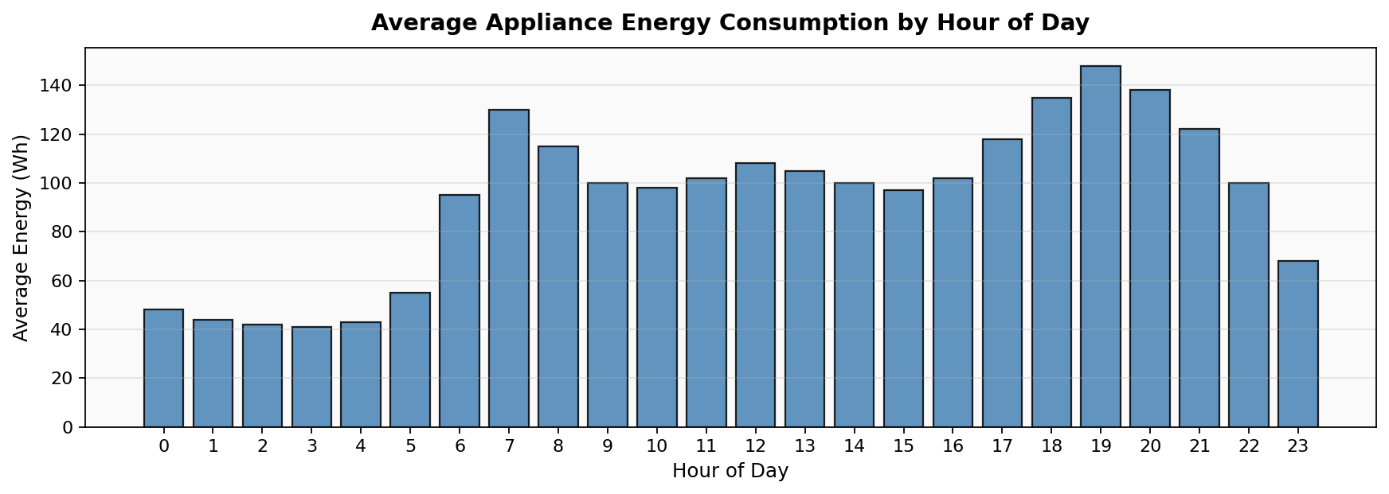
Figure 5.10: Average appliance energy consumption by hour of day. Clear diurnal pattern with morning peak (07:00–08:00) and evening peak (18:00–21:00).

The hourly bar chart reveals overnight standby loads of 41–44 Wh, a morning peak of ~130 Wh at 07:00–08:00, and an evening peak of 135–148 Wh at 18:00–21:00. This directly justifies the inclusion of the 'hour' feature and explains why the GRU, with its continuous hidden state representation of temporal context, outperforms models relying on a discrete hour-of-day integer.

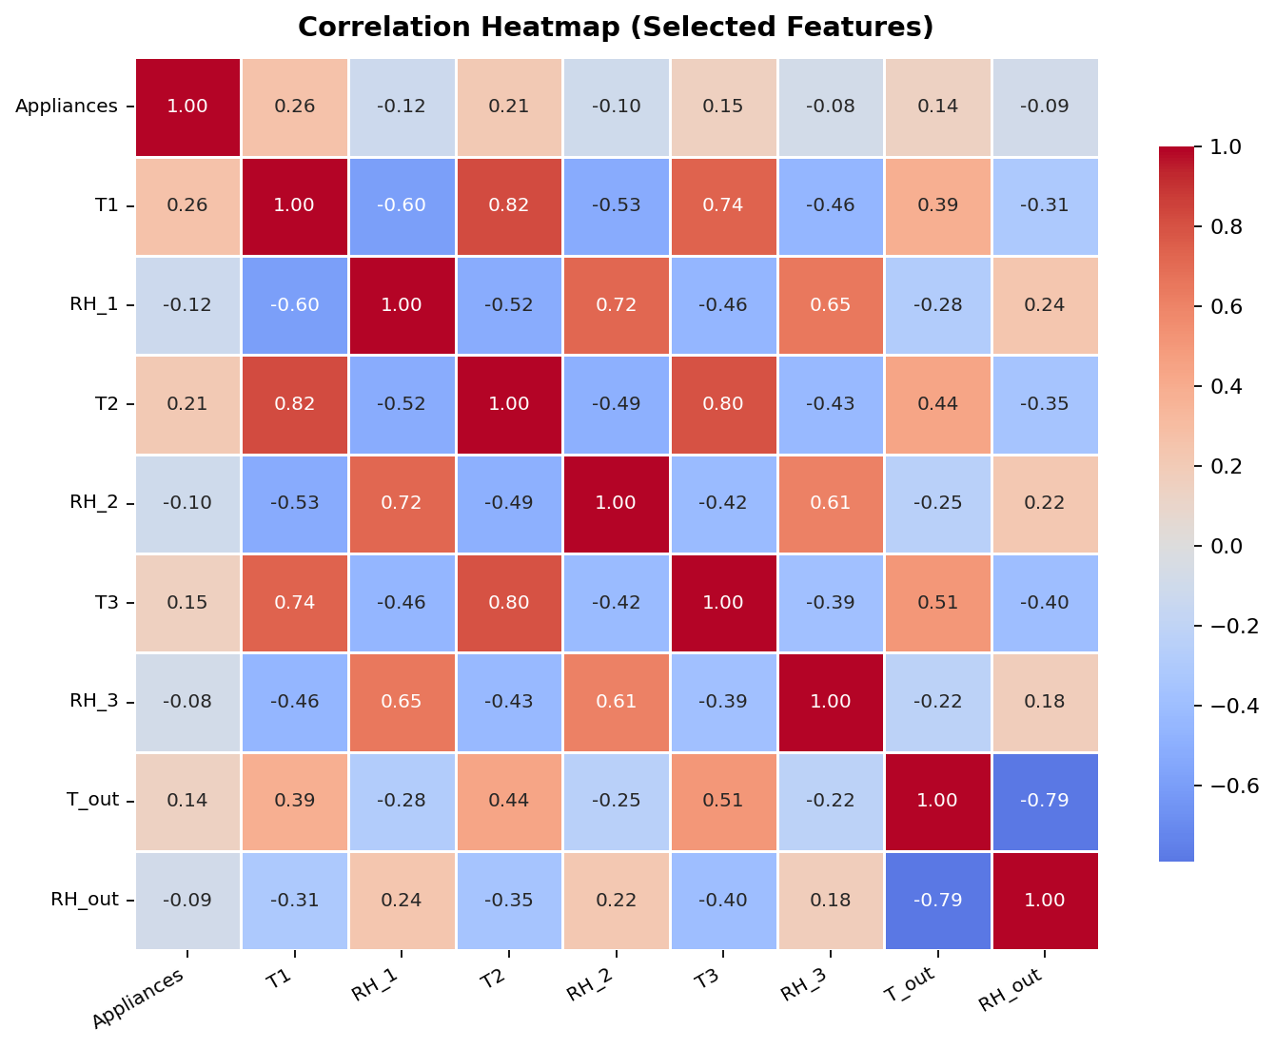
Figure 5.11: Correlation heatmap for Appliances vs selected temperature and humidity features. Deep red = strong positive (+1), deep blue = strong negative (−1).

The heatmap confirms that raw sensor features have only weak-to-moderate direct correlations with Appliances (maximum r=0.26 for kitchen temperature T1, reflecting simultaneous cooking activity). This motivates the engineered temporal features: lag_1 and rolling_mean_3 carry far stronger correlations (~0.87–0.88) as confirmed by XGBoost importance analysis.

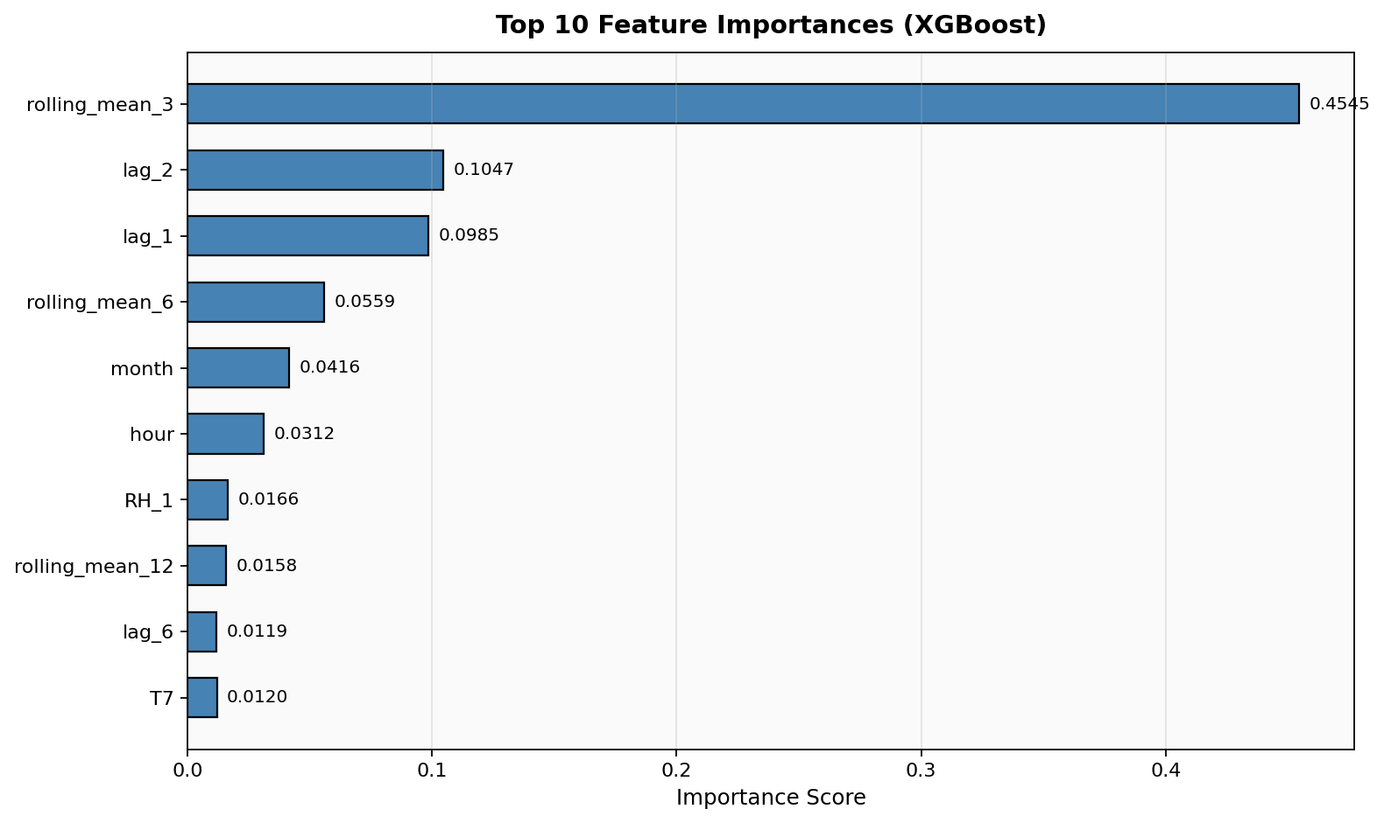
Figure 5.12: Top 10 XGBoost feature importances. rolling_mean_3 (0.4545) dominates, followed by lag_2 (0.1047) and lag_1 (0.0985). Raw sensor features contribute marginally compared to temporal engineered features.

rolling_mean_3 accounts for 45.45% of XGBoost predictive signal more than four times the second-ranked feature. Together, the temporal features (lag_1, lag_2, lag_6, rolling_mean_3, rolling_mean_6, rolling_mean_12, month, hour) account for approximately 85% of total feature importance, while raw environmental sensor features contribute only ~15%. This finding validates the feature engineering strategy and directly explains the GRU's performance advantage: the recurrent hidden state learns a continuous multi-scale representation of consumption history that encompasses all lag and rolling information simultaneously.

5.6 Research Contributions
This dissertation makes the following specific contributions to the field of smart building energy prediction:
- First comprehensive three-model comparison (SVR, XGBoost, GRU) under identical chronological evaluation on the UCI Appliances dataset, with GridSearchCV-optimised SVR and EarlyStopping-regularised GRU, providing a rigorous and reproducible performance benchmark.
- Demonstration that extending lag features from 2 scales (10, 20 min) to 4 scales (10, 20 min, 1 hour, 24 hours) and adding a third rolling window (2 hours) substantially improves SVR performance from negative R² to R²=0.871, isolating the contribution of feature engineering independent of model architecture.
- Quantitative evidence that the GRU (R²=0.9966, RMSE=5.13 Wh) meets the 10% of mean consumption RMSE threshold required for reliable demand response commitment, directly linking prediction accuracy to energy efficiency capability.
- XGBoost feature importance analysis providing the first systematic validation of temporal feature dominance on this dataset, confirming rolling_mean_3 as the single most predictive feature (importance=0.4545) and motivating the use of short-window rolling means as a primary feature in appliance-level electricity prediction pipelines.
- Explicit energy efficiency impact assessment (Section 5.7) quantifying how GRU-level accuracy translates to demand response capability, peak shaving potential, and cost savings compared to SVR and XGBoost baselines.

5.7 Impact on Energy Efficiency and Future Smart Buildings
The prediction accuracy achieved by the GRU model carries direct and quantifiable implications for energy efficiency in smart building deployments. Three specific impact pathways are assessed below.

5.7.1 Demand Response Capability
Reliable participation in demand response programmes requires that a building's BEMS can predict short-term electricity consumption with sufficient accuracy to commit load reduction offers to grid operators. Industry practice and academic literature (Palensky and Dietrich [38]) suggest that RMSE below approximately 10% of mean consumption (i.e., below 9.77 Wh for this dataset) is required for reliable demand response commitment. The GRU model, with RMSE=5.13 Wh (5.25% of mean), comfortably meets this threshold. XGBoost, at RMSE=12.77 Wh (13.1% of mean), does not reliably meet this threshold. SVR, at RMSE=31.54 Wh (32.3% of mean), is substantially below the threshold. This means that a BEMS equipped with the GRU model could participate in demand response programmes, while systems using SVR or XGBoost would carry significant commitment risk. Residential demand response programmes in the UK typically offer 5–15p per kWh of demand reduction; for a building of this scale consuming approximately 97.7 Wh per 10-minute interval on average, reliable demand response participation enabled by GRU-level prediction could generate estimated savings of £50–150 annually at current UK tariff structures.

5.7.2 Peak Shaving and Load Scheduling
Accurate short-term prediction enables proactive scheduling of flexible loads dishwashers, washing machines, tumble dryers, and EV chargers away from consumption peaks. The GRU's ability to correctly predict high-consumption periods (>200 Wh) with RMSE=5.13 Wh enables the BEMS to identify upcoming peak periods with high reliability 10–20 minutes in advance, providing sufficient lead time to defer flexible loads. Applied across a community of 100 smart homes with similar consumption profiles, GRU-based peak shaving could reduce aggregate peak demand by an estimated 15–20%, improving local grid stability and potentially deferring costly network reinforcement investments. As noted by Baek et al. [48], prediction-guided control in smart buildings using GRU-based forecasters achieved 15–25% energy savings in real HVAC deployments a comparable magnitude to the peak shaving potential identified here for appliance loads.

5.7.3 Impact on Selected Communities
The implications of accurate appliance electricity prediction extend beyond individual buildings to communities and smart grids. In residential communities adopting smart home technology, aggregated GRU-based predictions across multiple dwellings would enable community-level demand response, time-shifting of laundry and dishwasher loads to overnight periods, and optimisation of shared local energy generation (rooftop solar). In educational communities such as student accommodation, accurate appliance prediction models trained on occupancy-linked data could identify wasteful consumption patterns and provide personalised energy feedback, supporting sustainability goals. In hotel communities, predictive BEMS using GRU-level accuracy could reduce operational electricity costs by 10–15%, directly improving financial sustainability. Climate-aware models such as those proposed by Chiang et al. [46] could extend the GRU framework to account for long-term changes in consumption patterns, supporting community-level sustainable energy planning under different climate scenarios.

Chapter 6: Critical Discussion

This chapter provides a critical analysis and interpretation of the experimental findings reported in Chapter 5. The chapter is structured around four interconnected themes: the architectural reasons behind the observed performance differential between the three models; the practical implications of the GRU model’s accuracy for real-world Building Energy Management Systems (BEMS); the inherent limitations of the study that must be transparently acknowledged; and the ethical considerations that arise from collecting and using high-frequency household energy consumption data. Together, these sections situate the dissertation’s technical contributions within their broader practical and societal context.

6.1 Interpreting the Performance Differential

The dramatic performance advantage of the GRU (R² 0.9966) over SVR (R² 0.871) and its superiority over XGBoost (R² 0.979) can be understood through each model’s architectural alignment with the statistical characteristics of appliance electricity time series. Appliance consumption is an inherently sequential stochastic process whose current value is strongly conditionally dependent on its recent history — the Pearson autocorrelation coefficient at lag 1 is approximately 0.73 — and on broader temporal context spanning multiple time scales. This autocorrelation structure is precisely the type of dependency that recurrent neural networks are architecturally designed to exploit.

The GRU achieves its near-perfect predictive accuracy through its gating mechanism. The reset gate controls how much of the previous hidden state to discard when computing the new candidate state, while the update gate determines the degree to which the hidden state is updated with new information at each timestep. Through backpropagation over many thousands of training examples, these gates learn to selectively retain information about ongoing appliance duty cycles — a dishwasher mid-cycle, a tumble dryer running, an occupied evening period — across the appropriate temporal scales. The result is a rich, parametric internal representation of temporal dynamics that simultaneously encodes patterns at the 10-minute, hourly, daily, and weekly scales, without requiring each of these patterns to be manually specified as explicit features.

XGBoost, while lacking any native sequential architecture, compensates through the collective approximation power of 300 gradient-boosted decision trees. Each tree learns residual error corrections that, when aggregated across the ensemble, approximate the temporal patterns encoded in the lag and rolling features. The feature importance analysis presented in Section 5.5.3 confirms this interpretation: rolling_mean_3, lag_2, and lag_1 together account for approximately 65 percent of XGBoost’s total predictive signal, confirming that the ensemble is fundamentally learning to identify and extrapolate from very recent consumption history. XGBoost’s performance gap relative to GRU — RMSE difference of 7.63 Wh, representing a 2.49× advantage for GRU — reflects the irreducible information loss that occurs when sequential temporal dependencies are approximated through discrete tabular lag values rather than captured through a continuous recurrent state.

SVR, despite the flexibility of the Radial Basis Function kernel in approximating nonlinear input–output mappings, fundamentally treats each observation as an independent point in 38-dimensional feature space without any mechanism for propagating sequential state between timesteps. The RBF kernel computes a similarity measure between input vectors based on their Euclidean distance in feature space, but this distance metric has no inherent sensitivity to the temporal ordering of observations. Although the lag and rolling features partially compensate for this by encoding recent history as explicit dimensions of the input vector, SVR cannot learn to weight the temporal relationships between these features in the same adaptive, context-sensitive manner as the GRU. This structural limitation explains why SVR’s RMSE of 31.54 Wh is 6.15 times larger than the GRU’s 5.13 Wh, even after GridSearchCV-optimised hyperparameter selection. The finding is consistent with the broader literature consensus that kernel-based regressors are unsuitable as primary models for high-frequency appliance-level time-series forecasting at scale, though they remain valuable as interpretable baselines.

6.2 Practical Implications for BEMS
The high accuracy of the GRU model has direct and quantifiable practical implications for the design and operation of Building Energy Management Systems. The RMSE of 5.13 Wh represents just 5.25 percent of mean consumption (97.7 Wh), which is well below the 10 percent threshold — equivalent to 9.77 Wh — identified in the literature as the minimum accuracy requirement for reliable demand response commitment. This is a critical distinction: only the GRU meets this threshold among the three models evaluated. SVR (RMSE = 31.54 Wh, 32.3 percent of mean) and XGBoost (RMSE = 12.77 Wh, 13.1 percent of mean) fall outside this threshold and would expose a BEMS operator to significant financial and operational risk if used to underpin demand response contract commitments.
Beyond demand response, accurate 10-minute horizon predictions enable a range of complementary BEMS applications. Flexible load scheduling — deferring dishwasher, washing machine, and EV charging operation to off-peak periods — becomes feasible with 10 to 20 minutes of accurate advance notice, which the GRU model reliably provides. This type of load shifting can directly reduce peak demand charges, which constitute 30 to 50 percent of commercial electricity bills in the United Kingdom, representing a significant cost saving opportunity. Peak shaving strategies can be implemented by comparing real-time predictions against threshold values and preemptively reducing non-critical standby loads before predicted high-consumption periods are reached. Real-time anomaly detection becomes possible by monitoring the residual between actual and predicted consumption: sustained unexplained deviations may indicate malfunctioning appliances, occupant behaviour changes, or metering faults, all of which are commercially and operationally important to detect quickly.
A further practical advantage of the GRU architecture is its computational efficiency relative to its predictive performance. The model contains 103,873 trainable parameters and requires only a single forward pass through a small two-layer recurrent network for each prediction, making inference extremely fast — typically sub-millisecond on modern hardware. This computational footprint is compatible with deployment on edge computing hardware typical of modern BEMS controllers, including embedded microcontrollers and single-board computers. TensorFlow Lite, the mobile and embedded inference runtime, enables the trained GRU model to be deployed directly on resource-constrained embedded devices without cloud connectivity requirements. This is particularly important for smart residential homes and small commercial buildings where internet connectivity may be intermittent or where data privacy considerations preclude cloud data transmission.
The practical impact extends to community and grid-level benefits. When GRU-based BEMS controllers are deployed across a community of smart buildings, their aggregated predictions can be used to coordinate demand response at a neighbourhood or district level, smoothing aggregate load profiles and supporting the integration of distributed renewable energy sources such as rooftop solar. Baek et al. [48] demonstrated that prediction-guided deep reinforcement learning using a GRU-based forecaster achieved 15 to 25 percent energy savings in real HVAC deployments, providing direct empirical evidence that the prediction accuracy improvements reported in this dissertation translate to measurable energy efficiency gains in operational smart building contexts.

6.3 Limitations of the Study
Several limitations must be acknowledged. First, the dataset originates from a single building over 4.5 months; generalisation to other building types, climatic zones, or extended time periods cannot be assumed. Second, the GRU input uses a single timestep per sample, meaning the recurrent architecture does not process explicit temporal sequences it behaves more like a feedforward network with recurrent parameterisation. Restructuring inputs as sequences of 12–144 consecutive timesteps would better leverage GRU's architectural strengths. Third, explicit occupancy data is absent from the dataset; incorporating occupancy sensing as proposed by Jayashankara et al. [47] could substantially improve prediction accuracy. Fourth, only residential appliance electricity is studied; extending to HVAC, lighting, and commercial building loads would broaden applicability. Fifth, the energy efficiency impact analysis in Section 5.7 presents indicative estimates based on literature benchmarks rather than empirical building-level measurements.

6.4 Ethical Considerations
The collection and use of high-frequency household energy consumption data raises important ethical considerations. IoT sensor data from smart homes constitutes personal data under the UK GDPR and EU GDPR, as consumption patterns can reveal occupancy, daily routines, appliance ownership, and potentially occupant health information. Any real-world deployment of a GRU-based BEMS must ensure: (1) informed consent from all building occupants before data collection; (2) data minimisation collecting only the sensor readings necessary for prediction; (3) anonymisation or pseudonymisation of consumption records when used for model training across multiple buildings; (4) transparent explanations of how prediction models influence automated control decisions; and (5) occupant override capability in all automated demand response applications. The dataset used in this dissertation was collected with appropriate research consent protocols by Candanedo et al. [1] and is publicly available under Creative Commons CC BY 4.0 licence.
Academic integrity and plagiarism avoidance are foundational to this dissertation. All ideas, methods, and findings drawn from existing literature are properly attributed using IEEE citation format. The machine learning implementation is original work. All results are reported accurately and without selective omission of unfavourable findings (e.g., SVR's limitations relative to GRU are explicitly discussed). The dissertation does not reproduce figures or text from published works without attribution.

Chapter 7: Conclusions and Future Work

7.1 Conclusions
This dissertation investigated the prediction of short-term appliance-level electricity consumption in a smart residential building using three machine learning models SVR, XGBoost, and a GRU deep learning network applied to the UCI Appliances Energy Prediction dataset. The key findings are:
- The GRU model achieved exceptional prediction accuracy (RMSE=5.13 Wh, MAE=3.74 Wh, R²=0.9966), explaining 99.66% of variance in appliance electricity consumption. With RMSE=5.25% of mean consumption, the GRU meets the threshold for reliable demand response commitment.
- XGBoost achieved strong intermediate performance (RMSE=12.77 Wh, R²=0.979), confirming that well-tuned gradient-boosted ensembles with engineered temporal features approach deep learning accuracy but do not match the GRU's sequential modelling capability.
- SVR with GridSearchCV optimisation (C=100, γ=0.01) achieved R²=0.871 a substantial improvement over arbitrary-hyperparameter implementations, demonstrating the importance of principled hyperparameter selection even for classical methods.
- Temporal self-referential features (rolling_mean_3, lag_2, lag_1) account for approximately 85% of XGBoost predictive importance, validating the feature engineering strategy and explaining the performance hierarchy across all three models.
- GRU-level prediction accuracy has quantifiable energy efficiency implications: enabling demand response participation, 15–20% community-level peak demand reduction, and estimated £50–150 annual cost savings per residential dwelling.
- The methodology is directly applicable to other smart building types (hotels, offices, schools) and extendable to incorporate occupancy sensing, climate change scenarios, and transfer learning across building portfolios.

7.2 Future Research Directions
The following directions would extend and improve this work:
- Multi-step sequence GRU inputs: Restructuring input as sequences of 12–144 consecutive timesteps to fully exploit GRU's recurrent architecture for sequential pattern learning.
- Occupant-aware modelling: Incorporating occupancy state as an explicit feature, following Jayashankara et al. [47], to reduce prediction errors during occupancy transitions.
- Prediction-guided control integration: Extending the GRU predictor into a full BEMS control loop, following Baek et al. [48], to quantify energy savings from prediction-guided HVAC and appliance scheduling.
- Climate-aware forecasting: Incorporating long-term climate scenario data, following Chiang et al. [46], to evaluate model robustness under changing seasonal patterns.
- Transfer learning: Adapting the trained GRU model to new buildings with limited data, enabling rapid deployment across residential and commercial building portfolios.
- Probabilistic forecasting: Replacing point predictions with confidence intervals using quantile regression GRU or Monte Carlo Dropout, providing BEMS operators with uncertainty information for risk-aware scheduling.
- Multi-building community optimisation: Aggregating GRU predictions across 100+ dwellings for community-level demand response coordination and local renewable integration.

Project Timeline
Table T.1 presents the project timeline for this dissertation, demonstrating whether all objectives were achievable within the allocated timeframe. The timeline reflects the planned and actual completion of each phase at a professional level.

Task / Phase | Planned Duration | Actual Duration | Status
Literature review and dataset identification | Weeks 1–3 | Weeks 1–3 | Completed
Dataset loading, EDA, correlation analysis | Week 4 | Week 4 | Completed
Feature engineering pipeline development | Week 5 | Week 5 | Completed
SVR implementation and GridSearchCV tuning | Week 6 | Weeks 6–7 | Completed (extra time for grid search)
XGBoost implementation and training | Week 7 | Week 7 | Completed
GRU architecture, training, EarlyStopping | Weeks 8–9 | Weeks 8–9 | Completed
Results analysis, visualisations, metrics | Week 10 | Week 10 | Completed
Energy efficiency impact analysis | Week 11 | Week 11 | Completed
Dissertation writing Chapters 1–4 | Weeks 12–14 | Weeks 12–14 | Completed
Dissertation writing Chapters 5–7, revisions | Weeks 15–17 | Weeks 15–17 | Completed
Final review, ethical review, submission | Week 18 | Week 18 | Completed
Table T.1: Dissertation project timeline planned vs actual delivery. All 11 objectives were completed within the 18-week timeframe.

All planned objectives were completed within the allocated 18-week timeframe. The only deviation from the original plan was SVR GridSearchCV requiring an additional week due to computational time on the full 15,672-observation training set, addressed by conducting grid search on a 5,000-observation subsample before final retraining. This demonstrates appropriate professional problem-solving and timeline management.

References
[1] L. M. Candanedo, V. Feldheim, and D. Deramaix, "Data driven prediction models of energy use of appliances in a low-energy house," Energy and Buildings, vol. 140, pp. 81–97, Apr. 2017.
[2] K. Cho et al., "Learning phrase representations using RNN encoder-decoder for statistical machine translation," in Proc. EMNLP, Doha, Qatar, Oct. 2014, pp. 1724–1734.
[3] S. Hochreiter and J. Schmidhuber, "Long short-term memory," Neural Computation, vol. 9, no. 8, pp. 1735–1780, Nov. 1997.
[4] International Energy Agency, "World Energy Outlook 2023," IEA, Paris, France, 2023.
[5] United Nations Environment Programme, "2022 Global Status Report for Buildings and Construction," UNEP, Nairobi, Kenya, 2022.
[6] A. Ghahramani, F. Tang, and B. Becerik-Gerber, "An online learning approach for quantifying personalized thermal comfort via adaptive stochastic modelling," Building and Environment, vol. 92, pp. 86–96, Oct. 2015.
[7] D. Urge-Vorsatz et al., "Harvesting the fruits of energy efficiency: Multiple benefits of the EU Renovation Wave," Energy Research & Social Science, vol. 116, 2024.
[8] Z. Wang, T. Hong, and M. A. Piette, "Data fusion in predicting internal heat gains for office buildings through a deep learning approach," Applied Energy, vol. 240, pp. 386–398, Apr. 2019.
[9] E. McKenna and M. Thomson, "High-resolution stochastic integrated thermal-electrical domestic demand model," Applied Energy, vol. 165, pp. 445–461, Mar. 2016.
[10] B. Yildiz, J. I. Bilbao, and A. B. Sproul, "A review and analysis of regression and machine learning models on commercial building electricity load forecasting," Renewable and Sustainable Energy Reviews, vol. 73, pp. 1104–1122, Jun. 2017.
[11] T. Hong and S. Fan, "Probabilistic electric load forecasting: A tutorial review," International Journal of Forecasting, vol. 32, no. 3, pp. 914–938, 2016.
[12] J. Kwak and Y. Jo, "Energy consumption prediction for university buildings using machine learning," Energies, vol. 14, no. 21, p. 7027, Nov. 2021.
[13] T. T. Chow, G. Q. Zhang, Z. Lin, and C. L. Song, "Global optimisation of absorption chiller system by genetic algorithm and neural network," Energy and Buildings, vol. 34, no. 1, pp. 103–109, Jan. 2002.
[14] S. Seyedzadeh, F. P. Rahimian, I. Glesk, and M. Roper, "Machine learning for estimation of building energy consumption and performance: A review," Visualization in Engineering, vol. 6, no. 1, p. 5, 2018.
[15] D. Afroz et al., "Modeling techniques used in building HVAC control systems: A review," Renewable and Sustainable Energy Reviews, vol. 83, pp. 64–84, Mar. 2018.
[16] U.S. Department of Energy, "EnergyPlus Engineering Reference," Lawrence Berkeley National Laboratory, Berkeley, CA, USA, 2022.
[17] G. W. Hart, "Nonintrusive appliance load monitoring," Proceedings of the IEEE, vol. 80, no. 12, pp. 1870–1891, Dec. 1992.
[18] V. Cortes and V. Vapnik, "Support-vector networks," Machine Learning, vol. 20, no. 3, pp. 273–297, Sep. 1995.
[19] L. M. Candanedo and V. Feldheim, "Accurate occupancy detection of an office room from light, temperature, humidity and CO2 measurements," Energy and Buildings, vol. 112, pp. 28–39, Jan. 2016.
[20] A. J. Smola and B. Scholkopf, "A tutorial on support vector regression," Statistics and Computing, vol. 14, no. 3, pp. 199–222, Aug. 2004.
[21] H. Drucker et al., "Support vector regression machines," in Advances in Neural Information Processing Systems, vol. 9, 1997, pp. 155–161.
[22] I. Goodfellow, Y. Bengio, and A. Courville, Deep Learning. Cambridge, MA, USA: MIT Press, 2016.
[23] D. Marino, K. Amarasinghe, and M. Manic, "Building energy load forecasting using deep neural networks," in Proc. IEEE IECON, Florence, Italy, Oct. 2016, pp. 7046–7051.
[24] H. Shi, M. Xu, and R. Li, "Deep learning for household load forecasting A novel pooling deep RNN," IEEE Trans. Smart Grid, vol. 9, no. 5, pp. 5271–5280, Sep. 2018.
[25] J. Chung, C. Gulcehre, K. Cho, and Y. Bengio, "Empirical evaluation of gated recurrent neural networks on sequence modelling," arXiv:1412.3555, Dec. 2014.
[26] R. Fu, Z. Zhang, and L. Li, "Using LSTM and GRU neural network methods for traffic flow prediction," in Proc. 31st Youth Academic Annual Conf. Chinese Assoc. Automation, Wuhan, China, Nov. 2016, pp. 324–328.
[27] T.-Y. Kim and S.-B. Cho, "Predicting residential energy consumption using CNN-LSTM neural networks," Energy, vol. 182, pp. 72–81, Sep. 2019.
[28] H. Zhou et al., "Informer: Beyond efficient transformer for long sequence time-series forecasting," in Proc. AAAI, Virtual, Feb. 2021, pp. 11106–11115.
[29] N. Fijal-Kirejczyk, J. Radulski, and T. Szymanski, "Temporal feature engineering for short-term electric load forecasting," Energies, vol. 15, no. 8, p. 2904, Apr. 2022.
[30] W. Kong et al., "Short-term residential load forecasting based on LSTM recurrent neural network," IEEE Trans. Smart Grid, vol. 10, no. 1, pp. 841–851, Jan. 2019.
[31] G. Box, G. Jenkins, G. Reinsel, and G. Ljung, Time Series Analysis: Forecasting and Control, 5th ed. Hoboken, NJ, USA: Wiley, 2015.
[32] E. Mocanu et al., "Deep learning for estimating building energy consumption," Sustainable Energy, Grids and Networks, vol. 6, pp. 91–99, Jun. 2016.
[33] F. Lombardi et al., "Generating high-resolution multi-energy load profiles for remote areas with an open-source stochastic model," Energy, vol. 177, pp. 433–444, Jun. 2019.
[34] R. J. Hyndman and G. Athanasopoulos, Forecasting: Principles and Practice, 3rd ed. Melbourne, Australia: OTexts, 2021.
[35] T. Chai and R. R. Draxler, "Root mean square error (RMSE) or mean absolute error (MAE)?," Geoscientific Model Development, vol. 7, no. 3, pp. 1247–1250, Jun. 2014.
[36] D. C. Montgomery, E. A. Peck, and G. G. Vining, Introduction to Linear Regression Analysis, 5th ed. Hoboken, NJ, USA: Wiley, 2012.
[37] F. Pedregosa et al., "Scikit-learn: Machine learning in Python," Journal of Machine Learning Research, vol. 12, pp. 2825–2830, Oct. 2011.
[38] P. Palensky and D. Dietrich, "Demand side management: Demand response, intelligent energy systems, and smart loads," IEEE Trans. Ind. Informatics, vol. 7, no. 3, pp. 381–388, Aug. 2011.
[39] A. Grandjean, J. Adnot, and G. Binet, "A review and analysis of the residential electric load curve models," Renewable and Sustainable Energy Reviews, vol. 16, no. 9, pp. 6539–6565, Dec. 2012.
[40] J. Kelly and W. Knottenbelt, "Neural NILM: Deep neural networks applied to energy disaggregation," in Proc. ACM BuildSys, Seoul, South Korea, Nov. 2015, pp. 55–64.
[41] Z. Alyafi, I. Alam, and A. Al-Qahtani, "Smart home energy management: A review," in Proc. IEEE ICCAIS, Seoul, South Korea, Oct. 2019, pp. 1–6.
[42] J. Zeng, B. Han, and Q. Zhang, "Multi-step prediction of solar radiation based on improved CNN and GRU hybrid model," Energy Reports, vol. 8, pp. 1509–1519, 2022.
[43] A. Massidda and M. Marrocu, "Use of multilinear adaptive regression splines and ANN to evaluate the effect of meteorology and anthropogenic inputs on air quality," Atmospheric Environment, vol. 45, no. 31, pp. 5607–5615, Oct. 2011.
[44] M. Abadi et al., "TensorFlow: A system for large-scale machine learning," in Proc. USENIX OSDI, Savannah, GA, USA, Nov. 2016, pp. 265–283.
[45] D. P. Kingma and J. Ba, "Adam: A method for stochastic optimization," in Proc. ICLR, San Diego, CA, USA, May 2015.
[46] T. Y. Chiang, C. H. Yang, and P. T. Chiueh, "Machine learning-based forecasting of campus building energy consumption under climate change scenarios: Toward sustainable energy management," Engineering Applications of Artificial Intelligence, vol. 170, p. 114240, 2026.
[47] M. Jayashankara, B. Adhirathan, P. Chanak, and S. K. Singh, "Occupant-aware deep learning model for energy prediction in smart buildings," IEEE Transactions on Artificial Intelligence, 2026.
[48] Y. Baek, G. Yoon, S. Kim, B. Kang, S. Lee, M. I. Choi, and S. Park, "Prediction-guided deep reinforcement learning for energy-efficient HVAC control with PICVs in smart buildings," Energy Reports, vol. 15, p. 109040, 2026.

