[Date]
Osama Zeyad Alhusen (2014492)

International marketing
Teacher: Tushara
Student number:2014492
Student name: osama Alhusen

Table of Contents
INTRODUCTION: 5
Background information about MacDonald ’s 5
The Macro Environment of MacDonald’s corporation in United Kingdom and Turkey: 6
The PESTEL Analysis 6
The Political Environment of MacDonald’s in United Kingdom and turkey: 8
The Economic Environment of MacDonald ’s in United Kingdom and turkey: 8
The Socio-Culture Environment of MacDonald ‘’s in United Kingdom and Turkey: 9
The Technological Environment of McDonald’s in United Kingdom and Turkey: 12
The Ecological environmental of McDonald’s in United Kingdom and Turkey: 13
The logical Environment of McDonald’s in United Kingdom and Turkey 13
Limitations of the PESTEL Model 14
Suggestions to McDonald’s PESTEL Analysis 14
The porter’s five Five Forces Model as it relates to McDonald’s. 15
A-The Buyer power (Medium): 16
Recommendations for McDonald’s of porter’s Five Force Model: 20
SWOT Analysis of McDonald’s Business: United Kingdom and turkey 21
The STP Model-Application to McDonald’s in United Kingdom and Turkey: 23
Market Segmentation: 24
Demographic Segmentation: 24
Geographic Segmentation: 25
Undifferentiated: 26
Differentiated marketing: 26
Concentrated: 27
Marketing positioning 27
The McDonald’s Marketing Mix: 27
Produc 28
PRICE: 30
Place 30
Promotion 31
Comparisons of McDonald’s Promotional strategies -United Kingdom vs Turkey: 32
People 32
Process: 33
Physical evidence 33
The Directional Development (future strategies) of McDonald’s 33
The market Development 34
The product development 35
Diversification. 35
Recommendations 35
Conclusion. 36
References 37

INTRODUCTION:
In this study, I will compare the marketing strategy used by McDonald s corporation. I will conduct a process explaining McDonald s corporate strategy in Turkey and United Kingdom. Most importantly, I Will perform a process of displaying several participating models and explaining how this product works in both countries. The first of these models is the PESTEL analysis, which will reveal to us the external factors of the company that will affect the work of the company, and then I will go the SWOT model, where it will present us the strengths and weaknesses of the company and will present the opportunities and threats facing McDonald s company. As for the porter fire force model, by showing the competitive procedures within the organization, and finally, I will present the Ansoff model for the company s target strategy in the future and the state of development that the company is seeking.
Background information about MacDonald ’s
In 1948, the first MacDonald’s restaurant was started, as it was established by brothers Morris and Richard Macdonald in California, USA. The two brothers discovered a simple coordination that has a strong effect that allows them to produce huge quantities of food at very cheap prices, as the coast of the basic hamburger is 15 cents, and that cost was half the price of the competing restaurants. As for the customers, they did not have to wait a long time to receive their meals because they used to prepare the meals in advance and they had to heat it and wrap it under the heating lamps (Tikkanen, 2020).
In 1955, in April, the first McDonald’s franchise was opened, and within one decade the number of MacDonald ’s outlets were over 1000, supported by steady growth, and in 1965 the company’s shares began trading. The chain has expanded both locally and internationally and has spread to more than 100 countries in the world, and they operate more than 35000 outlets in the world, and its growth was very rapid in the last decades, as it was said that McDonald ’s opens a new branch every 5 hours in the world. The restaurant has become a destination for all age groups and attracts children and it is one of the most popular restaurants for its reasonable prices and flavours in the food.
The Macro Environment of MacDonald’s corporation in United Kingdom and Turkey:
It is very important that we work to understand the micro and macro environment. That the external macro environment can greatly affect the business on the organization, and it consists of six cultural and social factors. These forces are economic, political, cultural, social, demographic, and political forces (Harvy, 2020). The change in demographics has a major impact on the organization and on the costs of commodities and annual profits. The movement of a certain segment of the population such as the rich has an impact on the organization. Also, companies must resort to the help of new management systems and journals to maintain the information they need to do their work effectively, such as the location (census, gov) used in the United Kingdom. The political factors and the system of governance followed in the country can also affect the company’s policy in setting prices for products, so it is very important to understand the governmental system followed in the country. It is possible that legal factors will not affect the two countries in the same way.
The PESTEL Analysis:
The purpose of conducting a PESTEL analysis is to conduct a comprehensive analysis process of the environment within which the organization operates and to create a possible strategic business plan for marketing planning and product development (Matovic, 2020). We must define the goal of conducting a PESTEL analysis a potential investment opportunity or a potential partnership as well, and this analysis is very important when starting a new business where the market is analysed, and a process is compared to the potential.
The PESTEL analysis is the framework for a major factor analysis that consists of 6 components (MORRISON, 2020):

This diagram by (Business to you, 2016)
P: political 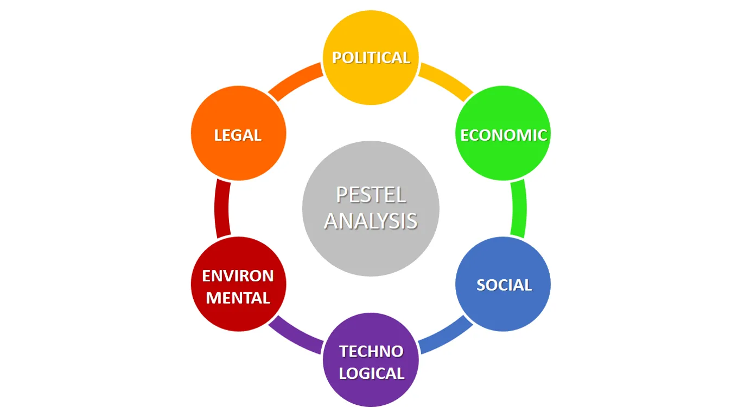
E: economic
S: sociological
T: technological
L: legal
E: environmental
The Political Environment of MacDonald’s in United Kingdom and turkey:
The United Kingdom is one of the most prosperous and developing countries and it has influence in the international arena. The United Kingdom is considered a permanent member of the Security Council and founding member of (NATO), in addition to being a member of the Group of Eight (8G) (MARKET LINE, 2020). After Theresa May’s resignation in 2019, Boris Johnson was appointed and in the same year parliament agreed to prevent Britain’s exit from the European Union without an agreement, and in January 2020 the United Kingdom officially left the European Union. The political environment is favourable to MacDonald ’S because it provides a tremendous opportunity for growth and expansion, meaning there is an opportunity for free trade agreements with many other countries.
In the year 2020 in March, the government announced its economic recovery plan to confront the resulting crisis due to the epidemic and announced an economic package estimated at 73 billion dollars, equivalent to 8,9 percent of GDP, to confront the crisis and maintain economic growth, and August it concluded trade agreements with the Libyan government. And development projects we note that this component is unfavourable to McDonald ’s (MARKET LINE, 2020)
The Economic Environment of MacDonald ’s in United Kingdom and turkey:
Reports have indicated that the growth rate between 2013 and 2015 was estimated at 2.37 precent, and this rate slowed to 1,65 percent between 2016 and 2019 and the public in the United Kingdom is high. It is expected in 2020 due to the Corona pandemic, as Market line estimates showed that it will decrease by 10.2 percent, and in 2019 net government borrowing amounted to about 2,2 percent of GDP, as it decreased 2,3 in 2018 and it is expected that government borrowing will increase to 16,5 percent of GDP due to the amount of government expenditures and this is a favourable factor for MacDonald’s.
Market line expects that the economy will head into recession and a decrease in the real GDP ratio by -4,5percent and in 2020 the devaluation of the Turkish Lira and the consequences of the closure and their repercussions in the main sectors of the Turkish economy because of the closure imposed in April, the credit rating agency fitch ratings reduced Turkish credit long-term (LDRS)to -BB and the outlook has changed from stable to negative. This factor is considered unfavourable to MacDonald’s.
The Socio-Culture Environment of MacDonald ‘’s in United Kingdom and Turkey:
The cultural aspect, religious traditions and values are taken into considerations here. We must consider the ethics, values, and perceptions towards the industry and towards the business within the labour market and operation (PERERA, 2017). For example, prostitution, funeral service, and drugs may be ethical and encouraging in one work environment and not necessarily in another work environment, as it must be considered that business environment is linked to the cultural and traditional values of the country and it is important to adapt these values to improve performance, increase productivity and raise the level of growth. In addition to the fact that purchasing, and consumer behaviour is shaped by social and cultural factors of utmost importance. Where the product or service development must these factors to ensure customer satisfaction in the industry. Most economies have shown good resistance to changing cultural and social factors that need to be addressed when introducing services or goods.
This factor is one of the favourable factors for MacDonald’s in Turkey for eating halal product, most people in Turkey are Muslims and they only eat halal meat and for the United Kingdom it is an unfavourable factor, as most people in the United Kingdom buy MacDonald’s products.
We will use Hofstede to explain more about the impact of the social and cultural environment of McDonald’s business. It will describe what is the impact of the impact of the community ’s cultural on people and the size of the interconnectedness between values and behaviour of individuals and other things that will affect the business.
According to the Hofstede Insight Index (Hofstede insights, n.d.)

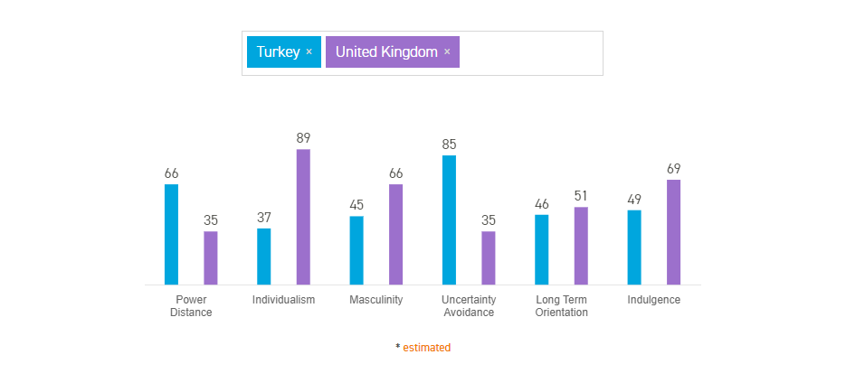
A-Power Distance Index: This indicator expresses and explains the extent of consumer’s willingness to be affected upward, as the index showed that the United Kingdom showed a score of 35percent, and for Turkey, the index showed that 66percent. The Turkish consumer who accepts power inequality as a rule, while the results showed that the consumer in the United Kingdom should remove it. This is reflected in the effect on buyer behaviour on the McDonald’s company, where the Turkish buyer believes that buying from McDonald’s is only for the upper or the wealthy class, while the British buyer believes that it is suitable for all people.
B-Individualism Index: The main point addressed by this dimension is the degree of mutual dependence on who can maintain the members of society, where the fixed image of people is defined as being, we or I, and Turkey has a good balance of 37 percent of a social community. This means that the word we are very important where the buyer will the average McDonald’s looks at the numbers of his family members before deciding to buy or inviting several friends, the benefit to McDonald’s will be the size of the number of individuals. As for the United Kingdom, society is essentially an individual society, which is mainly reflected in the buyer’s considerations. Where consumer’s tastes are directed to other varieties.
C-Masculinity versus femininity: In general, this indicator indicates that the male society indicates that it will be driven by competition, success, and a sense of achievement while the female society indicates that it will be driven by the quality of life. As the index showed that 45 percent in Turkey live for work, and this means that this percentage will work to get the best things in life, such as food, clothing, and housing, which positively affects McDonald’s, as it is a global company with a quality of food, and everyone there seeks to eat this quality of food. There is percentage in United Kingdom is also high, as it showed a percentage of 66percent, which is reflected in consumer behaviour in the same way it was shown in Turkey.
D- Uncertainty Avoidance Index: This indicator shows how society deals with the fact that the future cannot know how it will be, and from unknown concerns such as caution from reality, and thus it will negatively affect consumer behaviour, as the consumer in these circumstances within this, through which he refers to fear to saving, to face difficulties. They can be predicted. As the index showed a high 85 percent of fear in Turkey, which drives a large portion of people to save. As for the United Kingdom,35 percent, it showed that the British consumer will face some risks or will be willing to spend more.
E-Long term orientation: This indicator shows he is thinking about the future, the past, the present, or how he thinks about the future, is it short-term or long-term??? This index showed that 46 of the ordinary buyers in Turkey are thinking in the long term or making future in the long term, and the index showed that 51 percent of the buyers will be serious and realistic and think about the long term and future.
F-Indulgence versus restraint: It is one of the challenges that is committed with humanity in the present and the past, as it means the extent to which people can control their desires and motives, as the results showed that 49 of the people in Turkey or consumers will be ready to realize their motives and desires and enjoy life and spend money and thus affect the work of McDonald’s in the United Kingdom. The United Kingdom will have a higher ratio of 69than Turkey, and it will have higher spending capacity.
The Technological Environment of McDonald’s in United Kingdom and Turkey: Recent decades have witnessed a remarkable change in terms of technology, and it had a strong impact in all industrial sectors, where in an earlier period it shortened the times of marketing new inventions, for example, it looks the phone 40 years to reach only 10 million users around the world and television took 18 years. shortening in marketing times resulted in shortening product life (Hooley, et al., 2020). The technology factor is a favourable factor in the United Kingdom. There are many applications such as Deliveroo and Uber Eats through which McDonald’s can guarantee the loyalty of its customer to its products and it has shown its effectiveness during the closing period. As for Turkey, this factor is unfavourable due to the small number of branches there and the lack of such technology.
The Ecological environmental of McDonald’s in United Kingdom and Turkey:
Environmental factors have received a large amount of attention and have become important due to the scarcity of raw materials, the government’s carbon footprint targets and pollution target. These include factors such as weather, climate and environmental offsets that particularly affect industry, agriculture, insurance, and tourism (business-to-you, 2016). And this factor in Turkey is not favourable to McDonald’s, as there are no companies specialized in these factors. As there will be a problem in the supply chain for McDonald’s due to the risks resulting from climate change and weather changes that will affect the output of crops, which leads to an increase in the prices of inputs. As for the United Kingdom, on the contrary, it is favourable factor for what these factors are of great interest.
The logical Environment of McDonald’s in United Kingdom and Turkey: The laws, rules and guidelines are according to legal considerations, where the legal rules differ greatly according to the type of industry ,laws and regulations related to consumer affairs related to food, laws related to the quality of services, etc .Where these regulations and laws can have an impact on businesses that must be taken into consideration, as compliance with legal consequences results in a strategic advantage for the organization over competitors and will in turn lead to the company’s ethical guarantee towards the concept of ethical business (PERERA, 2017). This factor is complicated in Turkey, which makes it unfavourable, as the consumer protection law is very complex, as importers of primary resources of McDonald’s face difficulties in import regulations, which leads to fees in production and tariffs, which makes it costly and affects the profitability of the company. As for the United Kingdom, the legal environment is favourable. This driving McDonald’s company to grow well.
Limitations of the PESTEL Model
1-The different factors related to the environment differ from one period to another. This will affect the analytical data and make it differ from one period to the next. For this when performing a good analysis, we must seek the help of an expert in the field of research and development to ensure that the company is provided with accurate information that will avoid errors. In the future. 2- Environmental changes that would affect businesses significantly as no detailed attention is given to PESTEL’s will result in uncertainties and doubts.3- This simple presentation of PESTEL analysis is insufficient to fully understand all the difficulties and obstacles facing the company because these results may be inaccurate and subject to error.
Suggestions to McDonald’s PESTEL Analysis
Although the analytical limitations of McDonald’s showed some elements that are not favourable, but of increased opportunities for improvement in the company’s performance:
A-The company can further enhance its presence in the market by opening more branches and establishing them in medium-densely populated areas in Turkey and the United Kingdom.
B-The company can McDonald’s produce meals of a vegetarian nature unless it is criticized by the percentage of hydrogenated oils that result in obesity for its customers.
C-Increasing the offers offered by McDonald’s to customers to gain their loyalty and increase the percentage of customers, which works to maintain the company’s reputation.
The porter’s five Five Forces Model as it relates to McDonald’s.
Porter’s model presents five main and important factors that describe the behaviour of competition in the McDonald’s industry, and the diagram shown in the figure studies McDonald’s business in Turkey and the United Kingdom. The purpose of this model is to examine and analyse the strengths and weaknesses of the industry and this model is based on attractiveness and profitability. We can say that when we understand these forces in the industry, they can affect the ability of McDonald’s to operate, as we can adjust the
improve it, find out the location of weakness and avoid taking wrong use of a
strategy, accordingly, for example, we can make good and fair position and strong steps in the future. These factors are mainly and fundamentally explained in the fast-food industry, as this company is considered one of the important companies in the world and its effective strategy, and this has been demonstrated through its competition with major competitors in various global markets such as subway, Burger King and Dunkin’ Donuts, in addition to other companies. Food and hot drinks like Starbucks coffee.
. 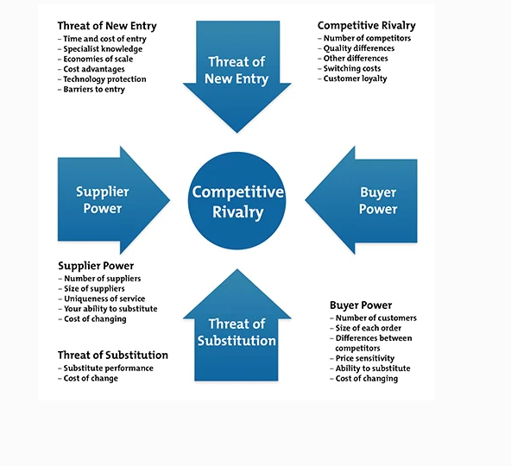
(the porter’sFive forces modal diagram created by Michael E. porter (harvard Business Review, 1979)
A-The Buyer power (Medium):
Those who buy from McDonald’s are individual consumers, as losing any buyer does not have a significant impact on the company because of the large size of potential customers because the revenues and profits that the consumer achieve are minimal (Market line, 2019).With the observation of the growth of buyer power over the years, it increased with growth, as TripAdvisor showed in 2018 that 87 percent in the United Kingdom is affected by reviews via the internet. Food service is not necessary for buyers, but rather it is entertainment and can be avoided in times of financial crisis.
It should be noted that also in turkey, the price of the product will have an impact on demand, if food outlets from other companies will present offers to win new customers, for example, McDonald’s company offers initiatives throughout the year and continuously to ensure loyalty from customers. The food service industry is heavily invested by the big players to build a brand, especially the segments that have medium and low prices. This brand helps in customer loyalty and this adds to the fact that it is not just a simple source of food and the convenience of food service (Market line , 2017).
B-The supplier power (Medium):
In general, the suppliers of this industry are often wholesalers and many pf these companies are large, which means that one of the players can be dispensed with somewhat and the suppliers have ahigh level of bargaining power in terms of pricing and that McDonald’s company exercises greater authority over suppliers for its ability to dispense with one of them will be it has an impact on the revenue of the suppliers (Market line, 2019). Large restaurant companies usually maintain relationships with a wide range of suppliers, which ensures the continuity and stability of the company and helps offset avoiding local sourcing problems and price fluctuations as McDonald’s avoids long-term commitments while minimizing switching costs. Players must be careful when selecting suppliers for the sake of food quality and not damaging the restaurant’s reputation. Britain’s exit from the European Union will disrupt the supply chain for many food companies as the UK is self-sufficient in addition to that the food resources that are imported to the United Kingdom, 70 million from the European Union. In Turkey, all McDonald’s restaurants should contain antibiotic-free chicken. Suppliers of food, fast food or bar industries are unlikely to merge, which means that suppliers are more dependent on market players (Market line , 2017).
C- The New entrants(high):
Because of the proportion of suppliers and relative capital expenditures and the industry that is growing will make it very attractive, as there are many barriers in front of it to enter into an industry with a low profit margin in general, where the newcomers will face large multinational companies such as McDonald’s and find the reference here that such huge companies that allow it saves its size by negotiating with suppliers and improving its profitability (Market line, 2019). The food industry is a highly regulated industry where the food standards Agency works with local authorities to monitor all places where food is served and give them a score of five to enforce hygiene standard, for example in Wales and Northern Ireland all restaurants are required by law to display the degree of cleanliness clearly. At the restaurant entrance it is likely that all restaurants in UK will require this rating. Because of food allergies, the United Kingdom has been subjected to several criticisms in case of allergies, so in 2016 the United Kingdom should be very aware and cautious because of Britain leaving the European Union, and the deterioration of the price of the pound sterling, which would effect on the price of the product and thus the likelihood that consumers are prevented from purchasing. The same applies to Turkey that the food service industry is a regulated industry and is subject to the applications of important laws and rules in matters of health. The ministry of Food, livestock and Agriculture has centres to provide food services in Turkey. These laws and rules are strict for human health due to factors related to poor hygiene and their application requires the appointment of employees Two presidents have already completed the appropriate training. Very rarely, the industry needs many people with high-wage incomes instead of low, as in Turkey there is a minimum wage of 917,32$ per month, which increased barriers to newcomers (Market line , 2017).
D- The threat of substitutes(high):
Usually, food inside the home is cheaper than food outside, and drinking and eating outside is considered unnecessary as it is considered a non-essential activity. It can be replaced with some effort and times as food inside the home contains fewer calories, less fat and salt. Major companies such as Subway and McDonald’s have provided meals like salad as an option. It should be noted that going to the gardens, the beach and cinema are alternatives to eating, although there are usually options to buy food at the same time. One of the strategies that have been adopted to deal with these threats is selling the experience, and it has been achieved through this investment to build a commercial relationship. In addition, recently individual restaurants with specific services have appeared, such as private cooking in the United Kingdom and a specific service system to attract customers such as restaurants inside prison and cat cafes (Market line, 2019).As for Turkey ,there are very few who have moved to change a certain style of cooking and service to attract customers looking for more than one meal, but it is very likely that the next decade will be directed by such a pattern.
E- The Degree of rivalry (high in UK) and (medium in Turkey):
When comparing the industry in the United Kingdom with other European countries, where the United Kingdom is considered to be somewhat distinctive in this industry, as bars and clubs dominate food services and sales, which represent about 35 percent of the industry value in 2018, in addition to the service and fast-food sector, which represents about 26, in these two sectors, green king and Ei group plc represent about 15 percent of sales in this sector, an indication of the huge number of competitors that make up the industry. McDonald’s represented about 15 percent of sales in this category, and the next one is Domino’s pizza, in addition to many food services companies that work side by side with major companies, as results in 2018 showed that 51 percent of food services are owned by independent companies. A switching cost when changing a food service provider, this increases competition due to the presence of many companies with similar services that offer products with similar services, especially hot drink. The big companies are expanding their offerings to diversify their sources. Deliveroo and Uber Eats have helped increase competition in this industry and the competition in the UK has been assessed as strong or high. With regard Turkey, there are many small and medium-sized companies that are considered competitors, except for large companies with multiple nationalities, and therefore within this industry there are companies with similar structures, offering similar prices and because consumers do not bear any costs of switching food service providers, competition rises, however we can distinguish in terms of food. Sold and price. And players benefit from the ease of expansion. If failure to do so, the exit cost is inexpensive because the physical assets are not of a high cost and can be sold at a good price. For the employees who have been laid off are not eligible for large payments, and in general the degree of competition is moderate.
Recommendations for McDonald’s of porter’s Five Force Model:
Business for institution of an international nature can easily affect their profitability through competition, as the smaller the number of competitors, the more attractive and effective the industry, as high levels provide a great threat if the profitability levels are low because customers are they will have the ability to switch easily to the alternatives available and that means that any high-level forces will provide the greatest level of threat to the company ,so in McDonald’s the newcomers and the threat of alternatives will pose the biggest threats and the degree of competition in the UK only.
SWOT Analysis of McDonald’s Business: United Kingdom and turkey
The purpose of a SWOT analysis is to study the external and internal environment of the company by identifying the strengths and weaknesses of the company in addition to the threat and opportunities it is exposed to. One of the most important purpose of the SWOT analysis is to identify the factors that affect the organization’s work well to provide information on the strategic planning process. We can divide the SWOT analysis 1-External environment where weaknesses and strengths are identified, which aims to determine business priorities for a strategic plan that includes raising the level of positive points, indicating points that must be improved, studying the company’s capacity and sales expectations within the consequent market conditions, and eliminating deficiencies (heflo, n.d.).
United Kingdom | Turkey
STRENGTHS:  A-strong trading company that has existed since 1954 and has established a strong name in the food industry through quality and influential promotion.  B-According to statisticaca.com, the brand value is around 79,73 billion$  C-It is loyal to consumers for the diversity of its products and its global brand. D-McDonald’s company has a wide variety of food products such as potatoes, cold and hot drinks, burgers, and sweets. E-McDonald’s operates with high quality and fast speed. F- it is pricing policy is attractive and strong and attracts a large sector of the market. G- McDonald’s has a list of buyers who are price sensitive, for example often McDonald’s prepares a special menu for limited students aimed at those who can afford to spend more ( LearnMarketin, n.d.). | STRENGTHS:  A-McDonald’s serves customers in more countries than any other competitor in the fast-food industry.  B-large economies of scale  C-wide audience reach.  D-McDonald’s exerts market power over suppliers and competitors.  E-The most recognized brand in the fast-food industry.  D-competitive price
WEAKNESSES:  A-The number of meals is limited for vegetarians. B- At peak times of work, long queues occur- She is criticized because of the obesity that results from her meals. D-There is no substitute for fried potatoes in the United Kingdome- problems of treating animals with cruelty-breakfast meals end early. Which makes it a problem in some countries | WEAKNESSES:  A-High employee turnover  B- Negative publicity (portraying McDonald’s as an unhealthy food choice)  C-there is not much difference in seasonal products.  D-Quality Inconsistency due to the franchising process  E-Focus on fast food, not healthy options for consumers.
OPPORTUNITES:  A-Expanding the sales of vegetarian products and expanding the experience that was conducted in Finland after the vegan burgers were sold and the operation was successfully completed and made international-B-Expanding sales related to fish. C- Providing specialized potatoes instead of fried potatoes in the United Kingdom-Introducing McDonald’s Café to take advantage of the hot drinks market-Providing a range of decaffeinated coffee products. | OPPORTUNITES:  A-Responding to social changes with healthy choices  B-Expending the business to new parts of the world.  C-Allergy-free options and gluten-free foods Corporate social responsibility.
THREATS:  A-The most prominent competitors for McDonald’s companies are KFC, Burger King and Subway. B-working to change consumer systems that change with campaigns and government rules to continue in proper and good health. | THREATS:  A-To more health-conscious clients  B-Threat from competitors in different countries  C-The threat of economic downturn  D-Social change to a more balanced meal.

The STP Model-Application to McDonald’s in United Kingdom and Turkey:
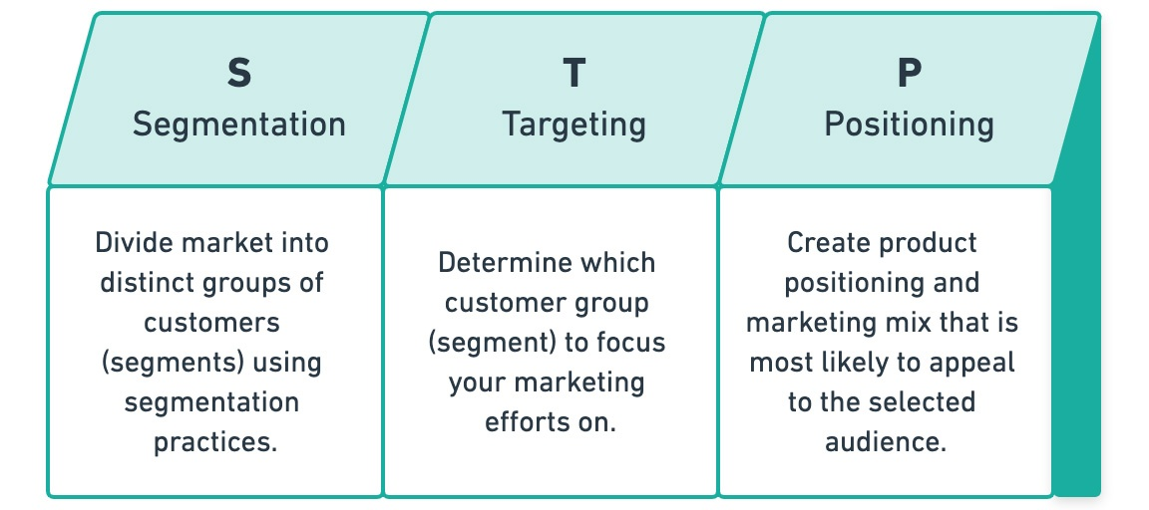
This diagram by (Wright, 2020).
The STP model is an important concept in marketing to serve the market and this concept refers to three trends which are segmentation, targeting and positioning. Where marketers segment the market and designate attractive sectors to target. As this model has become popular within the increasing prevalence of mature markets and the example of access to specialized sectors to do so. Among the benefits of this model is to improve the competitiveness of the company. This model guides marketing strategies, product development and differentiation of this brand by allocating resources to the target parts in addition to identifying growth opportunities in the market by appointing new customers or new uses of the product and effectively and effectively matching the company’s resources to target market sectors that are the largest return on marketing investment “ROMI” (claessens, 2019).
Market Segmentation: Marketers can identify areas of special needs, find new customers, and deliver more focused and effective marketing messages to audiences within different sectors. The needs of each segment are the same, so marketing messages must be designed for each segment to emphasize the benefits and relevant features required instead of one size fits all types of customers. We can divide the Turkish market and the United Kingdom according to demography, geography, psychological planning, lifestyles, level of commitment, benefits, and usage patterns.

This diagram by (Claessens, 2016)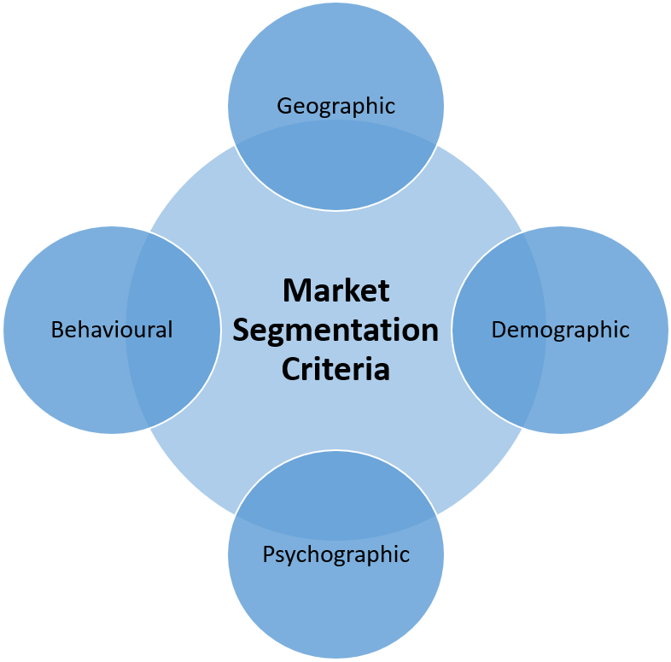
Demographic Segmentation:
The demographic segmentation pf all customers and prospects with each other by focusing on certain specifications by gender, age, income, and job. This can be done by segmenting the market because it requires fewer data points for implementation than the behaviour experience while presenting a nuance more selective than the geographical experience (Thomas, 2020). The most common demographic factors are race, age, gender, education level and religion. For Turkey and the United Kingdom, demographic segmentation allows the delivery of different messages to different groups and the presentation of the company’s products in different ways as the products are marketed as suitable for all ages and can attract a large group of consumers, especially vegetarians. McDonald’s has provided all its branches. Worldwide, vegetarian meals in addition to halal meat that target Muslim consumers by offering it to the public. We can say that McDonald’s company allows family sections and individual place within its branches where advertisements show that they are suitable for all age group, whether individually or collectively.
The division by the age, Although it is not a scientific and universal fact, but we must take into account that often the expectations are completely different as it can be taken into account this tool is very useful and McDonald’s company takes the division on the basis of gender and it is an affective and powerful tool when applied well As the general demands of girls and boys differ in terms of food, and the McDonald’s company is dividing on the basis of income in both Turkey and the United Kingdom, where the target in both countries is students as a segment with specific needs and interests and are attracted to this division, as those on low incomes are likely to be affected by good value. For McDonald’s products, those with higher incomes are preparing to spend more.
Geographic Segmentation:
The first adventure in establishing a branch of McDonald’s in Turkey was in Istanbul in 1986, which is considered one of the major cities in the world, and the company aimed to target families, children, workers and youth, as Turkey has a high percentage of this category, as statistics indicated that 24 percent of the population there is located Between 1 to 14 years (ÜÇER, 2021). The strong culture in Turkey prompted McDonald’s company to produce halal meat because the vast majority there are Muslims, and kebab sandwiches are within the menu and focus on establishing branches only in major cities with high population density because the nature of consumer in the countryside like to eat at home. As for the United Kingdom, the division was geographically prepared, ready from the major cities and the population in the countryside with some and the provision of meals commensurate with all varieties as McDonald’s company provided also one of its products is halal as well, and in terms of the culture in the United Kingdom, many people want to eat Food outside their homes and their homes, and this helped McDonald’s improve its sales.
Market Targeting.

The process of targeting the market according to the definition is the process of determining the sector that the organization will target through advertisements that it will publish. Once this sector and its customers are known, the company will place its services and goods that it will produce in this target sector and there are main types usually done within the corporate strategy, which is the non-sector. Differentiated, often targeting all or consumers, the differentiated, and the concentrated sector.
Undifferentiated: In general, this undifferentiated targeting produces on product in the entire market, and we can consider it as a comprehensive market, and given that McDonald’s has a lot of meals and foods it offers and cold and hot drinks, this approach or method will not be appropriate for the company in any market because the production of certain products in general will be it is cheaper in terms of the production process as well and also because the company is not based on targeting specific groups within the market, and this approach or method will be profitable enough.
Differentiated marketing: The company does it when it targets certain sectors of the market, as McDonald’s has developed its products in both Turkey and the United Kingdom by producing meals with halal meat to attract Muslims and certain types of meals that focus on vegetarians to attract people who do not eat meat. Attracting many consumers.
Concentrated: Concentrated marketing often occurs when the company targets a specific category or segment only in the market without the rest of the market. This product meets one sector and requires the company to make marketing efforts for that. This may reduce the number of customizations targeted by the company, in addition to the fact that company needs to make sure that it chooses the part of the market.
Marketing positioning: Strategic positioning is defined as away different from what your competitors do in distinctive way, and this is what distinguishes the company from its competitors within the same industry, for example, the Burger King focuses on the young male category (McDonald's Franchise Strategy, n.d.). McDonald’s has established a popular base targeted at all consumer groups, especially families, because it is low-cost. In recent years, McDonald’s has expanded the scope to attract customers due to the decline in the number of sales. Where the focus has become on reducing the receipt time and reducing the cost of food, as the focus has been on the latest types of technology in restaurants, which makes it easier and the need for a small number of workers, and on the other hand, the focus has been on publishing advertisements within the stadiums and advertisements that include that it is family friendly and is said to be a happy meal for children. All over the world.
The McDonald’s Marketing Mix: marketing mix refers to a set of procedures and tactics that a company uses to promote its brand or products in the market, and it can be said that is the responsibility of the factors that can be controlled. The company works by disseminating the marketing mix and pays great attention to influencing the buying behaviour of potential consumers ( Dominici, n.d.). These elements include, previously, it consists of 4 elements, which are product, price, promotion, and place. Three other elements were added later, namely, people, process, and physical evidence. To sell and market McDonald’s in Turkey and the United Kingdom McDonald’s Corporation actively deploys the seven elements of the marketing mix.

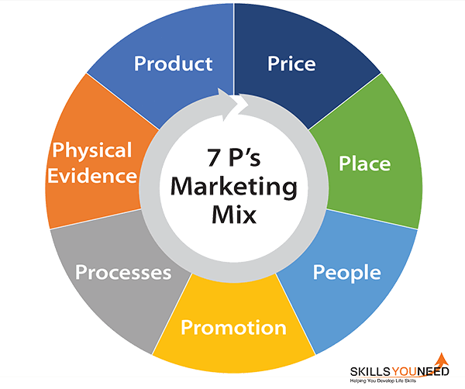
Figure 1Diagram for mix 7p's (skilles you need, n.d.)
Product: McDonald’s is one of the most famous restaurants in the world and a pioneer at the same time and therefore always tries to offer distinct services from its competitors, and the number of branches in the United Kingdom is 1270 branches that provide a variety of snacks, sandwiches, sweets, and snakes, for example the picture below a sample of the existing menu in the UK (Howandwhat, 2020).

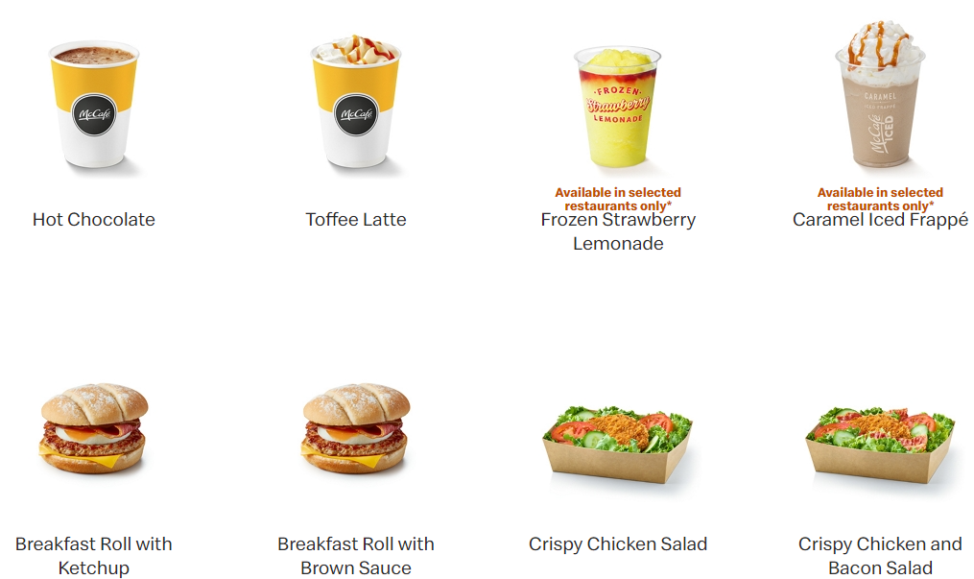
this Diagram by McDonald’s (McDonald's, 2017-2021)

As for Turkey, the number of branches is very small compared to the United Kingdom, as the number of branches there does not exceed 260 branches distributed over 46 governorates and most of the suppliers are local, and the
same strategy is followed in diversifying its products to make it distinct within the number of competing restaurants in Turkey, and this is a sample of the
menue there. 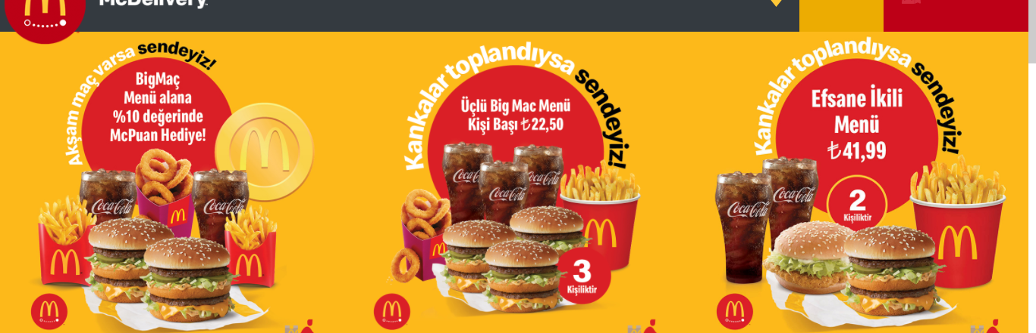

PRICE: Firms use some of the pricing methods, techniques, and pricing to sell their products. As the current rate of value. And cost is in addition to pricing and price discrimination and some common pricing methods. An important goal of all McDonald’s restaurants in the United Kingdom is to provide customers with high quality meals at an affordable price. Where the price of meals varies between restaurants slightly depending on several factors. And the restaurant determines the prices with a demand-based technology and does not specify the prices for the franchisees who can manipulate their price structure in the way they see fit in the local market. Despite this, franchisees need to offer a premium price that is driven by value to their customers (Howandwhat, 2020). McDonald’s in Turkey practices a price-grouping strategy where the company provides an offer to sell two products or a package at a good price that is better for the buyer than to buy it separately, such as potatoes, hamburgers, and Coca-Cola. McDonald’s also uses psychological pricing, which is common for international and multinational companies, such as setting a product price of 31.99 instead of 32 Turkish liras to prevent bargaining on the price. The company also uses the specific pricing and grouping prices at the same time, effectively aiming for expansion. In the market, even within the financial problems and crises (KOLMAKOVA, 2017).
Place: In general, place symbolizes distribution. Distribution strategies are the methods and means that a company uses in delivering products to customers. McDonald’s has in all its departments places to eat inside the restaurant and a home delivery service in several countries, although this service is not available in many countries (Howandwhat, 2020). As for the United Kingdom, McDonalds company signed a delivery contract with UberEATS in 2017 and there is also a delivery service and many restaurants operate in McDonald’s company 24 hours a day and this expresses the intensive distribution, which means products are available through all distribution channels, which helps in total sales and thus increase revenues. It must be into account where customers search for the products that you produce in the company and where these customers spend most of their time and then decide where you are and the middleman for distribution. There are 3 types of distribution in both the United Kingdom and Turkey: The intensive distribution that reaches the masses and this is very difficult due to the services because of course it is the services because of course it is the service that have a sense of specialization in the related services, but the technology has brought about a change in terms of banking and internet services. Exclusive distribution of products that customers seek to obtain to distinguish from others through certain places. And selective distribution is considered better by using a franchising model where McDonald’s has become present even in second-tier cities thanks to this strategy (Pandey, 2021).

Methods McDonald’s Entry into the market in Both Turkey and United Kingdom, the factors affecting both countries, and the method of entering the selected market?
Turkey is one of the countries that requires specific methods and means to expand its market. It should be noted that it is a competitive market and has many local and international actors within its market. The Turkish market does not have an attractive market, because reaching market share will require many years. This is due to the large number of fast-food stores and the culture of Turkish cuisine. As the Turkish Kebab is considered to have a special importance in the Turkish community, however, McDonald’s has managed to have more than 200 branches in Turkey within 40 cities there. And, among the factors that had an interest in entering are the challenges, as at first the field of research was restricted, as there were 260 branches in 42 cities due to funding, timing, and logistical reasons. Istanbul was chosen as the main centre of this research. The data from there, from 1997 to 2017, is to limit the search to only 20 years (KOLMAKOVA, 2017). As an issue of the reality, Mc Donald's needed to create %95 of its items from the horticultural merchandise that are being gotten from Turkish food providers and this is exceptionally valued from Mc Donald's Turkey's clients as it was seen through the surveys. Due to
emotional occasions that occurred from 1999-2001 in Turkey, Mc Donald's needed to close 60 of its cafés and Mc Donald's needed to reset all its showcasing methodology in Turkey. Mc Donald's begun to zero in additional on nearby requests to recapture its piece of the overall industry. For that reason, Mc Donald's needed to deliver entirely unexpected items than its typical items. beginning from Puff Bork to Kofta Burger to re-grow in the Turkish market. This change in the methodology has been for the most part appreciated from its clients in Turkey as it was seen in the surveys. Numerous clients lean toward worldwide items like Huge Macintosh and Mc Chicken, yet they do likewise incline toward globalized items like Puff Bork, Kofta Burger, Mangal Burger and Akili Tabuk Burger. All in all, globalized items were down transformers for Mc Donald's in Turkey since Mc Donald's benefit brought just about multiple times up in 13 a long time. In 1974 McDonald's originally opened its eatery in UK at Woolwich, London and it dispatched around 1200 stores everywhere on the country. In food administration retailing as well as in work market it gives enormous scope of freedoms to a noteworthy number of individuals around the world. Also, as McDonald's has high brand picture, it gives colossal returns for its investors. In any case, some of the time McDonald's is scrutinized for its high turnover rates and low-quality nourishment. Miniature climate covers the inner elements which impact the tasks of association. McDonald's is affected by its inner elements. The inside factors are- Supplier:McDonald's has its own providers and it rehearses exceptionally cosy relationship with providers. McDonald's partitions its providers into two divisions who are called direct providers and roundabout providers. The backhanded providers convey the fixings to the immediate providers and the immediate providers produce the nourishment for McDonald's. McDonald's comprehends the significance of its providers and consistently co-works with proficient habits. (aboutmcdonalds.com). Competitors: As the worldwide market of 21st century is profoundly serious, McDonald's has some solid contenders, for instance, KFC, Burger Lord, Pizza Cottage and so on all contenders have great brand picture, noteworthy piece of the pie, long business history, etc. On this serious circumstance, McDonald's necessities to consider its rivals ability to guarantee its ruling position. Customers: McDonald's is serving many clients every day. In most recent three months, McDonald's served around 329 million individuals in UK (News Mirror, 22 Oct 2010). In first world's nations, all individuals are focused as clients by McDonald's. It serves food varieties for pretty much every sort of individuals. McDonald's accepts the clients as their main goal and attempts to guarantee most extreme fulfilment. The general population
The general population incorporates the outside bunches who are intrigued and related with the organization. McDonald's works with thinking about the force and significance of various gatherings for example, Media, focal and nearby government, monetary local area, customer bunch, pressure bunch, etc (UKESSAYS, 2015)

Promotion: There are many ways to promote products. McDonald’s used to promote sales through television, radio, and public places, but with the advancement of technology, it has become directed through advertisements on the internet, where intensive advertisements increase revenues and affect the customer in the purchase process. McDonald’s is multinational company that uses different marketing mixes to effectively attract customers, as this mix consists of sales promotions, public relations, advertising, personal selling, and direct marketing (KOLMAKOVA, 2017). McDonald’s advertisements work better and bigger within this mix, McDonald’s uses sales promotions by way of discounts and coupons to attract customers, and McDonald’s public relations plays in increasing credibility and enhancing value.
Comparisons of McDonald’s Promotional strategies -United Kingdom vs Turkey: I will attempt to compare the promotional strategies used by the manufacturer to sell McDonald’s in United Kingdom and Turkey.
First, the similarities in the promotional strategy of both countries:
Countries use classified newspapers and general magazines to publish their products. Both countries use other media to raise awareness of the company’s products and services through television, radio, billboards, telemarketing, and television. The use of the most prominent and effective billboards in strategic locations, as it affects customer attention due to the long duration of the billboards. McDonald’s uses the technique of publishing a periodical to transfer its ads to a variety of sports and political businesses.
Second, the differences in the promotional strategy of both countries:
Turkey uses more traditional media while the UK focuses on digital and informational media. The media is the leader in Turkey while the UK is the leading specialist media. The UK has a successful integrated communication strategy but in Turkey it has some problems due to poor network services.
People: The McDonald’s Company is one of the major companies that work on recruiting employees in the United Kingdom, as there are about 1270 branches in the United Kingdom that employ about 120,000 employees, as 70% of the McDonald’s restaurants company in the United Kingdom are local women and men. McDonald’s is investing around 40million£ in employee competency development every year in the UK. The goal on the part of the people in the marketing mix is to address problems involving employees and customers. If employees face certain problems or issues, they will often provide bad service to customers and thus it is likely that will not return to buy. Therefore, any company must consider the desires and needs of both customers and employees (Howandwhat, 2020).
Process: The process is a set of services and activities that are performed by the company to achieve something in return. McDonald’s company carries out several services and activities to reach the product to customers, for example: The process of making food is a very important process in the overall process. It is very well prepared and stands for all the rules where the customers can know the wating time to get the food in United Kingdom and Turkey (Howandwhat, 2020).
Physical evidence: The last element of the marketing mix is McDonald’s physical evidence that symbolizes the element of the physical environment of the guests and the customer experience of the company. As this evidence does not work on the customer’s impressions of the restaurant, but rather affects the way McDonald’s company operates, as the restaurant operates in clean and attractive environment, and the restaurant maintains an interior for each of its outlets (Howandwhat, 2020).
The Directional Development (future strategies) of McDonald’s
The Market penetration: The process of penetrating the market for McDonald’s is a strong and solid strategy and plan, whereby this company can, through this strategy, reach and satisfy the desires of the largest number of consumers or customers in our existing market, for example when McDonald’s started its work in North America and Europe through franchising or joint ventures. Or sole proprietorship. Expanding to open more branches in both Turkish cities and the United Kingdom is a strategic goal linked to the intensive growth strategy as McDonald’s has found a low-price strategy policy that helps penetrate the market easily in order to achieve intense growth (Khankasi, 2020).

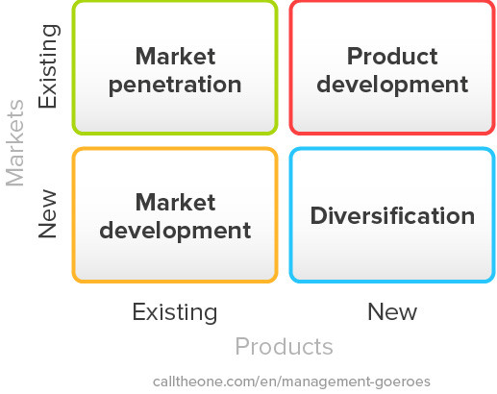

The market Development. Since the establishment of McDonald’s company, the strategy of selling products in the market has been by attracting customers and consumers from the market by providing high quality food at a competitive price, and this way is called market development. Since its establishment, McDonald’s has been aiming to grow all over the world to expand its business even though the market development has become a plan. Marginal to the large number of its branches and places of its presence in the world, except for some areas in west Asia and some regions in Africa and the Middle East as well. It has now become the strategic purpose of McDonald’s to introduce new branches in Turley in addition to the McDonald’s company is working to implement a general strategy which is leadership the cost to support a plan of intensive growth by selling at low prices to stay distinct from its competitors (Khankasi, 2020).
The product development. McDonald’s is working on producing cutting-edge new products with a development and modernization strategy to promote its intensive growth. McCafé is an example of this development. And this product may be different from the current or old that has been completely changed, and the purpose of this strategy is to attract many customers by providing differentiation products to provide additional benefits to customers. There is a slight risk from this strategy if consumers do not like it, but if they want to take it again, it will save increase in sales. McDonald’s has added a product to the menu that is low cost and attractive example for customers who want to get rid of fats and oils (Khankasi, 2020).
Diversification. When the company produces new products and is distinct from its competitors, this means that there is a unique product that helps the intensive growth of the company, for example, when McDonald’s produced McCafé, most of the time the drinks do not come with high quality, but this enables the company to sell hot drinks such as tea, cakes, cappuccino, and coffee because of this fact. The customers will not just go for coffee (Khankasi, 2020).
Advantages of Ansoff Matrix. | Disadvantages of Ansoff Matrix.
1-Simplicity: It is very easy to understand as anyone with limited knowledge of marketing can understanding the scenarios developed for McDonald’s company, as this matrix does not present complex accounts and topics in both countries, but rather provides 4 simple alternatives. You can choose one of them to achieve the goals of profit and increase sales.  2-Monitor all possible alternatives: This feature is to make possible alternative under review so that the company can make a correct decision, for example if a new product does not work in the market, the company can work on developing it in the event there is no alternative product in case it does not want in risking a new market and thus increasing sales and profits.  3-Risk analysis: where the company must work on analysing risks in the strategy followed all over the world, for example, high-priced products are not commensurate with income within developing countries, so it must work on a diversification strategy within the available market. | 1-Ignoring competitors: One of the most important disadvantages of this matrix is ignoring competitor’s strategy, as McDonald’s has several competitors and each of the competitors has their own products and who play an important role in the market as KFS.  2-The absence of a cost-benefit analysis: it refers to the strategies followed but works to ignore or the absence of cost-benefit analysis from the various strategies followed in most cases. The company is confused in choosing diversification or product development, which must consider cost assistance where there is a need for an analysis process. Cost and reason to justify a correct decision.  3-Difficult to predict: In fact, Ansoff’s matrix appears to predict the impact of this strategy, but in theory it appears simple as it is not possible to predict the reaction of the consumer and the market with high accuracy, and therefore the company must consider that there is a procedure for all calculations when deciding based on Ansoff matrix (Parikh, 2019)

Recommendations. These strategies that McDonald’s is operating in both Turkey and United Kingdom have very insightful and unique strategies that have made this company work permanent expansion in the world I will make some recommendations and focus on the product life cycle.
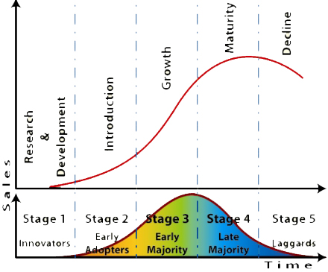this Diagram by (Avshetty, 2104)
This graph shows the growth and maturity stage of the product life cycle, where sales show how the graph line grows in the product life cycle and increases it permanently through the permanent education of its customers with new products for McDonald’s and the continuous production of the new meals that meet the customer’s desire to make them always distinguished from its competitors in quality and price. As for when the curve appears flat, this means that competitors are working with a policy like the policy of McDonalds such as KFC. As for the decline of the curve, this means a decrease in sales for some reason, due either to customers turning to a new competitor who offers better offers from McDonald’s company, or just a financial crisis.
Conclusion. The question that we must ask now is to what extent do we agree with the approach that McDonald’s has used in both Turkey and the United Kingdom?? Looking at the market strategies followed in both countries, we see that McDonalds followed a correct strategy, and in both countries it worked to meet consumers’ desires by providing halal meat in Turkey and vegetarian foods in the United Kingdom, and McDonald’s made a home delivery service mechanism to increase customer loyalty to the company through it contracted with delivery companies, and the company also continued to achieve high sales at competitive prices.

Bibliography
Dominici, G., n.d. From Marketing Mix to E-Marketing Mix. [Online]
Available at: file:///C:/Users/osama/Downloads/SSRN-id1961974.pdf
[Accessed 14 April 2021].
LearnMarketin, n.d. SWOT Analysis of McDonalds. [Online]
Available at: https://www.learnmarketing.net/SWOTMcDonalds.html
[Accessed 9 April 2021].
Avshetty, P., 2104. Marketing diary. [Online]
Available at: https://pranavshettydiary.wordpress.com/2014/07/29/life-cycle-of-the-product/
[Accessed 12 April 2021].
business-to-you, 2016. pestel analysis. [Online]
Available at: https://www.business-to-you.com/scanning-the-environment-pestel-analysis/
[Accessed 5 APRIL 2021].
claessens, M., 2019. Marketing-Insider. [Online]
Available at: https://marketing-insider.eu/the-stp-model-segmentation-targeting-positioning-done-right/
[Accessed 13 April 2021].
harvard Business Review, 1979. How Competitive Forces Shape Strategy. [Online]
Available at: https://hbr.org/1979/03/how-competitive-forces-shape-strategy#
[Accessed 11 April 2021].
Harvy, J. N., 2020. Localizing Global. USA: IGI Global.
heflo, n.d. The purpose of SWOT analysis. [Online]
Available at: https://www.heflo.com/blog/swot/purpose-of-swot-analysis/
[Accessed 8 April 2021].
Hofstede insights, n.d. COUNTRY COMPARISON. [Online]
Available at: https://www.hofstede-insights.com/country-comparison/turkey,the-uk/
[Accessed 8 April 2021].
Hooley, G., Nicoulaud, B., Rupp, J. m. & Lee, N., 2020. marketing strategy and comotitire positioning. seventh edition ed. Umited Kingdom: pearson.
Howandwhat, 2020. Marketing mix of McDonald’s – McDonald’s marketing mix. [Online]
Available at: https://howandwhat.net/marketing-mix-mcdonalds-mcdonalds-marketing-mix/#:~:text=It%20explores%20the%207Ps%20(Product,explains%20its%20business%20%26%20marketing%20strategies.&text=McDonald's%20is%20renowned%20for%20being,world%20leader%20in%20this%20secto
[Accessed 18 APril 2021].
Khankasi, A., 2020. Ansoff Matrix of McDonald’s. [Online]
Available at: https://ansoffs.com/ansoff-matrix-of-mcdonalds-2/#:~:text=This%20is%20the%20detailed%20Ansoff,utilizing%20to%20increase%20market%20share.
[Accessed 14 April 2021].
KOLMAKOVA, L., 2017. Glocalization Marketing Strategy of, STOCKHOLM, SWEDEN: KTH ROYAL INSTITUTE OF TECHNOLOGY.
Market line , 2017. MarketLine Industry Profile, Turkey: Market line.
Market line, 2019. MarketLine Industry Profile , United Kingdom: Market line.
MARKET LINE, 2020. Turkey, In-depth PESTLE Insights, UNITED KINGDOM: MARKET LINE.
MARKET LINE, 2020. United Kingdom, In-depth PESTLE Insights, United Kingdom: MARKET LINE.
Matovic, I. M., 2020. PESTEL Analysis of External Environment. CONSCIENS CONFERENCE PROCEEDINGS, 28-29 sptemper, p. 96.
McDonald's Franchise Strategy, n.d. McDonald's Positioning. [Online]
Available at: https://sites.google.com/site/mcdonaldsfranchisestrategy/home/mcdonald-s-positioning
[Accessed 15 April 2021].
McDonald's, 2017-2021. Reduced Menu. [Online]
Available at: https://www.mcdonalds.com/gb/en-gb/menu.html
[Accessed 19 April 2021].
MORRISON, M., 2020. PESTLE analysis, LONDON: CIPD.
Pandey, K., 2021. 7Ps of Marketing Mix with Examples. [Online]
Available at: https://www.superheuristics.com/7ps-of-marketing-mix-with-examples/#t-1609511435655
[Accessed 20 April 2021].
PERERA, R., 2017. The pestel analysis. 1,0 ed. s.l.:Nerdynaut.
skilles you need, n.d. The 7 Ps of Marketing Mix. [Online]
Available at: https://www.skillsyouneed.com/lead/7-marketing-ps.html
[Accessed 16 April 2021].
Thomas, R. S., 2020. Demographic Segmentation Defined with 5 Marketing. [Online]
Available at: https://www.yieldify.com/blog/demographic-segmentation-ecommerce-marketing/
[Accessed 17 April 2021].
Tikkanen, A., 2020. McDonald's American corporaton. [Online]
Available at: https://www.britannica.com/topic/McDonalds
[Accessed 1 APRIL 2021].
ÜÇER, N., 2021. HAMBURGERS AND HAND-HOLDING:. 12 April, p. 38+39+40+41+42+43+44+45.

