Hiba omer 1813755

Lecturer: Anupam Mazumdar

Digital skills and research methods

Introduction
Current technology is essentially a headway of old technology. The effect of technology in present day life is unmeasurable, we use innovation in various ways and some of the time the way we actualize different advances accomplish more harm than great. Technology is the term used to describe the application tools, materials and knowledge to solve problems and extend human capabilities. (citation)the nowadays technology consists of electronical developments, that make human life easier. It provides services for humans in a faster direction allowing them to go about their daily life knowing that most things are being sorted out with the use of electrical technology. As years go by the update of technology has evolved rapidly. Types of technology are the internet, genetic engineering, mobile phones, money transfer, medical technology, all which manipulates the word around to make thing more convenient for the world we live in.

Effectiveness of the use of modern technology within the work place
In every workspace technology is very necessary, because the business is more likely to fail. Technology is utilized in different ways at a working environment, and these incorporate, correspondence inside the organization, information sharing, information security, snappy basic leadership, learning the executives and it additionally improves work subsequently expanding creation at work. At its most essential measurements, technology enables you and your representatives to be increasingly profitable and capable. Regardless of whether you're applying a word handling program that allows you to change things differently, technology makes life simpler. You can plan meeting arrangements and important business calls, track representative time, and perform numerous tedious errands that once took hours in just minutes.
target of executing computerized abilities in the firm is that workers can produce novel and new thoughts for overseeing fruitful business activities. Through this, association can deal with various difficulties that guide them in boosting open doors for wanted achievement. Before executing advanced expertise in firm, it is required for the board to distinguish required territories in which workers are searching for new changes for augmenting achievement choices.
Remaining Innovative
A creative work environment is on the front line of innovation, structure and business rehearses. With a little imagination, you can think of better approaches to structure items, associate with clients, advertise your business, and create advancements. When you break new ground, you may discover a response to an issue that nobody else thought of previously. Also, on the grounds that your developments resemble no different organizations', ideally, potential clients and workers will pay heed and go to your business rather than another.
Industry Efficient
Whatever item or administration you give, you must contend. Your rivals use innovation, so you must also. Having the most recent innovation enables your organization to remain focused and give the best quality administration or items as could reasonably be expected.
Convey Better, Collaborate More
. We can truly associate with any of our representatives, pioneers, and colleagues whenever, anyplace. The flood of innovation in the working environment has influenced how representatives convey, team up and work more effectively. Truth be told, with numerous representatives trusting that up close and personal gatherings will be outdated soon, the standards of office correspondence could be the following significant change affecting the work environment. In the nearer future you can relax and get payed from home.
Security and Safety
The security of organization data can be seriously traded off without the execution of legitimate channels of innovation and programming. An organization should actualize creative innovation as a place of refuge against such breaks of security. Taking basic and significant data was simple previously, however at this point with the utilization of innovation, the risk of information robberies and breaks is almost unimaginable.
Increment Productivity
It's essential to ponder and use diverse equipment and programming arrangements that can improve representative efficiency. Organizations these days depend on numerous apparatuses to beat difficulties of executing on system consistently. It empowers supervisors to all the more effectively track advance amid each period of objective consummation and offer quick fortification or instructing to keep execution and due dates on track.

How modern technology is used for various purposes
First things first what is social media?
Online networking alludes to the methods for associations among individuals in which they make, share, or potentially trade data and thoughts in virtual networks and systems. The Office of Communications and Marketing deals with the principle Facebook, Twitter, Instagram, Snapchat, YouTube and Vimeo accounts (tufts, 2019). Social media is a platform and communication presence amazing for getting to know you things in a fun interesting matter while still going about your daily life!
In order to answer this task, I’m going to explain how social media can be used as a tool for marketing, information gathering and communication below;

Marketing
Marketing through social media is very common in most areas of business, especially in the 21st century. It is very convenient for small businesses on the come up, this allows them to promote and make people aware of their venture cost-effectively. Big business’s also use social media as a tool for marketing to relate to their audience and keep up to date with the new trends constantly changing in the now society, which also raises sales of the product and grows account. Social media need to be a priority and commitment for your desired outcome. Innovation is making its essence known in stores. The utilization of computerized signage is a pattern that enables organizations to catch the consideration of clients and market explicit items to them. ... Giving magnificent client administration is a key to effective deals and advertising. Marketing your business on social media means you need to gain followers, where people will share your content, this means people are aware of your establishment and are interested in what you have to offer. There are different social media platforms you can use to market your business, once you have successfully established your business to the social media platform you have chosen to attracts your customers, you can now branch out and choose different platforms as you are now a business that people trust. Social media as a marketing tool allows you to use images and videos and a variety of types of advertisement, allowing you to connect with your users creating an engagement, this is when you start to see an improvement in sales. Marketing in social medias allows you to gain brand loyalty and power users, this is important in business because that is where your product will sell (13 Proven Social Media Marketing Tips for Small Businesses & Entrepreneurs, 2017).
Things you need to market your business on social media;
- Social media content planning
- A consistent brand image
- Tracking competitor
- Measuring success (word stream, n.d.)

Information gathering
Information gathering – is the collecting of information with in various sources, through various means.
Using social media as a tool for information gathering is a more advanced version of your basic information gathering. Social media tracks how each person is engaged with your content or platform your using to market your business-like Facebook or twitter. It gathers numbers, percentages, and statistics where you can analyse the performance of your business with in your social media. Social media can help you gain;
market research: recognize and comprehend the objective market and key socioeconomics
Consumer insight: to find the direction for your company
User experience: discover key discussions of how users feeling about your brand, the great news the awful news. this allow you to stay relevant and allows you to see where you need improving and a good way of seeing how your customers are cooperating with your social image.
Audience engagement: Comprehend what themes, terms, feelings, and so forth., increment commitment, intrigue, and brand reliability.
Evaluation: find how successful your present battle and endeavours truly are (xplenty, 2017).
You can also monitor your social media and other the information on the product you are advertising by posting and seeing how many shares and likes you receive, this is a very basic but great strategy or monitoring.
With the calculation of 74 percent of online adults, us social networking sites and their 2billion active social media accounts (trends, 2019).
Other ways of collecting data would be;
- Audio
- Image
- Objects
- Statistics
- Texts

As technology evolves all these things can be found on a social media networking site. Other companies, clients and customers can reach you through emails, texts, they can even message you personally on the platform or platforms which you are providing you services.

Communication
Exploring social media as a tool of communication, drawing in shoppers in intelligent promoting correspondence is instrumental in business– client connections building and improvement. Internet based life empowers customers to start promoting messages and addition developing control in the communication procedure because of its improved intelligence highlights. communication with your customers is very important for business as it creates seller-buyer reliability using features of social media to facilitate relationships formulation and development. (Zhang, july)
Social Media plays a important role in connecting people and emerging relationships, not only with key influencers and journalists casing your company's part, but also provides a great opportunity to establish customer service by information gathering input, answering questions and listening to their responses.
Social media is revolutionizing communication as it has become the new level of influencing social change. Consumers can interact with other consumers and customers in one platform. The internet and social media have dramatically changed the way people communicate. Social media lets us Internet based life is a gathering of online correspondence choices that enable clients to take part, offer input, get data and offer thoughts. Web based life enabled her to have cost funds, improve client correspondence, better focus on her purchasers, and make surveys and devotion.
connect with a wider audience, this a great way business can attract more people achieving the goals they were intending. (conscious company media, 2018)
Creating an online presence 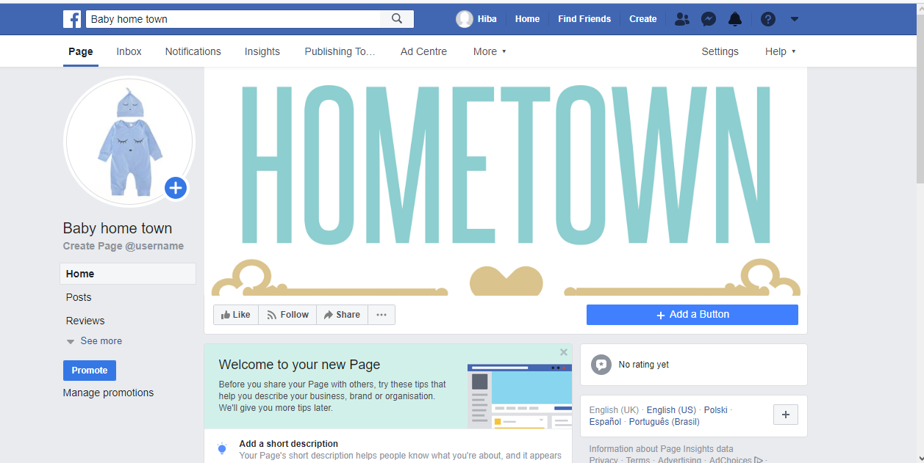

Creating an online presence is a simple way to market, communicate and gather information. Web based promoting is critical for all organizations since it affects the way shoppers settle on buying choices. ... Present day organizations must guarantee that they are not abandoned. An online nearness is a standout amongst the most significant ventures that a business can make. The advantages are interminable!

Conclusion
.
The basic objective of social media in the work place is to elevate and prosper in your field of work, with social networking program that will gather information for your business letting you see the progress of your connection with your customers, allow you to communicate with your customer, representatives and future venture that could possibly occur, also market your business to ensure you are getting one of the widest range of audience to help you gain more followers and more fame.
From the above report it has been abridged that cutting-edge innovation is a powerful apparatus that help with giving quality administrations to clients. Presently a day, various associations executes these sorts of idea in their business to make things simpler for representatives and clients as well. This report is depicted Digital aptitudes and research techniques in associations just as viability of web-based life as correspondence and advertising practice. It likewise depicts the viability of web gatherings by actualizing various applications

.

References
(n.d.).
13 Proven Social Media Marketing Tips for Small Businesses & Entrepreneurs. (2017, september 21). Retrieved from youtube : https://www.youtube.com/watch?v=q_RVYMN2SB8
conscious company media. (2018). Retrieved from HOW SOCIAL MEDIA IS CHANGING COMMUNICATION FOR THE BETTER: https://consciouscompanymedia.com/sustainable-business/how-social-media-is-changing-communication-for-the-better/
trends, s. (2019, may 3). Social Media Data Collection — Insights You Can Use. Retrieved from http://snaptrends.com/social-media-software/data-collection/
tufts. (2019). Retrieved from communication and marketing: https://communications.tufts.edu/marketing-and-branding/social-media-overview/
word stream. (n.d.). Retrieved from social media marketing for buisness: https://www.wordstream.com/social-media-marketing
xplenty. (2017, june 14). why youu should gather information from social media . Retrieved from xplentyblog: medium.com
Zhang, C. B. (july, 2015 24). Exploring interactive communication using social media. Retrieved from taylor and francis online : https://www.tandfonline.com/doi/abs/10.1080/02642069.2015.1064396?journalCode=fsij20

