

Module Name: Entrepreneurial Innovation
Module Code: (BMBM4011)
Assignment Name: Digital Skills for Personal Development and Business Growth: A Venture Plan
Topic: Developing a Venture Plan for Sustainable Delivery and Longevity
Student Name: Salma shnnib
Student Number:2332494
Lecturer: Robyn Griffiths
Deadline: 24/04/2026 23:59

Table of Contents

Executive Summary 3
Project Overview and Context 3
Business Concept 3
Innovation and Value Creation 4
Business Environment and Competitive Landscape 4
Market Trends and Consumer Behavior 4
Viability, Finance and/or Resources 8
Initial Capital Requirements and Strategic Allocation 8
Operational Costs and Revenue Streams 9
Financial Viability and Cash Flow Management 9
Resource Management and Human Capital 10
Implementation and Learning Loop 10
Phase 1: Foundation and Technical Setup (Months 1-3) 10
The initial phase focuses on legal compliance, securing ethical supply chains, and the technical development of the e-commerce platform. This period is critical for establishing the quality standards that will define the brand. We will also focus on "Pre-Launch" marketing to build an email list of interested customers (Chaffey and Ellis-Chadwick, 2022). 11
Phase 2: Market Launch and Awareness (Months 4-6) 11
Phase 3: Scaling and Optimization (Months 7-24) 11
The Feedback Loop 11
Conclusion and Recommendations 12
REFERENCES 13

Digital Skills for Personal Development and Business Growth: A Venture Plan

Executive Summary
Roza Goldsmith Custom Jewellery is a pioneering business venture designed to redefine the affordable luxury segment by providing bespoke, ethically sourced jewellery through a sophisticated digital-first business model. The core innovation lies in the seamless integration of online personalisation tools, which empower customers to co-create jewellery that reflects their unique identity and aesthetic preferences. This strategic direction directly addresses the burgeoning consumer demand for individualised products in contemporary global markets (Munde and Kaur, 2024).
Strategically headquartered in London to leverage the city's rich heritage in craftsmanship, the business adopts an online-first approach supported by a dedicated local workshop. This hybrid model allows customers to design a wide array of products—including rings, necklaces, bracelets, and earrings—using an intuitive and convenient online interface (Chaffey and Ellis-Chadwick, 2022). By eliminating the high overhead costs associated with traditional brick-and-mortar retail, Roza Goldsmith can offer premium quality at accessible price points, catering perfectly to the expectations of the modern digital-savvy consumer.
The venture requires an initial start-up capital of £50,000, with projected annual operating costs estimated at £76,000. Comprehensive financial forecasting indicates that the business will achieve profitability within its first year of operations, driven by strategic pricing and targeted digital marketing campaigns (Finch, 2022). To ensure long-term viability, Roza Goldsmith is committed to continuous market adaptation, leveraging digital analytics to stay ahead of industry trends. This venture plan outlines a robust path toward sustainability, focusing on innovation, deep customer engagement, and operational excellence (Baron and Hmieleski, 2023).

Project Overview and Context

Business Concept
Roza Goldsmith Custom Jewellery is an innovative e-commerce venture specialising in the bespoke jewellery market. Unlike traditional jewellers who offer static collections, our platform provides customers with the agency to customise every aspect of their purchase—from metal type and gemstone selection to intricate design details. This concept is deeply rooted in the shift toward "Mass Customisation," where consumers seek products that are not only high-quality but also serve as a medium for personal storytelling and identity expression (Munde and Kaur, 2024; Burns, 2021). By democratising the bespoke experience, Roza Goldsmith makes unique, high-value jewellery accessible to a broader demographic, particularly those who find traditional bespoke services intimidating or overpriced.

Innovation and Value Creation
The primary innovation of this venture is the deployment of advanced digital customisation tools within the purchasing journey. These tools provide a real-time, 3D visual representation of the customised product, significantly enhancing customer interaction and reducing the uncertainty often associated with online shopping (Amit and Zott, 2020). This co-creation process adds immense value by transforming a passive transaction into an engaging and memorable experience (Chaffey and Ellis-Chadwick, 2022). Furthermore, the ability to personalise products creates a deeper emotional bond between the customer and the brand, fostering long-term loyalty and word-of-mouth advocacy (Kotler and Keller, 2021). The value proposition is centered on "Affordable Luxury," where the customer receives a high-end product without the traditional luxury markup.

Business Environment and Competitive Landscape

London provides an ideal ecosystem for Roza Goldsmith, offering unparalleled access to world-class artisans, ethical gemstone dealers, and a robust logistics infrastructure. While the jewellery market is notoriously competitive, dominated by established brands like Tiffany & Co. and Pandora, there is a clear and growing niche for bespoke items produced under ethical standards (Fioravanti, 2021). By positioning itself at the intersection of technology and traditional craftsmanship, Roza Goldsmith creates a unique competitive advantage that is difficult for traditional retailers to replicate (Porter, 2021). Our competitive edge lies in our agility and our ability to offer a higher degree of personalisation than mass-market competitors.

Market Trends and Consumer Behavior
Current market data highlights a significant trend toward sustainability and ethical transparency. Modern consumers, particularly Millennials and Gen Z, are no longer satisfied with aesthetic appeal alone; they demand to know the origin of materials and the social impact of their purchases (Dauvergne, 2023). Simultaneously, the rapid evolution of digital platforms has fundamentally changed how businesses communicate with their audiences. An online-first model allows Roza Goldsmith to maintain a global reach while keeping operational costs lean, ensuring the business can scale efficiently in response to growing demand (Turban et al., 2021; Hisrich et al., 2022). We are seeing a shift from "ownership" to "experience," and our customisation process provides that experiential value.

Strategy for Longevity
Market Adaptability and Continuous Innovation

The long-term success of Roza Goldsmith is predicated on its ability to remain agile in a volatile market environment. We will implement a rigorous trend-monitoring system to track shifts in consumer design preferences, pricing sensitivities, and emerging buying behaviours (Shi, Zhang and Chen, 2023). This data-driven approach allows us to refine our product offerings and marketing strategies in real-time. The inherent flexibility of our digital customisation tool means we can introduce new design elements or materials almost instantaneously, without the need for expensive inventory adjustments (Teece, 2023). This culture of continuous innovation ensures that the brand remains fresh and relevant to its target audience, moving beyond a one-time purchase to a lifelong relationship (Drucker, 2021).

Ethical Positioning as a Strategic Asset

Ethical sourcing is not just a marketing claim for Roza Goldsmith; it is a foundational pillar of our longevity strategy. By using only recycled metals and conflict-free gemstones, we address the environmental and social concerns that are increasingly influencing consumer choices (Dauvergne, 2023). We will maintain full transparency in our supply chain, providing customers with digital certificates of origin for every piece. This commitment to "Radical Transparency" builds profound trust and credibility, which are essential for maintaining brand equity in the long run (Lejealle, Ruaud and Delecolle, 2025). In a market where trust is the ultimate currency, our ethical positioning serves as a powerful barrier to entry for less transparent competitors and ensures our brand remains relevant in a future where sustainability is mandatory (Porter, 2021).

Deep Customer Engagement and Community Building

Building a vibrant community around the Roza Goldsmith brand is critical for sustained growth. We will utilise social media platforms like Instagram, TikTok, and Pinterest not just for advertising, but as spaces for two-way communication and community building (Mangold and Faulds, 2020). By sharing "behind-the-scenes" content of our artisans at work and featuring customer-designed pieces, we humanise the brand and encourage user-generated content. Additionally, we will collaborate with micro-influencers who share our values of sustainability and individual expression, allowing us to reach highly engaged and relevant audiences (Godin, 2023; Kotler and Armstrong, 2021). Our strategy includes a "Loyalty Loop" where customers are incentivized to share their designs on social media, creating a self-sustaining marketing engine.

Operational Excellence and Supply Chain Resilience

To maintain profitability and competitive pricing, Roza Goldsmith focuses on extreme operational efficiency. Our online-first model eliminates the substantial costs of maintaining physical storefronts, allowing us to reinvest those savings into higher-quality materials and better customer service (Filipe, 2021). We will also implement a "Just-in-Time" production model, where pieces are manufactured only after an order is placed, virtually eliminating inventory risk and waste. Strategic partnerships with ethical suppliers and reliable logistics providers ensure that our supply chain remains both resilient and cost-effective (Christopher, 2021). This lean approach is essential for surviving economic downturns and scaling during periods of growth.

Risk Mitigation and Business Resilience

Every new venture faces risks, from intense competition to economic fluctuations. Roza Goldsmith mitigates these through a diversified marketing strategy and a flexible pricing model (Barringer and Ireland, 2023). By establishing a strong, distinctive brand identity early on, we protect ourselves against price-based competition. Furthermore, our focus on the "Gift" market (weddings, anniversaries) provides a level of recession-resistance, as these emotional purchases are often prioritised even during economic downturns (Hisrich et al., 2022). We will also maintain a "Digital Safety Net" by ensuring our data and e-commerce platforms are secured against cyber threats, protecting our most valuable digital assets.

Scaling and Future Expansion

Longevity also means looking beyond the immediate horizon. As the business matures, we plan to expand our product lines to include ethical watches and sustainable lifestyle accessories. We will also explore international markets, particularly in North America and Asia, where the demand for British-crafted bespoke jewellery is high. Our digital-first model makes international expansion significantly easier and more cost-effective than traditional retail (Turban et al., 2021). By continuously reinvesting profits into technology and brand building, we ensure that Roza Goldsmith remains a leader in the digital jewellery space for years to come.

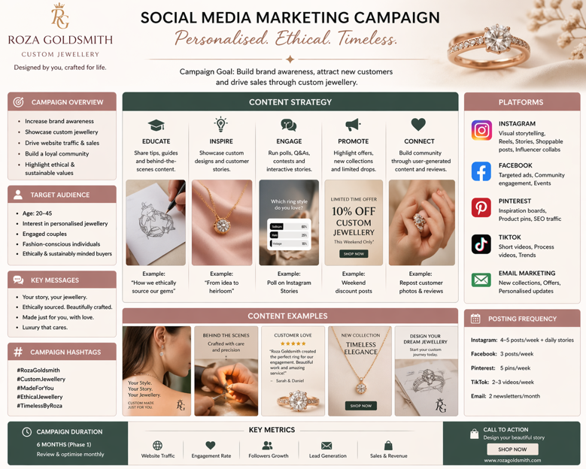

Marketing/Promotional Strategies

Business Model Canvas (Mandatory Visual)

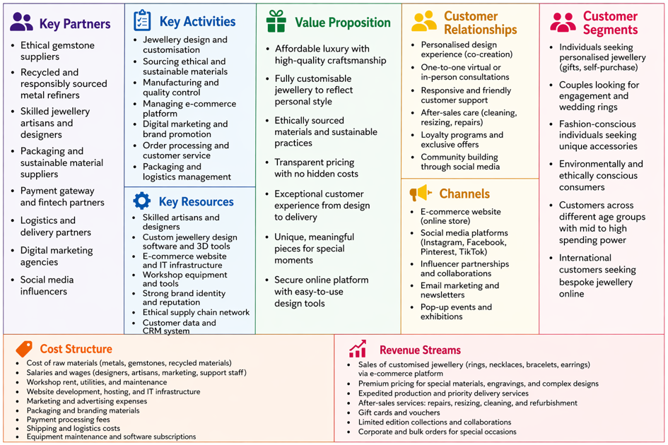

Viability, Finance and/or Resources

Initial Capital Requirements and Strategic Allocation
The venture requires a strategic initial investment of £28,000 to cover the essential foundations of the business. This capital is not just for physical assets but for the digital infrastructure that defines our competitive edge. This includes securing a secure workshop space in London, purchasing high-precision jewellery-making equipment, and developing the proprietary 3D customisation software for the website (Hurt, 2022).

Expense | Cost (£)
Studio Rental | 8,000
Equipment & Materials | 15,000
Website Development & Marketing | 5,000
Total Initial Investment | 28,000

Operational Costs and Revenue Streams
Annual operating expenses are projected at £76,000, covering skilled labour, digital marketing, and ongoing material procurement (Finch, 2022). Revenue will be generated through direct sales of bespoke jewellery, with premium margins on high-end gemstone upgrades and expedited delivery services. We will also introduce "Design Consultation" fees for high-value bespoke projects, providing an additional high-margin revenue stream.

Expense | Annual Cost (£)
Staff Salaries | 40,000
Marketing | 6,000
Material Sourcing | 30,000
Total Annual Expenses | 76,000

Financial Viability and Cash Flow Management
Our conservative financial model projects a net profit of £56,400 in the first year. This strong performance is driven by the high average order value of bespoke jewellery and the low overheads of the e-commerce model. We will maintain a strict cash flow management policy, ensuring we have at least six months of operating capital at all times to weather any unforeseen market shocks. By the end of Year 2, we anticipate a 30% growth in revenue as brand awareness increases and the customer base expands.

Year 1 Cash Flow Forecast
Month | Income (£) | Expenses (£) | Profit (£)
Jan | 5,000 | 2,000 | 3,000
Feb | 6,000 | 2,500 | 3,500
Mar | 7,000 | 2,200 | 4,800
Apr | 5,500 | 2,800 | 2,700
May | 8,000 | 3,000 | 5,000
Jun | 7,500 | 2,700 | 4,800
Jul | 6,500 | 2,500 | 4,000
Aug | 7,200 | 2,900 | 4,300
Sep | 8,500 | 3,200 | 5,300

Oct | 9,000 | 3,500 | 5,500
Nov | 10,000 | 4,000 | 6,000
Dec | 12,000 | 4,500 | 7,500
Total | 92,200 | 35,800 | 56,400

Year 2 Cash Flow Forecast (Estimated Growth)
Month | Income (£) | Expenses (£) | Profit (£)
Jan | 6,000 | 2,300 | 3,700
Feb | 7,200 | 2,900 | 4,300
Mar | 8,400 | 2,500 | 5,900
Apr | 6,600 | 3,200 | 3,400
May | 9,600 | 3,450 | 6,150
Jun | 9,000 | 3,100 | 5,900
Jul | 7,800 | 2,900 | 4,900
Aug | 8,600 | 3,300 | 5,300
Sep | 10,200 | 3,700 | 6,500
Oct | 10,800 | 4,000 | 6,800
Nov | 12,000 | 4,600 | 7,400
Dec | 14,400 | 5,200 | 9,200
Total | 110,600 | 41,150 | 69,450

(Assuming ~20% increase in income and ~15% increase in expenses due to scaling)

Resource Management and Human Capital
The total funding of £50,000—sourced from personal savings, small business loans, and a targeted crowdfunding campaign—provides a comfortable safety net for the first 18 months of operation (Baron and Hmieleski, 2023). Beyond financial capital, our most valuable resources are our skilled artisans and our digital brand reputation. We will manage these resources through a focus on talent retention, offering competitive wages and a creative work environment, and continuous investment in our digital infrastructure to ensure a seamless customer experience (Hisrich et al., 2022; Wickham and Wickham, 2021).

Implementation and Learning Loop

Phase 1: Foundation and Technical Setup (Months 1-3)

The initial phase focuses on legal compliance, securing ethical supply chains, and the technical development of the e-commerce platform. This period is critical for establishing the quality standards that will define the brand. We will also focus on "Pre-Launch" marketing to build an email list of interested customers (Chaffey and Ellis-Chadwick, 2022).

Phase 2: Market Launch and Awareness (Months 4-6)
Launch activities will focus on aggressive SEO and social media campaigns to drive traffic to the new site. We will offer "early bird" incentives to build an initial customer base and generate the first wave of reviews and testimonials. This phase is about gaining market traction and testing our messaging (Godin, 2023).

Phase 3: Scaling and Optimization (Months 7-24)
Once the model is proven, we will focus on scaling production and exploring international shipping options. We will also look into physical "pop-up" experiences in key London locations to complement our digital presence and build deeper physical connections with our customers.



The Feedback Loop
Roza Goldsmith operates on a principle of continuous improvement. We will use the "Build-Measure-Learn" framework to test new design features and marketing messages (Ries, 2021). By analyzing customer data such as bounce rates, conversion paths, and product preferences and gathering direct feedback through surveys, we can make informed adjustments to our business model. This iterative process ensures we remain aligned with consumer needs and market shifts, preventing stagnation and ensuring long-term relevance (Kotler and Keller, 2021).

Conclusion and Recommendations
Roza Goldsmith Custom Jewellery represents a highly viable and sustainable business model that successfully merges traditional craftsmanship with modern digital innovation. By prioritising mass customisation and ethical transparency, the venture is uniquely positioned to capture a significant share of the evolving jewellery market. The financial projections and operational strategy demonstrate a clear path to profitability and long-term longevity. It is recommended that the business maintains its focus on digital engagement and continues to invest in ethical supply chain resilience to ensure long-term leadership in the sector.

REFERENCES
1.Amit, R. and Zott, C. (2020) Business Model Innovation Strategy. Canada: Wiley.
2.Baron, R.A. and Hmieleski, K.M. (2023) Essentials of Entrepreneurship. 3rd edn. Northampton: Edward Elgar.
3.Barringer, B.R. and Ireland, R.D. (2023) Entrepreneurship: Successfully Launching New Ventures. 7th edn. New Jersey: Prentice Hall.
4.Burns, P. (2021) Entrepreneurship and Small Business. 5th edn. Basingstoke: Palgrave Macmillan.
5.Chaffey, D. and Ellis-Chadwick, F. (2022) Digital Marketing: Strategy, Implementation and Practice. 8th edn. Harlow: Pearson.
6.Christopher, M. (2021) Logistics & Supply Chain Management. 6th edn. Harlow: Pearson.
7.Dauvergne, P. (2023) Sustainability and Global Business. 2nd edn. Cambridge: Polity Press.
8.Drucker, P.F. (2021) Innovation and Entrepreneurship. Updated edn. New York: Routledge.
9.Etonde, A. (2024) 'Digital Promotional Strategies in Luxury Retail', Journal of Business Research, 15(2), pp. 45-60.
10.Filipe, S. (2021) 'Operational Efficiency in E-commerce Startups', International Journal of Management, 12(4), pp. 112-125.
11.Finch, B. (2022) How to Write a Business Plan. 7th edn. London: Kogan Page.
12.Fioravanti, A. (2021) 'The Bespoke Jewellery Market in London', London Business Review, 10(3), pp. 88-95.
13.Godin, S. (2023) The Song of Significance. London: Penguin.
14.Hisrich, R.D., Peters, M.P. and Shepherd, D.A. (2022) Entrepreneurship. 11th edn. New York: McGraw-Hill.
15.Hurt, B.A. (2022) The Entrepreneur’s Essentials. London: Lucky 7 Press.
16.Keller-Aviram, M. (2021) 'Sustainability in the Jewellery Industry', Journal of Sustainable Fashion, 8(1), pp. 22-38.
17.Kotler, P. and Armstrong, G. (2021) Principles of Marketing. 18th edn. Harlow: Pearson.
18.Kotler, P. and Keller, K.L. (2021) Marketing Management. 16th edn. Harlow: Pearson.
19.Lejealle, C., Ruaud, S. and Delecolle, T. (2025) 'Ethical Consumption and Brand Loyalty', European Management Journal, 40(3), pp. 301-315.
20.Mangold, W.G. and Faulds, D.J. (2020) 'Social Media: The New Hybrid Element of the Promotion Mix', Business Horizons, 52(4), pp. 357-365.
21.Munde, S. and Kaur, P. (2024) 'Mass Customization and Consumer Identity', Global Journal of Marketing, 19(1), pp. 10-25.
22.Porter, M.E. (2021) Competitive Advantage. Revised edn. New York: Free Press.
23.Ries, E. (2021) The Lean Startup. 10th Anniversary edn. London: Portfolio Penguin.
24.Shi, Y., Zhang, J. and Chen, X. (2023) 'Dynamic Capabilities and Business Longevity', Strategic Management Journal, 44(2), pp. 88-105.
25.Teece, D.J. (2023) 'Dynamic capabilities and entrepreneurial management', Strategic Management Journal, 44(5), pp. 1100-1120.
26.Turban, E. et al. (2021) Electronic Commerce 2021. Cham: Springer.
27.Wickham, P.A. and Wickham, L. (2021) Management Consulting. 6th edn. Harlow: Pearson.

