Student name: Osman Kamara
Student ID: 2324742
Module name: Changemakers: Building your Personal Brand for Sustainable Employment
Module code: ( BMHP5015_LON)
Lecturer’s name: Caroline Salami

Introduction
The course ‘’Changemakers: Building your Brand for Sustainable Employment’’ equipped me with essential insights into personal and professional growth throughout its span. The study program focused on four key subjects: Personal branding, boundaryless careers, networking techniques, and emotional intelligence. The conventional career ladder, defined by a linear ascent within a single organisation, has been dismantled. In its place, the concept of the boundaryless career has become the prevailing model, necessitating a new array of skills for career success and longevity. This report will examine the four critical components necessary to excel in this evolving landscape. We will first define the boundaryless career, outlining its features and obstacles. Next we will highlight personal branding , Rachmad sees it as a significant human endeavour rooted in genuineness, honesty, and ethical consciousness ( Rachmad, Y.E. 2023). Third, we will delve into effective networking strategies that foster meaningful and mutually beneficial partnerships, rather than merely amassing contacts. Lastly we will explore the significance of emotional intelligence in self- management and building effective relationships. Collectively, these skills provide a comprehensive framework for navigating the challenges of the modern professional environment.

TASK 1: BRAND YOU

Boundaryless career: Social, economic, and technological shifts are increasingly resulting in a career landscape that is fragmented and characterised by frequent transitions. As noted by Feldman and Ng (2007), several factors have influenced individual career mobility over the past decade. For example, macroeconomic conditions have led to geographic differences in mobility opportunities and an optimistic view of economic conditions in certain areas. Additionally, companies have downsized and outsourced to enhance flexibility, efficiency, and innovation, shifting career expectations away from job security toward continuous learning and maintaining marketability in the broader job market. Social changes have also prompted greater upward mobility for women and minority employees, partly due to the introduction of diversity initiatives. Furthermore, the widespread adoption of information and technologies has transformed how individuals perceive their jobs, enabling virtual work that promotes mobility and may reduce their of connection to a specific organisation. As a result, the conventional career model, which is centred on permanent full- time roles with one employer, has increasingly been supplanted by a modern career model that focuses on movement between organisations and temporary contracts ( Sammarra et al., 2013).

Personal Branding: It highlighting the unique value you bring . Initially, the term personal branding felt uncomfortable, as it appeared contrary to the collaborative and altruistic values of health and social care. I associated it with corporate self- promotion. However, I have come to see it as the intentional and authentic expression of my professional identity , including my values, distinctive skills, and the contributions I aspire to make. In a field built on trust, I had to consider my desired reputation. What do I want to be recognised for? Is it for advocating co- production with service users, maintaining analytical rigor in programme evaluation, or introducing innovative solutions for community- based initiatives? My personal brand signifies the quality and character I aim to provide. Engaging in practical exercises during the module, as developing a LinkedIn profile and creating an elevator pitch for networking , pushes me to transform vague ambitions into precise expressions. For instance, I now clarify,’’ I am a future health and social professional dedicated to utilising community assets to address health inequalities by integrating strengths – based practices with data- informed service design’’.
Ambition: Aligning Aspirations with Sector Values . My ambition has often caused internal conflict, is it appropriate to be ambitious within a field dedicated to serving others? This module created a space for me to reconcile these feelings. I have come to understand that ambition in health and social care does not equate to self-serving careerism, rather, it can be a significant force for positive change.
Reflection linking: The modern job market and the rise in flexible work options necessitate that individuals adopt a more market-focused approach ( Lair et al., 2005., Manai and Holmlund,2015).
Describe soft skills and why are they crucial in today’s world
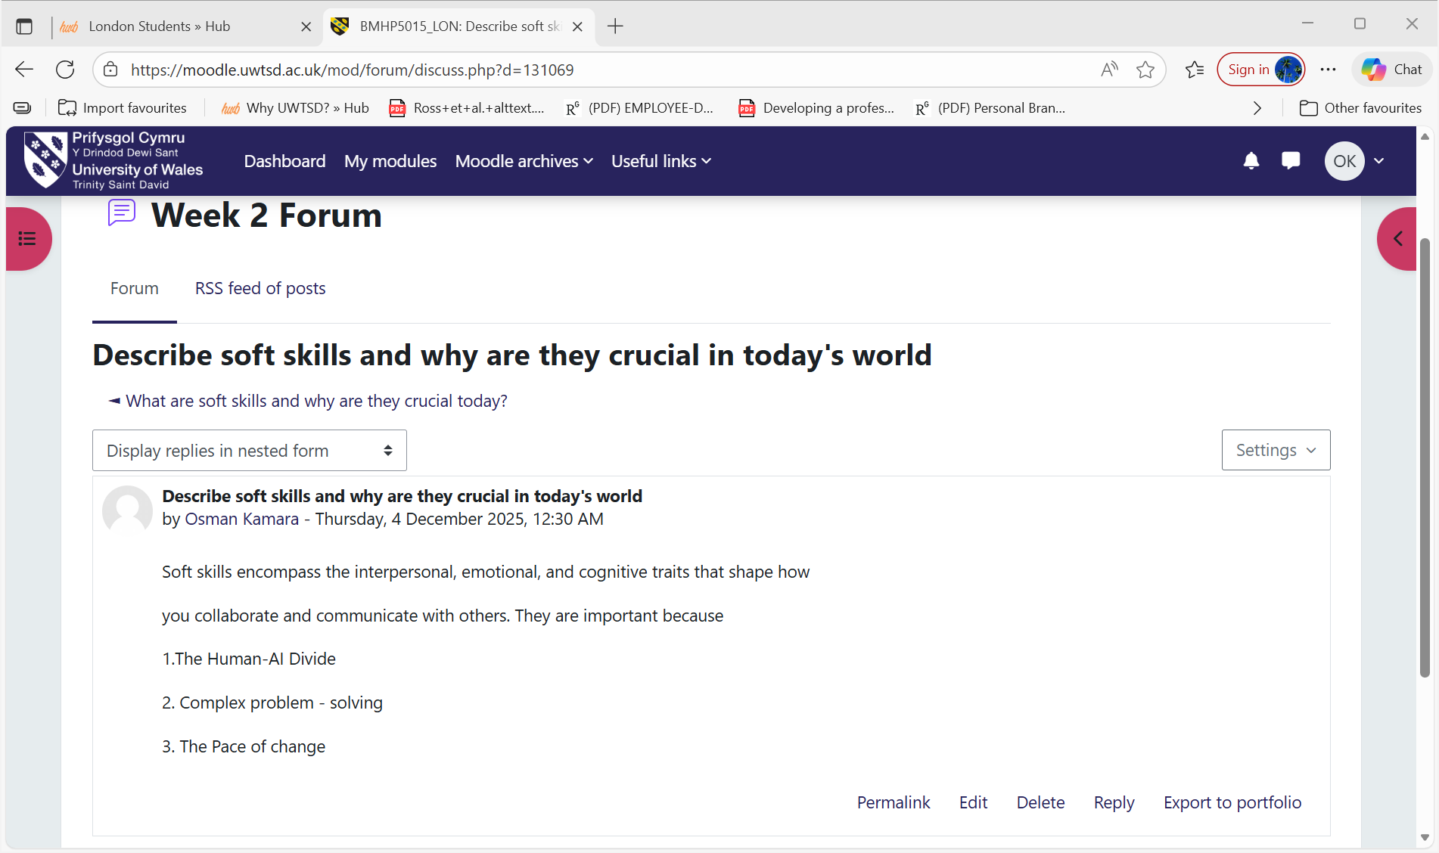

TASK 2 : Reflection on unit 2
It is a small world: Prior to attending university, my perception of health and social care was largely local in nature. This module broadened my perspective significantly. Through coursework on global health factors and lectures discussing different social care systems, I learned that the challenges faced by a care home in Luton are often linked to worldwide issues. The most impactful learning emerged from case studies . Analysing how austerity measures in one country affect care services globally. I began to understand local practices as interconnected within global networks of people, ideas, policies, and diseases. This was not mere theory; during the pandemic, I observed firsthand how disruptions in global supply chains influenced the availability of PPE in health care locations.
Variety is the spice of life: My conception of diversity transformed significantly on this module. Initially, I viewed ‘’variety’’ simply as basic tolerance and cultural appreciation. Through comprehensive course content and interactive simulations, I learned that diversity should be celebrated, not just tolerated, as essential to ethical and effective practice. Furthermore, I realised that ‘’variety’’ extends to different forms of knowledge and healing.
Network society: The term’’ network society’’ refers to a social structure influenced by digital communication, interconnected systems, and flexible relationships instead of rigid hierarchies. Reflecting on this concept has provided me with insights into the evolving landscape of health and social care practice and the need for my development as a future practitioner. In a network society, information travels quickly through digital channels, facilitating connections between individuals, organisations, and communities . This transformation is particularly vital in health and social care, where services are no longer solely dependent on traditional methods. Care now occurs within digital networks, collaborative partnerships, and community – oriented frameworks. For instance telehealth consultations, online support groups, shared digital records, and joint care plans exemplify how digital networks are reshaping everyday practices.
Additionally, informal social networks such as friends, family, peers, and community organisations play a crucial role in assisting individuals with chronic health conditions.
Making connections: Initially, I regarded ‘’ making connections’’ as a transactional, linear process focused on networking , collecting contacts, attending events to ‘’ gain something’’, and viewing relationships as steps on a ladder. The module introduced the idea of connection as relational capital, prompting a significant shift. I came to realise that sustainable employment is not achieved through a single handshake with a hiring manager, but by becoming part of a network built on mutual trust, shared values, and collaboration. We were prompted to look beyond immediate professional contacts to include mentors, alumni, interest- based communities, and even casual connections from volunteer efforts.
Linking networking: Digital technologies have created unparalleled opportunities to encourage health behaviour changes and enhance health outcomes. Social networking sites and online health communities act as powerful platforms for sharing health information( Kim et al.,2016), enabling individuals to connect with others who have similar conditions or experiences (DeAndrea, 2015; Zhang et al.,2018).
What does networking means screenshot
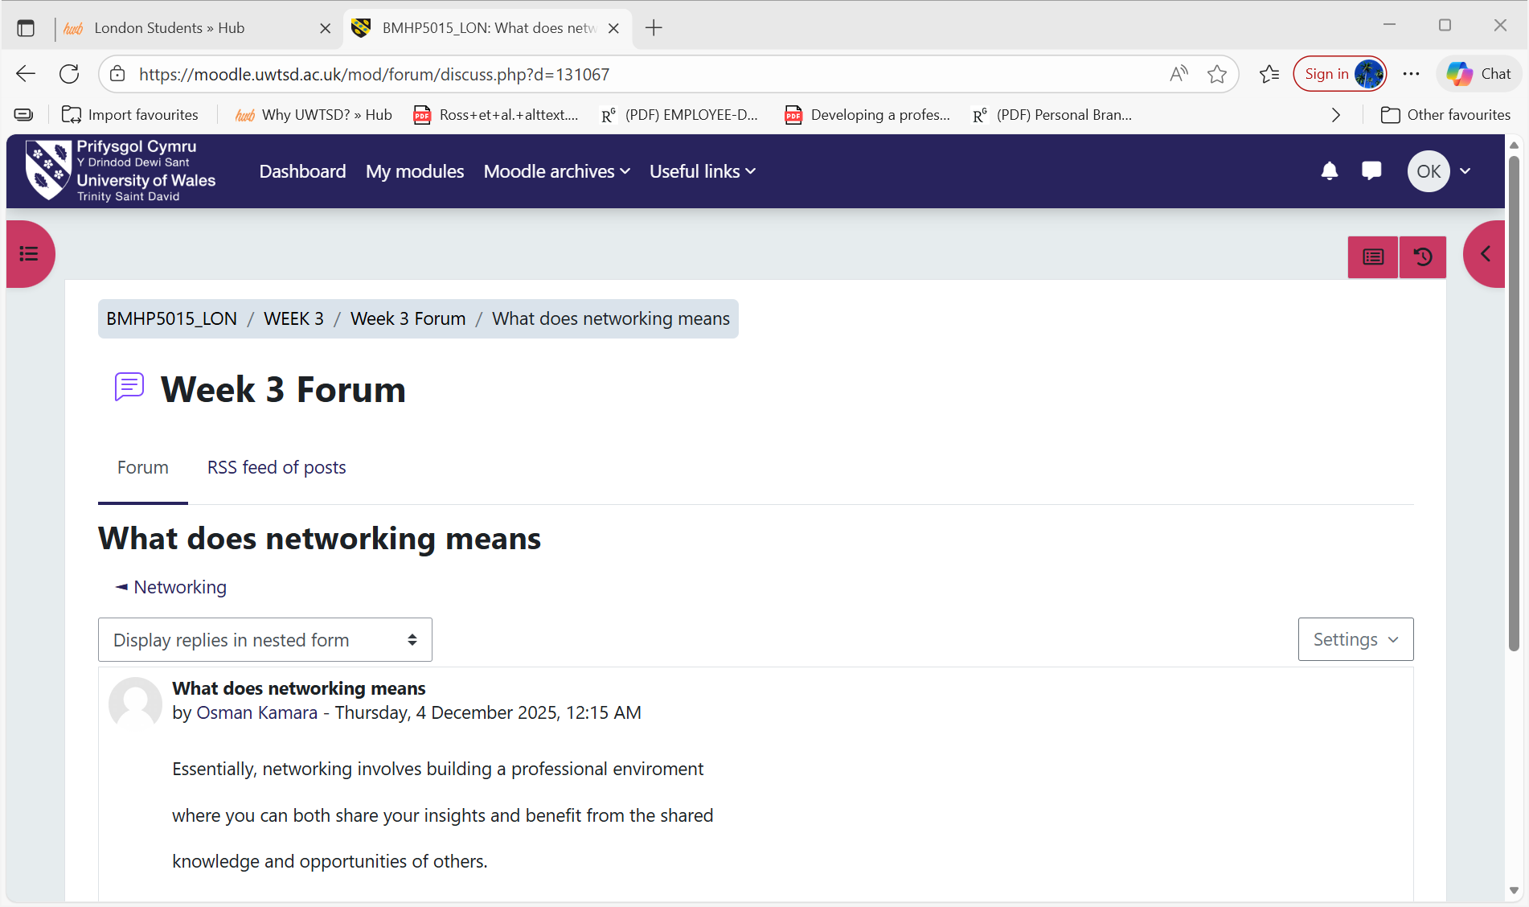

Task 3: Creating your own luck: This module has transformed my understanding of luck in Health and Social Care. It’s not merely about chance; rather, it’s the outcome of a proactive and visible professional identity. By participating in multidisciplinary conversations, offering thoughtful insights, and fostering a trust- based network. I generate myself at the intersection of readiness and demand, making sure I am acknowledged as a dependable resource when opportunities for growth or meaningful work present themselves. I am now actively shaping my own professional success.
Identifying career opportunities: The module changed my approach to spotting opportunities in Health and Social Care . I discovered that having a strategic personal brand enhances my visibility within the industry. By participating thoughtfully in professional discussions, sharing
Insights from my experiences, and networking with a variety of professionals, I have shifted from merely responding to job openings. Now, I actively seek out unlisted positions, partnership projects, and growth opportunities that resonate with my values.
Opportunities arise from my proactive involvement and commitment rather than being left to luck.
Open doors: It transformed my understanding of professional opportunities, viewing them not as fixed barriers but as portals activated by relationships and reputation.
Before this module, I viewed career progression in Health and Social Care as a straightforward path , spotting a job posting, applying, and hoping for an interview. The’’ open doors’’ were those explicitly advertised. However, this module has radically altered that passive perspective. I have realised that the most meaningful and sustainable opportunities are often those that are not clearly marked and are opened through generic applications, but by establishing a reliable professional identity.
Me. Com: Me.com delves into individual identity, strengths , and values to develop a professional brand in health and social care.
It enhanced my awareness of the significance of recognising my individual strengths, values, and career aspirations in health and social care. It prompted me to contemplate my identity, how I want others to see me, and the attributes that define my professional persona. Through examining my skills and goals, I gained confidence in creating a lasting personal brand, motivating me to authentically and purposefully present myself in future job prospects.
Importance of changing perspective in health and social care screenshot
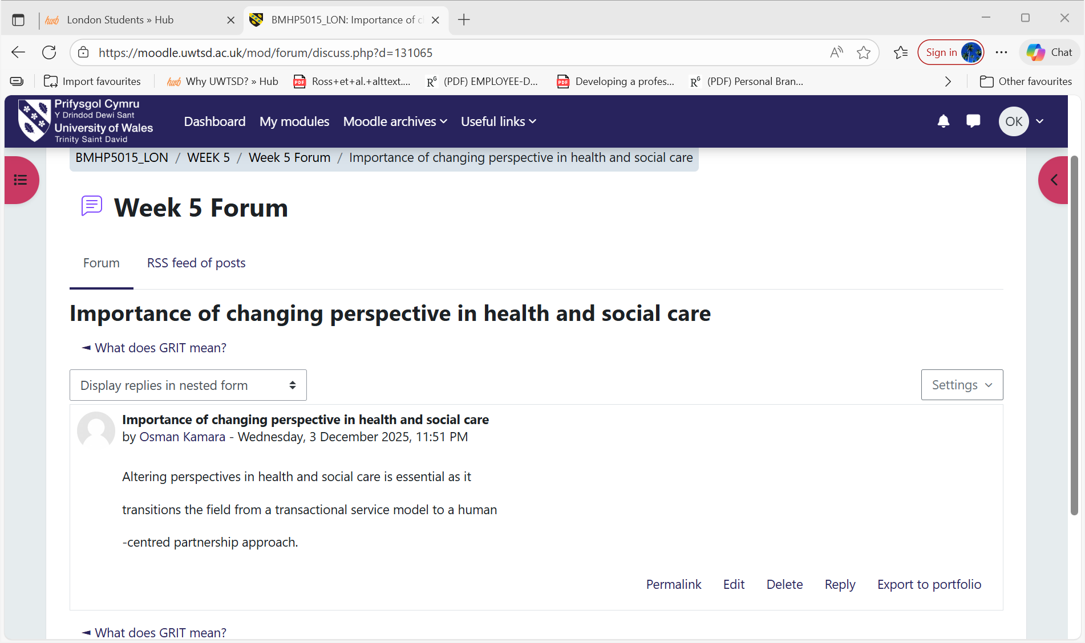
Reflection linking: Individuals can serve as valuable allies, offering insights, ideas, and access to unadvertised prospects. These connections do not always have to be close friendships. A study by Wise man (2004) found that many fortunate individuals attributed their good luck to the casual interactions they had with people they encountered daily. Additionally, research indicates that most people are likely to respond positively to requests for assistance ( Ober,2023). Thus, friendly acquaintances can be incredibly beneficial.

Task 4: Future me: It examines the role of personal development, vision, and branding in achieving lasting success in health and social care.
In reflecting the topic ‘’Future Me’’, I gained insight into how my values, skills, and ambitions influence my personal brand within health and social care. This module prompted me to envision my future professional self and identity the necessary steps to build confidence, enhance communication, and improve employability. By emphasising personal growth and self-awareness, I now understand how purposeful branding can foster sustainable employment and shape my career path over time.
Passion and Perseverance: Passion and determination illustrate how drive and tenacity enhance personal branding in health and care professions.
In the changemakers module, reflecting on passion and perseverance deepened my understanding of how motivation and resilience influence my personal brand in health and social care. This topic revealed that true passion fuels purpose, while perseverance enhances my capacity to face obstacles. Collectively, these traits shape my professional development and enhance my long-term employability in a dynamic and challenging field.
Plan, Prepare, Perform: It examines how to effectively create and convey your professional identity, or ‘’personal brand’’, in the health and care sectors.
This module provides professionals with a strategic framework of ‘’plan, prepare , perform’’ to enhance career resilience. Planning entails introspectively identifying one’s distinct values and professional goals. Preparation focuses on establishing a trustworthy online presence that mirrors this identity. Lastly, performing involves confidently communicating this brand during networking and interviews, ultimately leading to sustainable employment as a recognised and influential changemaker in health and social care.
Career role models: It offer practical examples for advancing in health and social care. By examining their paths, we can pinpoint the skills, values, and strategic decisions that contribute to fulfilling and lasting careers.
Career role models are essential guides in the intricate realm of health and social care. By exploring their career paths, we uncover valuable insights into the skills, ethical beliefs, and strategic choices that contribute to a strong and influential career . This examination goes beyond simple admiration; it is a purposeful process of analysis and learning. Through these individuals, we can see how they effectively presented their value, establishing a trustworthy personal brand that fosters connections and influence.
Limited beliefs screenshot

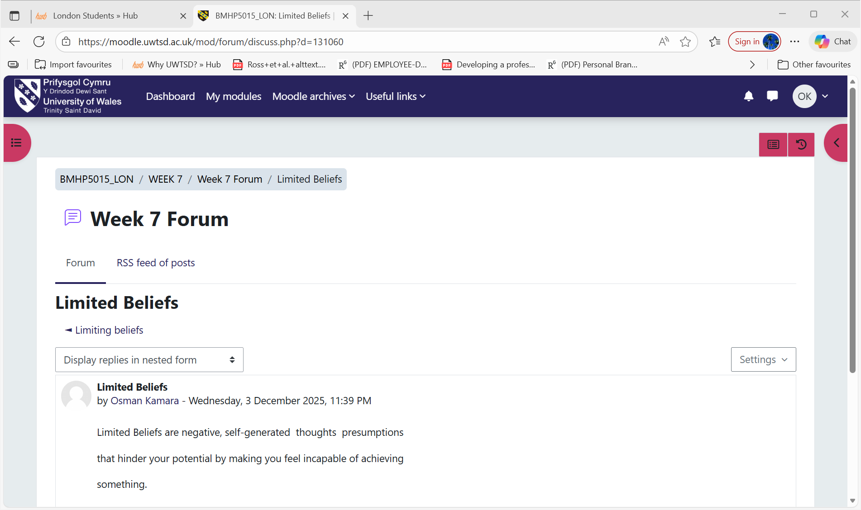

Linking role modelling: It plays a vital role in influencing the future workforce’s perceptions of general practice. Identifying a GP as a role model is a key factor in deciding to pursue a career in this speciality, with this influence being notably stronger among junior doctors compared to students at the time of the study ( Connelly MT, Sullivan AM, Peters AS, et al.2003). Individuals who opt for this speciality and recognise a GP role often come from universities that promote family medicine, and they tend to express greater satisfaction with their decision ( Kutob RM, Senf JH, Campos- Outcalt D,2006).

References
Connelly MT, Sullivan AM, Peters AS, et al. Variation in predictors of primary care career choice by year and stage of training: a national survey. J Gen Intern Med. 2003;18(3):159–169. [DOI] [PMC free article] [PubMed] [Google Scholar

DeAndrea, D. C. (2015). Testing the proclaimed affordances of online support groups in a nationally representative sample of adults seeking mental health assistance. Journal of Health Communication, 20(2), 147–156. https://doi.org/10.1080/10810730.2014.914606
Feldman, D.C, and Ng, T.W.H.(2007). Careers: Mobility, embeddedness, and success. j. Manage.33.350-377. Doi:10.1177/0149206307300815

Kim, E., Hou, J., Han, J. Y., & Himelboim, I. (2016). breast cancer social networks: Network and content characteristics. Journal of Health Communication, 21(4), 479–486. https://doi.org/10.1080/10810730.2015.1103326

Kutob RM, Senf JH, Campos-Outcalt D. The diverse functions of role models across primary care specialties. Fam Med. 2006;38(4):244–251. [PubMed] [Google Scholar]
Lair, D. J., Sullivan, K., and Cheney, G. (2005). Marketization and the recasting of the professional self. Manag. Commun. Q. 18, 307–343. doi: 10.1177/ 0893318904270744

Manai, A., and Holmlund, M. (2015). Self-marketing brand skills for business students. Mark. Intell. Plan. 33, 749–762. doi: 10.1108/MIP-09-2013-0141
Ober, H. (2023). Small acts of Kindness and Frequent and Universal, Study Finds. UCLA Newsroom. : Small acts of kindness are frequent and universal,( Accessed: 2 December 2025).
Rachmad , Yoesoep.(2023). Multidisciplinary Academic Institute of Learning. Ras Al Khaimah Mountain Kitab Nashr. Available at: DOI: 10.17605/osf.io/ urwq2
Sammarra, A., Profili, S., and Innocenti, L. (2013). Do external careers pay-off for both
managers and professionals? The effect of inter-organizational mobility on objective career success. Int. J. Hum. Resour. Manage. 24, 2490–2511. doi: 10.1080/09585192.2012.725076
Zhang, R., Eschler, J., & Reddy, M. (2018). Online support groups for depression in China: Culturally shaped interactions and motivations. Computer Supported Cooperative Work (CSCW), 27(3–6), 327–354. https://doi.org/10.1007/s10606-018-9322-4

