Slide 1: Title page for Organizational Behaviour
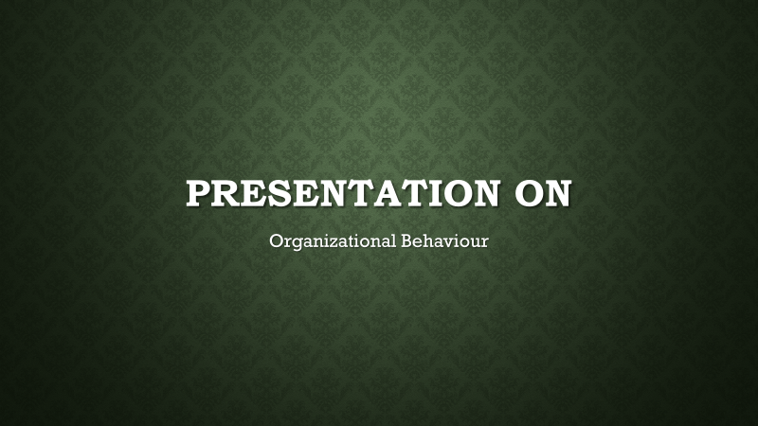

Slide 2: Chosen Organization



Slide 3: Introduction
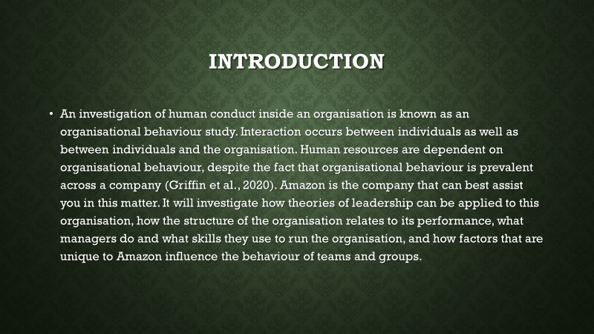
An investigation of human conduct inside an organisation is known as an organisational behaviour study. Interaction occurs between individuals as well as between individuals and the organisation. Human resources are dependent on organisational behaviour, despite the fact that organisational behaviour is prevalent across a company (Griffin et al., 2020). Amazon is the company that can best assist you in this matter. It will investigate how theories of leadership can be applied to this organisation, how the structure of the organisation relates to its performance, what managers do and what skills they use to run the organisation, and how factors that are unique to Amazon influence the behaviour of teams and groups.

Slide 4: Background of Amazon.com
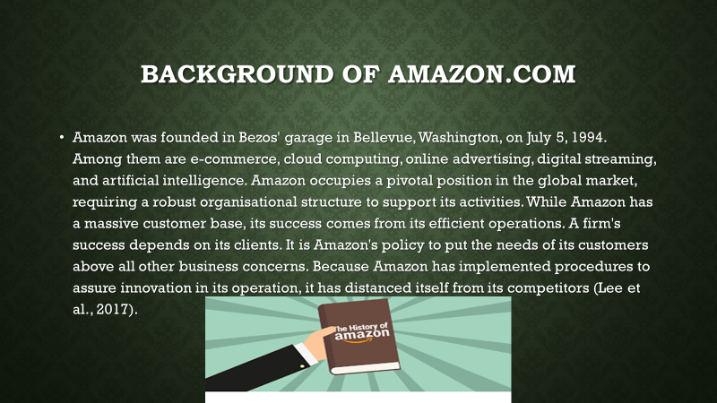


Amazon was founded in Bezos' garage in Bellevue, Washington, on July 5, 1994. Among them are e-commerce, cloud computing, online advertising, digital streaming, and artificial intelligence. Amazon occupies a pivotal position in the global market, requiring a robust organisational structure to support its activities. While Amazon has a massive customer base, its success comes from its efficient operations. A firm's success depends on its clients. It is Amazon's policy to put the needs of its customers above all other business concerns. Because Amazon has implemented procedures to assure innovation in its operation, it has distanced itself from its competitors (Lee et al., 2017).

Slide 5: Definition of organizational culture
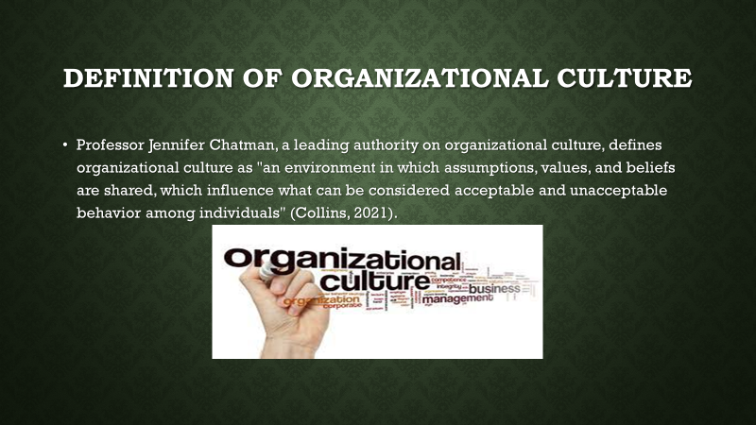


Professor Jennifer Chatman, a leading authority on organizational culture, defines organizational culture as "an environment in which assumptions, values, and beliefs are shared, which influence what can be considered acceptable and unacceptable behaviour among individuals" (Collins, 2021).
Slide 6: Characteristics of organizational culture
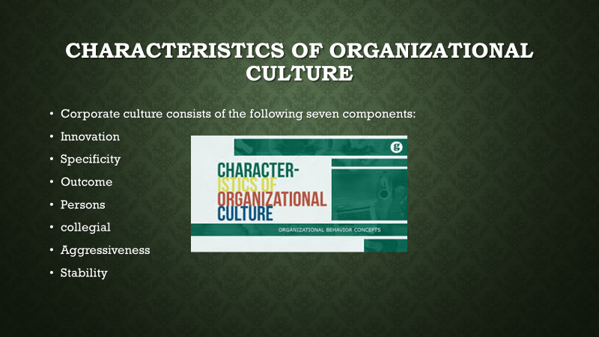


Corporate culture consists of the following seven components:
1. Innovation
Taking risks and being courageous will be encouraged in innovative companies.
2. Specificity
Depending on this, workers are required to be accurate in their work.
3. Outcome
It is more important to focus on outcomes than procedures in businesses that place a high value on results.
4. Persons
Putting too much emphasis on finances rather than people results in rigid standards and processes in businesses.
5. collegial
A work environment that emphasizes teamwork over individualism is a teamwork supporter.
6. Aggressiveness
Competitors are generally expected to treat each other aggressively based on this trait.
7. Stability
Stable businesses are administratively focused and follow rules (Kocak & Pawlowski, 2022).

Slide 7: Features of organizational structure
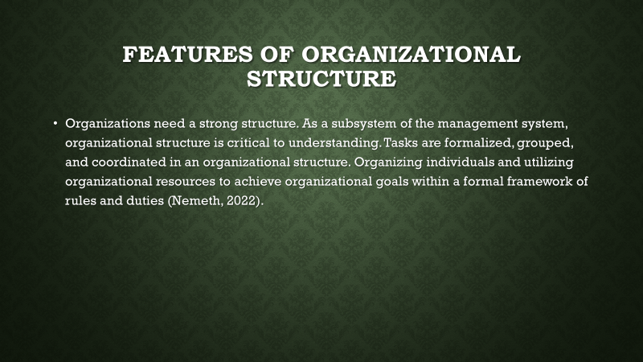
Organizations need a strong structure. As a subsystem of the management system, organizational structure is critical to understanding. Tasks are formalized, grouped, and coordinated in an organizational structure. Organizing individuals and utilizing organizational resources to achieve organizational goals within a formal framework of rules and duties (Nemeth, 2022).

Slide 8: Basic Characteristics of Organizational Structure
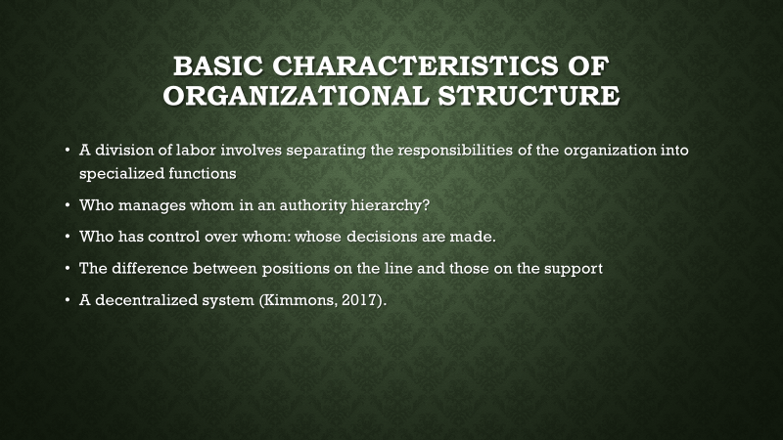
- A division of labor involves separating the responsibilities of the organization into specialized functions
- Who manages whom in an authority hierarchy?
- Who has control over whom: whose decisions are made.
- The difference between positions on the line and those on the support
- A decentralized system (Kimmons, 2017).

Slide 9: Examine the link between the organization's structure and its performance.
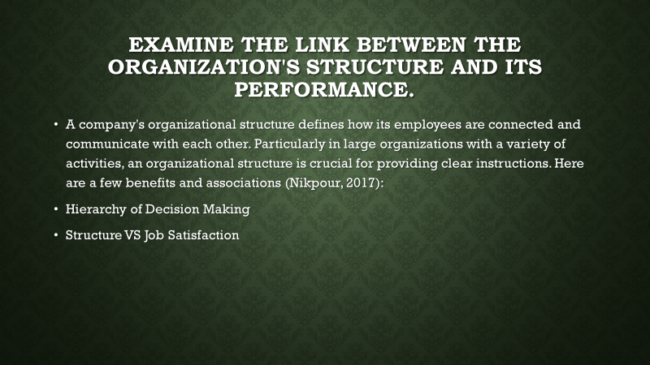
A company's organizational structure defines how its employees are connected and communicate with each other. Particularly in large organizations with a variety of activities, an organisational structure is crucial for providing clear instructions. Here are a few benefits and associations (Nikpour, 2017):
- Hierarchy of Decision Making
- Structure VS Job Satisfaction

Slide 10
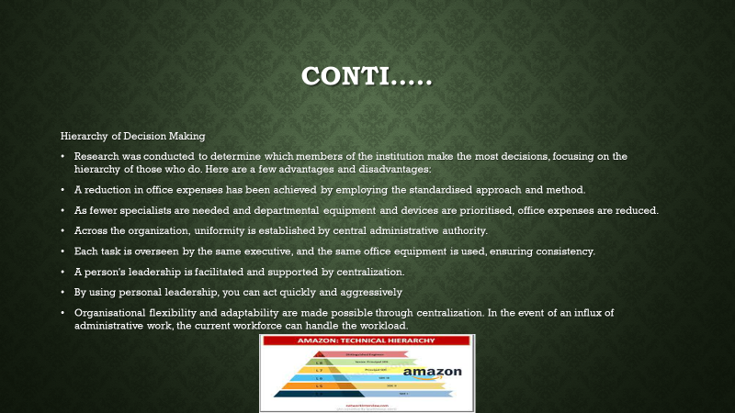
Hierarchy of Decision Making
Research was conducted to determine which members of the institution make the most decisions, focusing on the hierarchy of those who do. Here are a few advantages and disadvantages:
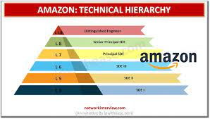

- A reduction in office expenses has been achieved by employing the standardised approach and method.
- As fewer specialists are needed and departmental equipment and devices are prioritised, office expenses are reduced.
- Across the organization, uniformity is established by central administrative authority.
- Each task is overseen by the same executive, and the same office equipment is used, ensuring consistency.
- A person's leadership is facilitated and supported by centralization.
- By using personal leadership, you can act quickly and aggressively
- Organisational flexibility and adaptability are made possible through centralization. In the event of an influx of administrative work, the current workforce can handle the workload.

Slide 11: Structure VS Job Satisfaction
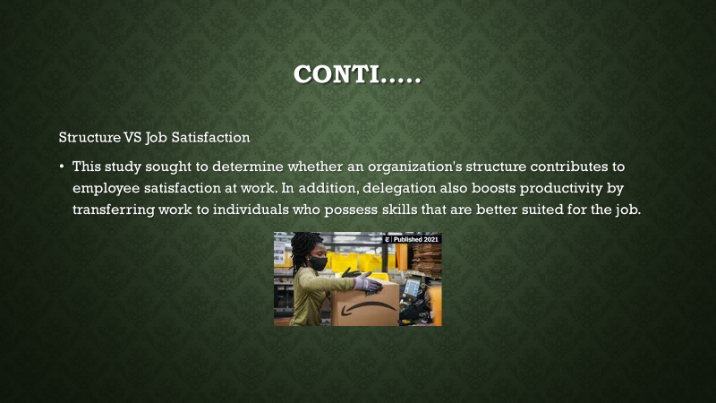


This study sought to determine whether an organization's structure contributes to employee satisfaction at work. In addition, delegation also boosts productivity by transferring work to individuals who possess skills that are better suited for the job.

Slide 12: Amazon's management team may employ a variety of activities and competencies to increase operational performance.
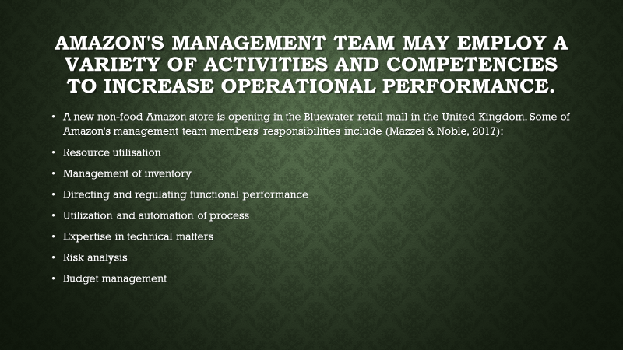
A new non-food Amazon store is opening in the Bluewater retail mall in the United Kingdom. Some of Amazon's management team members' responsibilities include (Mazzei & Noble, 2017):
- Resource utilisation
- Management of inventory
- Directing and regulating functional performance
- Utilization and automation of process
- Expertise in technical matters
- Risk analysis
- Budget management

Slide 13
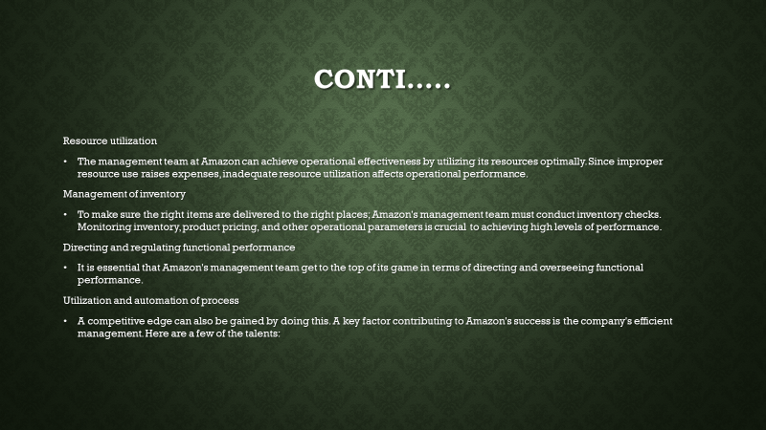
Resource utilisation: The management team at Amazon can achieve operational effectiveness by utilizing its resources optimally. Since improper resource use raises expenses, inadequate resource utilization affects operational performance.
Management of inventory: To make sure the right items are delivered to the right places; Amazon's management team must conduct inventory checks. Monitoring inventory, product pricing, and other operational parameters is crucial to achieving high levels of performance.
Directing and regulating functional performance: It is essential that Amazon's management team get to the top of its game in terms of directing and overseeing functional performance.
Utilization and automation of process: A competitive edge can also be gained by doing this. A key factor contributing to Amazon's success is the company's efficient management. Here are a few of the talents:

Slide 14
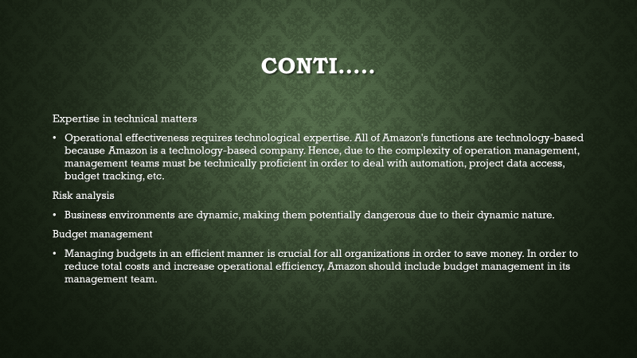
Expertise in technical matters. Operational effectiveness requires technological expertise. All of Amazon's functions are technology-based because Amazon is a technology-based company. Hence, due to the complexity of operation management, management teams must be technically proficient in order to deal with automation, project data access, budget tracking, etc.
Risk analysis. Business environments are dynamic, making them potentially dangerous due to their dynamic nature.
Budget management. Managing budgets in an efficient manner is crucial for all organizations in order to save money. In order to reduce total costs and increase operational efficiency, Amazon should include budget management in its management team.

Slide 15: Introduction to leadership theories
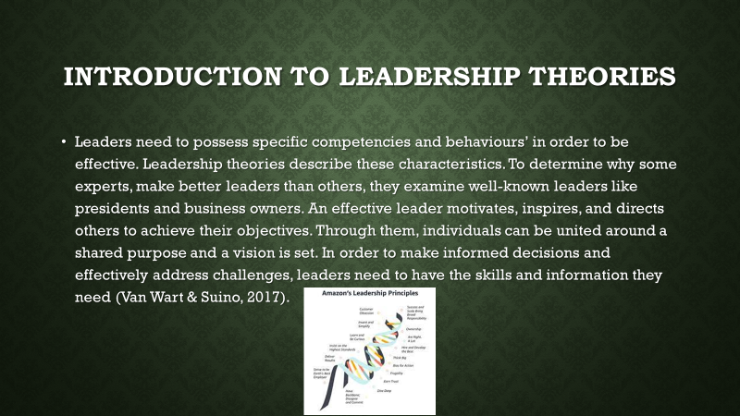
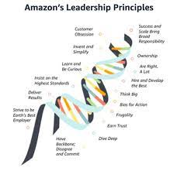

Leaders need to possess specific competencies and behaviours’ in order to be effective. Leadership theories describe these characteristics. To determine why some experts, make better leaders than others, they examine well-known leaders like presidents and business owners. An effective leader motivates, inspires, and directs others to achieve their objectives. Through them, individuals can be united around a shared purpose and a vision is set. In order to make informed decisions and effectively address challenges, leaders need to have the skills and information they need (Van Wart & Suino, 2017).

Slide 16: Importance of leadership theories in organization
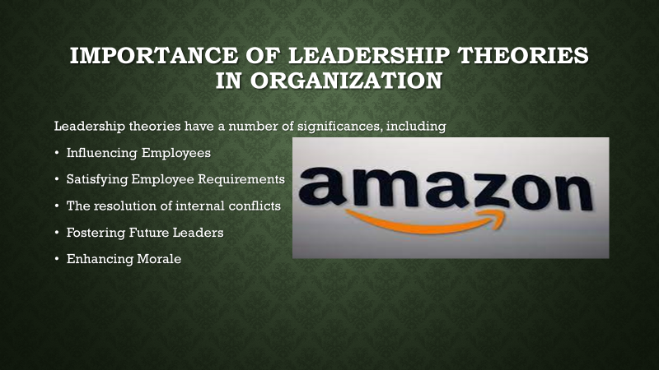


Leadership theories have a number of significances, including:
1. Influencing Employees
Discipline from a manager can have a positive impact on the performance of the workers, which can improve the work environment.
2. Satisfying Employee Requirements
Leadership is about prioritising the needs of the team and creating an environment where everyone can thrive and grow in order to ensure that the team is successful.
3. The resolution of internal conflicts
There are leaders who are aware of this situation, and they make it a priority to remedy any problem that might hinder the production of a product.
4. Fostering Future Leaders
Leadership/mentorship programs increase the self-confidence and potential of employees as well as benefiting the organization as a whole by increasing the level of confidence and potential.
5. Enhancing Morale
Leadership is sometimes entrusted with the responsibility of encouraging their team members by appreciating/recognizing the work that they do, grasping complicated problems, and experiencing the appropriate behavior necessary to establish a positive and productive working environment (Anderson et al., 2017).

Slide 17: Different Leadership in Amazon
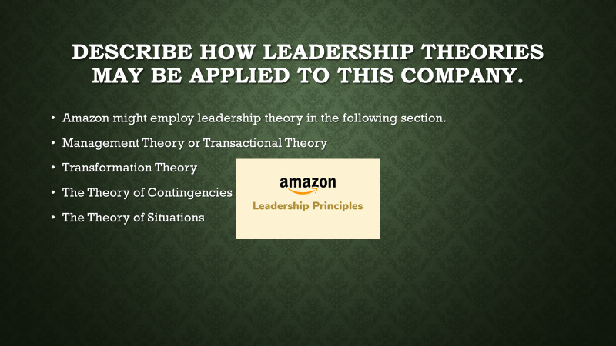


Amazon might employ leadership theory in the following section.
- Management Theory or Transactional Theory
- Transformation Theory
- The Theory of Contingencies
- The Theory of Situations

Slide 18: Management Theory or Transactional Theory
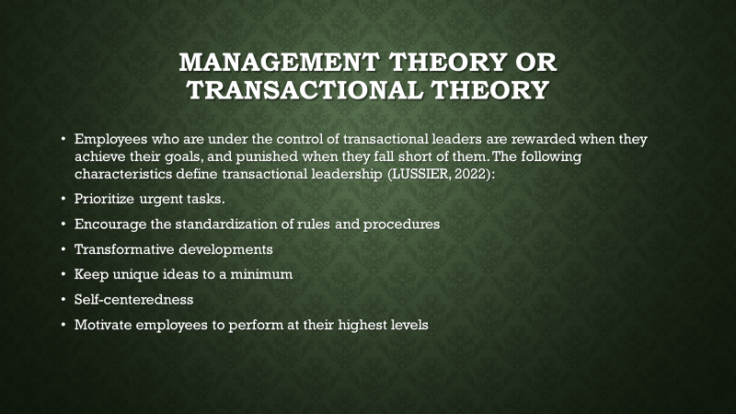
Employees who are under the control of transactional leaders are rewarded when they achieve their goals, and punished when they fall short of them. The following characteristics define transactional leadership (LUSSIER, 2022):
- Prioritize urgent tasks.
- Encourage the standardization of rules and procedures
- Transformative developments
- Keep unique ideas to a minimum
- Self-centeredness
- Motivate employees to perform at their highest levels

Slide 19: Transformation Theory
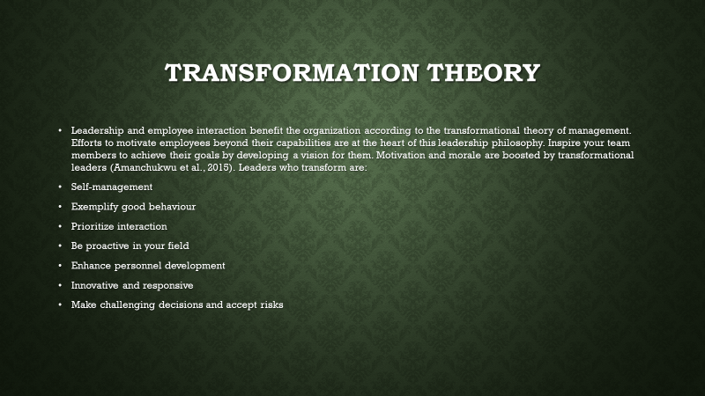
Leadership and employee interaction benefit the organization according to the transformational theory of management. Efforts to motivate employees beyond their capabilities are at the heart of this leadership philosophy. Inspire your team members to achieve their goals by developing a vision for them. Motivation and morale are boosted by transformational leaders (Amanchukwu et al., 2015). Leaders who transform are:
- Self-management
- Exemplify good behaviour
- Prioritize interaction
- Be proactive in your field
- Enhance personnel development
- Innovative and responsive
- Make challenging decisions and accept risks

Slide 20: The Theory of Contingencies
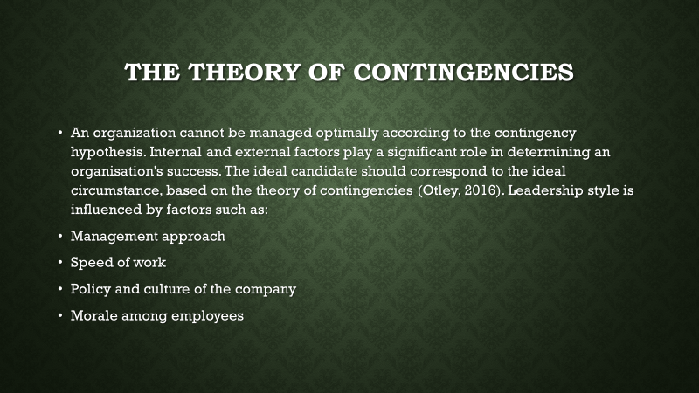
An organization cannot be managed optimally according to the contingency hypothesis. Internal and external factors play a significant role in determining an organisation's success. The ideal candidate should correspond to the ideal circumstance, based on the theory of contingencies (Otley, 2016). Leadership style is influenced by factors such as:
- Management approach
- Speed of work
- Policy and culture of the company
- Morale among employees

Slide 21: The Theory of Situations
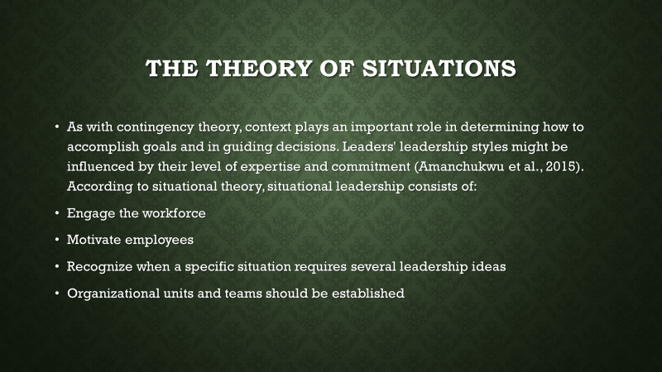
As with contingency theory, context plays an important role in determining how to accomplish goals and in guiding decisions. Leaders' leadership styles might be influenced by their level of expertise and commitment (Amanchukwu et al., 2015). According to situational theory, situational leadership consists of:
- Engage the workforce
- Motivate employees
- Recognize when a specific situation requires several leadership ideas
- Organizational units and teams should be established

Slide 22: Explanation of the elements that impact group and team behaviour
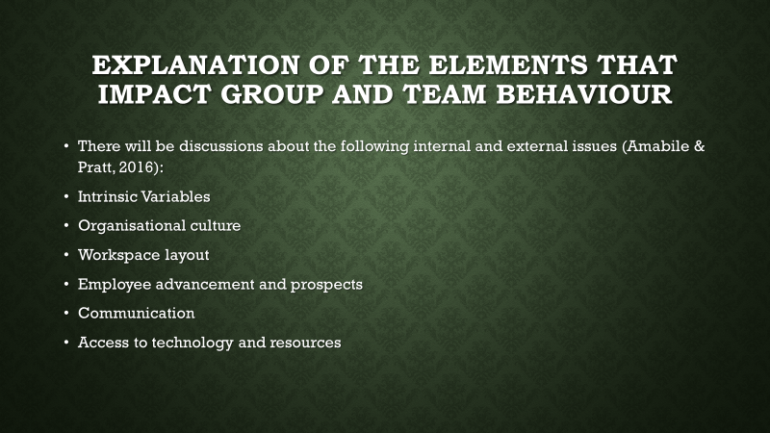
There will be discussions about the following internal and external issues (Amabile & Pratt, 2016):
Intrinsic Variables: Many internal factors or traits influence an individual's and a group's efficiency.
Organisational culture: The attitudes and behaviors of individuals and groups establish an organization's culture.
Workspace layout: Keeping competitive means adapting to an ever-changing workplace. The Amazon 4-star program is specially designed to provide a retail experience that mimics the online buying experience of Amazon consumers, as well as motivating staff to learn, make friends, and build trust among themselves.
Employee advancement and prospects: Managers must find new ways to engage their employees at Amazon, which is known as an innovative workplace.
Communication: A crucial aspect of internal communication is communication. Teams and team leaders must communicate clearly and regularly in order for an organization to achieve efficiency.
Access to technology and resources: A number of factors can contribute to improved employee performance and efficiency, including updated equipment, software, and technical assistance.

Slide 23: External Factors
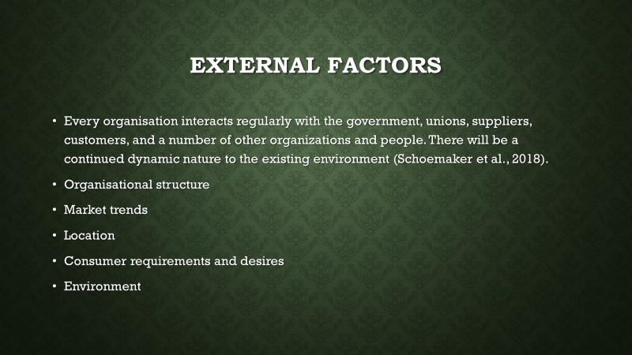
Every organisation interacts regularly with the government, unions, suppliers, customers, and a number of other organizations and people. There will be a continued dynamic nature to the existing environment (Schoemaker et al., 2018).
Organisational structure: There are several ways in which organizational structures can differ, but they share certain characteristics. Technology, structure, operational procedures, and environment are all interdependent in global organisational models.
Market trends: Each firm must engage in market competition because they provide products to the environment. It features products from small businesses in the United Kingdom as well as items rated 4 stars or higher by online consumers, and the offerings will change often to meet market needs.
Location: Among the most important factors Amazon must consider when looking for a retail site are the cost, size, facilities, and customer satisfaction.
Consumer requirements and desires: A company's operations are significantly influenced by its customers.
Environment: External factors such as pressures, conditions, and events can have an impact on the functioning of an organization. Managers face limitations and difficulties as a result of it.

Slide 24: Conclusion
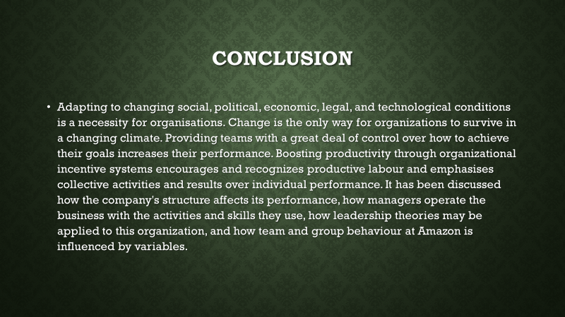
Adapting to changing social, political, economic, legal, and technological conditions is a necessity for organisations. Change is the only way for organizations to survive in a changing climate. Providing teams with a great deal of control over how to achieve their goals increases their performance. Boosting productivity through organizational incentive systems encourages and recognizes productive labour and emphasises collective activities and results over individual performance. It has been discussed how the company's structure affects its performance, how managers operate the business with the activities and skills they use, how leadership theories may be applied to this organization, and how team and group behaviour at Amazon is influenced by variables.

Slide 25: References
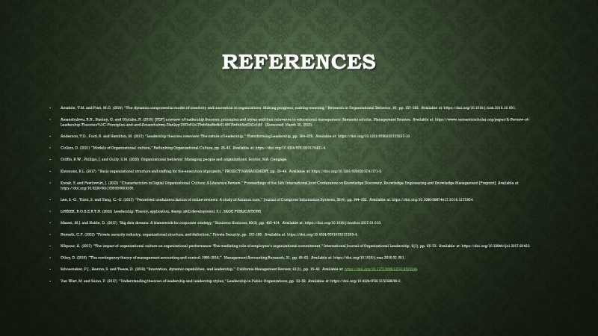
Amabile, T.M. and Pratt, M.G. (2016) “The dynamic componential model of creativity and innovation in organizations: Making progress, making meaning,” Research in Organizational Behavior, 36, pp. 157–183. Available at: https://doi.org/10.1016/j.riob.2016.10.001.
Amanchukwu, R.N., Stanley, G. and Ololube, N. (2015) [PDF] a review of leadership theories, principles and styles and their relevance to educational management: Semantic scholar, Management Science. Available at: https://www.semanticscholar.org/paper/A-Review-of-Leadership-Theories%2C-Principles-and-and-Amanchukwu-Stanley/2307c61b175cb5ba9bdb614907bdb46cd242c1d6 (Accessed: March 20, 2023).
Anderson, T.D., Ford, R. and Hamilton, M. (2017) “Leadership theories overview: The nature of leadership,” Transforming Leadership, pp. 264–278. Available at: https://doi.org/10.1201/9780203735237-10.
Collins, D. (2021) “Models of Organizational culture,” Rethinking Organizational Culture, pp. 25–43. Available at: https://doi.org/10.4324/9781003174431-4.
Griffin, R.W., Phillips, J. and Gully, S.M. (2020) Organizational behavior: Managing people and organizations. Boston, MA: Cengage.
Kimmons, R.L. (2017) “Basic organizational structure and staffing for the execution of projects,” PROJECT MANAGEMENT, pp. 29–44. Available at: https://doi.org/10.1201/9780203741771-5.
Kocak, S. and Pawlowski, J. (2022) “Characteristics in Digital Organizational Culture: A Literature Review,” Proceedings of the 14th International Joint Conference on Knowledge Discovery, Knowledge Engineering and Knowledge Management [Preprint]. Available at: https://doi.org/10.5220/0011530500003335.
Lee, S.-G., Trimi, S. and Yang, C.-G. (2017) “Perceived usefulness factors of online reviews: A study of Amazon.com,” Journal of Computer Information Systems, 58(4), pp. 344–352. Available at: https://doi.org/10.1080/08874417.2016.1275954.
LUSSIER, R.O.B.E.R.T.N. (2022) Leadership: Theory, application, &amp; skill development. S.l.: SAGE PUBLICATIONS.
Mazzei, M.J. and Noble, D. (2017) “Big data dreams: A framework for corporate strategy,” Business Horizons, 60(3), pp. 405–414. Available at: https://doi.org/10.1016/j.bushor.2017.01.010.
Nemeth, C.P. (2022) “Private security industry, organizational structure, and definition,” Private Security, pp. 157–180. Available at: https://doi.org/10.4324/9781003217299-4.
Nikpour, A. (2017) “The impact of organizational culture on organizational performance: The mediating role of employee’s organizational commitment,” International Journal of Organizational Leadership, 6(1), pp. 65–72. Available at: https://doi.org/10.33844/ijol.2017.60432.
Otley, D. (2016) “The contingency theory of management accounting and control: 1980–2014,” Management Accounting Research, 31, pp. 45–62. Available at: https://doi.org/10.1016/j.mar.2016.02.001.
Schoemaker, P.J., Heaton, S. and Teece, D. (2018) “Innovation, dynamic capabilities, and leadership,” California Management Review, 61(1), pp. 15–42. Available at: https://doi.org/10.1177/0008125618790246.
Van Wart, M. and Suino, P. (2017) “Understanding theories of leadership and leadership styles,” Leadership in Public Organizations, pp. 33–58. Available at: https://doi.org/10.4324/9781315268699-2.

