

University of Wales Trinity Saint David
Ordnance Munitions and Explosives Engineering Degree Apprenticeship

BEng

Academic Year 2025 - 2029

Conor James Nolan

Reflection on Study Skills

Supervisor: Jenni Steen
January 2025

This thesis is submitted in partial fulfilment of the requirements for the degree of OME Engineering Apprenticeship BEng
(NB. Remove if the degree award is based solely on examination of the thesis)

© UWTSD 2025. All rights reserved. No part of this publication may be reproduced without the written permission of the copyright owner.

Academic integrity declaration
I declare that:
- the thesis submitted has been written by me alone.
- the thesis submitted has not been previously submitted to this university or any other.
- that all content, including primary and/or secondary data, is true to the best of my knowledge.
- that all quotations and references have been duly acknowledged according to the requirements of academic research.
I understand that to knowingly submit work in violation of the above statement will be considered by examiners as academic misconduct.

Abstract
The student undertook the task of identifying, analysing and summarising the key skills necessary to present information and excel in a higher education environment. Conclusions were drawn about the most beneficial traits and behaviours which student can use to improve their learning, and it was found that self-organisation was the most important factor in success academically and professionally.

Keywords:
Study skills, self-organisation, presentation, literature review, planning, goal orientation

Acknowledgements
The student would like to thank the staff of the University of Wales Trinity Saint David for providing the learning content for this course as well as the literature resources needed to complete it.
The student would also like to extend a special thanks to Jenni Steen for teaching the study skills module.

Contents
Academic integrity declaration i
Abstract ii
Acknowledgements iii
List of Figures v
List of Tables vi
List of Equations vii
List of Abbreviations viii
1 Presentation 1
1.1 Creation of the presentation and key takeaways 1
1.1.1 Knowing your audience 1
1.1.2 Humour 1
1.1.3 Visualisation 1
1.1.4 Additional features 2
1.2 Future improvements 2
2 Skills Evaluation 3
2.1 Skills needed for higher education 3
2.2 Goals for the future 5
2.2.1 Personal 5
2.2.2 Professional/Academic 6
3 Application 8
3.1 Data security 8
3.2 Time management and self-organisation 8
3.2.1 Time management 8
3.2.2 Stress management 8
3.2.3 Personal development 8
3.3 Independent study: A literature review of Torpex 9
3.3.1 Abstract 9
3.3.2 Introduction 9
3.3.3 Composition 10
3.3.4 Conclusion 11
4 Conclusion & Evaluation 12
References 13
Appendices 14

List of Figures
Figure 1: A picture of a pet from the presentation 1
Figure 2: Example 1 of a humorous slide which is obviously not solvable in 5 minutes 2
Figure 3: Example 2 of a humorous slide wherein a cat is referred to with mean names 2
Figure 4: Example of drawing on cultural imagery 3
Figure 5: Showing a big 5 personality test score 6
Figure 6: Showing a learning style test score 6
Figure 7: Showing first part of job quiz result 7
Figure 8: Showing second part of job quiz result 7

List of Abbreviations
IT | Information Technology

Presentation
The student was tasked to give a 5-minute presentation about themselves, which detailed their birth town of Doncaster, their move to the Forest of Dean, their three pets and the education they received in chemistry from the University of Nottingham.

Creation of the presentation and key takeaways
To begin the presentation, the student first identified the goal of the presentation itself: to deliver information about the student to peers in a memorable fashion. With that being known, the student proceeded to research ways in which information can be presented to enhance memorability. Three key aspects were identified and implemented.

Knowing your audience
It is rather self-evident that the audience’s preferences must be considered in order to relay information in a palatable form. As such, the student reflected on previous discussions with the group and identified a couple of elements which all group members would be amenable to: household pets and effective use of humour combined with interaction with audience interjections.
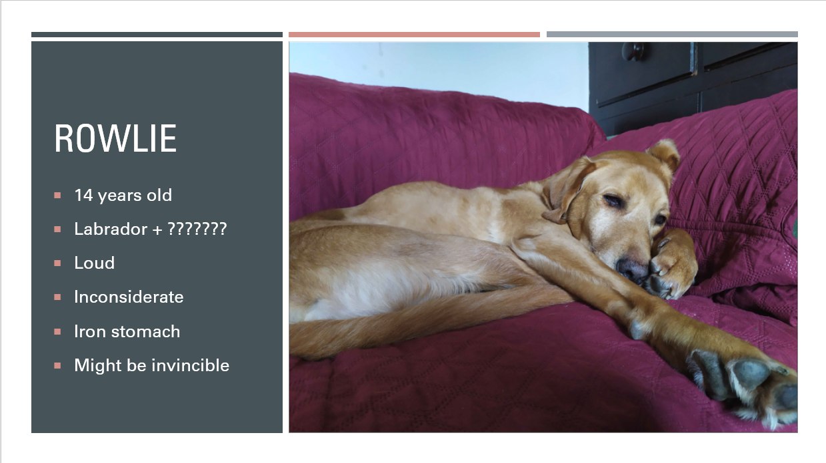
Figure 1: A picture of a pet from the presentation

Humour
Research [1] has demonstrated that humorous sentences are better recalled than non-humorous sentences. With this in mind, the student incorporated humorous elements throughout the presentation including a joke exercise to begin with and various funny details and anecdotes.

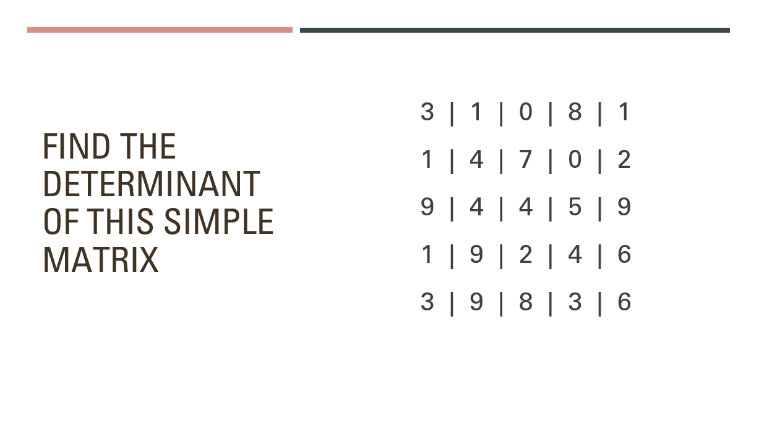
Figure 2: Example 1 of a humorous slide which is obviously not solvable in 5 minutes

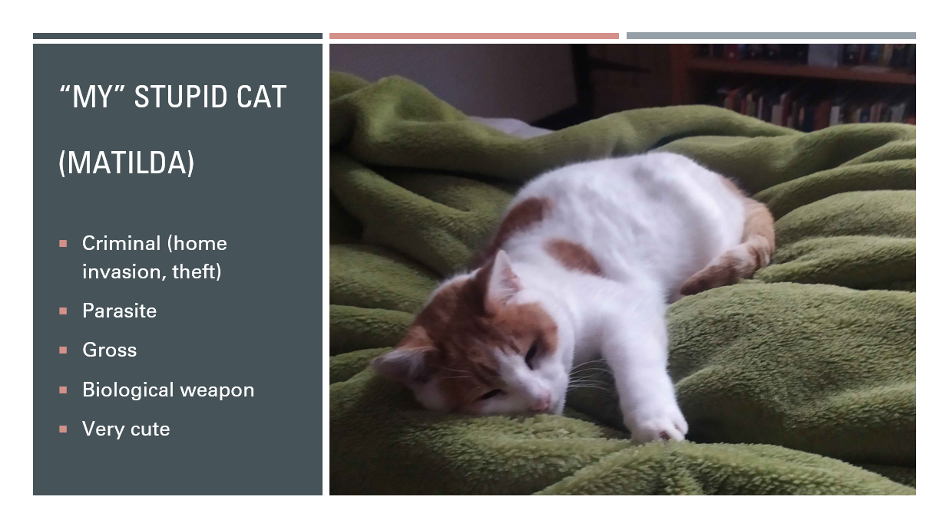
Figure 3: Example 2 of a humorous slide wherein a cat is referred to with mean names

Visualisation
Another finding [2, 3] has been that visualisation positively influences recall, both in the graphical sense and in the notion that information can itself carry with it some amount of mental imagery. The student therefore prioritised images and vocabulary with commonly associated imagery.

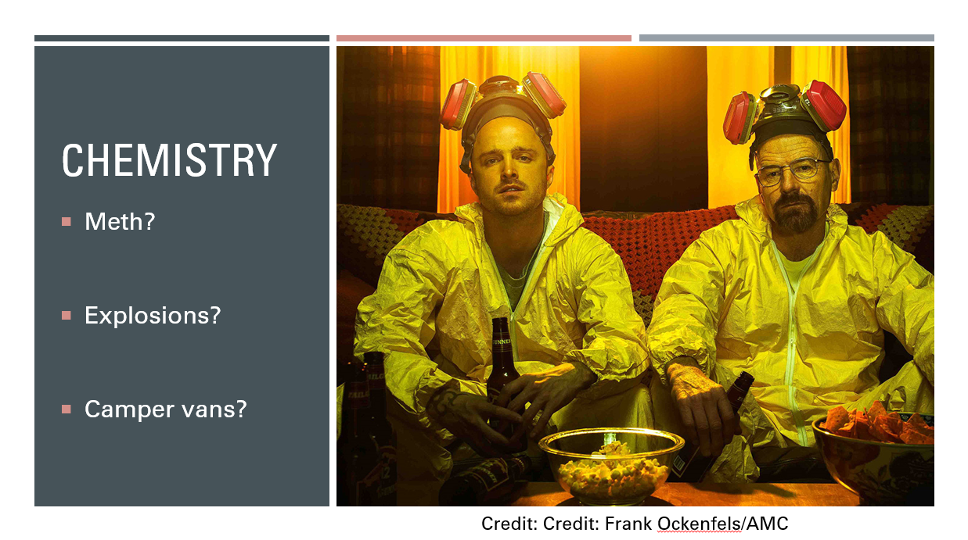
Figure 4: Example of drawing on cultural imagery

Additional features
Through self-reflection, feedback and further learning, the student also determined elements such as short sentence length, personal confidence and audience interaction.

Future improvements
Through peer feedback and self-reflection, the student found several areas for improvement but also confirmed many successes. While the subject of the presentation was rather wide in scope, the student focused narrowly on a few subjects and although these topics may have been those which would produce the most interest, they may not have painted a fully satisfactory picture of the student’s self as per the original assignment brief. As such, the student may wish to choose a wider range of topics and focus slightly less on each, solving not only the narrowness and time keeping issues, but also a third criticism: talking too fast. Literature from the advertising industry [4] has shown that talking speed can significantly affect audience attention, with slow speeds leading to attention loss and high speeds causing cognitive processing interference. Given this, it is vital that the student considers managing their talking speed in future.
As mentioned, the student was able to confirm several success cases with peer evaluations identifying good audience engagement, confidence and humour as key features of the presentation. It also appeared that the student correctly recognised personal preferences within the audience which were mentioned positively in feedback. This in itself suggests that knowing an audience and catering towards them will lead to better information recall. Overall this implies that the aforementioned methods are worth continuing to invest in for future work.

Skills Evaluation

Skills needed for higher education
The student has long held the belief that there are two factors which most strongly correlate with academic competence: personal interest and structure. The former is necessary as it is a strong source of motivation, and the student finds that information which is interesting is easily absorbed while boring information may simply never be fully recalled no matter the amount of repetition. The latter aspect of structure is necessary to prevent confusion and frustration, since the complexity of academic study only accumulates as time goes on. Without organised notes, files and citations, any academic task will become extremely challenging.
While it is commonly thought that intelligence is the most important factor contributing to academic success, research [5] has shown this to not necessarily be the case. Although traits associated with intelligence do correlate with high academic outcomes, it’s been found that traits associated with conscientiousness, i.e. being organised, systematic, tidy and efficient [6], seem to correlate much more closely with high academic scores and shortened times until graduation, more so even than intelligence does. It is therefore suggested that students with low conscientiousness trait scores should be given support in the way of “more structure, frequent deadlines and more clearly defined goals” [5].
These so called non-cognitive skills such as organisation and independence are also positively correlated with career success, as one study [7] has shown that individuals scoring highly in such traits when younger were more likely to have higher pay later in their careers.
Given this focus on conscientiousness and non-cognitive traits, the student engaged in self-evaluation exercises to discover what changes could be made to better support their learning. The first was a big five personality test which identifies amongst others, traits of openness and conscientiousness which are correlated with academic success as stated above. 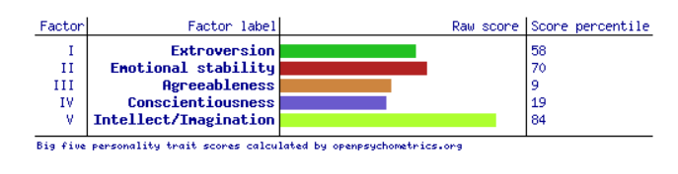
Figure 5: Showing a big 5 personality test score
The student scored highly in openness (renamed to Intellect/Imagination in figure but typically referred to as openness), but somewhat lower in conscientiousness, indicating that in future the student should take steps such as self-imposing shorter deadlines and creating clear goals [5].
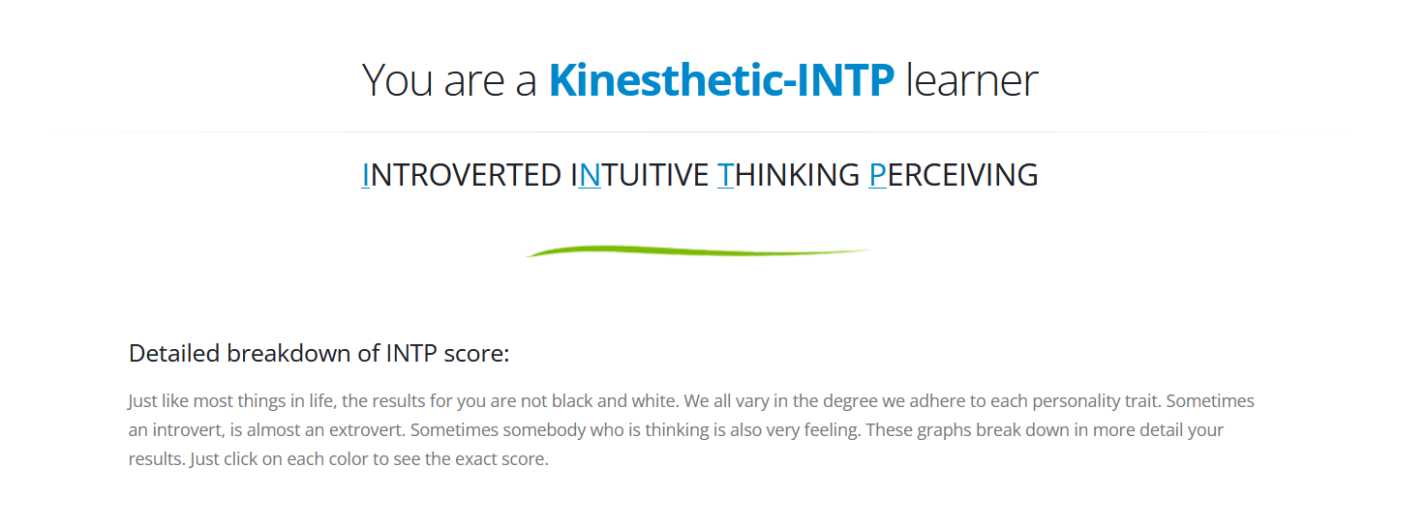
Figure 6: Showing a learning style test score
Additionally, the student took two more tests. One was a learning style test which indicates which method of learning is most likely to yield results. The learner scored highly in kinaesthetic learning and should therefore seek practical demonstrations in future. The last test was a careers quiz which asks for professional and personality traits so that it can match to a career that suits user. The student’s highest scoring category was science and research indicating that this would likely be a successful career path in the future. 
Figure 7: Showing first part of job quiz result
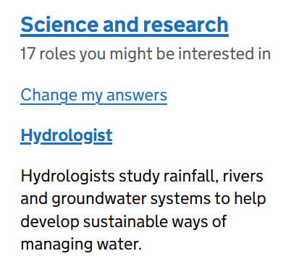
Figure 8: Showing second part of job quiz result
These results were largely in-line with the student’s expectations; however, they were not expecting to score so poorly in conscientiousness. This resulted in a valuable lesson for the student in what kind of changes could be made in future with respect to time management and goal selection.

Goals for the future
It is self-evident that without a goal, no progress can be made, but does the way in which you create a goal matter? It is generally recognised that effective goal setting is vital for success, particularly with respect to allowing for good time management [8], however there also exist more tangible benefits of specific task management strategies like Specific Measurable Achievable Relevant Time-bound (SMART), as a study [9] has demonstrated significantly higher scores achieved by student who created SMART goals for studying as opposed to those who did not.
The student therefore concluded that given their own person need for specific goal planning as suggested by conscientiousness score correlations [5], and the suspected positive outcome correlations of SMART, that a set of SMART goals should be created to further their personal and professional aspirations.

Personal
Bouldering:
The student wishes to improve their bouldering skill by progressing to V3 comfortably within the next 6 months and V4 within a year.
S – The student wants to consistently improve their bouldering grade.
M – Boulders are graded numerically ascending in difficulty.
A – The student can currently climb most V2 grades comfortably and wishes to progress to V3 and V4 within 12 months, which is achievable by most climbers.
R – This goal follows along with standard bouldering progression and student’s final goal will be to climb a V7.
T – The time frame of 6 months and then a year for respective goals.
Weightlifting:
The student wishes to implement progressive overload into their training regimen by aiming to increase the weight in each exercise by approximately 10% rounded to the nearest kilo per two-week period with the same repetition count.
S – The student wants to improve their weight at a given repetition count.
M – Weight is measurable, and a 5 kg goal is given.
A – 10% to the nearest kilo is a light increase for most muscle groups and a two-week period should be manageable provided adequate recovery is taken.
R – Progressive overload is shown to be effective in both promoting hypertrophy and encouraging strength output increase.
T – a two-week repeatable deadline is given.

Professional/Academic
Learning python:
The student would like to develop a matrix calculator script by the end of the next university block which is capable of “n by n” matrix multiplication.
S – The student wants to create a specific script that does one thing.
M – If the calculator script can process several 2x2 and 3x3 matrix products correctly it will be considered working.
A – Such scripts already exist, and this will simply be a learning experience.
R – The skills used to create this program will allow the student to understand programming for use later in their career.
T – Clear time frame of end of next block given.
Spreadsheets:
The learner would like to complete the advanced spreadsheet course on LinkedIn Learning within 2 months’ time.
S – Refers to a specific course.
M – The course is timed and has quizzes which indicate progress and success.
A – The learner has already completed the beginner’s course, so this is the natural progression, and the total course time is only a few hours.
R – The course features information on lookups and advanced formulae which will be useful in the workplace.
T – A two-month time frame is given.

Application

Data security
The student stored their important university work including presentation files, notes and copies of their e-Portfolio in three different places, with one being on a university work dedicated laptop, the second on Microsoft’s cloud storage service OneDrive, and the third being on their home PC, delivered via email. This set-up allows the student to have two easily accessible working copies in separate locations such that if something were to compromise the integrity of the primary laptop, the second working copy would have a recent update available to work on. The third storage location allows access to a less frequently updated copy that can be seen even without internet connection.

Time management and self-organisation

Time management
The student has made frequent use of online and digital calendars to schedule study sessions and attend lectures, as well as work-related meetings and activities. Additionally, the student employed timers and alarms to space out their study time and allow for stress management opportunities.

Stress management
The student mainly employed two stress management techniques. The first was frequent physical training at a local gym including cardiovascular endurance and muscular hypertrophy training.
The second stress management technique used was engaging in numerous hobbies to blow off steam. This included bouldering, reading, talking with friends and playing video games.

Personal development
Personal development is an important part of a person’s professional success, and the student has taken steps towards developing their professional qualifications including taking on training courses such as prevent awareness. They have also joined several LinkedIn Learning courses involving advanced spreadsheet usage and python coding which could be used in future physics and mathematics applications.
The student has also produced an e-Portfolio which is used to organise all their university related documents and store important information pertaining to their personal development and professional competencies.
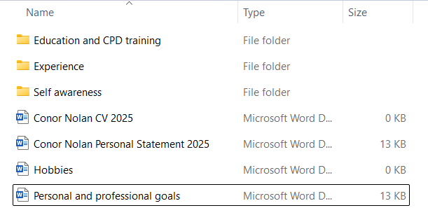

Independent study: A literature review of Torpex

Abstract

Introduction
Torpex is an explosive composition made up of trinitrotoluene (TNT), 1,3,5-trinitro-1,3,5-triazinane (known as RDX) and aluminium powder in the ratio of 40:42:18 respectively [10, 11] and typically contains some small amount of wax as a phlegmatizing agent [11]. Although torpex has now fallen out of use due to the effectiveness of polymer bonded explosives (PBXs) [12], it was of great interest during the second world war, not only an underwater explosive, but also as an air-blast explosive [13].

Composition
Torpex was considered a more effective explosive for munitions than one of its constituent parts, boasted as an improvement on the performance of TNT [us army] and even outperformed composition B filled munitions with claims of a “20 percent greater power” [13]. This is due to the role aluminium powder plays when used in combination with explosives.
Aluminium will readily oxidise to aluminium oxide (Al₂O₃) exothermically provided enough oxygen and energy are supplied [alum oxidation], both of which are present in the decomposition of RDX and TNT [decomp source]. This effectively allows the energy of an explosion to be amplified through this exothermic reaction, producing a more energetic, delayed blast [14].
It is important however, that the aluminium particle size and mass ratio are controlled. The particle size can radically change the dynamics of a reaction, with large aluminium particles causing lengthier reaction durations and a lower degree of oxidation [15], which we can reason to mean a lower amplification of energy. As such it stands to reason that a smaller particle size is important. A range of 18-20% aluminium powder is also considered to be the optimal ratio, as claimed to be determined by the British Government in a US army report [10].
The two other main components were the well-established explosives TNT and RDX. Both TNT and RDX are effective explosives due to the same principle: they contain nitro functional groups which will readily decompose into several moles of Nitrogen and Oxygen gas, the former infamously having one of the most energetic formation enthalpies known in nature. This combination of high energy of formation and sudden pressure generation causing a rapid increase in the amount of gas molecules in a small volume, produces massive pressure wave known as a shockwave, which causes significant damage to anything nearby.
Torpex also featured wax as a phlegmatizing agent [10]. This reduces the impact and friction sensitivity of explosives with crystalline structures and is suspected to work by acting as a sort of lubricant between crystal structures [11].

Conclusion
To summarise, Torpex is an explosive that was deployed frequently during the second world war as it had a superior performance to similar compositions at the time, until it was replaced by superior PBXs. Literature indicates its performance was mainly owed to two unique characteristics: the leveraging of redox chemistry by using aluminium powder to boost explosive power, and the phlegmatization via wax to allow for safer transport and storage. Perhaps with fewer constraints on time and word count, more could have been included about the chemistry and physics of explosives, as well as a more detailed history of torpex and its replacements.

Conclusion & Evaluation
Through this assignment the student has gained insight into practises and skills including the use of humour and imagery during presentation, as well as the importance of organisation and intelligent goal selection which will allow them to excel in a higher education environment. The student also learned about the challenges and limitations of personal research and information gathering. In future the student will implement clear goal setting and self-imposed deadlines to more effectively complete academic tasks and activities. The student would also like to learn more about methods of goal selection and self-organisation in the future to further aid in their higher education and career.

References
[1]
S. R. Schmidt, “Effects of humor on sentence memory.,” Journal of Experimental Psychology: Learning, Memory, and Cognition, vol. 20, no. 4, pp. 953–967, 1994, doi: 10.1037/0278-7393.20.4.953.
[2]
M. Sadoski and Z. Quast, “Reader Response and Long-Term Recall for Journalistic Text: The Roles of Imagery, Affect, and Importance,” Reading Research Quarterly, vol. 25, no. 4, pp. 256–272, 1990, doi: 10.2307/747691.
[3]
M. A. Borkin et al., “What Makes a Visualization Memorable?,” IEEE Transactions on Visualization and Computer Graphics, vol. 19, no. 12, pp. 2306–2315, 2013, doi: 10.1109/TVCG.2013.234.
[4]
E. Rodero, “Do Your Ads Talk Too Fast To Your Audio Audience?,” Journal of Advertising Research, vol. 60, no. 3, pp. 337–349, Sep. 2020, doi: 10.2501/JAR-2019-038.
[5]
R. Kappe and H. van der Flier, “Predicting academic success in higher education: what’s more important than being smart?,” European Journal of Psychology of Education, vol. 27, no. 4, pp. 605–619, 2012, doi: 10.1007/s10212-011-0099-9.
[6]
E. R. Thompson, “Development and Validation of an International English Big-Five Mini-Markers,” Personality and Individual Differences, vol. 45, no. 6, pp. 542–548, 2008, doi: https://doi.org/10.1016/j.paid.2008.06.013.
[7]
E. Lindqvist and R. Vestman, “The Labor Market Returns to Cognitive and Noncognitive Ability: Evidence from the Swedish Enlistment,” American Economic Journal: Applied Economics, vol. 3, no. 1, pp. 101–128, Jan. 2011, doi: 10.1257/app.3.1.101.

[8]
G. Fitsimmons, “Time management part I: goal setting as a planning tool,” The Bottom Line, vol. 21, no. 2, pp. 61–63, Jan. 2008, doi: 10.1108/08880450810898328.
[9]
T. Tofade, A. Khandoobhai, and K. Leadon, “Use of SMART Learning Objectives to Introduce Continuing Professional Development Into the Pharmacy Curriculum,” American Journal of Pharmaceutical Education, vol. 76, no. 4, p. 68, 2012, doi: https://doi.org/10.5688/ajpe76468.
[10]
O. E. Sheffield, J. E. Abel, and H. E. LaBeur, “DEVELOPMENT OF EXPLOSIVES - METALLIZED EXPLOSIVES,” Dover, Sep. 1953.
[11]
R. Meyer, J. Köhler, and A. Homburg, Explosives, 7th ed. Weinheim, Germany: Wiley-VCH Verlag GmbH & Company KGaA, 2015.
[12]
M. B. K. Graf, Avro Lancaster - Handley Page Halifax - Short S.29 Stirling. REI (Rifreddo), 2017. [Online]. Available: https://books.google.co.uk/books?id=EuFKDgAAQBAJ
[13]
C. F. BAXTER, “Torpex and the Air War,” in The Secret History of RDX, in The Super-Explosive that Helped Win World War II. , University Press of Kentucky, 2018, pp. 25–32. doi: 10.2307/j.ctt2111h03.7.
[14]
I. Edri, V. R. Feldgun, Y. S. Karinski, and D. Z. Yankelevsky, “Afterburning Aspects in an Internal TNT Explosion,” International Journal of Protective Structures, vol. 4, no. 1, pp. 97–116, Mar. 2013, doi: 10.1260/2041-4196.4.1.97.
[15]
Y. ZHOU, J. LIU, D. LIANG, W. SHI, W. YANG, and J. ZHOU, “Effect of particle size and oxygen content on ignition and combustion of aluminum particles,” Chinese Journal of Aeronautics, vol. 30, no. 6, pp. 1835–1843, 2017, doi: https://doi.org/10.1016/j.cja.2017.09.006.

