Calah Riley-Lamb
2121869
Digital skills
BMSW4003
Lectures name: Muno Zuwirai

Abstract
This report contests of the introduction of my overall research report. You will be able to understand a clear structure of the assignments I have done based on the research I have been able to gather from reliable resources. These are out of the group presentation that presented to my fellow peers, the data collected back from the questionnaire how we were able to form the analysis. What the group presentation was about and more in details about this. We then move onto the poster we formed in our found groups, communication problems and more in detail about what we had to do. Out of these it was all based-on research. We were able to complete both through taking notes from our lectures and then using all of them skills to move forward in getting these done. The challenges I have faced completing these things individually, how I hope to overcome these problems.

Contents page
- Title page
- Abstract
- Introduction
- Research design
- Results
- Discussion
- Conclusion
- Reference page

Research Report
Introduction
In this you will find the research we found on our group presentations and how we were able to establish this information. Communication skills on how I was able to round up my group, put the research together and complete the spreadsheet to form our analysis. It will also include the challenges I found completing the assignments given. It will provide how we came to our results, how we were able to learn how to form this altogether. While completing the research process incorporating mixed methods of research from our group. The skills that have gained this systemiser for example learning how to write academically. Having more than one presentation we put together a poster in a group of five ready to then present this to our peers based on design a job ad. This included information on the employer’s name, job title and description skills required, information and the application deadline. You will be able to source information on the challenges I face and how I want to overcome these challenges to be able to do better academically. One of these is learning how not to be so stuck in my mind on how to start of any of my assignments and feel less stressed. This affects me on starting my work as I do not know how to overcome these feelings.
Research design
We chose to do a poster as a group. This was based on information collected from reliable resources to put together all the information into a poster and present this to our lectures and peers. The information collected was based on a sister nurse within the ICU. Through this we were able to decide on the research proposal that used, which was secondary we chose this as the research put together already existed. Within our groups of five we each had our part to play in finding information to add into our poster ad. This were based on the description about what it takes to become a sister nurse. The equalization is a band six, so this would show it takes a high skilled developer to take this on as it is a very demanding job. The communication within our group was surprisingly good as we all came to the same understanding quickly. The group leader asked us that part of the poster we wanted to go and research to incorporate into our poster. I chose to complete the following information relating to benefits and pay. In this part it will be about the group presentation on Ms PowerPoint. How I come to form the group I was in, how the communication was and the research analysis, the type of method we proposed would be quantitative as we had to put it together to be able to form the results. The chosen question research question was How do we use technology to collaborate at UWTSD? In this we then had to the chose one research question out of three, our groups were our staff and students confident in using technology to collaborate? We found the answers to this question through then completing a questionnaire to send out to follow students and staff within the university. How I able to form both groups to be able to complete both presentations. I communicated with my follow peers through ms teams and was able to form my group quickly as we only need two more people to add to make a group of five, this time I was not the team leader. The app we used to create our poster, called Canva. The ethical considerations that got made during these presentations was based on the power point presentation as it was included as a slide. This was one out the two slides I had chosen to complete. Within this reviewing we changed words to make it to more of an appropriate level of vocabulary included within our questionnaire and our presentation we found from our results that overall students and staff are confident within using technology at uwtsd. With the results also of some, the percentage is not confident in using technology at uwtsd. The method of research put together by everyone in the group on however they chose to gather that piece of information to include. We then had to use communication skills to put this into 1 type of research method.
Results
The results we found through the answers we got back from the questionnaire. We then put it into excel to gain our results. Learning how to put this together was a challenge for me as I have never done this before. Thankfully, our lecturer doing his job and talking the class through this was very helpfully I am sure to everyone. There were boxes to answer why the reason to your answer is, so we can review this.
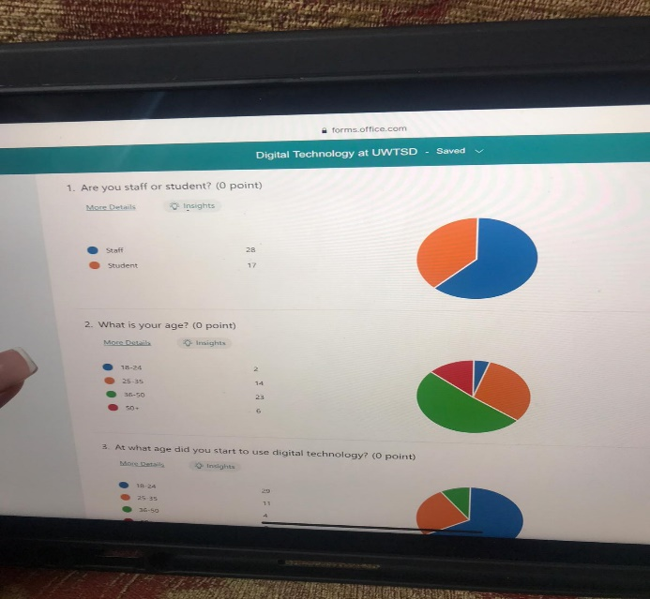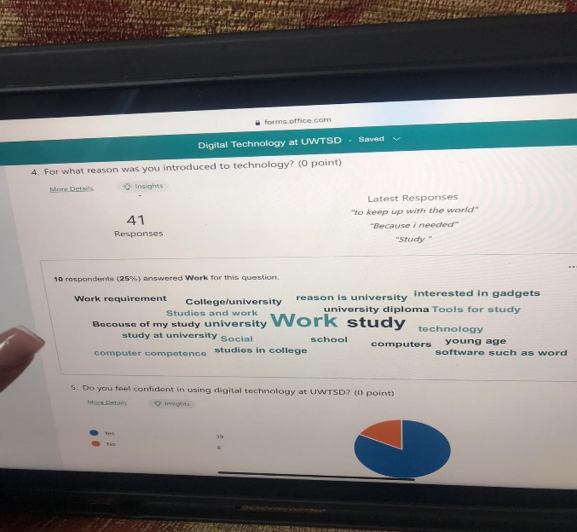
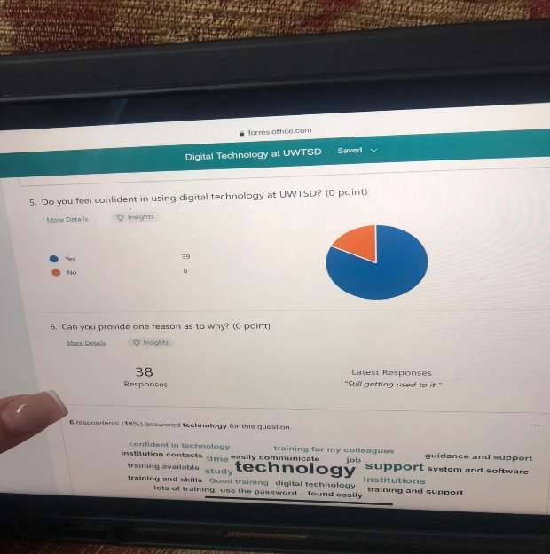
I do not have the questionnaire the group leader does. I was not able to complete the table to form the results due to this. I am only able to insert the pictures that I got sent
Discussion
The results that have been reported back for us to analyse was that overall, most students and staff are confident in using technology to collaborate at uwtsd. Our chosen research question was:
Chosen research question
Are staff and students confident in using technology to collaborate at UWTSD?
We chose this research question in our chose groups. We presented research and brought together through a presentation which included a questionnaire that we were able to collect data analysis. We found out answers to our questions and are now able to give a detailed report on that. Through this we were able to reach out to staff and students to be about to collect the data to support our data.
We sent out a questionnaire where we were able to receive results to be able to review and analyse these. It was found that overall, the results I have been shown allows me to understand that most students and staff is confident in using technology to collaborate at uwtsd. However, the staff and students that is not confident in using technology to collaborate at uwtsd is a lower percentage. There was a question box to tell us why this is and what we could do to improve on this. This matches our hypothesis by comfiting that the overall percentage is a positive outcome. With results of what the university could do to improve on this. The challenges of working in a group is that we all would have to fit in suitable times for us all to have an Ms teams meeting. My induvial challenges are being able to complete the full report due to lack of communication between my group to be able to get the full information that was needed. In future I would like to change this with the groups that I will work in as it can lead to under achieving academically. However, our timeline of completing the assignments given was within the timeframe and we delivered well on this. we spent over the weeks given with both, we planned it out, reviewed what we were doing regularly through contact using emails and Ms teams. Gaining the knowledge of the newly found research to present I was able to extend of my skills. This matched our hypothesis on what we thought our overall outcome was going to be, that most are confident. These results from the questionnaire were relatable between these. We seen that even though completing the questionnaire there was technology used as it was sent through email. The responses came through straight away once sent out.
Conclusion
This allows us to have the conclusions that these results from our group presentation that overall, most student and staff are confident in using technology at uwtsd. It can tell the reader the overall review summary from the questionnaire. The poster ad with the job of being a sister nurse, allows the reader to receive the full information on this before looking into applying. As it is a demanding job being a sister nurse you will need to be able to tick all the right boxes for this. The benefits pf working in a group is the work can split and not so much pressure to be able to do it. This makes the stress levels of completing it in the timeframe given much easier to do.

