

Emma Biggs

Titration Lab Report

Table of Contents
1 Introduction 3
1.1 Purpose of Titration 3
1.2 Hypothesis 3
1.3 Variables 3
1.4 Equations 3
2 Materials and Equipment 4
2.1 List of Materials and Equipment 4
2.2 Experimental Procedure 4
3 Results 5
4 Discussion 7
4.1 Interpretation of Experimental Results 7
4.2 Relevance of Findings to OME 7
4.3 Limitations and Sources of Error 7
5 Conclusion 8
5.1 Summary of Findings 8
5.2 Suggestions for Future Research 8
6 Bibliography 9

Introduction

Purpose of Titration
To determine the unknown concentration of a solution by reacting it with another of known concentration (standard solution).

Hypothesis
If a known volume of Hydrochloric Acid [HCl] (unknown concentration) reacts with a known volume of Sodium Hydroxide [NaOH] (known concentration), the concentration of HCl can be calculated using Equation 1 and Stoichiometry.

Variables
- Independent – volume of NaOH
- Dependent – colour change of Phenolphthalein Indicator
- Control – volume of HCl, volume of water, volume of Phenolphthalein Indicator

Equations
$$M=n ÷v$$
Equation 1
Where $M$ is Molarity (mol/L), $n$ is number of moles (mol) and $v$ is volume (cm³)

$$M_{A}V_{A}= M_{B}V_{B}$$
Equation 2
Where $M_{A}$ is concentration of HCl to be calculated, $V_{A}$ is volume of HCl in conical flask, $M_{B}$ is known molarity of NaOH and $V_{B}$ is volume of NaOH used from burette.

Materials and Equipment

List of Materials and Equipment
- 50 ml Burette
- Filter Funnel
- Stand and Clamps
- 10 ml Pipette
- Pipette Filler
- 3 x Conical Flasks (100 ml)
- Wash Bottle filled with Deionised (DI) Water
- Graduated Cylinder (10 ml)
- White Tile
- Waste Beaker
- 80 ml Standard NaOH Solution
- 80 ml HCl (unknown concentration)
- Phenolphthalein Indicator

Experimental Procedure
- Rinse pipette with DI water followed by using small volume of HCl. Empty into waste bucket.
- Rinse burette with DI water followed by a small volume of NaOH. Empty into waste bucket.
- Wash conical flask with small volume of water and discard.
- Set up burette on stand and place filter funnel in the top. Fill burette with NaOH, running some solution through burette tap, remove filter funnel and record initial meniscus line, ensuring no air bubbles.
- Use pipette filler and pipette to measure 25ml HCl into each conical flask.
- Measure 10ml DI water using graduated cylinder and decant into conical flasks.
- Add 3 drops of phenolphthalein to each conical flask and swirl.
- Place first conical flask beneath burette on white tile and run tap, swirling regularly until the solution turns pink from colourless. Record final meniscus reading of NaOH.
- Repeat step 8 for the next conical flask, however, stop the tap 2ml before the previously recorded result. Open tap at a reduced rate (singular drops) and record volume of the first colour change to 0.05ml.
- Repeat for final conical flask or until at least 2 results within 0.1ml of each other are obtained.

Results

Molarity of standard NaOH Solution = 0.1026 (mol/L)

FLASK | 1 rough titration | 2 | 3
V _{HCl}  from pipette | 25.00 ml | 25.00 ml | 25.00 ml
Initial burette reading | 0.62 ml | 7.70 ml | 27.00 ml
Final burette reading | 19.60 ml | 27.00 ml | 46.40 ml
V _{NaOH} | 18.98 ml | 19.30 ml | 19.40 ml
Moles of NaOH | 0.1026 m/L x 0.01898 L =  1.95 x 10⁻³ mol | 0.1026 m/L x 0.01930 L =  1.98 x 10⁻³ mol | 0.1026 m/L x 0.01940 L =  1.99 x 10⁻³ mol
Moles of HCl | 1.95 x 10⁻³ mol | 1.98 x 10⁻³ mol | 1.99 x 10⁻³ mol
Molarity of HCl | 1.95 x 10⁻³ mol $÷$ 0.025 L =  0.0778 mol/L | 1.98 x 10⁻³ mol $÷$ 0.025 L =  0.0792 mol/L | 1.99 x 10⁻³ mol $÷$ 0.025 L =  0.0796 mol/L

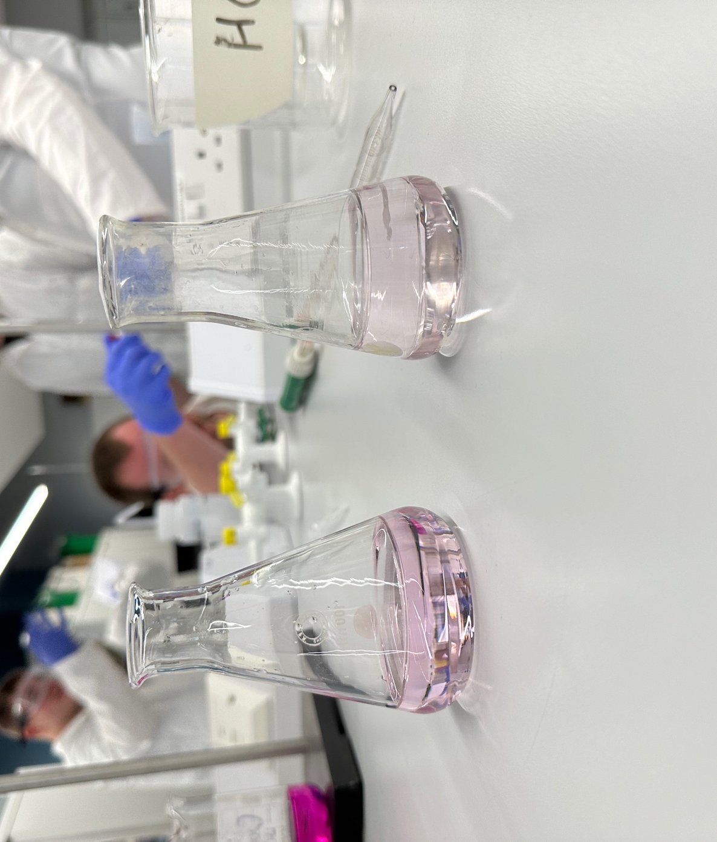
Figure 1 Completed titrations.

Discussion

Interpretation of Experimental Results
When HCl (acid) and NaOH (base) reacted in a neutralisation reaction during titration, they produced NaCl (aqueous salt) and water [1]. This can be represented by the chemical equation:

${HCl}_{\left(aq\right)}+{NaOH}_{(aq)}→{NaCl}_{(aq)}+ {H_{2}O}_{(l)}$
Equation 3
The stoichiometry of this reaction shows that 1 mole of HCl reacts with 1 mole of NaOH to form 1 mole of each product. The chemical equation can also be written as the net ionic equation (equation showing reacting ions in solution [1]):

$${H^{+}}_{\left(aq\right)}+ {{OH}^{-}}_{\left(aq\right) }→H_{2}O_{(aq)}$$
Equation 4
The end point of the titration occurred when moles acid (H⁺) were equal to moles of base (OH⁻), which was also the point that moles HCl equalled moles NaOH. This equivalence point was visible through the colour change of the Phenolphthalein Indicator from colourless to pink.

As the molarity volume of NaOH at end point was known, the number of moles at this point could be calculated using Equation 1. Using the stoichiometry of the equation, at the end point of the reaction moles NaOH equalled moles of HCl. As the number of moles and volume of HCl were now known, the molarity could be calculated using Equation 1 and checked using Equation 2.

Relevance of Findings to OME
- Detection of Explosives
  - Fluorescence titration experiments are used in the rapid detection of nitroaromatic explosives such as TNT, PETN and RDX [2] required for crime scene and counter-terrorism investigations [3].
  - Titration is used to detect explosive compound Picric Acid, belonging to the same family as nitroaromatic explosives [4].
- Synthesis of Explosives
  - Titration is used in the production of primary explosives such as DBX-1 to remove performance impacting impurities [5].

Limitations and Sources of Error
- Only 2 titrations after the rough titration were performed as results were within 0.1ml. More repeats would increase reliability of results and allow opportunity to increase accuracy of titration.
- Completed titrations varied in colour meaning inconsistent volumes of NaOH were recorded, resulting in different molarities of HCl being calculated, reducing accuracy.

Conclusion

Summary of Findings
From the data collected by reacting a known volume of HCl (unknown concentration) with a known volume of NaOH (known concentration), it was possible to calculate the concentration (molarity) of HCl, supporting the hypothesis.

Suggestions for Future Research
- Methods of increasing accuracy of molarity calculations such as increasing number of titrations completed and using equipment with a higher degree of accuracy.
- Looking into possibly using titration as a method for rapid detection of explosives outside the nitroaromatic family to increase cost efficiency and reduce complexity.

Bibliography

[1] | M. Bossart, R. Clarke, I. H. Davis, J. Duffy, E. Grimwood, L. Muncaster, D. Swain and P. Warren, A-Level Chemistry for AQA: Year 1 & 2 Student Book with Online Edition, Newcastle upon Tyne: CGP, 2020.
[2] | F. Ghasemia and M. R. Hormozi-Nezhadb, “Determination and identification of nitroaromatic explosives by a double- emitter sensor array,” Talanta, vol. 201, pp. 230-236, 15 August 2019.
[3] | S.-B. Ding, W. Wang, L.-G. Qiu, Y.-P. Yuan, F.-M. Peng, X. Jiang, A.-J. Xie, Y.-H. Shen and J.-F. Zhu, “Surfactant-assisted synthesis of lanthanide metal-organic framework nanorods and their fluorescence sensing of nitroaromatic explosives,” Materials Letters, vol. 65, no. 9, pp. 1385-1387, 15 May 2011.
[4] | H.-J. Jiang, J.-L. Zhang, Q.-W. Zhang and S.-H. Ye, “Synthesis, characterization and explosive detection of photoluminescent compounds with intramolecular charge-transfer characteristic,” Synthetic Metals, vol. 201, pp. 30-42, March 2015.
[5] | T. M, Klapötke, D. G. Piercey, N. Mehta, K. D. Oyler, M. Jorgensen, S. Lenahan, J. S. Salan, J. W. Fronabarger and M. D. Williams, “Preparation of High Purity Sodium 5-Nitrotetrazolate (NaNT): An Essential Precursor to the Environmentally Acceptable Primary Explosive, DBX-1,” Zeitschrift für anorganische und allgemeine Chemie, vol. 639, no. 5, pp. 681-688, 15 March 2013.

