Programming 1
Module Code: ACCA4004
Module Tutor: Mike Dacey
[
Student Name: Mohamad Wael Baghdadi
Student Number: 1708309
Course: Software Engineering
Date: 22/03/2018

Table of Contents
Table of Contents 1
Introduction: 2
PART A (UNDERSTANDING): 3
1- What is a variable and why they are important in writing programs: 3
1.1- types of variables: 3
Name: 3
Size: 3
Value: 4
Type: 4
Memory address: 4
2- Why the for-loop can also be referred to as a counting-loop: 4
1.2- Example for the while and for loop 4
3- How arguments in functions can be used: 5
4- The purpose of a class in Object Oriented Programming: 5
PART B (INTERPRETATION): 7
1- Flow chart: 7
7
2- The problem in the program is: 8
5- References: 9
Appendix: 10
PART B (INTERPRETATION): 10
Exercise 1: 12
Exercise 2: 12
Exercise 3: 12
Exercise 4: 12
Exercise 5: 13
Exercise 6: 13
Exercise 7: 13
Exercise 8: 13

Introduction:
The aim of report is to describe and make small explanation about the variables in programming and what the variables can do, how can we use them, what is the type of variables, and describe each variable in brief, the other thing in this report is to compare the points or the different between for loop and while loop and why the for loop can referred to as a counting-loop with an example of why they use it, also it’s include a brief about the what is the arguments and how arguments in functions can be used, in the last section in the part one the author describe in few lines the class and objects and what the purpose of a class in Object Oriented Programming and why they important.
In part B and part C have some exercises in C and C++ programming

PART A (UNDERSTANDING):

1- What is a variable and why they are important in writing programs:
The first thing the author wants to describe it in the variables is the most important thing has been founded in his research which is the variables can contain only one value and it must have a type for example int, string, double … etc.
In other research the author has been found that the variables are used to store values which mean that we can use them to save the inputs and information which will be referenced and processed and restored by the user in a computer program at any time, the variables can offer a way of describing the data with a descriptive name. They are important because they allow the programs to be more readable and clearly for us and for the reader, it is useful to understand the variables as a storage that keeps our inputs and information, the main purpose of them is to name and saved the values in memory, then this value or the data can be used during and everywhere in our program
the author found in his research that is naming the variables as a know is the hardest task in writing programs, so the programmer needs to think very hard to give the variable a name, which that allow to the other reader to be easily, clearly and descriptive also it might the read is ourselves when we need to revisit and read a program after a period of time.[1][2]

types of variables:
in variables we have the following basic types:[3][4][2]
char (a single character): Typically, a single octet (1 byte). This is an integer type. Example: (d, E, #, £, $)
int (whole number): which is mean an integer, the most natural size of the integer for the machine and it has the size 1 to 8 bytes, example: (-1, -9, -15, 4, 6, 11, 54, 200)
float (decimal number): a single-precision floating point value, the size for the float 4 to 8 bytes, example: (3.9, 5.11)
double: a double-precision floating point value, the size:
string: which is the sequence of character, and the size for string is limited to the amount that can be stored in main memory, example: (abc, hello world, computer)
bool (Boolean): this can take just two values true or false, and it has 1 byte.
It’s very important for the programmer to remember the following:[5]

Name:
the name is Symbolic. It demonstrates the "name" of the data that is being stored with the variable. The name is maybe the most essential ascribe to the software engineer, as this is the means by which we "get to" the variable. Each factor must have a sole or a unique name!

Size:
Each variable has a size for example the char size is 1 byte and the int size is 1 to 8 bytes

Value:
A variable, by its exceptional name, changes after some time. Consequently, if the variable is jims_age and is doled out the value 21. At another point, jims_age might be allocated the value 27.

Type:
The data type is the assortment of a specific type of information, and consider it as very necessary to any computer programming language, even without them, it gets very hard to keep the data within a computer program, and in the data types have different sizes in different memory rely on the machine and compilers

Memory address:
Each value in the variables has a memory address where is located

2- Why the for-loop can also be referred to as a counting-loop:
According to the author’s research he found that for-loop and while-loop both are used to perform one or more lines of code certain number of times and there is not much difference between them as the
for-loop: (counting loop) when we know the maximum count which it’s mean we can used to
repeat a specific block of code a known number of times
while-loop: it’s used to test a condition which mean more basic compared to other loops and it is used to repeat a block of code but not the same as the for-loop known number of times it used with different type as it has one control expression as a specific condition and executes as long as the given expression is true and the for loop is a very specialized while loop, which increases the readability of a program.

1.2- Example for the while and for loop
While loop | For loop
int i = 0;  while (i<10) {  printf("Hello World");  i++;  } | int i = 0;  for (i = 0; i<10; i++) {  printf("Hello World");  }

3- How arguments in functions can be used:
The term argument is utilized for a declaration passed by a function call; the term parameter is utilized for an input object or its identifier and got by a function definition or described
in a function declaration. The terms of actual argument (parameter) and the formal contention (parameter) particularly are some of the time utilized for a similar distinction.
In getting ready for the call to a function, a duplicate is made of every argument; all argument passing is strictly by value, A function may change the values of its parameter objects, which are copies of the argument expressions, but these changes cannot influence the values of the arguments. In any case, it is conceivable to pass a pointer on the understanding that the function may change the value of the object to which the pointer focuses.[6]
In other research [7] the author has found that the arguments in functions must declare variables that approve the values of the arguments. These variables are named the affected parameters of the function.
Formal parameters conduct similar to other local variables contained the function and are produce upon entry into the function and destroyed upon exit.
In the functions there are two ways in which arguments can be passed which they are:
Call by value: this procedure copied the real value of an argument into the formal parameter of the function. In this situation, changes made to the argument inside the function have no impact or result on the argument.
Call by reference: this procedure copied the address of an argument into the formal parameter. Inside the function, the address is utilized to get to the genuine argument utilized in the call. This implies changes made to the parameter influence the argument.

4- The purpose of a class in Object Oriented Programming:
- In brief the first and important things need to know about the object-oriented programming is allow us to solve a larger problem by grouping together the values and the functions required to solve smaller related problems and also it allows us to hide some data which have an access mechanism to limit how the values in the data can be changed and identify a specific set of functions for changing it. Also, it allows the data for multiple entities in the real world to be created similar to rows in the database.
- Now the class is a new data type that contains variables and functions, and each object that contains the data and its functions, for example, the class is a blueprint, the blueprint is like a diagram that shows how to build a building. The object is the same building, which was built according to the blueprint, and the method of declaring a class is similar to the structure where the structure contains variables called domain, the class contains variables named structure, in addition to the functions that work on these variables and called the functions - and also some classes contain only variables.
In the class contain a private which is mean that functions inside the class are Protected from outside the class to other class, and in the class contain public which it’s mean that any function can access to theirs.
The idea of the object in the real world is can be a person, a house and a car which this is a noun object which we can say it is the same for the computer program we can design the object to hold an own specific information, also known attributes and properties, for example, a glass cap stating whether a full or empty and the mileage in the car we called as an object properties not only this object can contain information but also certain behaviors, for example, a dog object could bark which it’s mean an actions of the object also known methods that are actually just sub routines or functions so according to that we can say the object means is a class and the classes allowed to create as many objects as we need.
The aim of classes in object-oriented programs is that the class is the main unit of abstraction in object-oriented programming, and it allows the user to organize the problem to find the solution in the program. In object-oriented programming, a class is a template definition of the methods and variables in a specific type of object. so, an object is a specifying instance of a class, also it includes real values instead of variables. So, we can say is the advantages of object-oriented programming is: a class can have subclasses that can inherit all or some of the advantage of the class. In the link to each subclass, the class will be the superclass, subclasses can also define their own methods and variables that are not part of their superclass, the structure of a class and its subclasses is called the class hierarchy.[8]

PART B (INTERPRETATION):

1- Flow chart:
Start the program

printf to describe the program
and main page for the program

Switch statement to let the user choose one of 5 options

Output: option 1 to let the user enter some number (for loop)

Input: 3 numbers

Output: option 2 to display to the user smallest number was entered (for loop and if statement)

Output: smallest number entered

input number

Output: largest number entered

Output: option 3 to display to the user the largest number was entered (for loop and if statement)

Output: display the number

Output: option 4 to display the number that were entered
(for loop and if statement)

Option 5 to ask the user if close or stay in the program

If the user tries to enter any other number, it will display a message, “Unknown option value entered”

If statement
Output
Yes

No
End the program

////// note: if anything not clear in this flow chart, I did another two in Appendix.

2- The problem in the program is:
The case four in the switch statement is the same fifth option is to ask the user if he wants to exit the program or not, but in fact in the program, the fourth option is to display the numbers that entered by the user,
So, we need to create another function for the option four to display the same number and change the case four in the switch statement to the correct function.

## | An option is missing
Description |  |  | The fours option in the menu is missing and the fifth option is repeated in the fourth one, so we need to add a function in fourth option to let the user to display the numbers
 |  |  | Test Steps:
1 | Display the menu
2 | Ask the user to enter number to choose from 5 options
3 | Number 4 entered to display the numbers
4 | The program is closed

Response and problem |  |  | The problem in the program is when the user need to display the numbers that has been entered and input number 4, the program is close, which is should let the program to display the numbers. so we need to create new function to let the program displayed the numbers for the user
Status |  | Date |  |  |  | Description
Fail |  | 20/03/18 17.00 |  |  |  | The user can’t display the number
Pass |  | 20/03/18 18.00 |  |  |  | Passed and the user can display the number in option 4

PART C (IMPLEMENTATION):
All the exercises with codes and screenshots are present in appendix below.
N

5- References:
[1] Launch school, “What is a variable in computer programming?,” 2018. [Online]. Available: https://launchschool.com/books/ruby/read/variables#assigningvaluetovariables. [Accessed: 06-Mar-2018].
[2] “BBC Bitesize - GCSE Computer Science - Constants, variables and data types - Revision 2,” 2018. [Online]. Available: https://www.bbc.co.uk/education/guides/zc6s4wx/revision/1. [Accessed: 06-Mar-2018].
[3] O. R. Words, “Variables and Data Types,” 2006.
[4] “C Variables.” [Online]. Available: https://www.tutorialspoint.com/cprogramming/c_variables.htm. [Accessed: 09-Mar-2018].
[5] “PROG0101 Fundamentals of Programming PROG0101 FUNDAMENTALS OF PROGRAMMING Chapter 4 Variables and Data Types.”
[6] B. W. Kernighan and D. M. Ritchie, The C programming language, vol. 78. 1988.
[7] L. H. Sullivan, “C Functions,” 2016.
[8] Rouse Margaret, “What is ad blocker? - Definition from WhatIs.com,” 2018. [Online]. Available: http://whatis.techtarget.com/definition/class. [Accessed: 15-Mar-2018].

Appendix:

PART B (INTERPRETATION):
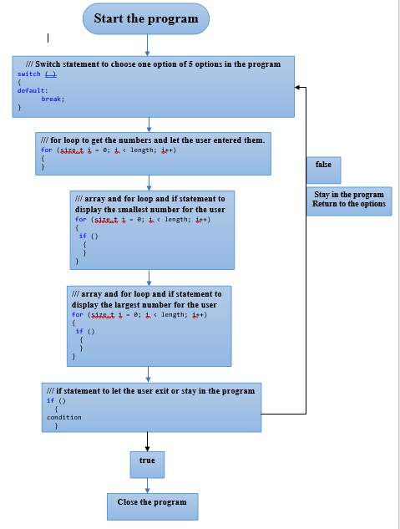

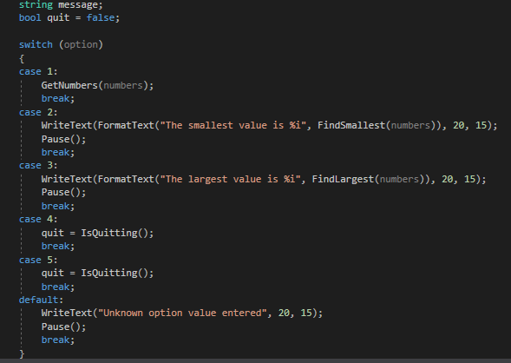
Start the program
1

Choose an option in the following program

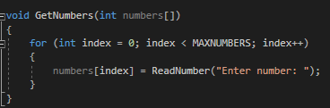

Option 1: To enter the numbers
2

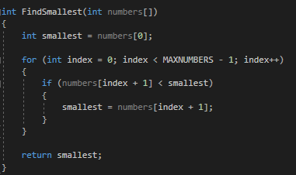
The numbers entered by the user then return to main options
3

Option 2: To find the smallest value

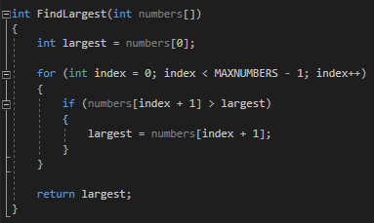
The smallest number has been displayed, return to main options

4

Option 3: To find the largest value

The largest number has been displayed, return to main options
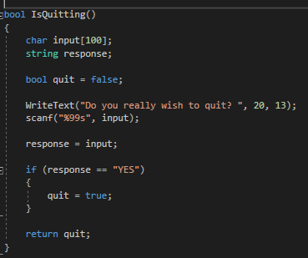

Option 5: To exit or stay in the program

5
If (yes) the program will exit,
otherwise will stay and return to options
N
Y
End the program
1- Using switch statement to choose one option in the program.
2- Using the array and for loop to get the numbers and entered,
Then the program will return to start to let the user to choose an option.
3- Using array and for loop to get the smallest number from the number that
the user has entered.
4- Using array and for loop to get the largest number from the number
that the user has entered.
5- Using if statement to let the user choose if he wants to exit or stay in the program.

Note:
indicate the function….............….
indicate the next step…....................
indicate the code………............
Number to explanation the function
the displayed for the user...............
…..

.
…

PART C (IMPLEMENTATION)

Exercise 1:
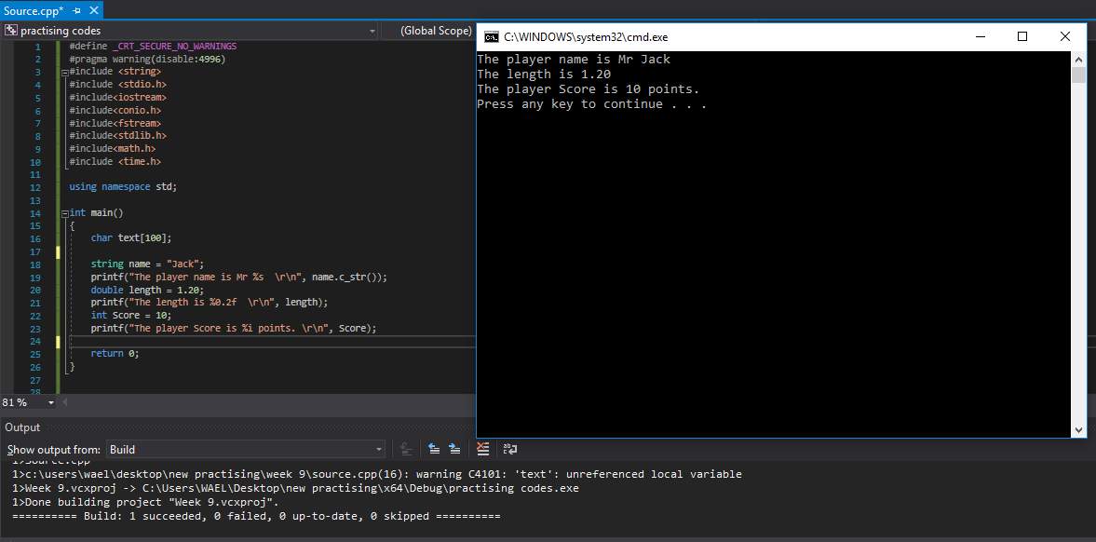

#define _CRT_SECURE_NO_WARNINGS
#pragma warning(disable:4996)
#include <string>
#include <stdio.h>
#include<iostream>
#include<conio.h>
#include<fstream>
#include<stdlib.h>
#include<math.h>
#include <time.h>

using namespace std;

int main()
{
char text[100];

string name = "Jack";
printf("The player name is Mr %s \r\n", name.c_str());
double length = 1.20;
printf("The length is %0.2f \r\n", length);
int Score = 10;
printf("The player Score is %i points. \r\n", Score);

return 0;
}

Exercise 2:
//// Shaded area in function, I did the shaded area in non-function below.

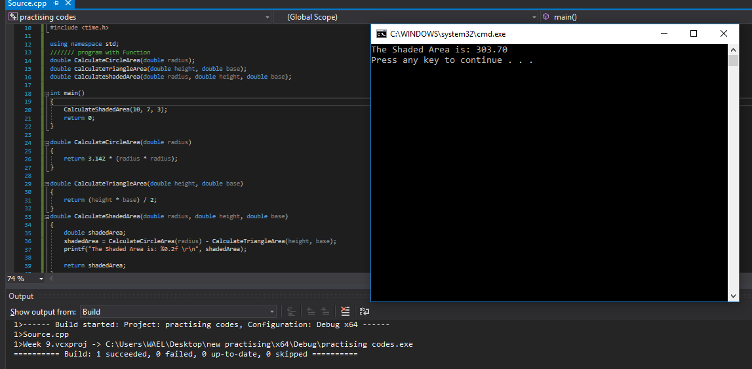
#define _CRT_SECURE_NO_WARNINGS
#pragma warning(disable:4996)
#include <string>
#include <stdio.h>
#include<iostream>
#include<conio.h>
#include<fstream>
#include<stdlib.h>
#include<math.h>
#include <time.h>

using namespace std;
/////// program with Function
double CalculateCircleArea(double radius);
double CalculateTriangleArea(double height, double base);
double CalculateShadedArea(double radius, double height, double base);

int main()
{
CalculateShadedArea(10, 7, 3);
return 0;
}
double CalculateCircleArea(double radius)
{
return 3.142 * (radius * radius);
}
double CalculateTriangleArea(double height, double base)
{
return (height * base) / 2;
}
double CalculateShadedArea(double radius, double height, double base)
{
double shadedArea;
shadedArea = CalculateCircleArea(radius) - CalculateTriangleArea(height, base);
printf("The Shaded Area is: %0.2f \r\n", shadedArea);

return shadedArea;
}

//// shaded area in non-function.
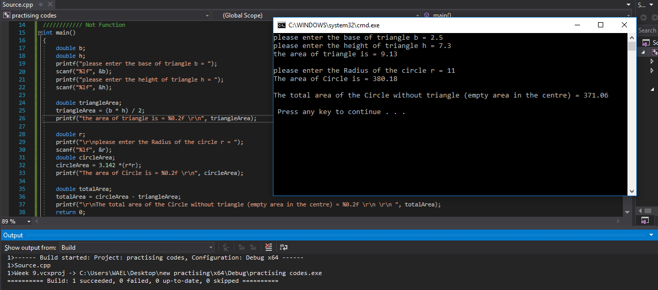
#define _CRT_SECURE_NO_WARNINGS
#pragma warning(disable:4996)
#include <string>
#include <stdio.h>
#include<iostream>
#include<conio.h>
#include<fstream>
#include<stdlib.h>
#include<math.h>
#include <time.h>

using namespace std;
//////////// Not Function
int main()
{
double b;
double h;
printf("please enter the base of triangle b = ");
scanf("%lf", &b);
printf("please enter the height of triangle h = ");
scanf("%lf", &h);

double triangleArea;
triangleArea = (b * h) / 2;
printf("the area of triangle is = %0.2f \r\n", triangleArea);

double r;
printf("\r\nplease enter the Radius of the circle r = ");
scanf("%lf", &r);
double circleArea;
circleArea = 3.142 *(r*r);
printf("The area of Circle is = %0.2f \r\n", circleArea);

double totalArea;
totalArea = circleArea - triangleArea;
printf("\r\nThe total area of the Circle without triangle (empty area in the centre) = %0.2f \r\n \r\n ", totalArea);
return 0;
}

Exercise 3:
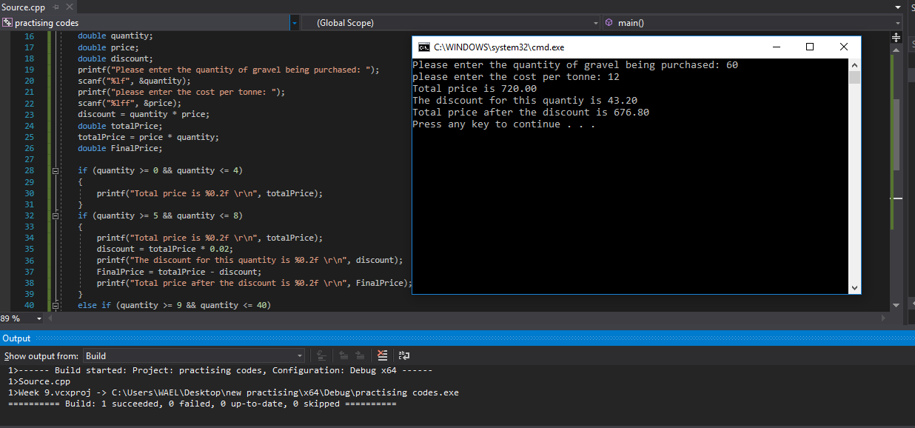
#define _CRT_SECURE_NO_WARNINGS
#pragma warning(disable:4996)
#include <string>
#include <stdio.h>
#include<iostream>
#include<conio.h>
#include<fstream>
#include<stdlib.h>
#include<math.h>
#include <time.h>

using namespace std;

int main()
{
double quantity;
double price;
double discount;
printf("Please enter the quantity of gravel being purchased: ");
scanf("%lf", &quantity);
printf("please enter the cost per tonne: ");
scanf("%lff", &price);
discount = quantity * price;
double totalPrice;
totalPrice = price * quantity;
double FinalPrice;

if (quantity >= 0 && quantity <= 4)
{
printf("Total price is %0.2f \r\n", totalPrice);
}
if (quantity >= 5 && quantity <= 8)
{
printf("Total price is %0.2f \r\n", totalPrice);
discount = totalPrice * 0.02;
printf("The discount for this quantity is %0.2f \r\n", discount);
FinalPrice = totalPrice - discount;
printf("Total price after the discount is %0.2f \r\n", FinalPrice);
}
else if (quantity >= 9 && quantity <= 40)
{
printf("Total price is %0.2f \r\n", totalPrice);
discount = totalPrice * 0.04;
printf("The discount for this quantity is %0.2f \r\n", discount);
FinalPrice = totalPrice - discount;
printf("Total price after the discount is %0.2f \r\n", FinalPrice);
}
else if (quantity > 40)
{
printf("Total price is %0.2f \r\n", totalPrice);
discount = totalPrice * 0.06;
printf("The discount for this quantiy is %0.2f \r\n", discount);
FinalPrice = totalPrice - discount;
printf("Total price after the discount is %0.2f \r\n", FinalPrice);
}
else
{
printf("No discount \r\n");
}
return 0;
}

Exercise 4:
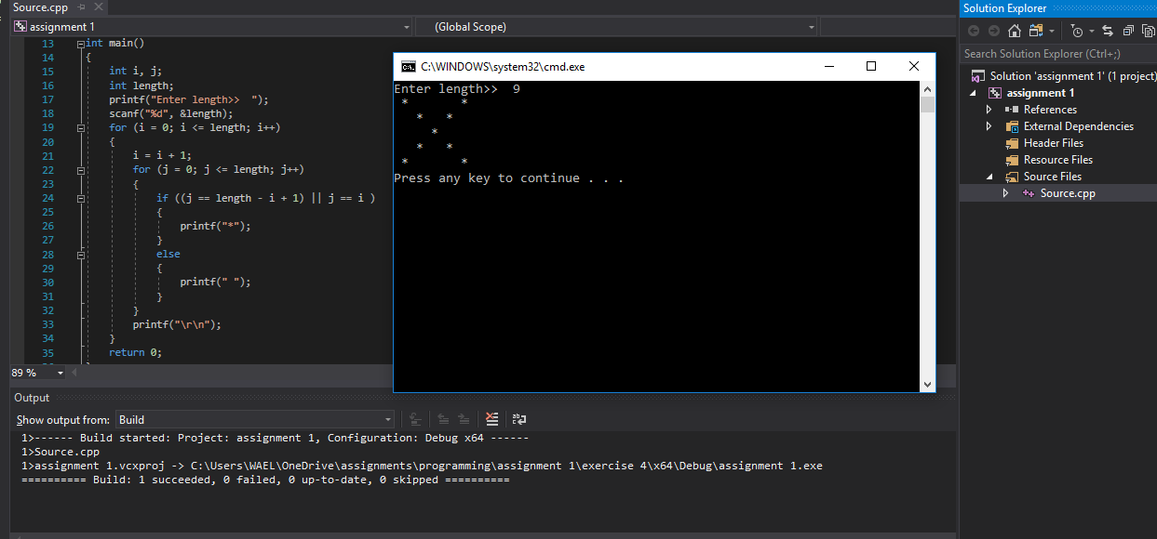
#define _CRT_SECURE_NO_WARNINGS
#pragma warning(disable:4996)
#include <string>
#include <stdio.h>
#include<iostream>
#include<conio.h>
#include<fstream>
#include<stdlib.h>
#include<math.h>
#include <time.h>

using namespace std;
int main()
{
int i, j;
int length;
printf("Enter length>> ");
scanf("%d", &length);
for (i = 0; i <= length; i++)
{
i = i + 1;
for (j = 0; j <= length; j++)
{
if ((j == length - i + 1) || j == i )
{
printf("*");
}
else
{
printf(" ");
}
}
printf("\r\n");
}
return 0;
}

Exercise 5:
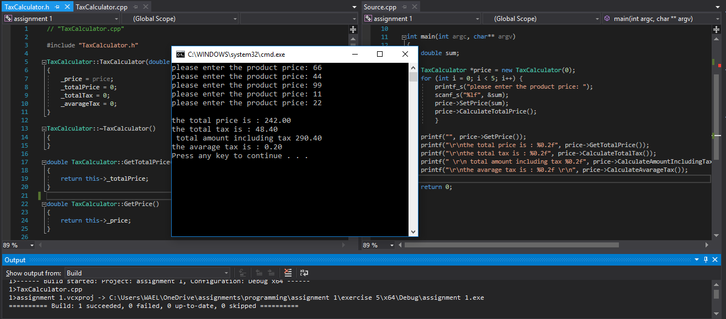
// Source.cpp
#define _CRT_SECURE_NO_WARNINGS
#include <conio.h>
#include <string>
#include <stdarg.h>
#include <Windows.h>
#include "TaxCalculator.h"

using namespace std;

int main(int argc, char** argv)
{
double sum;

TaxCalculator *price = new TaxCalculator(0);
for (int i = 0; i < 5; i++) {
printf_s("please enter the product price: ");
scanf_s("%lf", &sum);
price->SetPrice(sum);
price->CalculateTotalPrice();
}

printf("", price->GetPrice());
printf("\r\nthe total price is : %0.2f", price->GetTotalPrice());
printf("\r\nthe total tax is : %0.2f", price->CalculateTotalTax());
printf(" \r\n total amount including tax %0.2f", price->CalculateAmountIncludingTax());
printf("\r\nthe avarage tax is : %0.2f \r\n", price->CalculateAvarageTax());

return 0;
}

// "TaxCalculator.cpp"

#include "TaxCalculator.h"

TaxCalculator::TaxCalculator(double price)
{
_price = price;
_totalPrice = 0;
_totalTax = 0;
_avarageTax = 0;
}

TaxCalculator::~TaxCalculator()
{
}

double TaxCalculator::GetTotalPrice()
{
return this->_totalPrice;
}

double TaxCalculator::GetPrice()
{
return this->_price;
}

void TaxCalculator::SetPrice(double value)
{
this->_price = value;
}

double TaxCalculator::CalculateTotalPrice()
{

return this->_totalPrice = _price + _totalPrice;
}

double TaxCalculator::CalculateTotalTax(void)
{

return this->_totalTax = _totalPrice/100* 20;
}
double TaxCalculator::CalculateAmountIncludingTax()
{
return this->_totalPrice + _totalTax;
}

double TaxCalculator::CalculateAvarageTax(void)
{
return this->_avarageTax = _totalTax / _totalPrice;
}

// TaxCalculator.h
#pragma once

#include <iostream>

using namespace std;

class TaxCalculator {

private:

double _price;
double _totalPrice;
double _totalTax;
double _avarageTax;

public:
TaxCalculator(double price);
~TaxCalculator();

double GetPrice();
double GetTotalPrice();
void SetPrice(double value);

double CalculateAmountIncludingTax();
double CalculateTotalPrice();
double CalculateTotalTax(void);
double CalculateAvarageTax(void);

};

Exercise 6:
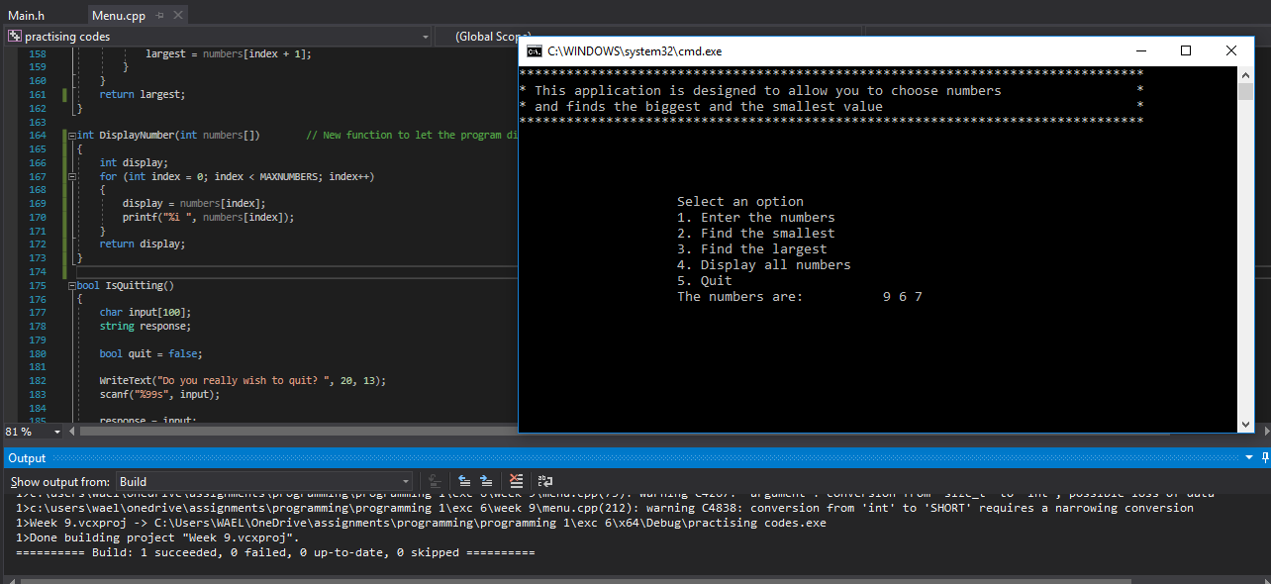
/* The error in the program was: the case four in the switch statement is the same fifth option which is to ask the user if he wants to exit the program or not, but in fact in the program, the fourth option is to display the numbers that entered by the user,
So, we need to create another function for the option four to display the same number and change the case four in the switch statement to the correct function. */

//// Main.h
#pragma once

const int MAXNUMBERS = 3;
const int MAXINPUTCHARS = 100;

void InitialiseNumbers(int numbers[], int size);
void DisplayHeader(void);
void DisplayMenu(void);
int ReadNumber(string prompt);
void IgnoreInput(void);
void ClearText(int x, int y, int length);
bool ProcessMenu(int option, int numbers[]);
void GetNumbers(int numbers[]);
int FindSmallest(int numbers[]);
int FindLargest(int numbers[]);
int DisplayNumber(int numbers[]);
bool IsQuitting();
void WriteText(string text, int x, int y);
void SetCursorPosition(int x, int y);
string FormatText(const char *format, ...);
void ClearConsole(void);
void Pause(void);

// AssignCode_Menu.cpp : Defines the entry point for the console application.
//

#define _CRT_SECURE_NO_WARNINGS

#include <conio.h> // For pause
#include <string>
#include <stdarg.h>
#include <Windows.h> // To change cursor position

using namespace std;

#include "Main.h"

int main()
{
int theNumbers[MAXNUMBERS];
int chosenOption = 0;
bool quit = false;

InitialiseNumbers(theNumbers, MAXNUMBERS);

while (quit == false)
{
DisplayHeader();
DisplayMenu();
chosenOption = ReadNumber("Please choose an option: ");
quit = ProcessMenu(chosenOption, theNumbers);

ClearConsole();
}

return 0;
}

void InitialiseNumbers(int numbers[], int size)
{
for (int index = 0; index < size; index++)
{
numbers[index] = 0;
}
}

void DisplayHeader(void)
{
WriteText("*******************************************************************************", 0, 0); // Top left hand corner of screen is x = 0, y = 0
WriteText("* This application is designed to allow you to choose numbers *", 0, 1); // Next line down is x = 0, y = 1, etc
WriteText("* and finds the biggest and the smallest value *", 0, 2);
WriteText("*******************************************************************************", 0, 3);
}

void DisplayMenu()
{
WriteText("Select an option", 20, 8); // Display menu at at x = 20, y = 8
WriteText("1. Enter the numbers", 20, 9);
WriteText("2. Find the smallest", 20, 10);
WriteText("3. Find the largest", 20, 11);
WriteText("4. Display all numbers", 20, 12);
WriteText("5. Quit", 20, 13);
}

int ReadNumber(string prompt)
{
int number = -1;
int inputCharCount;

WriteText(prompt, 20, 14);
inputCharCount = scanf("%i", &number);
if (inputCharCount == 0) // Wasn’t a number, so ignore what they typed in!!
{
IgnoreInput();
}

ClearText(20, 14, prompt.length() + inputCharCount); // Clear the text at this line

return number;
}

void IgnoreInput(void)
{
char ch;
while ((ch = getchar()) != '\n' && ch != EOF);
}

void ClearText(int x, int y, int length)
{
// Write space ' ' characters starting at x, y for 'length' times
string spaces(length, ' ');
WriteText(spaces, x, y);
}

bool ProcessMenu(int option, int numbers[])
{
string message;
bool quit = false;

switch (option)
{
case 1:
GetNumbers(numbers);
break;
case 2:
WriteText(FormatText("The smallest value is %i", FindSmallest(numbers)), 20, 15);
Pause();
break;
case 3:
WriteText(FormatText("The largest value is %i", FindLargest(numbers)), 20, 15);
Pause();
break;
case 4: // ((quit = IsQuitting();)) was wrong function >>> /// in case 4 we need to crate new function to let the number displayed when the user input 4 in the main options in the program.
WriteText(FormatText("The numbers are:", DisplayNumber(numbers)), 20, 14);
Pause();
break;
case 5:
quit = IsQuitting();
break;
default:
WriteText("Unknown option value entered", 20, 15);
Pause();
break;
}

return quit;
}

void GetNumbers(int numbers[])
{
for (int index = 0; index < MAXNUMBERS; index++)
{
numbers[index] = ReadNumber("Enter number: ");
}
}

int FindSmallest(int numbers[])
{
int smallest = numbers[0];

for (int index = 0; index < MAXNUMBERS - 1; index++) // <-- subtract 1
{
if (numbers[index + 1] < smallest)
{
smallest = numbers[index + 1];
}
}

return smallest;
}

int FindLargest(int numbers[])
{
int largest = numbers[0];

for (int index = 0; index < MAXNUMBERS - 1; index++) // <-- subtract 1
{
if (numbers[index + 1] > largest)
{
largest = numbers[index + 1];
}
}
return largest;
}

int DisplayNumber(int numbers[]) // New function to let the program displayed the numbers for the usrer
{
int display;
for (int index = 0; index < MAXNUMBERS; index++)
{
display = numbers[index];
printf("%i ", numbers[index]);
}
return display;
}

bool IsQuitting()
{
char input[100];
string response;

bool quit = false;

WriteText("Do you really wish to quit? ", 20, 13);
scanf("%99s", input);

response = input;

if ((response == "YES") || (response == "Yes") || (response == "yes"))
{
quit = true;
}

return quit;
}

void WriteText(string text, int x, int y)
{
SetCursorPosition(x, y);
printf(text.c_str());
}

// JUST USE THIS FUNCTION
// This function positions cursor in Console window,
// and you DON'T need to understand it!!!
void SetCursorPosition(int x, int y)
{
static HANDLE handle = NULL;
if (!handle)
{
handle = GetStdHandle(STD_OUTPUT_HANDLE);
}
COORD coords = { x, y };
SetConsoleCursorPosition(handle, coords);
}

// JUST USE THIS FUNCTION
// This function does creates a string
// using a format string and values i.e.
// FormatText("Number is %i", 5) returns "Number is 5",
// and you DON'T need to understand it!!!
string FormatText(const char *c_format, ...)
{
char ch[100];
va_list args;
va_start(args, c_format);
vsnprintf(ch, 100, c_format, args);
va_end(args);
return string(ch);
}

// JUST USE THIS FUNCTION
// This function clears the screen,
// and you DON'T need to understand it!!!
void ClearConsole(void)
{
system("cls");
}

void Pause(void)
{
// Pause
while (1) { if (_kbhit()) break; }
_getch(); // Clear the keypress
}

Exercise 7:
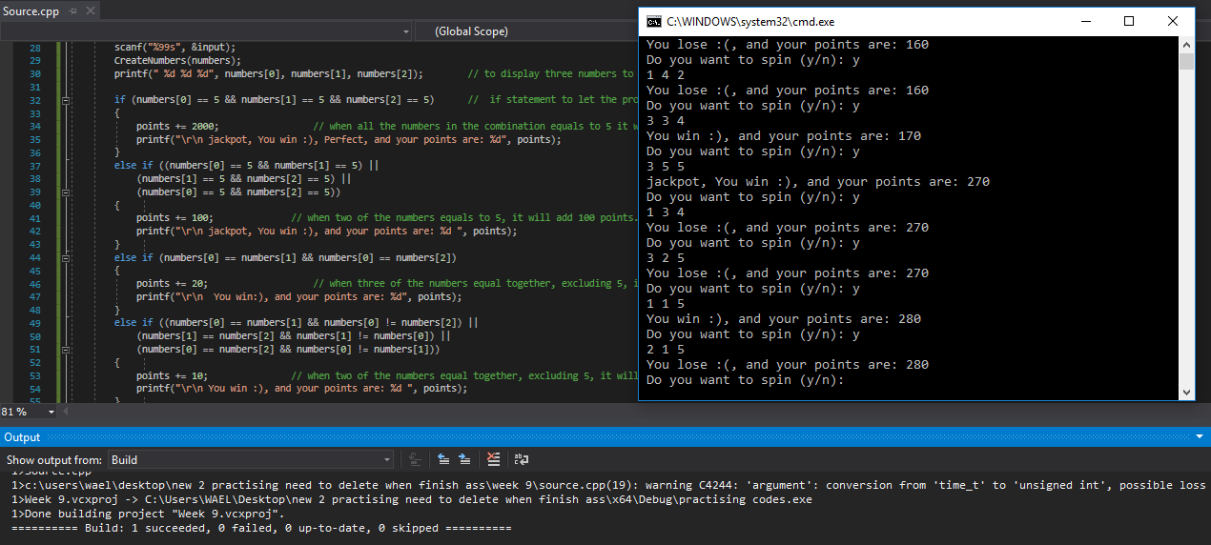
#define _CRT_SECURE_NO_WARNINGS
#pragma warning(disable:4996)
#include <string>
#include <stdio.h>
#include<iostream>
#include<conio.h>
#include<fstream>
#include<stdlib.h>
#include<math.h>
#include <time.h>

using namespace std;

int GetRandomNumber(int maxNumber);
void CreateNumbers(int numbers[]);

int main()
{
srand(time(NULL)); // To generate random numbers .
int numbers[3]; // an array to create 3 numbers.
int points; // to let the user know what his points.
points = 0;
CreateNumbers(numbers); // this function to generate random number in for loop.
char input = 'y';
while (input != 'n') // while loop to let the user keep spin again until he wants to close (y or n).
{
printf("\r\n Do you want to spin (y/n): ");
scanf("%99s", &input);
CreateNumbers(numbers);
printf(" %d %d %d", numbers[0], numbers[1], numbers[2]); // to display three numbers to the user.

if (numbers[0] == 5 && numbers[1] == 5 && numbers[2] == 5) // if statement to let the program add the points in each different one.
{
points += 2000; // when all the numbers in the combination equals to 5 it will add 2000 the points, the big jackpot.
printf("\r\n jackpot, You win :), Perfect, and your points are: %d", points);
}
else if ((numbers[0] == 5 && numbers[1] == 5) ||
(numbers[1] == 5 && numbers[2] == 5) ||
(numbers[0] == 5 && numbers[2] == 5))
{
points += 100; // when two of the numbers equals to 5, it will add 100 points.
printf("\r\n jackpot, You win :), and your points are: %d ", points);
}
else if (numbers[0] == numbers[1] && numbers[0] == numbers[2])
{
points += 20; // when three of the numbers equal together, excluding 5, it will add 20 points.
printf("\r\n You win:), and your points are: %d", points);
}
else if ((numbers[0] == numbers[1] && numbers[0] != numbers[2]) ||
(numbers[1] == numbers[2] && numbers[1] != numbers[0]) ||
(numbers[0] == numbers[2] && numbers[0] != numbers[1]))
{
points += 10; // when two of the numbers equal together, excluding 5, it will add 10 points.
printf("\r\n You win :), and your points are: %d ", points);
}
else // if all the numbers different, the user will lose and will not add any points.
{
printf("\r\n You lose :(, and your points are: %d", points);
}
}
return 0;
}

int GetRandomNumber(int maxNumber) // this function to generate random numbers.
{
int random = rand() % maxNumber;
return random;
}

void CreateNumbers(int numbers[]) // this function is to create the 3 numbers from 1 to 5.
{
for (int i = 0; i < 3; i++)
{
numbers[i] = (rand() % 5) + 1;
}
}

Exercise 8:
// Source file
#define _CRT_SECURE_NO_WARNINGS
#pragma warning(disable:4996)
#include <string>
#include <stdio.h>
#include<iostream>
#include<conio.h>
#include<fstream>
#include<stdlib.h>
#include<math.h>
#include <time.h>

using namespace std;
int main()
{

return 0;
}

// BattleshipsGame.cpp file

#include "BattleshipsGame.h"

BattleshipsGame::BattleshipsGame(string player1, string player2, int numbers, int rows, int columns)
{
_player1 = player1;
_player2 = player2;

}

BattleshipsGame::~BattleshipsGame()
{
}

// BattleshipsGame.h file

#pragma once
#include <string>
using namespace std;

class BattleshipsGame
{

private:
string _player1;
string _player2;
int _numbers;
int _rows;
int columns;

public:
BattleshipsGame(string player1, string player2, int numbers, int rows, int columns);
~BattleshipsGame();
};

