Digital Surveying
Module Code: ACBA4002
Ayesha Williams

Table Of Contents

Table of Contents…………………………………………………………………………...2
List Of Figures & Pictures………………………………………………………………….3
Introduction…………………………………………………………….…………………...4
Essay;
Part One…………………………………………………………………………..5 - 6
Part Two………………………………………………………………………….7 - 8
Conclusion…………………………………………………………………………………..9
References………………………………………………………………………………….10

List Of Figures & Pictures

Figure 1 – Diagram to show plane surveying and geodetic surveying- (CIVIL CREWS, n.d.)
Figure 2 – Diagram to show Triangulation, Trilateration, Traverse Surveying (Saud, 2015)
Figure 3 – Diagram to show grading of most listed buildings (Anon., n.d.)
Figure 4 - Diagram displaying pacing method of surveying (Anon., n.d.)

Introduction
The evolution of surveying dates back to historic times with three significant periods, ancient Egyptian’s period, The Greek period, the Roman Era, all of which developed the use of survey into today’s society. Surveying has two definitions, one of which is the “Study or practice of measuring altitudes, angles and distances on the land surface so that they can be accurately plotted on a map” [1] (CollinsEnglishDictionary, 2014) The alterative definition of surveying would be “The setting out on the ground of positions of proposed construction or engineering works.” [2] (CollinsEnglishDictionary, 2014).
This report will contain two parts, firstly the report will provide full understanding of Surveying and the classification based on a number of factors, throughout this report you will clearly understand the five main areas on how surveying works in terms of the steps in which you will carry out a survey, This report will outline the primary factors of surveying in two major forms, It will also provide classification based on equipment used throughout surveying in a two different forms and highlight the classifications on surveying based on its purpose and the method and the factors behind both of these factors. The second part to the report will in depth understanding of digital surveying for listed buildings, the report will provide the technologies and tools used and also the information that can be collected from these technologies and tools and the survey.

Part One
The evolution of surveying equipment comes into two forms, the more traditional surveying techniques and requitements which were used were pacing, chain, tape, ranging pole, compass and the plumb bob and line, these all lead to the development of the modern evolution of surveying equipment which is now most commonly known as digital surveying, this involves modern and technical equipment such as the electronic theodolite, electronic distance measurement, total station, leaser measurers and Global positioning systems also known as GPS.
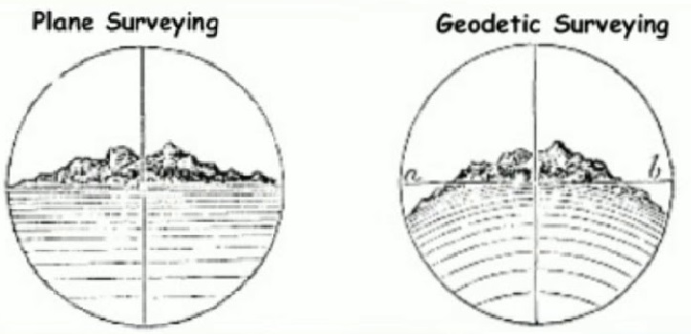
Surveying can be classified on two major primary factors; these factors are Plane surveying and Geodetic Surveying. Plane surveying which is the most commonly used survey out of the two, is where the earth’s surface has been considered as a flat or plane surface and with the curvature of the earth being ignored, another point which helps in identifying a plane survey is if the joining of any two stations is considered a straight line and the triangle formed by any three points is considered as a Plane survey, with the triangle formed by three lines, each of those angles are classified as plane angles. Plane surveys are carried out on small areas of less than 250km². The other major factors would be the use of Geodetic Survey which considers the earth as a curved surface and with that in mind it is taken into account for the whole survey, the any two stations with a line joining is now considered a curved line, in regards to the areas in which a geodetic survey is carried out would be in a larger area more than 250km², the triangle which is now formed by any three points is considered a spherical and the same for the angles of this three point triangle now being considered as spherical (Unknown, n.d).
Figure 1 – Diagrams Plane & Geodetic Surveying
The use of a survey based on purpose has many classifications, using a survey based on purpose would be to provide better accuracy in the data within its given field. The main classifications just to outline would be Cadastral, City, Construction, forestry and hydrographic.
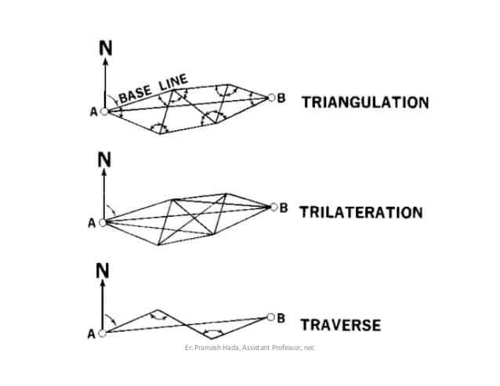
Finally, the use of surveying based on method, these classifications would be the use of the following; Triangulation, Traversing and Trilateration. To outline these, the method of using triangulation “is a surveying method that measures the angles in a triangle formed by three survey control points” (Anon., 2020), Traversing is a “series of connected lines whose lengths and directions are to be measured and the process of surveying to find such measurements” (Anupoju, 2019-2021) and Trilateration “in which the lengths of the sides of a triangle are measured, usually by electronic means, and, from this information, angles are computed. By constructing a series of triangles adjacent to one another, a surveyor can obtain other distances and angles that would not otherwise be measurable” (Britannica, 2016). To further the details of these three methods of surveying, The use of Triangulation has structured field work operation of the following, Reconnaissance, Station preparation, baseline measurement and Measurement of the angles, these coincide with the use of figures within the triangulation systems which can be in the form of Triangles, Quadrilaterals, Polygons (Anupoju, 2019-2021) .Traversing can be used in to formats, these are either closed or open, using closed traversing, the point closes or finishes at your known start point and then in regards to open traversing, this is starting at a known point and then ending anywhere else but your start point. To follow these factors of traversing has stated points which are, Chain traversing, Chain and compass traversing, Transit type traversing “by either the fast needle method or by the measurement of angles between the lines and plane table traversing” (Anon., N.D) and finally further detail in regards to Trilateration it is “that only lines are measured, while all angles are computed, the field procedures for trilateration are like those for triangulation.” (Britannica, 2016).
Figure 2 - Diagram for Triangulation, Trilateration, Traverse Surveying

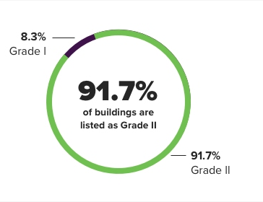
Part Two
The use of digital surveying technologies for the application of surveying listed buildings, is to gather a general understanding of the current building condition, with implementing the use of technologies, this gives the surveyor a visual and mental understanding. Listed buildings have been graded in three categories of significance such as the following;
- Grade I for buildings of the highest significance
- Grade II* and
- Grade II
Figure 3 - Grading Of Listed Buildings
(Anon., n.d.)
The surveyor would take from the technologies and tools a better knowledge of the following applications, they would be able to conclude, all or the majority of the current condition the building is currently in, they would gather an analyse on the decaying prospect of the building, they would be able to gather archaeological investigations or information on this listed building and also gather just a general recording of the site.
The use of tools in conducting a survey on a listed building has developed massively, the use of surveying tools in this present day helps conduct an in-detail report of the current condition the building is currently in, the use of modern tools also helps speed up the process of developing this report, there are also useful tools available to collect data even though the access may be limited.
The first step in conducting a survey on a listed building would not only be the steps to take within the completion of the survey itself but also the factors that need to be taken into consideration by the surveyor. The use of correct equipment such as “Thermal Imaging, Thermal Hygrometers , Roof Cameras and Drones” (HERITAGECONSULTING, 2021) using some of the equipment in a building surveying would help ensure that all systematic and instrumental errors are minimised and that the equipment that is due to be used within the survey is suitable for its usage, for example if limited access is granted, does the surveyor have equipment to fore fill this area, it also ensures that the information that has been captured is adequate. The correct usage of equipment falls in line with the safety of the personnel who will be using this equipment, so training in terms of using the equipment correctly and safely would need to be of knowledge to the surveyor, all in all the importance of using the correct equipment comes down to how the results of the final survey has been provided and whether a full and informed decision can be made from the results, giving clear steps in what is needed for the next stage.
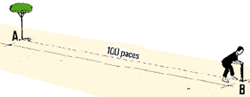
The following tools and equipment are all examples of what can be used as to conduct a survey on a listed building. To start the survey, it would be beneficial to collect the general measurements this could be in the form of calculating the linear measurements of the building, the tools that can be used here would be either the traditional ways in which would include pacing, type measures or to the more modern ways of using a digital measurer or a pedometer. The other forms of equipment that can be used would be Thermal cameras which would analyse thermal bridging, detect heat loss in poor detailed areas and also the thermal cameras would be able to identify if there is a damage or vast construction defects within the listed building. The use of a moisture meter or also known as a damp meter would help identify areas of water ingress due to damage and vast areas of damp (RICS, 2021).
Figure 4 - Diagram displaying pacing method of surveying
In terms of surveying a listed building and the access is very limited, there are certain tools and equipment which would help in accessing data within this limited access. The follow tools that could be used would be the telescopic inspection camera – this piece of equipment has been designed with a light weight camera that is attached to a self-locking pole, with tool, the access to taking pictures or videos of areas out of site such as you’re guttering and roofs, there is also is a piece of equipment named the optical distance measurer which produces building plans and drawing. The final tool that could be used in instances where access is limited would be the digital camera, this would help identify and ensure that all small and intricate details are captured for the use within the technical report, it has the use of high-quality images which helps with this process. All of these tools will aid the survey entirely from top to bottom, without these items of equipment It would be prove difficult to produce an accurate survey of all of the listed building.

Conclusion
To conclude this report highlighting surveying and how it can be classified based on different factors which are suggested in part one of this report and detailing the different types of surveying under those mentioned in part one. Surveying can be classified on a number of different factors starting with what primary classification you intend to survey, classification based on what the purpose of the survey is and what results you wish to gain, the method in which the surveyor will used to carry out the survey and the equipment which is most suitable for the extent of the survey. In conclusion with part two of the report, this predominately focused on listed buildings and how the application of digital technologies helps conduct an accurate, detailed and safe survey a report to help discover the bare skeleton an underlaying conditions a listed building would have, this report also highlights the appropriate tools that help to collect the information needed.

References
Anon., 2020. Anzlic Commitee On Surveying & Mapping. [Online]
Available at: https://www.icsm.gov.au/education/fundamentals-mapping/surveying-mapping/surveying-methods
Anon., n.d. Compare My Move. [Online]
Available at: https://www.comparemymove.com/advice/surveying/listed-building-survey
[Accessed 2021 December 27].
Anon., n.d. FAO.org. [Online]
Available at: https://www.fao.org/fishery/static/FAO_Training/FAO_Training/General/x6707e/x6707e02.htm
[Accessed 2021 December 27].
Anon., n.d. Historic England. [Online]
Available at: https://historicengland.org.uk/advice/your-home/owning-historic-property/listed-building/
[Accessed 2021 December 27].
Anon., N.D. Civil Engineering. [Online]
Available at: https://civiltoday.com/surveying/251-traverse-surveying
Anupoju, S., 2019-2021. Thecontructor.org. [Online]
Available at: https://theconstructor.org/surveying/traversing-surveying-types-methods/35684/
Anupoju, S., n.d. theconstructor.org. [Online]
Available at: https://theconstructor.org/surveying/triangulation-surveying/11218/
Britannica, T. E. o. E., 2016. Encyclopedia Britannica. [Online]
Available at: www.britannica.com/science/trilateration
CIVIL CREWS, n.d. Types of Chain Surveying in Survey and Representative Factor. [Online]
Available at: https://civilcrews.com/chain-surveying/
[Accessed 2021 December 27].
CollinsEnglishDictionary, 2014. The Free Dictionary. [Online]
Available at: https://www.thefreedictionary.com/Land+surveyor
HERITAGECONSULTING, ©. 2., 2021. Heritage Consulting Chartered Surveyors. [Online]
Available at: https://www.heritage-consulting.org/listed-building-surveys/
[Accessed 2021 12 06].
RICS, 2021. RICS - Equipment checklist. [Online]
Available at: https://www.rics.org/uk/upholding-professional-standards/sector-standards/building-surveying/home-surveys/equipment-checklist/
[Accessed 2021 December 27].
Saud, G., 2015. SlideShare. [Online]
Available at: https://www.slideshare.net/gokulsaud/triangulation-and-trilateration-pdf
[Accessed 2021 December 27].
Unknown, n.d. we civil engineers. [Online]
Available at: https://wecivilengineers.wordpress.com/2018/09/17/difference-between-plane-surveying-and-geodetic-surveying/
[Accessed 2021 December 27].

