Professional career development report

Student name: Cezar Stroescu
Student ID: 2123047

Module name: Professional Career Development
Module code: (BMSW4005_LON)
Lecturer name: Joanna Walsh

Contents
Introduction 3
A personal reflection based on Gibbs Reflective Cycle 4
Current Skills Applied to the job 6
The gap in skills that should be developed 7
Systematic Approach to skill acquisition 8
Recruitment and selection 10
Conclusions and Recommendations 11
References 12
Appendix: Professional Career Development, (Related to the role play) 14

Introduction
In every job, there are some skills needed. Different positions have different responsibilities. In this report, I am going to describe my job positions and my career paths. My different skills which will help me to perform as a workshop manager are also included. My weakness and the way to develop them are also described in this paper. The reflection of my interview in the selection process is included here. I want to make myself a perfect suit for the work position. As a workshop manager, I must play some important managerial roles. I need to be experienced in computers and other technology. Besides, as a manager, Human resource management is also my responsibility. Employee satisfaction and observation of their performance are major concerns of a workshop manager (Omoz-Oarhe et al., 2022). In this study, I will describe all the necessary things about my job position, skills, lacking, development plan and others. Besides systematic approach to skill acquisition is also described. Finally, recommendations are provided based on my experience.

A personal reflection based on Gibbs Reflective Cycle
A reflective analysis is the overview of a person's condition regarding his strengths and weakness (Brown, 2022). It also focuses on the experiences gained by a person. Different types of skills and lacking are analysed here. The way of eradicating those lacking is also a part of reflective analysis. It helps them to take necessary actions for one's personal development. Gibbs's reflective cycle is one of the most famous ways of reflection. It was introduced by Graham Gibbs in 1988 (Husebø et al., 2015). His intention in formulating the concept was to give structure to learning from experience. Now, the model is a structured framework which describes the experiences of a person. Gibbs's reflective model covers 6 steps. I will describe my career development plan using Gibbs's reflective cycle as a guide.
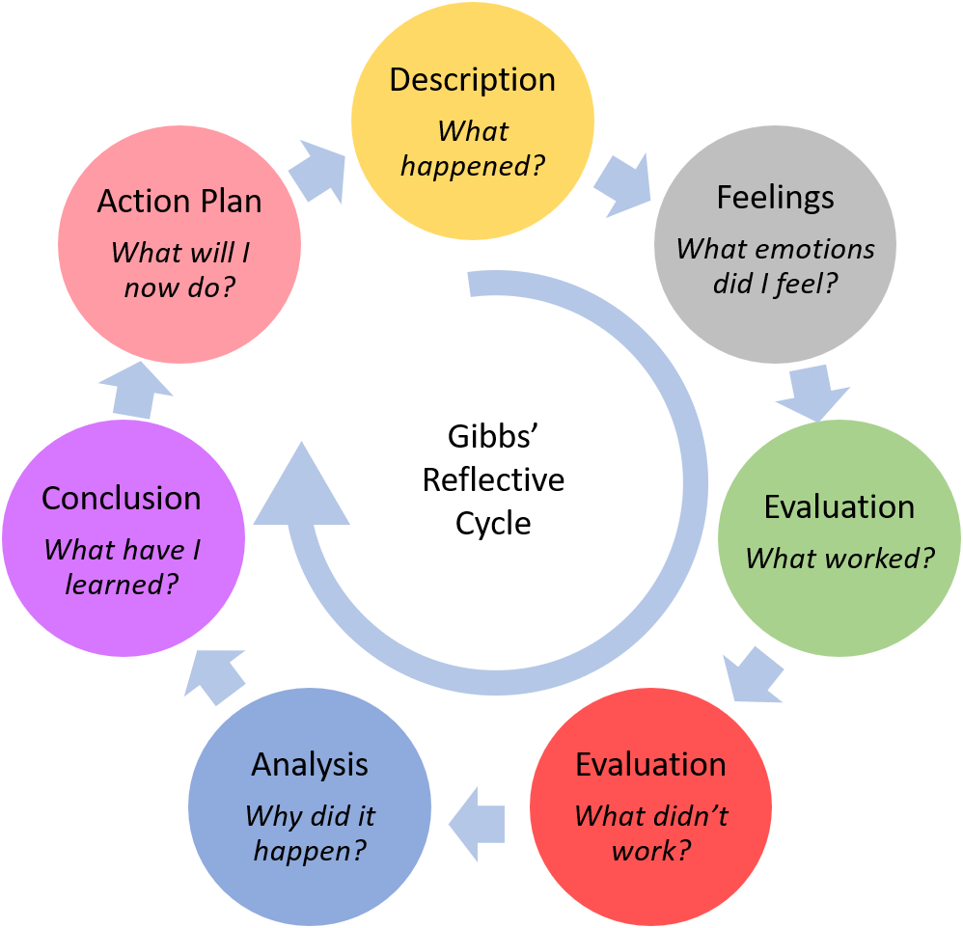
Figure: Gibbs Reflective model (Elsden, 2022)
Description:
I have experience working in the position of maintenance co-ordinator for a long time. The organizations have some problems, and they promote employees based on age, not performance. So, as I am not an aged person, there is no chance of my promotion. That's why I applied for the job. I want to be the workshop manager. As I have experience, I think I will be successful in this position.
Feelings
I am capable enough to perform the role of the workshop manager. But I am worried about my selection. I gave an interview, and the experience was good. Now I am eagerly waiting for the result. I will be very happy If I got selected.
Evaluation
I have had both good and bad experiences in my previous workshop position. As a manager, I have some skills which help to manage people. But I have some anger issues. Sometimes it’s hard to keep control and my facial expression reflects my anger. Besides, I think trusting people are my other weakness.
Analysis
In the evaluation stage, I have mentioned my weaknesses. I think I should improve these skills. I am consulting a psychiatrist to get control over my anger. Besides, I am trying to learn more about people, so that I can trust the right person. After improving these issues, it will be very easy to play the role of a workshop manager.
Conclusion
I have performed all the responsibilities in my previous job. I will try to give more effort if I get the opportunity in the organization. Lacking which hampered my work the previous time; I will try my best not to repeat them.
Action Plan
I am a quick learner. I will learn all the necessary things regarding the job within a concise time. As controlling anger is not an easy task, it cannot be overcome within a day. It is a long journey. I am determined to overcome my weaknesses. So, I will perform better in future.

Current Skills Applied to the job
For performing the role of a workshop manager, I must be able to control all the situations. The skills which I have applied in my previous job, and which will help to perform in my expected job position are described in brief.
Communication
Communication is an important skill that helps a manager to know about his organization and customer (Training, 2012). I did debate in my student life and engaged with a different organization. It helps me to develop my communication skills. The skill will help me to influence people. Customer perception regarding an organization can be known with the help of communication skills.
Experience regarding technology
In a workshop there are a lot of technologies are used. A manager needs to monitor, maintain, and sometimes operate them. As being good at technology, I will be able to perform my job properly. So, the technological experience will help me in performing my task.
Adaptability, flexibility, and time management
I can adapt to different situations. It will help me to deal with a problematic situation in the organization. Flexibility is my other strength. Besides, I am very careful about time management. It will facilitate me to complete my assigned task on time during my job period (Englehardt and Simmons, 2002).
Microsoft Office and computer software
I have a good influence over Microsoft office and computer software. As a manager, I have to record the performance of all the employees. Knowledge of Microsoft Excel is needed to do that. Sometimes, I have to present some plan, design, and idea. It cannot be possible to present without the help of Microsoft PowerPoint. Computer software activities are also important (Simon, 1987). So, these skills will facilitate me in performing the job.
Problem-solving and Human Resource management
I have good knowledge regarding managing people at work. While performing the duties of an assistant manager, I have experienced different situations which help me to enhance my problem-solving capability. I can apply this skill in my job.

The gap in skills that should be developed
My skills that should be developed to be a workshop manager are described.

Electrical and mechanical issues
I should be an expert in the sector of electric and mechanical issues. I know some factors regarding this field. But I think I should develop more to be an effective manager.
Negotiation skills
I need to develop my negotiation skills to deal with buyers from other organizations.
Quality and cost
Quality and cost management is an important responsibility of a manager (Lari and Asllani, 2013). Without ensuring quality, long-term success cannot be possible. So I need to know more about cost and quality issues
Brainstorming
A manager has to develop strategies for the organization. Sometimes, they need to decide in an emergency situation. These decisions can affect the whole organization. So, I should care about brainstorming to deal with this type of situation.
Leadership skills
Workshop managers should be good leaders (Daft, 2014). They monitor team activities and lead the planning process along with other managerial activities. I should develop my team collaboration skills. Besides, I should focus more on my leadership capability.
Anger and Trust Issue
I should be careful about my anger issues. Otherwise, it may impact negatively my performance (Friedman et al., 2004). Besides, I should be more careful while trusting anyone.
So, I think I should develop all the skills mentioned and make myself a charismatic workshop manager of the organization.

Systematic Approach to skill acquisition

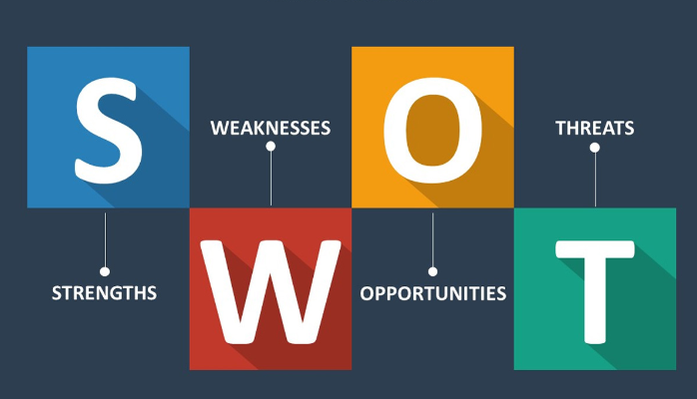
Figure: SWOT Analysis (Rangkuti, 2015)

After conducting my SWOT analysis, I found some of my skills should be developed. I also find out my strengths related to the performance of the job which I mentioned before in this report. Now I am going to describe my skills acquisition plan based on Dreyfus Model. It is a model which describes the way of acquiring skills and experiences in a systematic approach. The five stages of the Dreyfus model are described.
1. Novice: For developing my skills I will work hard. My first step is developing leadership skills more effectively. I will consult with an expert to know more about the skill.
2. Advanced beginner:
I have the capability of ensuring quality at the workplace. I will try to develop the quality in a more cost-efficient way than my competitors do.
3. Competent
After working on my lacking, I will be able to achieve negotiation, cost and quality, anger management, and leadership skills gradually.
4. Proficient
While working in the organization, I will try to apply all these skills. It will enhance my experiences.

5. Expert
After applying these skills frequently I will be able to understand all the problems. It will make me an expert in these skills.
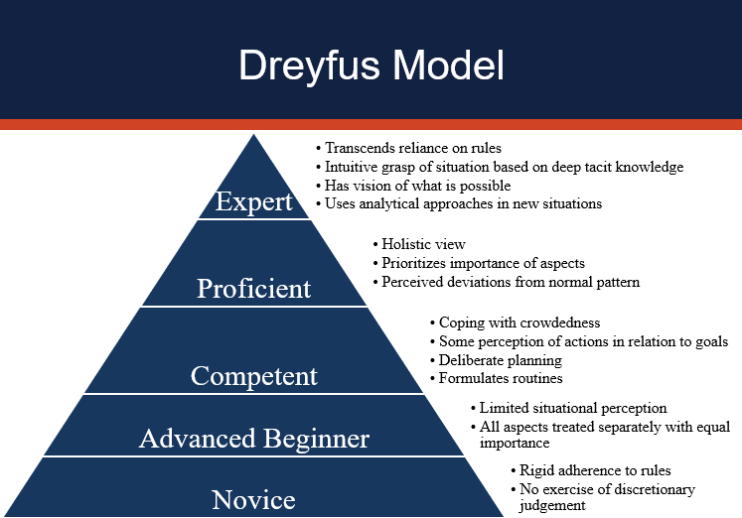
Figure: Dreyfus model of skill acquisition (Lyon, 2015)

Recruitment and selection
From my job interview, I have learned so many things. My interviewer asked me different types of questions regarding my skills, gap, previous job, and future career planning. I was so nervous at the time of the interview. After a long time, I faced VIVA Board. That's the reason for being nervous. My nervousness affected my way of answering questions. I could have replied with more confidence. I should be prepared myself for a better way to face such types of situations. The interviewer was very friendly. They do not show any negative attitude during the whole interview process. Their face was full of satisfaction. So I think they were satisfied with my answers. I forgot to tell you about my expectations regarding promotion issues when I left my previous job. The experience was good but I could have done better. So, I should practice more for further interviews. Besides, they took my written examination. I answered all the questions perfectly in the written examination. The interviewer asked me about my performance if I get the job. At first, I was confused. Then I tried my best to share my plans if I get the chance to play the role of a workshop manager. So the whole experience regarding the recruitment and selection process was quite good and informative.

Conclusions and Recommendations
Skill development is very important for a career. One should develop skills as much as possible in one's student life (Rosander et al., 2022). In professional life, these skills will work like stairs to success. Organizations should promote on the basis of performance besides seniority. I had so many lacking. I should have developed them before entering professional life. This report will help people to understand the process of skill development. SWOT analysis of people should be conducted before entering any job (Phadermrod et al., 2019). It will help them to find out their strength and weaknesses as well as opportunities and threat. One will be able to succeed in life if one ensures all the skills related to their role. In this report, I have described my career development plan with the help of Gibbs's reflective cycle. My development plan is also included in the paper. I will try to remove my skills gap. Besides, I will try to implement my current skills for the welfare of the organization.

References
Brown, N., (2022), March. Teaching reflective practice in teams: In-person and virtual activities. In (2022) IEEE Global Engineering Education Conference (EDUCON) (pp. 419-422). IEEE.
Campbell, D., (2008). Nonfinancial performance measures and promotion‐based incentives. Journal of Accounting Research, 46(2), pp.297-332.
Daft, R.L., (2014). The leadership experience. Cengage Learning.
Elsden, J., (2022). Using reflective practice for personal development planning. Dental Nursing, 18(2), pp.76-78.
Englehardt, C.S. and Simmons, P.R., (2002). Organizational flexibility for a changing world. Leadership & Organization Development Journal.
Friedman, R., Anderson, C., Brett, J., Olekalns, M., Goates, N. and Lisco, C.C., (2004). The positive and negative effects of anger on dispute resolution: evidence from electronically mediated disputes. Journal of Applied Psychology, 89(2), p.369.
Husebø, S.E., O'Regan, S. and Nestel, D., (2015). Reflective practice and its role in simulation. Clinical Simulation in Nursing, 11(8), pp.368-375.
Lari, A. and Asllani, A., (2013). Quality cost management support system: an effective tool for organisational performance improvement. Total Quality Management & Business Excellence, 24(3-4), pp.432-451.
Lyon, L.J., (2015). Development of teaching expertise viewed through the Dreyfus model of skill acquisition. Journal of the Scholarship of Teaching and Learning, pp.88-105.
Omoz-Oarhe, O.S., Yusuf, A.A. and Shaibu, H., (2022). THE EFFECT OF JOB SATISFACTION ON EMPLOYEES’PRODUCTIVITY. INTERNATIONAL JOURNAL OF MANAGEMENT, SOCIAL SCIENCES, PEACE AND CONFLICT STUDIES, 5(2).
Phadermrod, B., Crowder, R.M. and Wills, G.B., (2019). Importance-performance analysis based SWOT analysis. International journal of information management, 44, pp.194-203.
Rangkuti, F., (2015). Personal SWOT analysis. Gramedia Pustaka Utama.
Rosander, M., Forslund Frykedal, K., Barimani, M. and Berlin, A., (2022). Experiences from leading parental education groups: Perceived difficulties and rewards as an indication of skill acquisition. Journal of Child Health Care, 26(1), pp.68-81.
Training, M.T.D., (2012). Effective communication skills. Bookboon.

Appendix: Professional Career Development, (Related to the role play)
Interviewer
Good morning. Your Curriculum Vitae shows you have a good academic result. Why do you want to be a workshop manager?
Interviewee
Thank you, sir. I want to build my career in the administrative field. I am interested in a Management related job. So, I think this position will help me to know the application of management. It will enhance my experience regarding management. As there is a diversity of work it will be really exciting for me.
Interviewer
Tell me about your qualifications for what I should hire you for.
Interviewee
I have strong leadership power. I can easily influence people that will help me to play the role of a manager. My communication skill is good as I have engaged in different clubs in my student life. You mentioned my academic result too. So I have many skills in technical, conceptual and human resource management. I love to take on challenges and can work under pressure. These all things will make me able to play the role of a workshop manager properly.
Interviewer
That's good. If have you been selected for the job, what do you expect from this organization?
Interviewee
It will be a great pleasure if I get the chance to be a part of this organization. I expect a favourable work environment with cooperative colleagues. Besides, I expect recognition as motivation for my performance.
Interviewer
You shared your skills and other positive things about yourself. Not let me know about your weaknesses.
Interviewee
I trust people easily. I am very emotional and cannot hurt people. I think these are my weaknesses.
Interviewer
How the position of this job is related to your career in future?
Interviewee
As a manager, I have to perform some activities. These are managing people, establishing policies, managing stock, operating equipment and technologies, maintaining technologies and so on. All the activities will enhance my knowledge and expertise regarding technology, operational management, and human resource management. It will help me to develop my career in these fields.

Job application form

Application for [Workshop Manager]

Your details

Name: Cezar Stroescu

Education and training

College Doctor Constantin Angelescu, Buzau, Romania
University of Wales Trinity Saint David, London

Qualifications
- Engineering Diploma
- Certificate of higher education in skills for the workplace
- Microsoft Office and computer software

Employment history

Current or most recent employer

Name of employer: Mobility Giant

Job title: Maintenance co-ordinator

Length of time with employer: 2015- 2022

Reason for leaving: Searching for a better opportunity

Duties:
- Stock taking, offering guidance to the drivers and problem solving.
- Recording sales, purchase and storage of the products.
- Setting all the schedules of the organization.
- Maintained staff-related activities.
- Managed the department's budget.
- Worked as a helping hand of the Manager of the organization.
- Forklift operator, loan and unload products from shelfs.

Previous employers
Two years as a packer in Romania, chef and in the sales team for a fast food in London, delivery driver, packer tea blender for tea merchandise, and last but not least engineer, van driver, maintenance co-ordinator.

Supporting statement

In my previous job, there was little scope for promotion. I want to implement my knowledge and experience in a wide range of. I have all the capabilities you mentioned for the job. If I get a chance to play the role of workshop manager, I would be successful in this position. I will try to contribute my best for the improvement and advancement of the organisation.

Right to work in the UK
No, the work permit is not needed.

References
Please give the names and contact details of 2 people who we can ask to give you a reference. We may ask them before an employment offer is made. We will not ask your current employer until we get your permission.

Declaration
I confirm that to the best of my knowledge the information I have provided on this form is correct and I accept that providing deliberately false information could result in my dismissal.

Name: Cezar Stroescu

Signature: Cezar

Date: 05/12/2022

Job Description

Responsible for job allocation and job flow in the workshop including job scheduling and labour allocation for day-to-day operations. within area of responsibility, company-owned plant and machineries including heavy equipment management
- Manage maintenance and repairs in and out of the workshop
- Undertake all levels of servicing, maintenance and repairs of all eath moving equipments, trucks, vans and mobile plant
- Capable of following the repair process from fault analysis to completion as well as supervising and guiding others
- Manage small mobile team of mechanics incl. safety, performance and conformance monitoring
- Prioritise and delegate work within the team
- Manage and control the stock of supplies and order
- Carry out general maintenance and repairs across the site
- Ensure paperwork is complete and accurate
- Use variety of specialist equipment and tools
- Liaise with site management with regards to required repairs and part ordering
- Liaise with suppliers, source parts and compare prices
- Administrative duties – internal systems, inspections, servicing, etc

Job Desired Skills

- Must be personable with strong communication skills
- Strategic from a business development point of view but also when it comes to reviewing performance
- Previous management experience; people, finance and relationship management
- Ability to interpret targets and data will be required. This could also include having an understanding of package review, payroll, reporting and cost processes
- Confidence with overseeing training and performance appraisals
- Conversant with computer software programmes, including word and excel

PERSONAL INFORMATION | Cezar Stroescu
 | 07841623452
 | E-mail address cezar.stroescu@yahoo.com

WORK EXPERIENCE

APRIL 2017 – PRESENT MOBILITY GIANT LIMITED
Engineer, van driver, maintenance
Co-ordinator MOBILITY GIANT, SEVENOAKS, VESTRY ESTATE, UNIT 5, KENT, TN1 45DF

- Servicing, testing, repairing, painting mobility scooters
- Deliver mobility products and engage with customers across the UK
- 6 months trial as workshop manager, offering training to new staff
- Stock taking, keeping track of parts needed
- Maintenance co-ordinator, offering guidance to drivers and problem solving
- Forklift operator, load and unload products from/off the shelfs

APRIL 2016 – PRESENT SHS PIZZA LTD , DOMINOS TONBRIDGE
Delivery driver
20 HIGH STREET TONBRIDGE KENT TN91EJ

- Deliver a wide variety of items to different addresses and through different routes
- Follow routes and time schedule
- Load, unload, prepare , inspect and operate a delivery vehicle
- Ask for feedback on provided services and resolve clients’ complaints
- Collect payments
- Inform customers about new products and services
- Complete logs and reports
- Follow DOT regulations and safety standards

APRIL 2016 - APRIL 2017 TEA MERCHANTS AND BROKERS
Packer, tea blender
UNIT 12 TANNERY RD INDUSTRIAL ESTATE TONBRIDGE KENT TN91RF

- Handling whole sacks of imported tea
- Mixing / blending different types of tea with chemical flavours
- Recognizing products and batches
- Operating machinery
- Focus on food hygiene
- Completing packing tasks as directed by supervisor / management
- Palletization of finished products

December 2015 – March 2016 VARIOUS SAMS STORES
Chef, sales team SAMS CHICKEN 47 HIGH RD WILLESDEN GREEN NW102TE LONDON

- Take food and drink orders and receive payment from customers
- Cook, pack batches of food, such as hamburgers and fried chicken
- Clean, stock, and restock workstations and display cases
- Measure ingredients required for specific food items being prepared
- Wash, cut, and prepare foods designated for cooking
- Verify that prepared food meets requirements for quality and quantity
- Operate large-volume cooking equipment such as grills, deep-fat fryers, or griddles
- Clean food preparation areas, cooking surfaces, and utensils

April 2013 – September 2015
Farmer

march 2011 – March
2013
PACKER

S. C. Bioland GmbH, Im Kirchfeld Street, Bad Nauheim / Wisselsheim City, Postcode 61231, Germany.

- Practical activities operating tractors, ploughing fields, sowing seeds.
- Maintaining knowledge of pests and diseases and an understanding of how they spread and how to treat them.
- Protecting the environment and maintaining biodiversity.
- Making sure that products are ready for deadlines, such as markets
- Ensuring that farm activities comply with government regulations.
- Arranging the maintenance and repair of farm buildings machinery and equipment.
- Laying and trimming hedges.
- Digging and maintaining ditches.
- Putting up and mending fences.
- Working with animals - such as feeding, cleaning caring for sick or new-born
S.C. ALISON HAYES Romania S.R.L., Industries Alley Street, No. 17, Buzau City, Postcode 120224, Romania.

- Follow all tasks requested by the management.
- Skill in handling packaging machines.
- Packaging in accordance with the quality standards set.
- Keeping products under optimal conditions during their handling.
- Operations on schedule.
- Assemble, line, and pad cartons, crates, and containers, using hand tools.
- Mark, label and count products and materials.
- Load materials and products into package processing equipment.
- Transport packages to customers vehicles.

FEBRUARY 2022- UNIVERITY OF WALES TRINITY SAINT DAVID, LONDON
FEBRUARY 2023D CERTIFICATE OF HIGHER EDUCATION FOR THE WORKPLACE:
BUSINESS AND MANAGEMENT

September 2005-June 2009 | High School  Agricultural College Doctor Constantin Angelescu, Buzau City, Romania
September 2005-June 2009 | Domain-Mechanic.  Professional Qualification-Auto Mechanic.  -Communication and numeracy, Use of computer and information processing, Communication in foreign language, Personal development in order to obtain performance, Hygiene and safety, Teamwork, Quality assurance, technical documentation, Maintenance systems, Using engine fluids, Determining and measuring the wear, Mechanical assembly of vehicle, Exploitation of electrical installations of the means of transport, Management car, Construction and functioning of car, Maintenance and repair car.

PERSONAL SKILLS

Mother tongue(s) | Romanian
Other language(s) | UNDERSTANDING |  | SPEAKING |  | WRITING
Other language(s) | Listening | Reading | Spoken interaction | Spoken production
English | C1 | C1 | B2 | B2 | B2
Levels: A1/2: Basic user - B1/2: Independent user - C1/2 Proficient user
Common European Framework of Reference for Languages

Communication skills | Good communication skills gained through my experience and studying at the University

Organisational / managerial skills | - Handles details, punctual, meets deadlines, team leader

Job-related skills | - Skill in handling machines.  - Able to work unsupervised.  - Patient, reliable and punctual worker.  - Attention to detail.  - Forklift licence

Computer skills | - Good command of Microsoft Office™ tools.  - Advanced knowledge of PC/Laptop

Other skills | - Creative thinking and problem solving.  - Developed sense of observation.  - Listen attentively.  - Positive attitude and fast learner.  - Decision making, critical thinking, organizing and planning.  - Desire for professional development.

Driving licence | - Category B, from July 2012.

Job Description

Responsible for job allocation and job flow in the workshop including job scheduling and labour allocation for day-to-day operations. within area of responsibility, company-owned plant and machineries including heavy equipment management
- Manage maintenance and repairs in and out of the workshop
- Undertake all levels of servicing, maintenance and repairs of all eath moving equipments, trucks, vans and mobile plant
- Capable of following the repair process from fault analysis to completion as well as supervising and guiding others
- Manage small mobile team of mechanics incl. safety, performance and conformance monitoring
- Prioritise and delegate work within the team
- Manage and control the stock of supplies and order
- Carry out general maintenance and repairs across the site
- Ensure paperwork is complete and accurate
- Use variety of specialist equipment and tools
- Liaise with site management with regards to required repairs and part ordering
- Liaise with suppliers, source parts and compare prices
- Administrative duties – internal systems, inspections, servicing, etc

Job Desired Skills

- Must be personable with strong communication skills
- Strategic from a business development point of view but also when it comes to reviewing performance
- Previous management experience; people, finance and relationship management
- Ability to interpret targets and data will be required. This could also include having an understanding of package review, payroll, reporting and cost processes
- Confidence with overseeing training and performance appraisals
- Conversant with computer software programmes, including word and excel

