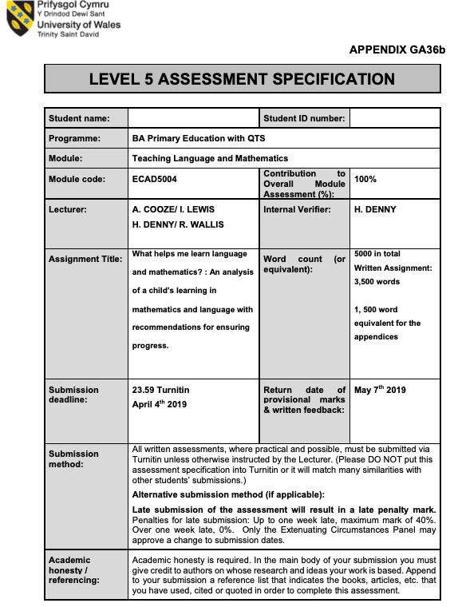
Nicholas Thomas 1702851
What helps me learn language and mathematics? : An analysis of a child’s learning in mathematics and language with recommendations for ensuring progress.
In this assignment there will be an analysis of the work produced by a pupil from one class from a second placement of a BA Primary education with QTS course. It will include analysis of both numeracy and literacy work, linking the pupils learning to theories to further understand how the pupil is developing. There will be reference to brief interviews undertaken with the pupil, where we discussed their perspective on their learning including difficulties, strengths and personal preferences. Following the analysis of the pupils learning there will be suggestions for further improvement of the pupils skills following theories and best practices given by reputable sources.
The focus of my writing and analysis is a 9 year old boy of Asian parents in year 4 of a small village school in South Wales here forth referred to as ‘J’. This pupil is of average attainment overall, who is placed in the upper middle group in the class. The decision to choose this pupil was based on the interesting learning characteristics he displayed.
I gathered the information through pictures and discussions of work with the pupil, the pupil was happy to answer but was reassured that everything gathered and discussed was completely voluntary and he could change his mind at any time. I conducted mostly quick interviews discussing work that the pupil was undertaking, this was done during the lesson and with the pupils whole work group. Although the whole group was included in the discussion only the answers ‘J’ provided were recorded for this analysis. ‘J’ was shown the notes taken and was reminded again that his participation was voluntary and I can dispose of his data if he so wished. I did collect some samples of work but this was limited for two reasons; firstly ethically the school wished that the pupil was involved in the photo taking and that it was done on a class iPad, this iPad was old and the camera was of poor quality. Secondly, there was marking issues as the school I attended administered a verbal feedback policy where the class teacher gave feedback verbally to an individual or group whichever was most appropriate. This was primarily to limit the feedback given in written for in the pupils books, as the school believed that pupils responded better to verbal feedback. All of the data gathered loosely followed the Mosaic Approach as I conducted interviews with the learner and engaged the learner in taking photos which enabled the learner to become part of their learning. This will mirror Prof. Donaldsons (2015) aims for a learner in the updated curriculum by building an enjoyment of learning they will become ambitious, capable learners who are ready to learn throughout their lives
The Evidence i collected on ‘J’s’ written work was poor, he very rarely produced much writing during lessons simply writing the answers following the question number and as such there was very little to analyse, issues discussed later also played into this. ‘J’ was also hesitant to take pictures of his work if he perceived he did poorly.

‘J’ was very good at mental maths. He displayed good recall of number bonds and would be able to quickly answer mathematical calculations in class if called upon. He was personally very confident in mathematics but lacked the self confidence to raise his hand quickly and answer a question in front of others unless prompted.
‘J’s’ parents own a restaurant, this could possibly be the reason behind his and his parents particular mathematical outlook. Through an interview with the class teacher [Appendix 1] I discovered that the family put a lot of significance on mathematics especially mental mathematics. ‘J’ would often spend time in the restaurant and his parents would question him on his mental mathematics by asking him to calculate prices and totals of food orders and sometimes recalling order numbers.This is a common belief held by many Asian families (Stigler, J. W.,1984). As an assumed result of this ‘J’ displayed very good number recall, with particular ability recalling his times tables. He displayed a very good ability to quickly add and subtract numbers. The pupil was average at calculations that included multiplication although he was very good at his times tables this was not always helpful as he began to confuse numbers with each other and would sometimes multiply by the incorrect number as an example. This also carried into division that consisted of multiple steps he would again confuse numbers up and divide by the incorrect number or carry the wrong number forward. ‘J’ also struggled struggled with non-decimal(base 10) number systems such as time (base 60) this was displayed in many of the time based numeracy lessons in particular the time interval lesson.

He was extremely hesitant to write his calculations down and insisted on doing sums completely in his head, this was often a issue as he made mistakes that were hard to correct as there was no way to understand where he had gone wrong without a written step by step process that the teacher could quickly scan for issues [Appendix 4]. Numerous times ‘J’ had the answer incorrect and the class teacher needed to then encourage ‘J’ to attempt the task again but also ensuring that he wrote the process down. ‘J’ was uncomfortable in using long written mathematical processes and reported in the interviews that he liked to do it in his head and that he felt he should learn to do it in his head (Appendix 2). This belief is not without merit John Threlfall (2002) notes four key benefits to mental calculations; insight into number sense, increased problem solving skills, promotion of written calculations later, and better preparation for adult life as most calculations are done mentally. Although there is many benefits to completing calculations mentally Sweller’s (1988) theory of cognitive load suggests that both adults and children have a differing cognitive load when mentally processing, this theory also suggests that increasing the cognitive load beyond this point will greatly increase risk of error (Mousavi, S. & Low, R. & Sweller, J., 1995). This cognitive load theory would explain the increase in errors in ‘J’s’ work at certain points and explain that although his belief that mental calculations is superior he must remain cautious not to overload his abilities. Ensuring that ‘J’ would record his calculations was difficult as the pupil would often say ‘but I just know that it’s…’ and they could not see that the knowledge that, for example ‘5 + 5 = 10’ is learned and is a step in a mathematical process and therefore a valid part of the calculation. There was often need to remind all pupils in the class that they should also write things they know about numbers down in the calculations e.g. ‘10+10+10= 30, because I know that 3x10=30’.A guidance publication by the Department for Education and Skills (2010) on promoting mental calculations states that although mental calculations are important it is necessary to aid the mental calculations with note taking and jottings. This pairing of notes and mental calculations aids in improving the complexity of the calculations undertaken mentally. This would also help the practitioner guide the pupils on the mistakes they have make.

During a lesson on time ‘J’ struggled with consistently calculating correctly as there was issues with the ‘base 60’ format of time as opposed to ‘base 10 that is our main counting method and the one used with our currency. Whilst calculating time intervals ‘J’ would often revert back to using a ‘base 10’ system that would alter his answers. Ryan, J. & Williams, J. (2007) write that children often confuse time and standard decimal number systems often calculating minutes as 100 seconds or assuming 50 minutes is half an hour. ‘J’ had so much contact with calculations that involved currency (base 10) he showed difficulty adapting to the time calculations that involved base 60. He would sometimes mistake 1 hour as 100 minutes and 1 minute as 100 seconds whilst attempting to undertake the calculation mentally. This problem was reduced by ensuring that ‘J’ wrote out number lines that were in base 60 and followed a simple written method [Appendix 5].
The class as a whole showed great ability with mathematics with a large portion of the class working at the higher end of the outcomes for the age group. The groups the middle two groups were far closer to the abilities of the highest group than they were to the bottom. This means that although ‘J’ was in the higher of the middle groups he would be able to complete the activities given to the top group on most days as were many others. He was showed great ability in numeracy and hopefully with continued progress and targeted improvements he will excel.

Similarly to mathematics ‘J’ was very self conscious with his ability. He comes from a home where Chinese is the main language and all communication in the home is through Chinese. This form of bilingualism is called immersion bilingualism as the learner is immersed inside an education system that focuses on one language in this case english whilst the primary language spoken at home and by immediate family is different (Cummins, 2009). Both his spoken and written language was adequate and he found himself again in the middle of the groups. He did unfortunately have a slight accent and often mispronounced some sounds which would then impact his confidence in speaking. Eckman, F. R. (1995) acknowledges the difficulty of learning languages this way. He writes that it is extremely difficult to become proficient in two languages and there will always be a weaker language. The weaker language will often be the language the speaker is least confident in and the one that is spoken the least. This lack of confidence in himself caused ‘J’ to avoid speaking out loud and would also refrain from answering the simplest of questions if it required him speaking in front of others. This was reflected in his writing having limited confidence in his ability meant that ‘J’ would write the bare minimum that was required of him. He would choose the simplest option regularly and would very rarely push or extend himself in his literacy skills. His fear of failure limited his growth as he wished to remain inside his comfort area where he was confident in his ability. This lack of confidence is a large issue for learners as under confidence in oneself and feeling uncomfortable in the learning environment is a huge detriment to learning. (Maslow, 1954)
He did have difficulty with his spelling, he struggles with sounding out words in an attempt to spell them. The difficulty is due to Chinese being the main language he hears unless he is at school, this withholds ‘J’ the experience of regularly hearing correct pronunciations and phonics. Even at school ‘J’s’ social interaction was limited. He often chose to play on his own or with very small groups [Appendix 3] . If he did join in he was again mostly silent and very rarely did he have extended conversations with his peers. He would though, have conversations with adults at the school.
Bruner (1983) expanded on the word done by Vygotsky (1934) on the zone of proximal development and social interaction being the driving force behind learning by adopting the theory for language acquisition. Gallaway, C. & Richard, B.J. (1994) have researched into the theory of differential acquisition by result of social interaction, finding that social interaction has notable effects on the attainment and acquisition of language. This research displays the importance of peer interaction on language attainment, and having limited interaction with his peers ‘J’ would exemplify these results.
There was one instance of anecdotal evidence of ‘J’s’ lack of confidence in his language skills, where he practiced a ‘show and tell’ presentation with me before doing it in front of the class. During play time he asked and then proceeded to talk at length about his watch and some of its features. He spoke well with very few if any pronunciation mistakes, he seemed comfortable talking which was rare for him. Following the practice he stood in front of the class and spoke, although there was long pauses and some confusion with what to say next his language and pronunciation was good. Klippel (1984) advises in his publication on language activities, that role play and simulations are effective tools to use in language acquisition and will aid the learner in feeling confident in what they intend to say having practised it. ‘J’ unknowingly used this technique to help his confidence when speaking.
‘J’s’ handwriting was good quality, he wrote in cursive and followed most of the key writing criterion [Appendix 6] . He was also knowledgable in his use of punctuation, he understood the placement of the main punctuation (full stop, question mark, exclamation mark) and the reasons why they are placed there when questioned on them. His use of wider punctuation was mostly accurate but very limited, he again would restrict himself to using only punctuation he was sure was correct. He would focus on only writing small amounts where he was sure he could apply punctuation correctly and he would avoid the use of commas almost completely. ‘J’s’ skills in language and literacy were a decent standard and would have placed him at the correct outcome for his age and year group, and following interviewing the class teacher for more insight [Appendix 3], he was more than happy with ‘J’s’ level and ability but noted that he wished he would write more and that he believed in himself enough to attempt more complex writing.

To work on ‘J’s’ mathematics progression I will examine two areas and how I can support the learner in developing their attitude, skills and knowledge. Following this ASK model I will further support the learners future development. These mathematical areas will be to limit cognitive load and promote mental calculations with the use of aids and note taking. Firstly we will look at his attitude towards numeracy and as noted above he personally feels very confident in his mathematical ability. He enjoys mathematics and sees the skills he learns as important and purposeful. He does however feel the need to perform mental calculations that sometimes hinders his ability in complex calculations. This is not necessarily a negative attitude, although he is sometimes hindered he is unknowingly preparing himself for future success (Threlfall, 2002; Sweller, 1988) . Therefore his attitude will not need any instruction other than the practitioner developing the learners memory skills and giving ‘J’ the mathematical skills to continue with his mental calculation. In his book on ‘Understanding and teaching primary mathematics’ Tony Cotton (2010) notes that there has been debate on how much a pupil should be expected to memorise. He suggests that the possession of a quick recollection of number facts aids in the creation on new number facts. His advice for a practitioner would be to regularly call upon these facts to solidify memory. For further development he suggests slowly introducing new number facts over time, ensuring that the pupil receives the opportunity to memorise the fact before building further limiting the cognitive load on the learner. In the English ‘Primary Framework for literacy and mathematics’ (DfES 2006) there is emphasis placed on the teaching of mental mathematics stating that “It is crucial that mental methods of calculation are taught to children and not confined to starter activities in lessons”(DfES, 2006:68).
Alongside improving his mental recall Cotton (2010) advises that we allow learners to create their own systems for mentally calculating as children sometimes adopt counting systems that are unknown or unfamiliar to the teacher but are effective. To ensure we are remaining to limit the cognitive load it is advised to promote and encourage note taking and ‘jottings’ while mentally calculating to reduce the amount of numbers needed to be recalled and as a result improving the mental capabilities of the learner DfES (2010).Jill Russell (2013) writes that an additional aid to mental calculations and memory is telling number stories with numbers representing amounts of items in the story.This technique will also tie into the note taking aspect as ‘J’ may be willing to draw images and the story rather than the normal written calculations. Following these suggestions may be a method to ensuring further progress in ‘J’ but this cannot be guaranteed as all learners are different and what may work for some may not work for ‘J’. We cannot be certain that although these suggestions come from reputable sources they will be a perfect fit for the learner and more changes may be needed.

To continue the development of ‘J’s’ language skills we will again look to support him using the ASK model. Using this model we will focus on strengthening his attitude, skills and knowledge of language and literacy. The largest focus on the future development of this learner is confidence and attitude towards his own ability. His lack of confidence has been the largest limiting factor in his learning and a facet of his own resistance to push himself. As a teaching team working on improving ‘J’s’ confidence will greatly improve all other aspects of his attainment of language and as such must be the goal of the next stage of his development. In Vygotsky’s Thinking and Speech (1934) he writes that thought to word is not always realised relying on the crossing of many planes from where it begins at the motivation to the actuation of the word. What we may take from that is that learners must subconsciously and consciously want and intend to learn before they even begin to create thought. They must see a necessity for the learning that they are undertaking. This way of thinking around motivation and attitude may explain ‘J’s’ unwillingness to develop himself. He may see no reason to improve his English as Chinese is the language he interacts in primarily. To counter this we may need to promote and encourage an increase in ‘J’s’ social interaction inside and outside the classroom. Mahn & John-Steiner (2002) suggests that creative collaboration and mutual appropriation are important to the learning of language for students and the shared workload also shares the risk and criticism, creating a safety zone. They call this ‘The gift of confidence’. ‘J’s’ difficulties with pronunciation and spelling may be elevated by working collaboratively with another learner or a group, his abilities in understanding punctuation may then aid another learner. Isaac Gaines pf the University of Oregon (2015) corroborates these suggestions asserting that poor integration into immersion environments can lead to poor language development, and as such students must be engaged in structured collaborative activities. These activities will scaffold the learner giving them opportunities to; practice pronunciation, role-play, simulate and be immersed in informal language. Gaines’s research showed that the scaffolding collaborative activities improved students confidence and increased the use of English outside of the classroom, which would possibly be of huge benefit to ‘J’.

Mahn (1998) Suggests a different solution to confidence issues is English second language learning. Mahn gave students journals where they were asked to write in English a few sentences on any topic ‘risk free’ these journals were not read or marked. The students were instructed to focus on communication and not about mistakes. Mahn notes this ‘risk free’ writing improved the students confidence and this confidence carried over into other writing ultimately improving language ability overall. It may be possible to include free writing journals into the classroom, the students are already encouraged to write into learning journals. If a page or section of these learning journals where dedicated to ‘risk free writing’ this may improve all students writing including building the confidence of ‘J’.
Following the guidance and suggestions of researchers and leading theorists in the learning of languages and Mathematics mentioned above will possibly ensure the future progress of the learner, but as with all areas of learning there is no one size fits all approach to development and learning. The methods and techniques are not guaranteed to provide success and must be trialed and reevaluated with input from the learner to ensure positive outcomes.

Word count 3,360

References-

Bruner, J. (1983). Child's Talk: Learning to Use Language Oxford: Oxford University Press

Cotton, T. (2010) Understanding and teaching primary mathematics.

Cummins, J. (2009). Bilingual and Immersion Programs. The Handbook of Language Teaching. Malden, MA: Wiley-Blackwell.

Department for Education and Skills DfES (2010) Teaching children to calculate mentally, crown publishing

Department for Education and Skills DfES (2006) Primary Framework for literacy and mathematics, Crown publishing

Donaldson, G. (2015). Successful Futures: Independent review of curriculum and assessment arrangements in Wales. Caerdydd: Llywodraeth Cenedlaethol Cymru.

Eckman, F. R. (1995). Second language acquisition : theory and pedagogy.

Gaines, I. (2015) ‘Increasing Confidence and English Use Outside the ESL/IEP Classroom for Lower-Level Learners’. University of Oregon ORTESOL Journal, Volume 32, p. 56-67.

Gallaway, C. and Richard, B.J. (1994) Input and Interaction in Language Acquisition, Cambridge University Press, UK.

Klippel, F. (1984). Keep talking: communicative fluency activities for language teaching. Cambridge, Cambridge University Press.

Mahn, H. (1998) Dialogue journals: Perspectives of second language learners in a Vygotskian theoretical framework.

Mahn, H. and John-Steiner, V. (2002). The gift of confidence: A Vygotskian view of emotions. Learning for life in the 21st century.

Mahn, H. and Reierson, S. (2012). Research Methods and Sociocultural Approaches in Second Language Acquisition. The Encyclopedia of Applied Linguistics.

Maslow, A. (1954) Motivation and personality. Harper and brothers.

Mousavi, S. and Low, R. and Sweller, J. (1995). Reducing cognitive load by mixing auditory and visual presentation modes. Journal of Educational Psychology.

Russell, J. (2003) ‘Interactive pictures’ in Mathematics Teaching 182. March 2003, available online at http://www.atm.org.uk/mt/archive/mt182files/ATM-MT182-28- 29.pdf. [Accessed on 28/03/19]

Ryan, J. and Williams, J. (2007) Children's Mathematics 4-15 Learning from Errors and Misconceptions.

Stigler, J. W. (1984). "Mental abacus": The effect of abacus training on Chinese children's mental calculation. Cognitive Psychology, 16(2), 145-176.

Sweller, J. (1988). Cognitive load during problem solving: Effects on learning.

Threlfall, J. (2002) Educational Studies in Mathematics, Vol. 50 Issue 1, p29-47

Vygotsky, L, S. (1934) Thinking and speech. Translated MIT press 1962.

APPENDIX

Appendix 1
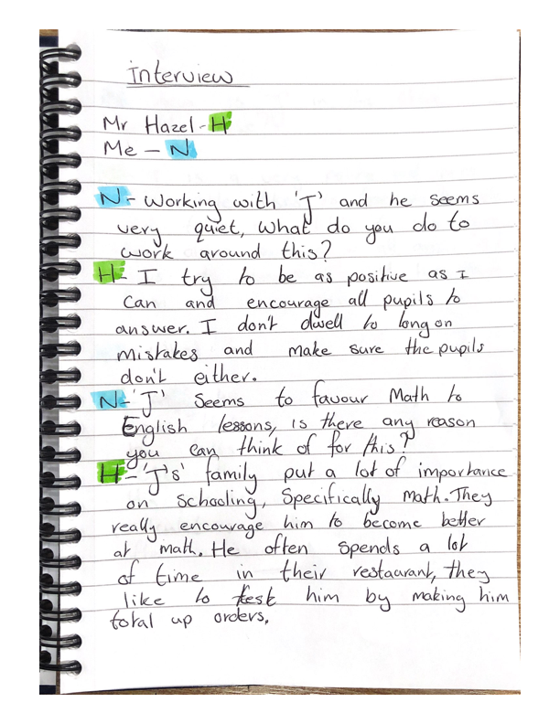
Interview with class teacher.

Appendix 2
Interview with pupil
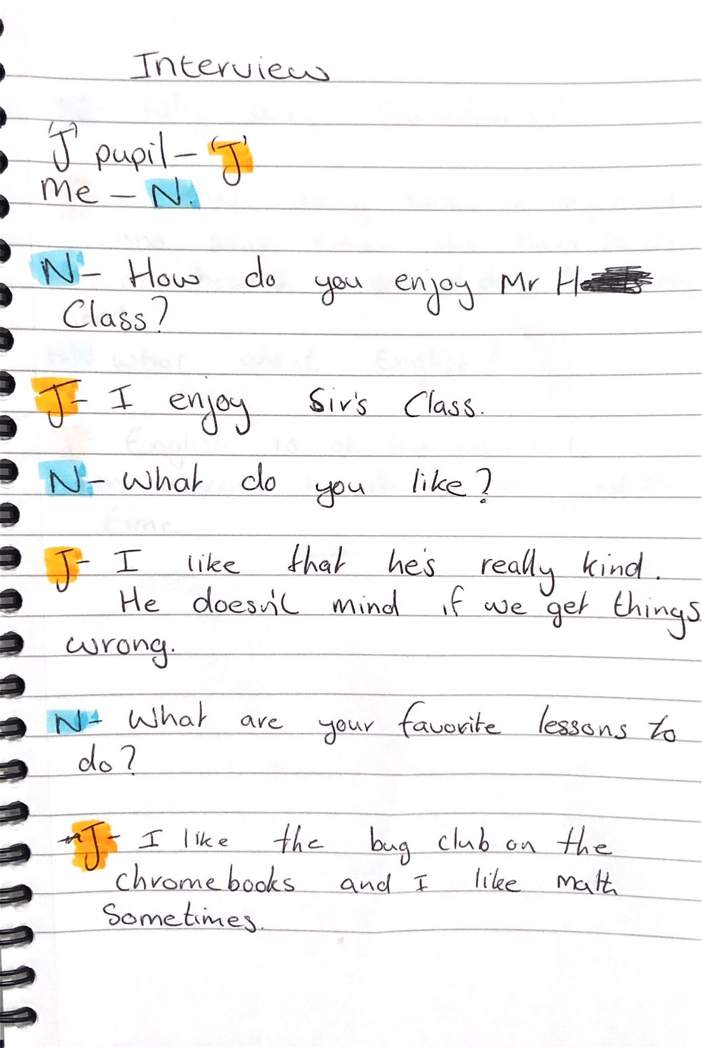
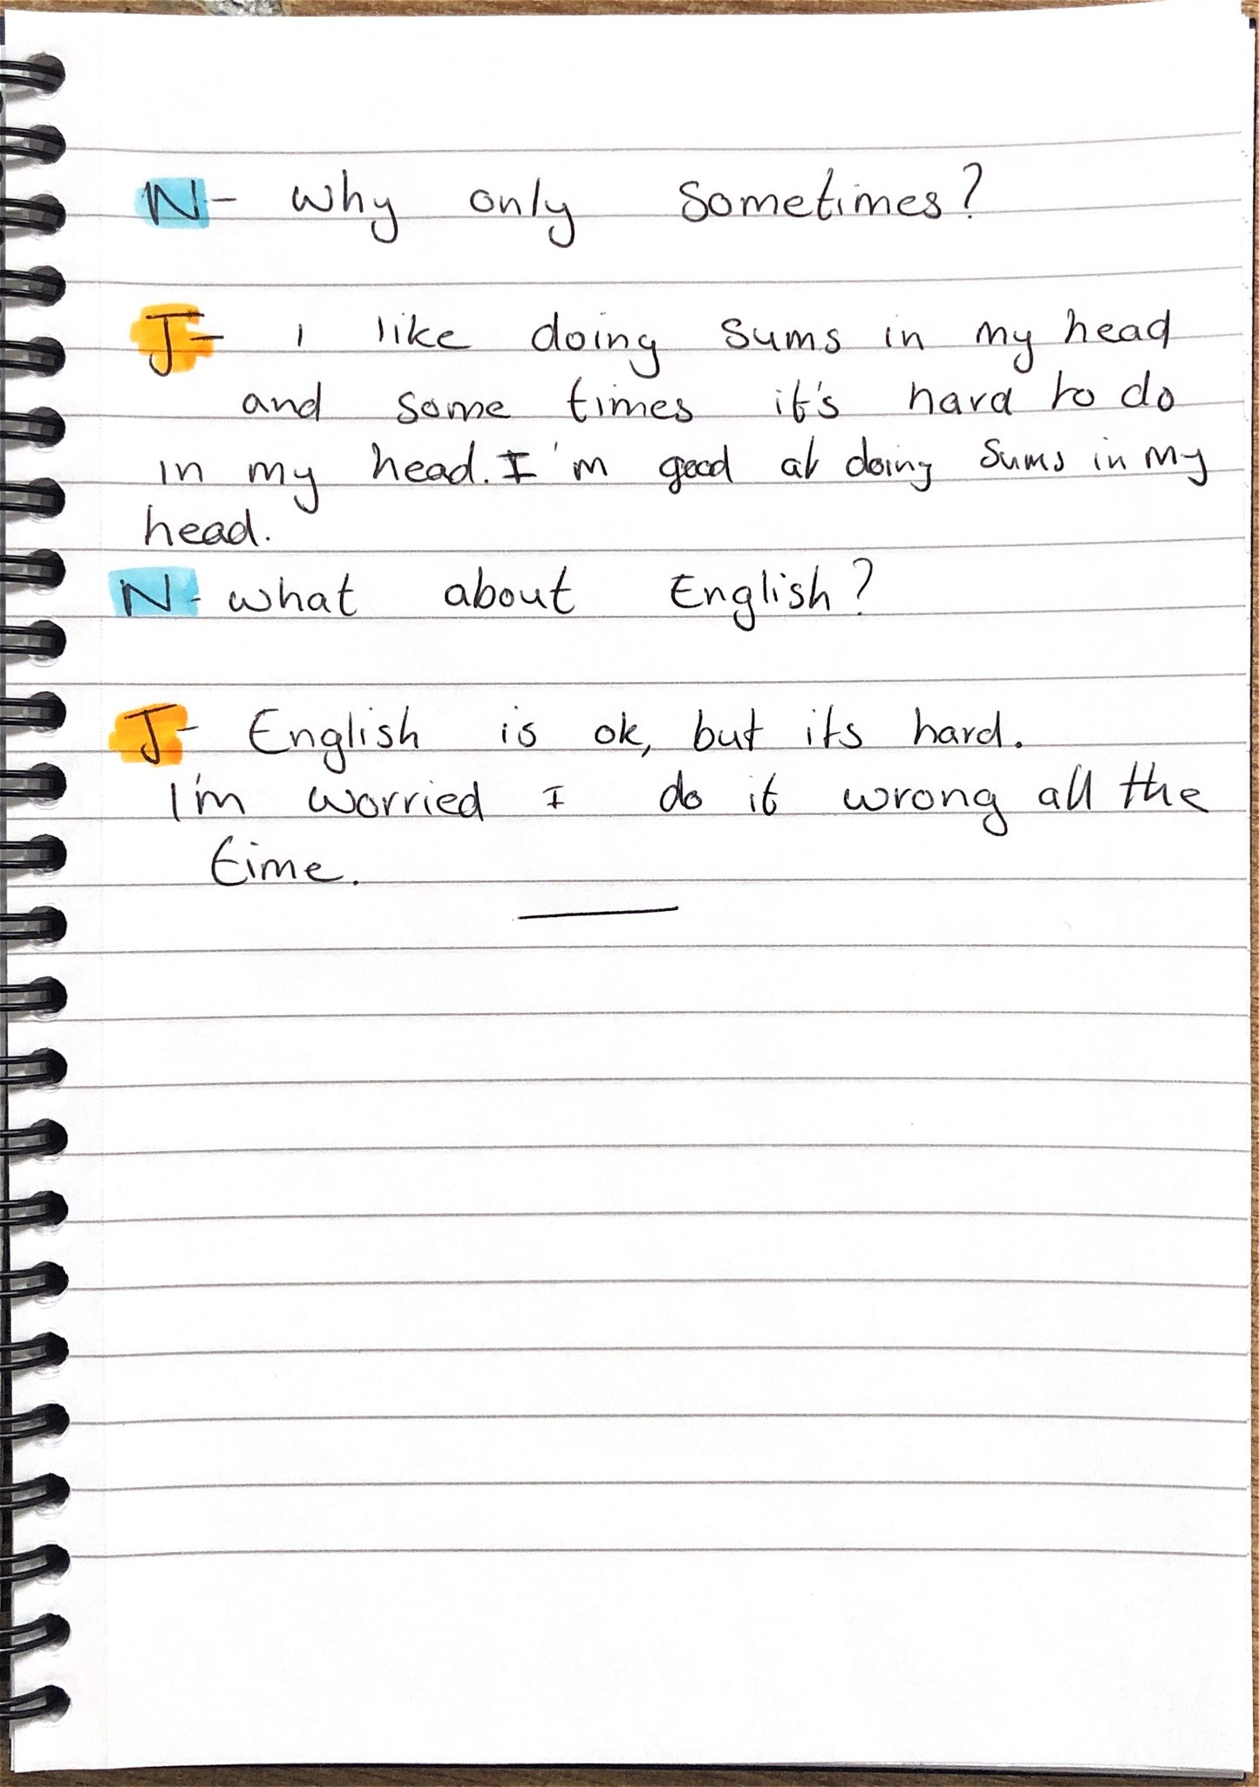

Appendix 3
Interview with teacher 2
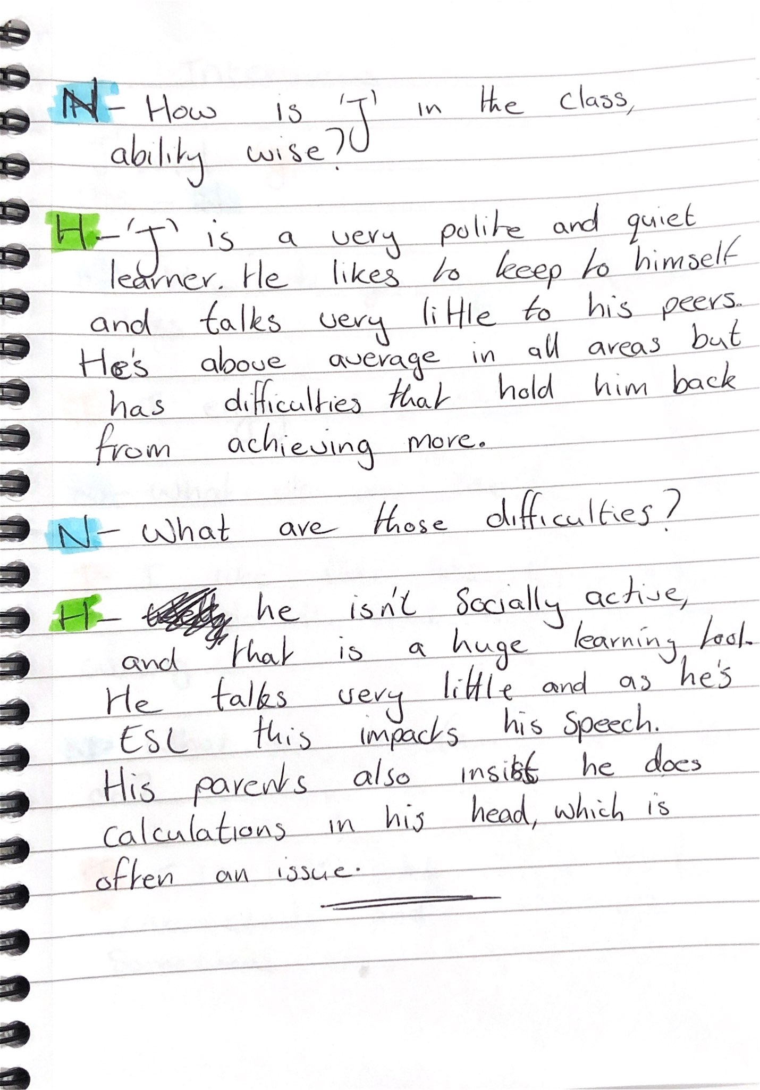

Appendix 4
Mathematics work example.

Appendix 5
Example written method.

Appendix 6
Example of writing.



