Strategic Management for SMEs: Academic Report

Razvan Aurelian Huminic 1915413
Module code: BMSW 6104
Lecturer: Dr Richmond Lamptey

Executive Summary
Through effective organizational structure and the manager of the company with the most impressive thoughts may be able to accomplish organizational goals easily. They both are considered as two sides of the same coin because effective leadership or managerial style glances into the upcoming time and on the other hand, management of the company performs in the present regarding the achievement of their objective. While management of the company comprises concentrates on planning, directing, organizing, staffing, etc and leadership of the organization mainly comprises teamwork within the firm, inspiring, inducing, and motivating the employees by the leaders or managers of the company towards the accomplishment of organizational growth and objectives. Therefore, it put attention on the strategic decisions that must adapt by the manager of the organization like MOMA Foods' main aim is generally considered to become the head of the pack when it comes to great and healthy breakfast options for the consumers. It also gives a brief explanation of internal as well external stakeholders of MOMA Foods such as the Company giving employment to 1500 employees recently and the main shareholders of MOMA Foods are James Michael Paisley, who owns about 2300 shares of the company with a total value of 2300 GBP.

Table of Contents
Introduction 4
Company overview (MOMA foods) 5
Organization’s current strategic directions 6
PESTEL Analysis of MOMA Foods 8
Porter’s five forces model of MOMA Foods 10
SWOT Analysis of MOMA Foods 12
VRIO Model of Moma Foods 14
Stakeholder’s Analysis 16
Stakeholder’s Matrix 17
Porter’s Generic Model of organization 18
Recommendation 20
Conclusion 21
Reference List 21

Introduction
The report mainly focused on existing strategic decisions or approaches that were taken by the organization to enhance its performance. When a firm has a great strategic direction, whether it is small or large, it assists the company to recognize their objective and how it plans to achieve them. Like, the FireCask approach was brought by the manager of MOMA Foods who assisted the organization to accomplish its full potential. Political, environmental, economical, social factors, and so on that are must affecting the business operations of the company as well as some strengths, opportunities, weaknesses, and problems that were facing MOMA Foods should comprise in this report. Like, MOMA foods would increase its strong connection of distribution with other restaurants and hotels to distribute their food which is very healthy for the people. The main threat to MOMA Foods is competition as many other companies also launching the same products at lower rates day by day to attract customers towards them. It may result in sales of the company should be decreasing.

Company overview (MOMA foods)

In the year of 2006, MOMA (Making Oats More Awesome) Foods was developed by Tom Mercer and the CEO of the company established their organization as a challenger brand or developed their well-built image in the porridge market. MOMA Foods uses the greatest quality of British jumbo oats, a company serving its products or services at a great quality to its customers(Dongmo et al., 2014). Thus, Now Company becomes the United Kingdom’s third greatest brand of oat milk. MOMA Foods generally produces a wide range of low sugar granola as well asBircher muesli branded commodities to the consumers. The company pays 100% attention to crafting oats keen on the tastiest food. Furthermore, firms looking ahead to put up the next leg of their journey. The company is also committed to lessening its production influence on the surrounding with the help of recyclable packaging of their products. MOMA Foods mainly offers muesli, low sugar granolas, and soluble fiber whole grain oats, thereby offering healthy breakfast options to the consumers. Headquartered of the company situated is in Greater London, employees around 66 individuals within its firm. MOMA Foods generates annual revenue of around $4.6M (Lawrence, 2021).. Generally, the rating, as well as comprehensive company insights, allow its customers to make informed decisions and on the other hand, lessen counterparty uncertainty.
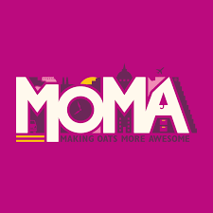
Source: (Lawrence, 2021)

Organization’s current strategic directions
Current strategic directions or strategies of the organization generally refer to the approaches would take by the manager of the firm. Directions were implemented by the leaders of the company within their workplace to fulfill both their vision and pre-determined goals. Generally, it ensures that management and owners can effectively communicate the significance of employees' efforts and their contribution to accomplishing the objectives of the organization(Liu et al., 2021). Developing a solid strategy within the firm that mainly outlines its direction can assist the manager of the firm to enhance its performance of the company in the current marketplace and on the other hand, also increases its efficiency. It also allows the leader of the company to unite all the strategies of the firm and enables greater profitability and stability shortly.. There are mainly four types of strategic decisions that may bring by the company within its workplace i.e., Mission, Culture, Vision, and Values. However, mission refers to the purpose of the organization for its establishment in the marketplace and also explains why the company relies on the market. Thus, with the adaption of this strategic decision company mainly use its mission as a lead for the accomplishment of its goals.
As MOMA delights or their products stocked in Morrisons, Tesco, Sainsbury or customers find its products on an EasyJet flight and the other hand Wetherspoons pubs across the regions (Long et al., 2015). The company continues to grow as an international brand as well and enabling its consumers with delicious as well as healthy breakfasts as they go. Company's in-house marketing and on the other side, a brand activity by the manager of MOMA Foods defined that company works closely or greatly with its team to make sure that all gaps into place.

PESTEL ANALYSIS (MOMA FOODS)
There's no denying that enabling healthy breakfast products to its customers is considered one of the significant factors regarding its success in the existing marketplace. However, some fascinating dynamics take part in this space such as increasing costs of labor which may influence the profitability of the company (Lipponen, 2017).
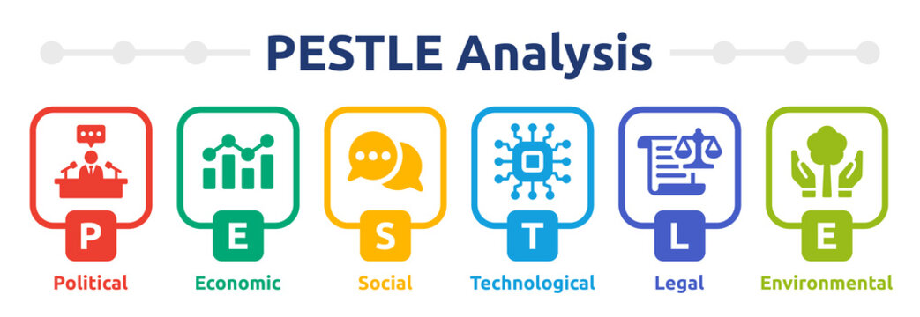
Source: (Long et al., 2015)
Political factors-World's government brings a great regulatory framework regarding every aspect or circumstance of the food industry. This mainly comprises the sanitation of commercial kitchens the way of keeping and transporting their products, and also the needs of their workforce in the organization (Poerwanto et al., 2022). Thus, there brings a need for the manager of MOMA Foods to bring several rules and efforts to fulfill this framework.
Economic Factors-Now nearly all the population of the world is only receiving richer. It defines that people in the middle, lower, and higher classes all can spend on expensive or luxury items comprising restaurant food (Lipponen, 2017). This leads to enhancing the revenue of MOMA Foods because mainly peoples are less likely to cook and prefer to eat in restaurants. As a result, this will lead to a positive influence on the profitability as well as the performance of MOMA Foods in the market. As a result, it enhanced the cost of bringing workers into the organization as this is caused by both an enhancing demand for workers as well as enhancing the expectations of government regarding minimum wages. Thus, it possesses a negative impact on the profitability of MOMA Foods.
Social Factors-According to the research by several scientists, it was found that there is an obvious relationship between the food that individuals eat and their health. Thus, consumers in the UK or across the world are more conscious regarding their healthy and more preferred healthy food and products(Mathiesen et al., 2022). It doesn’t carry significantly a positive influence or negative influence on the performance of MOMA Foods. But it brings the need for the manager of the company to adapt some changes in their products or offerings.Another social factor for MOMA Foods refer as dietary restrictions, company needs to bring changes regarding keeping customers happy as well as satisfied.
Technological Factors-MOMA Foods must bring several types of automation and technological innovation within their organization. For instance, McDonald' adapts self-investigate screens at their product venues. As, this proves as a great improvement for the organization because it allows the company to enhance its profitability as well as lessen the likelihood of uncertainties and human error(Lipponen, 2017).
Environmental Factors-One of the significant issues for MOMA Food from an environmental point of view is considered meat. The manufacture of meat, generally red meats utilizes great amounts of water and develops an important carbon footprint. However this has not had a negative influence on the operations of the company but the manager of MOMA Foods needs to determine the influence of this move over a long period(Poerwanto et al., 2022).
Legal Factors-As there is a wide range of rules and regulations in every region such as how the products of the organization should be transported, prepared, produced, and stored. Thus, this carries a legal issue for the company, and the manager of MOMA Foods needs to be enormously careful(Mathiesen et al., 2022).

PORTER’S FIVE FORCES (MOMA FOODS)
Porter’s competitive model influences the organization at the national level as well as international level by concentrating on five areas which are discussed below:
Competition among the contenders-Generally, the competitive approach of the organization with effective contenders will enable MOMA Foods to catch a competitive edge over other organizations. As in the food industry or sector, competitions were relatively high(Islam, 2022). Thus, the manager of MOMA Foods needs to focus on developing competitive benefits with the help of several strategies or approaches. Like, brings changes in the prices of their products or services, concentrates on differentiating their product from its contenders as well as also bringing development in their distribution process.
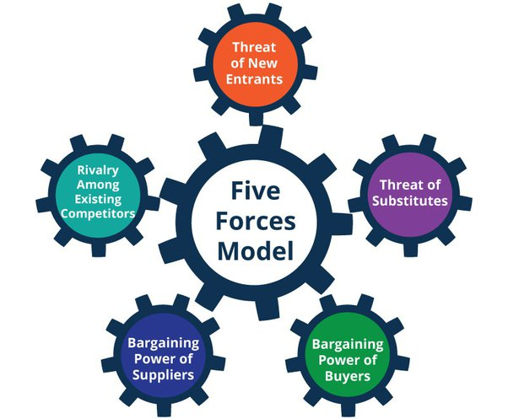
Source: (Angkat and Nawawi, 2022)
The Bargaining Power of Buyers-If the consumers are more powerful, their capability to bargain enhances mainly the price responsive consumers leading to prices of the products of MOMA Foods may be vigorously decreased. This may result in a threat to the organization. In the circumstances of the food industry, the bargaining power of the consumers is relatively high. Customer wants quality products at reasonable prices (Eskandari et al., 2015).If MOMA Foods fixed high prices of its products or services purchasers might go away unreasonably.
The Bargaining Power of Suppliers-Just reverse of the bargaining power of customers refer as the bargaining power of suppliers. The selection of the supplier of the company's products or services is directly dependent upon the costs of the product sales organization(Islam, 2022). Therefore, it may result in a weak element or maybe result in an advantage for MOMA Foods.
Threat toward the entry of New Entrants into the market-In the case of the food industry, this threat is high as there are wide ranges of new entrants in the marketOn the other hand, it is also very less costly for any new entrants in the case of a food firm. Peoples are convenient to carry their investments or funds as compared to some other businesses (Angkat and Nawawi, 2022). As well as it is considered as the experience that keeps pivotal significance and not only the food. The manager of MOMA Foods must concentrate on new entrants in the existing marketplace that may result in a threat to the performance of the company in near future.
Substitute of Existing Products-The issue of substitutes for existing products by its several contenders is considered the greatest threat to the performance of MOMA Foods as it influences the profitability of the organization to a greater extent(Eskandari et al., 2015). This model generally defined that this threat developed usually because of the immense competition that exists in the market regarding the pricing of the products by the organization.

SWOT Analysis of MOMA Foods

MOMA foods provided integrated food services in France and all over the world. Mainly, food companies are the sub-industry of restaurants, hotels, etc where they have to dish up their guest. If we talk about MOMA foods company, it depends upon two factors i.e. distribution and production (Kolbina, 2019). The best and exact SWOT analysis would help to make a good decision on which is better for MOMA foods. It helps to identify the strengths, weaknesses, opportunities, and threats. Here are the steps which are as follows:
Strength- MOMA foods would increase its strong connection of distribution with other restaurants and hotels to distribute their food which is very healthy for the people. . Company has a large supply chain of their products. It has great distribution services for its products i.e. oats, healthy granolas, vegan dishes, muesli, etc., so that customers are highly interested in buying their product (Kolbina, 2019). The connection between the company and its supply chain is permanent. It would continue for years to supply its product in different cities. The company has a trustworthy supply chain and partners so that there would not has any kind of delay in the delivery of their products.
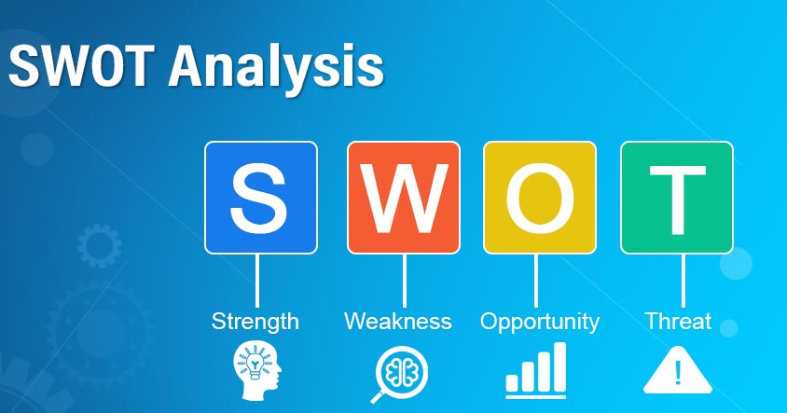
Source: (Danca, 2019)
Weakness- The organization mainly does not allocate any kind of research on their foods because if the customers do like their product they would buy again and again. But sometimes it would harm the organization as well. Cooks of MOMA foods follow the same technique method of preparing their products every time (Ahmad, 2019). The company needs to work on that specific time to time to attract their regular customers.
Opportunity- MOMA Foods Company is now selling its products online also. Where customers have the option of purchasing what they want and also do online payments. The company's store would get the online order and have to deliver to those particular customers through the home delivery option (Danca, 2019). Nowadays the population of the UK is increasing day by day, and they all want to be healthy by eating healthy foods provided by MOMA Foods Company. An increase in population means the rate of feeding also increases day by day. This is beneficial for MOMA very much.
Threat- The main threat of MOMA Foods is competition as many other companies also launching the same products at lower rates day by day to attract customers towards them. It would decrease in sales also and more competition would happen. Technology is adopted by all the food and beverages companies (Namugenyi et al, 2019). It also has a threat for MOMA Foods Company because all the companies are now selling their product online at discount prices. The food market is very much competitive but the chain of supply is very limited. Customers would not want the only good taste but also wants healthy plus tasty foods

VRIO Model of Moma Foods
VRIO model is adapted by MOMA Foods Company also. VRIO mainly focuses on four questions such as valuable, rarity, inimitable, and organization. This criterion is followed many most organizations to enhance their capabilities.. This VRIO model has a connection with the internal analysis of the organization (LEE, 2022). If any asked the manager of MOMA Foods, that why your company is doing well in comparison to others. They normally say “good connection with our people”. It also explains how much the company is competitive with others or not. The four criteria adopted by the organization are as follows:
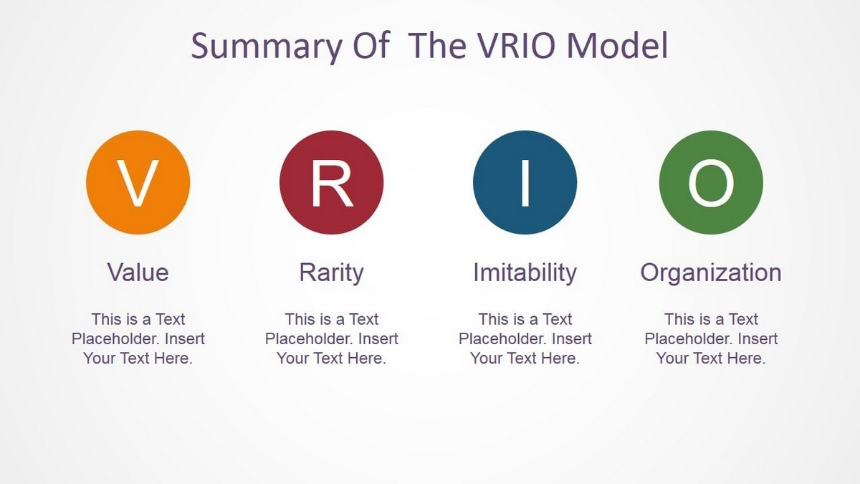
Source: (LEE, 2022)
Valuable- The capability of MOMA Foods has to be valuable as it allows all the members of the organization to achieve particular goals by giving those opportunities. The capability mainly allows the organization to maximize the opportunities given by the company (LEE, 2022). It would help in enhancing the position of the company in front of other food companies. Many researchers show that if the company would not pass this VRIO test, then that company does not fit in the competitive market.
Rare- A source of rare is slightly very easy when it comes to competition with the other companies. This VRIO model is a very easy way of giving any kind of judgment on the company i.e. MOMA Foods Company (Lopes et al, 2018). For example, MOMA Foods is a valuable brand for selling oats and different kinds of healthy items to the customers but many more competitors with the same products also have a valuable name in the market, which is not very rare. Healthy food providers might be very recognized but that would make it a more valuable brand name but not a rare brand.
Imitable- Inimitable source is very difficult to reproduce or create the replacement of that source in any organization. A source is unique, and not replaceable at one time. It. It would apply the most competitive advantages to all MOMA Foods companies (Sheng et al, 2019). If any capability is valuable plus rare then the responsibility of the competitors in the marketplace depends on the organization only. This leads any food company to this third criterion I.e. inimitability.
Organization- The last and very final criteria of VRIO is an organization which describes as a source of advantages happening in the competitive marketplace (Gudz, 2019). It also controls all the necessary criteria which are very helpful for MOMA Foods Company. The company is always ready to enter a new market with full confidence because the organization owns its capability of doing better in the new marketplace. Also, the organization is always aware of its expenses and profits.

Stakeholder’s Analysis

Stakeholder's analysis in MOMA Foods Company is very wide. They can assort external shareholders and internal shareholders. It also includes exporters, retailers, partners, other organizations, and all the government policies. MOMA Foods Company has multiple departments that already merged with the different shareholders. This mainly creates high-interest rates. By applying four principles of stakeholder analysis in an organization and has a definite tool for the benefit of the organization in the food industry to build the long-term relationship with the partners. The stakeholder analysis is very deep and diverse due to the importance of stakeholders in an organization (Cosmulese et al, 2019). Implementing a solid plan to engage the stakeholders in their business makes out a good effort. For example: taking any food industry, the production of its stakeholders is at different stages, like farmers develop wheat to make eating material from that. The engagement of stakeholders depends upon the balance of the company, engagement of suppliers, always engaging automatically, etc.

Internal stakeholders MOMA Foods- This Company has given employment to 1500 employees recently. In comparison to the previous year, there was no increment in the staff selection i.e. 0% of staff is increasing, this results in 0 employments given by the organization. The company gives employment to 1500 people. If we look out all the details of the company, including emails, phone numbers, and letters for all the employees working in the organization i.e. MOMA Foods Company (Braglia and Petroni, 2020). The main shareholders of MOMA Foods are James Michael Paisley, who owns about 2300 shares of the company with a total value of 2300 GBP. Alex Glasner owns about 900 shares with a total value of 900 GBP. Amy Victoria Farren owns about 1200 shares of the company with a value of 1200 GBP.
External stakeholders of MOMA Foods - Stakeholder plays a vital role in any organization in the form of internally and externally. It experiences the activities of the business operations and holds all the shares of the company. External shareholders mainly describe the external operations of MOMA Foods which operate the external factors (Morsing, 2020). For example, any one of the customers also becomes an external shareholder of the company because all the customers easily examine the situation of the business operations. The government also regulates all the business operations of MOMA Foods because it is considered the external stakeholder of the company.

Stakeholder’s Matrix
The evaluation of stakeholders is done with the help of a stakeholder matrix, in which an organization can easily current the implication of applicable and concerned parties. Knowing about the stakeholder matrix would help the workers of the company more effectively with the stakeholders of MOMA Foods. It is also known as stakeholder mapping of any organization, which involves the mapping of the stakeholders as y-axis and x-axis. This variable includes many high and low categories of MOMA Foods such as high-low, low-low, high-high, and low-high. There are many types of stakeholder matrices used in the organization. MOMA Foods mainly uses an x-y variable set. Firstly, it includes high power and low interest, in this stakeholder the company needs to be satisfied by this. CEO of the company and other accounting department employees look after the whole budget given to the organization (Slivar, 2018). Secondly, low power and low interest, this category of stakeholder matrix mainly include those stakeholders which are monitored by the employees. The company needs to keep an eye on all the employees working in the organization. Thirdly, high power and high interest include the stakeholder of MOMA Foods to be managed very deeply. This is called the direct and deep supervision of stakeholders by the HOD of the company. Lastly, low power and high interest include the employees who are mainly being informed about what is going on in the organization and what is going to happen in the organization.
. The benefit of the stakeholder is to make a business successful as visually can help in explaining the concept of the business and understanding it very properly. A matrix is a form of grip mapping used in all kinds of business (Slivar, 2018). The use of graphs with the help of two variables i.e. X and Y. Any company can easily make its stakeholder matrix with the help of computer programs and many more applications. It also allows a quick change in the mapping program of the organization. Keeping the stakeholders of MOMA Foods to be engaged, helps in achieving the goal.

Porter’s Generic Model of organization
Porter's mainly called the generic strategies which include cost leadership, differentiation cost focus, and differentiation focus in the marketplace (Indiatsy et al, 2019). It was first introduced by Michael Porter in the year 1985.
Cost leadership strategy- In this Porter’s generic leadership style, depends upon the profit by the completive advantages of an organization. The periphery that contributes to the sale, moves the organization from the competitors of MOMA Foods (Indiatsy et al, 2019). There are two ways of achieving the goal of cost leadership reducing the cost value and increasing the profits of an organization despite changing the average prices of the product To change the price of the product in low which results in increasing the market share value of the organization. To make all products at a reasonable cost to make more profit.
Differentiation strategy- This strategy mainly involves services that are very different from the other organization to attract their customers in this competitive era of business. This strategy depends on the nature of the organization and which kind of material are they providing to the customers. it also involves the function of business, the durability of the product, the support system of MOMA Foods, partners of the organization, the brand image of the company, and the value of their customers (Spitzeck and Chapman, 2019 ). To make this strategy more successful, MOMA Foods needs to follow the research which is beneficial for them, do development in their industry, to make their food industry more innovative. The company has to reach the ability to produce a higher quality of products for the consumers to make a profit. The sales and marketing might be increasing day by day to enhance their business at the next level. Many organizations apply this strategy to their business, to stay in the top ten organizations in the marketplace.
Cost Focus strategy- Many organizations that use focus strategies would mainly concentrate on the particular cost value in the marketplace, by appreciating the dynamics of the marketplace and the needs of the product in the new market. It mainly develops the low-cost value of the product for the future development of the company (Mkakile et al, 2022). MOMA Foods serve the product in a very unique to their customers to attract them in purchasing that particular item. The company also learns how to deal with the customers by reducing the cost value of their product. The brand strategies are done with the help of board members. It is very much important to decide whether the cost leadership is done by the best leader or not. Cost focus is different from the differentiation focus.
Differentiation Focus strategy - This focused strategy is mainly guaranteed that adding something new to the business is only for the market and the consumers. It is not that easy to focus on the differentiation of the market and the consumers (Liu, 2022). The focus on the market is not enough for any organization to deal with. The "extra" that is used to reduce the value of cost knows that it will affect the differentiation focus in the market.

Recommendation
MOMA Foods across the world are currently handling several threats and challenges, comprises generally its marketing strategies, way of production, etc. The marketplace become an environment and creating several threats regarding the growth and enlargement of MOMA Foods. Here are several contenders against the company as it was found with the help of IBISWorld, that there exist around 60,000 firms in the food industry or sector (Rösler, 2021). Thus, the manager of MOMA Foods needs to create sustainable operations and must develop several strategies regarding catching the competitive benefits from its standards and achieving note-worthy growth in this competitive marketplace. There is no room for the company to sacrifice the quality of its products, generally in the face of enhancing customer demand. The company also needs to develop strict authoritarian policies to follow all the regulations brings by the government as well as must develop great transparency across their whole supply chain.

CONCLUSION
The report mainly concludes the current strategic directions of the organization as developing a solid strategy within the firm that mainly outlines its direction can assist the manager of the firm to enhance the performance of the company in the current marketplace. With the help of their great strategic decisions or approaches, MOMA Foods can continuously enhance its brand and image in the market. It also emphasizes the external environmental factors as well as internal environmental factors that must be affecting the company's performance such as health consciousness by the consumers considered as a social factor that must analyze by the manager of the company. On the other hand, one of the significant issues for MOMA Food from an environmental point of view is considered as meat. The company's store would get the online order and have to deliver to those particular customers through the home delivery option, refer as an opportunity towards the enhancement in their sales and profitability. Porter's five models as well as the VRIO model of MOMA Foods should also conclude in this report as MOMA Foods needs to focus on developing competitive benefits with the help of their several strategies or approaches. Generally, if anyone asked the manager of MOMA Foods, that why your company is doing well in comparison to others, normally say "good connection with our people". VRIO model is a very great way of giving any type of judgment on the firm as on MOMA Foods. For instance, the company's valuable brand of selling oats and varied kinds of healthy items to the customers but many more contenders with the same products also has a valuable name in the market, it is not very rare. It also indulges stakeholders' analysis of the company and Porter's Generic model.

REFERENCE LIST

Dongmo, A.L., Ijang, T.P., Tuete, A., Okolle, J., Fru, S.B., Djomkwo, C., Nyambi, G., Fozen, F., Ntsefong, G.N., Toko, A. and Ngaunkam, P., 2014. A situational analysis of agricultural production and marketing, and natural resources management systems in the humid tropical zones of Cameroon.
(Dongmo et al., 2014)
Lawrence, A.R., 2021. Drawing on Architecture: The Object of Lines, 1970–1990.
(Lawrence, 2021)
Liu, D., Liberton, M., Hendry, J.I., Aminian-Dehkordi, J., Maranas, C.D. and Pakrasi, H.B., 2021. Engineering biology approaches for food and nutrient production by cyanobacteria. Current Opinion in Biotechnology, 67, pp.1-6.
(Liu et al., 2021)
Long, M.R., Ong, W.K. and Reed, J.L., 2015. Computational methods in metabolic engineering for strain design. Current opinion in biotechnology, 34, pp.135-141.
(Long et al., 2015)
Lipponen, M., 2017. Market review of Nuijamaa: Case Food Agent J&L Ltd.
(Lipponen, 2017)
Poerwanto, I., Hussein, A.S. and Prabandari, S.P., 2022. Market orientation and innovation on corporate performance: A study of food and beverage sector SMEs in Surabaya. International Journal of Research in Business and Social Science (2147-4478), 11(3), pp.27-32.
(Poerwanto et al., 2022)
Mathiesen, S.L., Moula-Stahli, D., Byrne, D.V. and Wang, Q.J., 2022. Leaving your comfort zone for healthier eating? Situational factors influence the desire to eat comfort food and simulated energy intake. Food Quality and Preference, 100, p.104605.
(Mathiesen et al., 2022)
Islam, A., 2022. Project Report on" Marketing Activities of Square Food and Beverage Ltd.".
(Islam, 2022)
Eskandari, M.J., Miri, M., Gholami, S. and Nia, H.R.S., 2015. Factors affecting the competitiveness of the food industry by using porters five forces model case study in Hamadan province, Iran. Journal of Asian Scientific Research, 5(4), pp.185-197.
(Eskandari et al., 2015)
Angkat, E.Y. and Nawawi, Z.M., 2022. Food and Beverage Business Development Strategy at Time Depot to AET Surabaya. Jurnal Akuntansi, Manajemen dan Bisnis Digital, 1(2), pp.327-332.
(Angkat and Nawawi, 2022)
Kolbina, O., 2019. SWOT analysis is a strategic planning tool for companies in the food industry. Problems of Economic Transition, 57(9), pp.74-83.
(Kolbina, 2019)
Ahmad, R.O., 2019. Strengths, weaknesses, opportunities, and threats (SWOT) analysis for farming system businesses management: Case of wheat farmers of Shadervan District, Shoushtar Township, Iran. African journal of business management, 5(22), pp.9448-9454.
(Ahmad, 2019)
Danca, A.C., 2019. SWOT analysis. available at: website–www. Francis. edu.
(Danca, 2019)
Namugenyi, C., Nimmagadda, S.L. and Reiners, T., 2019. Design of a SWOT analysis model and its evaluation in diverse digital business ecosystem contexts. Procedia Computer Science, 159, pp.1145-1154.
(Namugenyi et al, 2019)
LEE, K.K., 2022. A Study on 7-Eleven's Core Competencies: Focusing on the VRIO Model. International Journal of Advanced Culture Technology, 10(1), pp.67-74.
(LEE, 2022)
Lopes, J., Farinha, L., Ferreira, J.J. and Silveira, P., 2018. Does the regional VRIO model help policy-makers to assess the resources of a region? A stakeholder perception approach. Land Use Policy, 79, pp.659-670.
(Lopes et al, 2018)
Sheng, C.C. and Kodono, Y., 2019, December. The management strategy of master kong is based on fuzzy VRIO analysis. In 2014 Joint 7th International Conference on Soft Computing and Intelligent Systems (SCIS) and the 15th International Symposium on Advanced Intelligent Systems (ISIS) (pp. 1382-1385). IEEE.
(Sheng et al, 2019)
Gudz, Y.F., 2019. FEATURES OF USING THE VRIO-ANALYSIS TO ASSESS THE ECONOMIC POTENTIAL OF FOOD COMPANIES. The Genesis of Genius, 1(2), pp.55-59.
(Gudz, 2019)
Cosmulese, C.G., Socoliuc, M., Ciubotariu, M.S., Mihaila, S. and Grosu, V., 2019. An empirical analysis of stakeholders’ expectations and integrated reporting quality. Economic research-Ekonomska istraživanja, 32(1), pp.3963-3986.
(Cosmulese et al, 2019)
Braglia, M. and Petroni, A., 2020. Stakeholders influence and internal championing of product stewardship in the Italian food packaging industry. Journal of Industrial Ecology, 4(1), pp.75-92.
(Braglia and Petroni, 2020)
Morsing, M., 2020. Corporate social responsibility as strategic auto‐communication: on the role of external stakeholders for member identification. Business Ethics: A European Review, 15(2), pp.171-182.
(Morsing, 2020)
Slivar, I., 2018. Stakeholders in a tourist destination–matrix of possible relationships towards sustainability. Open Journal for Research in Economics, 1(1), p.1.
(Slivar, 2018)
Indiatsy, C.M., Mucheru, S.M., Mandere, E.N., Bichanga, J.M. and Gongera, E.G., 2019. The application of Porter’s five forces model on organization performance: A case of cooperative bank of Kenya Ltd.
(Indiatsy et al, 2019)
Spitzeck, H. and Chapman, S., 2019. Creating shared value as a differentiation strategy–the example of BASF in Brazil. Corporate Governance: The international journal of business in society.
(Spitzeck and Chapman, 2019 )
Mkakile, R.M. and Salum, V.S., 2022. The Influence Of Generic Strategies On Performance Of Tanzaniaâ€™ S Tourism Firms In Northern Circuit. Oradea Journal of Business and Economics, 7(1), pp.62-73.
(Mkakile et al, 2022)
Liu, Y., 2022. A Review of the Basic Theory of the Great Michael Porter’s Positioning School. In Proceedings of the 5th International Conference on Economic Management and Green Development (pp. 265-271). Springer, Singapore.
(Liu, 2022)
Rösler, F., Kreyenschmidt, J. and Ritter, G., 2021. Recommendation of good practice in the food-processing industry for preventing and handling food loss and waste. Sustainability, 13(17), p.9569.

