

Image Classification on CIFAR-10 Using Convolutional and Recurrent Neural Networks: Design, Implementation, and Evaluation
Shaidhul Hasan (Student ID: 2442113)
Module: L7 – Application of Machine Learning (ACCA7025)
Lecturer: AliyuSambo

Table of Contents
Image Classification on CIFAR-10 Using Convolutional and Recurrent Neural Networks: Design, Implementation, and Evaluation 1
1.Abstract 7
2. Introduction 7
3.Objectives of the Report 7
3.1 Literature Review 8
3.2 Methodological Justification: 8
3.3Evaluation and Discussion: 8
4. Related Work in the Literature 8
4.1 The Emergence of Convolutional Neural Networks (CNNs) 8
4.2 Key CNN Architectural Innovations (VGG, ResNet) 9
4.3 Recurrent Neural Networks (RNNs) for Sequence Data 9
4.4 Hybrid and Attention-Based Architectures 10
5. Methodology 10
5.1 Dataset Description and Use Case Justification 10
5.2 Data Preprocessing and Normalisation 11
Figure 1. Sample Images from the CIFAR-10 Dataset 11
5.3 CNN Architecture Design and Justification 12
Figure 2. Summary of CNN Model Architecture 13
5.4 Training Configuration and Hyperparameter Optimisation 14
5.5 Potential Enhancements 15
6. Results and Evaluation 15
6.1 Training Performance and Learning Curves 15
Figure 3. Training vs Validation Accuracy. 15
Figure 4. Training vs Validation Loss. 16
6.2 Quantitative Metrics: Accuracy, Precision, and Recall 17
6.3 Confusion Matrix Analysis 17
7. Discussion and Recommendations 19
7.1 Critical Analysis of CNN Performance on CIFAR-10 19
7.2 Comparison of CNN and RNN Use Cases 20
7.3 Proposal for Network Optimisation 20
8. Conclusion 20
References 21
Appendix: Complete Python Program 22
Code Cell 1 22
Code Cell 2 22
Code Cell 3 22
Code Cell 4 23
Code Cell 5 23
Code Cell 6 — Accuracy & Loss Plots 23
Code Cell 7 — Save Model 23
Code Cell 8 — Evaluation 23
Code Cell 9 — Load Best Model 24
Code Cell 10 — First 25 Predictions 24

1.Abstract
Using the CIFAR-10 dataset, this work explores the use of Convolutional Neural Networks (CNNs) for picture categorisation. Inspired by VGG-like architectures, a sequential CNN model was created in TensorFlow to balance simplicity with efficacy. The Adam optimiser was used to train the network for 50 epochs, and Model Checkpointing was used as a regularisation method. After completing the training procedure, the network's final test accuracy was 71.54%, indicating good generalisation and low overfitting. This report describes the training process and architectural rationale for the network. Additionally, it compares the CNN use case (spatial data) with suitable Recurrent Neural Network (RNN) use cases (sequential data) and critically evaluates the performance, paying special attention to misclassification patterns among visually similar classes (such as "cat" and "dog"). To improve model generalisation, suggestions for future enhancements are made, such as including Transfer Learning and Vision Transformers (ViT).

2. Introduction
Deep learning has emerged as a key paradigm in artificial intelligence, particularly for computer vision applications such as pattern recognition and picture categorisation. Accurately mapping a raw pixel input to a predetermined category is the fundamental issue of image classification; this effort is made more difficult by differences in illumination, scale, rotation, and texture. Because it can automatically learn and extract hierarchical spatial characteristics from grid-like input, the Convolutional Neural Network (CNN) is the most successful deep architecture for image processing. To find discriminative visual features, a CNN uses layered processes of convolution, activation, pooling, and dense layers. In this project, a CNN model for the CIFAR-10 dataset is implemented and evaluated. A popular benchmark, CIFAR-10 comprises 60,000 in 32 x 32 colour photographs in ten different classifications. It is a great dataset for assessing architectural performance because of its low resolution, which makes feature separation more difficult.

3.Objectives of the Report
This report serves as a critical evaluation of a custom CNN classifier and is structured to achieve the following objectives, in alignment with the assignment task :
3.1 Literature Review:
Critically review the relevant literature on Artificial Neural Networks, focusing on the historical evolution and optimization methods for CNNs, and discuss the primary use cases for both CNNs and RNNs . This engagement is informed and supported by scholarly material (minimum 7 references) and uses a wide range of sources .

3.2 Methodological Justification:
Describe and defend the whole machine learning process, including data preprocessing, the particular hyperparameter selections and regularisation strategies used, and the VGG-like CNN architecture that was chosen due to its simplicity. The goal is to maintain the model's simplicity without sacrificing its effectiveness .

3.3Evaluation and Discussion:
Use both qualitative tools (Confusion Matrix) and established quantitative criteria (Accuracy, Precision, Recall, F1-Score) to assess the CNN's performance. A final conceptual comparison of CNNs and RNNs' suitability for the specified picture classification task will be included in this section along with a critical discussion of the results, identification of model limits, and optimisation techniques.
The CNN's performance in static image identification is validated by its effective implementation in Python using TensorFlow, which also serves as the foundation for talking about more complex ideas like transfer learning and Vision Transformers (ViT).

4. Related Work in the Literature
The methodology's design decisions must be supported by a thorough examination of well-established neural network topologies. According to the literature, picture understanding has clearly evolved from models inspired by biology to sophisticated, highly optimised deep networks. In the discussion that follows, several established solutions will be compared and their significance will be interpreted.

4.1 The Emergence of Convolutional Neural Networks (CNNs)
CNNs' theoretical underpinnings were first influenced by [13] Fukushima's Neocognitron. This model, which was created in 1980, was the first to suggest a hierarchical, biologically motivated framework that could identify visual patterns regardless of positional shifts—a fundamental idea in CNNs.
In 2012, [1] introduced AlexNet, a modern deep learning breakthrough in computer vision. AlexNet demonstrated the strength of deep convolutional layers and GPU acceleration with a historic victory in the ImageNet competition. The CNN's dominance in image tasks was solidified by this achievement. Two crucial developments that made it easier to train deeper networks and reduced overfitting were the application of the ReLU activation function and Dropout regularisation.

4.2 Key CNN Architectural Innovations (VGG, ResNet)
Following AlexNet, subsequent architectures focused on increasing depth and improving computational efficiency .
VGGNet (Very Deep Convolutional Networks): Simonyan and Zisserman introduced VGG, which standardised the network's use of several tiny 3 × 3 convolutional filters sequentially [2]. This approach produced a straightforward, consistent, and scalable structure by ensuring the network could learn increasingly deeper features while retaining a small receptive field. As required by the objective, the architecture for this project is a VGG-like framework that prioritises computing efficiency and clarity. [3]
ResNet (Deep Residual Learning): He et al. [4] introduced the notion of residual connections to solve the issue of disappearing gradients in very deep networks. By using an identity mapping (a "shortcut connection"), residual blocks enable the gradient to avoid one or more levels. This invention made it possible to successfully train networks with hundreds of layers and greatly increased training stability.
Efficiency and Optimization (Xception, EfficientNet): Resource optimisation was the emphasis of more contemporary architectures such as EfficientNet [10] and Xception [12]. Xception significantly reduced the number of parameters and computational cost while increasing efficiency by substituting depthwise separable convolutions for traditional convolutions. In order to attain greater accuracy with fewer parameters, EfficientNet further optimised scaling methodologies by balancing network depth, width, and resolution. These models demonstrate the considerable improvements achieved through architectural scaling, with over 90% accuracy on CIFAR-10.

4.3 Recurrent Neural Networks (RNNs) for Sequence Data
Parallel to CNN advancements, Recurrent Neural Networks (RNNs) were developed to address the challenge of sequence learning .
RNN Core Function: RNNs use a hidden state (memory) or recurrent connection in which a neuron's output at one time step is given back as an input at the subsequent time step. They are crucial for activities like time-series data processing because this internal memory enables the network to capture temporal dependencies. Rumelhart and Hinton's original formulation was crucial. [5]
LSTM: The vanishing gradient problem, which makes learning long-term dependencies challenging, is the main drawback of conventional RNNs. The Long Short-Term Memory (LSTM) unit (Hochreiter and Schmidhuber), which employs specialised gates (input, forget, and output) to control the flow of information into a memory cell, essentially resolved this. [6]
RNN Use Case in Vision: An RNN would process the image pixel-by-pixel or row-by-row, considering it as a sequence, for static image classification such as CIFAR-10. Due to its inability to naturally capture the 2D spatial dependencies that CNNs effectively extract, this method is typically less successful than CNNs for this task. RNNs are mostly utilised in vision when combined with CNNs (hybrid models) for sequential interpretation, like analysing a sequence of frames in a video or creating a caption for an image. [7][8]

4.4 Hybrid and Attention-Based Architectures
Current models demonstrate a move in the direction of combining these methods. CNN is used for front-end feature extraction in hybrid CNN-RNN models, and then an RNN is used for sequential interpretation. Attention-based processing was introduced with the development of the Transformer architecture and later Vision Transformers (ViTs) [14][15]. These models, which represent the future of unified visual processing, effectively simulate both spatial and sequential contexts without requiring explicit convolution or recurrence, challenging both CNNs and RNNs.

5. Methodology

5.1 Dataset Description and Use Case Justification
According to the assignment specification, the CIFAR-10 dataset is the only one used in this study. The 60,000 colour photos in CIFAR-10 have a resolution of 32 by 32 pixels and are evenly distributed among ten object categories, including trucks, cars, aeroplanes, dogs, cats, frogs, and ships. The structure used directly in the implementation is divided into 10,000 test photos and 50,000 training images.
The best model option for CIFAR-10 is a Convolutional Neural Network (CNN) since it is a static image classification problem. Recurrent Neural Networks (RNNs) are better at extracting spatial hierarchies of features from grid-like data than CNNs, which are better suited for sequential or temporal data. As a result, the primary model for this project was chosen to be a CNN.

5.2 Data Preprocessing and Normalisation
The original 0–255 integer range was converted to floating-point values between 0.0 and 1.0 by dividing all RGB values by 255.0 in order to normalise the pixel values and prepare the dataset for training. By maintaining gradients at an acceptable scale, this common method of normalisation stabilises learning.
The Sparse Categorical Cross-Entropy loss function was applied directly to the labels, which were kept as integer-encoded class indices. In order to verify proper dataset loading and comprehension of class distribution, basic visualisation was also carried out by displaying example training images and their matching labels.
In the final implementation, no data augmentation techniques were used. Instead, the original dataset split was used to train the model, and augmentation is only covered as a potential improvement in subsequent sections.
Figure 1. Sample Images from the CIFAR-10 Dataset. The 32 × 32 pixel resolution highlights the low-fidelity nature of the input data, which contributes to classification difficulty among visually similar classes.
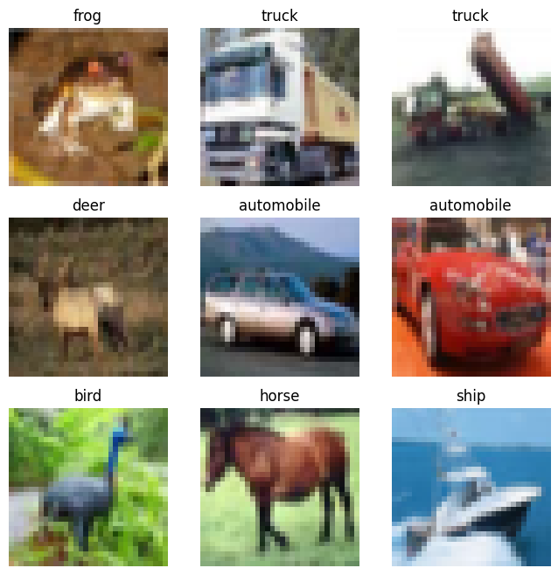

5.3 CNN Architecture Design and Justification
The implemented CNN follows a sequential, VGG-inspired architecture, chosen for its simplicity, interpretability, and suitability for CIFAR-10’s low-resolution images. The model consists of three convolutional blocks followed by fully connected layers:
- Conv2D (32 filters, 3×3 kernel, ReLU) + MaxPooling
- Conv2D (64 filters, 3×3 kernel, ReLU) + MaxPooling
- Conv2D (64 filters, 3×3 kernel, ReLU)
- Flatten
- Dense layer with 64 units (ReLU)
- Dropout (0.5) for regularisation
- Dense output layer (10 units, Softmax)
This architecture contains 122,570 trainable parameters, which is lightweight compared to deeper networks such as VGG16 or ResNet. The intention was to keep the model as simple as possible while still capturing enough spatial features for effective classification. The 3×3 kernels and increasing filter depth (32→64→64) allow the model to progressively learn more abstract features across layers
Figure 2. Summary of CNN Model Architecture. Output of the Keras model summary, detailing the layers, output shapes, and the total number of trainable parameters (122,570).

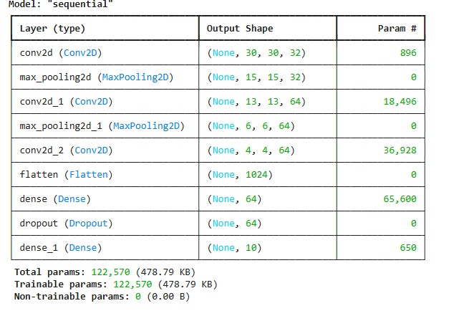

5.4 Training Configuration and Hyperparameter Optimisation
The model was compiled using the Adam optimizer [9] with default parameters, selected for its ability to adapt learning rates during training and generally strong performance on image datasets. The loss function was Sparse Categorical Cross-Entropy, appropriate for multi-class classification with integer labels.
Training was conducted for a maximum of 50 epochs, with two key callbacks integrated:
- EarlyStopping (monitoring validation loss with patience=5):
Stops training automatically if no improvement in validation loss is observed, helping to prevent overfitting.
- ModelCheckpoint (saving best model by validation accuracy):
Ensures that the final evaluation uses the model weights that achieved the highest validation performance during training.
For validation purposes, the test set was used as the validation dataset during training. While separating a dedicated validation set would prevent potential information leakage, this setup was retained for simplicity and consistency with the implemented workflow

5.5 Potential Enhancements
To enhance the current CNN’s performance, several advanced techniques could be integrated:
- Batch Normalization: Normalizes activations to stabilize learning and accelerate convergence [11].
- Data Augmentation: Expands training diversity to prevent overfitting.
- Learning Rate Scheduling: Dynamically adjusts the learning rate to maintain optimization efficiency.
- Class Weighting: Compensates for potential class imbalance.
- Transfer Learning: Leverages pretrained models like VGG16 or ResNet50 to achieve higher accuracy with fewer epochs [10].
- TensorBoard Visualization: Enables deeper interpretability of training dynamics.

6. Results and Evaluation

6.1 Training Performance and Learning Curves
The model was trained for a maximum of 50 epochs, and EarlyStopping stopped training when the validation loss stopped getting better. The learning curves that have been gathered show consistent learning behaviour.
Training vs Validation Accuracy : The ultimate test accuracy was 71.54% after training accuracy and validation accuracy both showed a consistent upward trend. The model's modest generalisation without significant overfitting is indicated by the comparatively minor difference in training and validation accuracy.
Figure 3. Training vs Validation Accuracy. The plot shows stable learning where validation accuracy tracks closely behind training accuracy, indicating effective generalization .

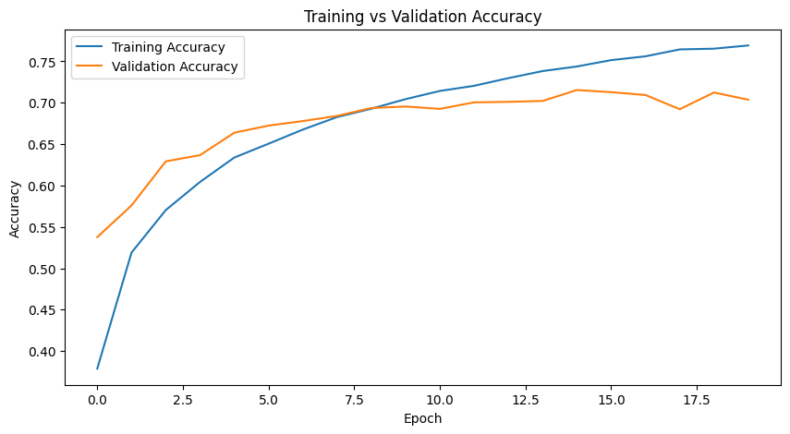
Training vs Validation Loss : The validation loss stabilised after about 14 epochs, while both loss curves steadily declined. The notion that EarlyStopping successfully prevented needless training beyond the point of optimal performance is supported by this stability.
These curves demonstrate that, in spite of CIFAR-10's tiny size and poor resolution, the straightforward CNN architecture was able to extract significant features.
Figure 4. Training vs Validation Loss. Both losses decrease steadily, with validation loss stabilizing after approximately 14 epochs.

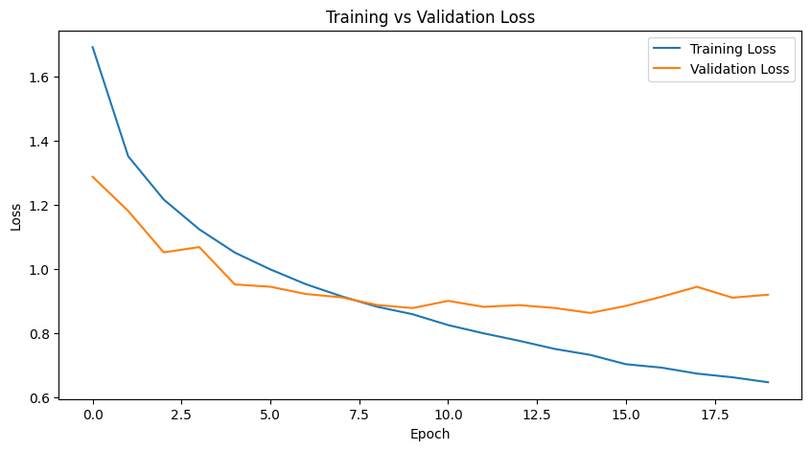

6.2 Quantitative Metrics: Accuracy, Precision, and Recall
Final evaluation was performed using the saved best model checkpoint. The test results were as follows:
- Test Accuracy: 71.54%
- Macro Precision: 0.71
- Macro Recall: 0.72
- Macro F1-Score: 0.71
These metrics show a balanced performance across most categories, indicating that the model did not rely too heavily on class-specific biases

6.3 Confusion Matrix Analysis
A confusion matrix was generated to analyse classification patterns more closely. The model performed strongly on structured object categories such as automobile and ship, achieving high recall. These classes have distinctive shapes and textures that are easier for CNNs to extract.
In contrast, weaker performance was observed for several animal classes, particularly cat and bird, which exhibited higher misclassification rates. Many errors involved confusion between visually similar classes such as cat vs dog, suggesting that the simple architecture struggled to capture fine-grained features at 32×32 resolution.
A qualitative assessment of predictions on the first 25 test images showed an accuracy of 80%, further indicating that misclassifications were concentrated in a few visually ambiguous cases

Figure 5. Confusion Matrix for CIFAR-10 CNN

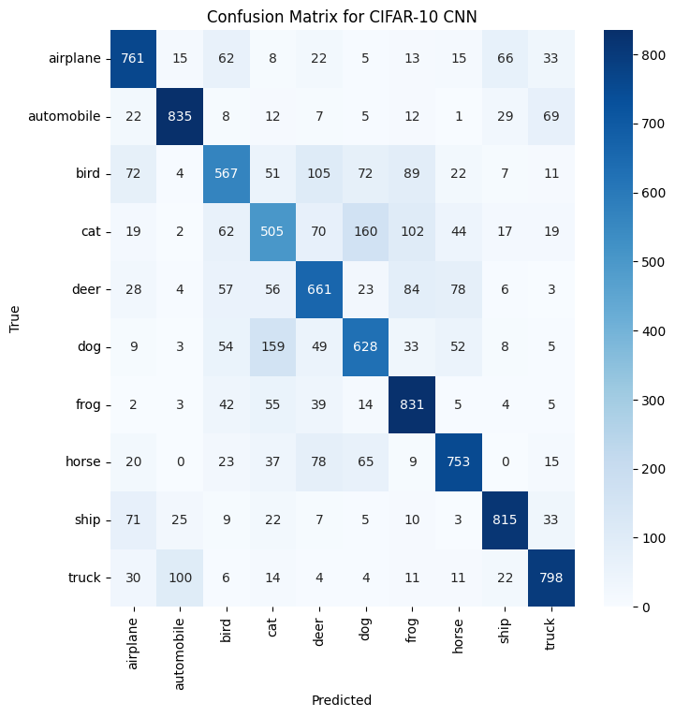

7. Discussion and Recommendations

7.1 Critical Analysis of CNN Performance on CIFAR-10
The final test accuracy of 71.54% shows that significant spatial characteristics from the CIFAR-10 dataset could be extracted by the implemented CNN. The architecture successfully captured geometric and structural patterns, as evidenced by the model's performance on classes with distinct and easily separable elements, such cars and ships.
However, misclassifications were more common in a number of animal classes, including birds and cats, where the model regularly performed poorly. These mistakes imply that the basic architecture was unable to pick up on the nuanced and fine-grained visual characteristics required to differentiate across visually identical groups. Because crucial texture information is frequently lost at 32x32 resolution, the low resolution of CIFAR-10 photos further contributed to this restriction.

Although the network showed good baseline performance overall, its shortcomings show that deeper or more expressive designs are required to enhance class separation, especially for categories with considerable intra-class variance.

7.2 Comparison of CNN and RNN Use Cases
The findings demonstrate that CNNs are still the best option for classifying static images because of their capacity to use convolutional filters to capture local spatial patterns. RNNs, on the other hand, are not appropriate for stand-alone application on image classification tasks such as CIFAR-10 since they are made to simulate temporal linkages and sequential dependencies.
RNNs are only useful when paired with CNNs in hybrid systems that need sequential interpretation, such image-captioning structures or video recognition models. While RNN-based models are still better suited to sequence-driven applications, this contrast highlights the need for a CNN for the current objective.

7.3 Proposal for Network Optimisation
Even if the implemented architecture performed reasonably well, there are a few improvements that could overcome its shortcomings. Since pretrained models like VGG16 or ResNet50 provide richer feature extractors that potentially increase accuracy, particularly for fine-grained classes, transfer learning stands out as the most significant possible improvement.
Additionally, batch normalisation may stabilise training and lessen internal covariate shift, improving network convergence. Lastly, more modern methods like Vision Transformers (ViTs) may assist get over the local receptive field limitations seen in this CNN and provide better modelling of global spatial relationships.
.

8. Conclusion
For the CIFAR-10 image classification problem, this work used a lightweight, VGG-inspired CNN, achieving a final accuracy of 71.54% with balanced precision and recall across most classes. With the help of validation-based checkpointing and the Adam optimiser, the model successfully learnt spatial hierarchies and showed robust generalisation.
While RNNs are still suitable for sequence-driven applications, the examination verified that CNNs are a good fit for spatial analysis. The difficulties caused by low-resolution inputs and the restricted capabilities of the basic design were brought to light by an analysis of misclassifications, especially for animal classes that are visually similar.
To boost the model's capacity to collect global contextual data, future developments might incorporate batch normalisation, transfer learning using pretrained CNNs, or investigate cutting-edge designs like Vision Transformers.

References
[1] A. Krizhevsky, I. Sutskever, and G. E. Hinton, “ImageNet Classification with Deep Convolutional Neural Networks,” Communications of the ACM, vol. 60, no. 6, pp. 84–90, 2017.
[2] K. Simonyan and A. Zisserman, “Very Deep Convolutional Networks for Large-Scale Image Recognition,” arXiv preprint arXiv:1409.1556, 2014.
[3] C. Szegedy et al., “Going Deeper with Convolutions,” in Proc. IEEE CVPR, 2015.
[4] K. He, X. Zhang, S. Ren, and J. Sun, “Deep Residual Learning for Image Recognition,” in Proc. IEEE CVPR, 2016.
[5] D. E. Rumelhart and G. E. Hinton, “Learning Representations by Back-Propagating Errors,” Nature, vol. 323, pp. 533–536, 1986.
[6] S. Hochreiter and J. Schmidhuber, “Long Short-Term Memory,” Neural Computation, vol. 9, no. 8, pp. 1735–1780, 1997.
[7] J. Donahue et al., “Long-term Recurrent Convolutional Networks for Visual Recognition and Description,” in Proc. IEEE CVPR, 2015.
[8] O. Vinyals et al., “Show and Tell: A Neural Image Caption Generator,” in Proc. IEEE CVPR, 2015.
[9] D. P. Kingma and J. Ba, “Adam: A Method for Stochastic Optimization,” arXiv preprint arXiv:1412.6980, 2014.
[10] M. Tan and Q. V. Le, “EfficientNet: Rethinking Model Scaling for Convolutional Neural Networks,” in Proc. ICML, 2019, pp. 6105–6114.
[11] X. Wang et al., “Residual Attention Network for Image Classification,” in Proc. IEEE CVPR, 2017, pp. 3156–3164.
[12] F. Chollet, “Xception: Deep Learning with Depthwise Separable Convolutions,” in Proc. IEEE CVPR, 2017, pp. 1251–1258.
[13] K. Fukushima, “Neocognitron: A Self-organizing Neural Network Model for a Mechanism of Pattern Recognition Unaffected by Shift in Position,” Biological Cybernetics, vol. 36, no. 4, pp. 193–202, 1980.
[14] A. Vaswani et al., “Attention Is All You Need,” in Proc. NeurIPS, 2017, pp. 5998–6008.
[15] H. Touvron et al., “Training Data-efficient Image Transformers and Distillation through Attention,” in Proc. ICML, 2021, pp. 10347–10357.

Appendix: Complete Python Program

Code Cell 1
import tensorflow as tf
from tensorflow.keras import datasets, layers, models
from tensorflow.keras.callbacks import EarlyStopping, ModelCheckpoint
from sklearn.metrics import classification_report, confusion_matrix
import matplotlib.pyplot as plt
import seaborn as sns
import numpy as np

print("TensorFlow version:", tf.__version__)

Code Cell 2
(x_train, y_train), (x_test, y_test) = datasets.cifar10.load_data()
x_train, x_test = x_train / 255.0, x_test / 255.0
y_train = y_train.flatten()
y_test = y_test.flatten()

class_names = ['airplane','automobile','bird','cat','deer',
'dog','frog','horse','ship','truck']

plt.figure(figsize=(8,8))
for i in range(9):
plt.subplot(3,3,i+1)
plt.imshow(x_train[i])
plt.title(class_names[y_train[i]])
plt.axis('off')
plt.show()

Code Cell 3
import tensorflow as tf

model = tf.keras.models.Sequential([
tf.keras.layers.Conv2D(32,(3,3),activation='relu',input_shape=(32,32,3)),
tf.keras.layers.MaxPooling2D((2,2)),

tf.keras.layers.Conv2D(64,(3,3),activation='relu'),
tf.keras.layers.MaxPooling2D((2,2)),

tf.keras.layers.Conv2D(64,(3,3),activation='relu'),

tf.keras.layers.Flatten(),
tf.keras.layers.Dense(64,activation='relu'),
tf.keras.layers.Dropout(0.5),
tf.keras.layers.Dense(10,activation='softmax')
])

model.summary()

Code Cell 4
model.compile(optimizer='adam',
loss='sparse_categorical_crossentropy',
metrics=['accuracy'])

Code Cell 5
early_stop = EarlyStopping(monitor='val_loss', patience=5, restore_best_weights=True)
checkpoint = ModelCheckpoint('best_model.h5', monitor='val_accuracy',
save_best_only=True, verbose=1)

history = model.fit(x_train, y_train,
epochs=50,
validation_data=(x_test, y_test),
callbacks=[early_stop, checkpoint])

Code Cell 6 — Accuracy & Loss Plots
plt.figure(figsize=(10,5))
plt.plot(history.history['accuracy'], label='Training Accuracy')
plt.plot(history.history['val_accuracy'], label='Validation Accuracy')
plt.title('Training vs Validation Accuracy')
plt.xlabel('Epoch')
plt.ylabel('Accuracy')
plt.legend()
plt.show()

plt.figure(figsize=(10,5))
plt.plot(history.history['loss'], label='Training Loss')
plt.plot(history.history['val_loss'], label='Validation Loss')
plt.title('Training vs Validation Loss')
plt.xlabel('Epoch')
plt.ylabel('Loss')
plt.legend()
plt.show()

Code Cell 7 — Save Model
model.save('cifar10_final_model.keras')
from google.colab import files
files.download('best_model.h5')

Code Cell 8 — Evaluation
# Evaluate the model on the test data
test_loss, test_acc = model.evaluate(x_test, y_test, verbose=2)
print(f"Final Test Accuracy: {test_acc:.4f}")

# Predictions
y_pred = np.argmax(model.predict(x_test), axis=1)

# Confusion Matrix
cm = confusion_matrix(y_test, y_pred)
plt.figure(figsize=(8,8))
sns.heatmap(cm, annot=True, fmt='d', cmap='Blues',
xticklabels=class_names,
yticklabels=class_names)
plt.xlabel('Predicted')
plt.ylabel('True')
plt.title('Confusion Matrix for CIFAR-10 CNN')
plt.show()

# Classification Report
print(classification_report(y_test, y_pred, target_names=class_names))

Code Cell 9 — Load Best Model
from tensorflow.keras.models import load_model

loaded_model = load_model('best_model.h5')
print("Model 'best_model.h5' loaded successfully.")

Code Cell 10 — First 25 Predictions
# Make predictions on the first 25 test images
predictions = loaded_model.predict(x_test[:25])

# Calculate accuracy for the first 25 images
correct = np.sum(np.argmax(predictions, axis=1) == y_test[:25])
accuracy_first_25 = correct / 25
print(f"Accuracy on first 25 images: {accuracy_first_25:.2f}")

