PORTFOLIO

Inclusive Practitioner Passport
Social Responsibility and Inclusive Working

Student name: Simion Alex Mihai
Student ID: 2621631
Programme: Enterprise and Social Innovation
Module code: BMSE4014D
Lecturer: Helen Evans
Submission date: 25 November 2026

PART A: PROFESSIONAL PRACTICE CREDENTIALS

1. Inclusion Advocate
Activity summary: Exploring barriers that can stop people from joining activities and considering how a group can help everyone feel welcome.
My reflection: The Inclusion Advocate activity helped me see that inviting people to an event is not enough. People also need to feel comfortable, listened to and able to take part. A person may face barriers such as stairs, difficult language, limited internet access or a fear of being judged. I learned that it is important to ask people what support they need instead of making assumptions. For example, a community project could offer an accessible room, clear information and different ways to share ideas. Edmondson (1999) explains why feeling safe to speak matters in teams. I can apply this lesson by checking who is missing from a discussion and inviting their views without putting pressure on them. I also need to accept feedback when an activity is not inclusive. In future group work, I will use simple language, listen carefully and review whether everyone has a fair chance to contribute.


2. Equality Champion
Activity summary: Comparing equality and equity and thinking about fair rules and opportunities in workplaces and community projects.
My reflection: The Equality Champion activity taught me that equality and equity are connected but not exactly the same. Equality means offering people the same opportunity. Equity means noticing that some people need different support to reach that opportunity. For example, giving everyone the same online form may seem equal, but a person with a disability may need an accessible version. I learned to look for hidden barriers in recruitment, meetings and community services. Rawls (1971) helped me think about fairness and why rules should protect people who face disadvantages. In a social enterprise, I would ask whether the rules work for people with different needs, rather than assuming one approach fits everyone. I would also explain decisions clearly and treat people with dignity. A challenge is that support must be planned carefully and fairly. In future, I want to check decisions for bias and use feedback to improve access.
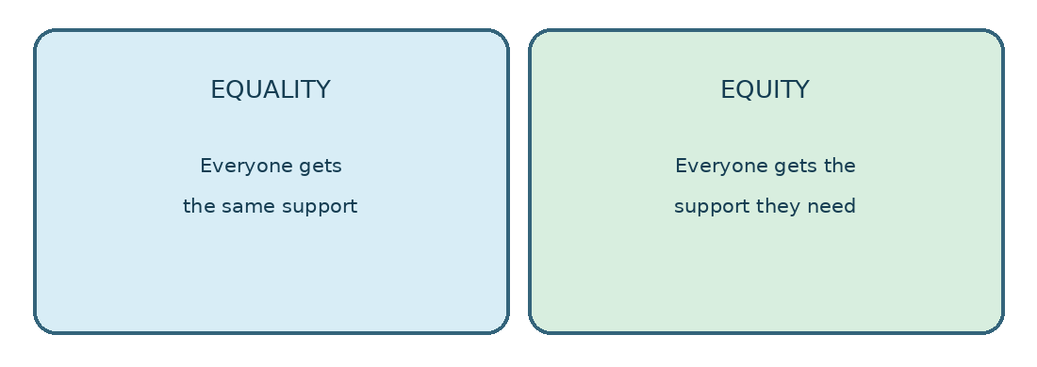

3. Respectful Professional
Activity summary: Practising active listening, appropriate communication and respect for people with different experiences.
My reflection: The Respectful Professional activity made me think about how my words and behaviour affect other people. Respect is not only about being polite. It also means listening without interrupting, keeping promises and avoiding quick judgements. People may have different cultures, beliefs, experiences and communication styles. I learned that I should not assume that my way of doing something is the only correct way. Tajfel and Turner (1979) show how group identity can affect how people see others. This reminds me to notice my own assumptions. For example, when someone disagrees with me in a team meeting, I should ask questions and understand their reason before replying. Tervalon and Murray-García (1998) describe the importance of cultural humility. I can use this by staying open to learning from others. In future work, I will try to give constructive feedback, communicate calmly and make people feel that their views are taken seriously.
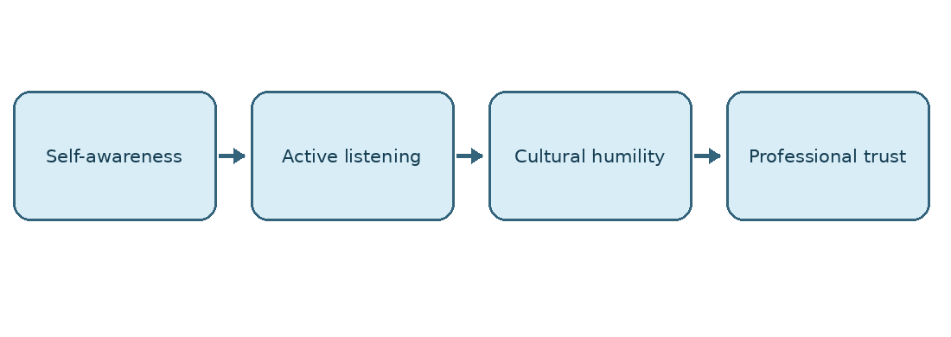

4. Inclusive Team Collaborator
Activity summary: Considering how teams can share decisions, manage disagreement and make good use of different ideas.
My reflection: The Inclusive Team Collaborator activity showed me that a team is stronger when different people can share their ideas. However, diversity alone does not guarantee good teamwork. Some members may speak often while others stay quiet. I learned that a team needs clear rules, shared goals and opportunities for everyone to contribute. Tuckman (1965) explains that teams develop through stages and may experience disagreement. I now understand that disagreement can be useful when people remain respectful. For example, in a community project, the team could invite each person to speak before making a decision. It could also offer written feedback for people who prefer not to speak in a large group. Janis (1972) warns about groupthink, when people agree too quickly without checking other options. In future teamwork, I want to listen to quieter members, explain decisions and share responsibility. This would help the team make choices that reflect different community needs.
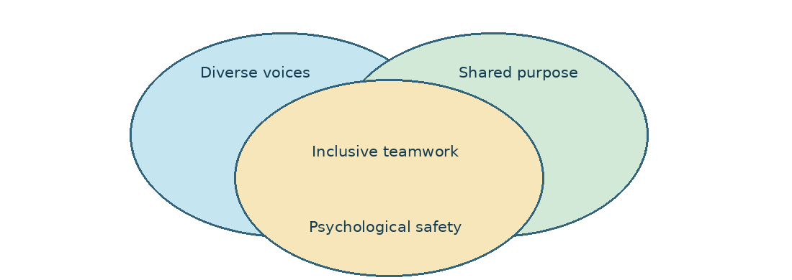
Evidence note: The completed Moodle credential must be added in the appendices. The diagrams above explain ideas; they are not Moodle evidence.

PART B: REFLECTIVE COMMENTARY (approximately 1,000 words)

1. Introduction
Social enterprises aim to help communities while running activities that can continue over time. They need to act fairly, respect people and listen to different views. This commentary reflects on four learning areas: inclusion, equality, respectful communication and inclusive teamwork. It uses ideas from academic authors and explains how I could apply them in a social enterprise. The reflections describe what I learned from the portfolio topics; they should be checked against my own completed Moodle activities before submission.

2. Inclusion and psychological safety
At first, I thought inclusion mainly meant letting everyone join. I now see that joining and belonging are different. A person may be present at a meeting but still feel unable to speak. Edmondson (1999) calls psychological safety the shared belief that people can take interpersonal risks without fear. This matters when a team needs honest ideas or wants to learn from mistakes. Thomas and Ely (1996) also show that organisations need to value differences, not simply count how many different people they employ. In practice, a community group might have members with different ages, languages and abilities. A leader should use accessible rooms, plain language and different ways to contribute. I also need to ask whether people actually feel included, rather than assuming that a good intention is enough. A limitation is that changing a meeting format does not remove every barrier. Listening and improving must continue.

3. Equality, equity and fair opportunities
The Equality Champion topic helped me understand why treating everybody in exactly the same way can sometimes create unfair results. Equality is important because people should have the same rights and opportunities. Equity asks what extra support may be needed to make those opportunities real. Rawls (1971) argues that fairness must take disadvantage seriously. For example, a social enterprise offering training could provide travel help, accessible materials or flexible times. These adjustments may help people who would otherwise be excluded. However, a fair approach also needs clear rules and responsible use of limited money. It would be wrong to promise support that an organisation cannot provide. I would begin by speaking to participants and finding out what stops them attending. I would then review which changes are possible and measure whether they improve participation. This is better than assuming that all people need the same solution.

4. Respect and ethical behaviour
Respectful working is more than speaking kindly. It means taking responsibility for decisions, being honest and considering how other people experience our actions. Tajfel and Turner (1979) explain that people often identify with groups, which can affect their opinions of others. This reminds me that unconscious assumptions may influence whom I trust or listen to. Tervalon and Murray-García (1998) encourage cultural humility: professionals should keep learning instead of believing they already understand every culture. In a community project, I could ask open questions, avoid stereotypes and explain why a decision was made. I should also protect private information and avoid making promises I cannot keep. Carroll (1991) describes different responsibilities of organisations, including ethical responsibilities. For a social enterprise, doing the right thing should be part of everyday work, not something considered only when a problem occurs. A difficult situation may involve different people wanting different outcomes. In that case, I would listen to the people affected, consider the evidence and explain the decision fairly.

5. Working well with different people
The Inclusive Team Collaborator topic showed me that a successful group needs more than talented members. People need to understand the task, feel respected and share responsibility. Tuckman (1965) describes how groups can move through stages that include conflict before they work effectively. This helped me see that disagreement is not always negative. It can reveal a problem that the team has missed. At the same time, Janis (1972) warns that groupthink can lead to poor decisions when people avoid questioning the majority. West (2012) explains how effective teamwork depends on clear goals and good team processes. In practice, I would invite different opinions, give quieter members time to speak and record agreed actions. I would also check whether tasks are shared fairly. One risk is that a discussion can take too long when everyone has different views. A useful response is to agree on a clear decision-making process before the discussion begins.

6. Applying the learning in a social enterprise
These four areas connect closely in a real organisation. Imagine a small social enterprise that offers practical support to older residents. Inclusion means asking older people what they need and making the service easy to use. Equity means offering suitable support to people who face extra barriers, where resources allow. Respect means listening carefully, protecting privacy and avoiding assumptions about age or ability. Inclusive teamwork means involving staff, volunteers and service users in improving the service. Gibbs (1988) offers a reflective cycle that can help review what happened, what worked and what should change. For example, if few people attend a community meeting, the team could ask why, test a different location or time, and review the result. The main lesson for me is that responsible practice needs evidence and action. Good values matter, but the organisation must also check whether people experience real benefits. I would collect simple feedback from service users and staff, such as whether appointments are accessible and whether people feel listened to. I would compare this feedback with the organisation’s goals and discuss any problems openly. If a change helps one group but makes access harder for another, the team should reconsider it. This would make reflection practical and help the organisation improve over time.

7. Conclusion and personal action plan
This portfolio has changed how I think about professional responsibility. I have learned that inclusion requires belonging, equity requires attention to different needs, respect requires self-awareness and teamwork requires space for different voices. I still need to develop these skills through real activities, not only reading. My next steps are to ask for feedback after group tasks, use accessible communication, question my assumptions and reflect on difficult decisions. I will also review my progress using Gibbs’ (1988) approach. These actions can help me become a more careful and responsible practitioner in social enterprise and community work.

REFERENCES
Carroll, A.B. (1991) 'The pyramid of corporate social responsibility', Business Horizons, 34(4), pp. 39–48.
Edmondson, A. (1999) 'Psychological safety and learning behavior in work teams', Administrative Science Quarterly, 44(2), pp. 350–383.
Gibbs, G. (1988) Learning by Doing: A Guide to Teaching and Learning Methods. Oxford: Oxford Polytechnic.
Janis, I.L. (1972) Victims of Groupthink. Boston: Houghton Mifflin.
Rawls, J. (1971) A Theory of Justice. Cambridge, MA: Harvard University Press.
Tajfel, H. and Turner, J.C. (1979) 'An integrative theory of intergroup conflict', in Austin, W.G. and Worchel, S. (eds.) The Social Psychology of Intergroup Relations. Monterey, CA: Brooks/Cole, pp. 33–47.
Tervalon, M. and Murray-García, J. (1998) 'Cultural humility versus cultural competence', Journal of Health Care for the Poor and Underserved, 9(2), pp. 117–125.
Thomas, D.A. and Ely, R.J. (1996) 'Making differences matter', Harvard Business Review, 74(5), pp. 79–90.
Tuckman, B.W. (1965) 'Developmental sequence in small groups', Psychological Bulletin, 63(6), pp. 384–399.
West, M.A. (2012) Effective Teamwork: Practical Lessons from Organizational Research. 3rd edn. Chichester: Wiley-Blackwell.

APPENDICES: MOODLE CREDENTIAL EVIDENCE
IMPORTANT: Insert your genuine completed Moodle credential or screenshot under each heading. These pages are placeholders, not evidence of completed activities.

Appendix 1: Inclusion Advocate
Activity 1 – Scenario Analysis: answers to the three scenarios (screenshot provided).
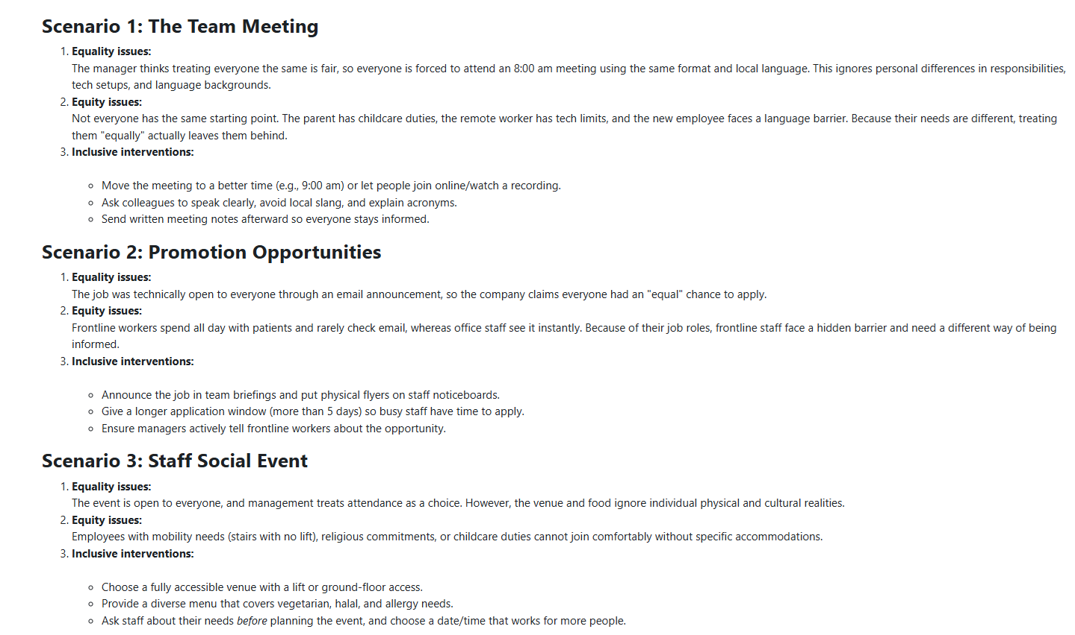
Note: This is evidence of activity work, not an official credential certificate.

Appendix 2: Equality Champion
Activity 2 – Equality Act 2010 Essentials: Moodle forum submission and responses (screenshots provided).
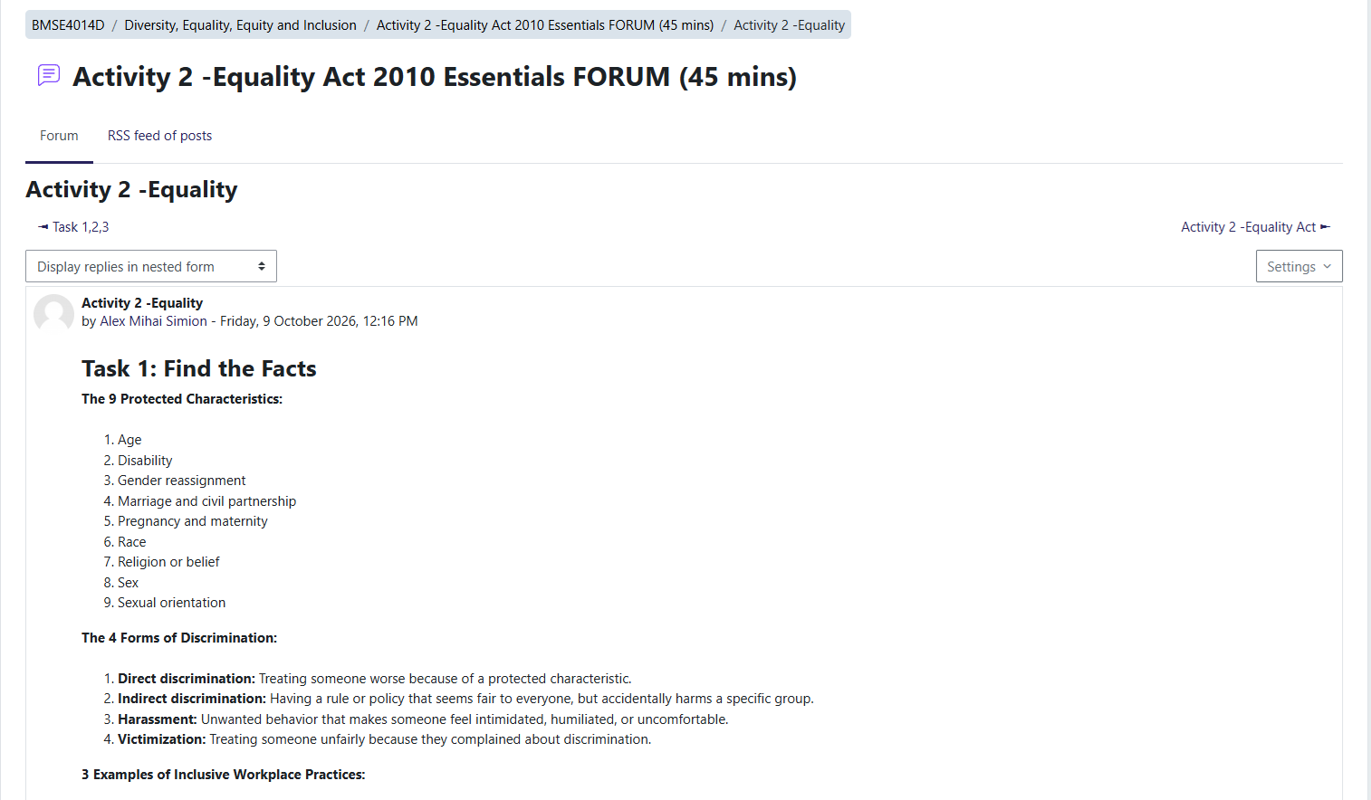
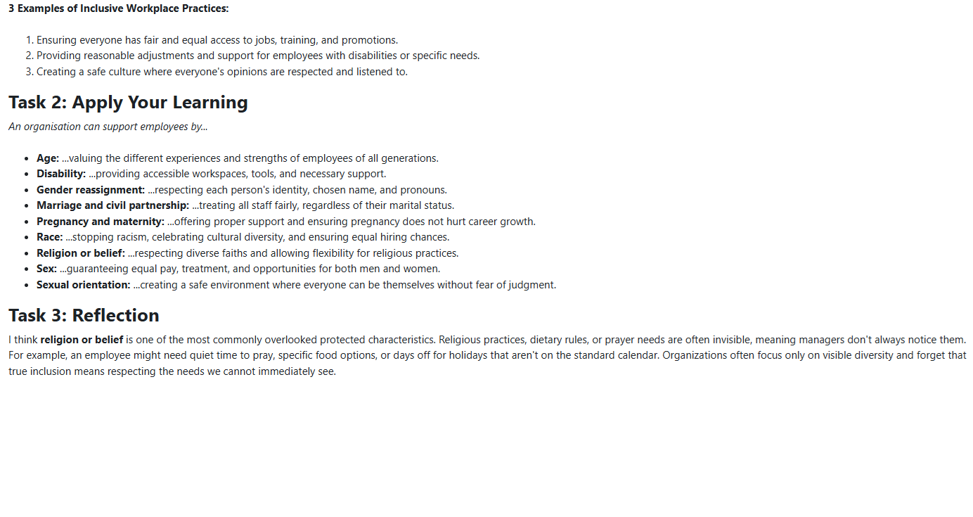
Note: This is evidence of activity work, not an official credential certificate.

Appendix 3: Respectful Professional
Activity 3 – Personal Experience of Inclusion or Exclusion
(screenshots provided).



