A critical assessment of “Towards a creative approach in subtitling: a case study”

Yuan Liang
2100055@student.uwtsd.ac.uk

1. Introduction

Some well-known foreign films and TV shows, such as the Japanese anime series Burst Angel and American TV show Rupaul’s Drag Race, subtitled by the fansub groups, received great popularity among the target audience. When watching these programmes, I am fascinated by not only the charm of the foreign cultures. What also interest me is the creative ways in which the translators have done the subtitling. For instance, in the Japanese animated film, Burst Angel, the translators resort to dynamic writing in the karaoke-driven titles which appear in the center of the screen, although some translation theorists argue that, “The true translation is transparent, it does not cover the original” (Stolze 1997:35); “subtitles should ideally blend in with the film in such a way that the viewer doesn’t notice them and they must never distract the viewer from the story” (Subtitling International UK, 1994:3). The kind of subtitling by the fansub groups obviously do not apply these theories and deviate significantly from the traditional conventions of subtitling that are commonly practiced by the mainstream or commercial subtitling industry. However, despite the wide controversy and criticism such translation arouses, it has been received quite well among the targeted audience and is becoming a new trend in the translation profession.

Therefore, it is my interest to investigate the kind of translation phenomena that interrogates the traditional translation conventions in the digital era. The article I choose is Towards a creative approach in subtitling: a case study by Anna Foerster from Imperial College, London, UK, in which she aims to discover “whether aesthetic subtitling has the potential to become a professionally recognised approach and to illustrate the requirements that are needed for such recognition”. In my essay, I am going to critically assess this article in terms of its theoretical considerations, methodology and results and relevance to theory.

2. Theoretical considerations:

Challenging The Translator's Invisibility

The author geniusly brings forward her argument by challenging traditional theory of Translator Invisibility. The conventional subtitling standards, based on the A Proposed Set of Subtitling Standards in Europe (Karamitroglou, F. 1998), have dominated the subtitling industry till today. A set of rules proposed in the document regulate the colour, the typeface, maximum characters per line, minimum and maximum of seconds the subtitles appear on screen. Subtitling based on these regulations aim solely to understand what is being said on screen and never draw attention to subtitles themselves, making the subtitlers’ work invisible.

To justify the fansub’s subtitling that is against the above-mentioned conventional practice, Anna Foerster successfully applies the argument that “Translator's invisibility is an illusion” by the renowned translation theorist Lawrence Venuti (1995:12):

“A translated text, whether prose or poetry, fiction or non-fiction is judged acceptable by most publishers, reviewers, and readers when it reads fluently, when the absence of any linguistic and stylistic peculiarities makes it seem transparent, giving the appearance that it reflects the foreign writer‟s personality or intention or the essential meaning of the foreign text – the appearance, in other words, that the translation is not in fact a translation but the “original”. [...] What is so remarkable here is that this illusory effect conceals the numerous conditions under which the translation is made, starting with the translator‟s crucial intervention in the foreign text.”

Anna Foerster effectively expands the theory to the audiovisual context by arguing that subtitling shifts spoken language to written language from the auditory to the visual channels of communication, so one could never give the illusion of the other. Also, subtiltes cannot possibly be invisible as they always intrude into the visual space of a screen.

Fansubbing conventions

Then, the author introduces the fansubbing theories. First, Anna quotes Díaz Cintas and Muñoz Sánchez (2006:51) as saying: “Fansubs share some of the characteristics of professional subtitling but they are clearly more daring in their formal presentation, taking advantage of the potential offered by digital technology.”

Secondly, she introduces Pérez González’s (2006:270-1) study that gives a more detailed description of fansubbing conventions. In Pérez’s study, he contends that subtitlers should ensure it is a top priority that the visual mode of the subtitles is compatible with the aesthetics of the programme; subtitlers can use different types, styles, sizes and fonts in an aesthetics manner. For instance, fansubbers can use glosses at the bottom as well as “headnotes‟ at the top of the screen. This strategy is echoed by Nornes (1999:32) who believes that “headnotes‟ help fansubbers to deal with untranslatable cultural concepts, which can appear virtually anywhere of the screen.

At last, the author brings about her own argument by illustrating examples of the unconventional subtitling in some mainstream TV productions and advertisements. For instance, in the advertising - Carlton Draught‟s Big Ad, in which a chorus are singing the advertisement text Big Ad to the melody of O Fortuna taken from Carl Orff’s Carmina Burana, the subtitles show on screen like karaoke subtitles with words appearing on the screen rhythmically as they are being sung. When emphasizing words, for instance “HUGE” (Figure 1), they resort to capital letters, and they use longer rhythms with multiple letters, like “bloooooooody” (Figure 2):
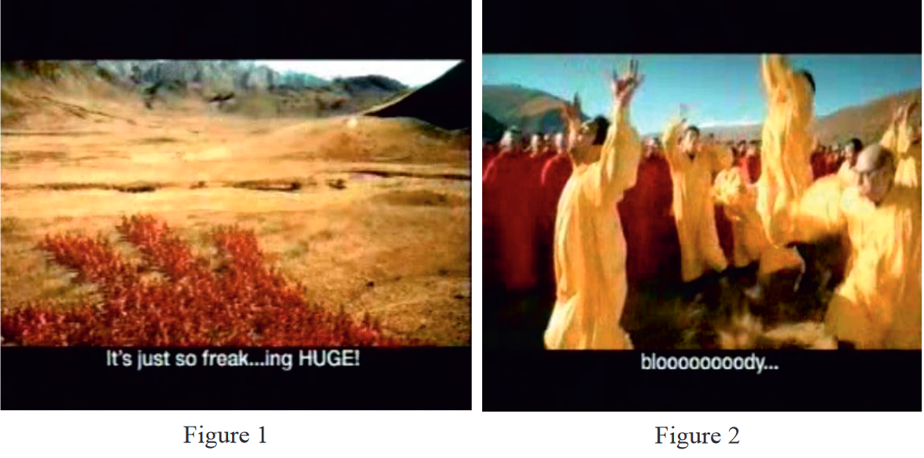
These ways of subtitling attract people’s eyes to the subtitles through aesthetic means that make use of all kinds of semiotics. Therefore, the author names the form of subtitling “aesthetic subtitling” and argue that “in aesthetic subtitling the subtitles are predominantly designed graphically to support or match the aesthetics of the audiovisual text and consequently develop an aesthetic of their own.”

3. Methodology

To explore the ways of doing aesthetic subtitling and their advantages and weaknesses, the author conducts a case study on the Russian fantasy action thriller Night Watch, directed by Timur Bekmambetov in 2004. Rather than the linguistic aspects, she focusses on the technical issues and special effects. This is because the subtitles feature the special effect that is realized through digital technology, which has provided utmost technical means of making aesthetics in subtitling possible. More importantly, it matches the aesthetics of the audiovisual text that is graphically designed using digital technology. The author does not totally pander to the film subtitling’s popularity amongst the audiences and critics. Rather, she assesses the subtitling against the Code of Good Subtitling Practice as put forward by Ivarsson and Carroll (1998:157-9).

She first measures the reading speed of the subtitles. After that, she examines the special effects of subtitles in terms of Diegetic Subtitle Design, Stylistic Subtitle Design, and then, evaluates the subtitling in an overall manner.

Temporal considerations

To measure if the reading speed is scientifically designed and the audience can receive it in a comfortable way, she reproduced the same in and out times as the original subtitles as well as their line breaking and positioning on screen, using a subtitling programme (WinCAPS). A total of 1,139 subtitles are calculated, which are more than average number of an action or horror movie. It is also observed by the author “Whenever a character in Night Watch starts to speak, a new subtitle comes in.” This has created a high number of subtitles, which renders reading speed of 190 wpm and higher, often way above 230 wpm speeds, an extremely high throughout the film.

According to the Code of Good Subtitling Practice, the cueing of the subtitles should “leave two to four – sometimes even up to six – frames between subtitles to make it easier to distinguish between individual subtitles” (ibid.:76). A number of the subtitles in this film either left no space or too many frames in between. The author also observes that the in and out times before and after shot changes are irregular which is not in line with the standard subtitling practice. Such nonstandard subtitling practice results in a very irregular rhythm which is hard for the audience to follow. Good subtitling should have a rhythm that is relaxing and comfortable to the eye and matches the rhythm of the film.

Based on the above observations, the author concludes that the subtitling in the film have not been done by professionals, who understand the underlying reasons for the conventions applied in standard subtitling practice.

Special effects

Again, by assessing all the subtitles against the Code of Good Subtitling Practice, she finds that around 30 percent of them deviate from the Practice, with regards mainly to the layout. Then she separates the subtitles that are apparently related to the plot and have diegetic function (e.g., Figures 3–6), from those that suit the aesthetics of the picture composition of the film (e.g., Figures 7–10). The author names the former Diegetic Subtitle Design and the latter Stylistic Subtitle Design.

Diegetic Subtitle Design
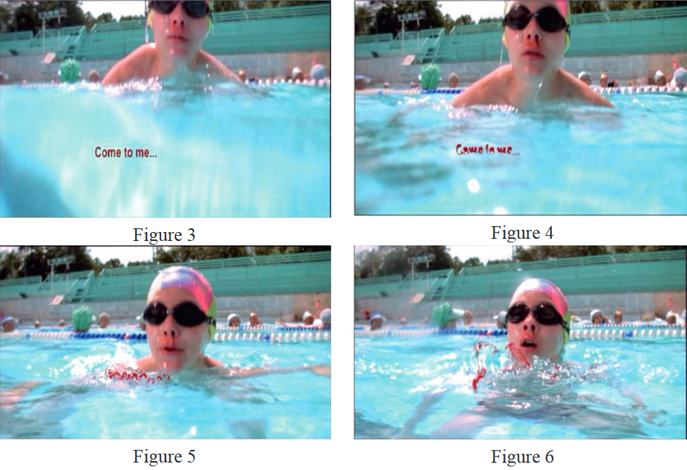
The subtitles (Figures 3–6) in red and in the form of clouds of blood demonstrate a vampire whispering voice. Instead of appearing at the bottom of the screen, they can appear anywhere, even designed to turn into clouds of blood connected to the boy’s nose bleeding.

Stylistic Subtitle Design.
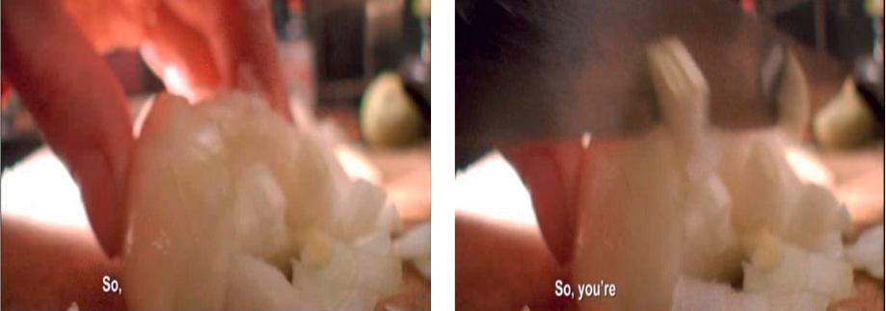
Figure 7 Figure 8
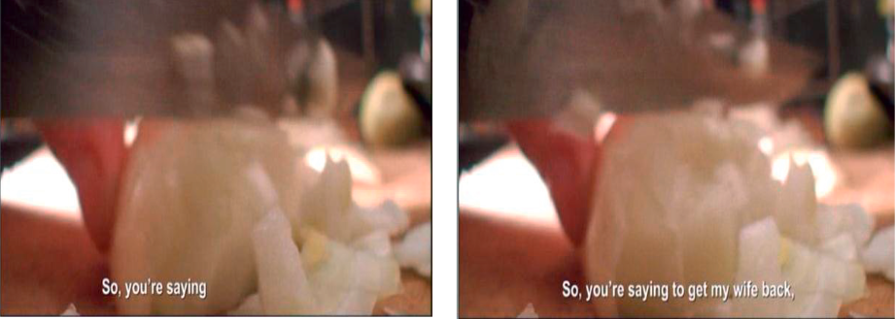
Figure 9 Figure 10
Subtitles in Figures 9–10 are designed as add-on subtitles, which are cued in synchronically with the speakers’ utterance before the previous one has disappeared.

In addition to these, the author illustrates many other kinds of creative subtitle designs. For instance, some take on an outstanding position on the screen; some change their colour to highlight a word; some show a “picture in a picture” effect; some break apart and fly away like swarm of mosquitoes; some move in the same way as a particular object (a hand, a bottle or an owl); some follow the focus of the camera; others even stay on screen longer than the rest of the subtitle.

4. Results and relevance to theory

Based a comprehensive illustration and analysis of the above subtitles, the author reached the following conclusions:

The subtitles in the film are a daring innovation and creative deviation from traditional practice and they are well executed. However, they are not without their major weaknesses. More efforts need to be made to strike a balance between the strengths and weaknesses of the conventions and the innovations. This is obvious regarding the high reading speeds and the lack of rhythm, caused by the chaotic subtitle cueing. Therefore, breaking the rules for reading speeds and subtitle cueing would results in loss of quality.

The author affirms the interesting idea of aesthetic subtitling. But then she argues that subtitlers need to improve a simply aesthetic way to a creative subtitling way. The former is far enough from the latter because “The evaluation of a creative solution is thus based on two pillars: the awareness of a problem, as innovations generate out of discontent; and sensibility, as innovations have to meet certain parameters and norms to eliminate the discontent and to be regarded as satisfactory by experts” (Kußmaul, 2000:17). The Night Watch can be regarded as a creative product if it is judged by the first criteria. However, it does not meet the second criteria.

Then, she applies the same argument on the overuse of different designs that appear rather irregular or unpredictable and seem to be implemented for the sake of techniques. To produce real creative subtitling, we need to combine aesthetics with the standard subtitling practice that are proven to be sensible.

5. Concluding remards

The conclusion part of “Towards a creative approach in subtitling: a case study” overlaps a lot with the Evaluation that is a part of methodology, making information a bit confusing and messy. It would be clearer if the author could integrate these two parts into one. But generally, this article originally examines the new trends in subtitling profession and discusses the aesthetic aspects found in subtitles. Another weakness is that the article focuses solely on the technical side of the subtitling. I would argue that creative subtitling approach has a wealth of issues to address regarding the linguistic and cultural aspect. It is a promising field of study in translation studies to open up new space and is worth more investigation.

Reference

Díaz Cintas, Jorge (2010) “The highs and lows of digital subtitles”, in Lew N. Zybatow (ed.) Translationswissenschaft – Stand und Perspektiven. Innsbrucker Ringvorlesungen zur Translationswissenschaft VI. Frankfurt am Main: Peter Lang, 105-30.
Díaz Cintas, Jorge and Aline Remael (2007) Audiovisual Translation: Subtitling. Manchester: St Jerome.
Kußmaul, Paul (2000) Kreatives Übersetzen. Tübingen: Stauffenburg.
Pérez González, Luis (2006) “Fansubbing anime: insights into the “Butterfly Effect of globalisation on Audiovisual Translation”. Perspectives: Studies on Translatology 14(4), 260-77.
Venuti, Lawrence (1995) The Translator‟s Invisibility. London: Routledge. Stein, Morris I. (1953) “Creativity and Culture”. Journal of Psychology: Interdisciplinary and Applied 36, 311-22.
Willberg, Peter and Friedrich Forssman (1997) Texttypographie. Mainz: Hermann Schmidt

