Lecture: Nadeem Mirza

Student: Vanya Dragneva Student N0-2010312 Assessment 1- Organisational Structure and Culture Business Management- Level 4
Module Code- LCBB4003, Introducing the Modern Workplace

Report: Organisational Structure and Culture in Tesco

Assessment 1

Content Page:
1. Executive Summary…………………………………………………………………..p. 1
2. Introduction………………………………………………………………………………p.1-2
3. Main body………………………………………………………………………………….p.2-8
4. Recommendations……………………………………………………………………..p.9
5. Conclusion………………………………………………………………………………….p.9
6. Reference list……………………………………………………………………………..p.9-10

1. Executive Summary:
Tesco as the largest UK retail store has memorable moments and deep falls in the market involving a large number of employees. In the most problematic and troubled time were born some of the most brilliant ideas and underlining changes have taken place. Proving that the difficult times are the best for initiating change and giving the indication of the respective problem Tesco has done its part. Through their performance, analyzing the methods and looking at the organizational structure and culture will provide a deep understanding of the company statement and results achieved in the latest years.

2. Introduction
Tesco is a global supermarket that is the largest in the UK with a staff of more than 300,000 members and operates in 12 countries across Asia, Europe and North America (Daily Mail 2020). Their mission declares –,, to be the champions for the customers ’’and their purpose is to keep serving customers a little better every day (Annual report, 2020). Tesco offers not only groceries but homeware, consumer electronics and maintained effectively more than 3,400 stores and online trade.
At the beginning of all, the first shop has opened in East London in 1919 by Sir Jack Cohen and has great success, therefore started the business in other countries. The business strategy of the multinational is based on highly professional leadership and extremely customer-focused. Although their success the company have risen issues such as poor financial performance and overstatement of commercial income.
3. Main Body
Aim and objectives
The core purpose of Tesco is outlined by their statement above and besides, they said that is helping the customers to enjoy life with better quality in an easy way. (Annual Report,2020 ) The SMART goals are essential and well- applicate as they are a profit organization seeking to supper their competitors.
Organisational Structure of Tesco
According to (Millins, 2017, p.472) the most effective way to describe any organization is to be outlined its structure. Tesco has a highly tall hierarchical structure reflecting the large size of the company. In this kind of structure, positions and obligations are separated into different and many sections to make sure the process is going smoothly and effectively. 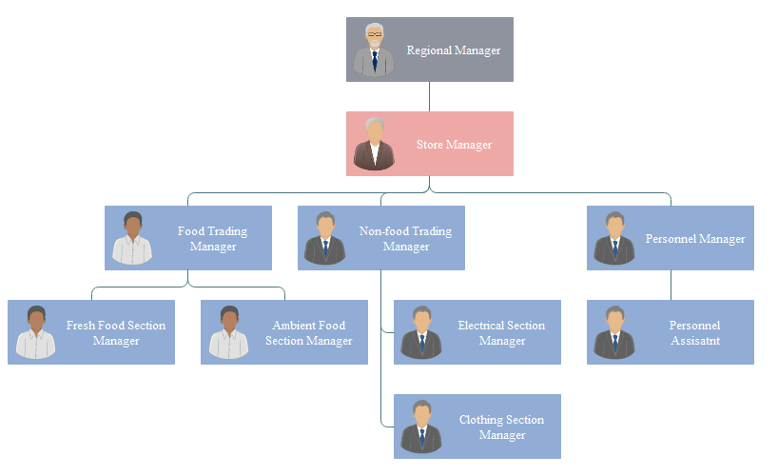 Source: Tesco organizational structure at store level

The most specific principles of the structure within the organization are the hierarchy, the span of control and the chain of command.
Hierarchy
The hierarchy is vitally important to outline the levels of authority and consequently the coordination and control processes in such a size business. The final authority in Tesco is the Regional Manager and for him have to be taken the final decision and it is expected to be obeyed. Besides, it important to note that not every Tesco store is operating in the same way. It depends on the location, size and other specific store factors. According to (Drucker,1999, p.11),, the need for a properly implemented hierarchy is irreversible’’ but could be argued if it used properly and if does not emerge barriers and lack of equinox within the organization. Moreover as is noted by ( Mullins, 2017,p, 460) Cloke and Goldsmith questioned that as employees whether we are accustomed to accepted hierarchy, rules and managers as essential pieces of the organizational life?
Span of control
This design principle, accordingly( Mullins, 2017, p.460) consigns to how many workers need to inform straight to their managers. In case that it is too narrow, subordinators might suffer from too close supervision and this will affect their morale and finally might harm the performance. Tesco is trying to balance the tasks and the span of control, but as a whole, it supports a narrow span of control. Noted that the span of control is very influenced by factors such as the nature of the organization, the score of responsibilities and complexity of work and it is closely related to the organizational culture in Tesco.
Chain of command
Chain a command provides the framework for authority and responsibility within the organization. Every employee has to know their position within the company. This principle is implemented in Tesco and it might notice that is wide, especially in the large stores and could cause a bureaucracy and be a reason to slow down the decision-making process.

Organisational Culture in Tesco
According to (Schein, 2016) culture is a complex of beliefs, values and understandings which are shared within the organization. They are values that define how the members should act, think and performed within the company. It is the personality of the organization and according to Buchanan, David A (2013 p. 107) and its functions are:
- Shaping the image on the organization
- Influence the effectiveness
- Leading the company on chosen direction
- Helps to motivate, attract and retain the workers

Tesco is multi-cultural because operates in diverse countries influenced by their own national culture, although its organisational culture is clearly expressed in their statement, aims and objectives.
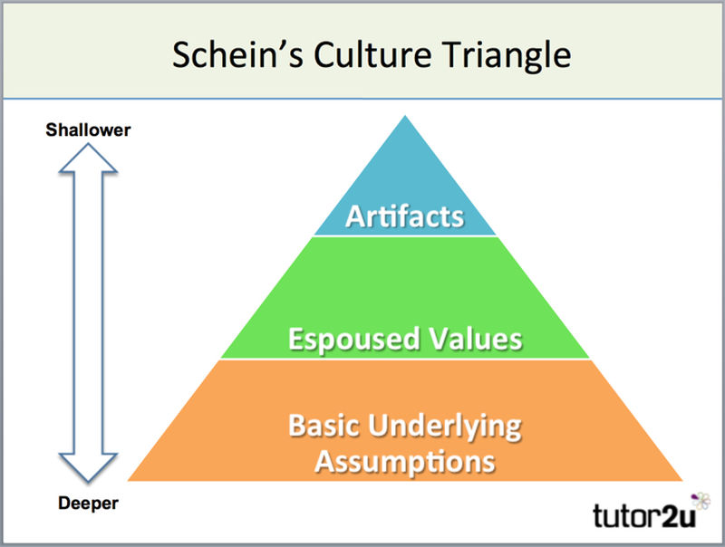
Source: Tutor2u
There are different levels of culture that can be developed within the company such as national, corporate, professional culture and culture and management. It’s complex and complicated to be identified which one of them in Tesco and there is an important part of the company performance results. The main influences of the cultural organization are at the Macro level such as laws and economic institutions in different countries where Tesco operates. At the Micro level, the firm is influenced through the relationship between employer and employee and as well as the behaviour among employees.
The overall view about Tesco organizational culture is noticeable that their strategy is determined and company goals are established with small differences in the diverse countries. According to (Schein,1999) the personnel of the organization are influenced by their backgrounds and being shared as own values and perceptions they changing the firm culture. It could be said that Tesco has a task-oriented culture and therefore is quite flexible and changing culture.
According to Tesco PLC profile (2020) was an important step in 2016 the management team took a different strategy to stabilize the firm, restore the company and move to higher growth. The result of this remodel was that Tesco had achieved through the strong new platform a new strategic period focus on risen growth, cash profitability and cash flow. The aim of customer satisfaction did not change. This effective management and innovative approach gained Tesco in June 2019 to have vital opportunities in the Capital Markets Day in three areas such as growth, innovation and enabling technology (Tesco Profile 2020).
As noted by Hofstede’s Cultural Dimensions Theory, expand by Geert Hofstede is a framework used to mark the differences in culture across countries and to understand the ways that business is done across different cultures.
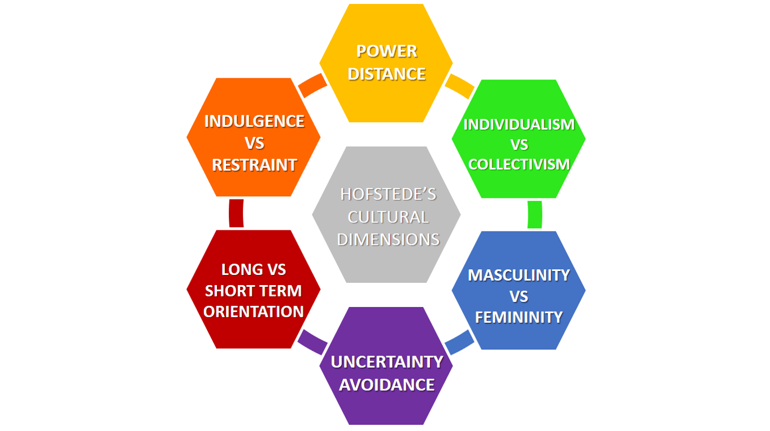
Source: business-to-you (2021)

Tesco performance relating to the organizational structure
The Organisational Structure has to effectively create and maintain the threat between the flatter hierarchy, teamwork, empowerment and working flexible throughout in the whole organization to achieve performance. Variety of operations such as planning, organizing and control have to be distributed among the members as noted Mullins ( 2019,p. 484)
The tall depicted organizational structure in Tesco is very relative to the company performance in many ways. At first, it needed to be noted increasing Profit and Revenue although that the Liabilities are still high.

According to Tesco Annual Balance Sheet (2020)
Assets | Feb2020 | Feb2019 | Feb 2018 | Feb 2017 | Feb 2016
Cash | 3,408.00 | 2,916.00 | 4,059.00 | 3,044.00 | 3,082.00
Total Equity | 13,275.00 | 13,456.00 | 9,160.00 | 6,438.00 | 8,626.00
Shares Outstanding | 9,793.50 | 9,793.50 | 8,192.12 | 8,192.12 | 8,192.12
Total Liabilities | 39,049.00 | 43,466.00 | 43,466.00 | 39,439.00 | 35,288.00

Source: Annual Report Tesco (2020)
For example, in 2014 besides the sales reaching GBP 69.7 billion the retailer has a net loss of GBP 6,4 billion(Annual report, 2015). Therefore, 2014 was noted bad performance within Tesco and a major change was made that relative to leadership positions in the organization. (The Guardian, 2014)
The narrow span of control is helpful in Tesco in the vast stores and is truly fruitful. It could be argued, however, that the working process and organizational performance is different for the small stores and is very diverse in other countries.
The chain of command in the organizational structure is strict and sometimes lack of flexibility even in the smaller shops may be discussed as a negative in the light of the company results. It could be discussed the issue of unnecessary bureaucracy in some huge Tesco stores and the clear evidence of negative implications and as a result poor performance
Tesco performance relating to the organizational culture
Focus on the organizational culture and their relation with the performance could be marked some important aspects. The leader staff is expected to deliver to the subordinated the right percept for the company's culture, therefore is highly important along to achieve the goals as well satisfying the needs and expectations of the workers. Nonetheless creating a healthy organizational climate where people might work effectively and motivated for best performance. Mullins (2019,p. 39 quoted in Gratton,2004) noted that when the workers are dedicated and devoted they possibly behave in the interest of the organization and there is less need to be measured in their work.
It seems that the five elements of the organizational culture have an impact on the results. No doubt that as a commercial company Tesco is seeking effectiveness on the performance which means profit. The Manpower such as having the right employees in the right place and the machinery and technic ate the next important for enhancing effectiveness and revenue, the mechanism which is managed by people and ensure the best results and the money. What is more, this could be seen in the revenue growth in the table below.
According to Tesco Financial Market Data (2020)
Growth | 12 months | 36 months | 60 months
Revenue growth | 1.33% | 5.02% | 2.61%
Source: Annual Report Tesco (2020)

Effects on various factors on individual behaviours
Organisations are made up of people and they influence each other in many ways. Individual behaviour depends on factors such as ability, motivation and opportunity known as AMO factors (Buchanan, David A,2019, p.27). The subordinates as workers can contribute according to their qualification, competence and level of involvement in the company, organizational commitment and job satisfaction. Is truly important an individual ability to adapt rapidly to fast changes within Tesco above all in the huge stores. Highly important is the motivation, the support and opportunity given by managers for continuously skill development and lifetime learning in each area for all at the working ladder.

4. Recommendations
In fact, to improve the results Tesco has to take in mind the effectiveness is a collection of individual, team, structural, managerial and process factors.
Despite that Tesco is a leader in UK retail stores there might be done more about the more flexibility of operations and positive changes in the store to accelerating the flow via and reducing the bureaucracy in the big stores. As well as will be worth having every working team a bit more freedom and get involved in the decisions actively. Another option for improving the results of organizational performance is the core manager practices might be used more widely, give career opportunities, paying their work equitable, implementation of two-way information sharing and so on.
5. Conclusion:
Without any doubt, Tesco as a leading firm in the UK retail market has achieved high results. During the different stages including the pandemic nowadays they still trying to offer and build trust in their customers. Once more they are willing to improve the services and keeping the products in a better way and condition. Despite the difficulties and ups and downs of the performance, Tesco continues to want to be the champions for the customers. The review of all information above about their performance connected to the organizational structure and culture is the sum of their prominent behaviour in the market place.
6. Reference list:
1. Annual Report Tesco (2020), Available at: https://www.tescoplc.com/investors/reports-results-and-presentations/annual-report-2020/ (Accessed: 19th March 2021)
2. Annual Report Tesco (2015), Available at: https://www.tescoplc.com/media/1426/tescoar15.pdf (Accessed: 19th March 2021)
3. Buchanan, David A (2019) Organisational Behavior, Available at: https://r2.vlereader.com/Reader?ean=9781292251585# (Accessed:1 April 2021)
4. Butler, S., Farrell, S. (2014). ‘Tesco must change culture and reinvent brand, new boss tells employees’. The Guardian [online]. Available from <https://www.theguardian.com/business/2014/sep/26/tesco-must-change-culture-reinvent-brand&gt. (Accessed: 28th March 2021)
5. Cultural Dimensions (2021) Available at: https://i0.wp.com/www.business-to-you.com/wp-content/uploads/2017/04/Hofstedes-Cultural-Dimensions.png (Accessed: 1 April 2021)
6. D&B Business Directory, Available at: https://www.dnb.com/business-directory/company-profiles.tesco_plc.048e2e08d67eb84d4832c4445213ebe6.ht (Accessed: 28th March 2021)
7. Drucker, P. F. Management Challenges for the 21st Century, Butterworth-Heinemann (1999), p. 11.
8. Managing Organisational Culture: Tesco, Available at: https://culclopezbee.wordpress.com/2017/12/07/managign-organisational-culture/(Accessed: 28th March 2021)
9. Mail Online (2020) Available at: https://www.dailymail.co.uk/news/article-9099839/Tesco-tops-list-firms-failed-pay-staff-minimum-wage.html (Accessed: 21th March 2021)

10. Models of Organisational Cultire - Schein(2021),Available at: :https://www.tutor2u.net/business/reference/models-of-organisational-culture-schein (Accessed: 26th March2021)
11. Mullins, LJ, & McLean, JE (2019), Organisational Behaviour in the Workplace, Pearson Education
12. Tesco Company chart (2017), Available at: https://www.orgcharting.com/tesco-company-organisational-structure-chart-example/ (Accessed: 19th March 2021)
13. Tesco PLC Report, Available at: https://research-methodology.net/tesco-plc-report-6/ (Accessed: 19th March 2021)

14. The Guardian (2017), Available at: https://www.theguardian.com/business/2017/mar/09/tesco-payroll-errors-national-minimum-wage (Accessed: 28th March 2021)

