Multidisciplinary Telehealth Solution to Manage Swallowing Difficulties of Residents in Care Homes
System Improvement Programme Assignment
Sheiladen Aquino
2115317
Problem Domain

The aging population in increasing faster than in the past. Globally, there are 703 million people aged 65 years old and older in 2019 (World Bank, 2019). It is predicted that by 2050, this is to increase to 1.5 million. In the UK, around 19% of the population or nearly 12 million are aged 65 and above (Age UK, 2019). This is also expected to double by 2035. Wales has the highest proportion of older people compared to other nations in the UK (Age Cymru, 2021). It is projected that by 2038, 1 in 4 of the Welsh population will be over 65. In addition, people aged 75 and over are projected to increase from 9.3% to 13.7% in 2038 (Welsh Government, 2020).

The implications of having an aging population suggests that the number of both chronic and long-term illnesses will increase. 58% of people over 60 have long term conditions or chronic diseases that places them in the vulnerable category (Barnett et al., 2012). The elderly population are more likely to experience several complicated medical conditions at the same time which is commonly called geriatric syndromes (Inouye et al., 2007). They often result from multiple underlying factors that includes frailty, urinary incontinence, falls, functional decline, cognitive impairment, delirium and pressure ulcers. Common conditions in older age include hearing loss, cataracts, back and neck pain resulting from osteoarthritis, chronic obstructive pulmonary disease, diabetes, depression, dementia and oropharyngeal dysphagia or difficulties with swallowing (World Helath Organisation, 2021).

The European Union Geriatric Medicine Society, recognized oropharyngeal dysphagia as a geriatric syndrome in the European Union Geriatric Medicine Society (Baijens et al., 2016). Oropharyngeal dysphagia pertains to any disruption of the swallowing process that leads to difficulties with eating and drinking. It is characterised by impaired preparation and transit of food or liquid from the mouth to the stomach. It can be due to age-related changes in the swallowing mechanism due to loss of muscle mass and strength. It is known to precipitate malnutrition and affect compliance with medication that can significantly reduce quality of life. It can cause severe malnutrition, respiratory infection, increased readmissions, dehydration, institutionalization, aspiration pneumonia and potential death (Cichero and Altman, 2011).

Oropharyngeal dysphagia is an important health concern for elderly populations as this is it is highly prevalent among older people. It is estimated that it affects up to 13% of adults aged 65 and 11.4% of ‘healthy’ community dwelling older population (Madhavan et al., 2016). Particularly vulnerable to dysphagia are individuals with cognitive impairment and those residing in assisted-living facilities, of which at least 50% experience swallowing difficulties on a daily basis (Nawaz and Tulunay-Ugur, 2018; Chen et al., 2020; Kelly et al., 2020; Chen, Kent and Cui, 2021)
Oropharyngeal dysphagia matches the definition of a geriatric syndrome as it is a complex condition that significantly affect quality of life, with social and psychological consequences. It is crucial to detect dysphagia early and requires a multi- disciplinary approach with involvement from at least the primary care physicians, geriatricians, carers, nurses, speech and language therapists, dietitians and pharmacists (Martino and McCulloch, 2016; McGinnis et al., 2019).
It is therefore, important that care home staff should be trained to identify presence of dysphagia, provide immediate care and refer to specialist multi disciplinary input (Davies, 2002; McGinnis et al., 2019). To prevent complications from dysphagia in nursing home residents, Park et al., (2013) recommended systematic screening and evaluation programs for care home residents with dysphagia by multidisciplinary teams. However only a few care home staff are trained to provide current evidence based dysphagia management.
As the number of people aged 65 and over in Wales is projected to increase by 232,000 (36.6 per cent) between 2016 and 2041, this is one of the increasing issues in the region that can put high financial costs for the patient & the health service (Griffiths and Brock, 2003). This trend is already being seen as the referrals for specialist dysphagia assessments has almost doubled in the Bridgend areas in the last few years for Speech and Language Therapists, Dietitian and Pharmacy. Speech and Language Therapists (SLTs) diagnose dysphagia, provide treatment and recommend safest diet & fluids to reduce risk. Dietitians assess, diagnose and treat dietary and nutritional-related problems to promote good health. Nutrition assessments may aid in decreasing dysphagia-related complications (Wall et al., 2016). Swallowing difficulties are common and can affect patients' ability to take oral medications, thus compromising medication adherence. Marquis et al., (2013) report a fairly high prevalence of swallowing difficulties in polypharmacy patients. Pharmacists advise nursing staff, carers and other healthcare professionals on how to prepare medicines for residents to swallow safely.
Care home residents are often unable to access timely integrated specialist services required to effectively manage their eating and drinking difficulties; potentially causing more distress in the longer-term. Care home staff need approval from the patient’s Primary Care Physician to make any dysphagia referrals. They would then need to make separate referrals for speech and language therapy, dietetics and pharmacy. This increase waiting times and residents at times need to be on multiple waitlists before they can be seen. Figure 1 shows a current pathway diagram of multiple referrals and reduplications of tasks by the three allied health professionals.

Figure 1 Current Pathway for Multiple Dysphagia Related Referrals in Care Homes
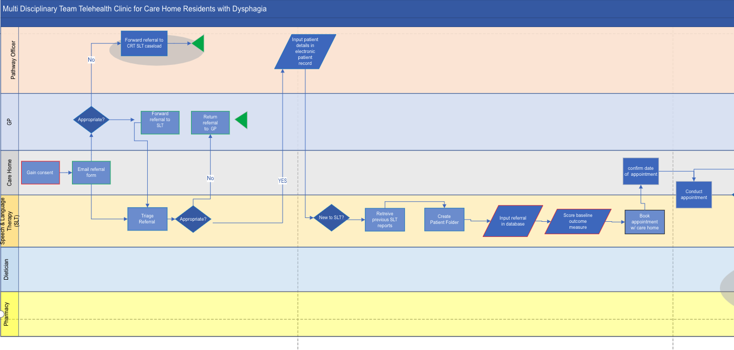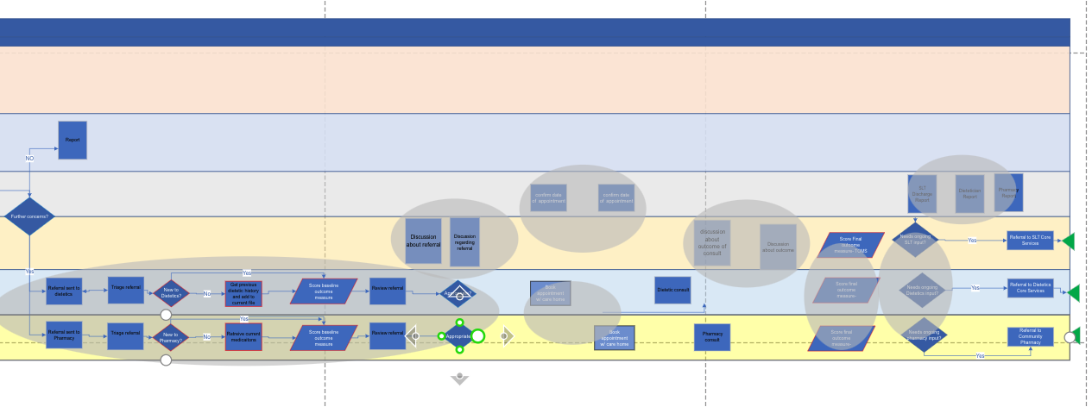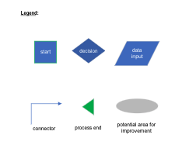

Multiple appointments are expensive as ambulance transport is required and staff needs to be present for each appointment. This could also put strain and fatigue on an already frail and vulnerable population. Multiple appointments can also lead to disjointed care and lack of care coordination that can cause miscommunications with patients, family and carers. This situation is also complicated by reduced health and social care resources that is unable to meet the increasing demands of a complicated swallowing management.

Project Aims and Objectives

The severity and complexity of the problem means that we need to initiate innovative ways to address this gap in care. The need for new care models and technologies that support residents in the care homes has never been greater especially after the covid-19 pandemic. Adopting technological innovations can help challenge the system to focus on timely intervention, prevent further deterioration, support self-care and deliver care to people in their own home environment.

This project has three aims:

- To develop an integrated telehealth pathway between three specialist services namely, Speech & Language Therapy, Dietetics and Pharmacy within the Health and Social Care integrated Care to ensure safe standards of practices across the professions. This will also include safe, ethical and appropriate data pathways in an attempt to design a strategy for multi organizational systemic change. In addition, this will provide a single point of access for three allied health professional services.

- To provide current evidence based training to care home staff to ensure safe practice when referring residents, conducting telehealth consultations and adhering to safe swallowing recommendations and guidelines.

- To conduct remote joint dysphagia assessment using synchronous video consultation software (Attend Anywhere) with the aim to provide a fully integrated
management of swallowing difficulties for residents in care homes.

To contribute to a prudent sustainable recovery, this project will trial a new collaborative model of providing care using a remote telehealth digital solution. This project is a collaboration of allied health professionals at a primary cluster level to create meaningful integration while developing new models of care to ensure that care and support are provided to the right people, in the right place, at the right time. This will explore a new integrated way of working between three allied health professionals in a multi -disciplinary approach from Speech & Language Therapy, Dietetics and Nutrition, and Pharmacy. It will explore and test a novel service process in an attempt to deliver easily accessible high quality care and improved health outcomes for residents in care home who needs specialist swallowing, nutrition and medication support by using a single point of referral.

This project ensures that support is about the whole person and addresses the challenge to provide seamless, holistic and organized around the needs of residents in care homes by Allied Health Professionals. There are approximately 2000 registered care home residents in Bridgend with of which 50-75% are at risk of having dysphagia and high risk of malnutrition. These population are the most vulnerable during winter months and/or a prediction of the next wave of the pandemic. This will help keep people well, give preventive care, promote wellbeing and provide care as close to home as possible and provide capacity to clinicians. This includes integration between the primary care services and community services to support the Covid 19 recovery efforts. By increasing the capacity of community based staff we will support long term physical and mental health conditions, including people living with dementia and long –COVID.

National Clinical Guidelines for good dysphagia and malnutrition prevention evidence based practice supports early identification and management in a collaborative multi-disciplinary context to ensure maximal outcomes and improved quality of life. Dysphagia assessment and management for older people is best provided by the multi-disciplinary team because of the complexities and inter-related nature of their needs. Inappropriate variation of practice is usually evident when this is done in isolation. Training to staff will ensure consistency in practice and standards of care are maintained.

This project proposes an opportunity to explore alternatives to the current service model and ensure consistency and transparency of practice between the 3 disciplines. Through training and collaborative working, this project will also empower nursing home staff to support residents and their families to make shared decision about their health.

In addition, this project will propose a single point of referral to cut bureaucracies and eliminate repetition of tasks in the clinical pathway to ensure a more streamlined and efficient service provision. Documentation will also be provided an integrated digital multi-disciplinary report to ensure clear communication, efficient dissemination of recommendations and any anticipatory care from all disciplines.

Project Management Methodology

The proposed project is a small scale quality improvement project. The Plan-Do-Study-Act (PDSA) cycle is chosen to document the effect of this new intervention and measure change. It has four steps: Plan, Do, Study and Act. The “Plan” identifies the objectives and processes needed to implement the innovation. It identifies tasks, who are responsible to do the tasks as well as when how and where the plan will be implemented. Hypothesis and possible predictions are included in this step. The second step, “Do”, is the actual implementation of the innovation. It also includes all the documentation required to identify, measure and evaluate success as well as record challenges and problems. The “Study” step is collating and analysing the results. This is the time when actual results are compared with previous similar studies and hypothesis is tested. Further information on gain and other acquired learnings are also synthesized and documented. Lastly, “Act” is the step where the researchers will evaluate if the innovation can be adopted, adapted or abandoned. Adapt is to make needed modifications derived from the analysis of the results and run another PDSA cycle. Adopt is when the innovation is to be tested in a larger cohort in an attempt to replicate the results in a bigger context. Abandoned is when no further testing is needed or appropriate. This is also the step where the preparation for the next PDSA Cycle is conducted. (Morelli, 2016; Christoff, 2018; NHS England (NHS-E) and NHS Improvement (NHS-I), 2020).

In contrast to PRINCE 2, this method can be easily applied and is focused on incremental change and not transformation on a large scale. This is persuasive because it focuses on ﻿rapid small-scale tests of change. The strength of this method is its structured experimental approach to testing changes and novel processes. I believe the most significant aspect of this method is informed action. It could rapidly test and derive quick accessible learnings to identify whether an intervention is feasible in a particular setting. It also has the potential to reveal theories on how to increase the chances of delivering and sustaining the desired results.

However the model also has limitations (Reed and Card, 2016; Knudsen, 2018). It lacks rigor because this method can be oversimplified when used in a complex setting similar to health and social care environment. The process of change and factors affecting it does not always happen in a simple linear path. There are times when events outside the scope of the PDSA method could affect outcomes such as ﻿national or organizational issues. In addition, in order for PDSA to show reliable tests of change, a thorough definition of the problem is needed. There is a danger that frontline health and social care staff who do not have ample time to research and investigate the real source of the problem can have compromised results.

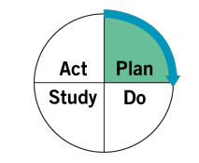

Plan

In planning for the project, I have made a number of steps as specified in the GANT CHART below. I will first finetune the Methodology to clearly identify the problem, produce the project work plan, Key Performance Indicators (KPIs) to be able to write a Project Proposal. I will then approach key decision makers to create a project board that will advice on clinical governance and enser buy-ins and further collaboration with the target partners. During this step, I will also develop a communicaiton plan and stakeholders resource matrix. Although there will be no purcheses required for the project, the costs of professionals invovled will the the primary resources dedicated for the project, thus clear reoles and responsibilites are need to ensure that the value of these resources are maximised. A risk register for the project can also be seen below.

Table 1: Risk Register

Key
Likelihood |  |  |  |  | Rating
1 | Rare |  |  |  | One to four | Low
2 | Unlikely |  |  |  | Five to nine | Moderate
3 | Possible |  |  |  | Ten to sixteen | High
4 | Likely |  |  |  | Seventeen to twenty five | Extreme
5 | Almost Certain
Consequence
1 | Insignificant
2 | Minor
3 | Moderate
4 | Major
5 | Severe
Risk | Likelihood  a | Consequences  b |  | Rating  a x b | Mitigation
Political
Lack of support or opposition to the project from Care Homes | 1 | 4 |  | 4 | The premise of the Challenge is unlikely to be contentious. Senior management of the different stakeholders will be fully involved in the project and will be represented on the project team and Board.
Change in government priorities over the lifetime of the project | 1 | 5 |  | 5 | The priorities this project aligns with is unlikely to change throughout the duration of the project.
Financial
Failure to deliver project within designated/ budgeted allocated time | 1 | 4 |  | 4 | The project team will follow routine procedures and use past experience to deliver on all project elements within the cost envelope for the project. The project manager will oversee the timescale and will report to the project board to ensure the project remains on budget.
External market forces which may restrict the potential to commercialise the solution | 1 | 5 |  | 5 | The project team will work closely with professionals to ensure that the companies are taking into account changes in markets. The project team will also work with Welsh Government advisors to ensure the solution aligns with any changes in the market.
Social
Approval to engage with stakeholders may be delayed or refused | 2 | 4 |  | 8 | Discussions have already taken place with stakeholders that might benefit from the solution and further briefing will take place at the start of the project. This feasibility study is unlikely to raise any concerns at this early stage of the project and an early prototype of the solution is likely to be appealing to the various stakeholders. Stakeholders can raise any concerns about the project during the initial engagement.
Agreements to share information that might be needed for the project may be delayed or refused | 2 | 4 |  | 8 | Initial discussions have already took place to ensure each stakeholder understands the project prior to initiation. Again It is unlikely that stakeholders that will benefit from the solution will oppose the project. The project manager will plan accordingly to ensure any agreements which are required are not delayed.
Technical
Architecture and design does not complement existing systems | 3 | 3 |  | 9 | The architecture will be based on our experiences of working with health care systems and using industry standard development tools. We will also work with the stakeholders closely throughout the project to ensure the architecture and design complement existing systems.
The solution proves overly complex or unachievable in the time scales. | 2 | 4 |  | 8 | The solution will be based on our tried and tested technology. Whilst this platform does not provide all the elements required it provides sufficient time for us to consider the design specification and architecture required to deliver the project on time.
Integration with existing systems may not be possible | 3 | 3 |  | 9 | The Project Manager will ensure of system compliance with agreed data formats and standards. We will also provide workable business models for cooperation with relative platforms.
Privacy & Information security breach | 2 | 5 |  | 10 | The Project Manager will use proven technology for data security, comply with national standards of information security and create an advanced authentication tool.
Organisational and managerial
The size of the project | 3 | 3 |  | 9 | The proposed solution is broad in scope but has been designed to be totally modular with clear milestones in each work package. This will allow effective monitoring and partner engagement as the work proceeds.
Regular engagement with stakeholders may not be possible due to their limited time and resources of staff | 3 | 3 |  | 9 | Stakeholders have expressed an interest to meet again to discuss the solution. Dates have also been set up with some stakeholders to ensure we can gather the required information. The project manager will also coordinate activities to ensure everyone’s time on the project is used efficiently.
Technical resource is not available to complete the project in the required timescales | 1 | 4 |  | 4 | The Project Manager has already identified the required technical resource and placed them on an internal team schedule ready to start the project on time. All team members are aware of the project and have had an input into this document. In addition we will be using a dedicated project manager with the appropriate experience of delivering innovative health solutions to time and budget.
Environmental
Injury to project staff on company or stakeholder site | 1 | 4 |  | 4 | Employ appropriate health and safety procedures. Educate staff in safety procedures for site as part of their initial induction.
Injury to stakeholders on site | 1 | 4 |  | 4 | Employ appropriate health and safety procedures. Educate visitors in safety procedures

Table 2: Gant Chart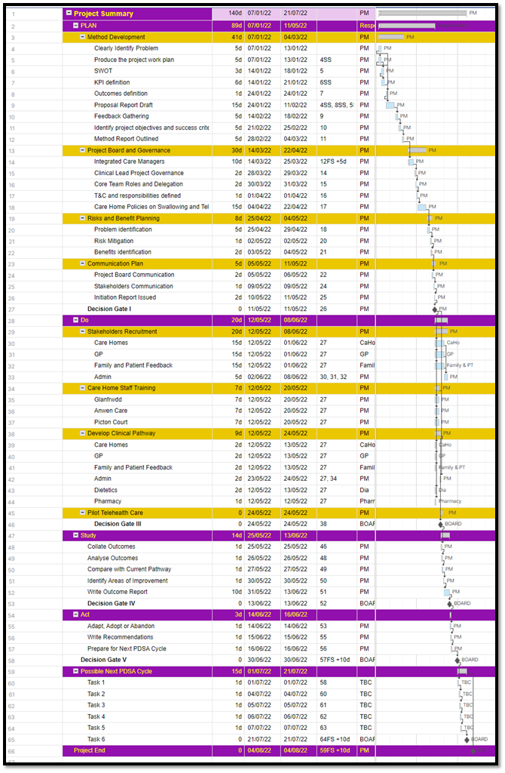t

Table 3: Stakeholders Resource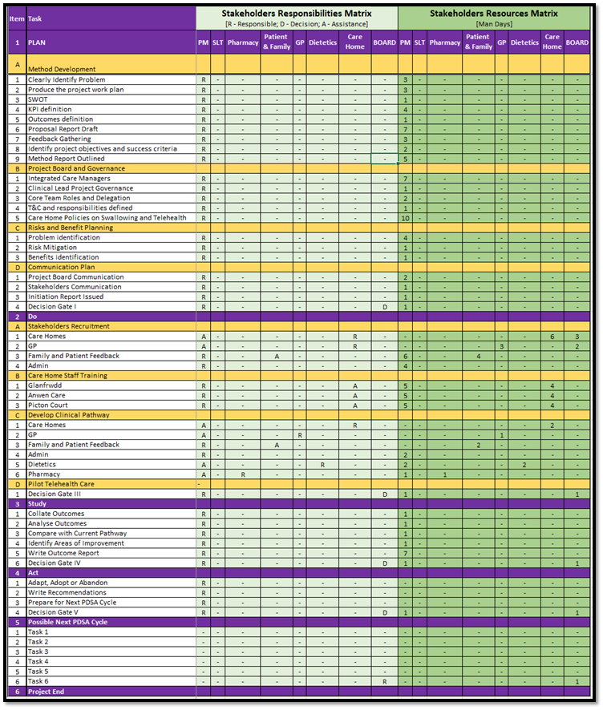

James et al., (2021) used the Nonadoption, Abandonment, and challenges to the Scale-up, Spread, and Sustainability (NASSS) as a framework to review multiple reported issues on using video consultations in health care provision during the Covid 19 pandemic. The NASSS framework was devised by Greenhalgh et al., (2017) to provide an evidence based framework to manage and study complex digital innovation and change in health and social care. They identified seven domains and each domain can be can be simple, complicated or complex. “Simple” has a predictable outcome, while a “complex” has a high level of unpredictability and do not have the same result because of a number of dynamic factors can influence that condition. “Complicated” is somewhere in between. The first domain is condition or medical presentation, second is technology, third is the value proposition or how the the technology bring value to the care service and the forth domain is the people or adopters who wants to use the system. The fifth domain is organisational, this is particularly complex if the technology is going to be implemented across multiple organisations and they do not have an established contractual relationship. The sixth domain is the influences outside the organisation and the seventh domain is time.
James et al., (2021) identified that service development using video consultation can face opposition from staff and organisations who are resistant to change. They also reported that technical experience of staff has been one of the challenges that prevents scale up and spread of video consultations. This can be mitigated by including key stakeholders in co-designing service development and ensure close communication throughout the project.
Thus it is important to co-design the pathway with key stakeholders and provide staff training before conducting the remote consultation. A process mapping approach will be used to ensure that relevant stakeholders are identified, process flow between activities is coordinated and resources (time spent) for each activity is measured to identify bottlenecks and waiting times (Trebble et al., 2010). Process-oriented information and improvements will be identified by all stakeholders to include allied health professionals, care home staff and patients’ families.

Co-designing systems of care is important to ensure high level of care, added value and optimal use of skills and resources especially on quality improvement projects (Antonacci et al., 2018). We will also involve care home managers, nursing staff and carers in the design and delivery of the project. There will be an initial consultation with them to identify and analyse training needs, understand swallowing, nutrition and medication needs of their residents, and comprehend the demands of their workforce whilst discussing strategies on how to effectively partner and collaborate with them in driving this project forward. This will also ensure that there is a shared risk with this new model and that service provision is targeted to what is needed (nothing more and nothing less) within safe practices.

To ensure adoption of the new technology, we will also include the patient (when able) and their families to have an active role in the consultation process and actual service deliver. They will be included in the evaluation phase to concentrate on what matters to them, ensure that their needs are met and delivered according to their preference. We will conduct information feedback sessions and send questionnaires. This will ensure that the patient and patient families are able to make informed decision about the care they are receiving. These measures will ensure that care home staff, multi-disciplinary allied health team, patient and families are equal partners in designing and developing this new service delivery through co-production.
Figure 2 shows a possible new clinical pathway that reduced task reduplication and ensures data flow is safe and accurate. This will be presented to all stakeholders for development and review.

Figure 2: New Integrated Clinical Pathway for Consultation with Stakeholders
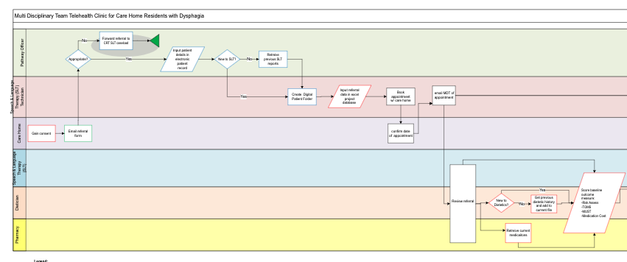
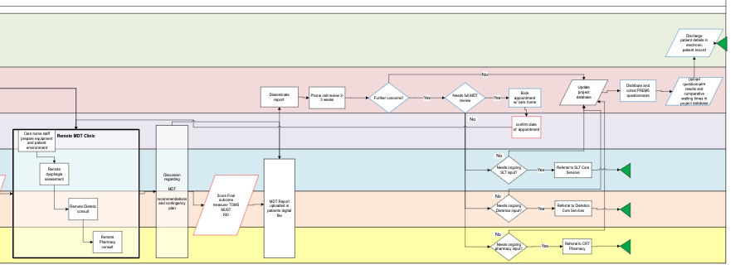
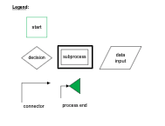

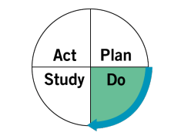 Do

We will attempt conduct a two phase pilot (with a duration of 3 months each) with an evaluation component after each phase (3 months) to provide any changes derived from new learnings gathered from evaluation forms, questionnaires, interviews and standardized outcome measures during previous phase of the pilot. This project aims to present a new effective integrated model for the future provision of care for people with swallowing difficulties in Wales. We will conduct the pilot in 3 care homes in Bridgend, one from each primary care cluster networks (North, West and East). All referrals will be sent to one email and admin support will collate and upload relevant referral data to the project digital file and database.

Clinicians from these disciplines will conduct a joint remote consultation session once a week and will direct Care Home Nurses and/or Senior Care Home Staff using a secure two way video link to address holistic swallowing, nutrition and medication needs of care home residents. These clinicians will also provide multi-disciplinary training to Care Home Nurses and/or Senior Care Home to contribute to skills development across health and social care.
Training will be conducted in the care homes to ensure that care home staff have access to the correct equipment, environment and policies that will be adhered to when conducting the joint video consultations.
We will be using the Attend Anywhere software for all telehealth consultations. Attend Anywhere is a web-based program that allows remote video consultation to take place between patients and clinicians (Attend Anywhere, 2021). It was designed to mimic, as close as possible, the current clinical pathway without extra processes or resources. Care homes will be use the Attend Anywhere software via the patient portal, where they will have access to a virtual waiting area. The clinician will then join the care home to begin the consultation process or in this case, remote dysphagia assessment. Figure 3.2 shows the process of this transaction

Figure 3- Attend Anywhere Procedure
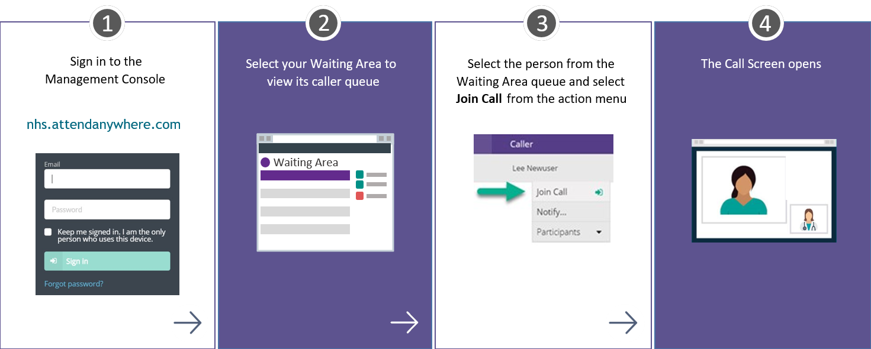

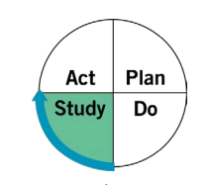 Study

It is envisioned that the use of project mapping, technical and clinical training of care home staff and joint video consultation will have a number of benefits based on the detailed outcomes which can be found in the table below. These will be collated, analysed, and compared with expected projections and current literature.

Value added clinical outcome measures before and after intervention will be measured separately by each allied health professionals. Speech & Language Therapy will use scores from the Therapy Outcome Measures (TOMS), Dietitians will use the Malnutrition Universal Screening Tool (MUST) and Modified Rio Score for Pharmacy. This will identify if the patient’s risk for choking, pneumonia, malnutrition and dehydration is decreased after the intervention. Medication review will highlight if the patient have benefitted from an improved adherence to medication and decrease cost brought about by correct instructions to safely swallow medications.

Patient-Reported Experience Measure and Patient-Reported Outcome Measures questionnaires will be sent to care home residents and/or their families to gauge the ease of use, engagement and value added care with using telehealth

Waiting times of residents in the pilot will be compared with waiting time to that of other care homes that are not receiving multidisciplinary telehealth care. Along with incidence of hospital admission, these values will be used to calculate the cost effectiveness of the project.

Table2: Benefits of the Innovation
Benefits | Associated High Level Deliverable
Improved patient outcomes for residents with Dysphasia in Care Homes. | - Improve clinical outcomes using the Therapy Outcome Measures- Dysphagia (TOMS)  - Reduction in incidence of adverse complications due to mismanagement of medications  - Reduced waiting times for SLT, Pharmacy and Dietetics input
Creation of a more efficient and timely service to Care Home residents with dysphagia using current health technologies. | - ‘Current state’ review and understanding of current challenges, impacts, burdens upon systems.  - New referral process design and adjustments to documentation  - Technical integration in clinical pathway  - Assessment process standardization e.g. protocol/systems of work
Implementation of new integrated training program for care home staff to address eating and drinking needs | - Identify and develop training requirements, package and implementation plan  - Develop an easily accessible and effective resource for care home staff to improve confidence in dysphagia, malnutrition and hydration management  - Ensure that minimum competencies are monitored and maintained
Carry out a “One Teams” approach to dysphagia services in Care Homes using current health technologies. | - Planning of future business change blueprint and specification of requirements (e.g. information flows, documentation, data spec, staff resources and technologies)  - Design and delivery of future state user experience journeys.  - Develop a sustainable costing model to access highly specialist skills from multiple disciplines
To realise the projected benefits and adopt an evidenced based evaluation framework to roll out to wider network. | - Evidence benefits maps and profiles in planning roll out to other care homes  - Identify evaluation models to measure patient outcomes, service gains and training goals.  - Establish knowledge sharing models and disseminate lessons learned

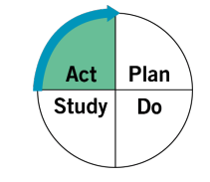Act

It is in this phase that the project board will decide if the innovation is going to be adopted, adapted or abandoned. If pertinent learning is acquired, then this will be implemented for the next phase of the PDSA cycle.

Measure that will be Implemented

Telehealth and remote consultations is the primary digital solution that is explored in this project. Telehealth is the delivery of remote care using equipment to transfer health related information to evaluate evaluate, diagnose and treat patients in remote locations using digital technology. This is often used interchangeably with telemedicine (Bacon, 2021; James et al., 2021). Video consultations have been used by Speech & Language Therapists to assess swallowing difficulties, Dietitians for Medical Nutrition Therapy and Pharmacists for remote Medication Management (Kelly et al., 2020).

Speech and Language Therapists was able to fine tune protocols to ensure safety when conducting swallowing assessments that has potential for choking, aspiration pneumonia or provoke anxiety (Sharma, 2012; Omori et al., 2021). Ward et al., (2012) was able to prove validity of remote dysphagia assessments for normal or patients with mild cognitive disabilities. Following this study, Borders et al., (2021) presented objective and subjective clinical swallowing outcomes when using telehealth. This has helped to showcase the reliability of outcome measures in real-world clinical practice because it took into account variability in devices, WifFi Internet connectivity, presence or absence of assistance, or remote patient/caregiver training. Following an increased need for remote dysphagia assessment during the Covid-19 pandemic, Ward et al., (2021) published specific instructions on how to establish multisite remote clinics.

There are a number of multidisciplinary teams that have also used remote telehealth consultation to provide joint care for their patients needing complex dysphagia care. Mayadevi et al., (2018) was able to manage difficult cases of dysphagia for their patients with head and neck cancer by providing an multi disciplinary remote video consultation. The sessions helped to facilitate interdepartmental collaboration between two similar clinics. Both clinics provide specialized dysphagia management treating similar sets of patients across the globe.

Zughni et al., (2020) used telemedicine for synchronous or real-time transmission to conduct an interactive evaluation and treatment of patients by both a laryngologist and speech-language pathologist. They were able to report the inclusion of multiple clinicians and health care professionals when using the telehealth platform. By using telemedicine for concurrent interdisciplinary appointments, the traditional in-person interdisciplinary model can be simulated while removing the risk of direct patient contact during the Covid-19 pandemic. In developing an effective and efficient telemedicine program, they needed to identify clear roles of support staff, including the booking team and medical assistants; the creation of dedicated telemedicine clinic slots; the delivery of patient-reported outcome measures; and the development of an evaluation protocol.

Care homes have also adopted telehealth practices in providing specialist care to their residents who are more vulnerable to the Covid-19 pathogen and are high risk to suffering the effects of long Covid (Hungerbuehler et al., 2015). However from a recent limited literature search there has not been any studies that reported on remote swallowing assessments with multidisciplinary telemedicine provision for care home residents.

Future Improvements

In the absence of compete data, the following possible outcomes and future improvements are identified to implement change strategies when using multidisciplinary video consultation in providing swallowing management for residents in care homes.

In 2010 Goodwin, (2010) reported that about 1.7 million people benefit from telecare services in the UK. It has not gained traction due to the lack of robust evidence on cost-effectiveness, interoperability of technology between service sectors, and the implications for professionals and organisations in changing their established methods of practice.

Kho, Gillespie and Martin-Khan, (2020) suggested that the slow rate of adoption of telemedicine may be due to a piecemeal approach to the change process and the lack of an overarching plan to manage longitudinal change. There needs to be a wider change management method with a strong evidence framework to ensure telehealth intervention is integrated in clinical practice. Thomas et al., (2020) highlight five key requirements for the long-term sustainability of telehealth. These include: “(a) developing a skilled workforce; (b) empowering consumers; (c) reforming funding; (d) improving the digital ecosystems; and (e) integrating telehealth into routine care”

Harst, Lantzsch and Scheibe, (2019) presented a systematic review of theories on end user acceptance of telehealth. They strongly advocated that the reason for lack of acceptance of telehealth by potential end users is to accommodate the requirements not only of the target group but also the group’s social environment when planning telemedicine applications. These results support the importance of theory-guided user-cantered design approaches to telemedicine development

This project will be implemented within the Bridgend community integrated care for health and social care. A longitudinal assessment to establish integrated systems and engaging with users in co-designing digital health technologies are transferable principles when applying this digital health project in an integrated health and social care model. The success of implementing an integrated tetelehealth service is dependent on the ability to engage the wider population to adopt these services.

When (Ovretveit, (2017) described how information technology was used to support integrated care schemes in six EU services, he suggested practical ways on how to ensure these new opportunities were exploited. He strongly recommended that data management and designs should not be left with IT technicians or the IT industry alone. There needs to be engagement with users who are coordinating and providing care and users who are receiving care. Their needs and goals are needed to be specified to allow good quality data that will be used to monitor care plans and in turn provide better clinical outcomes. Inferring from this, it means that co-designer should be chosen carefully to recruit those who understand clinical and social care practice and can lead a successful co-design process.

Baltaxe et al., (2019) conducted a study to analyse the implementation of digital health tools in integrated health and social care from 8 European countries, namely Austria, Croatia, Germany, Hungary, the Netherlands, Norway, Spain, and the United Kingdom. They report that there are different levels of maturing of the integrated systems and this affected implementation of digital health technologies. ﻿They showed a strong correlation between maturity of digital health and proper evaluation strategies of integrated care. This study suggests that integrated care services need to have comprehensive longitudinal assessment strategies to measure integrated care principles for digital health innovations to be successful.

Baltaxe et al., (2019) identified the lack of well-defined macro-level policies, with effective operational implementation plans in the health care systems in which most integrated care programs operate. Often, the use and scope of digital health tools depends on local or regional initiatives of individual providers involved in these programs. The maturity of digital implementation for non-established program is currently rather poor.

There remains a significant lack of evidence that can support the spread and scale-up of video consulting (James et al., 2021). Given the recent pace of change due to COVID-19, a more definitive evidence base is urgently needed to support global efforts and match enthusiasm for extending use.

.

Bibliography

Age Cymru (2021) Senedd Elections 2021.
Age UK (2019) ‘Later life in the United Kingdom 2019 - Factsheet’, (May), p. 27. Available at: https://www.ageuk.org.uk/globalassets/age-uk/documents/reports-and-publications/later_life_uk_factsheet.pdf.
Antonacci, G. et al. (2018) ‘The use of process mapping in healthcare quality improvement projects’, Health services management research. SAGE Publications Sage UK: London, England, 31(2), pp. 74–84.
Attend Anywhere (2021) Make Travel Optional. Available at: https://www.attendanywhere.com/ (Accessed: 4 December 2021).
Bacon, E. (AMD G. T. (2021) Telemedicine Defined. Available at: https://amdtelemedicine.com/telemedicine-defined/ (Accessed: 1 December 2021).
Baijens, L. W. J. et al. (2016) ‘European society for swallowing disorders - European union geriatric medicine society white paper: Oropharyngeal dysphagia as a geriatric syndrome’, Clinical Interventions in Aging, 11, pp. 1403–1428. doi: 10.2147/CIA.S107750.
Baltaxe, E. et al. (2019) ‘Digital health transformation of integrated care in Europe: Overarching analysis of 17 integrated care programs’, Journal of Medical Internet Research, 21(99), pp. 1–14. doi: 10.2196/14956.
Barnett, K. et al. (2012) ‘Epidemiology of multimorbidity and implications for health care, research, and medical education: A cross-sectional study’, The Lancet, pp. 37–43. doi: 10.1016/S0140-6736(12)60240-2.
Borders, J. C. et al. (2021) ‘Objective and subjective clinical swallowing outcomes via telehealth: Reliability in outpatient clinical practice’, American Journal of Speech-Language Pathology, 30(2), pp. 598–608. doi: 10.1044/2020_AJSLP-20-00234.
Chen, S. et al. (2020) ‘Prevalence and risk factors of dysphagia among nursing home residents in eastern China: a cross-sectional study’, BMC Geriatrics. BMC Geriatrics, 20(1), pp. 1–11. doi: 10.1186/s12877-020-01752-z.
Chen, S., Kent, B. and Cui, Y. (2021) ‘Interventions to prevent aspiration in older adults with dysphagia living in nursing homes: a scoping review’, BMC Geriatrics. BMC Geriatrics, 21(1), pp. 1–14. doi: 10.1186/s12877-021-02366-9.
Christoff, P. (2018) ‘Running PDSA cycles’, Current Problems in Pediatric and Adolescent Health Care. Elsevier Inc., 48(8), pp. 198–201. doi: 10.1016/j.cppeds.2018.08.006.
Cichero, J. and Altman, K. W. (2011) ‘Definition, Prevalence and Burden of Oropharyngeal Dysphagia: A Serious Problem among Older Adults Worldwide and the Impact on Prognosis and Hospital Resources’, in Cichero, J. and Clavé, P. (eds) 72nd Nestlé Nutrition Institute Workshop. Barcelona, p. 12. Available at: https://www.karger.com/Article/Abstract/339974.
Davies, S. (2002) ‘An interdisciplinary approach to the management of dysphagia’, Professional nurse (London, England). Queen Elizabeth Hospital, Gateshead., 18(1), pp. 22–25. Available at: http://europepmc.org/abstract/MED/12238717.
Goodwin, N. (2010) ‘The State of Telehealth and Telecare in the UK: Prospects for Integrated Care’, Journal of Integrated Care. Emerald Group Publishing Limited, 18(6), pp. 3–10. doi: 10.5042/jic.2010.0646.
Greenhalgh, T. et al. (2017) ‘Beyond adoption: A new framework for theorizing and evaluating nonadoption, abandonment, and challenges to the scale-up, spread, and sustainability of health and care technologies’, Journal of Medical Internet Research, 19(11). doi: 10.2196/jmir.8775.
Griffiths, C. and Brock, A. (2003) ‘Twentieth century mortality trends in England and Wales.’, Health Statistics Quarterly, 18, pp. 5–16. Available at: http://eglobalmed.com/opt/FreeBooks/www.statistics.gov.uk/downloads/theme_health/HSQ18_revised_21Aug03.pdf#page=6.
Harst, L., Lantzsch, H. and Scheibe, M. (2019) ‘Theories predicting end-user acceptance of telemedicine use: Systematic review’, Journal of Medical Internet Research, 21(5). doi: 10.2196/13117.
Hungerbuehler, I. et al. (2015) ‘A randomized clinical trial of home-based telepsychiatric outpatient care via videoconferencing: design, methodology, and implementation’, Rev. psiquiatr. clín. (São Paulo). Hungerbuehler, Ines; University of São Paulo Medical School. Department and Institute of Psychiatry. Laboratory of Neuroscience. São Paulo. BR, 42(3), pp. 76–78. doi: 10.1590/0101-60830000000052.
Inouye, S. K. et al. (2007) ‘Geriatric syndromes: Clinical, research, and policy implications of a core geriatric concept’, Journal of the American Geriatrics Society, 55(5), pp. 780–791. doi: 10.1111/j.1532-5415.2007.01156.x.
James, H. M. et al. (2021) ‘Spread, Scale-up, and Sustainability of Video Consulting in Health Care: Systematic Review and Synthesis Guided by the NASSS Framework’, Journal of Medical Internet Research, 23(1). doi: 10.2196/23775.
Kelly, J. T. et al. (2020) ‘Dietitians Australia position statement on telehealth’, Nutrition and Dietetics, 77(4), pp. 406–415. doi: 10.1111/1747-0080.12619.
Kho, J., Gillespie, N. and Martin-Khan, M. (2020) ‘A systematic scoping review of change management practices used for telemedicine service implementations’, BMC Health Services Research. BMC Health Services Research, 20(1), pp. 1–16. doi: 10.1186/s12913-020-05657-w.
Knudsen, S. V. (2018) ‘Can Quality Improvement improve the Quality of Care? A systematic review of effects and methodological rigor of the Plan-Do-Study-Act (PDSA) method’, Bmj Quality and Safety. BMC Health Services Research, 6, pp. 1–10. Available at: http://www.forskningsdatabasen.dk/en/catalog/2396085451.
Madhavan, A. et al. (2016) ‘Prevalence of and risk factors for dysphagia in the community dwelling elderly: A systematic review’, Journal of Nutrition, Health and Aging, 20(8), pp. 806–815. doi: 10.1007/s12603-016-0712-3.
Marquis, J. et al. (2013) ‘Swallowing difficulties with oral drugs among polypharmacy patients attending community pharmacies’, International Journal of Clinical Pharmacy, 35(6), pp. 1130–1136. doi: 10.1007/s11096-013-9836-2.
Martino, R. and McCulloch, T. (2016) ‘Therapeutic intervention in oropharyngeal dysphagia’, Nature Reviews Gastroenterology and Hepatology. Nature Publishing Group, 13(11), pp. 665–679. doi: 10.1038/nrgastro.2016.127.
Mayadevi, M. et al. (2018) ‘Interdisciplinary Telemedicine in the Management of Dysphagia in Head and Neck’, Dysphagia, 33(4), pp. 474–480. doi: 10.1007/s00455-018-9876-9.
McGinnis, C. M. et al. (2019) ‘Dysphagia: Interprofessional Management, Impact, and Patient-Centered Care’, Nutrition in Clinical Practice, 34(1), pp. 80–95. doi: 10.1002/ncp.10239.
Morelli, M. S. (2016) ‘Using the Plan, Do, Study, Act Model to Implement a Quality Improvement Program in Your Practice’, American Journal of Gastroenterology. Nature Publishing Group, 111(9), pp. 1220–1222. doi: 10.1038/ajg.2016.321.
Nawaz, S. and Tulunay-Ugur, O. E. (2018) ‘Dysphagia in the older patient’, Otolaryngologic Clinics of North America. Elsevier, 51(4), pp. 769–777.
NHS England (NHS-E) and NHS Improvement (NHS-I) (2020) ‘Online library of Quality, Service Improvement and Redesign tools Plan, Do, Study, Act (PDSA) cycles and the model for improvement’, pp. 1–8. Available at: https://www.england.nhs.uk/wp-content/uploads/2021/03/qsir-plan-do-study-act.pdf.
Omori, F. et al. (2021) ‘Development of a Remote Examination of Deglutition Based on Consensus Surveys of Clinicians (Part I): Selection of Examination Items’, Dysphagia. Springer US, (Part I), pp. 5–12. doi: 10.1007/s00455-021-10357-6.
Ovretveit, J. (2017) ‘Digital technologies supporting person-centered integrated care - A perspective’, International Journal of Integrated Care. doi: 10.5334/ijic.3051.
Park, Y. H. et al. (2013) ‘Prevalence and associated factors of dysphagia in nursing home residents’, Geriatric Nursing. Elsevier Ltd, 34(3), pp. 212–217. doi: 10.1016/j.gerinurse.2013.02.014.
Reed, J. E. and Card, A. J. (2016) ‘The problem with plan-do-study-act cycles’, BMJ Quality and Safety, 25(3), pp. 147–152. doi: 10.1136/bmjqs-2015-005076.
Sharma, S. (2012) Telerehabilitation application for the clinical assessment of dysphagia. The University of Queensland. Available at: https://espace.library.uq.edu.au/view/UQ:282069.
Thomas, E. E. et al. (2020) ‘Building on the momentum: Sustaining telehealth beyond COVID-19’, Journal of Telemedicine and Telecare. doi: 10.1177/1357633X20960638.
Trebble, T. M. et al. (2010) ‘Process mapping the patient journey: an introduction’, BMJ. BMJ Publishing Group Ltd, 341. doi: 10.1136/bmj.c4078.
Wall, L. R. et al. (2016) ‘Evaluation of a weekly speech pathology/dietetic service model for providing supportive care intervention to head and neck cancer patients and their carers during (chemo)radiotherapy’, Supportive Care in Cancer. Supportive Care in Cancer, 24(3), pp. 1227–1234. doi: 10.1007/s00520-015-2912-5.
Ward, E. C. et al. (2012) ‘Validity of conducting clinical dysphagia assessments for patients with normal to mild cognitive impairment via telerehabilitation’, Dysphagia, 27(4), pp. 460–472. doi: 10.1007/s00455-011-9390-9.
Ward, E. C. et al. (2021) ‘Establishing Clinical Swallowing Assessment Services via Telepractice: A Multisite Implementation Evaluation’, American Journal of Speech-Language Pathology, 30(6), pp. 2456–2464. doi: 10.1044/2021_ajslp-21-00109.
Welsh Government (2020) ‘Age Friendly Wales: Our Strategy for an Ageing Society Consultation Document’, (March). Available at: https://llyw.cymru/strategaeth-ar-gyfer-cymdeithas-.
World Bank (2019) World Population Ageing 2019, World Population Ageing 2019. Available at: http://link.springer.com/chapter/10.1007/978-94-007-5204-7_6.
World Helath Organisation (2021) Ageing and Health.
Zughni, L. A. et al. (2020) ‘Telemedicine and the Interdisciplinary Clinic Model: During the COVID-19 Pandemic and Beyond’, Otolaryngology - Head and Neck Surgery (United States), 163(4), pp. 673–675. doi: 10.1177/0194599820932167.

