Research Proposal





The Connection Between Management,
Emotional Intelligence and Stress in the Workplace.

Alina G Mucenic
Student Id 2108840
Date 23/02/2024
Word Count: 1500

Table of Content
Introduction 2
Context and Justification 2
Review of Existing Literature 2
Goals and Purposes 3
Study Framework 3
Research Methods 3
Theoretical Foundation 4
Approach to Inquiry 4
Gathering of Data 4
Participant Selection 5
Analysis of Data 5
Ethical Considerations 6
Constraints on Resources 6
Ethical Issues 6
Accuracy and Credibility 6
Preparation and Resources 7
Schedule Overview 7
Bibliography 8

Introduction

The objective of this proposal is to examine the correlation between the management of emotional intelligence and work-related stress. The study will concentrate on the use of emotional intelligence within the engineering industry, exploring its benefits and examining the impact of emotionally intelligent managers on their teams (Turner and Lloyd‐Walker 2008). This proposal aims to explore the potential of lowering stress by implementing management practices that prioritise emotional intelligence and foster strong connections between managers, workers, and the workplace.
Context and Justification
Stress may reduce productivity and creativity in the engineering business, which has high-stakes projects, tight deadlines, and sophisticated problem-solving (Weehuizen et al. 2011). Management in this area requires emotional intelligence (EI) to handle obstacles and demands. This study hypothesises that high EI managers may reduce stress, increase communication, and improve project results for engineering teams (Maamari and Majdalani 2017). Engineering leaders can create a more collaborative and resilient workplace by managing emotions and interpersonal dynamics, which is essential for innovation and addressing the demands of a quickly changing technology context. This research emphasises the necessity of incorporating emotional intelligence into management methods to improve engineering team well-being and performance (Syed-Abdullah et al. 2006).

Review of Existing Literature
Studies on emotional intelligence (EI), occupational stress, and burnout in engineering highlight the specific issues engineers experience (Ismail et al. 2009). Researchers say engineers are more prone to stress and burnout due to tight deadlines and complicated problem-solving (Campbell and Campbell 2024) tasks. EI the capacity to sense, express, comprehend, and control emotions (Palmer & Stough, 2001) is essential for overcoming these problems. Engineers with greater EI may better manage stress, interpersonal connections, and work satisfaction, avoiding burnout (Maslach & Jackson, 1986; Schlebusch, 1998). To promote resilience, team relationships, and workplace well-being, engineering education and professional development programmes should include EI development (Mindeguia et al. 2021). John (2019) states that companies hire high-EQ trainers and teach their personnel to get a competitive edge in today's workplace.

Goals and Purposes

This research examines how emotional intelligence (EI) affects engineering managers and workers' work attitudes, actions, and results. It investigates how high EI promotes workplace harmony, altruism, and productivity. The study will also explore EI's moderating influence on workplace conflict's consequences on career commitment and job satisfaction. The research fills the empirical vacuum to demonstrate the role of EI in building successful leadership and good organisational environments (Carmeli 2003), guiding future management practices and training programmes.

Research Methods

This structured research-based mixed-methods study will examine management emotional intelligence (EI) and workplace stress (Roohani and Esmailvandi 2016). The technique combines quantitative EI evaluations with qualitative interviews from varied management levels to determine how EI manages and mitigates workplace stress. By collecting and analysing data on how EI affects employee stress (Yang et al. 2021), the study technique may reveal how emotionally intelligent management strategies can improve workplace wellness.
Bell et al. (2022) emphasise the dominance of quantitative research techniques in business studies and the growth of qualitative approaches. For quality research, they emphasise concept definitions, dependability, and validity assessments. Critical issues include measurement accuracy, causation, generalizability, and reproducibility. Addressing quantitative technique criticisms is crucial to developing trustworthy, generalizable research results, according to the authors.
Saunders’ et Research Onion provides a flexible model for developing methodology, enabling researchers to select the most suitable theory or practices based on existing layers and research questions. This framework encourages a holistic and structured approach, facilitating decision-making from philosophical to practical in crafting research methodology (Floyd 2008).
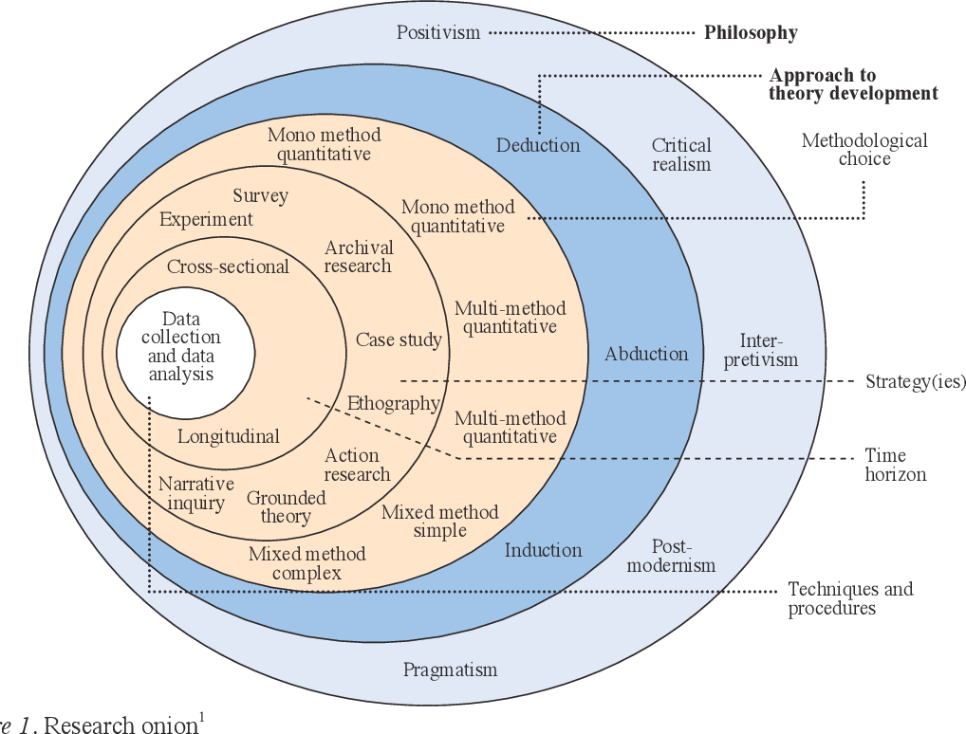
(Todd 2021)

Theoretical Foundation
This study adopts an interpretivist approach to explore how management emotional intelligence impacts workplace stress, (Lindebaum and Cassell 2010) recognizing that individuals interpret their experiences uniquely. This philosophy supports analyzing diverse perspectives on stress and EI, enabling a deeper understanding of their interplay in the workplace.

Approach to Inquiry
The study uses a simple, hands-on approach to understand emotional intelligence. It lets people ask questions, share ideas, and learn by doing, which helps them figure out how emotions work in everyday life (Emotional Intelligence in Action: Training and Coaching Activities for Leaders, Managers, and Teams, 2012)

Gathering of Data

Surveys will provide quantitative data and interviews qualitative data (Tunarosa and Glynn 2016). This strategy combines statistical data with subjective experiences and perceptions to analyse how management emotional intelligence affects workplace stress.
Denscombe (2014) advises researchers to clearly state their reasons for mixing methods, including improved accuracy, a more complete picture, balancing the strengths and weaknesses of different approaches, improving analysis, and optimising sampling strategies. This emphasis on transparency in research methodology is crucial for understanding the purpose and potential benefits of mixed methods, emphasising the need for methodological clarity to explain qualitative and quantitative research methods.

Participant Selection
Participant selection is one of the most invisible and least critiqued methods in qualitative circles. (Reybold et al. 2012) The expected sample for this study is projected to include over 100 individuals working or study in engineering sectors to understand the connection between management, EI and stress in the workplace. Structural properties and evolving primarily due to the dissemination of the survey through social media channels.

Analysis of Data
For data analysis, this study will employ a mixed-methods approach. Quantitative data will be visualized using graphs and charts to identify trends and calculate percentages. this statistical analysis will highlight patterns within the quantitative aspects of the research. Concurrently, qualitative data obtained from interviews will be meticulously reviewed to identify recurring themes and insights among participants. (Wickham 2016) This thematic analysis will allow for a deeper understanding of the nuances and complexities behind the quantitative findings, (Jiang et al. 2023) ensuring a comprehensive analysis that integrates both numerical data and subjective experiences.

Ethical Considerations

Researchers struggle to prove emotional intelligence (EI) boosts job effectiveness. Inconclusive evidence persists. Researchers must utilise rigorous procedures to show EI's value. Honesty regarding EI's capabilities is crucial. Companies may squander time and money on harmful training if researchers make inflated promises without evidence. Focus on attractive EI and employment benefits statistics (Murphy, K. R.Ed, 2006). When examining management emotional intelligence and workplace stress (Sarrionandia et al. 2018), ethical principles suggest to respect autonomy, promote benefits, limit damage, and maintain fairness. Since the research is low-risk, an ethical approval form protects participants. Informing participants about the study's scope in consent forms ensures their comfort and understanding. Data protection rules guarantee privacy and honesty. This ethical framework protects research integrity and participants (Leibert et al. 2019).

Constraints on Resources
Facing tight deadlines, the study may encounter challenges such word count of the dessertation and as engineers being reluctant to respond due to their busy schedules, and students being preoccupied with their own commitments, potentially impacting participation rates. Effective time management and early engagement are critical strategies to mitigate these obstacles, (Ammattikorkeakoulu 2010) ensuring a diverse and meaningful data set is collected despite the limited availability of participants.

Accuracy and Credibility
To thoroughly assess the study's aims and objectives, researchers need data from several sources. Eustis (2013) will search Google Scholar and online libraries for papers, textbooks, and journals for secondary data. Data will come from reliable sources. Create a Google form online to collect main data. Posting it on social media will draw replies. Interviews will provide primary data (Yurduseven 2023). These procedures will include a few interested parties.

Preparation and Resources
Combining Adair's Action-Centred Leadership with Goleman's Emotional Intelligence in engineering leadership balances task completion, teamwork, and personal development. Adair's job, team, and person model matches Goleman's self-awareness, self-regulation, social awareness, and relationship management (Saxena et al. 2017). This synergy helps leaders handle complicated tasks and collaboration. Leaders can manage stress, make informed choices, create a supportive workplace, and promote personal and professional growth using emotional intelligence. This comprehensive strategy allows engineering leaders to maximise productivity, engage their team, and encourage innovation, producing a robust and flexible workforce that can overcome problems.

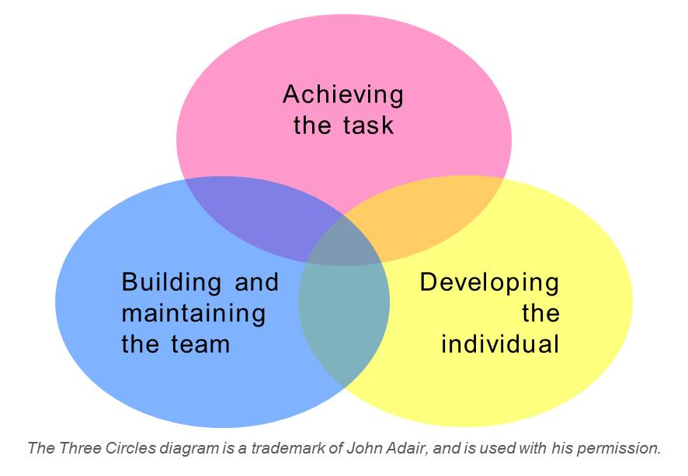
(Hedlund and Österberg 2013)

Schedule Overview
A Gantt chart is a project management tool that aids in the organisation and scheduling of projects of various magnitudes (Nurre and Weir 2017).
W/C | Date | Independent Project (BMSW6009_CARD)  (Dissertation) Schedule January 2024
w/c | 10/01/2024 | Dissertation Talk /Schedule of Work for assessment
w/c | 17/01/2024 | Supervisor Relocate
w/c | 24/01/2024 | One to One supervision session
w/c | 31/01/2024 | Draft Research Proposal – forward to Supervisor
w/c | 07/02/2024 | One to One supervision session
w/c | 08/02/2024 | One to One supervision session
w/c | 15/02/2024 | Supervisor Draft feedback
w/c | 23/02/2024 | Research Proposal 1500w and Ethics Form  Upload an electronic copy to Turnitin by 15:00
w/c | 28/02/2024 | Advised guideline
w/c | 06/03/2024 | One to one supervisor session
w/c | 13/03/2024 | One to One supervision session
 |  | Easter Vacation 25/03-01/04-08/04
w/c | 11/04/2024 | Advised starting dissertation
w/c | 17/04/2024 | One to One supervision session
w/c | 24/04/2024 | One to One supervision session
w/c | 01/05/2024 | Advised guideline for completion of ‘Analysis of Results’ chapter
w/c | 08/05/2024 | One to One supervision session
w/c | 15/05/2024 | One to One supervision session
w/c | 22/05/2024 | Draft project
w/c | 29/05/2024 | One to One supervision session
w/c | 05/06/2024 | One to One supervision session
w/c | 12/06/2024 | Advised guideline for draft submission of completed dissertation
w/c | 19/06/2024 | One to One supervision session
w/c | 26/06/2024 | One to One supervision session
w/c | 05/07/2024 | Final Submission/Project dissertation  Upload an electronic copy to Turnitin by 15:00

Bibliography

Adair’s Action Centered Leadership. 2016. Youtube . Available at: https://www.youtube.com/watch?v=mX0chkpg1SA (Accessed: 21 February 2024).
Ammattikorkeakoulu, H.-H. (2010). Work deadlines and Time management process: case: Galileo Tanzania. Available at: https://www.theseus.fi/handle/10024/17343 (Accessed: 9 February 2024).
Bell, E., Bryman, A., and Harley, B. (2022). Business Research Methods. Oxford: Oxford University Press.
Carmeli, A. (2003). The relationship between emotional intelligence and work attitudes, behavior and outcomes. Available at: https://doi.org/10.1108/02683940310511881 (Accessed: 9 February 2024). Chaudhry, A.F., Aniol, H., and Shegos, C.J. (2020). Available at: https://www.consultant360.com/article/consultant360/congenital-hypothyroidism-due-thyroid-agenesis (Accessed: 10 February 2024).
Chaudhry, A.F., Aniol, H. and Shegos, C.J. 2020. ‘Congenital hypothyroidism due to thyroid agenesis’, Consultant. Available at: http://dx.doi.org/10.25270/con.2020.05.00011 (Accessed 5 February 2024).
Eustis, J.M. (2013). Tech Services on the Web: Steven J. Miller’s Metadata Resources Page. Technical Services Quarterly, 30(2), pp. 237–238. Available at: http://dx.doi.org/10.1080/07317131.2013.760372 (Accessed: 13February 2024).
Floyd, J. 2008. ‘Towards an Integral renewal of systems methodology for futures studies’, Futures, 40(2), pp. 138–149. Available at: http://dx.doi.org/10.1016/j.futures.2007.11.007 [Accessed 15 February 2024].
Hedlund, E. and Österberg, J. 2013. Team Training, Team Learning, Leadership and Psychology Safety: A Study of Team Training and Team Learning Behavior during a Swedish Military Staff Exercise. Sociology Mind 03(01), pp. 89–98. Available at: http://dx.doi.org/10.4236/sm.2013.31014. (Accesed 20February 2024)

John, S. 2019. A Study on the Numerous Elements of Emotional Intelligence and Leadership Qualities and Its Impact on Conflict Management: A Review of Literature. Available at: https://papers.ssrn.com/sol3/papers.cfm?abstract_id=3525977. (Accesed 18 February 2024)
Jiang, S., Huang, J., and Lee, H.S. (2023). Visualizing qualitative data: unpacking the complexities and nuances of technology-supported learning processes. Available at: https://doi.org/10.1007/s11423-023-10272-7 (Accessed: 15 February 2024).
Leibert, T.W., Powell, R.N., and Fonseca, F.D. (2019). Client descriptions of outcomes compared with quantitative data: A mixed-methods investigation of a quantitative outcome measure. Counselling and Psychotherapy Research, 20(1), pp. 9–18. Available at: http://dx.doi.org/10.1002/capr.12260 (Accessed: 7 February 2024).
Lindebaum, D. and Cassell, C. 2010. A Contradiction in Terms? Making Sense of Emotional Intelligence in a Construction Management Environment. British Journal of Management 23(1), pp. 65–79. Available at: http://dx.doi.org/10.1111/j.1467-8551.2010.00729.x. (Accesed: 11 February)
Littlejohn, P. (2012). The Missing Link: Using Emotional Intelligence to Reduce Workplace Stress and Workplace Violence in Our Nursing and Other Health Care Professions. Available at: https://doi.org/10.1016/j.profnurs.2012.04.006 (Accessed: 9 February 2024).
Maamari, B.E., and Majdalani, J.F. (2017). Emotional intelligence, leadership style and organizational climate. Available at: https://doi.org/10.1108/ijoa-04-2016-1010 (Accessed: 11 February 2024).
McGrath, J., and Coles, A. (2015). Your Education Masters Companion. Routledge. Available at: http://books.google.ie/books?id=60WsCQAAQBAJ&pg=PA147&dq=Biggam,+J.+(2015),+Succeeding+with+your+Masters+Dissertation+%E2%80%93+A+Step+by+Step+Handbook,(Third+Edition),+Berkshire:+McGraw+Hill&hl=&cd=2&source=gbs_api (Accessed: 6February 2024).
Murphy, K.R. (Ed.). (2006). A Critique of Emotional Intelligence: What Are the Problems and How Can They Be Fixed? 1st ed. Psychology Press. Nurre, S.G., and Weir, J.D. (2017). Interactive Excel-Based Gantt Chart Schedule Builder. INFORMS Transactions on Education, 17(2), pp. 49–57. Available at: http://dx.doi.org/10.1287/ited.2016.0168 (Accessed: 5 February 2024).
Reybold, L.E., Lammert, J., and Stribling, S.M. (2012). Participant selection as a conscious research method: thinking forward and the deliberation of ‘Emergent’ findings. Available at: https://doi.org/10.1177/1468794112465634 (Accessed: 11 February 2024).
Nurre, S.G. and Weir, J.D. 2017. ‘Interactive Gantt Chart Generator Based on Excel’, INFORMS Transactions on Education, 17(2), pp. 49–57. Available at: http://dx.doi.org/10.1287/ited.2016.0168 (Accessed 6 February 2024).
Roohani, A., and Esmailvandi, M. (2016). A Sequential Mixed Method Analysis of Students’ Burnout and Emotional Intelligence. Available at: http://ilt.atu.ac.ir/article_7729_fba8a36c4bf2374ab40a864f671c73c7.pdf (Accessed: 13 February 2024).
Sarrionandia, A., Ramos-Díaz, E., and Fernández-Lasarte, O. (2018). Resilience as a Mediator of Emotional Intelligence and Perceived Stress: A Cross-Country Study. Available at: https://doi.org/10.3389/fpsyg.2018.02653 (Accessed: 10 February 2024).
Singh, I., and Jha, A. (2012). Teacher Effectiveness in Relation to Emotional Intelligence Among Medical and Engineering Faculty Members. Available at: https://doi.org/10.5964/ejop.v8i4.483 (Accessed: 13 February 2024).
SINGHA, K. 2022. ‘Translation Today’, Translation Today, 16(2), pp. 187–198. Available at: http://dx.doi.org/10.46623/tt/2022.16.2.ab1 (Accessed 12 February 2024).
Syed-Abdullah, S.L., Holcombe, M., and Gheorge, M. (2006). The Impact of an Agile Methodology on the Well Being of Development Teams. Available at: https://doi.org/10.1007/s10664-006-5968-5 (Accessed: 4 February 2024).
The Leadership Coaches. (2023) Adair’s Action-Centred Leadership Model. Available at: https://www.theleadershipcoaches.co.uk/amp/adair-s-action-centred-leadership-model (Accessed: 12 February 2024).
Todd, R.J. 2021. From Net Surfers to Net Seekers: The WWW, Critical Literacies and Learning Outcomes. IASL Annual Conference Proceedings , pp. 231–242. Available at: http://dx.doi.org/10.29173/iasl8173 (Accessed: 6 February)
Tunarosa, A. and Glynn, M.A. 2016. Strategies of Integration in Mixed Methods Research. Available at: https://doi.org/10.1177/1094428116637197. (Accesed 15 February 2024)
Turner, R.A., and Lloyd‐Walker, B. (2008). Emotional intelligence (EI) capabilities training: can it develop EI in project teams? Available at: https://doi.org/10.1108/17538370810906237 (Accessed: 10 February 2024).
Weehuizen, R., Sanditov, B., and Cowan, R. (2011). Productivity effects of innovation, stress and social relations. Available at: https://doi.org/10.1016/j.jebo.2011.01.028 (Accessed: 14 February 2024).
Wickham, H. (2016). Data Analysis. Available at: https://doi.org/10.1007/978-3-319-24277-4_9 (Accessed: 8 February 2024).
Yang, R., Díaz, V.G., and Hsu, C. (2021). WITHDRAWN: Use of emotional intelligence to promote innovation among employees in the work environment through qualitative and quantitative analysis. Available at: https://doi.org/10.1016/j.avb.2021.101589 (Accessed: 7 February 2024).
Yurduseven, S. (2023). Available at: https://dergipark.org.tr/tr/download/article-file/3050423 (Accessed: 10 February 2024).

