Problem Solving and Decision Making (BMSW4004_LON)
Elvis Akpede (1916147)
Lecturer (Yajesh Kumar)

Introduction
This report assignment will use fishbone analysis to discuss poor customer service problem in hotels such as Hilton hotel and solution to the problem. Rendering poor services to a customer has a more direct and great influence on a business. The power and influence of the internet and social media has contributed a greatly to impact of bad customer service on business. However, these two media of connecting or bring people together worldwide, has become very easy to share and discuss one's experience with almost everyone. In the long run every hotel wants to give in the best in guest satisfaction, and hotel guest satisfaction is based on customer service and it stretches beyond check-out. It is true that excellent customer service is seriously lacking in most places where people put in their money but service giving to a customer is explained as the achievement of the business. The following, such as method, machine, measurement,
people, material, and environment will be used to analyze the causes and impact of bad customer service in hotels such as Hilton hotel and solution to the problem.
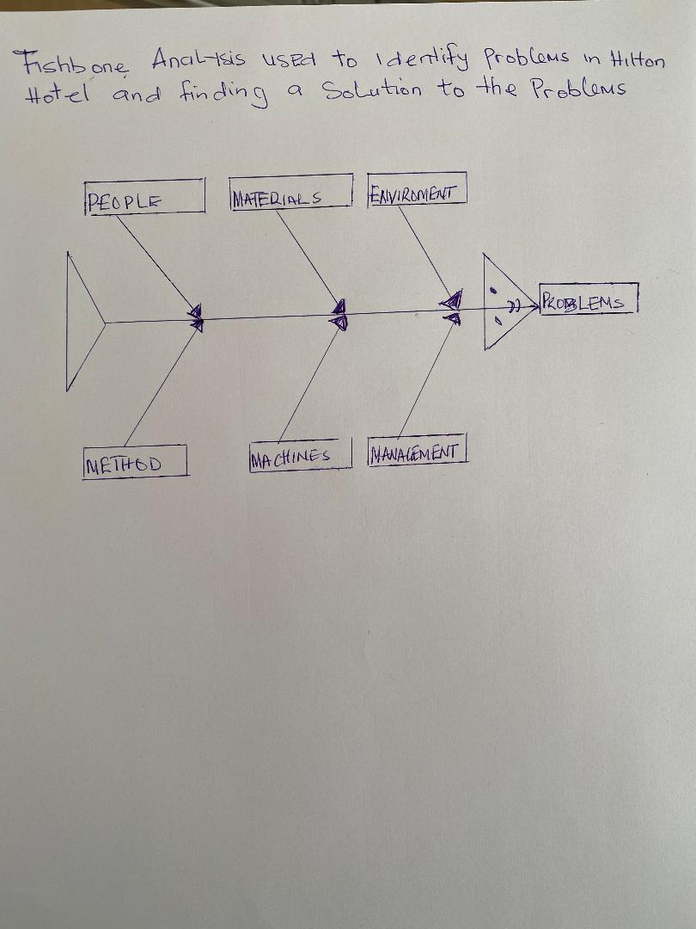

People
Customers are seen as lifeblood in most companies. In hotels, clients are viewed as their means of support therefore addressing their bad customer services issues is very important because it can lead to losing their customers. Naturally, staff in hotels especially those at the front desk should not be responsible for poor attitude when a customer is consulting them. In Hilton Hotel, an employee once displays a bad attitude, and was also rude to a client. Usually in most hotels, it happens when they are not under any supervision. Sometimes this type of behavior is triggered by the culture of the management and the staff as well for example employees that have little or no experiences and no skills. However, issues like this can cause bad customer service and ruin a company’s reputation. Bad behavior from employees can come from working in poor conditions and the way employees are being handled. Problem like this can result to shortage of staff, customer dissatisfaction, and general customer service greatly which can further lead to loss of customer’s loyalty therefore they would want to patronize other competitors or service provider.
According to Alison Doyle (2020) communication is censorious for staff serving customers and hotel employees at front desk because they talk with customers in person and on the phone all the time, so it is very vital that they speak clearly and maintain a positive tone. In Hilton hotel, one of the reasons for poor customer service is poor communication and innovation method. In hotels particularly nobody enjoys waiting especially at the front desk which is due to poor communication and lack of innovative methods. A long wait at the front desk for hotel check-in can be very painful for guests arriving after a grueling day of travel and typically has an extremely negative impact on guest satisfaction scores. According to Jeff Mayerczak (2015) the problem of check-in with hotels is not necessary because of technical limitations but is the difference in opinion and the goals that is involve and this goals sometimes comes without speed and efficiency and leaving guest without alternative in the issue. However, if the right method and approach is not engaged to reduce the long waiting time and lines, training staff, making sure customers and needs are met and timely cheerfully welcoming customers. The result of this contribute to bad customer service and customers will choose other service provider.

Materials
In this context materials are the resources or inputs businesses utilizes. For example, in Hilton hotel materials are supplies that are being consumed by customers. However, there are different suppliers that supply these resources, sometimes Hotel Industries fail to get the entire stock that is required for the smooth running of the business other times, inventory might be insufficient to meet the demand of customers, for example guest might request for specific items or things that are not available. In some cases, Hotels must be anxious about their inventory level and if the products are good quality, sometimes hotels might receive materials from their supplier that are below standard, and customers would make complaints which lead to customer dissatisfaction and poor customer services. Another area that is being considered is aesthetics quality of product in their meals which involves how a product feels, looks, tastes, sounds or smells is also actually based on the judgment or opinion of the customer. However, if a guest thinks that the hotel services and products contains undesirable taste, odor, or not delicious, they are likely to have a rejection view of that hotel and give a rating of poor customer service. This can be communicated to other people through words from mouth or social media.

Machines
For a fact it is not compulsory that bad customer service always come with poor experience from people at the front Desk in a Hotel. Several factors contribute to poor customer service, and they include insufficient funds and materials, not enough staff, little or no employees training, inefficient processes and methods, equipment problems etc. Machinery problem is part of the genesis of Hilton Hotel poor customer service. For example, if all equipment’s are not functional, this can keep customers waiting for a long time before they can be attended to, it can cause reduced profit, bad communication, customer frustration, slow rate of production in the kitchenette, not having a price list attach with discounted rate can also with guest decision and satisfaction as some customers would put out their publicly like on the internet.
Environment
Problems associated with environment are always external and internal. Some of the external factors are poor roads leading to the hotel location if the area is usually flooded can also cause transportation issues as well as if the area is linked to a high traffic jam or congested places. This can be discouraging to both staff and customers it can as well interrupt the performance of staff because these situations can cause frustration. The internal conditions include the social and physical environment, and these are room’s conditions, if the building is well lighted and free from electrical disturbances, maintenance measures, ambient sound, oxygen condition quality, relaxation within the premises, the kitchen, laundry services etc. In Hilton hotel, the settings within are mostly old fashion, and maintenance measures is poor because some of the walls in the rooms are in dire need of painting and some bathroom needs plumbing attention. Lights too are not regulated in some places; some areas need more brightness while some don’t. The temperatures too have issues as some rooms are well ventilated and some are not. When an environment for business fails to match customers’, expectations affect their feeling and judgment. Guest option to patronize hotel services is likely to be disturbed by an undesirable social environment. Also, conflicts can result among staff due to undesirable social environment; such conduct can destroy the willingness of the staff to work together. However, management have to take important measures to provide a cheerful and positive workplace where staff can enjoy it, and efficiently do their work. This can be achieved by establishing a good social environment. Francine Haliva (2016) explains the difficulty in recruiting and training staff and that managers need employee that they can trust to work effectively.

Management
Hotels such as Hilton hotel have fast-paced up-to-date corporate environment to be thriving and successful, managers must have strategies and set goals, inspire staff, control resources, financial and human assets must be position appropriately. Although, the most vital resource in any company is human resources because when a staff is given a job and poorly trained for the duties and responsibilities given can cause bad customer service, damages the reputation, low productivity for the company, reduce profit and deprivation of goals achievement. It is important and compulsory for staff to know and be competent about their work, specifications, and job descriptions. Most often employees are employed for a particular occupation or position yet given other several jobs to do. Many a time such staff develops resentment and fail to do the job to standard or at the best level, sometimes management assign employees work to do which are not included in the process of decision making. It can make them to be less useful individuals and feeling less appreciated.

Solution

According to DJ Vallauri (1999) hotel manager wants to give the best in guest satisfaction and recent times, hotel guest satisfaction is centered on consumer service and it goes beyond check out. It takes a lot of time to build up reputation and yet can be destroyed with just a moment. Therefore, consistent poor customer service can bring about different type of undesirable and expensive impacts in hotels. But when actions are taken rapidly to improve them, a hotel manager will prevent any long-term impacts on their hotel’s status and profits. Retaining existing, possible, and future clients is by building loyalty and good connections. Guests would like to report their stay and speak significantly about the hotel within their orbit of family and friends if they are given the right attention that they feel they deserve. However great client service and helpful reviews offer the fuel for invaluable word-of-mouth advertising and rather than costing it, the guests could become the hotel influencers in neighborhood. The reputation of the hotel is very important. There is no guest that wants to be overlooked and no hotel manager wants to drop bookings because of inadequate customer service. Therefore, most guests are quick to publicize depressing evaluations and vent their frustrations to their immediate social circles and beyond. Yet it is all in the hands of the decision-making to ensure the key representative reaches out right away to address the issue. Another important part is accepting responsibility and making amends. This is an indication of good faith and allows a guest or prospective guest with the knowledge that the hotel listen to every voice and cares. It is vital to set up customer service standard that can be routine in Hilton hotel operations.
Take notice of those low performing employees that leave the best staff to take the slack. And if this situation continues for a long time without correction the best employees would want to resign because they would become dissatisfied and tired. Hiring and training new staff is expensive; therefore, staff should be encouraged to provide best customer service. Encourage and speak highly of best performing employees that goes further to make the guest happy. The efforts they put out in working to ensure a terrific customer service should be the level of quality or set up standard that defines the hotel’s culture in turn they will be the staff supporters or champions. Actually, no hotel industries wants to customers to lose interest because of poor customer service therefore there should b reduction of costs and discounted rates should be offered sometimes to customers and this will help service standard greatly. It is important to frequently monitor and address customer service problems early and very often, however the best solution to bad customer service is to prevent it and another good way is to fix the problem before the problem become bigger or generates other problems that would affect the company’s mission and vision or set goals. Good customer service is not just about attracting new guests but keeping them and encouraging and rewarding best performing staff. It provides the basis for a reputable, profitable, and outstanding hotel.
Conclusively the problem discuss in this report assignment was bad customer service using fishbone analysis. Solution to the problem was also discuss however poor customer service problem cannot be over stressed, and customer service should always be made priority in operations list because it is the groundwork that generate revenue opportunities as stated by DJ Vallauri (1999) and hotels such as Hilton hotel would not want to miss.

Reference
- Alison Doyle (2020) important hotel front desk/guest service job skills https://www.thebalancecareers.com/hotel-front-desk-guest-services-skills-list-2062408
- Francine Haliva (2016) challenges that keep hotel managers up at night https://blog.kryonsystems.com/pss/3-challenges-that-keep-hotel-managers-up-at-night
- Jeff Mayerczak (2015) How Check-In Times Impact Hotel Guest Satisfaction https://www.stayntouch.com/blog/hotel-check-in-wait-times-impact-guest-satisfaction/
- DJ Vallauri (1999) The costly Effects of Bad Customer Service on Hotels. https://www.4hoteliers.com/features/article/10162

