Programme: International Hotel Management (BA)
Module: International Meetings Management for the Hotel Industry
Module code: BMIH6007
Student name: Carolina Zastavnitchi
Student number: 2233507
Lecture name: Kathryn Flynn
Voices of Inclusion - EDI Leadership Summit 2025

Slide 1: title
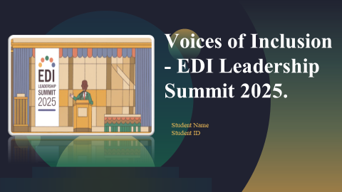

Slide 2: Introduction
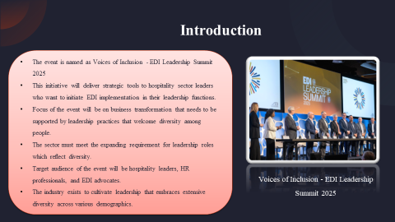
The event is named as Voices of Inclusion - EDI Leadership Summit 2025. This initiative will deliver strategic tools to hospitality sector leaders who want to initiate EDI implementation in their leadership functions. It focus of the event will be on business transformation that needs to be supported by leadership practices that welcome diversity among people. However, the sector must meet the expanding requirement for leadership roles which reflect diversity. The target audience of the event will be hospitality leaders, HR professionals, and EDI advocates. The industry exists to cultivate leadership that embraces extensive diversity across various demographics.
Slide 3: Event Cycle
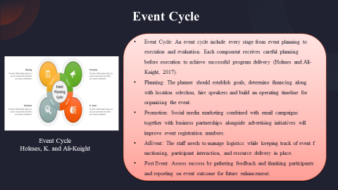
An event cycle include every stage from event planning to execution and evaluation. Each component receives careful planning before execution to achieve successful program delivery (Holmes and Ali-Knight, 2017). There are 4 stages of event cycle such as planning where Tte planner should establish goals, determine financing along with location selection, hire speakers and build an operating timeline for organizing the event. Second is promotion where social media marketing combined with email campaigns together with business partnerships alongside advertising initiatives will improve event registration numbers. Third, AtEvent where the staff needs to manage logistics while keeping track of event functioning, participant interaction, and resource delivery in place. Fourth, post Event: Assess success by gathering feedback and thanking participants and reporting on event outcome for future enhancement.

Slide 4: Event Context
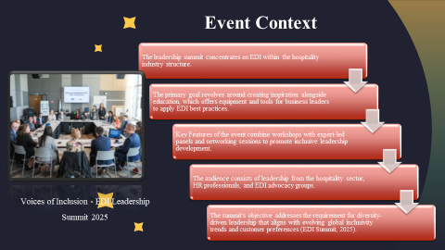
The leadership summit concentrates on EDI within the hospitality industry structure. The primary goal revolves around creating inspiration alongside education, which offers equipment and tools for business leaders to apply EDI best practices. Key Features of the event combine workshops with expert-led panels and networking sessions to promote inclusive leadership development. The audience consists of leadership from the hospitality sector, HR professionals, and EDI advocacy groups. The summit's objective addresses the requirement for diversity-driven leadership that aligns with evolving global inclusivity trends and customer preferences (EDI Summit, 2025).

Slide 5: Aims and Objectives
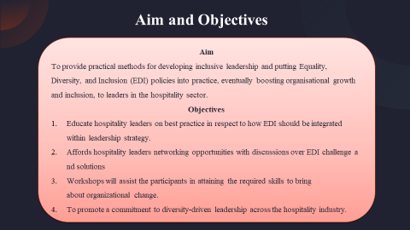
Aim
To provide practical methods for developing inclusive leadership and putting Equality, Diversity, and Inclusion (EDI) policies into practice, eventually boosting organisational growth and inclusion, to leaders in the hospitality sector. The objectives are following:
- Educate hospitality leaders on best practice in respect to how EDI should be integrated within leadership strategy.
- Affords hospitality leaders networking opportunities with discussions over EDI challenge and solutions
- Workshops will assist the participants in attaining the required skills to bring about organizational change.
- To promote a commitment to diversity-driven leadership across the hospitality industry.
Slide 6: Event Management: Skills Required and Resources
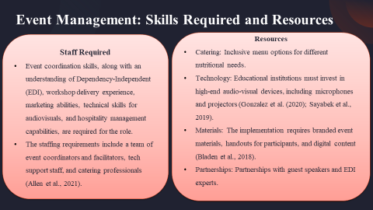
Skills required for the vent include: event coordination skills, along with an understanding of Dependency-Independent (EDI), workshop delivery experience, marketing abilities, technical skills for audiovisuals, and hospitality management capabilities, are required for the role. The staffing requirements include a team of event coordinators and facilitators, tech support staff, and catering professionals (Allen et al., 2021). The resources include catering: Inclusive menu options for different nutritional needs. Technology: Educational institutions must invest in high-end audio-visual devices, including microphones and projectors (Gonzalez et al. (2020); Sayabek et al., 2019). Materials: The implementation requires branded event materials, handouts for participants, and digital content (Bladen et al., 2018). Partnerships: Partnerships with guest speakers and EDI experts.
Slide 7: Event Management: Marketing Activities
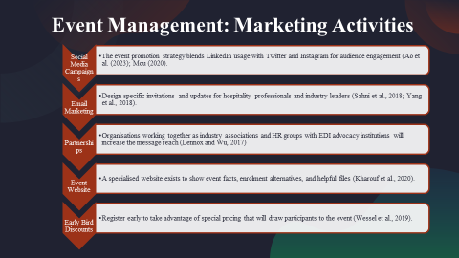
The event promotion strategy uses various channels to reach the maximum audience while improving engagement and attendance numbers. A targeted approach to social media engagement is practiced on LinkedIn along with Twitter and Instagram by Follow X (Ao et al., 2023; Mou, 2020). Through email marketing strategies professionals and leaders in the hospitality field receive customized invitations in addition to event updates (Sahni et al., 2018; Yang et al., 2018). Through partnerships with EDI advocacy groups along with industry associations the event enhances its reach (Lennox and Wu, 2017). Through a special event website users access vital information while they can perform registration tasks (Kharouf et al., 2020). The event provides savings opportunities as early bird discounts to attract participants who join during the registration's initial period (Wessel et al., 2019).
Slide 8: event budget
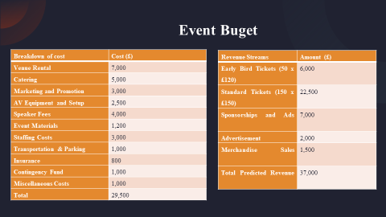
Venue rentals come to 7,000 pounds, food service amounts to 5,000 pounds and advertising costs are 3,000 pounds which all fall within the budgeted £29,500 total. Standard ticket sales along with sponsorships predicted a total revenue of £37,000 for the event while sponsorships accounted for £7,000 and standard ticket sales amounted to £22,500. Multiple income streams support the event including product sales and advertisings programs. The event's financial stability becomes clear through its £37,000 revenue projections that exceed the calculated £29,500 costs by £7,500 thus providing additional funds for unanticipated needs and promotional activities to reach more people.
Slide 9: Industry Trends
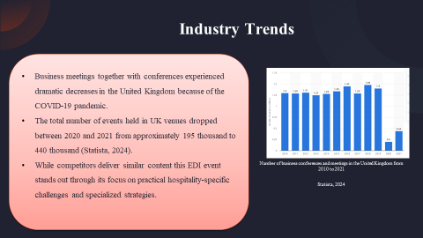
Business meetings together with conferences experienced dramatic decreases in the United Kingdom because of the COVID-19 pandemic. The total number of events held in UK venues dropped between 2020 and 2021 from approximately 195 thousand to 440 thousand (Statista, 2024). While competitors deliver similar content this EDI event stands out through its focus on practical hospitality-specific challenges and specialized strategies.

Slide 10: Situational and Cultural Consideration
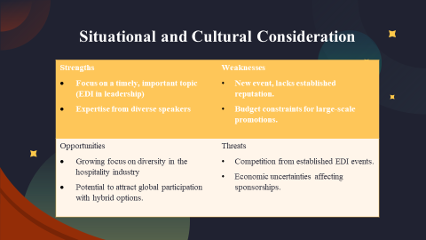

The conference is well-timed when the theme of EDI leadership is concerned through its speaker program. Budget constraints combined with new status remain the two major drawbacks for this conference. There are two new initiatives that should be considered for the event in order to strengthen diversity outreach and hybrid event formats for global reach. This event is confronted by other EDI events as well as financial instability that can limit sponsorship sources.
Slide 11: Situational and Cultural Consideration
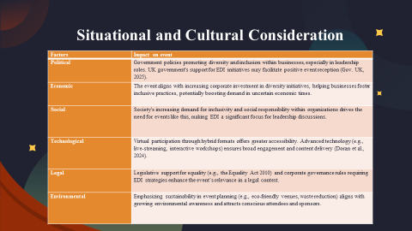
Political factors include the promotion of diversity leadership through government policies along with relevant event strategies. The elevation of demand for diversity creation is driven by financial support from corporations. The present social patterns follow inclusive principles that make EDI events highly important. Advanced technological tools alongside hybrid event structures enable better attendee participation. The Equality Act 2010 gives legal support to EDI-focused events as they become more relevant in the field. The increasing awareness of environmental issues fuels eco-friendly practices that attract participants and sponsors who are concerned about the environment. The coming together of these contributing factors to facilitate logistics for the ‘Diverse Leaders Conference 2025’ creates a positive environment.

Slide 12 and 13: References


