DS 1

My Screenshots/Photos
- Please add 4–6 screenshots or photos of your digital life.
- You can use your phone or laptop.
- For each screenshot, write one or two sentences explaining what it shows.

Screenshot/Photo 1
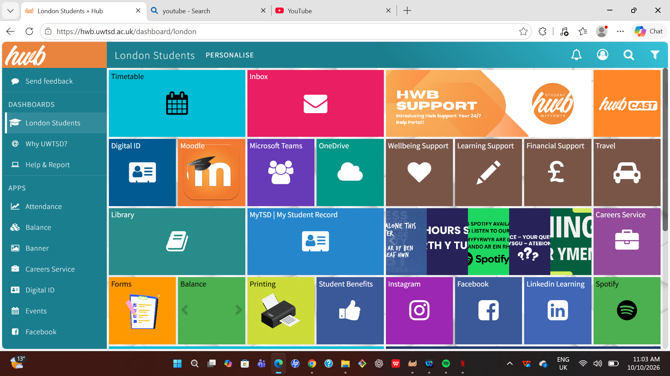

This screenshot shows an academic app for everything relating to my schoolwork where I get information and submit assignment

Screenshot/Photo 2
[Insert Photo/Screenshot below]

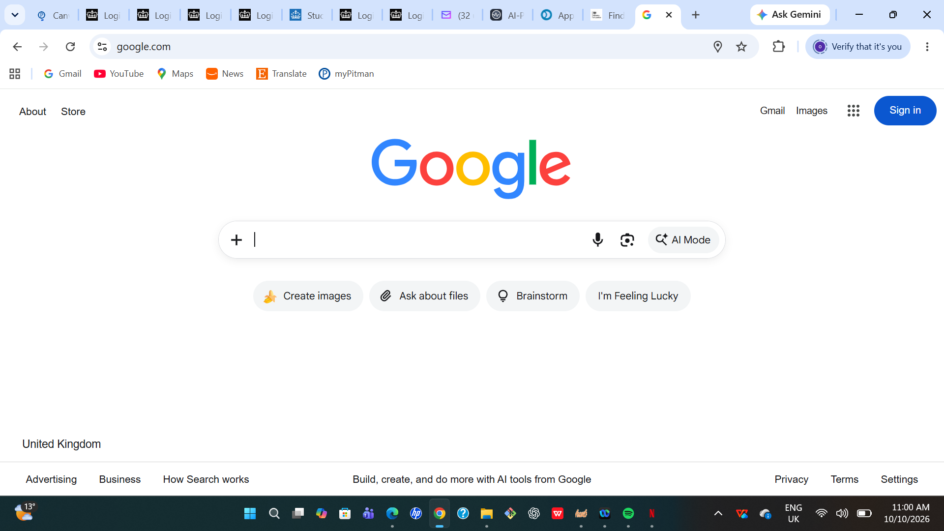
Google is my favourite search engine where I get all sort of information like weather forecasts

Screenshot/Photo 3
[Insert Photo/Screenshot below]
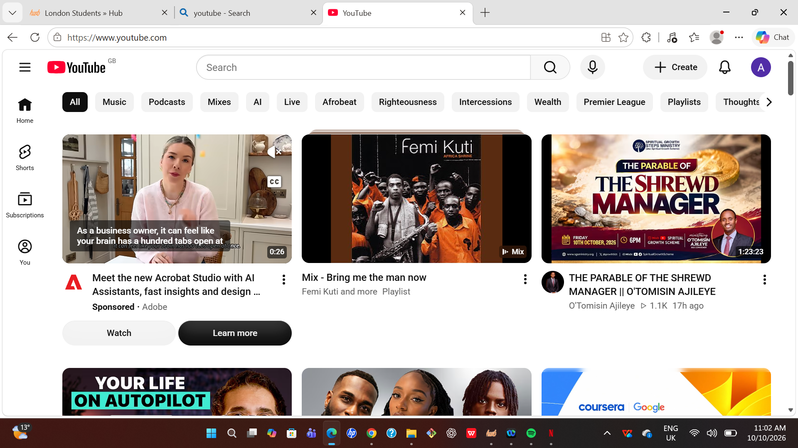I use youtube to watch free movies and learn free video courses

Screenshot/Photo 4
[Insert Photo/Screenshot below]
Yahoo mail is my major email where I get all communications relating to work
] 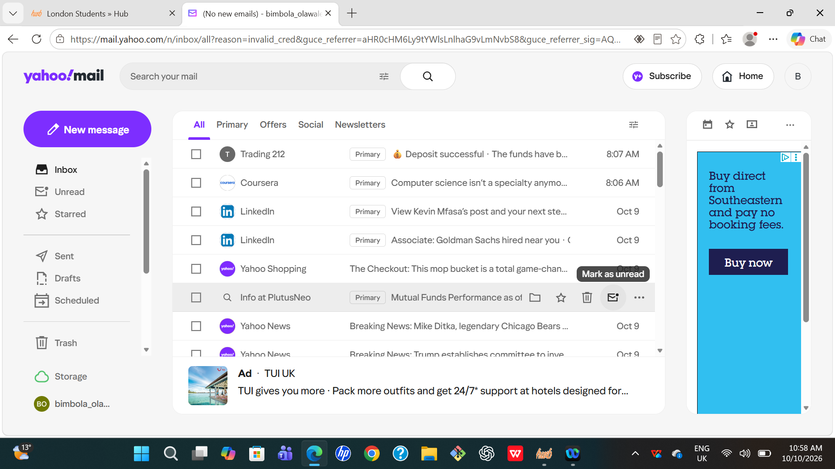

Screenshot/Photo 5
[Insert Photo/Screenshot below]
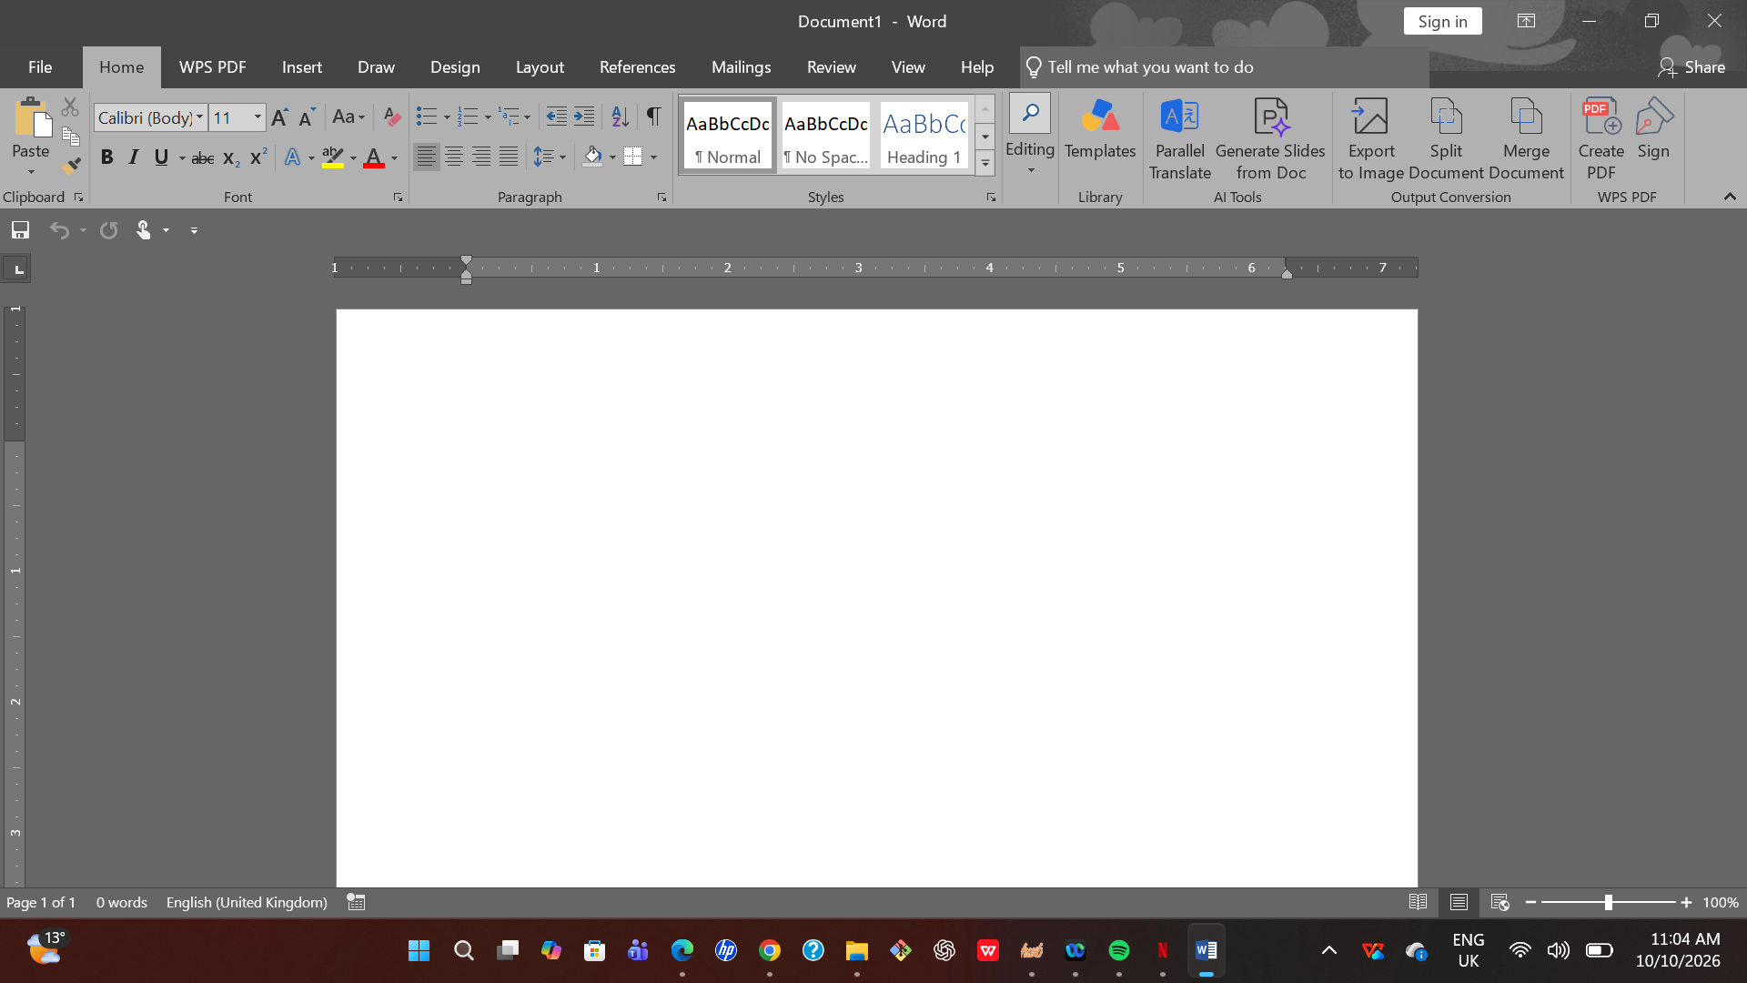
I use Microsoft word for typing and organising my work

Screenshot/Photo 6
[Insert Photo/Screenshot below]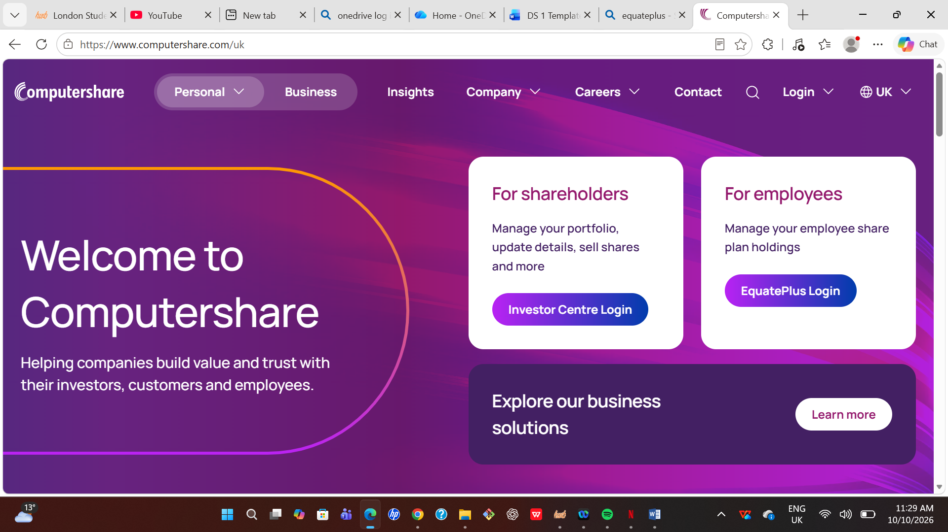
This is my investment platform where I get all information relating to my investment portfolio

My Short Reflection
- Write 5–8 simple sentences about your digital life.
- You can use the sentence starters below if helpful.
I use all the digital tools I have uploaded above daily and they help make life much easier for me.
I use them for communication, organising, learning, planning and entertainment
Although some of these digital tools can sometimes be complex to use. I am positive and confident in developing my knowledge of them
With some of these digital tools you save cost and help in time management

Sentence starters
- I use digital tools to …
- I feel confident when I …
- I want to improve …
- I often use these tools: …
- I sometimes feel nervous about …
- I hope this module will help me …
- Digital skills are important for me because …
You can write more if you want.

Submission Checklist
Before you submit, please check:
​​​ ☒ I added 4–6 screenshots
☒ I wrote short sentences for each screenshot
☒ I wrote my short reflection
☒ My work is my own
☒ My file opens correctly
​​☒ My file opens correctly

